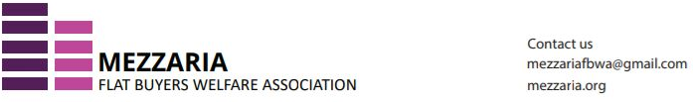
MINUTES OF MEETING
Executive Committee (EC)
Mezzaria Flat Buyers Welfare Association
Date: 13th June 2026 | Time: 1500 hrs | Venue: Mezzaria Club House
Attendees:
1. Rahoul Mundra
2. Suneal Singhal
3. Meenakshi Jhamb
4. Jayant Jhamb
5. Narendra Kumar
6. Gp Capt H.K. Srivastava
7. Shwetank Garg (online — Zoom)
8. Dinesh Sharma (online — Zoom, briefly)

Points discussed:
1. Acceptance of resignation by Sinha sahab.
The Executive Committee accepted the resignation of Gurudeo Sinha from the post of President. Sinha sahab cited reasons of not keeping in good health, which is impairing his ability to actively participate in the affairs of the Association. The Committee placed on record its appreciation for his contributions during his tenure.
2. Proposal of making Jayant Jhamb President.
Shwetank Garg proposed the name of Capt. Jayant Jhamb for the post of President. The proposal was seconded by Suneal Singhal. All present members approved the appointment, and Capt. Jhamb graciously accepted the responsibility.
3. Proposal to choose another person as treasurer.
Meenakshi Jhamb expressed her inability to continue as Treasurer. The Committee discussed the need to identify and appoint a new Treasurer.
4. Association to pursue delinking of electricity meter from maintenance.
The Committee discussed and agreed that the Association should actively pursue the delinking of electricity meters from maintenance charges.
5. KYC completion and payments.
It was informed that KYC documentation will be completed within a day or two. Accordingly, payments will be carried out as requisitioned once KYC is in order.

Capt. Jayant Jhamb  President  Mobile: 8826055558 | Suneal Kumar Singhal  Secretary  Mobile: 9811428209

