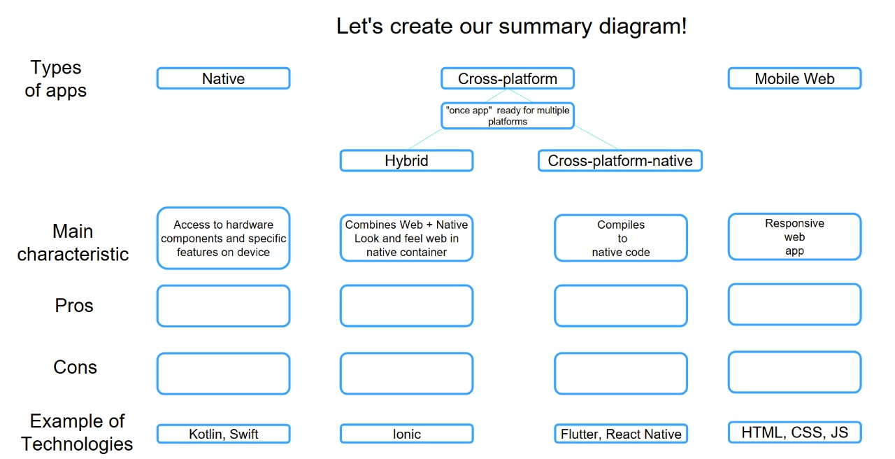

Progressive Web Applications: is a web application that uses modern web technologies to provide a user experience similar to a native mobile app