**Sequence Diagrams**

Create Menu Sequence Diagram

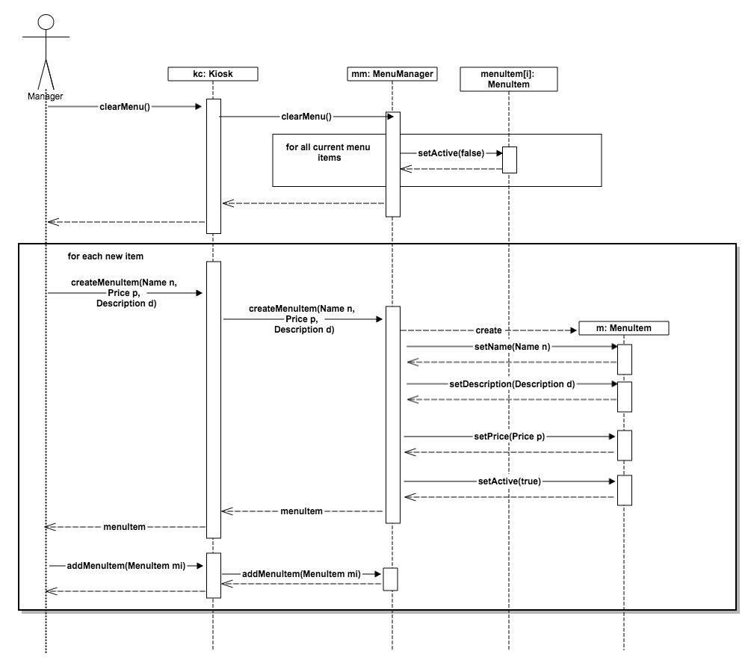

Assumptions: Our assumption for this sequence diagram is that the manager has logged in as the manager prior to starting to create the menu. We considered logging in as a certain user as a different sequence diagram.

Create Order Sequence Diagram

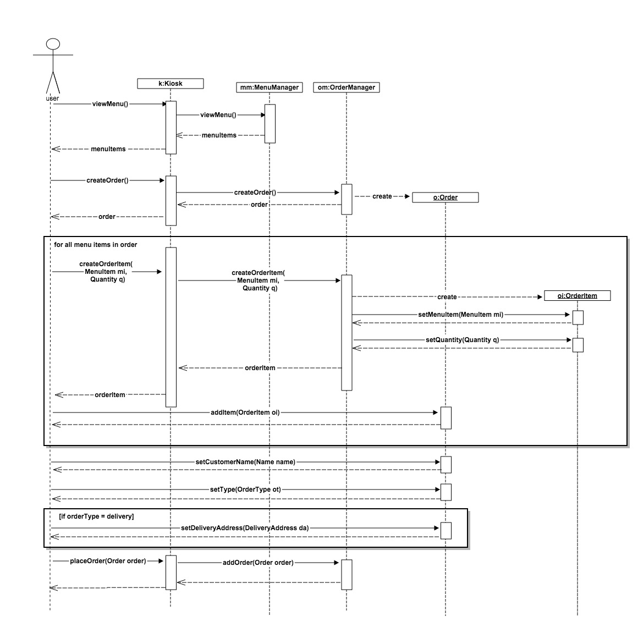

Assumptions: Our assumption for this sequence diagram is that the payment and completing the order are different sequence diagrams and that this is just for creating an order and placing it. Payment and completing it will follow after.

Complete Order Sequence Diagram

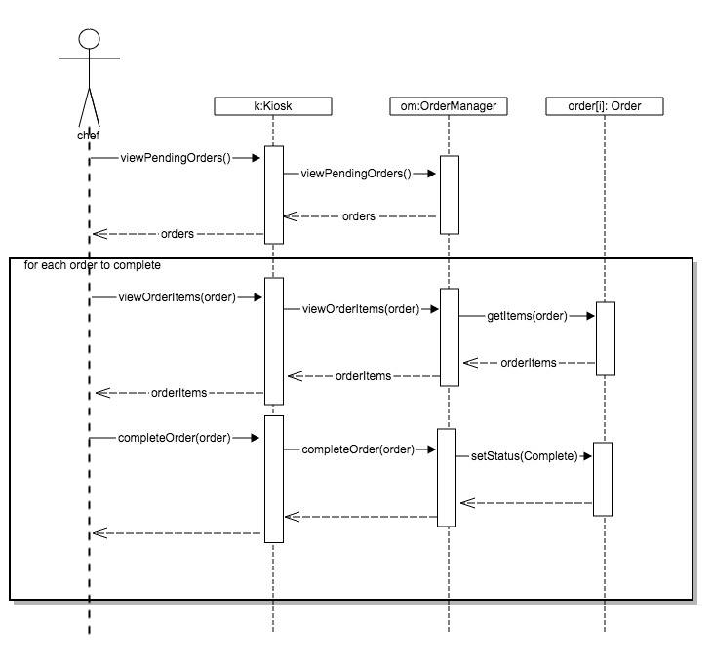

Assumptions: Our assumption for this sequence diagram is that the chef has logged in as the chef prior to starting to create the menu. We considered logging in as a certain user as a different sequence diagram.

**Class Diagram**

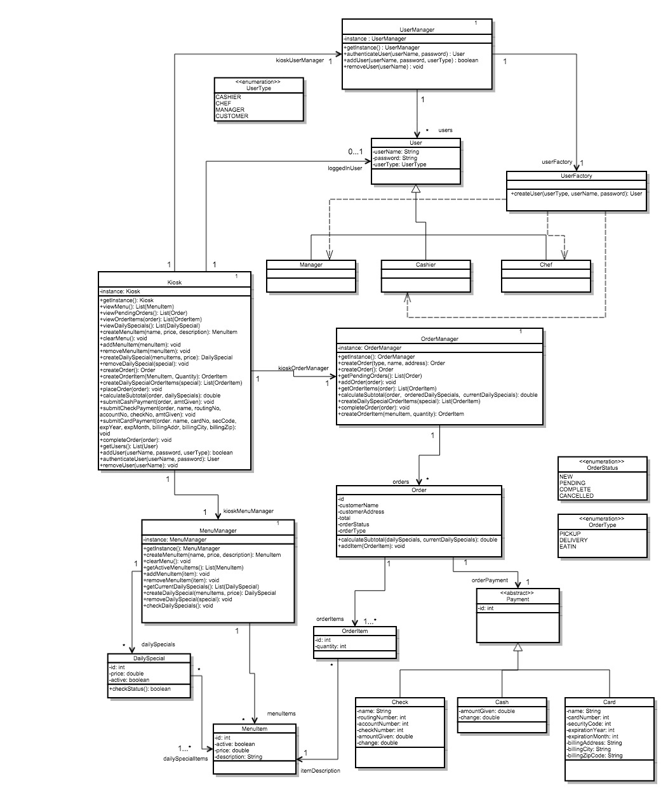

Assumptions For Class Model:

* In order to delete a menu item, create menu item, clear menu, add daily special, remove daily special , add user, or remove a user that current logged in user must be of user type manager.
* In order to complete orders or view current orders the current logged in user must be of user type chef.

**System Test Plan**

**Login as chef - Test 1**

System: User System

Importance: High

Prerequisites: Make sure that there is at least one chef credentials that can be logged into. Go to test case 20 to create one.

Instructions:

1. Launch Pizza Ordering System.
2. Click “Login”.
3. Enter chef username and password.
4. Click “Login”.

Expected result:

After step 4, the chef should be able to view the menu, and there should be a “Chef View” button visible. Upon clicking the “Chef View” button, the chef should be able to see the list of pending orders to be completed.

If the entered username or password is incorrect, an error message should be displayed.

Cleanup:

Click “Logout” to log out as the customer. (Test case 4)

**Login as manager - Test 2**

System: User System

Importance: High

Prerequisites: Make sure that there is at least one manager credentials that can be logged into. Go to test case 21 to create one.

Instructions:

1. Launch Pizza Ordering System.
2. Click “Login”.
3. Enter manager username and password.
4. Click “Login”.

Expected result:

The manager should be able to see the menu. After step 4, the manager should be able to see an “Edit Menu” and ‘Edit Specials’ button. The manager should be able to click the edit menu button to open the edit menu dialog and should be able to click on the edit specials button to open the edit specials dialog.

If the entered username or password is incorrect, an error message should be displayed.

Cleanup:

Click “Logout” to log out as the manager. (Test case 4)

**Login as cashier - Test 3**

System: User System

Importance: High

Prerequisites: Make sure that there is at least one cashier credentials that can be logged into. Go to test case 22 to create one.

Instructions:

1. Launch Pizza Ordering System.
2. Click “Login”.
3. Enter cashier username and password.
4. Click “Login”.

Expected result:

The cashier should be able to see the menu. They should also see a “Place Order” button. They should be able to click this button to open the “Place Order” dialog and successfully place an order.

If the entered username or password is incorrect, an error message should be displayed.

Cleanup:

Click “Logout” to log out as the cashier. (Test case 4)

**Logout - Test 4**

System: User System

Importance: High

Instructions:

1. Login as employee (Go to one of the test cases from 1-3 to log in)
2. Click “logout” in main menu page.

Expected result:

There should be no options, except for the place order, shown since you are not logged in as any other user

Cleanup:

No clean up

**Creating Menu - Test 5**

System: Menu Editor

Importance: High

Instructions:

1. Launch Pizza Ordering System.
2. Login as manager (Perform test case 2)
3. Erase current menu.
   1. Click “Edit Menu” > “New Menu” > Yes.
4. Add items to the menu.
   1. Click “Create Item”.
   2. Enter a name, price, and an optional description.
   3. Click “Save”.
   4. Repeat steps 4a-c until satisfied.
5. Click “Close”.

Expected result:

After every completion of step 4c, the user should see the new menu item (name, price, description) listed on the menu (exactly as they were entered), as well as previously created items. After completing step 5, the user should be able see all created menu items in the application window.

If a name is not entered in step 4 when adding an item a pop up will show notifying you of the error. Close out the pop up and try entering information again. If a price is entered in as a negative number or a non number it will go back to the last positive number that was in that field.

Cleanup:

No cleanup

**Modifying Menu - Add Item - Test 6**

System: Menu Editor

Importance: High

Instructions:

1. Launch Pizza Ordering System.
2. Login as manager (Perform test case 2)
3. Add item to the menu.
   1. Click “Create Item”.
   2. Enter a name, price, and an optional description.
   3. Click “Save”.
4. Click “Close”

Expected result:

After completion of step 3c, the user should see the new menu item (name, price, description) listed on the menu (exactly as they were entered), as well as the already existing items. After completing step 4, the user should be able see the created menu item in the application window.

If a name is not entered in step 3 when adding an item a pop up will show notifying you of the error. Close out the pop up and try entering information again. If a price is entered in as a negative number or a non number it will go back to the last positive number that was in that field.

Cleanup:

If you want to remove the item go to test case 8

**Modifying Menu - Edit Item - Test 7**

System: Menu Editor

Importance: High

Instructions:

1. Launch Pizza Ordering System.
2. Login as manager (Perform test case 2)
3. Modify existing item in the menu.
   1. Click “Edit” under the item that you would like to modify.
   2. Enter a new name, new price, or a new description.
   3. Click “Save”.
4. Click “Close”

Expected result:

After completion of step 3c, the user should see the new modified menu item (name, price, description) listed on the menu (exactly as they were entered) and should see the item that they changed anymore. After completing step 4, the user should be able see the same menu that they saw after step 3c.

If a name is not entered in when modifying the item a pop up will show notifying you of the error. Close out the pop up and try entering information again. If a price is entered in as a negative number or a non number it will go back to the last positive number that was in that field.

Cleanup:

No cleanup

**Modifying Menu - Remove Item - Test 8**

System: Pizza Ordering Menu

Importance: Menu Editor

Instructions:

1. Launch Pizza Ordering System.
2. Login as manager (Perform test case 2)
3. Delete item from the menu.
   1. Click “Remove” under item that you would like to remove
4. Click “close”

Expected result:

After completion of step 3c, the user should no longer see the menu item that they hit remove on and after step 4 it should still not be there.

Cleanup:

If you want to re add the item go to test case 6

**Create Daily Special – Test 9**

System: Daily Special System

Importance: High

Prerequisites: Make sure there are items on the menu, if nothing is showing when you are in the menu frame go to test case 6 to create menu items.

Instructions:

1. Launch Pizza Ordering System.
2. Login as manager (Perform test case TODO:Insert 2).
3. Click on ‘Edit Specials’
4. Click on ‘Create Special’
5. Click “Add to special’ under each item that you want to add to the special.
6. If you want to delete an item from the daily special that you added under the ‘Properties’ frame select an item that you want to remove put clicking on it (which highlights it) and click the ‘Remove’ button.
7. Enter in price
8. Click the ‘Save Special’ button to save the special or click ‘cancel’ if you do not want to save the special.

Expected Result:

The daily special should be saved and should be open for people to order unless you hit cancel than it shouldn’t be visible anywhere. You should see it in the edit daily specials menu if created.

Cleanup:

If you want to remove the special that you just created go to test case 11.

**Edit Daily Special – Test 10**

System: Daily Special System

Importance: High

Prerequisites: That there is an existing daily special to edit, go to test case 9 to create a daily special.

Instructions:

1. Launch Pizza Ordering System.
2. Login as manager (Perform test case 2).
3. Click on ‘Edit Specials’
4. Under the Daily Special that you want to edit click ‘edit’.
5. Click “Add to special’ under each item that you want to add to the edited special.
6. If you want to delete an item from the daily special under the ‘Properties’ frame select an item that you want to remove put clicking on it (which highlights it) and click the ‘Remove’ button.
7. Enter in new price if you want to change the price.
8. Click the ‘Save Special’ button to save the edited special or click ‘cancel’ if you do not want to save the edited special.

Expected Result:

The new edited daily special should be saved and should be open for people to order if save was clicked if canceled the original daily special should remain in tact. You should see the correct one in the edit daily specials menu.

Cleanup:

None

**Remove Daily Special – Test 11**

System: Daily Special System

Importance: High

Prerequisites: That there is an existing daily special to remove, go to test case 9 to create a daily special.

Instructions:

1. Launch Pizza Ordering System.
2. Login as manager (Perform test case 2)
3. Click on ‘Edit Specials’
4. Under the Daily Special that you want to remove click ‘remove’.

Expected Result:

The daily special should be removed from the edit daily specials list.

Cleanup:

If you want to re add the special go to test case 9.

**Add item to order - Test 12**

System: Ordering Menu

Importance: High

Prerequisites: Make sure there are items on the menu, if nothing is showing when you are in the menu frame go to test case 6 to create menu items.

Instructions:

1. On the main kiosk menu, click ‘Place Order’.
2. Enter a quantity for an item off the menu.
3. Click ‘Add to Order’

Expected Result:

Under the ‘My Order’ section on the right side of the window, the selected item should appear with the quantity selected and the price noted in the menu on the left. The subtotal should update to include the price of the item times the quantity ordered. Also if the items on the list now meet a know daily special that daily special price will now reflect in the total.

Cleanup:

If you want to cancel adding the item than go to test case 14 to remove the item. If you want to cancel the order click “Cancel Order’ button.

**Add Daily Special to order - Test 13**

System: Ordering Menu

Importance: High

Prerequisites: Make sure there are daily specials on the menu, if nothing is showing when you are in the order frame go to test case 9 to create daily specials.

Instructions:

1. Go into placing an order if you are not there already by clicking on the ‘Place Order Button’ in the main kiosk menu.
2. Under the Daily Special that you want to select click on the “Add” button

Expected Result:

Under the ‘My Order’ section on the right side of the window, the selected daily special’s items should appear. The subtotal should update to include the price of the daily special not the by the prices of each item combined.

Cleanup:

If you want to cancel adding the daily special than go to **test case #** to remove each item that was in the daily special now in the order, or you can just remove one item that was included in the daily special and that daily special will no longer be applied. If you want to cancel the whole order click “Cancel Order’ button.

**Remove item from order - Test 14**

System: Ordering Menu

Importance: High

Prerequisites: Make sure there are items on the order, if nothing is showing under the ‘My order’ section when you are in the order frame go to 12.

Instructions:

1. Select an item from the list in the ‘My Order’ panel on the right side of the window.
2. Click ‘Remove’

Expected Result:

The selected item should be removed from the list. All other items in the list should remain intact. The subtotal should update so that it no longer includes the price of the removed item. If that removal of the item voids any daily special than the price will now include the regular price of the rest of the items that were included in that daily special, unless it now meets another daily special.

Cleanup:

If you want to cancel removing the item than go to test case 12 to re-add the item. If you want to cancel the order click “Cancel Order’ button.

**Placing an order - Test 15**

System: Pizza Ordering System

Importance: High

Prerequisites: Make sure that there is at least one item in the order under the ‘My Order’. If not go to test case 12 to add items

Instructions:

1. Select the type of order.
2. Enter a name into the ‘Name’ field.
3. Enter an address into the ‘Address’ field.
4. Click ‘Place Order’.
5. Complete one of the payment test cases (See test cases 16-18) to finish placing the order.

Expected Result:

If name is empty, an error message should appear. If type is Delivery and Address is empty then an error message should appear. Upon completion of the payment the kiosk should return to the main menu page. When following test case 19 the order just placed should appear in the list of placed orders in the Chef View.

Cleanup:

No clean up

**Submitting Card Payment - Test 16**

System: Payment System

Importance: High

Instructions:

1. After placing an order (Go to test case 15 to place an order)
2. Click on the Tab “Credit”
3. Enter in Card Holder Name
4. Enter in 16 digit Card Number
5. Enter in 3 or 4 digit Security Number
6. Select the expiration month from the first drop down and the expiration year from the second drop down, should be past the current month
7. Enter in Billing Address
8. Enter in City
9. Enter in Zip Code
10. Click on “Submit Payment”

Expected result:

After hitting on Submit payment you should see a message pop up that the payment was accepted and order was placed and after closing out of that it should close out of the payment window and order menu.

If the any of the fields are not entered, if the card number is not all numbers and isn’t 16 digits, if the security number is not all numbers and isn’t 3 or 4 digits long, or if the expiration month/year is before the current month and year a pop up error will show up. Close out the pop up and try entering in the information again.

Cleanup:

No clean up

**Submitting Check Payment - Test 17**

System: Payment System

Importance: High

Instructions:

1. After placing an order (Go to test case 15 to place an order)
2. Click on the Tab “Check”
3. Enter in Name
4. Enter in 4 to 17 digit Account Number
5. Enter in 9 digit Routing Number
6. Enter in any positive number for check number
7. Enter in a total the same or above the total due
8. Click on “Submit Payment”

Expected result:

After hitting on Submit payment you should see a message pop up with the change due if the payment is greater than the total due along with that the payment was accepted and order was placed and after closing out of that it should close out of the payment window and order menu.

If the any of the fields are not entered, if the account number is not all numbers and doesn’t fall between 4 and 17 digits, if the routing number is not all number and isn’t 9 digits long, if the check number is not a positive number, or the total is below the total amount due a pop up error will show up. Close out the pop up and try entering in the information again. If the total is entered in as a non-number or negative it will go back to the last positive number that was in that field.

Cleanup:

No clean up

**Submitting Cash Payment - Test 18**

System: Payment System

Importance: High

Instructions:

1. After placing an order (Go to test case 15 to place an order)
2. Click on the Tab “Cash”
3. Enter in a total the same or above the total due
4. Click on “Submit Payment”

Expected result:

After hitting on Submit payment you should see a message pop up with the change due if the payment is greater than the total due along with that the payment was accepted and order was placed and after closing out of that it should close out of the payment window and order menu.

If a total is entered that is below the total due a pop up will show up and prompt you to re enter the total. Close out the pop up and try entering information again. If the total is entered in as a non-number or negative it will go back to the last positive number that was in that field.

Cleanup:

No clean up

**Viewing and completing placed orders - Test 19**

System: Chef View

Importance: High

Instructions:

1. Launch Pizza Ordering System.
2. Complete ‘Placing an order’ test case at least once. (Perform test case 15)
3. Login as chef (Perform test case 1)
4. Click “Chef View”
5. Select an order from the Pending Orders.
6. Click “Mark as Filled”.
7. Repeat steps 5-6 until there are no more pending orders.
8. Close the dialog.

Expected Result:

After every completion of step 6, the pending order should disappear from the pending orders list. After completing all of the instructions, the user should click “Chef View” one more time, and the pending orders list should be completely empty.

Cleanup:

On the main kiosk menu page, click ‘Logout’ to logout as the chef. (Test case 4)

**Create Chef log in - Test 20**

System: Admin System

Importance: High

Instructions:

1. Launch Pizza Ordering System.
2. Click “Admin” on the top of the frame, it will show a drop down.
3. **TO DO**
4. Enter username and password for the new user.
5. Select the chef for the type of user
6. Click “Create”.

Expected result:

After a user of type chef will be created and can now be logged into. If the username already exists to someone else an error pop up will show. If shown close and try again.

Cleanup:

If you want to delete the user go to test case 23

**Create Manager log in - Test 21**

System: Admin System

Importance: High

Instructions:

1. Launch Pizza Ordering System.
2. Click “Admin” on the top of the frame, it will show a drop down.
3. **TO DO**
4. Enter username and password for the new user.
5. Select the manager for the type of user
6. Click “Create”.

Expected result:

After a user of type manager will be created and can now be logged into. If the username already exists to someone else an error pop up will show. If shown close and try again.

Cleanup:

If you want to delete the user go to test case 23

**Create Cashier log in - Test 22**

System: Admin System

Importance: High

Instructions:

1. Launch Pizza Ordering System.
2. Click “Admin” on the top of the frame, it will show a drop down.
3. **TO DO**
4. Enter username and password for the new user.
5. Select the cashier for the type of user
6. Click “Create”.

Expected result:

After a user of type casher will be created and can now be logged into. If the username already exists to someone else an error pop up will show. If shown close and try again.

Cleanup:

If you want to delete the user go to test case 23

**Delete Users - Test 23**

System: Admin System

Importance: High

Instructions:

1. Launch Pizza Ordering System.
2. Click “Admin” on the top of the frame, it will show a drop down.
3. **TO DO**

Expected result:

The user that you deleted should not be shown anymore and people should not be able to log in as them.

Cleanup:

If you want to re create the user go to test cases 23

**Commit Log (Used Git)**

Below is our log from our git repo. If you want more information and statistics go to <https://github.com/rbpeters/pizza>

commit 28776b3b5f9c0f119358807e423260e4d2ec98ae

Author: Tim Buckley <timothyb89@gmail.com>

Date: Tue Oct 28 22:14:30 2014 -0600

show an error when a user already exists

commit b3d031486706ad6c724a005be00d41ea0aad61ca

Author: Tim Buckley <timothyb89@gmail.com>

Date: Tue Oct 28 22:06:34 2014 -0600

don't let users delete themselves

commit 9ca269bf35aecdcc6ecafdb41307f62f438d1221

Merge: 84f9f69 d7889bd

Author: Tim Buckley <timothyb89@gmail.com>

Date: Tue Oct 28 22:01:13 2014 -0600

Merge branch 'master' of github.com:rbpeters/pizza

commit 84f9f69dbcfaa3b9a53b4c44cf3886b18ee73be2

Author: Tim Buckley <timothyb89@gmail.com>

Date: Tue Oct 28 22:00:35 2014 -0600

fix main class in build config and correct the classpath search location for

database config

commit d7889bd8763726d60f77583c1297a24582bb4972

Author: Michael_Hoppal <hoppalm@gmail.com>

Date: Tue Oct 28 21:55:59 2014 -0600

Fixing unit test bugs

commit cd844692fbf5a049565577fbe7a11c7f1372a7c3

Author: Michael_Hoppal <hoppalm@gmail.com>

Date: Tue Oct 28 21:50:23 2014 -0600

Model jpg

commit 06c79f003e1d154da0b540e0a2bae199caebc6ce

Merge: 3f73e75 ad23f8d

Author: Tim Buckley <timothyb89@gmail.com>

Date: Tue Oct 28 21:49:29 2014 -0600

Merge branch 'master' of github.com:rbpeters/pizza

commit 3f73e750abbf22c7bbe858a76d26ff103184e0b3

Author: Tim Buckley <timothyb89@gmail.com>

Date: Tue Oct 28 21:48:32 2014 -0600

added user management UI

commit 8ccc005999e8cdbffcbb5ff7f042e74354d838dd

Author: Tim Buckley <timothyb89@gmail.com>

Date: Tue Oct 28 21:48:15 2014 -0600

don't run tests during build

commit ad23f8dd5ae5f684a32de8959729266b2d34c53e

Author: Michael_Hoppal <hoppalm@gmail.com>

Date: Tue Oct 28 21:07:28 2014 -0600

payment changes

commit 86c0d974b52865d9858edf41c2fe9b632a9d55f1

Author: Tim Buckley <timothyb89@gmail.com>

Date: Tue Oct 28 20:52:12 2014 -0600

hide the admin menu

commit 069babc20357a926b7ef57240ce1ecf4662cb924

Author: Tim Buckley <timothyb89@gmail.com>

Date: Tue Oct 28 20:51:14 2014 -0600

fix for layout bug causing add button to be cut off for specials with several items

commit 614965a337e50614e7c4101a77cf351adb5401d5

Author: Rawlin Peters <rbpeters@rams.colostate.edu>

Date: Tue Oct 28 19:41:39 2014 -0600

Updated class model with payment methods

commit f5e8d520b41cd864e95f86ee0aabbb27bd94ebdf

Merge: ac0c03c c9d58db

Author: Rawlin Peters <rbpeters@rams.colostate.edu>

Date: Tue Oct 28 19:32:12 2014 -0600

Merge branch 'master' of https://github.com/rbpeters/pizza

commit ac0c03c4fadcbf853579a8402b280c09ae69e6be

Author: Rawlin Peters <rbpeters@rams.colostate.edu>

Date: Tue Oct 28 19:31:14 2014 -0600

Added payment submission funcitonality to PaymentDialog.

commit 29e60fe32cf3749fe6d1a6b5dbde62e2d99cd6ba

Author: Rawlin Peters <rbpeters@rams.colostate.edu>

Date: Tue Oct 28 19:04:12 2014 -0600

Set order total during payment submission.

commit e856d17ea6274aef1abe03a6012d785e6b76ec7b

Author: Rawlin Peters <rbpeters@rams.colostate.edu>

Date: Tue Oct 28 19:00:03 2014 -0600

Initial stubs for payment submission.

commit c9d58dbea03ca427ee67b82f1d135bbe30de9f04

Author: Michael_Hoppal <hoppalm@gmail.com>

Date: Tue Oct 28 18:46:26 2014 -0600

modelin

commit 8a6ce670e69ffe6201f0ef8584086d55d31bf789

Author: Michael_Hoppal <hoppalm@gmail.com>

Date: Tue Oct 28 11:12:02 2014 -0600

Fixing Daily Special calculation

commit 245f08d6bd37a4c5be925cd590c4dfc667b7240c

Author: Tim Buckley <timothyb89@gmail.com>

Date: Tue Oct 28 10:59:00 2014 -0600

properly pass a list of customer-selected DailySpecials to calculateTotal

commit 5ffbfe5b5be6a51238a7bf26de05195b31f8500c

Author: Tim Buckley <timothyb89@gmail.com>

Date: Tue Oct 28 10:37:52 2014 -0600

daily specials in customer order UI

commit 3f420001990ea130af457bf060ec4fa3225b2841

Author: Tim Buckley <timothyb89@gmail.com>

Date: Mon Oct 27 23:48:01 2014 -0600

don't allow specials with zero items

commit aa4f04ab05f206abdc9ca41fd3fe744cfc152ffd

Author: Tim Buckley <timothyb89@gmail.com>

Date: Mon Oct 27 23:45:19 2014 -0600

added daily special admin UI (working)

commit bafd0ad4a4f40ba1f82c099906b9153e82ec46b5

Author: Michael_Hoppal <hoppalm@gmail.com>

Date: Mon Oct 27 22:27:58 2014 -0600

Sequence Diagram updates

commit de3c846debc78051aa975a4a68bf2efb85ecf069

Author: Rawlin Peters <rbpeters@rams.colostate.edu>

Date: Mon Oct 27 20:31:27 2014 -0600

Changed login button text.

commit 60bcfbebf4c2fcde5c44387d9321adc4e148c534

Author: Michael_Hoppal <hoppalm@gmail.com>

Date: Mon Oct 27 18:51:26 2014 -0600

Last Sequence diagram

commit f8e17bc5c4ed775136e3966a89476a026b8a5169

Author: Michael_Hoppal <hoppalm@gmail.com>

Date: Mon Oct 27 18:27:16 2014 -0600

Modeling

commit a9713de6537fc2865b5dc0f840b7dba2a4080d10

Author: Michael_Hoppal <hoppalm@gmail.com>

Date: Mon Oct 27 16:34:46 2014 -0600

Implement dummy payment info

commit a92acec852692a84fb65f036219346ba599b5b78

Author: Michael_Hoppal <hoppalm@gmail.com>

Date: Mon Oct 27 16:01:41 2014 -0600

modeling

commit 3e0a35f069acdea31e927b099fc1e89ca043bed3

Author: Michael_Hoppal <hoppalm@gmail.com>

Date: Mon Oct 27 15:29:35 2014 -0600

Modeling and diagram changes

commit ddc1fe4fd8429d10119c55ec583a2f83e2e565cb

Author: Tim Buckley <timothyb89@gmail.com>

Date: Mon Oct 27 14:45:19 2014 -0600

minor cleanup, added dialog titles, and initial DailySpecialEditDialog implementation

commit cbc7449acf64a8425916a33226ddff0e5bf8b203

Merge: 067e896 70a0f0c

Author: Michael_Hoppal <hoppalm@gmail.com>

Date: Mon Oct 27 14:13:18 2014 -0600

Merge branch 'master' of https://github.com/rbpeters/pizza

commit 067e896514c84926afc08a6b4e58086d6b72f037

Author: Michael_Hoppal <hoppalm@gmail.com>

Date: Mon Oct 27 14:12:59 2014 -0600

Minor refractoring and class model

commit 70a0f0cdcd27e17a995ed25a090363a892562d02

Author: Tim Buckley <timothyb89@gmail.com>

Date: Mon Oct 27 13:11:00 2014 -0600

fixed bug causing menu to appear deleted after denying the new menu confirmation

commit 963b311aa3f0c3ea8a7c46d37437535901589d89

Author: Michael_Hoppal <hoppalm@gmail.com>

Date: Sun Oct 26 21:09:28 2014 -0600

Create menu sequence diagram

commit 2b52ade4ed4ef9efc4374a9ad4de408a060e5a2e

Author: Michael_Hoppal <hoppalm@gmail.com>

Date: Sun Oct 26 20:47:41 2014 -0600

Changing savemenu to clear menu

commit 2d37f5ebe0faf08f2f5f52cf6abc400372a04a74

Author: Michael_Hoppal <hoppalm@gmail.com>

Date: Sun Oct 26 20:27:50 2014 -0600

Order Sequence Diagram

commit 861a3f09ad6a69de8ca3ab662df73746349d7974

Author: Jeff <Jeff@ASUS_Tower_Win7>

Date: Sun Oct 26 19:11:25 2014 -0600

"Fixed" the filter causing all sorts of issues. May want to look into making it a cleaner fix in the future.

commit cc4ac137791c730c5c0e7dcb753c7e97c5b2e049

Author: Michael_Hoppal <hoppalm@gmail.com>

Date: Sun Oct 26 15:19:51 2014 -0600

Payment Gui

commit 4b74a4cb04498b6fcd8d24729fa5784f79a0a486

Merge: 2178e86 aa65566

Author: Michael_Hoppal <hoppalm@gmail.com>

Date: Sun Oct 26 09:35:50 2014 -0600

Merge branch 'master' of https://github.com/rbpeters/pizza

commit aa655668eea677fd20f974ac78ae6eb3df4c8522

Author: Tim Buckley <timothyb89@gmail.com>

Date: Fri Oct 24 13:19:29 2014 -0600

fixed new menu refresh bug

commit 2178e86c0a8ba0fd39fcbcc02b288dea39947828

Author: Michael_Hoppal <hoppalm@gmail.com>

Date: Fri Oct 24 13:06:05 2014 -0600

Payment Gui

commit 8a8d35880bcadb56ba3857bd242118d91a7eefdb

Author: Tim Buckley <timothyb89@gmail.com>

Date: Fri Oct 24 12:31:29 2014 -0600

finished login/logout flow with basic per-user-type permissions

commit c2f35b40c05679b126ad1ec4aaff2106a7e16fa0

Author: Rawlin Peters <rbpeters@rams.colostate.edu>

Date: Thu Oct 23 23:02:51 2014 -0600

Created LoginDialog, added method and User instance variable in Kiosk to

login a user.

commit 22ac4f103500a2a5566d21a34e9c3b71feead2e8

Author: Tim Buckley <timothyb89@gmail.com>

Date: Thu Oct 23 21:19:38 2014 -0600

added pending order frame + chef menu item

commit 99b6f3c1a8c6658cb690adcba0399ddc409a0827

Author: Michael_Hoppal <hoppalm@gmail.com>

Date: Thu Oct 23 12:12:21 2014 -0600

Refractoring code

commit 5e3cdb86fbeab7cc2728d255ad1ad4be0747ee9d

Author: Michael_Hoppal <hoppalm@gmail.com>

Date: Thu Oct 23 12:08:37 2014 -0600

Test User Factory

commit 2650778b57d1753ad5ecc7ccdd318ccd6c9bfb56

Author: Michael_Hoppal <hoppalm@gmail.com>

Date: Thu Oct 23 11:52:59 2014 -0600

Adding testing suite to run all unit test

commit b89fdec2b7638470080e8c2cbc00bdff0117db36

Author: Michael_Hoppal <hoppalm@gmail.com>

Date: Thu Oct 23 11:36:01 2014 -0600

Taking away main testing method since we have unit tests

commit 8396d12bdb9fb2f8babd4333f2cb28bf11602c26

Author: Michael_Hoppal <hoppalm@gmail.com>

Date: Thu Oct 23 11:35:05 2014 -0600

Daily special database controller unit tests

commit 3053182eb9a07583ea10ab22a42e30b8f9d280f3

Author: Michael_Hoppal <hoppalm@gmail.com>

Date: Thu Oct 23 11:26:56 2014 -0600

Fixing more bugs in the database controller

commit 8068e7e1324960865a87ab6d1cfb1c442cd31d1a

Author: Michael_Hoppal <hoppalm@gmail.com>

Date: Thu Oct 23 10:54:52 2014 -0600

Fixing Database for Daily Specials

commit 6adf321e50838ae78548221ab1b6cf3f5d053424

Author: Rawlin Peters <rbpeters@rams.colostate.edu>

Date: Thu Oct 23 00:35:06 2014 -0600

Finished UserDatabaseControllerTest, added equals and hashcode methods for

User.

commit 5d4a23897b1e2a5776ec7d35b9082002338a4530

Author: Michael_Hoppal <hoppalm@gmail.com>

Date: Wed Oct 22 23:10:40 2014 -0600

Menu db junit tests

commit 030e1d43e478f1fe4890e01c905a9e27644fc3c7

Author: Tim Buckley <timothyb89@gmail.com>

Date: Wed Oct 22 20:26:49 2014 -0600

added daily special button stub and a new menu button

commit 88589256fd66142cdc1f4f1fae7c3fc90ba68271

Author: Michael_Hoppal <hoppalm@gmail.com>

Date: Wed Oct 22 16:38:03 2014 -0600

Manager test

commit 9dc436924b7ee2e8dea284f53a6df35575896351

Merge: 58f29a6 1d7f87f

Author: Rawlin Peters <rbpeters@rams.colostate.edu>

Date: Wed Oct 22 14:35:31 2014 -0600

Merge branch 'master' of https://github.com/rbpeters/pizza

commit 58f29a6c7bb51be49e0bb1c8eb152e1e67a05e74

Author: Rawlin Peters <rbpeters@rams.colostate.edu>

Date: Wed Oct 22 14:34:26 2014 -0600

Finished OrderDatabaseControllerTest. Added equals and hashcode methods

for Order and OrderItem.

commit 1d7f87faded2b08473c3bd5961e10375d2863ad6

Author: Michael_Hoppal <hoppalm@gmail.com>

Date: Wed Oct 22 14:28:55 2014 -0600

Tests and bug fixes

commit 4cc3da734981c934dc013e164ea8b6015b4900eb

Author: Michael_Hoppal <hoppalm@gmail.com>

Date: Wed Oct 22 13:47:54 2014 -0600

Order database fix

commit 408f6f8d48cb89f07d5a47b4e09859a0ad8b997d

Merge: 66af87b 9dab409

Author: Tim Buckley <timothyb89@gmail.com>

Date: Wed Oct 22 13:43:07 2014 -0600

Merge branch 'master' of github.com:rbpeters/pizza

commit 66af87bbfc8bd3157140affb7f86877587dd443a

Author: Tim Buckley <timothyb89@gmail.com>

Date: Wed Oct 22 13:42:21 2014 -0600

minor db fixes and mostly completed OrderDialog

commit 9dab409fd560b94f61aac89b2bdaf08e12c9e7fa

Merge: 6cde6cd 5b48e61

Author: Michael_Hoppal <hoppalm@gmail.com>

Date: Wed Oct 22 12:31:18 2014 -0600

Merge branch 'master' of https://github.com/rbpeters/pizza

commit 6cde6cd11994cdc09854c4e7b81aa2e0b6e082b8

Author: Michael_Hoppal <hoppalm@gmail.com>

Date: Wed Oct 22 12:31:06 2014 -0600

User manager tests

commit 5b48e611af6090e15929b8b8ebb2dd3d2ffcb3ed

Author: Tim Buckley <timothyb89@gmail.com>

Date: Wed Oct 22 12:11:26 2014 -0600

fix update bug

commit dedb32943568471a0cea595f686f57ac4c1d4dcb

Author: Tim Buckley <timothyb89@gmail.com>

Date: Wed Oct 22 11:56:50 2014 -0600

fixed UI update issues in menu editor

commit d17c11fa3bc423025d47e06d336496e41bf8ab7b

Merge: 0ef58be 3638512

Author: Tim Buckley <timothyb89@gmail.com>

Date: Wed Oct 22 11:08:53 2014 -0600

Merge branch 'master' of github.com:rbpeters/pizza

commit 0ef58bed8743884beeabd4050a0dc3ecef28202c

Author: Tim Buckley <timothyb89@gmail.com>

Date: Wed Oct 22 11:08:17 2014 -0600

Mostly complete (but untested) menu editing.

commit 3638512a030ed090060edfd6db8514efc721a758

Author: Rawlin Peters <rbpeters@rams.colostate.edu>

Date: Wed Oct 22 00:11:32 2014 -0600

Added call to Utility.removeDataFromDatabase() in setUp and tearDown of

OrderManagerTest.

commit b8df3c19221fdecba574ee8562c7b6441f49a93b

Merge: e1fbd6f 2be4535

Author: Rawlin Peters <rbpeters@rams.colostate.edu>

Date: Wed Oct 22 00:02:23 2014 -0600

Merge branch 'master' of https://github.com/rbpeters/pizza

Conflicts:

src/main/java/edu/colostate/cs414/d/pizza/api/order/OrderManager.java

commit e1fbd6fdddfbf1ca9fe45c7342323ea22464efc7

Author: Rawlin Peters <rbpeters@rams.colostate.edu>

Date: Tue Oct 21 23:57:58 2014 -0600

Finished OrderManagerTest.

commit 2be4535ac8cbb042e9f890bba6b27171d6861e4e

Merge: 4ace572 7804b98

Author: Tim Buckley <timothyb89@gmail.com>

Date: Tue Oct 21 23:32:30 2014 -0600

Merge branch 'master' of github.com:rbpeters/pizza

commit 4ace572aba8ca8f463d249c548f9cc715a523776

Author: Tim Buckley <timothyb89@gmail.com>

Date: Tue Oct 21 23:32:18 2014 -0600

Minor reorganization, and largely completed menu admin UI. MenuFrame now works and pulls from the database (as does OrderFrame).

commit 7804b98dc4d037c60e26f92ca2f8c5d5106b426a

Author: Michael_Hoppal <hoppalm@gmail.com>

Date: Tue Oct 21 23:19:41 2014 -0600

Utility to delete database data

commit 6ac3e47f34a37f0cbf222064e0ca14d96911e5d0

Author: Michael_Hoppal <hoppalm@gmail.com>

Date: Tue Oct 21 22:33:39 2014 -0600

Fixing bugs

commit 88defa1673a7da5e3520a59366280116f8c5ef34

Author: Michael_Hoppal <hoppalm@gmail.com>

Date: Tue Oct 21 22:30:54 2014 -0600

changes for singletons

commit 9eed2ea247b06eafdcfbfb4a118d9f067edbb81c

Merge: 9e8581a d81b2d0

Author: Michael_Hoppal <hoppalm@gmail.com>

Date: Tue Oct 21 22:09:11 2014 -0600

Merge branch 'master' of https://github.com/rbpeters/pizza

commit 9e8581a3145cd91eac4860caf8f60a395edb9b8e

Author: Michael_Hoppal <hoppalm@gmail.com>

Date: Tue Oct 21 22:08:56 2014 -0600

deleting test that was moved

commit d81b2d0ef4371be96a087405fb21c792602f1dc8

Author: Rawlin Peters <rbpeters@rams.colostate.edu>

Date: Tue Oct 21 21:26:11 2014 -0600

Finished junit UtilityTest, slightly modified Utility.

commit b0d93920470e80b1f541f2627e3c1f11b108d20f

Author: Rawlin Peters <rbpeters@rams.colostate.edu>

Date: Tue Oct 21 20:08:31 2014 -0600

Created junit test classes with prototype tests

commit a88d4dfc5c06dba5e3ae63443c9261bfb596d03e

Author: Rawlin Peters <rbpeters@rams.colostate.edu>

Date: Tue Oct 21 19:59:12 2014 -0600

Added test directory structure

commit 02868f169161f6c8362a5980ad060add1319d620

Author: Michael_Hoppal <hoppalm@gmail.com>

Date: Tue Oct 21 19:31:17 2014 -0600

Adding junit dependency

commit 2e3d34daf5541709619352730988357fbf450913

Author: Michael_Hoppal <hoppalm@gmail.com>

Date: Tue Oct 21 14:59:38 2014 -0600

Adding in logging in and authentication. Changed db schema as well to match username and password

commit 5d41bf9ddc741a6c345efa6d8b19fbcaf40ab3ce

Merge: 5b64701 601aaa5

Author: Tim Buckley <timothyb89@gmail.com>

Date: Tue Oct 21 10:56:51 2014 -0600

Merge branch 'master' of github.com:rbpeters/pizza

commit 5b64701714c0463e96342c2e563c8e3cf6ae6c24

Author: Tim Buckley <timothyb89@gmail.com>

Date: Tue Oct 21 10:56:07 2014 -0600

added EventBus and a more or less complete implementation of MenuPanel and MenuItemComponent

commit 601aaa58b048b90ab7e626534b3c9fc23e1ce91f

Author: Michael_Hoppal <hoppalm@gmail.com>

Date: Tue Oct 21 10:07:52 2014 -0600

Adding implementation of place order

commit 268bc1e91bc6fe0947f3d0e7efa921315a64315e

Merge: 47e1c28 3eca59c

Author: Tim Buckley <timothyb89@gmail.com>

Date: Tue Oct 21 09:42:47 2014 -0600

Merge branch 'master' of github.com:rbpeters/pizza

commit 47e1c28ce84528e27f839d018f5c1cb35e0a09b0

Author: Tim Buckley <timothyb89@gmail.com>

Date: Tue Oct 21 09:42:34 2014 -0600

add tabs to PaymentDialog

commit be39bd4d424ea2d281d38df4fb53086dae8264b9

Author: Michael_Hoppal <hoppalm@gmail.com>

Date: Tue Oct 21 09:40:03 2014 -0600

Functions for gui to call when creating an order

commit 3eca59c5e0badcf2bbcd16a37d805abbdf518917

Author: Michael_Hoppal <hoppalm@gmail.com>

Date: Tue Oct 21 09:17:57 2014 -0600

Removing tim as the sole author :)

commit 0f8412895b4c2d132db7ce04605e6aa0ff52c0bd

Merge: 8e9947a 19256c1

Author: Rawlin Peters <rbpeters@rams.colostate.edu>

Date: Tue Oct 21 00:42:40 2014 -0600

Merge branch 'master' of https://github.com/rbpeters/pizza

commit 8e9947a97392f3e3e9ebc2c590ec80169ce83fae

Author: Rawlin Peters <rbpeters@rams.colostate.edu>

Date: Tue Oct 21 00:40:09 2014 -0600

Finished OrderDatabaseController getting all orders w/ their order items

from the database.

commit 19256c10751f32fa2e1f908b8772eb1617d3ffd2

Author: Michael_Hoppal <hoppalm@gmail.com>

Date: Tue Oct 21 00:03:52 2014 -0600

Database stuff

commit 107f8beee14c7425c9e727681b7e402b908741b4

Author: Michael_Hoppal <hoppalm@gmail.com>

Date: Mon Oct 20 23:39:58 2014 -0600

Adding calculating total cost and passing around menu items

commit b3ed699bc83ee19d319c632d5c584a6814d91ac3

Author: Michael_Hoppal <hoppalm@gmail.com>

Date: Mon Oct 20 22:53:18 2014 -0600

Adding customer name

commit 43673edf83395a155f3e0898cb0b49d837cf3753

Author: Michael_Hoppal <hoppalm@gmail.com>

Date: Mon Oct 20 22:45:34 2014 -0600

changing schema

commit 345f333074f010521c732c083c0d9dee3aa78174

Author: Michael_Hoppal <hoppalm@gmail.com>

Date: Mon Oct 20 22:24:38 2014 -0600

Changing stub

commit 341e4f83271dc400cfff9eb3ffb13fd993ada139

Author: Tim Buckley <timothyb89@gmail.com>

Date: Mon Oct 20 22:16:35 2014 -0600

cleanup to OrderDialog

commit 30e0560c09a525e4310728f8dcd89bd981619794

Author: Tim Buckley <timothyb89@gmail.com>

Date: Mon Oct 20 21:57:22 2014 -0600

Added stubs to kiosk and added several new GUI forms and some icons

commit c6bcaf254a24c8468c58d50e69bfccb1599176c0

Author: Michael_Hoppal <hoppalm@gmail.com>

Date: Mon Oct 20 20:02:04 2014 -0600

Finished database

commit 7120a94aabf0043412e02d92da154241103ac7b8

Author: Michael_Hoppal <hoppalm@gmail.com>

Date: Mon Oct 20 19:40:14 2014 -0600

Daily Special

commit 83867f09a59aae2b7239cfc56696a64f8079bc34

Author: Michael_Hoppal <hoppalm@gmail.com>

Date: Mon Oct 20 16:24:13 2014 -0600

Database implementation for menu

commit 74df7ec7f66132b19f18bb4706ba1df7f02ec6d0

Merge: 89fcdad 883a317

Author: Tim Buckley <timothyb89@gmail.com>

Date: Mon Oct 20 14:43:57 2014 -0600

Merge branch 'master' of github.com:rbpeters/pizza

commit 89fcdad73de197ea1e1b5eb9c9905217ec3969af

Author: Tim Buckley <timothyb89@gmail.com>

Date: Mon Oct 20 14:43:27 2014 -0600

Added database config files and a logging library (slf4j + log4j)

commit 883a3178aaeabb73a0a433d2ecac6690e736ef9a

Author: Michael_Hoppal <hoppalm@gmail.com>

Date: Mon Oct 20 14:37:53 2014 -0600

Adding database controllers

commit e8e716950de2efd4a46da95645c289f1e6026f69

Author: Michael_Hoppal <hoppalm@gmail.com>

Date: Mon Oct 20 14:16:58 2014 -0600

Daily Special dates taken out

commit 8bd3d456c6260d998e3920b9ece006e3e1ed84fb

Author: Michael_Hoppal <hoppalm@gmail.com>

Date: Mon Oct 20 12:36:06 2014 -0600

Adding git ignore and changing database

commit 9a5a8695af176b2946bea99f10e28d7ca6563b93

Author: Michael_Hoppal <hoppalm@gmail.com>

Date: Mon Oct 20 12:20:21 2014 -0600

Removing credientials

commit 2f93483ad122836a2cb286c6038df63345f2c7de

Author: Michael_Hoppal <hoppalm@gmail.com>

Date: Mon Oct 20 12:17:39 2014 -0600

Modifying menu finish

commit 950cb7e7fe91083f5c7abec5443cc0174073c6c6

Author: Michael_Hoppal <hoppalm@gmail.com>

Date: Mon Oct 20 11:42:41 2014 -0600

Adding in creating menu and started menu modifying

commit 7c06b1528fb22efa5914e5ed7bbb46912db2a706

Merge: ef86cad a7ebbbb

Author: Michael_Hoppal <hoppalm@gmail.com>

Date: Mon Oct 20 10:37:21 2014 -0600

Merge remote-tracking branch 'origin/master'

commit ef86cad8c9fd957de33b1ac4486a6f485a60b615

Author: Michael_Hoppal <hoppalm@gmail.com>

Date: Mon Oct 20 10:35:39 2014 -0600

Adding connection to database

commit a7ebbbbc35b8998c43430073f5f28171347c052e

Author: Michael Hoppal <Michael_Hoppal@Michaels-MacBook-Air.local>

Date: Sun Oct 19 23:25:27 2014 -0600

Adding database schema and scripts to create database

commit fe233049b8848b8fa30927b20abe95c15091de2b

Author: Tim Buckley <timothyb89@gmail.com>

Date: Sun Oct 19 15:43:00 2014 -0600

added OrderItems to Order with some helper methods

commit ab4c6bd1d94ed47e06cc7f9c72a90d7e47146105

Author: Tim Buckley <timothyb89@gmail.com>

Date: Sun Oct 19 13:41:28 2014 -0600

added class model and rendering

commit 80d2fead98b23997e837d69487a0285f44c30fc4

Author: Tim Buckley <timothyb89@gmail.com>

Date: Sun Oct 19 13:35:50 2014 -0600

add mysql-connector-java dependency

commit 2f9957e1bde8c3b6787f8c33ecf762f88def9f23

Author: Tim Buckley <timothyb89@gmail.com>

Date: Sun Oct 19 13:24:16 2014 -0600

update main class

commit 4e4cb48c4d8e709856fd97b8d80eafe92584ecaf

Author: Tim Buckley <timothyb89@gmail.com>

Date: Sun Oct 19 13:20:49 2014 -0600

more stubs

commit 30dbee6598862baa4c3cbfe40beaa810b7367579

Author: Tim Buckley <timothyb89@gmail.com>

Date: Sun Oct 19 13:09:40 2014 -0600

initiail stubs

commit 902125422ff1db36a3f391e59174ae82609380d1

Author: Tim Buckley <timothyb89@gmail.com>

Date: Sun Oct 19 11:31:48 2014 -0600

initial conversion to maven project

commit b26abd9ef011dd29b8043d1050867a5261fd1819

Author: Rawlin Peters <rbpeters@rams.colostate.edu>

Date: Mon Oct 13 17:07:55 2014 -0600

Created initial UI using Netbeans.

commit 60ee2fe334d05f07e9e4809ae44d18aca1fc6c50

Author: Rawlin Peters <rbpeters@rams.colostate.edu>

Date: Sun Sep 28 21:53:11 2014 -0600

Initial commit.

commit 815b2c3e4c15fa411e9c01101dd350b0c0bd428c

Author: rbpeters <rbpeters@rams.colostate.edu>

Date: Sun Sep 28 21:44:57 2014 -0600

Initial commit