General Component
DB Synchronization Add-in: DBSAdi
Module API Definition
Author: Bernie Zhao
Version: 0.1
Date: 2005-11-8

Contents
1 Introduction 4
1.1 Module Purpose 4
1.2 Responsibility 5
2 API Decomposition 6
2.1 Brief points 6
2.2 API Properties 6
2.3 API Operations 7
3 Remarks and Issues [optional] 8

Revision History
Version | Revise Date | Owner | Notes
0.1 | 2005-11-8 | Bernie Zhao | First Draft

Introduction

Module Purpose
SeaChange Database Synchronization Service is a part of ZQ solution to maintain media information based on SeaChange VOD System. DBSync will synchronize the media information from SeaChange IDS DB to ZQ DB. So that ZQ applications can use such information directly without affecting the performance of ITV CC. And any change of media on ITV System will be triggered to ZQ DB.
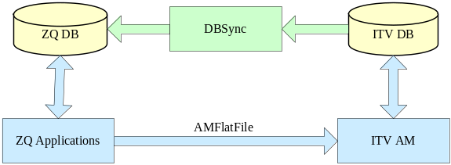
Figure 1
Usually in the ZQ solution based on SeaChange VOD System as Figure 1, ZQ Application will send an AMFlateFile to ITV AM.ITV System will parse the file and take the change as AMFlateFile do. And this action soon will take affect on ITV DB. And DBSync will get such trigger and make same change on Local ZQ DB from IDS Service. And DBSync will maintain the map relationship between ZQDB and ITVDB.
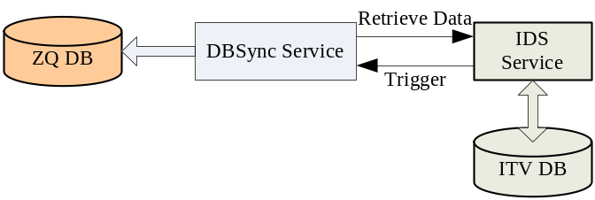
Figure 2
As the complexity of applications based on ZQ LAM DB grows, more and more requirements on DS data change are raised, especially in projects that support real-time encoding, navigation and streaming. DBSync Add-in (DBSAdi) is just the solution to extend current DBSync functions and provide flexibility to further development on DBSync without changing DBSync core service. DBSAdi works as an Add-in of DBSync service, in a dynamic library format (DLL), and is able to customize to any third party DLL which follows the standard programming interfaces (API) described in this document. If DBSAdi is activated in DBSync service, each callback from ITV DS system will be forwarded to the Add-in, with additional data from ZQ LAM database. The relationship is as figure 3.
DBSync Service
IDS Service
ITV DB
ZQ DB
Customized DBSynX Add-in
Different approaches
Figure 3

Responsibility
DBSAdi is a customized Add-in of DBSync. It is a standard Windows Dynamic Link Library file (.DLL). The Add-in DLL will be automatically loaded by DBSync service when started, with the DLL name and path configured in DBSync service registry setting.
- The DBSAdi Add-in is responsible for implementing some of or all notification interfaces described in Chapter API Decomposition
- The DBSAdi Add-in is responsible for allocate and free all private resources during initialization and uninitialization.

API Decomposition

Brief points
- Currently, all APIs of DBSAdi are Notification Event APIs. DBSync service will automatically invoke these APIs when required condition matches, and pass information regarding with this event to the DBSAdi Add-in.
- DBSAdi Add-in could choose to implement some of or all these notification event APIs. If the Add-in does not implement an API, DBSync service will NOT try to call the API when the notification event happens.
- DBSAdi Add-in should return as faster as possible in these APIs. It is strongly recommended to handle the event logic in asynchronous mode instead of blocking mode. However, if the API does not return within some time criteria configured in DBSync service, it will be simply discarded.

API Properties
ID | Class/Interface Name | Type | Description
1 | DBSA_Initialize() | Notification | Get called when Add-in is loaded. This usually happens when DBSync service starts.
2 | DBSA_Uninitialize() | Notification | Get called when Add-in is released. This usually happens when DBSync service stops.
3 | DBSA_SyncBegin() | Notification | Get called when full synchronization begins. The full synchronization is to query all data from DS database, usually when DBSync starting or DS connection is lost.
4 | DBSA_SyncEnd() | Notification | Get called when full synchronization is finished.
5 | DBSA_TriggerMd() | Notification | Get called when metadata is added, deleted or updated. For example, this API will be called when operator changed ‘Genre’ metadata of an asset on ITV AM.
6 | DBSA_TriggerMdd() | Notification | Get called when metadata descriptor changes. For example, this API will be called when operator added a new descriptor of id ‘3’ and value ‘$1.99’ to the metadata ‘price’.
7 | DBSA_TriggerHierarchy() | Notification | Get called when DS hierarchy structure changed. For example, this API will be called when operator link a new asset under a folder.
8 | DBSA_TriggerCa() | Notification | Get called when Complex Asset structure changed. For example, this API will be called when operator add a new asset element under an asset.
9 | DBSA_TriggerState() | Notification | Get called when object state changed. For example, this API will be called when an inactive asset became ‘active’ state.

API Operations
TBD.

Remarks and Issues [optional]
Any supplementary descriptions can be listed here.

