- Open the captured file with Wireshark
- Input “smb” in the “Filter” and press Enter.
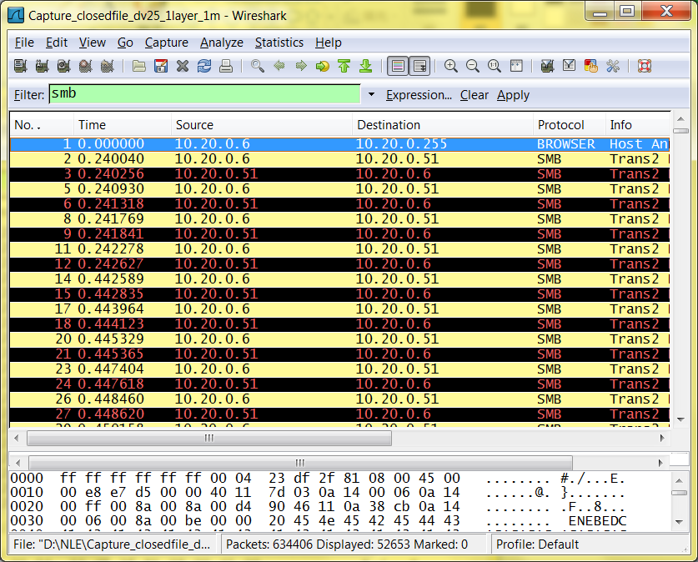
- Export the text data by Menu “File”->”Export”->”File”, and the “Save Type”: “CSV”.
- Execute the simulation with the saved trace file and the test directory.
CMD:
nelsimulation<OperationsTrace><TestDirectory><Iteration><Interval(ms)><OpenWithReadWrite>
