Multicast Forwarding
Product Design Specification
Revision: 0.4
Author: Hui Shao
Date Last Updated: 2004-5-27


124 Acton Street, Maynard, Massachusetts 01754
Phone: 978-897-0100
Fax: 978-897-5065

Revision History
Revision | Date | Who | Description
0.1 | 2004-5-12 | Hui Shao | Initial draft
0.2 | 2004-5-15 | Hui Shao | Updated configuration, added tunnel message definitions and initial m/s process
0.3 | 2004-5-24 | Hui Shao | Updated upon the review conference call on 5/18
0.4 | 2004-5-27 | Hui Shao | Added ManUtil GUI design/XML editor, installation sections
0.5 | 2004-6-10 | Hui Shao | Updated upon the comment from Maynard

Table of Contents

Contents
Revision History ii
Table of Contents iii
Contents iii
Purpose 5
Overview 6
Related Documentation 6
Design Status 7
Constraints 7
Assumptions 7
TBD 8
Prototype Status 8
Operations overview 9
Operations scenarios/scripts 9
System performance considerations 10
Detailed Design Specifications 12
Functional Hierarchy 12
Data Flow Description 12
General Conventions 13
McastFwd Service Description 14
Class Structures 14
Input 15
Configuration 15
Multicast traffic 18
Tunnel Message 18
Process 19
Service start 20
Accept tunnel connections 20
Package forwarding 20
Deny list validation 20
Invoking FtTCPComm 21
Output 21
Error Codes 22
Maintenance Utility Description 23
ManUtil 23
Tunnels 23
Listeners 24
Resenders 24
DenyList 25
XML configuration editor 25
Test Utilities 25
Installation 27
InstallShield 27
Outstanding Question 28
References 28
Appendix 29
External XML-formatted configuration schema 29

Purpose
This design specification (PDS) has the following functions:
- Provides a detailed description of capabilities and external characteristics of Multicast Forwarding System.
- When appropriate, describes the relationship of this product to other products using block and flow diagrams.
- Describes all aspects of user interface including input, expected output and error conditions.
- Identifies components that may be candidates for re-use in other products or components of other products that may be used in this product.
- Identifies other related documentation, i.e. product plan, requirements document, design specification and test plans.

Overview
It is anticipated that there are environments where ITV and other applications, would like to use or need to use multicast, but may not be allowed in portions of the customer network.
For example, it maybe acceptable from the customer perspective, for an application to use multicast in a subnet, but the multicast will never be allowed past the router serving the subnet. However, the application software may need to have a multicast conversation that spans 2 or more subnets.
The goal of this project is to build a service or daemon that will
- aggregate multicast traffic,
- forward it via a connection-oriented protocol to a receiving service or daemon
- re-multicast the traffic at the receiving service or daemon
- be able to be configured between 2 or more subnets
Also, a multicast conversation is required to traverse among 3+ network segments.
Some test utilities will be included to verify the functionalities of the new product.

Related Documentation
The following is a list of related documentations and locations where they can be found:
- Multicast Forwarding Requirements by Mike Kiskiel, Gregory Holbrow, ver 0.3
- Multicast Forwarding Scope Effort by Hui Shao
- Loop & Duplicate Traffic Avoidance by Hui Shao

Design Status

Constraints
- The program must run as a Windows service using the SeaChange Service Shell and App Shell, and be able to run on Windows 2003. The program must be configurable through the ITV Configurator service, and must support ManUtil interface and SNMP
- The program must use standard Layer 4 socket interface for all socket interactions, raw socket technology must not to be required.
- There must be support for both single and dual rail support for the connection between aggregators. Only one fault resilient (via FtTcpCom) connection is allowed between any 2 servers. All multicast conversations between two aggregators must tunnel through a single FtTcpCom connection. The service must not create separate connections for different multicast messages/conversations.
- A program should be able to be configured between 2 or more subnets.
- The program must not require a separate machine on which it runs. Messages must be able to be sourced from other services on the same machine running the aggregator.
- The program must not forward any messages that were sourced from itself (the same instance of the aggregator service). It must support a deny list, containing both source addresses as well as source ports. Any messages sent from an IP/Port in this list should not be forwarded.
- Multicast and inter-service connections must work in both IPV4 and IPV6 environments. The program must make no assumptions of IP version and work in all networks. The program should be possible to operate in a single stack environment in a non-mixed IP environment.
- The XML parser API used in this project is Microsoft XML(MSXML4)

Assumptions
- It is dropped to run on NT4.0.
- The solution is intended for low volume control and announcement messages but not for streaming or propagation of files.
- The duplicate traffic avoidance is left as a configuration problem. The administrator has to be responsible for this problem.
- If a host name can be resolved to multiple IPs, the service pick up one IP by itself. It is a configuration problem since the service may pick the incorrect one. The administrator should put the IP instead of the host name in the configuration
- Deny list only filters the source machines of the captured multicast messages
- A new release of MtTCPComm.dll will be available to support IPv6 later, which enables IPv6 on the tunnels

- If an error occurs on the destination peer after the message is successfully forwarded, the destination peer should record the error in the logfile but it is not required for the source peer get such a feedback.

TBD
- The default re-mulitcast port (when the administrator doesn’t specify). It is required since it covers most of the usage. Greg will create a symbol and put it in Seachange.h for the default multicast.
- The ManUtil/SNMP variables is dependent on the training provided by Maynard team
- Which release of InstallShield to be used: 7.0 or X?
- If the product is installed on a machine with other ITV components installed, there are multiple copies of ITV API dlls: one set comes with this installation and the other set is located in C:\ITV\Exe. It may cause some conflictions on the common resource such as API logfiles.

Prototype Status
The following list the current uncertain issues as of this document is drafted:
- The detailed items description about SeaChange style service architecture
A prototype is under construction without the above uncertain features.

Operations overview

Operations scenarios/scripts
Multicast capture and forwarding
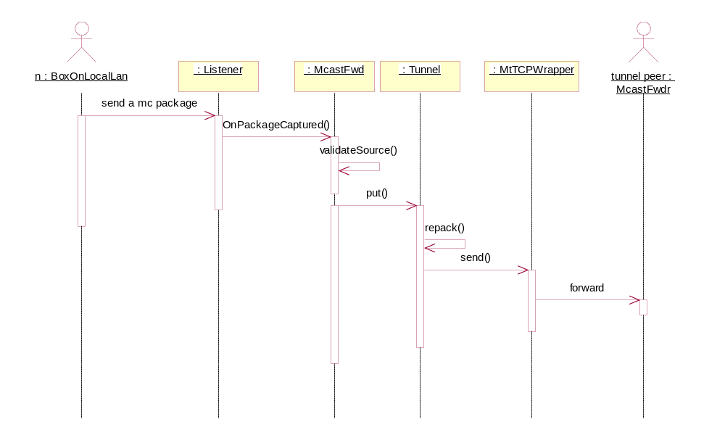
Figure 1
Accepts tunnel connection from peer server & receive data from tunnel peer
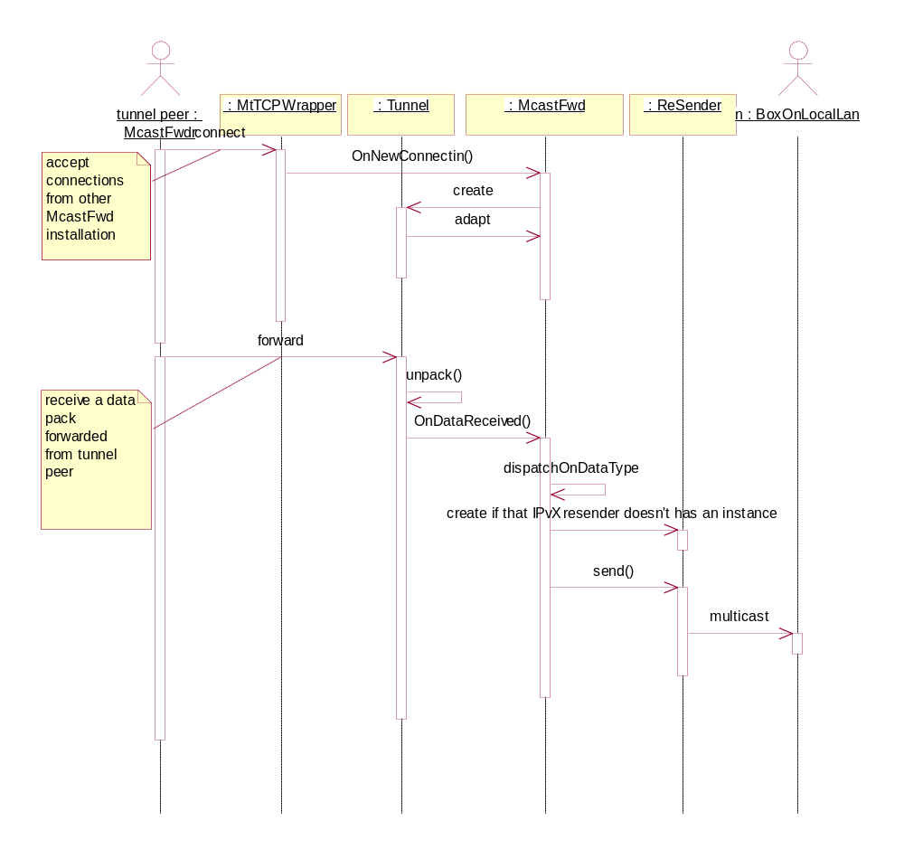
Figure 2

System performance considerations
Reliability
As a service, the aggregator inherits all the reliability from a standard SeaChange VOD service. It has fault resilient connection between any two servers by using FtTcpComm. Its listener and resender interface can natively handle network failure since they are working on connectionless-oriented protocol
All threads used in the program will be pooled by invoking SeaChange’s ScThreadPool.dll
Scalability
The service is intended for low volume control and announcement messages but not for streaming or propagation of files.
Compatibility
As a standard SeaChange service, the new service will has interfaces to ManUtil, alarm, pager and other standard SeaChange utilities. Besides them, the new service will not require additional ITV components to work, in other words, it has minimal dependents to run.
The new service can work on the existing ITV deployment without requiring additional hardware.
The new service must support previous versions in a large site during a rolling upgrade process.
The new sevice will be able to resolve domain names and numeric IPv4 and IPv6 addresses

Detailed Design Specifications

Functional Hierarchy
The McastFwd service trys to establish tunnels based on the configuration once it starts, and also accepts tunnels as a server from other McastFwd instance.

Data Flow Description
Describe data flow between this product and other products in the system.
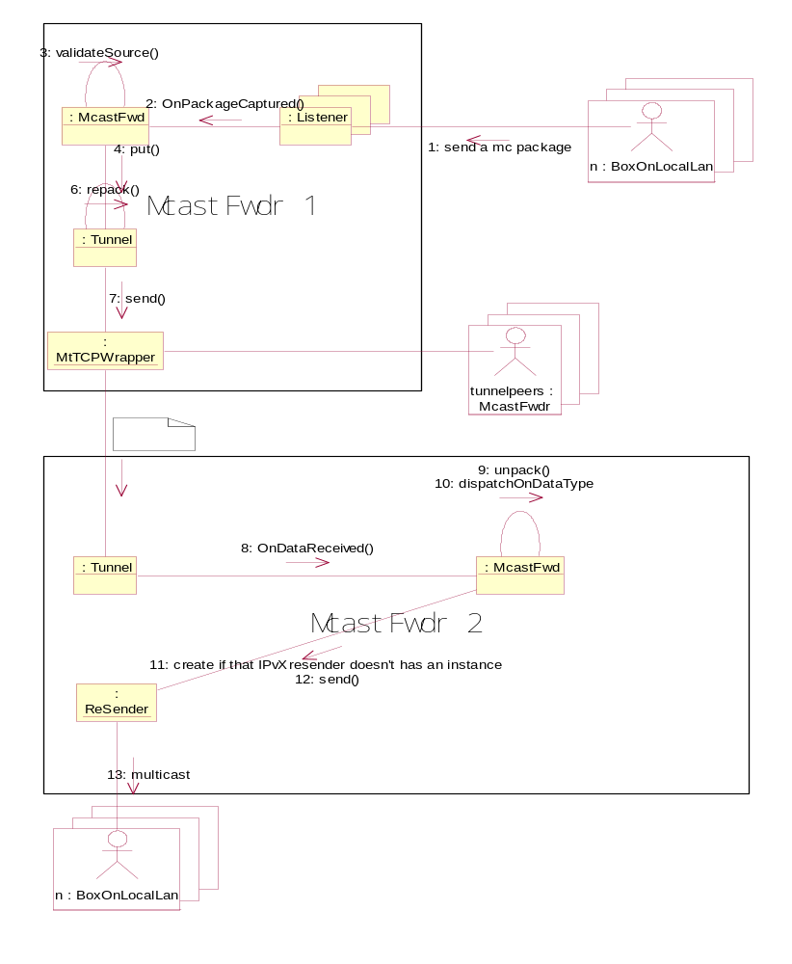
Figure 3
On the source side
- Any box on LAN-1 multicast a message
- One listener interface captured the package and fires a callback event to the service main class McastFwd
- McastFwd validates the incoming source with its deny list
- McastFwd put the valid message in to outgoing queue
- Each tunnel instance pick the outgoing message invalid for the current conversation
- Tunnel instance repacks the message with control data and routine data
- Send the repacked message by invoking MtTCPComm APIs to the various subnets to which it is destined
On the destination side:
- The destination tunnel-end received the forwarded message and fire a callback event to McastFwd instance
- The McastFwd unpack the incoming pack
- McastFwd dispatch on different message type in the case we have control messages later
- McastFwd calls Resender::send()
- The resender re-multicast on its LANs

General Conventions
This section describes the naming conventions or special notations that may be used in the detailed functional descriptions.
Term | Description
McastFwd | The service name, also it is the main service class name
McastFwd service | See McastFwd
McastFwd class | See McastFwd
Listener | The interfaces that captures multicast messages on the LAN
Tunnel | The tunnel implementation class to connect to other McastFwd instances by using FtTcpComm connectins. It also accepts the connections from other McastFwd instances.
peerRemoteServer | The other end of an active tunnel
resenderLocalBind | The local interfaces on to which re-multicast messages are sent on the LAN to the remote server
Conversation
MtTcpComm | The API DLL that provide both MtTcpComm layer and FtTcpComm layer
FtTcpComm | The fault tolerant communication layer exported from MtTcpComm API

McastFwd Service Description

Class Structures
The following is a high level object-oriented diagram of the program:
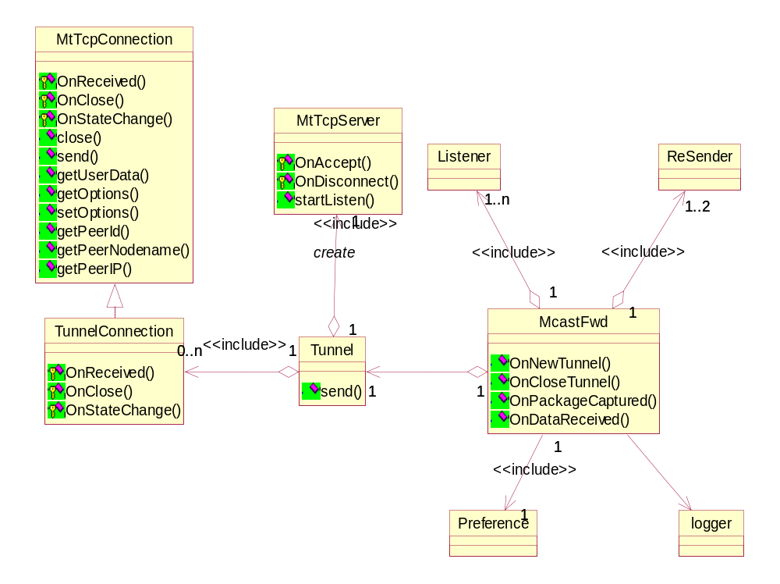
Figure 4
The McastFwd class is the main class of the service; it is an aggregator of Listener, ReSender and Tunnel instances.
Object | Instance number
Listener | 1..n
ReSender | one for IPv4, one for IPv6 per NIC if called
Tunnel | 1
preference | Storage for runtime information or static configurations

Input
The service has three classes of inputs:

Configuration
McastFwd has two-level configurations: standard SeaChange CfgPkg variables that are registry-based and external XML-formatted configuration
Registry-based variables
name | description
ExtConfiguration | The filename of the external XML-formatted configuration
ReMcastTTL | Optional. The TTL to apply when a resender remulticasts a message, default 1
TunnelServerPort | The server port to accept other McastFwds to establish tunnels
Logfile | The filename where to put the log messages
TODO: ManPkg/SNMP varaibles

External XML-formatted configuration
Appendix External XML-formatted configuration schema shows the schema definition of this configuration file. It defines
- the multicast channel that the listener have to monitor,
- the tunnels have to establish
- the deny list
The following is a configuration example:
<?xml version="1.0" ?>
<Config xmlns:xsi="http://www.w3.org/2001/XMLSchema-instance" xsi:noNamespaceSchemaLocation="McastFwd.xsd">
<!--
Default values to be used when not explicitly defined
-->
<Default>
<!-- Default Local Addresses on which to listen for multicast -->
<LocalListenAddress>
<Socket address="10.1.1.1"/>
<Socket address="LocalV4IP.company.com"/>
</LocalListenAddress>
<!-- Default Local Addresses on which to send multicast -->
<LocalSendAddress>
<Socket address="10.1.1.1" port="6000"/>
<Socket address="LocalV4IP.company.com" port="6000"/>
</LocalSendAddress>
<!-- Default list of addresses from which messages should be ignored -->
<DenyList>
<Socket address="10.3.2.26" port="6000"/>
<Socket address="MyV4IP.company.com" port="6000"/>
</DenyList>
<!-- Default list of remote servers that this service should connect and forward messages -->
<RemoteServer>
<Connection>
<AddrsLocal>
<Socket address="10.1.1.1"/>
<Socket address="LocalV4IP.company.com"/>
</AddrsLocal>
<AddrsRemote>
<Socket address="10.2.2.2" port="3456"/>
<Socket address="Remote_2_V4_IP.company.com" port="3456"/>
</AddrsRemote>
</Connection>
<Connection>
<AddrsLocal>
<Socket address="3f::22"/>
<Socket address="LocalV6IP.company.com" port="6000"/>
</AddrsLocal>
<AddrsRemote>
<Socket address="5f::2"/>
<Socket address="Remote_3_V6_IP.company.com" port="3456"/>
</AddrsRemote>
</Connection>
</RemoteServer>
</Default>

<!--
Conversation #1
Enable tunneling of multicast messages on address 225.25.25.25, Port 6000

Connect to the servers_u105 ?n the default RemoteServer list
Listen for multicast messages on the default LocalListenAddresses
Send multicast messages on the default LocalSendAddresses
Block incoming multicast messages from servers on the DenyList
-->
<Conversation>
<Socket address="225.25.25.25" port="6000"/>
</Conversation>

<!--
Conversation #2
Enable tunneling of multicast messages on address 225.25.25.25, Port 7000

Connect to the servers_u105 ?n the default RemoteServer list
Send multicast messages on the default LocalSendAddresses
Block incoming multicast messages from servers on the DenyList

Listen for multicast messages in the LocalListenAddresses configured below
As the LocalListenAddress contains no Sockets, the conversation will
not be listened to on the local network
-->
<Conversation>
<Socket address="225.25.25.25" port="7000"/>
<LocalListenAddress>
</LocalListenAddress>
</Conversation>

<!--
Conversation #3
Enable tunneling of multicast messages on address 225.25.25.25, Port 8000

Connect to the servers_u105 ?n the default RemoteServer list
Listen for multicast messages on the default LocalListenAddresses
Block incoming multicast messages from servers on the DenyList

Send multicast messages on the LocalSendAddresses configured below
As the LocalSendAddress contains no Sockets, the conversation should
not be forwarded to the local network
-->
<Conversation>
<Socket address="225.25.25.25" port="8000"/>
<LocalSendAddress>
</LocalSendAddress>
</Conversation>

<!--
Conversation #4
Enable tunneling of multicast messages on address that resolves from My_V6_MulticastGroup, Port 7000

Connect to the servers_u105 ?n the default RemoteServer list

Listen for multicast messages in the LocalListenAddresses configured below
Send multicast messages on the LocalSendAddresses configured below
Block incoming multicast messages from servers on the DenyList configured below
-->
<Conversation>
<Socket address="My_V6_MulticastGroup" port="7000"/>

<LocalListenAddress>
<Socket address="3f::22"/>
<Socket address="LocalV6IP.company.com"/>
</LocalListenAddress>

<LocalSendAddress>
<Socket address="3f::22" port="6000"/>
<Socket address="LocalV6IP.company.com" port="6000"/>
</LocalSendAddress>

<DenyList>
<Socket address="3f::22" port="6000"/>
<Socket address="MyV6IP.company.com" port="6000" family="???"/>
</DenyList>
</Conversation>

<!--
Conversation #5
Enable tunneling of multicast messages on address 239.2.3.4, Port 8000

Listen for multicast messages in the LocalListenAddresses configured below
Send multicast messages on the LocalSendAddresses configured below
Block incoming multicast messages from servers on the DenyList configured below
Connect to the servers_u105? n the RemoteServer list configured below
-->
<Conversation>
<Socket address="239.2.3.4" port="8000"/>

<LocalSendAddress>
<Socket address="10.3.2.26" port="6000"/>
<Socket address="MyV4IP.company.com" port="6000"/>
</LocalSendAddress>

<LocalListenAddress>
<Socket address="10.3.2.26"/>
<Socket address="MyV4IP.company.com"/>
</LocalListenAddress>

<DenyList>
<Socket address="10.3.2.36" port="6000"/>
</DenyList>

<RemoteServer>
<Connection>
<AddrsLocal>
<Socket address="10.1.1.1"/>
<Socket address="LocalV4IP.company.com"/>
</AddrsLocal>
<AddrsRemote>
<Socket address="10.4.4.4" port="3456"/>
<Socket address="Remote_4_V4IP.company.com" port="3456"/>
</AddrsRemote>
</Connection>
</RemoteServer>
</Conversation>

</Config>

Multicast traffic
Listeners capture the specified multicast traffic.

Tunnel Message
The messages transferred thru the tunnel connections. They can be divided into two classes
Forwarded data, the multicast traffic are captured by the listeners and packed by the tunnel with routine information
Interaction Commands, the commands to support the interation and co-operation between both peer of a tunnel.
The following is a message protocal. The header is combined with 2 parts:
      - Message header
      - Data body
0 1 2 3 bytes
version | type | reserved
Source machine port |  | Inet Family
Source machine Address (16bytes union)

Mcast channel port |  | Inet Family
Mcast channel Address (16bytes union)

Data body

In the message header, some fields are pre-defined:
Field |  | Size /byte | Description
Version |  | 1 | The message format version
type |  | 1 | - Forwarded conversion data  …
Source machine | port | 2 | Source machine is the machine that originally send mcast message on the source LAN
Source machine | Inet family | 2
Source machine | address | 16
Mcast Channel | port | 2 | Which channel is the forwarded message belong to
Mcast Channel | Inet family | 2 | Which channel is the forwarded message belong to
Mcast Channel | address | 16 | Which channel is the forwarded message belong to

When the type equals to “publishCommand”, the channel info to publish will be put in Mcast channel port/address

Process
This section will describe how the McastFwd server works in four topics: service start, accept tunnel establish, package forward and master/slave process.

Service start
Standard SeaChange service initialization must be added here
- Read the registry-base configuration once the service started and performed regular SeaChange service processes, keep the setting in Preference object.
- Generate a new Windows GUID-style number and save it in the registry as a hex string if it doesn’t exist, otherwise load the uid.
- Open and parse the XML-formatted configuration file specified in FwdTableConfiguration, and complete the Preference object initialization
- Establish the tunnels based on the configuration
- Create the Listener threads based on the configuration, see

Accept tunnel connections
Figure 2 shows the sequence of the process:
- The FtTCPcomm wrapper fires a event when a peer McastFwd connect to this service
- McastFwd create an instance of Tunnel
- Tunnel adapt its self to the main object McastFwd, McastFwd put it in its forwarding list
- Exchange InstallaionUid with the tunnel peer, client side closes the tunnel if the Uid pair already exists

Package forwarding
This is also described in Figure 2 and Figure 3.
- A machine multicast a package on the local LAN
- One listener captured the package, it fires a OnPackageCaptured() event
- McastFwd response the event and validate the data with its deny list, drop the data if it is in the black list
- McastFwd put the data in the outgoing queue for tunnel
- Each tunnel instance gets the data and repack with ordinal code and routine information
- Tunnel instance send the repacked data the tunnel peer
- The peer tunnel instance unpack the data fire a OnDataReceived() event
- The peer McastFwd dispatch the data process routine if it is received as control message
- If a right resender doesn’t exist, the McastFwd creates an instance of it based on the configuration.
- The peer McastFwd pass the data the right resender instance.
- The resender send the data on its local LAN with TTL=1 applied

Deny list validation
When a multicast message is captured by a listener, the service must determ if it is necessary to forward. Deny lists (upon the source machine of the messages) are introduced in this design. The deny lists can be defined in the following two levels with the prorities from highest to lowest:
Per Listener Deny List contains those source addresses or ports must be denied or reject to forward when a mcast message is captured thru a specified listener interface. It mutually exclude the Default Deny List if it is not empty.
Default Deny List When a multicast message is captured thru a listener interface with a empty Per Listerner Deny list, the validation will be performed base on the default deny list. The default resenders and the per-conversation resender will automatically be added in this list as an approach to avoid the loop traffic

Invoking FtTCPComm
The connection-oriented tunnels are established by invoking the FtTCPComm, the following figure 5 briefly shows how the wrapper classes MtTcpConnection, MtTcpListener and MtTcpState work:
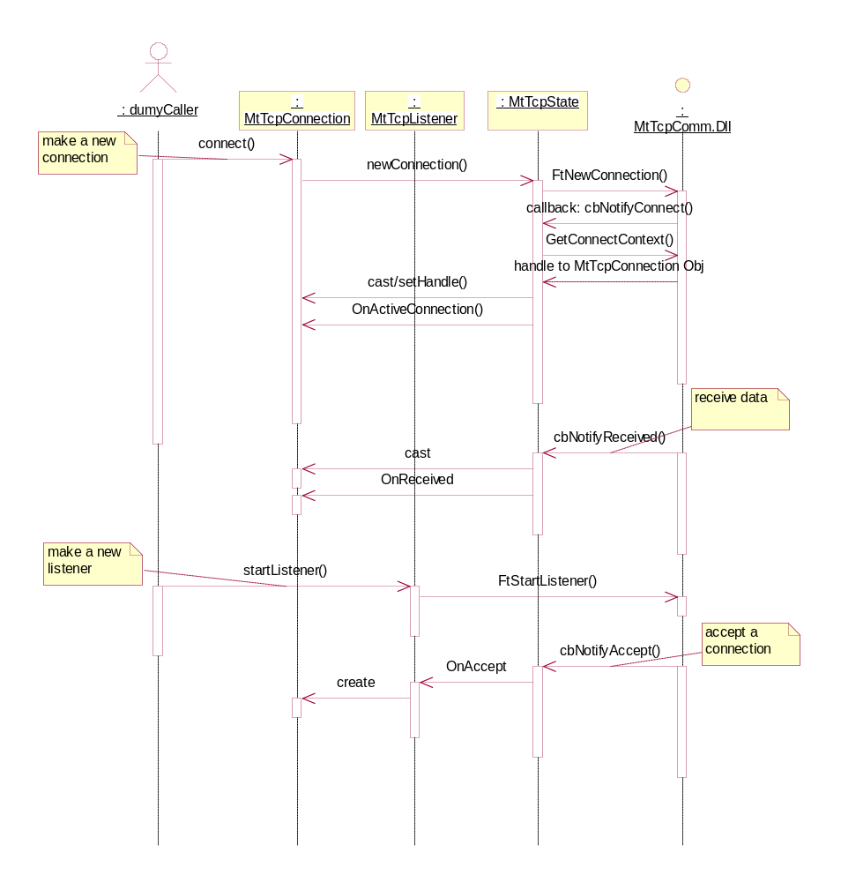
Figure 5

Output
The above section has already mentioned the following output of a McastFwd:
- The forwarded data through a tunnel
- The remulticast packages
Also the McastFwd keeps detailed log messages. The McastFwd will use two different log messages in different stage:
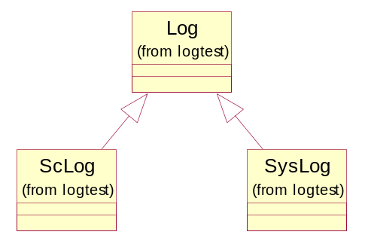
Figure 7
- Before the file log is open successfully, the service will put logs via SysLog after it starts. Syslog is implemented to put message as event log in Windows, which can be viewed in control panel->eventviewer
- Once the service opens the file log successfully, McastFwd uses the file log, which is implemented by invoking SeaChange Clog.dll

Error Codes
McastFwd will keep detailed error and trace messages in its log subsystem.

Maintenance Utility Description

ManUtil
ManUtil will be able to manage McastFwd as a Seachange style service.
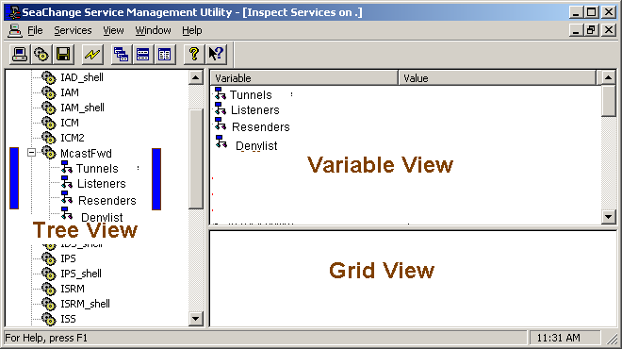
Figure 8
Figure 8 shows a typical ManUtil window screen shot. The window can be divided into three views: tree view, variable view and grid view.
McastFwd service will create a new branch in the tree view as shown. The following variables will be listed on the variable view for the top node (McastFwd) of this branch:
variable | description
ExtConfiguration | The filename of the external XML-formatted configuration
Logfile | The filename where to put the log messages
InstallationUid | A 16byte Windows GUID-style number (shown as hex string) to identify the installation
It also contains tree subnodes:

Tunnels
This node contains the runtime information about the active tunnels. The following will appear on its variable views:
variable | description
TunnelServerPort | The server port to accept other McastFwds to establish tunnels
TunnelCount | The number of active tunnels
This node also has a grid view to list the active tunnel informations:
column | description
PeerUid | A 16byte Windows GUID-style number (shown as hex string) to identify the peer to make sure only single tunnel between any two machine.  see also: InstallationUid.
PeerIP | The IP address of the tunnel peer
PeerPort | The port of the tunnel peer
LocalIP | The local IP that is used establish this tunnel
LocalPort | The local Port that is used establish this tunnel
EstablishTime | The time this tunnel becomes active

Listeners
This node contains the runtime information about the active listeners. The following will appear on its variable views:
variable | description
ListenerCount | The number of active listeners
The active listener interfaces will be listed in its grid view:
column | description
ListenerID | The unique number assigned to this listener, starts from 1. 0 is reseved
McastGroup | The multicast group IP that the interface listens
McastPort | The multicast port that the interface listens
BindIP | The local IP that the listener binds
Peers | The peer uid (see PeerUid) list delimited by ‘;’ to identify per-conversation tunnels.  - Forward to all default tunnels if this field is empty  - Remulticast if the value appears as a valid IP address
LocalPort | The local Port that is used establish this tunnel
EstablishTime | The time this tunnel becomes active

Resenders
This node contains the runtime information about the active resender interfaces. The following will appear on its variable views:
variable | description
ResenderCount | The number of active resenders
ReMcastTTL | Optional. The TTL to apply when a resender remulticasts a message, default 1
The active resender interfaces will be listed in its grid view:
column | description
BindIP | The local IP that the resender binds
BindPort | The local port that the resender binds
owner | 0 – this resender is a default resender  1..n – this resender belongs to a specified listener. see also: ListenerID & Peers in Listeners

DenyList
This node lists all deny roles in its grid view:
column | description
SourceIP | The IP of the machine that sends the multicast message, i.e. 192.168.0.1, 192.*.*.*
SourcePort | The port of the machine that sends the multicast message from
owner | 0 – this deny role belongs to default deny list  1..n – this role belongs to a specified listener. see also: ListenerID  The fields in the column is a string value and can be combined with multiple owner ids delimted by ‘;’. i.e. “0;2;3”

XML configuration editor
The service will be shipped with an XML schema definition in xsd format for the external configuration. The user will be free to choose any preffered XML editor or text editor to edit te configuration. The following briefly describes how to use XMLSpy, from AltoGmbH& Altova, Inc, to generate a sample configuration from the schema:
- Open McastFwd.xsd with XMLspy
- Click menu: DTD/Schema -> Generate sample XML file
- Check all checkbox and set “generate 2 elements if marked repeatable”
- Click “OK” button, a dummy-filled sample XML file will be created
- Fill in the right values in the XML file and save it as McastFwd.xml
More details about XMLspy can be found on www.xmlspy.com and its on-line help

Test Utilities
The product includes some test utilities to act as:
- McastSend, work as the source of multicast messages on the LAN for testing. The user will be able to specify the multicast group IP and port and message body
McastSend [-f {<PF_INET>|<PF_INET6>}] –g <IP> -p <port> -m <message>
- McastRcv, work as a destination of the multicast messages for testing. The user will be able to specify the multicast group IP and port and message body
McastRcv [-f {<PF_INET>|<PF_INET6>}] –g <IP> -p <port>
Please see the test plan for detail

Installation

InstallShield
The new product will have its own installation to setup the McastFwd service and its related components. The installation will be created as an InstallShield installation or MS installer (.MSI). Figure 9 shows an expected installation tree:

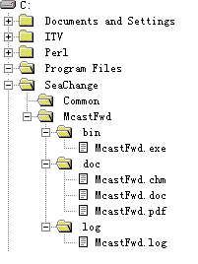
Figure 9

- The default location of the installation will be %ProgramFiles%\SeaChange\McastFwd
- The installation includes its own copies of SeaChange APIs such as MtTcpComm.dll, ScThreadPool.dll ItvMessages.dll and so on in the subdirectory bin under the installation root location.
- The installation includes a user manual in the subdirectory doc under the installation root location
- The default main logfile of the service and the utilities will be put in the subdirectory log under the installation root localtion

Outstanding Question

- Greg will create a symbol and put it in Seachange.h for the default multicast.—What symbol will it be?
- A taining on SeaChange style service framework
- Which release of InstallShield to be used: 7.0 or X?
- If the product is installed on a machine with other ITV components installed, there are multiple copies of ITV API dlls: one set comes with this installation and the other set is located in C:\ITV\Exe. It may cause some conflictions on the common resource such as API logfiles.

References

- ms-help://MS.MSDNQTR.2003FEB.2052/winsock/winsock/multicast_programming.htm
- ms-help://MS.MSDNQTR.2003FEB.2052/winsock/winsock/tcp_ip_raw_sockets_2.htm
- ms-help:// MS.MSDNQTR.2003FEB.2052/winsock/winsock/ipv6_guide_for_windows_sockets_applications_2.htm

Appendix

External XML-formatted configuration schema
<?xml version="1.0" encoding="UTF-8"?>
<xs:schema xmlns:xs="http://www.w3.org/2001/XMLSchema" elementFormDefault="qualified">

<xs:element name="Config">
<xs:annotation>
<xs:documentation>the root element of the configuration</xs:documentation>
</xs:annotation>
<xs:complexType>
<xs:sequence>
<xs:element ref="Default"/>
<xs:element ref="Conversation" minOccurs="0" maxOccurs="unbounded"/>
</xs:sequence>
</xs:complexType>
</xs:element>

<xs:element name="Default">
<xs:annotation>
<xs:documentation>
Default values to be used when not explicitly defined
</xs:documentation>
</xs:annotation>
<xs:complexType>
<xs:sequence>
<xs:element ref="LocalListenAddress"/>
<xs:element ref="LocalSendAddress"/>
<xs:element ref="DenyList" minOccurs="0"/>
<xs:element ref="RemoteServer" minOccurs="0"/>
</xs:sequence>
</xs:complexType>
</xs:element>

<xs:element name="Conversation">
<xs:annotation>
<xs:documentation>
Conversation #1
Enable tunneling of multicast messages on address 225.25.25.25, Port 6000

Connect to the servers in the default RemoteServer list
Listen for multicast messages on the default LocalListenAddresses
Send multicast messages on the default LocalSendAddresses
Block incoming multicast messages from servers on the DenyList

Conversation #2
Enable tunneling of multicast messages on address 225.25.25.25, Port 7000

Connect to the servers_u105 ?n the default RemoteServer list
Send multicast messages on the default LocalSendAddresses
Block incoming multicast messages from servers on the DenyList

Listen for multicast messages in the LocalListenAddresses configured below
As the LocalListenAddress contains no Sockets, the conversation will
not be listened to on the local network

Conversation #3
Enable tunneling of multicast messages on address 225.25.25.25, Port 8000

Connect to the servers_u105 ?n the default RemoteServer list
Listen for multicast messages on the default LocalListenAddresses
Block incoming multicast messages from servers on the DenyList

Send multicast messages on the LocalSendAddresses configured below
As the LocalSendAddress contains no Sockets, the conversation should
not be forwarded to the local network

Conversation #4
Enable tunneling of multicast messages on address that resolves from
My_V6_MulticastGroup, Port 7000
Connect to the servers_u105 ?n the default RemoteServer list
Listen for multicast messages in the LocalListenAddresses configured below
Send multicast messages on the LocalSendAddresses configured below
Block incoming multicast messages from servers on the DenyList configured below

</xs:documentation>
</xs:annotation>
<xs:complexType>
<xs:sequence>
<xs:element ref="Socket"/>
<xs:element ref="LocalListenAddress" minOccurs="0"/>
<xs:element ref="LocalSendAddress" minOccurs="0"/>
<xs:element ref="DenyList" minOccurs="0"/>
<xs:element ref="RemoteServer" minOccurs="0"/>
</xs:sequence>
</xs:complexType>
</xs:element>

<xs:element name="AddrsLocal">
<xs:complexType>
<xs:sequence>
<xs:element ref="Socket" maxOccurs="2"/>
</xs:sequence>
</xs:complexType>
</xs:element>
<xs:element name="AddrsRemote">
<xs:complexType>
<xs:sequence>
<xs:element ref="Socket" maxOccurs="2"/>
</xs:sequence>
</xs:complexType>
</xs:element>

<xs:element name="Connection">
<xs:complexType>
<xs:sequence>
<xs:element ref="AddrsLocal"/>
<xs:element ref="AddrsRemote"/>
</xs:sequence>
</xs:complexType>
</xs:element>

<xs:element name="DenyList">
<xs:complexType>
<xs:sequence>
<xs:element ref="Socket" minOccurs="0" maxOccurs="unbounded"/>
</xs:sequence>
</xs:complexType>
</xs:element>

<xs:element name="LocalListenAddress">
<xs:complexType>
<xs:sequence>
<xs:element ref="Socket" minOccurs="0" maxOccurs="unbounded"/>
</xs:sequence>
</xs:complexType>
</xs:element>

<xs:element name="LocalSendAddress">
<xs:complexType>
<xs:sequence>
<xs:element ref="Socket" minOccurs="0" maxOccurs="unbounded"/>
</xs:sequence>
</xs:complexType>
</xs:element>

<xs:element name="RemoteServer">
<xs:complexType>
<xs:sequence>
<xs:element ref="Connection" maxOccurs="unbounded"/>
</xs:sequence>
</xs:complexType>
</xs:element>

<xs:element name="Socket">
<xs:complexType>
<xs:attribute name="address" type="xs:string"/>
<xs:attribute name="port" type="xs:string"/>
</xs:complexType>
</xs:element>

</xs:schema>

The socket element can use attribute port=”*”, which is a wildcast for all the port value.
What information appears on the GUI will be changed according to the requirement from the customer, this section just a sample to give a general idea.

