Multicast Forwarding
Development Plan
Revision 0.1
Hui Shao
Date Last Updated Jun. 2, 04

Revision History
Revision | Date | Who | Description
0.1 | 6/2/2004 | Hui Shao | Initial draft: schedule and testing

Preface
This is the development plan for the project of Multicast Forwarding.
The development plan:
- Describes the development project for designing, developing, testing, and delivering the product.
- Lists the major issues and risks that are critical to finalizing the design
- Describes the tasks required to develop the product, and provides estimates for the time required to complete them.
- Is the master plan for successfully delivering a product.
- Is an operational plan for tracking the development of the product, managing the development effort, coordinating work from multiple groups or individuals, and is adjusted to continuously plan the development effort as actual development varies from the plan.
The development plan is developed by the development project leader, and is addressed to the project team, including engineering, marketing, sales, and financial management.

Executive Summary
The Executive Summary should provide an overview of the development plan. It should provide an overview of the product (i.e. the product contents, scope, deliverables, packages, purposes, goals, non-goals, etc.) as well as the major issues that could prevent the successful delivery of the product.

Purpose
It is anticipated that there are environments where ITV and other applications, would like to use or need to use multicast, but may not be allowed in portions of the customer network.
For example, it maybe acceptable from the customer perspective, for an application to use multicast in a subnet, but the multicast will never be allowed past the router serving the subnet. However, the application software may need to have a multicast conversation that spans 2 or more subnets.

This project is to build a service or daemon “McastFwd” that will
- aggregate multicast traffic,
- forward it via a connection-oriented protocol to a receiving service or daemon
- re-multicast the traffic at the receiving service or daemon
It is the rough equivalent of a V-LAN for multicast support.
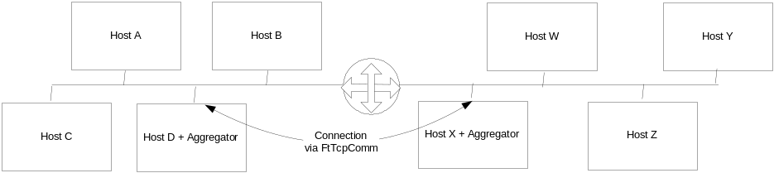
In the small 2 network system above, a collection of nodes in both networks may want to participate in 1 single multicast conversation. The aggregators in each network would be configured to listen for that conversation and forward it to the other side.
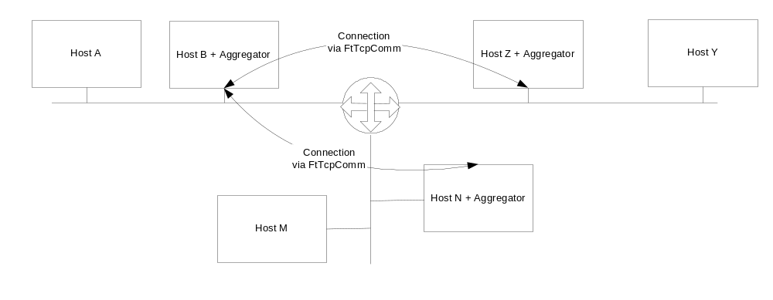
In the above 3-network system, a multicast conversation is required to traverse all three network segments. In this case the Aggregator on Hosts B, N and Z would be required to forward multicast messages on their local subnet to the other aggregators and the destined aggregator would subsequently re-multicast the received messages on their local subnet.

Glossary
Term | Description
McastFwd | The service name, also it is the main service class name
McastFwd service | See McastFwd
McastFwd class | See McastFwd
Listener | The interfaces that captures multicast messages on the LAN
Tunnel | The tunnel implementation class to connect to other McastFwd instances by using FtTcpComm connectins. It also accepts the connections from other McastFwd instances.
peerRemoteServer | The other end of an active tunnel
resenderLocalBind | The local interfaces on to which re-multicast messages are sent on the LAN to the remote server
Conversation
MtTcpComm | The API DLL that provide both MtTcpComm layer and FtTcpComm layer
FtTcpComm | The fault tolerant communication layer exported from MtTcpComm API

Development Strategy
This section summarizes the strategy for this project, including anticipated problem areas, and detailing any deviations from standard development such as reduction of effort due to use of existing modules, or increase in effort in order to produce reusable modules for other projects. In order to allow the reader a better understanding of the problem areas, issues, etc. this section should start out with a high level architecture for the product. The high level architecture should identify all major components in the product and their interactions.

The McastFwd is a tunnel between two subnets. It will be used at ITV propagation or streaming network to forward the multicast traffic.
Details on this architecture will be defined by engineers at ZQ. Please see Multicast Forwarding Product Design Specification for more information
Review Design [Sze Chan, Mike Kiskiel, Gregory Holbrow, VOD Architects]

The development must use available commercial QA tools, such as Compuware DevPartner

Tasks
This section details the major milestones that will be required to complete the project. In particular this section details the various baselines that will be built, their expected functionality/purpose, their current estimated delivery date, and a simple statement that details how completion of the milestone can be verified

# | task | duration | Predecessor | Start time | Finish date | D
1 | McastFwd | 54 days? |  | 2004-4-21 8:00 | 2004-7-8 17:00 | 4.1
2 | Requirement | 1 day |  | 2004-4-30 8:00 | 2004-5-7 17:00
3 | Scope | 2 days | 2 | 2004-5-8 8:00 | 2004-5-9 17:00
4 | Reseach | 10 days |  | 2004-4-21 8:00 | 2004-5-9 17:00
5 | Design and Hold Design review | 21 days? | 3 | 2004-5-11 8:00 | 2004-6-8 17:00
6 | Maynard Provides Detail Info on SeaChange Service | 0 days? |  | 2004-6-15 8:00 | 2004-6-15 8:00
7 | Implement | 44 days? |  | 2004-5-10 8:00 | 2004-7-8 17:00 | 2.7
8 | Invoke FtTcpComm | 2 days |  | 2004-5-10 8:00 | 2004-5-11 17:00
9 | Unique Tunnel Connection | 2 days? |  | 2004-6-4 8:00 | 2004-6-7 17:00
10 | XML configuration | 3 days? | 5 | 2004-6-9 8:00 | 2004-6-11 17:00
11 | IPv4, IPv6 Listener | 2 days? |  | 2004-6-3 9:30 | 2004-6-4 17:00
12 | Ipv4,Ipv6 Resender | 1 day? |  | 2004-6-3 9:30 | 2004-6-3 18:00
13 | Wildcast Denylist | 3 days? |  | 2004-6-3 9:30 | 2004-6-7 17:00
14 | Integration Implementation | 8 days? | 9,10,11,12 | 2004-6-14 8:00 | 2004-6-23 17:00
15 | Milestone: core engine implemented | 0 days | 14 | 2004-6-23 17:00 | 2004-6-23 17:00
16 | SeaChange service | 8 days? | 15,6 | 2004-6-24 8:00 | 2004-7-5 17:00
17 | Test Util implementation | 10 days? |  | 2004-6-3 9:30 | 2004-6-16 17:00
18 | Installation | 3 days? | 16,17 | 2004-7-6 8:00 | 2004-7-8 17:00
19 | Test and Document | 10 days | 14 | 2004-6-24 8:00 | 2004-7-7 17:00 | 3
20 | Project deliverables verified in Maynard | 0 days | 19,18 | 2004-7-8 17:00 | 2004-7-8 17:00

Resources
This section details the resources that will be required to complete the project. In particular this section details the staffing required to meet the major milestones detailed in the previous section. Alternative staffing levels may be summarized, and the impact of alternative staffing on the delivery date for the product is provided.

Staffing
This section lists all staff already assigned to this project and identifies any staffing requirements that are not currently in place. It is expected that individuals will remain on the team after the product shipment to ensure any immediate customer problems are resolved and/or knowledge is passed on to other team members.
TODO: add staffing requirement [ZQ]

Individual/Area | Qx | Qx+1 | Qx+2 | Qx+3 | Qx+4 | Totals
ZQ – Technical Lead/Developer
ZQ – SQA
ZQ – Engineering Doc Writer
ZQ – Support Team
SubTotal
Total Headcount

Training
Describe any training that should be provided to the individuals identified in the staffing section
ZQ will need support from Maynard Engineering to understand VOD software development process.
ZQ will training engineers to use Compuware DevParnter

Research
Describe any unsure techniques.
ZQ will do research upon the requirement

Software Tools
Describe the software tools that will be needed to develop this product. Identify cases where the individuals identified in the staffing section do not have the appropriate tools. Also list any internal “off-the-shelf” products that will be used as part of the development and delivery of this product.
Microsoft Visual Studio.net 2003
Windows 2003 is the target platform.
Microsoft Office XP
InstallShield 7.0
Compuware DevParnter

Hardware
Describe the hardware that will be needed to develop this product. Identify cases where the individuals identified in the staffing section do not have the appropriate hardware. Identify estimated costs of the hardware as well as anticipated lead-time for ordering the equipment.
Dual NIC Development Workstations
Lab Setup – 2+ multicast network segments, PC routers

Other
Describe any other resources needed to develop the product.

Responsibilities
This section provides a definition of the responsibilities of the various entities involved in the successful development and deployment of the product.

Product Team
This section identifies all members of the Product Team and their responsibilities. Typically a Product Team consists of representatives from Program Management, Development, Service, Manufacturing, Training, etc.
TODO: add team assignment [Maynard]

External Groups
This section identifies External Groups that are not part of the Product Team but that must provide something to the Product Team in order for them to successfully deliver the product.

Development Team
This section identifies Development Team members, specifically Engineering, SQA, and Documentation team members. For each team member it should also identify their main area of responsibility so the Support Team can contact the appropriate individuals when resolving customer issues.
ZQ will assign the development team. Hui Shao will work as the project manager on ZQ side.

Support Team
This section identifies Support Team members, specifically Field Staff, Product Support Engineers, etc.

Project Procedures
This section describes the engineering process that will be used for this development project.

Specifications
This section identifies the Product/Functional Specifications that will be written as part of the Development Process. It should detail the authors of those documents as well as the review date.
Multicast Forwarding Requirements (ver 0.3), Mike Kiskiel, Gregory Holbrow. – received on 5/7/2004, 4/14/2004
Multicast Forwarding Scope Effort, Hui Shao, 5/9/2004
Multicast Forwarding Product Design Specification (ver 0.4), Hui Shao, 5/12/2004-6/1/2004
Loop & Duplicate Traffic Avoidance, Hui Shao, 4/23/2004

Schedules / Progress
This section identifies how the development schedule will be monitored and corrected. In particular it should identify who is responsible for updating the project plan and deciding on modifications to it. The schedule should be maintained in a Microsoft Project plan and published so every team member has access to it. The initial plan that is put in place will be as feasible as possible by defining the product scope, tasks, and attainable milestones. Each task will be assigned a realistic estimated based on the best match of available resources and the skill set of the individuals assigned to those tasks. Ever after the product requirements have been frozen there is always the possibility that additional requirements will be added (or existing requirements changed). Where the Product Team feels strongly enough to defend a requirements change, they must provide the following cost benefit information to facilitate the change:
- Change Abstract
- Detailed description that answers why the change is required, what benefits will be recognized by the changes, and what impact will occur if the change is NOT implemented.
- Description of alternatives that were considered and why they were discarded.
- Estimated impact to the project schedule including impact on Development, SQA, Documentation, Translation, Training, Support, etc.
- Who proposed the change and the team members that approve of the change.

Dependency Management
This section identifies the dependencies that exist between the various organizations (both internal and external) cooperating to deliver the product. For each dependency, this section describes the Product Team member responsible for tracking the coordinating with the other organization to track the delivery of the dependency; that individual is responsible for communicating changes to the Product Team.
Maynard team must assign a person to coordinate with ZQ the delivery of this product.

Design
This section identifies the process that will be used to design the product; for example, design spec templates, reviews, responsible individuals, etc.
ZQ do the design, to be reviewed by SeaChange Engineering

Code and Implantation
This section identifies the process that will be used to code the product; for example, coding conventions, coding standards, code reviews, coding priorities (i.e. functionality, quality, portability, robustness, performance, internationalization, integration, reusability, etc.),
- All source code must be commented in English
- No 3rd-party licenses should be required, and especially not open software foundation licenses. When it’s all done, SeaChange owns the source code. XML parser must use MSXML4.0
- All tunnel connections must be provided by FtTcpComm, the multi-rail fault-resilient connection library currently used by ITV.
- Must not require additional interface from existing ITV components
- If there is no obvious way otherwise, it is OK to configure what multicast conversations are received by a service and to which other services they should be forwarded.
- Due to the limitation of the Windows stack with UDP packets, the service must minimize the likelihood of dropped packets. (e.g. read+queue then dequeue+process rather than read+process)
- The project should also provide a simple utility for testing the setup and configuration of the services. For example, the utility should have the ability to specify a conversation for a sender and receiver across one or more subnets and demonstrate the conversation is occurring with simple well-known messages. (similar to mcastsendtest and mcastrcvtest).

Publications
This section identifies the various documents that will be produced by the Documentation Team, their purpose, and their intended audience.
The following document will be produced by ZQ team:
Engineering doc covers:
- Scope Effort
- Design Spec
- Development Plan
- Test Plan and report
User Manual covers:
- Installation
- Configuration
- Administration

Phases of Product Test and Evaluation
This section details the testing procedures that will be used to define tests, develop test tools, and carry out testing of the product at the module, inter-module, and system level. The goals of field-testing and plans for meeting these goals are detailed.

Internal Testing

Quality Assurance
ZQ will using a set of QA softwares to improve the software quality, the tools will be picked from:
- Compuware DevPartner
- Parasoft C++ test

Unit and Integration Testing
Engineering is responsible for Unit and Integration Testing. This section outlines what test plans will be created and what testing will be done.
Listener Test:
- Capturing IPv4 multicast messages
- Capturing IPv6 multicast messages
Resender Test
- Re-multicast IPv4 message
- Re-multicast IPv6 message
Tunnel Test
- Invoke FtTcpComm
- Communication protocol on tunnel connections
- 1 to n tunnels
- single tunnel between any two machines
Loop avoidance Test
Installation Test

Regression Testing
ZQ SQA is responsible for Regression Testing. This section outlines what test plans will be created and what testing will be done.

System Testing
SQA is responsible for System Testing. This section outlines what test plans will be created and what testing will be done.
OS test:
- Windows 2003
SeaChange service test
- ManUtil GUI
- Configurator
- Log subsystem
- SNMP

External Testing

Field Testing
Engineering, SQA, and Service are all responsible for field-testing. This section outlines what test plans will be created, what testing will be done (typically testing that cannot be done on-site), potential field sites, and individuals responsible for coordinating with those sites. This section should list requirements of field test sites, including the desired number of field test sites and characteristics of the sites.

Certification Testing
This section should detail any certification process that the Product Team wants the go through.

Dependencies, Risks, and Contingencies
This section details any dependencies of this project on other development projects (either internal or external - any entity required by this project that is not readily available off-the-shelf). This section should also list when dependencies are expected, the level of risk associated with the product if the dependency is not delivered on time (High, Medium, and Low), the consequences if the dependency is not delivered on time, and the contingency plan for handling that situation.

Dependency on SeaChange techniques:
- High on the following issues, since ZQ doesn’t have the experience yet:
  - Service/application shell
  - Log subsystem
  - Configuration regulation
  - ManUtil support
Risks
- High on IPv6 supporting due to the technique standard and Microsoft issues
- High on communication channels open and working on a out-sourcing project

The assumption of design review complete data can not be met as of 6/10, the tasks that depend on it have to be shifted
This is a assumption also, and affects those depend on it.

