Multicast Forwarding
Test Procedures



Revision 0.4

Revision History

Revision | Author | Date | Description of Changes
0.1 | Hui Shao | 6/10/2004 | Initial draft
0.2 | Ashley Dong | 6/21/2004 | Supply Test Environment and Test Case
0.3 | Ashley Dong | 7/16/2004 | Update the Test Environment and relative Content
0.4 | Ashley Dong | 7/28/2004 | Supply Test Record
0.5 | Ashley Dong | 7/30/2004 | Detail Test Result
Table of Contents

1. Introduction 3
1.1 Scope 3
1.2 Product Description 3
1.3 Related Documents 3
2. Test Environment 4
2.1 System Overview 4
2.2 Software Environment 4
2.3 Operating System Environment 5
2.4 Hardware Environment 5
3. Test Coverage Chart 6
4. Implementation Quality 7
4.1 Tools 7
4.2 Test Field 7
5. Test Stage One 7
5.1 Requirements / Prerequisites 7
5.2 Test Cases 8
6. Test Stage Two 8
6.1 Requirements / Prerequisites 8
6.2 Test Cases 8

Introduction

This test plan document enumerates all test requirements for Multicast Forwarding on a high level, provides brief testing approach for each test points, estimates the whole workload and confirms the test schedule and personnel allocation.
This document provides test case examples for testing conformance and performance of the project of multicast forwarding. The testing will focus on:
- conformance testing on networking equipment and software environment
- automated scripts and tools to quickly generate test results
- load and performance testing

Scope

This document will describe unit tests, and system tests on the deliverables of the multicast forwarding project.
It covers the product features to be tested according requirement specification. Those features include functionalities, performance, design constraints, and attributes.
This document will conver the conformance and performance of the product, the general functionalities are covered in
- Describe test objectives, test designs, test procedures, and other project management information
- Define development and testing deliverables
Secure commitment and resources for the test effor
The brief test cases, test reports and test schedule will also be included in this plan

Product Description
The product is Multicast Forward that is the application software may need to have a multicast conversation that spans 2 or more subnets, since the multicast will never be allowed past the router serving the subnet when an application use multicast in a subnet. Broadly speaking, it is the rough equivalent of a V-LAN for multicast support.

It provides a service or daemon that will
- aggregate multicast traffic,
- forward it via a connection-oriented protocol to a receiving service or daemon
- re-multicast the traffic at the receiving service or daemon

Related Documents

The following lists the related project documents

- Multicast Forwarding Requirements by Mike Kiskiel, Gregory Holbrow, ver 0.3
- Multicast Forwarding Scope Effort by Hui Shao
- Loop & Duplicate Traffic Avoidance by Hui Shao
- Multicast Forwarding Product Design Specification by Hui Shao

Test Environment

This section describes the hardware and software configurations used for testing. It also describes any specifics pertaining to configurations, test tool requirements, dependencies, restrictions, or other information related to the test environment.

System Overview

The test environment overview is as below drawing.

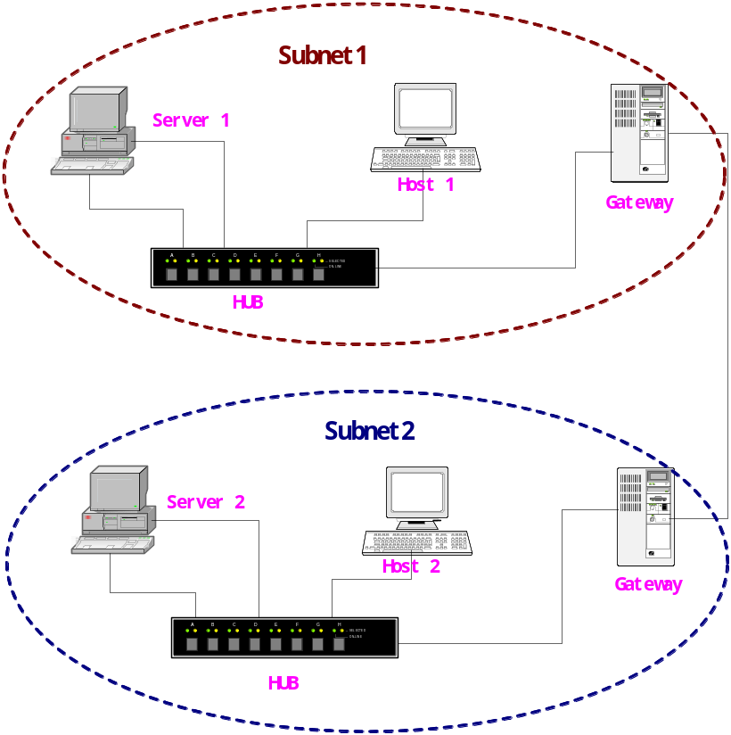

Figure 1 Test Environment Overview

There are two subnets connected with gateway to gateway, each of which has two computers including one server which OS is MS 2003 server and one PC whatever OS. In each subnet there are one server and one host computer that are connected with a hub. And servers here have two network cards that will be set two IP address to test.

Software Environment
The following software is needed for the multicast forward system.

- McastFwd.exe
- Mcastsend.exe
- Mcastrcv.exe

- MsXml4SDK
- Analyzer 3.0 from NetGroup [http://analyzer.polito.it/]

An expected installation tree can be showed below:

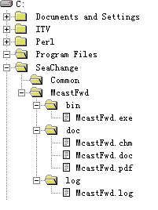
Figure 2 the Installation Tree

Operating System Environment

Windows 2003 is the target OS. The servers marked A1 and B1 in two sub-nets need MS2003 server OS, and the other hosts haven’t restriction in OS.

Hardware Environment

- 4+ Intel x86 PC
- 2+ Hub or Switch
- 2+ sub networks
- ITV command center
- ITV media cluster node

Min hardware requirement for windows 2003:
- Processor: P4 1.5G
- Memory: 256M
- Hard disk: 20G
- Net card: 10/100M ×2

The later two are used to verify that the multicast forwarding service can be installed and work friendly with existing ITV components.

Network Environment
There are four computers each installed 2003 OS in the network and their sites are as following picture:
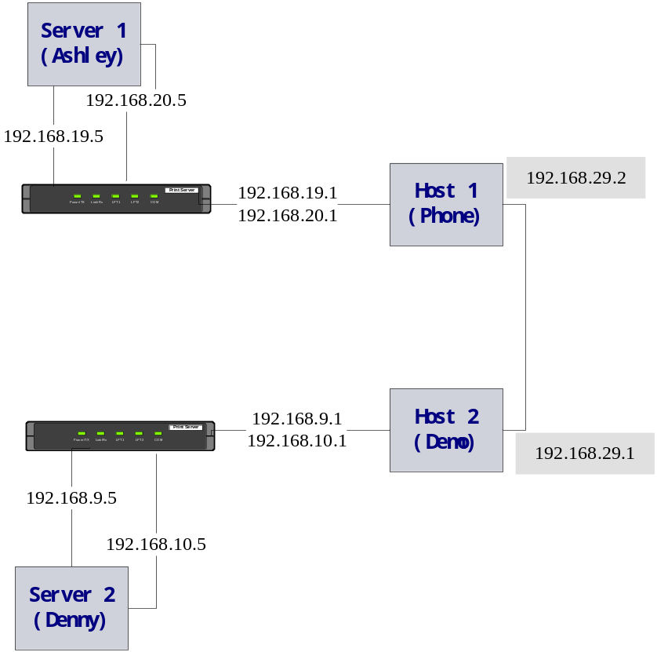
Figure 3 Network Environment

Each computers route configurations are as following chart:

Server1 (Ashley) : 192.168.19.5; 192.168.20.5
Network Destination | Netmask |  | Gateway | Interface |  | Metric
192.168.9.0 | 255.255.255.0 |  | 192.168.19.1 | 192.168.19.5 |  | 1
192.168.10.0 | 255.255.255.0 |  | 192.168.20.1 | 192.168.20.5 |  | 1
192.168.19.0 | 255.255.255.0 |  | 192.168.19.5 | 192.168.19.5 |  | 30
192.168.20.0 | 255.255.255.0 |  | 192.168.20.5 | 192.168.20.5 |  | 30
192.168.39.0 | 255.255.255.0 |  | ??? | ???
192.168.40.0 | 255.255.255.0 |  | ??? | ???
Host1 (PHONE) : 192.168.29.2，192.168.19.1，192.168.20.1
Network Destination | Netmask | Gateway |  |  | Interface |  | Metric
192.168.9.0 | 255.255.255.0 | 192.168.29.1 |  |  | 192.168.29.2 |  | 1
192.168.10.0 | 255.255.255.0 | 192.168.29.1 |  |  | 192.168.29.2 |  | 1
192.168.19.0 | 255.255.255.0 | 192.168.19.1 |  |  | 192.168.19.1 |  | 30
192.168.19.1 | 255.255.255.255 | 127.0.0.1 |  |  | 127.0.0.1 |  | 30
192.168.19.255 | 255.255.255.255 | 192.168.19.1 |  |  | 192.168.19.1 |  | 30
192.168.20.0 | 255.255.255.0 | 192.168.20.1 |  |  | 192.168.19.1 |  | 30
192.168.20.1 | 255.255.255.255 | 127.0.0.1 |  |  | 127.0.0.1 |  | 30
192.168.20.255 | 255.255.255.255 | 192.168.20.1 |  |  | 192.168.19.1 |  | 30
192.168.29.0 | 255.255.255.0 | 192.168.29.2 |  |  | 192.168.29.2 |  | 20
192.168.29.2 | 255.255.255.255 | 127.0.0.1 |  |  | 127.0.0.1 |  | 20
192.168.29.255 | 255.255.255.255 | 192.168.29.2 |  |  | 192.168.29.2 |  | 20
Server2 (Denny) :192.168.9.5; 192.168.9.6
Network Destination | Netmask | Gateway |  |  | Interface |  | Metric
192.168.9.0 | 255.255.255.0 | 192.168.9.5 |  |  | 192.168.9.5 |  | 20
192.168.9.5 | 255.255.255.255 | 127.0.0.1 |  |  | 127.0.0.1 |  | 20
192.168.9.255 | 255.255.255.255 | 192.168.9.5 |  |  | 192.168.9.5 |  | 20
192.168.10.0 | 255.255.255.0 | 192.168.10.5 |  |  | 192.168.10.5 |  | 20
192.168.10.5 | 255.255.255.255 | 127.0.0.1 |  |  | 127.0.0.1 |  | 20
192.168.10.255 | 255.255.255.255 | 192.168.10.5 |  |  | 192.168.10.5 |  | 20
192.168.19.0 | 255.255.255.0 | 192.168.9.1 |  |  | 192.168.9.5 |  | 1
192.168.19.0 | 255.255.255.0 | 192.168.10.1 |  |  | 192.168.10.5 |  | 1
192.168.20.0 | 255.255.255.0 | 192.168.9.1 |  |  | 192.168.9.5 |  | 1
192.168.20.0 | 255.255.255.0 | 192.168.10.1 |  |  | 192.168.10.5 |  | 1
192.168.29.0 | 255.255.255.0 | 192.168.9.1 |  |  | 192.168.9.5 |  | 1
192.168.29.0 | 255.255.255.0 | 192.168.10.1 |  |  | 192.168.10.5 |  | 1
Default Gateway: | 192.168.80.1
Host2 (DEMO) :192.168.29.1，192.168.9.1，192.168.10.1
Network Destination | Netmask | Gateway |  |  | Interface |  | Metric
192.168.9.0 | 255.255.255.0 | 192.168.9.1 |  |  | 192.168.9.1 |  | 20
192.168.9.1 | 255.255.255.255 | 127.0.0.1 |  |  | 127.0.0.1 |  | 20
192.168.9.255 | 255.255.255.255 | 192.168.9.1 |  |  | 192.168.9.1 |  | 20
192.168.10.0 | 255.255.255.0 | 192.168.10.1 |  |  | 192.168.9.1 |  | 20
192.168.10.1 | 255.255.255.255 | 127.0.0.1 |  |  | 127.0.0.1 |  | 20
192.168.10.255 | 255.255.255.255 | 192.168.10.1 |  |  | 192.168.9.1 |  | 20
192.168.19.0 | 255.255.255.0 | 192.168.29.2 |  |  | 192.168.29.1 |  | 1
192.168.20.0 | 255.255.255.0 | 192.168.29.2 |  |  | 192.168.29.1 |  | 1
192.168.29.0 | 255.255.255.0 | 192.168.29.1 |  |  | 192.168.29.1 |  | 20
192.168.29.1 | 255.255.255.255 | 127.0.0.1 |  |  | 127.0.0.1 |  | 20
192.168.29.255 | 255.255.255.255 | 192.168.29.1 |  |  | 192.168.29.1 |  | 20

Test Coverage Chart

Chart of all test cases and the test coverage categories assigned to each case. If tests are logically grouped by set of product functionality, tailor the chart to include this distinction.

ID | Test Case
R6.1 | Solution must run on Windows 2003..
R6.2 | SeaChange Style Windows Service
R6.3 | use standard Layer 4 socket interface for all socket interactions.
R6.4 | support both single and dual rail support for the tunnel connections
R6.5 | A single multicast conversation should be able to be configured between 2 or more subnets
R6.6 | No Additional Hardware required
R6.7 | The solution must not cause loop traffic
R6.8 | support a deny list to drop any messages sent from an IP/Port in this list
R6.9 | work in both IPV4 and IPV6 environments
R6.10 | accept explicit IP addresses and resolvable host and group names for both IPv4 and IPv6 addresses
R6.11 | Single Stack Support
R6.12 | Single tunnel connection between any two mcastfwd installation
R6.13 | must be configurable through the ITV Configurator service
R6.14 | Manutil/SNMP support is required

Implementation Quality

This section will focus on the software quality assurance during implementation. It mostly describe the QA strategy in implementation phase

Tools

Several QA tools are highly recommended during implementation:
    - DevPartner Studio, from Compuware
    - VTune, from Intel
    - C++ test, from ParaSoft

Test Field

# | Field | Expected Results
1 | memory/resource leak | No such error could be found
2 | Uncatched exception | No uncatched exception
3 | Code coverage
4 | Performance | Minimal response delay

And the following requirement must be met during implementation since they can hardly be verified in black-box testing:

ID | Test Case
R6.3 | use standard Layer 4 socket interface for all socket interactions.
R6.11 | Single Stack Support
R6.12 | Single tunnel connection between any two mcastfwd installation

Functionality Test

Test Stage One

This test stage is based on the core functionalities excluding SeaChange style service – related issues

Requirements / Prerequisites

The following items must be covered in this test stage:

ID | Test Case
R6.1 | Solution must run on Windows 2003..
R6.4 | support both single and dual rail support for the tunnel connections
R6.5 | A single multicast conversation should be able to be configured between 2 or more subnets (suspend)
R6.6 | No Additional Hardware required
R6.7 | The solution must not cause loop traffic
R6.8 | support a deny list to drop any messages sent from an IP/Port in this list
R6.9 | work in both IPV4 and IPV6 environments
R6.10 | accept explicit IP addresses and resolvable host and group names for both IPv4 and IPv6 addresses
R6.12 | Single tunnel connection between any two mcastfwd installation

Test Cases

Tailor this chart and format page width as required. Document the test and the steps using as much detail as possible. Remember, you may not be the only one that uses the procedures here.

The below is the project detailed network environment structure which can be referred to the test case.

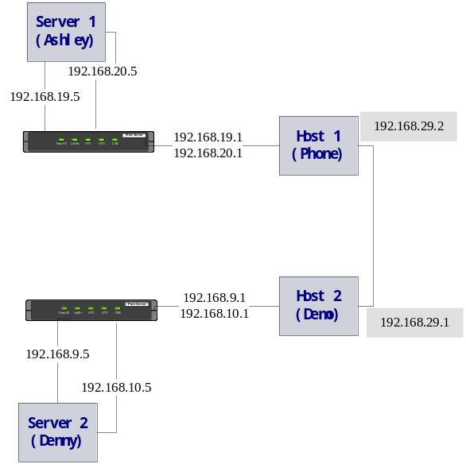

Figure 4 the network environment reference

 | # |  | Test and Description |  | Steps |  | Expected Results |  | SPR |  | Etc
1 |  | R6.1 Solution must run on Windows 2003 |  | - Install our procedure on two servers which OS is windows 2003;  - Check the run circumstance of the installed server such as memory and CPU to ensure the procedure runs normally on 2003. |  | - The installation process is normal.  - The procedure runs ok on 2003.
2 |  | Main Function: Solution may support multicast conversation |  | - Multicast can’t work on the subnet without procedure installing on servers.  - Before installation, open a sender on host1 and forward multicast messages;  - Open receiver on host2 and see if any message can be listened.  - Multicast can work on the subnet when the procedure installed.  - After installation, open a sender on host1 and forward multicast messages;  - Open receiver on host2 and see if any message can be listened. |  | Messages can be forwarded between two subnets after the procedure installed. It means that any host in the network can receive messages from other subnet until the procedure installed.
3 |  | R6.4 Support both single and dual rail support for the tunnel connections |  | - Pull out ONE cable of the servers each time and see if multicast works ok. It must be four times since there are two servers in the network, and each of them has two network cards.  - Pull out EACH cable of two servers and see if multicast works ok. It must be two times. |  | Multicast always works normally.
4 |  | R6.5 A single multicast conversation should be able to be configured between 2 or more subnets |  | Suspend until three subnets can be built.
5 |  | R6.6 No additional hardware required |  | It can’t be tested in the current environment.
6 |  | R6.7 The solution must not cause loop traffic |  | - Open receiver on host 1 and host 2;  - Use sender to forward multicast message from host 1;  - Check receivers above and see if the number of messages is more than those from sender. |  | The number of message is same wherever from sender or from receiver.
7 |  | R6.8 Support a deny list to drop any messages sent from IP/Port in this list |  | - Set deny list on server1 and add 192.168.19.1 into the deny list.  - Open sender on host1, and forward multicast message bound with 192.168.19.1.  - Open receiver on host2 to see if listen message. |  | No message can be forwarded to host2.
8 |  | R6.9 Work in both IPv4 and IPv6 environment; |  | Suspend until IPv6 environment is built.
9 |  | R6.10 accept explicit IP address and resolvable host and group names for IPv4 and IPv6 |  | - Set host1 as DNS server which can be followed by other three hosts;  - Add several multicast IP address as DNS name, for example set 225.25.25.25 mapping ‘mfwtest1’;  - Open sender on server1 and forward multicast message with ‘mfwtest1’ as multicast IP address;  - Open receiver on host2 and see if the message can be listened.  The test for IPv6 state suspends until IPv6 environment is built. |  | The multicast message can be forwarded and listened.
10 |  | R6.12 Single tunnel connection between any two mcastfwd installation |  | - Use ‘netstat –a –n’ command to check the tunnel connection information on either server. |  | Information approves the tunnel connection be single.

Test Record

After Tailor this chart and format page width as required. Document the test and the steps using as much detail as possible. Remember, you may not be the only one that uses the procedures here.

The following chart is the part of Multicast Forward test record.

St # | Condition | Operation Step | Actual Results
1 | Not installing IP v6 protocol on win 2003 OS in ‘Ashley’ pc and two net card integrated in one hub. | Send multicast package in IP v4 format such as 225.12.12.12 with port: 1000;  Open listening port to receive multicast package with test tools as Mcastrcv or Analyzer. | Do receive multicast package from 225.12.12.12.
2 |  | Send multicast package in IP v4 format such as 225.12.12.12 and bind one net card as 192.168.19.5;  Open listening port to receive multicast package with test tools as Mcastrcv or Analyzer. | Do receive multicast package from ip address of 225.12.12.12 and net card of 192.168.19.5.
3 | Installing IP v6 protocol on win 2003 OS in ‘Ashley’ pc and two net card integrated into one hub. | Send multicast package in IP v6 format such as ffff::1;  Open listening port to receive multicast package with test tools as Mcastrcv or Analyzer. | Do capture multicast package on ffff::1 by Analyzer but do not receive it with Mcastrcv.
4 |  | Send multicast package in IP v6 format such as ffff::1 and bind one net card as fe80::205:5dff:fe86:c46b%5;  Open listening port to receive multicast package with test tools as Mcastrcv or Analyzer. | Do not capture multicast package on ffff::1 by Analyzer and Mcastrcv.

Test Result

Stage one test result is as below:

 | # |  | Test and Description |  | Steps |  | Expected Results |  | Actual Result
1 |  | R6.1 Solution must run on Windows 2003 |  | s1. Install our procedure on two servers which OS is windows 2003;  s2. Check the run circumstance of the installed server such as memory and CPU to ensure the procedure runs normally on 2003. |  | 1. The installation process is normal.  - The procedure runs ok on 2003. |  | Ok.
2 |  | Main Function: Solution may support multicast conversation |  | S1. Multicast can’t work on the subnet without procedure installing on servers.  1.1 Before installation, open a sender on host1 and forward multicast messages;  1.2 Open receiver on host2 and see if any message can be listened.  S2. Multicast can work on the subnet when the procedure installed.  - After installation, open a sender on host1 and forward multicast messages;  - Open receiver on host2 and see if any message can be listened. |  | Messages can be forwarded between two subnets after the procedure installed. It means that any host in the network can receive messages from other subnet until the procedure installed. |  | Ok.
3 |  | R6.4 Support both single and dual rail support for the tunnel connections |  | S1. Pull out ONE cable of the servers each time and see if multicast works ok. It must be four times since there are two servers in the network, and each of them has two network cards.  S2. Pull out EACH cable of two servers and see if multicast works ok. It must be two times. |  | Multicast always works normally. |  | Can't forward multicast package pulling out any one cable. (bug id=12)
4 |  | R6.5 A single multicast conversation should be able to be configured between 2 or more subnets |  | Suspend until three subnets can be built.
5 |  | R6.6 No additional hardware required |  | It can’t be tested in the current environment.
6 |  | R6.7 The solution must not cause loop traffic |  | S1. Open receiver on host 1 and host 2;  S2. Use sender to forward multicast message from host 1;  S3. Check receivers above and see if the number of messages is more than those from sender and never stop until listener quit. |  | The listener can not stop receiving messages.
7 |  | R6.8 Support a deny list to drop any messages sent from IP/Port in this list |  | S1. Set deny list on server1 and add 192.168.19.1 into the deny list.  S2. Open sender on host1, and forward multicast message bound with 192.168.19.1.  S3. Open receiver on host2 to see if listen message. |  | No message can be forwarded to host2. |  | Ok.
8 |  | R6.9 Work in both IPv4 and IPv6 environment; |  | Suspend until IPv6 environment is built.
9 |  | R6.10 accept explicit IP address and resolvable host and group names for IPv4 and IPv6 |  | S1. Set host1 as DNS server which can be followed by other three hosts;  S2. Add several multicast IP address as DNS name, for example set 225.25.25.25 mapping ‘mfwtest1’;  S3. Open sender on server1 and forward multicast message with ‘mfwtest1’ as multicast IP address;  S4. Open receiver on host2 and see if the message can be listened.  The test for IPv6 state suspends until IPv6 environment is built. |  | The multicast message can be forwarded and listened.
10 |  | R6.12 Single tunnel connection between any two mcastfwd installation |  | S1. Use ‘netstat –a –n’ command to check the tunnel connection information on either server. |  | Information approves the tunnel connection be single. |  | Seeing double, not single tunnel connection between two aggregators. (bug id=13 )

Test Stage Two

This test stage is overall product test

Requirements / Prerequisites

All requirement items should be covered in this stage. Especially, the following items must be covered:

ID | Test Case
R6.2 | SeaChange Style Windows Service
R6.13 | must be configurable through the ITV Configurator service
R6.14 | Manutil/SNMP support is required

And, the installshiled implementation must be verified in the stage

Test Cases

Tailor this chart and format page width as required. Document the test and the steps using as much detail as possible. Remember, you may not be the only one that uses the procedures here.

TODO: SQA group add the planed test case descriptions
# | Test and Description | Steps | Expected Results | SPR | Etc
1
2
3
4

Conformance Test

Performance Test

