
SeaChange Company Confidential

Multicast Forwarding Requirements
*DRAFT – Limited Distribution*

Mike Kiskiel mikek@schange.com

SeaChange International Inc., 124 Acton Street, Maynard, MA 01754 USA

Revision History

Version | Date | Author | Description
0.1 | 2004-03-1 | Mike Kiskiel | Initial draft.
0.2 | 2004-03-18 | Gregory Holbrow | Reformat
0.3 | 2004-03-18 | Gregory Holbrow | Updated based on email discussions

Table of Contents
1 Revision History 1
2 Table of Contents 1
3 Acronyms 3
4 References 3
5 Overview 4
5.1 General Intent 4
5.2 Approach 4
6 Functional Requirements 5
6.1 Operating Environment 5
6.2 Windows Service 5
6.3 Layer 4 network interface 5
6.4 Inter-Network Connection 5
6.5 Multi-Network Forwarding 5
6.6 No Additional Hardware 6
6.7 Message Loop Avoidance 6
6.8 Deny List 6
6.9 IP Version Mixing 6
6.10 Machine/Group Addressing 6
6.11 Mixed network Support 6
6.12 Single Stack Support 6
6.13 Single tunnel connection 7
6.14 Configuration 7
6.15 ManUtil 7
6.16 SNMP 7
7 Development Requirements 7
7.1 Development Environment 7
7.2 Intellectual Property 7
7.3 Code Style 7
7.4 Inter-Network Connection 7
7.5 Limited Dependencies 7
7.6 Performance Oriented 8
7.7 Test Tools 8
7.8 Minimal Configuration 8
7.9 Portability 8
8 Dependencies 8
8.1 MtTcpComm 8
8.2 Configurator 8
8.3 ManUtil 8

Acronyms
IPv4 | Internet Protocol Version 4
IPv6 | Internet Protocol Version 6
MtTcpComm | Multithreaded TCP Communication Package
ManUtil | SeaChange Management Utility
SNMP | Simple Network Management Protocol

References
Configurator documentation?

Manutil Interfaces/ API?

MtTcpComm Interfaces/API?

SvrShell / AppShell

Overview

General Intent
It is anticipated that there are environments where ITV and other applications would like to use or need to use multicast but may not be allowed in portions of the customer network.

For example, it maybe acceptable from the customer perspective, for an application to use multicast in a subnet, but the multicast will never be allowed past the router serving the subnet. However, the application software may need to have a multicast conversation that spans 2 or more subnets.

Approach
Provide a service or daemon that will
- aggregate multicast traffic,
- forward it via a connection-oriented protocol to a receiving service or daemon
- re-multicast the traffic at the receiving service or daemon

Broadly speaking, it is the rough equivalent of a V-LAN for multicast support.

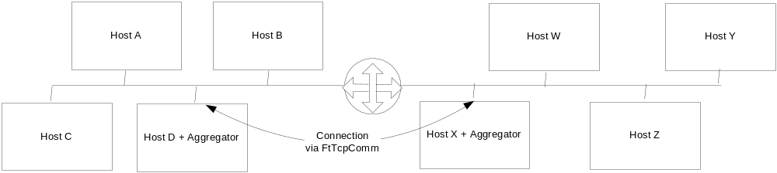
Figure 1, Small 2 Network System

In the small 2 network system above, a collection of nodes in both networks may want to participate in 1 single multicast conversation. The aggregators in each network would be configured to listen for that conversation and forward it to the other side.

Functional Requirements

Operating Environment
Solution must run on Windows 2003.

The design should not preclude running on NT4.0.

Windows Service
The program must run as a Windows service using the SeaChange Service Shell and App Shell.

Layer 4 network interface
The solution must use standard Layer 4 socket interface for all socket interactions.

Inter-Network Connection
There must be support for both single and dual rail support for the connection between aggregators.

Multi-Network Forwarding
A single multicast conversation should be able to be configured between 2 or more subnets.
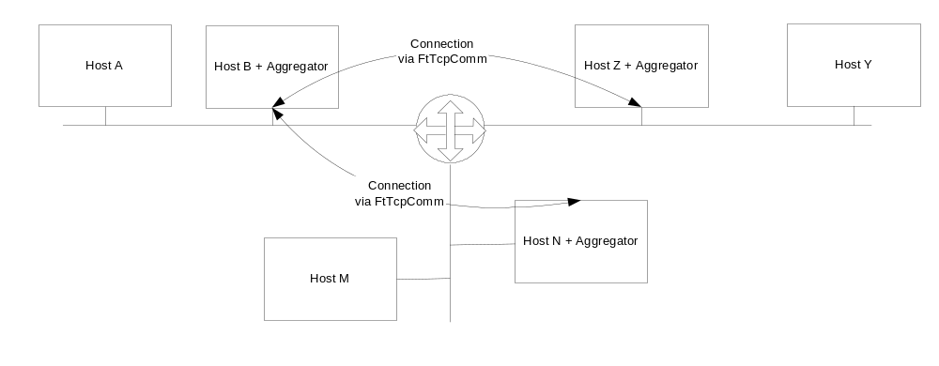 Figure 2, Medium 3 Network System
In the above network diagram, a multicast conversation is required to traverse all three network segments. In this case the Aggregator on Hosts B, N and Z would be required to forward multicast messages on their local subnet to the other aggregators and the destined aggregator would subsequently re-multicast the received messages on their local subnet.

No Additional Hardware
The solution must not require a separate machine on which it runs. Messages must be able to be sourced from other services on the same machine running the aggregator.

Message Loop Avoidance
The solution must not forward any messages that were sourced from itself (the same instance of the aggregator service).

Deny List
The solution must support a deny list, containing both source addresses as well as source ports. Any messages sent from an IP/Port in this list should not be forwarded.

IP Version Mixing
Multicast and inter-service connections must work in both IPV4 and IPV6 environments. The service must make no assumptions of IP version and work in all network combinations including:
- Multicast messages may be IPv4, but the inter-service connection can be IPv6
- Multicast messages may be IPv6, but the inter-service connection can be IPv6
- Multicast messages may be IPv4, but the inter-service connection can be IPv4
- Multicast messages may be IPv6, but the inter-service connection can be IPv4
- Multicast messages may be IPv4 and IPv6, but the inter-service connection can be IPv4
- Multicast messages may be IPv4 and IPv6, but the inter-service connection can be IPv6

Machine/Group Addressing
The solution must support both explicit IP addresses and resolvable host and group names for both IPv4 and IPv6 addresses.

Mixed network Support
The ability to work in a mixed IP environment will not require tunneling technologies to operate.

Single Stack Support
It should be possible to operate in a single stack environment. For example, if the subnets are all IPV6 and the network provided for the connection between aggregators is IPV6 and there are no other IPV4 requirements, then the service should be able to operate properly without the presence of an IPV4 stack. The converse should also be true.

Single tunnel connection
Only one fault resilient (via MtTcpCom) connection is allowed between any 2 servers. All multicast conversations between two aggregators must tunnel through a single TCP connection. The service must not create separate TCP connections for different multicast messages/conversations.

Configuration
The service must be configurable through the ITV Configurator service.

ManUtil
Manutil support is required for remote management and service status.

SNMP
SNMP support is required as provided through the ManUtil interface.

Development Requirements

Development Environment
The resulting software sources should provide a project and solution file for Developer Studio .NET and the project should compile under Studio .NET and otherwise operate properly.

Intellectual Property
No 3rd party licenses should be required, and especially not open software foundation licenses. When it’s all done, SeaChange owns the source code.

Code Style
All source code must be commented in English

Inter-Network Connection
All connections must be provided by FtTcpComm, the multi-rail fault-resilient connection library currently used by ITV.

Limited Dependencies
Must not require additional interfaces from existing ITV components

Performance Oriented
Due to the limitation of the Windows stack with UDP packets, the service must minimize the likelihood of dropped packets. (eg. read+queue then dequeue+process rather than read+process)

Test Tools
The project should also provide a simple utility for testing the setup and configuration of the services. For example, the utility should have the ability to specify a conversation for a sender and receiver across one or more subnets and demonstrate the conversation is occurring with simple well-known messages. (similar to mcastsendtest and mcastrcvtest).

Minimal Configuration
If there is no obvious way otherwise, it is OK to configure what multicast conversations are received by a service and to which other services they should be forwarded.

Portability
It would be nice if the solution is not “married to” or “alloyed with” Microsoft. The service should not latch on to Microsoft's latest abstraction layer that is subject to change on a whim. eg. Use Win32/Winsock as oposed to MFC or the latest architecture push (.NET)

It would be desirable to be able to port to another OS (like linux, unix, etc) without a rewrite. However, that is not to say that the first implementation must be portable already. The goal is to component-ise all OS specific code where practical.

Dependencies

MtTcpComm
The MtTcpComm component must be modified to be IP agnostic in order to support IPv6.

Configurator

ManUtil

