SMS interface for Teammark & ZQ

Author: Ken Qian
Document Version Number: 0.2

Revision History
Revision | Date | Who | Description
0.1 | 2006-02-21 | Ken Qian | Initial draft
0.2 | 2006-6-19 | Ken Qian | Adding flag and application rules for supporting forwarding message.

1 Contents
SMS interface for Teammark & ZQ 1
Revision History 2
1 Contents 3
2 Communication Model 4
2.1 Communication Diagram 4
2.2 Workflow 5
2.3 Heartbeat 6
2.4 No Response Case Processing 6
3 Interface 6
3.1 Common Data Interface 6
3.2 Command Definition 7
3.3 Interface Lists 7
4. Application 9
5 Message Forwarding 9

2 Communication Model

2.1 Communication Diagram
Following is the communication diagram between Treammark and ZQ. The communication is completed by socket in TCP/IP. In this diagram, ZQ’s SMSGateway works as the client. And the connection between Server and Client is always alive.
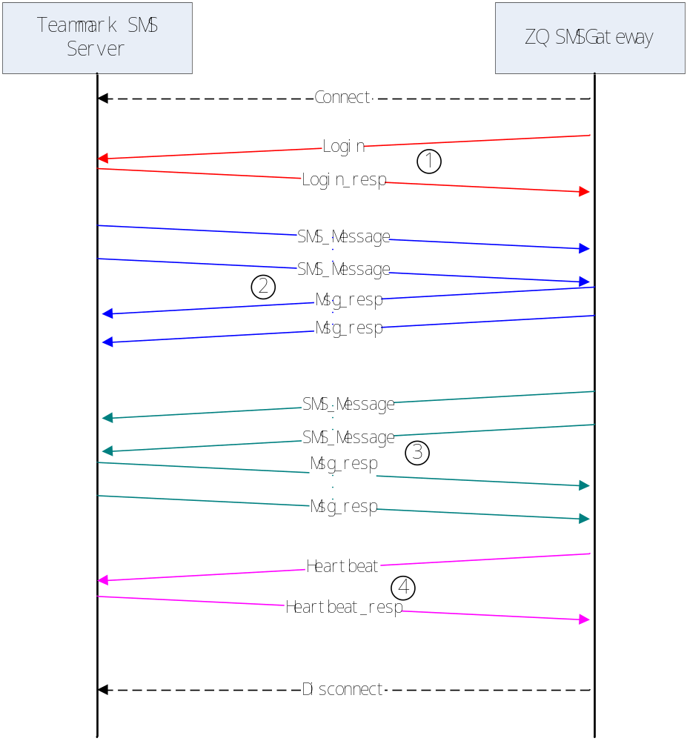
There are four type communications between the two applications. Each communication is completed as send/response mode.

2.2 Workflow
- When ZQ SMSGateway is started, it begins to connect to Teammark SMS Server application via TCP/IP. If it fails, it will retry until the success.
- After the connection setup, ZQ SMSGateway sends Login Message to do verify by the server to see whether it is a legal client. If not, server will disconnect the connection. Only after the authorization verified, other commands can be send/received.
- Teammark SMS Server delivers SMS message to ZQ SMSGateway when it receives new message from Service Provider. After ZQ SMSGateway received the message, it sends acknowledgement response back.
- ZQ SMSGateway sends message to Teammark SMS Server to notify customer its operation results. And then Teammark Server returns the response as the acknowledgment.
- In case of message without communication between server and client, client sends heartbeat message to keep the connection alive. And the server sends the response back.

2.3 Heartbeat
Teammark SMS Server requires that there must be message received from client in each 10 seconds (configurable) whatever the message is in order to keep the connection alive. Otherwise the Server will drop the connection. So in the idle period of the communication, ZQ SMSGateway needs to send heartbeat message to Teammark SMS Server to make sure the connection is available.

2.4 No Response Case Processing
- To Login Command, if in 5 second (configurable), there is no response back, ZQ SMSGateway terms the connection and reconnect and then resend the Login command, until the connection was setup and pass the credit verify.
- To Message Command (bidirectional)
If any side does not get response message in 5 seconds (configurable) from another side; it resends the message, and if there is no response after 5 seconds (configurable), this message will be dropped. So message command is only sent twice (configurable) in case no response in time.
- To Heartbeat Command
Teammark SMS Server must return heartbeat response in 5 seconds (configurable). If there is no response in time, the connection will be dropped by client and re-setup.

3 Interface
The communication between Teammark SMS Server and ZQ SMSGateway is completed by Socket.

3.1 Common Data Interface
Following is common data structure for communication. All the command types are based on this structure. If there is new interfaces been requested to add, new command will be added.
Field | Type | Length(bytes) | Comment
PackLength | Int | 4 | The total length of the whole package.
Cmd | Int | 4 | This define message type and content
UID | Int | 4 | Unique ID for each message. The response pack’s UID must be same to the original received one.
Content | string | (up to PackLength) | The real data in the communication.

3.2 Command Definition
In current interface, there are following commands are available.
Command | Value
CMD_LOGIN | 0x00000001
CMD_LOGIN_RESP | 0x80000001
CMD_MSG | 0x00000002
CMD_MSG_RESP | 0x80000002
CMD_HEARTBEAT | 0x00000003
CMD_HEARTBEAT_RESP | 0x80000003

3.3 Interface Lists
This section only demonstrates the Content field in different common data structure. To all Response Command, they don’t have the Content in the data structure.

3.3.1 CMD_LOGIN Command
CMD_LOGIN’s Content field is only a string that represents the authorization code which is assigned by Teammark for ZQ.

3.3.2 CMD_MSG Command
CMD_MSG command is a general command that covers all SMS message, it does not care the service code is, it does not care what the data format is and so on.
CMD_MSG’s Content is composed of a serial Key, Length, Value sets in well formatted string.
The Key is predefined name with length 20 bytes, which represents the meaning of the data followed, such as Service Code, Time, SMS Content and so on. The prototype Key list is provided by Teammark, and it will be revised and released by ZQ. Generally the key list includes all the possible parameters for all Service Providers (China Mobile, China Unicom and China Telecom).
The Length a 4 bytes value in string which represents the length of Value followed.
The Value is the string formatted value corresponding to the Key.
0 19 20 23
Key | Length | Value

There are following Keys we are care about, to the other key/length/value sets, just return them back as it was.
Key Name | Comment
ServerID | Each ZQ’s SMSGateway application has a ServerID that represents the client to communicate with SMS Server. The ServerID must be in this command’s message.
SPNumber | The SP number to provide the SMS service.
UserPhone | The telephone number of user
Content | The message content
recvTime | The message received time by SP
SrcServerID | This is new added key in v0.2 to identify the message is local or forwarded. If it is local, the value of SrcServerID is same to ServerID. If it is forwarded, the SrcServerID represents the source region ServerID.

Sample Content for Play a Movie:
SPNumber | 7 | 9359910 | UserPhone | 11 | 13912345678 | Content | 11
(To be continued)
AC 80004008 | recvTime | 19 | 2006-02-21 17:48:00 | ServerID | 4 | 1000
(To be continued)
SrcServerID | 4 | 10001 | …… | …… | …… | ……

Maybe in the CMD_MSG’s Content, we only care some of them, but some of others are very important, because if want to charge this message from the user, we must return a message that includes some info in the Content which works as ID by Service Provider to identify whether it is legal one or not.
To process the unvalued Key, Length, Value set, we can extractive the valuable sets first, and then combines all the unvalued sets together as a string without parsing it. If we need to return the corresponding message, we can add it in the CMS_MSG’s Content to Teammark SMS Server.

3.3.3 CMD_HEARTBEAT Command
In CMD_LOGIN’s data structure, it does not include Content field.

4. Application
The different applications on the SMS are by adding prefix in the content. This section is focusing on what kinds of applications are required to be implemented. Following is the table of the applications and the prefix.

 | Application |  | Prefix |  | Comment
TV-Now |  | CZM |  | This application includes Video On Demand, NPVR, Start Over TV and so on.
Live Chat |  | LT |  | This application is let the customer to send chat message, and these messages will be shown on TV.

5 Message Forwarding

5.1 To Identified SMSGateway
This function is intended to share the message between different systems, sites or regions according to different applications. Currently, the LT message needs to be forwarded, but in the feature, there is possible to share more than one type of message. So the server side application must be easily configured and extensible.
The local and forwarded message to SMSGateway is distinguished by ServerID and SrcServerID. If ServerID is same to SrcServerID, and they are all same to the configured ServerID in SMSGateway, this message is a local message. If ServerID is different to SrcServerID, that means this message is forwarded by SMS Server from other site. Only to local message, SMSGateway could send return message to SMSServer.

The rule of forwarding message is determined by application type first, then to each type of application level, identify which SMSGateway can receive the forwarded message.

Following diagram is to demonstrate this rule. Here I introduce a new application type, called Online Question (OQ).

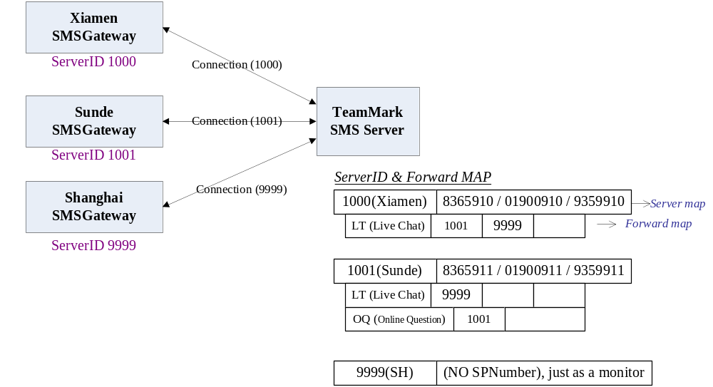

In this example, following are all the cases:
- All the (LT) Live Chat messages are required to forward to 9999 (SH), coz 9999 (SH) works as a monitor site.
- Xiamen Live Chat(LT) message is forwarded to Sunde(1001)
- Sunde Online Question(OQ) message is forwarded to Xiamen(1000)
- Sunde Live Chat(LT) message is NOT forwarded to Xiamen(1000)
- Any message for 9999(SH) is NOT forwarded to other sites

