SrvLoad Retriever
Detailed Design Document
Author: Kaliven Lee
Version:0.3
Date:2006-11-09
Revision History
Version | Revise Date | Owner | Notes
0.1 | 2004-12-30 | Kaliven Lee | Daft initialized
0.2 | 2005-1-10 | Kaliven Lee | Add Detail information
0.3 | 2006-11-9 | Ken Qian | New feature to support the SrvLoad information is able to save to multiple LAM database. And new configuration file is to set those database information.

1 Introduction 4
1 Introduction 4
1.1 Purpose 4
1.2 Scope 4
1.3 References 4
1.4 Overview 4
2 Data dictionary 5
2.1 ote_server 5
2.2 ote_instance 5
2.3 Sample of XML file 5
3 Static Class View 8
4 Tasks/Processes Function and Relation 9
5 System Sequence View 10
6 Error Handling 11
7 Configuration 12

Introduction

Purpose
SrvLoad Retriever is a component to implement a simple load balance mechanism to use CMS. Backoffice will use several CMS servers. And different servers will have different load, So Backoffice should get the information of each CMS Server instance. And SrvLoad Retriever takes the change of retrieving this information of CMS Server Instances from ITV system.

Scope
SrvLoad Retriever is a SeaChange Service. It resolved the problem to retrieve the information of CMS and write it into the DB of Local AM. ITV system will generate the information into a XML file in specified directory. And Backoffice will read the information from Load AM intermittently. And then it will adjust the usage of the CMS to keep the load of each of the CMS balance.

References
The emails from the Hancle

Overview
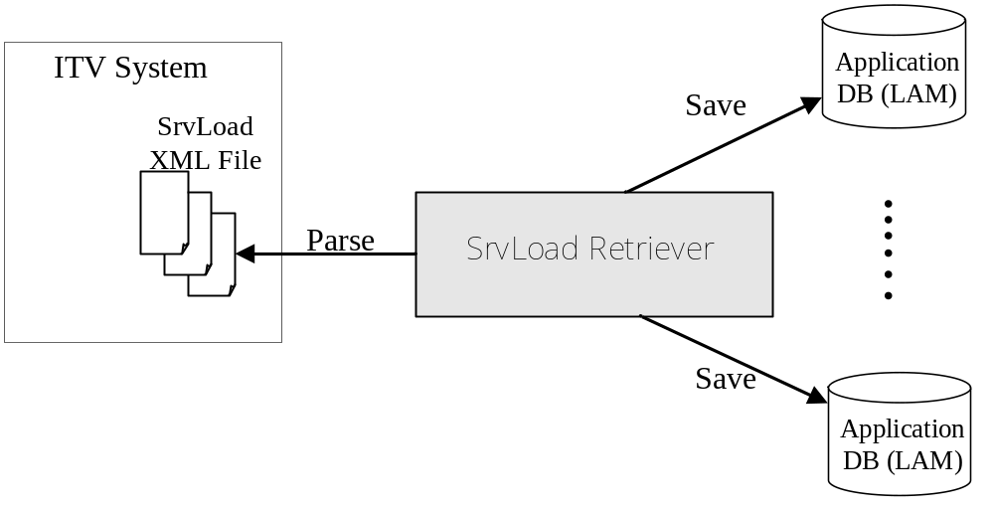
Figure 1 OverView of SrvLoad Retriever

Data dictionary

ote_server
FIELD | TYPE | NULL | DESCRIPTION
version | Varchar(10)
date_time | Varchar(25)
interval_time | Number(4)
app_type | Varchar(200) |  | Format: 0X80002_0X80004_0X80003
pg_level | Number(4)

ote_instance
FIELD | TYPE | NULL | DESCRIPTION
instance_number | Number(2), PK | NOT
ip_address | Varchar(15)
port | Number(4)
server_load | Number(4)
life_time | Number(8)

Sample of XML file
<?xml version="1.0"?>
<SrvrList>
<Header>
<Version>0</Version>
<DateTime>04.12.30.09.33.59</DateTime>
<Interval>300</Interval>
</Header>
<CMGroup>
<AppType>0X80001</AppType>
<AppType>0X80002</AppType>
<NodeGroup>0X1</NodeGroup>
<NodeGroup>0X2</NodeGroup>
<NodeGroup>0X3</NodeGroup>
<NodeGroup>0X4</NodeGroup>
<NodeGroup>0X5</NodeGroup>
<NodeGroup>0X6</NodeGroup>
<NodeGroup>0X7</NodeGroup>
<PGLevel>0</PGLevel>
<Instance>
<IPAddress>10.3.0.23</IPAddress>
<Port>1507</Port>
<Load>0</Load>
<LifeTime>330</LifeTime>
</Instance>
<Instance>
<IPAddress>10.3.0.25</IPAddress>
<Port>1048</Port>
<Load>0</Load>
<LifeTime>330</LifeTime>
</Instance>
</CMGroup>
<SCTPGroup>
<Instance>
<IPAddress>10.3.0.23</IPAddress>
<Port>7004</Port>
<Load>0</Load>
<LifeTime>330</LifeTime>
</Instance>
<Instance>
<IPAddress>10.3.0.25</IPAddress>
<Port>7021</Port>
<Load>0</Load>
<LifeTime>330</LifeTime>
</Instance>
</SCTPGroup>
</SrvrList>

Static Class View
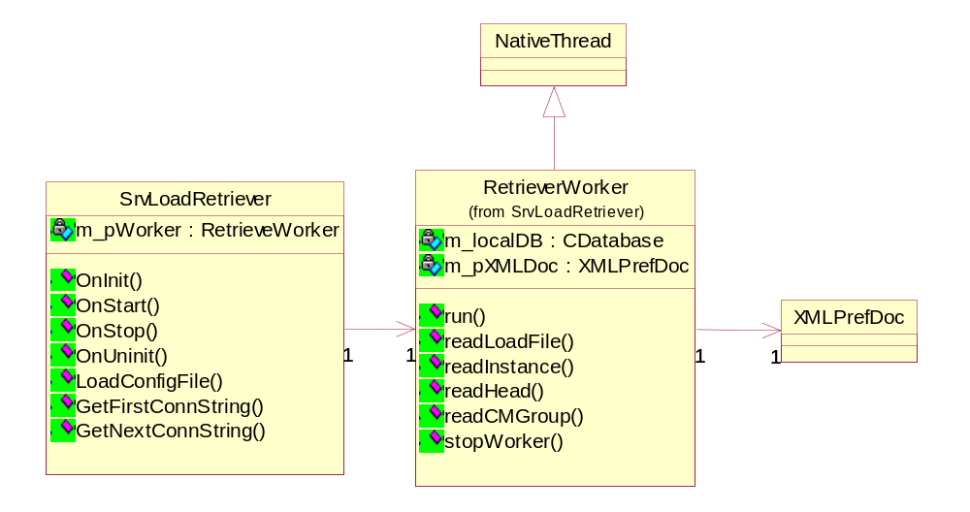
Figure 2 the static class view

Tasks/Processes Function and Relation

CMSRetriever service generalization class inherit from BaseSchangeServiceApp
RetrieverWorker work class of retrieve data from xml file and save to database
XMLPrefDoc The common class for XML parsing
NativeThread The thread common class.

System Sequence View
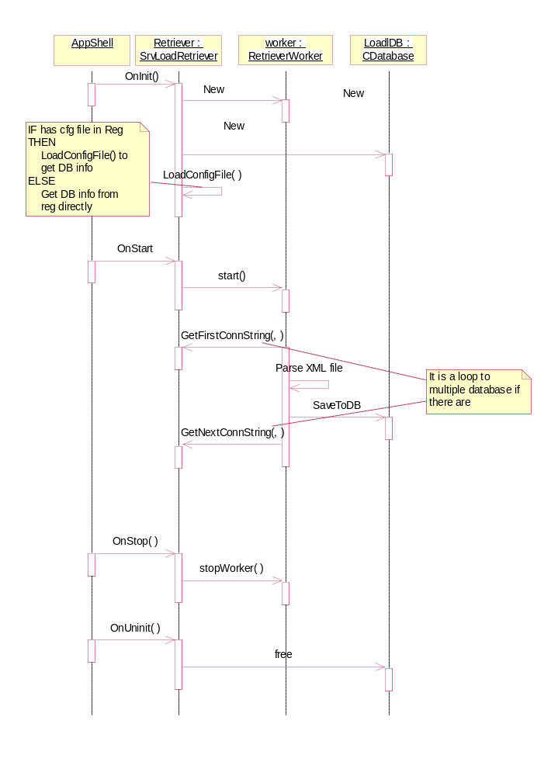. Figure 3 the sequence of system

Error Handling
All the error messages will be written into log file at first. And the function of SvrLoad retriever will be disabled until the next try of retrieving data. So in the worst condition, Some of the instance of CMS will be full of load, And some of the CMS are idle

Failed to read XML file
If srvload retriever encounters an error to read XML file, it will skip to the procedure of write information to DB. And if the error is still in the system, the instance load information will not be update in the Local AM. The Backoffice will use the latest Load information to use the resource of CMS.

Failed to write to Local DB
If SrvLoad Retriever encounters an error to write to Local DB, such as net break, Backoffice will use the latest load information of the CMS. The usage of CMS servers will be out of balance until the SrvLoad Retriever can get the new load information.

Configuration
The configuration is set in register:
HKEY_LOCAL_MACHINE\SOFTWARE\SEACHANGE\ITV\CURRENTVERSION\SERVICES\CMSRETRIEVER\
Configuration | Description | Default Value
LAMDBDSN | The DSN of Local AM DB | sqlserver
LAMDBNAME | The database name | multiverse
LAMDBUSERNAME | The User Name of Local AM DB | multiverse
LAMDBPASSWORD | The password of Local AM DB | multiverse
LOADFILENAME | The file name of Load file, specify it according ITV configuration. | C:\LoadFile\loadfile.xml
READINTERVAL | The interval of read the XML file | 2000(ms)
AppSitesConfigurationFile | The config file for supporting multiple application database.  If there is no such key, or it’s empty, SrvLoad uses the above configuration. If not, it parse the config file to get the database information list. For the config file detail scheme, see the followed information. | (empty)
The AppSitesConfigurationFile scheme example:
<ApplicationSites>
<AppSite Name="AppSite1" DSN="Multiverse1" Database="multiverse" UserName="multiverse" Password="multiverse"/>
<AppSite Name="AppSite2" DSN="Multiverse2" Database="multiverse" UserName="multiverse" Password="multiverse"/>
</ApplicationSites>

Unite Test Case
No. | Action | System Response
1 | Write a XML file as the sample file | The data will be right to the LAM DB

No. | Action | System Response
2 | Add and remove a instance data from the XML file | The table ote_Instance will add and remove a record.

