General Component for Multiverse
Navigation Service Synchronizer (NSSync)
Module Design Document

Revision: 1.2
Author(s): Bernie Zhao



Revision History
Date | Version | Description | Author
2004-11-29 | 0.1 | First draft | Bernie Zhao
2004-12-1 | 0.2 | Added sequence diagram and algorithms | Bernie Zhao
2004-12-30 | 0.3 | Added class diagram and source file description | Bernie Zhao
2005-3-15 | 0.4 | Added ManUtil screen | Bernie Zhao
2005-10-19 | 0.5 | Added support for Program Manager module (PM) | Bernie Zhao
2006-12-25 | 1.2 | Added support for QA Navigation function  Added ManUtil history function | Bernie Zhao

Table of Contents
Revision History 2
Table of Contents 3
Abbreviations 5
Introduction 6
Background 6
Overview 6
Responsibility 7
Related documentation 7
Design description 8
Static Class View 8
Workflow 9
External interface 9
Data definition 10
Data structure 10
NE Tree structure 10
Table diagram 11
File description 13
Kernel algorithm 14
Rebuild Algorithm 14
Folder Update Algorithm 16
Sample Update Algorithm 18
Work Queue Selection Algorithm 19
Performance and maintenance 21
Log trace 21
Status supervision 21
Remarks and Issues 23

Figure 1 6
Figure 2 8
Figure 3 9
Figure 4 10
Figure 5 16
Figure 6 17
Figure 7 19
Figure 8 21
Figure 9 22

Abbreviations
DB | Database
LAM | ZQ Local Asset Manager
EPG | Electronic Program Guide
PM | Program Manager
ITV | Interactive Television
NE | Navigation Engine
DBSync | DB Synchronizer
LAM DB | ZQ Local Asset Management Database
PM DB | Program Manager Database
NAV DB | Navigation Database
WQ DB | Work queue Database, storing operations that will affect NAV database
PO | Product offering
STB | Set Top Box
Space | A space includes all the assets that will be affected by the product offering (PO)
View | A view is a search layout that includes the assets derived from the space
WFES | Web Front End System

Introduction
This chapter provides an overview of the components and describes the features that will be implemented. All related information about component or project is encouraged to turn to related references.

Background

Overview
Navigation service (NS), cooperating with Work Queue (WQ), is a kind of cache mechanism. It provides synchronized database information between local LAM DB, PM DB and NAV DB. The work queue saves the object information that updates or refreshes, such as the information about modifying one asset, deleting one element, or updating/deleting metadata, etc. These updates or refreshes operations could be from Asset Manager (AM) of ITV system, Navigation Engine (NE), or from Program Manager (PM). NS is a background service that gets these update or refresh information from Work Queue, and keeps an up-to-date local database for NE.
The relationship as figure 1:
ITV
1
DB Sync
service
LAM DB
database
WQ DB
database
NSSync
service
NE
service
2
3
7
5
9
11
8
PM DB
database
NAV DB
database
PM
service
6
5
10
EPG
service
4
WFES
12
QA NAV DB
database
Figure 1
- ITV operates one asset or element or metadata, ITV posts the information to DBSync via IDS callbacks.
- DBSync updates the LAM database according to callbacks.
- DBSync inserts a work queue entry to inform NSSync to synchronize data to NAV database.
- PM ingests EPG information from EPG module, manually or automatically.
- PM updates the PM database according to EPG information.
- PM inserts a work queue entry to inform NSSync to synchronize data to NAV database.
- NE inserts a work queue entry when there is any Navigation hierarchy change or folder condition update, to inform NSSync to update data to NAV database.
- NSSync scans work queue database periodically, and fetches new work queue entries.
- NSSync fetches any necessary data from LAM database to update NAV database.
- NSSync fetches any necessary data from PM database to update NAV database.
- NSSync update new data to NAV database (and QA NAV database if QA is enabled).
- WFES uses data from NAV database, to provide asset navigation to end-users.

Responsibility
The primary responsibility of NS Sync falls into the following categories:
- NS Sync watches work queue database, and keep track of every entry, including deleting.
- NS Sync periodically update NAV tree to reflect correct and up-to-date data views from AM database.
- NS Sync periodically update NAV tree to reflect correct and up-to-date data views from PM database.
- NS Sync periodically update QA NAV tree to reflect correct and N-days later QA data views.

Related documentation
- DBSync detail design.doc, Rev 0.1, Kaliven Lee
- workqueue detail design.doc, Rev 0.1, Comet Ye
- NS summarize.doc, Rev 0.1, Comet Ye
- WFES.mdl
- NSSync.mdl

Design description
This chapter describes the basic design scheme for this component, and illustrates it using various methods such as Class Diagram, Sequence Diagram, Collaboration Diagram, as well as External Interface definition.

Static Class View
The primary classes in NSSync are as Figure 2.
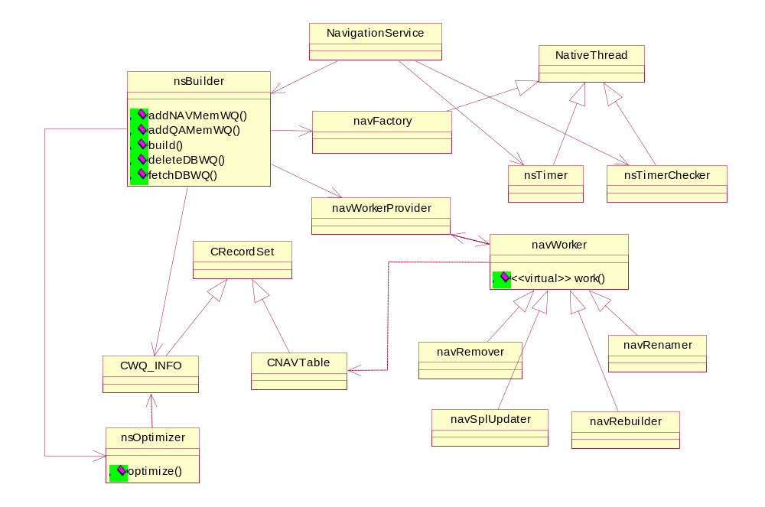
Figure 2

Workflow
NS Sync runs as a background service, handling data information update of AM database periodically.
The workflow is represented by sequence diagram as Figure 3.
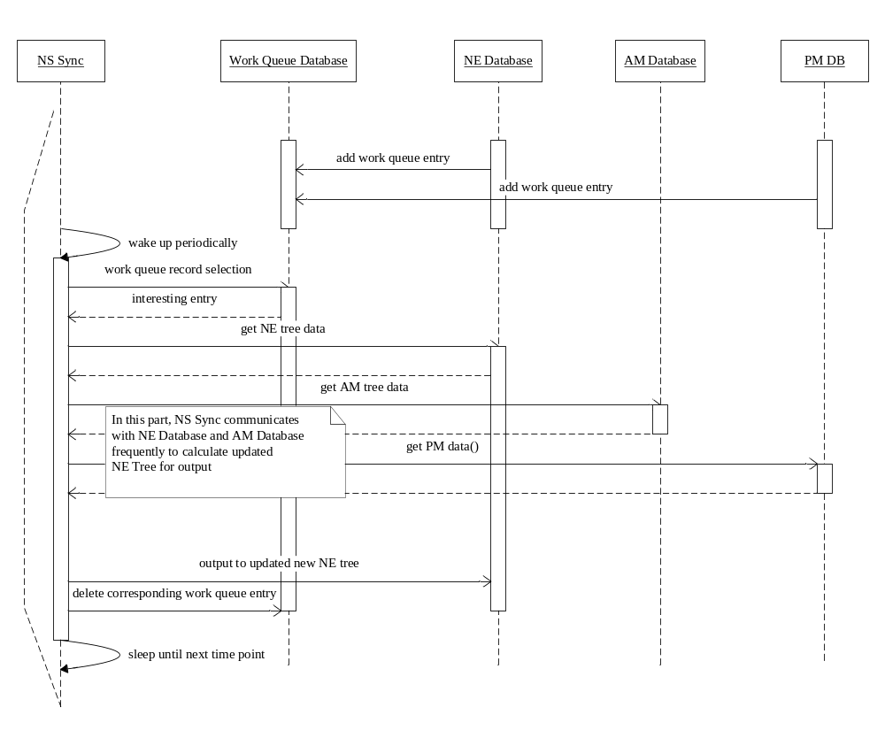
Figure 3

External interface
All external interfaces are thru work queue database. Please refer to Data Definition section for more detailed information.

Data definition
In this chapter, primary data structures and module headers are listed, to give a clear and detailed image of the data references. And also we will emphasize kernel patterns being used.

Data structure
Significant data structures are demonstrated with separated categories below Figure 4.

NE Tree structure
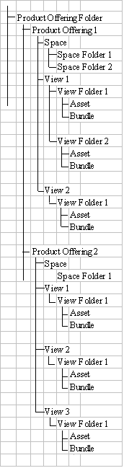
Figure 4

Table diagram

- WQ_INFO
Filed name | Data type | Description
Queue_UID | String(20) | Queue UID
Source_type | Number(2) | 0: DBSync  1: Navigation Engine  2: Program Manager
local_entry_UID | String (20) | See table below
Parent_HUID | String (20) | See table below
Entry_Name | String(255) | Name of the entry
Entry_type | Number(2) | When source is navigation Engine:  1: folder  2: product offering  5: bundle  6: asset  7: symbol link  When source is DBSync:  1: asset  2: element *  3: folder  4: application *  5: site *  6: work queue item *  7: clip *  8: number objects *  9: hierarchy *  10: work queue *  11: package(bundle)  When source is Program Manager:  1: folder  2: program
Operation_type | Number (2) | When source is navigation Engine  1: add or link  2: update  3: delete or unlink  4: pre-search condition update(only for folder)  5: target update(only for folder)  When source is DBSync  1: add  2: delete  3: link  4: unlink  5: rename  6: update  When source is Program Manager  1: add  2: delete  98: QA rebuild  99: rebuild
Operation_time | dateTime | The work queue insertion time
MD_name | String (255) | Metadata name
* indicate what we do not care currently
- NAV_Hierarchy/NAV_Hierarchy_QA
Filed Name | Data type | Description
Hierarchy_UID | String (20) | Primary key of hierarchy node.
Local_entry_UID | String (20) | The UID of linked entry.  Asset: local asset uid in LAM DB  Bundle: local folder uid in LAM DB  Folder: same as hierarchy uid  Link: same as hierarchy uid  PO: product offering uid in POMS DB
Entry_name | String (255) | Name of entry.  Asset: null  Bundle: null  Folder: specified when create folder  Link: specified when create link  PO: PO name
Entry_type | Number (2) | 1: folder  2: product offering  5: bundle  6: asset  7: symbol link
Sequence | Number (5) | The node sequence of some folder.  node means folder, asset
Parent_HUID | String (20) | this column describes what the node belongs to.
Parent_entry_type | Number (2)
Product_offering_UID | String (20) | This field is the product offering uid which the entry belong to. If the entry is a PO or PO folder, this field will be null.
Is_manual | Number (1) | 0: operate by system operator  1: auto maintain
Is_invisible | Number (1) | 0: visible  1: invisible
entry_count | Number(5) | The count of directly containing external entries (PO, asset, bundle, not include folders which defined in hierarchy).  If a entry is a folder, the could should be all contained asset and bundle in this folder(not include the entries in sub folder); if a entry is a bundle, the count should be conatined asset count.  If a entry is a PO or asset, this count should be zero.
Target_HUID | String (20) | Hierarchy uid of symbol link target.  Will be null when entry is not a symbol link.
Target_entry_type | Number (2) | Entry type of symbol link target.  Will be null when entry is not a symbol link.

- NAV_Folder
Filed Name | Data type | Description
Hierarchy_UID | String (20) | Foreign key to nav_hierarchy
Folder_type | Number (2) | 1: product offering folder  2: space folder  3: view folder  4: space  5: view
Link_type | Number(2) | 1: normal folder  2: Pre-search folder  3: Link
Link_target_HUID | String (20) | Target Hierarchy_UID
Description | String (200) | Folder description

- NAV_FolderCondition/NAV_Folder_QA
FiledName | Data type | Description
Hierarchy_UID | String (20) | Foreign key to NAV_Hierarchy
Source_type | Number (1) | Where does the entries come from, AM or NAV DB?  0: AM  1: NAV
Source_HUID | String (20) | Pre-search source hierarchy uid.  AM: local hierarchy uid  NAV: Hierarchy_UID
Condition_script | String (500) | SQL script(WHERE clause)
Order_script | String (500) | SQL script(ORDER clause)

- Functions
Name | Comment
nav_getQAEnableFlag  Function  Return: Int | To encapsulate the logic to get QA enable flag. No parameter, return 1 when QA is enable, return 0 when QA is disable.
nav_getQATime  Function  Return: datetime | To replace SQLServer system function - GetData(), return QA time.
nav_getQAGeneratingStatus  Function  Return: Int | Return current QA tree generating status.  If it returns GENERATING (1), NSSync should wait because Navigation is creating or deleteing navigation tree.  If it returns ERROR (2) or Un-generate(-1), NSSync should not work on QA tree.
nav_GetSequence | When NSSync and Navigation create new entry in QA navigation tree, it should use “Seq_QA_HierarchyUID” in seq_name parameter.
nav_getOfferingWindowEnableFlag  Function  Return: Int | When return 1:true , use OfferingWindow logic
nav_getOfferingWindowEndOffsetDays  Function  Return: Int | Unit is day.  LAM will delete the asset: (Asset.ProviderQAContact (end time of offering window) < Currnent time – Offset days).

File description
The following is compiled html description for NSSync C++ structure and code.
NSSync.chm

Kernel algorithm
In this chapter, kernel algorithms and key strategies are described, to give a quick and clear concept about primary problems and solutions.

NS synchronization and purification is basically a folder-purify process according to corresponding conditions. The following algorithms, vital to NS, describes how the process walks through.

Rebuild Algorithm
The NS task could be considered as a process of purify AM Database and PM Database to NE Database, according to information which users focus on. Rebuild Algorithm (RA) is used to fulfill this purpose. The algorithm is described as Figure 5.
- RA is implemented on C++ coding level.
- RA starts from root folder.
- RA purifies folder objects, including normal folder, view folder and space folder.
- RA is a recursive algorithm, in order to search through the whole NE hierarchy tree. The recursive process is named as PurifyFolder.
- RA takes Work Queue table (WQ_INFO), folder tables (NAV_Folder, NAV_FolderCondition), AM local Database hierarchy tree table (Hierarchy), PM Database hierarchy tree table(pm_Hierarchy_presenting), and previews output table (NAV_Hierarchy), as input.
- RA outputs purified NE tree table (NAV_Hierarchy).
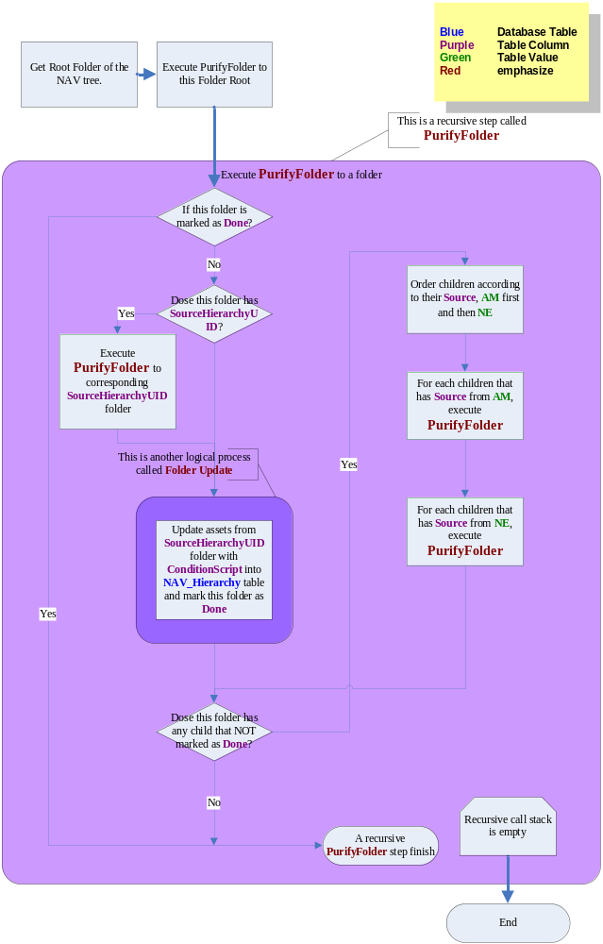
Figure 5

Sample Update Algorithm
Sample Update Algorithm (SUA) is responsible for rebuilding asset sample space of NE Tree. It differs from Rebuild Algorithm (RA) that SUA does not operate on all folder objects. Only related folders, whose assets might be altered due to sample space change, would be updated. For specified folder, SUA updates this folder itself, its parent folder, its grand-parent folder…, and folders whose Source is this folder, whose Source is this folder’s parent folder, whose Source is this folder’s grand-parent folder… etc.
- SUA is implemented on C++ coding Level.
- SUA operates on folder objects, including normal folder, view folder and space folder.
- SUA is a recursive algorithm, in order to search through all related affected folders in NE hierarchy tree. The recursive process is named as UpdateAffected.
- SUA takes folder tables (NAV_Folder, NAV_FolderCondition), AM local Database hierarchy tree table (NAV_Hierarchy), and NE Tree table (NAV_Hierarchy), as input.
- SUA outputs purified NE tree table (NAV_Hierarchy).
- SUA updates this folder, all its parent folders, as well as those folders whose Source is preview listed folders.
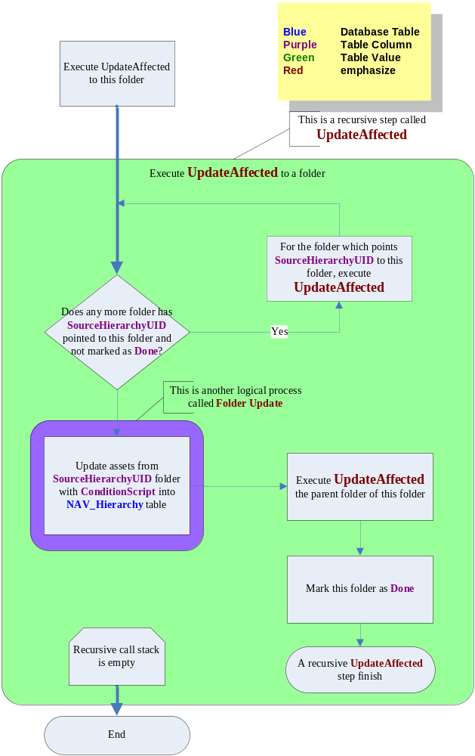
Figure 6

Folder Update Algorithm
The logical process of update specific folder using corresponding Condition is defined as Folder Update Algorithm (FUA). FUA searches all assets from Source folder and update the view according to Condition. The algorithm is described as Figure 7..
- FUA is implemented on SQL Stored Procedure level.
- FUA uses a SQL stored procedure to complete tasks, called ns_FolderUpdates.
- FUA takes folder tables (NAV_Folder, NAV_FolderCondition), AM local Database hierarchy tree table (NAV_Hierarchy), and NE tree table (NAV_Hierarchy), as input.
- FUA outputs updated NE tree table (NAV_Hierarchy).
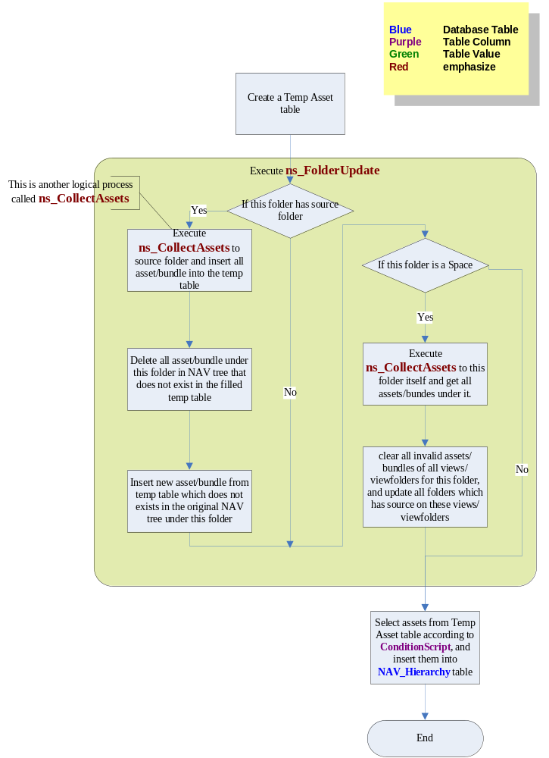
Figure 7

Collect Asset Algorithm
The logical process of collect all assets and bundles under specified folder using corresponding Condition is defined as Collect Asset Algorithm (CAA). CAA searches all assets and bundles from Source folder, apply condition and order string on them, and stored them into temp table. The algorithm is described as Figure 8..
- CAA is implemented on SQL Stored Procedure level.
- CAA uses a SQL stored procedure to complete tasks, called ns_CollectAssets.
- CAA takes folder tables (NAV_Folder, NAV_FolderCondition), AM local Database hierarchy tree table (NAV_Hierarchy), and NE tree table (NAV_Hierarchy), as input.
- CAA outputs selected assets and bundles to a temp table ns_FolderUpdate provided.
- CAA searches this folder’s own assets, all children’s assets, including Linked Folder’s children, to give a complete asset set.

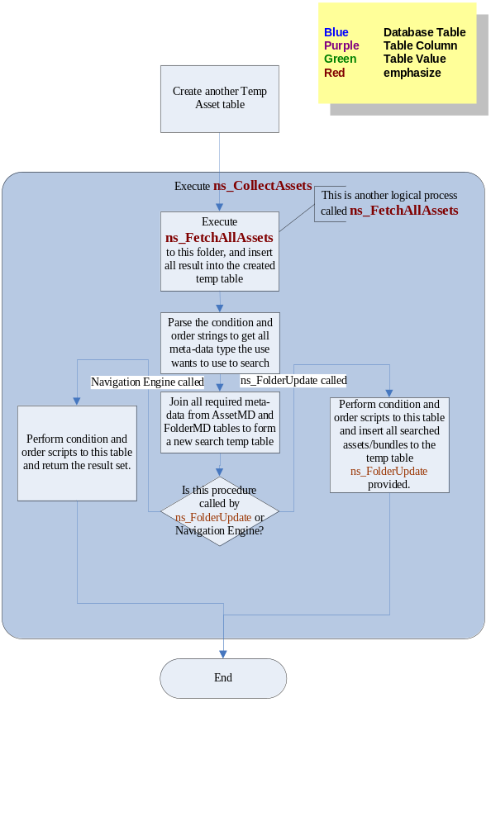
Figure 8

Fetch Asset Algorithm
Fetch Asset Algorithm (FAA) is in charge of fetching all asset and bundles under specified folder, no matter what condition script is.
- FAA is implemented on SQL stored procedure level.
- FAA is a recursive algorithm.
- FAA operates on any folder objects.
- FAA is a recursive algorithm, in order to search through all related affected folders in NE hierarchy tree. The recursive process is named as ns_FetchAllAssets.
- FAA takes folder hierarchy tree tables (NAV_Hierarchy) as input.
- FAA outputs fetched assets and bundles to temp table ns_CollectAssets provided.
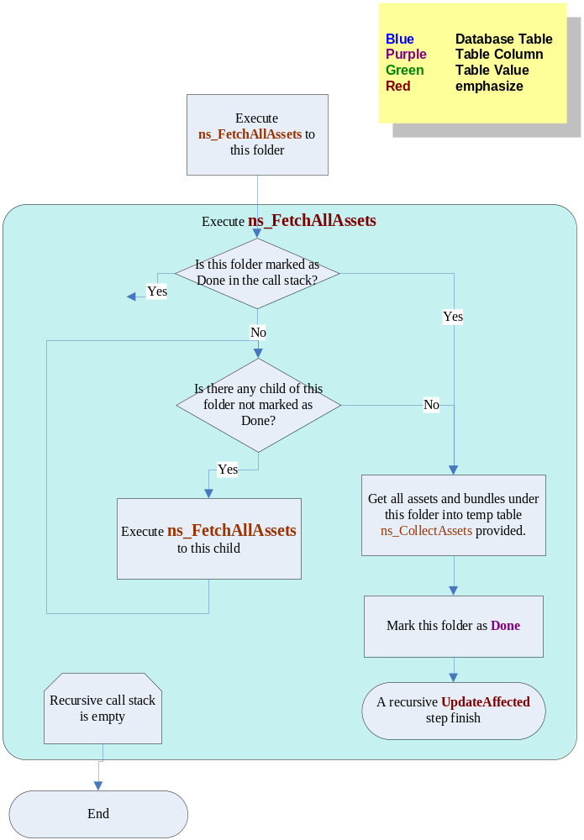
Figure 9

Work Queue Selection Algorithm
NS Sync wakes up from background sleep periodically and then scans work queue database. Due to the similar operation in walking thru the NE Tree and updating assets, some work queue entries would be somewhat ‘useless’ if the later entries update the entire tree despite of previous operations. This duplication gives birth to the Work queue Selection Algorithm (WQSA).
The strategy used to select work queue is as below:
- If work queue contains an entry which indicates Asset Unlink, and meanwhile has an entry indicating Asset Deletion for the same asset, the former Asset Unlink could be ignored.
- If work queue contains an entry indicating the entire NE Tree rebuilding, all previous entries could be skipped.

QA Navigation Function
NSSync will use function to check "QA_Enable" flag in configuration. If "QA_Enable = Yes", request in WQ_Table will take effect in both QA and Commerical table. If "QA_Enable = No", request in WQ_Table will take effect in Commerical table only.
When receive request "QA Tree Rebuild" from work queue, refresh QA tree.
When rebuild QA tree, compare Asset delete time with QA time, and remove assets from QA trre which should be deleted at QA time.
Handle the case that modify navigation structure and re-generate QA tree at same time

Performance and maintenance
This chapter describes performance expectation, status supervision, and function maintenance.

Log trace
- NS Sync works as a normal Windows NT Service. Service error and warning could be retrieved through Windows EventView (“$WINDOWS$\System32\eventvwr.exe”) application.
- NS Sync is a standard SeaChange Service, providing 7 leveled trace logging for administrators or engineers use. The location of log file and log level could be set in registry.
Entry | Value-Type | Description
LogLevel | REG_DWORD | The logging detail level  - Exception  - Critical  - Severe  - Warning  - Debug  - Information  - Trace
LogFileName | REG_SZ | The log file path for this service

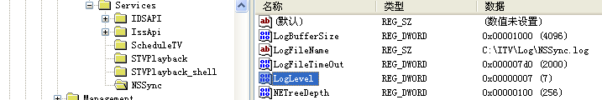
Figure 10

Status supervision
NS Sync is a standard SeaChange Service, thus making status supervision available. Use SeaChange ManUtil.exe (“$ITVROOT$\EXE\manutil.exe”) to view the service status.
latest 500 work queue entries could be viewed in ManUtil UI, together with task status, start time, end time, which would be more convenient for trouble shooting. Also, the QAEnableFlag, QAGeneratingStatus, OfferingWindowStatus could be viewed in ManUtil, in run-time.

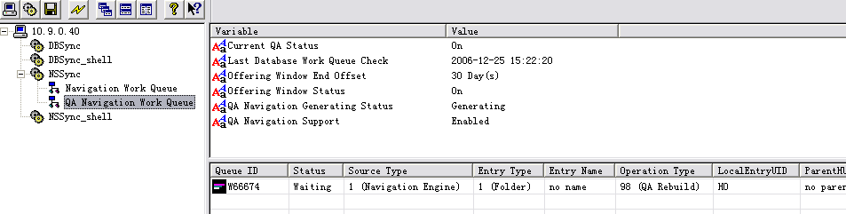
Figure 11

Remarks and Issues
Any supplementary descriptions can be listed here.

- What is the impact of multiple stored procedure running?

