Support of NGOD NAS & Cache Streaming

Design Specification

Version: 0.1
Author: Hui Shao
Document Status: |  | WorkInProgress (W) |  |  | Draft (D) | Issued (I) | Released (R)
Revision History:
Date | Version |  | By | Description
3/31/2008 | 0.1 |  | Hui Shao | Initial Draft
4/1/2008 | 0.2 |  | Hui Shao | Modified the resource selection logic per getAEList() definition changes

Contents

1. Introduction 1
1.1 Purpose 1
1.2 Definitions, Acronyms, and Abbreviations 1
1.3 References 2
2. Design Status 3
2.1 Constraints 3
2.2 Assumptions 3
2.3 TBD 3
3. Overview 3
3.1 Interfaces to support in a NGOD Streaming Server 3
3.2 The SeaChange NGOD Gateway Server 4
3.2.1 RTSP Proxy Service 4
3.2.2 Ssm_NGOD plugin 5
3.2.3 StreamSmith 5
3.2.4 ContentStore 5
3.2.5 LAM 5
3.2.6 Sentry Service 5
3.3 New Features and Efforts 5
3.3.1 Stream Control Restriction (Stage 1) 6
3.3.2 NAS or Pass-Thru Streaming (Stage 1) 6
3.3.3 Support of Cache Management (Stage 2) 6
3.4 SeaChange NGOD Streaming Server in RestartTV 7
3.5 Performance Considerations 7
4. RTSP Server and ssm_NGOD2 Extension 9
4.1 RTSP fields and parameters 9
4.2 Stream Control Restrictions 9
4.3 NAS import bandwidth and resource management 10
4.4 SOP selection 11
5. StreamSmith Extensions 13
5.1 Stream Control Restrictions 13
5.2 NAS and Pass-thru Streaming 13
5.3 Session Events for Cache Management 13
6. EventGateway for CME 13
7. CPE and cph_import Design Specifications 14

Introduction

Purpose
This document provides a detailed description of capabilities and external characteristics of SeaChange MediaCluster and RTSP server integrated in a Comcast NGOD compatible environment. It describes all aspects of interfaces including input, expected output and error conditions. The document identifies the components that many be candidates for re-use in other products or components of other products that may be used in this product. And identifies other related documentation, i.e. product plan, requirements document and test plans.

Definitions, Acronyms, and Abbreviations
The following acronyms are used throughout this specification document:
Streamer | - A device on the Stream Server that can be used to pump network streaming traffic with one physical connection to the successor component in a network topology. It is also called as streamer device  - A descriptor refer to a streamer device in Stream Transport network abstraction
Stream Server | A machine that consists of one or a number of streamer devices.
StreamSmith | A software service that implements StreamService interface definition, it is designed to run on SeaChange MediaCluster nodes
Streaming Server | A NGOD concept of the combination of stream server hardware and software that supports NGOD required intefaces
Storage | - A physical storage, refer to one single file volume if there are no additional indications.  - A descriptor refer to a ContentStore instance in Stream Transport network abstraction
Content Store | A software service that implements ContentStore interface definition. It refers to a single file volume
Service Group | A group of destination client applications
Session | An entity describes the context and lifecycle of an on-demand order. It refers to a server session if there are no additional indications
Client Session | An entity describes the content and lifecycle of a client order existing in client request gateway
RTSP Session | The client session entity refer to a RTSP session

References
[R-1] NGOD Overall Architecture, Version 2.0, Comcast
[R-2] Media Cluster and RTSP Server for NGOD Scenario, Apr 4, 2007, Hui Shao
[R-3] MediaCluster/RTSP Server for NGOD, Hui Shao
[R-4] Writing StreamSmith Modules - A Guide to StreamSmith Module API, Hui Shao
[R-5] StreamSmithModule SDK Documentation, Hui Shao
[R-6] NGOD RTSP Usage Specification, Version 2.0, Comcast
[R-7] NGOD Streaming Server Resource Interface (R2), Version 2.0, Comcast
[R-8] NGOD Client Session Interface – S1/C1 (RTSP), Version 2.0, Comcast
[R-9] NGOD 2.0 Service Discovery & Registration, Comcast
[R-10] NGOD 2.0 RTSP Usage Specification, Comcast
[R-11] Startover_R2_ECR R1.0.doc, SeaChange

Design Status

Constraints
- The system described in this design must provide required interfaces and support the interfaces defined in Comcast NGOD specifications to deploy as a NGOD compatible Streaming Server with support of streaming from NAS and streaming from cache
- The system in this design should be compatible with SeaChange Axiom NGOD solution with RestartTV support

Assumptions
- NAS or pass-thru streaming will be performed by SeaChange FMS cluster. MDS or HDS will only over stream from local storage
- Only a single FMS cluster under a NGOD gateway (pair) will work as a NAS streaming or cache cluster
- The NGOD gateway only exposes the storage of MDS or HDS cluster as the available storage space for NGOD A3 interface. The cache storage is private space and will not open for A3 to allocate
- In the beginning short-term, one LAM supports only one instance of cluster content storage. LAM may start support multiple content stores in a future stage

TBD
- The support status of D4/D5 TREP speaker
- How to call VstreamAPI about NAS Streaming
- Performance requirement
- Playback while caching needs supported in a stage of the roadmap

Overview
This design is based on the earlier stage of SeaChange NGOD Streaming Server deliverables. This documentation will not cover the details about the efforts scoped in the earlier stage, please see [R-3] MediaCluster/RTSP Server for NGOD for more details about that stage.

Interfaces to support in a NGOD Streaming Server
In order to deploy the SeaChange RTSP server as a NGOD streaming server, the following interfaces are expected to support by the RTSP server:

ASSET A3 | Support of NGOD Asset Propagation Manager to respond content lifecycle management control messaging
SRM R2 | Support of the interaction between the NGOD On-demand resource management components and the streaming server components
Client C1 | Support of the interaction between VOD clients and the streaming server components
Video V1 | Support of the NGOD video streaming specification
Discovery D4 | Support of NGOD asset storage auto-discovery and registration
Discovery D5 | Support of NGOD streaming resource auto-discovery and registration

The SeaChange NGOD Gateway Server
This section briefly describes where we are after NGOD lab entry, and where we start the development on NAS and cached streaming. Please refer to the references for more details about the existing NGOD gateway server.
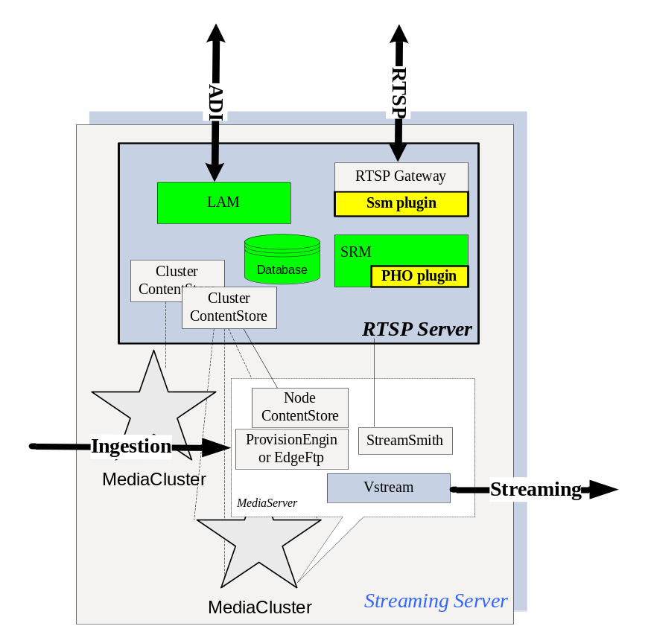
Figure 1 RTSP server

The key components of RTSP server based on the SeaChange MediaCluster products are:

RTSP Proxy Service
RTSP Proxy Service is a RTSP server-side component. It has RTSP session and connection management, can accept up to 10 K concurrent connections and map m-n session-to-connection relationship. The server core also parses incoming RTSP messages and format outgoing messages.
The RTSP Proxy Service is a plugin framework, the request handling can be well customized by the various plug-in implementations. The SeaChange NGOD Stream Server supports NGOD R2 and C1 by letting the RTSP Proxy Service to loads ssm_NGOD2, a RTSP plugin designed for NGOD interfaces.

Ssm_NGOD plugin
The plugin ssm_NGOD is designed to cover NGOD R2 and C1 interfaces. Besides handling the RTSP protocols defined in NGOD R2 and C1 interfance, the plugin also act as a Video Server Resource management and has a local server session lifecycle managements. It defines video transport network abstraction to manages Varity streaming network in a unified mechanism via SOP

StreamSmith
StreamSmith runs on each MediaCluster node and controls local stream instance on the node. It also works as a dynamic server-side playlist (DSPL) engine.

ContentStore
ContentStore provides file-system-like access to media contents. Powered with distributed content provision engines (CPE), the ContentStore will be able to perform scheduled content importing procedures automatically in both push mode and pull mode.

LAM
The LAM from SeaChange Multiverse works as a web server-side interface to respond NGOD A3 interface. It also caches the metadata and content names in its SQL database

Sentry Service
The SentryService works as a Windows NT service to monitor all the NGOD Streaming Server components, detects and forwards the events to the NGOD monitoring subsystem.
It also provide a web UI to allow the administrator to check the configuration, status and logs of each related component.

New Features and Efforts
SeaChange starts supporting NAS streaming and cached streaming since Vstream 6.0. The NGOD Streaming Server also presents those advantages to the customer. And these new stages of NGOD Streaming Server is targeting a better solution to fully support NGOD RestartTV application. One more goal for the streaming server is to provide more monitor and measure points for better integration.

Stream Control Restriction (Stage 1)
According to the Engineering Change [R-11] Startover_R2_ECR R1.0, the customer wishes to restrict some stream control operation per each playlist item that is being to play, for example, some operation such as FF or REW may be forbidden for a specific item. To response this requirement, ssm_NGOD2 and StreamSmith will be modified to meet this

NAS or Pass-Thru Streaming (Stage 1)
The NGOD Streaming Server may be expected to stream some assets off before the source contents haven’t been propagated from the regional library. In this case, the video server will perform a pass-thru streaming by read the source contents directly from the regional or central net attached storage (NAS) and instantly pump out to the destination clients. During such a streaming, no local disk writing may occurs. Vstream starts providing this pass-thru streaming since its version 6.0. The NGOD Streaming Server, especially StreamSmith, should present this new ability as one of the NGOD Streaming Server to offer a better solution for NGOD RestartTV application. To support this, some major changes will be required to make in StreamSmith and the RTSP proxy service and its plugin ssm_NGOD2

Support of Cache Management (Stage 2)
To offer bigger streaming capacity for the most popular assets, the system wishes to cache the asset from the regional or central NAS library, then streaming from the local cache of the video server.
CME is designed to collect the session activities and make the cache decisions based on its statistic.
StreamSmith is the source to issue the session activity data. However, in order to aggregate the multiple sources (StreamSmith instances) and translate the different cross-process communication protocols, a new component was introduced in this stage to sink all the session events from the TianShan event channel then forward to CME via SOAP invocations.
Also, CME wishes to know the storage capacity and usages, StreamSmith will sink VstreamIO events to offer a more real-time and exact report on the MediaCluster storages
CME’s cache decisions will be executed as the commands to LAM via an A3 comparable command set. In order to support this extended cache commands, changes on LAM and ContentStore and ContentProvisionEngine are required. The caching itself is defined as a new content provision method that imports the pre-trick-generated file set on a remote NAS into the local MediaCluster file system, this will also implemented as a new part of the existing ContentProvisionEngine

SeaChange NGOD Streaming Server in RestartTV
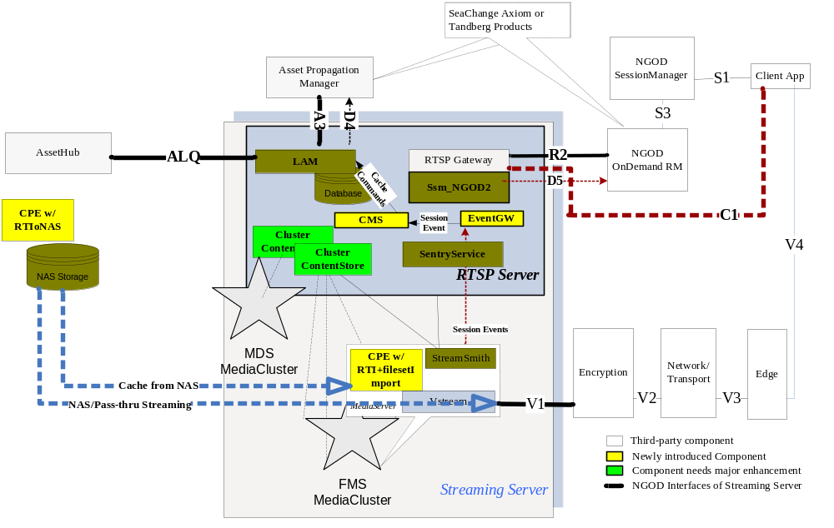
Figure 2 NGOD Streaming Server in RestartTV

The above figure shows how a SeaChange NGOD Streaming Server will be deployed with NAS and cache streaming supported in a typical NGOD RestartTV application. Two import methods are mentioned there:
- NAS or Pass-Thru Streaming. In this method, the contents are located at the external NAS storage, the video pumper layer directly import the content from the NAS and stream off without writing content into its local persistent storage
- Cached Streaming. Based on the population of the content, the video server firstly import and the content from the external NAS storage and save it in its local storage, then stream off from its local storage.
The figure also identifies the gaps of the current product to cover this stage of requirements

Performance Considerations
- The RTSP server-side of R2 must allow multiple sessions over a single TCP connection from NGOD ODRM components. When this connection was dropped and re-established, the RTSP sessions should be able to failed over to the new TCP connection
- The RTSP server-side of C1 must accept a plenty amount of TCP connection from VOD clients. The VOD clients may create per-session connections to C1 server-side.
- In the RTSP Server, the following points that maybe affect the system performance, but the accurate time delays have not been calculated now.
  - RTSP connection response time
  - Address the source streamer device selected by ODRM
  - Vstream API latencies
  - Server session state machine
- When ODRM shares one or a limited number of R2 connection among all the sessions, a pair of RTSP Server should support up to 9000 C1 concurrent connections. One pair of RTSP Server should work for up to 9000 stream sessions.
- A single RTSP server support up to 20000 content instances.
- A content provision engine runs at FTP active pull mode supports up to 10Mbps trick generation on MediaCluster node or 64Mbps trick generation on additional workstation with the same hardware configuration of RDS server

RTSP Server and ssm_NGOD2 Extension

RTSP fields and parameters
To support NAS and cache streaming, NGOD intended its R2 interface. Besides this, it also introduced stream control restrictions via [R-11] Startover_R2_ECR R1.0.doc:
- Introduced a new option of X-playlist-item: [tricks/[F][R][P]]
- Introduced a new descriptor X-trickControl
- Reserved a keyword “library” for asset that is located in the remote regional library. In this case, the Streaming Server is required to use ALQ to query ALS for asset location
- Added a RTSP status code "498 TrickModeNotAllowed" for C1 response

A sample of R2 SETUP after this engineering change may look like:

SETUP rtsp://streamingserver32.comcast.com:554 RTSP/1.0

CSeq: 896

Require: com.comcast.ngod.r2

OnDemandSessionId: be074250-cc5a-11d9-8cd5-0800200c9a66

Volume: library

Transport:

MP2T/DVBC/UDP;unicast;client=00AF123456DE;

bandwidth=2920263;destination=2.2.2.2;client_port=45;

sop_name=Boston.Pump1.2,

MP2T/DVBC/UDP;unicast;client=00AF123456DE;

bandwidth=2920263;destination=2.2.2.2;client_port=45;

sop_group=Boston.PGA2

SessionGroup: SM1

StartPoint: 1 3000

InbandMarker:type=4;pidType=A;pidValue=01EE;dataType=T;

insertDuration=10000;data=4002003030…

Content-type: application/sdp

Content-length: 168

v=0

o=- be074250-cc5a-11d9-8cd5-0800200c9a662890842807

IN IP4 10.47.16.5

s=

t=0 0

a=X-playlist-item: comcast.com abcd1234567890123456 1000-6000 tricks/FRP

c=IN IP4 0.0.0.0

m=video 0 udp MP2T

Stream Control Restrictions
These restrictions in R2 SETUP request will be passed to StreamSmith via the per-item setup flags TianShanIce::Streamer::PlaylistItemSetupInfo::flags:
PLISFlagNoPause | forbid pause the item if this flag is on
PLISFlagNoFF | forbid fastforward the item if this flag is on
PLISFlagNoRew | forbid rewind the item if this flag is on
PLISFlagNoSeek | forbid seek the item if this flag is on

The ssm_NGOD2 will parse the newly added trick options of X-playlist-item, then turn on the flag accordingly when it calls Stream API to add items into the playlist on StreamSmith.

When the RTSP server receives the C1 request, for those trick controls not allowed, StreamSmith will throw an InvalidArtOfState exception by specifying its error code as “9901”, ssm_NGOD will refuse by status code “498 TrickModeNotAllowed” if it receives such an exception

Parameters | to Stream Session | Comment
TrickRestrictions  Of R2 SETUP request | TianShanIce::Streamer::PlaylistItemSetupInfo::flags | The lowest 3 bits
Volume Of R2 SETUP request | TianShanIce::Streamer::PlaylistItemSetupInfo::privateData[“Volume”] | The volume to streaming off, “library” if wish to stream from an external storage
ImportURL | TianShanIce::Streamer::PlaylistItemSetupInfo::prviateData[“ImportURL”] | The import URL associated by replacing the reserved keywords of configuration item Library::templateURL

NAS import bandwidth and resource management
The ssm_NGOD2.xml’s schema will be modified to meet the requirement
- A new PassThruStreaming segment will be added, it enumerates all the possible import channels, which defines the channels that the video server can import content from the external NAS storage
- Each ImportChannel defines the maximal bandwidth and maximal import sessions
- The existing streamer element of SOP will be appended with a new attribute “importChannel” to link to the ImportChannel instances
- A new element Library is designed for a test purpose to lower the dependency of LAM

A new configuration may looks like:

<SOPRestriction enableWarmup="1" retryCount="3" maxPenaltyValue="5">

<sop name="TEST" serviceGroup="30">

<streamer netId="SEACHANGEF0022/BoardNumber0" serviceEndpoint="tcp -h 10.15.10.250 -p 10000" volume="TEST" totalBW="800000" maxStream="240" importChannel="SEACHANGEF0022" />

<streamer netId="SEACHANGEF0022/BoardNumber1" serviceEndpoint="tcp -h 10.15.10.250 -p 10000" volume="TEST" totalBW="800000" maxStream="240" importChannel="SEACHANGEF0022" />

<streamer netId="SEACHANGEF0022/BoardNumber2" serviceEndpoint="tcp -h 10.15.10.250 -p 10000" volume="TEST" totalBW="800000" maxStream="240" importChannel="SEACHANGEF0022" />

<streamer netId="SEACHANGEF0023/BoardNumber0" serviceEndpoint="tcp -h 10.15.10.251 -p 10000" volume="TEST" totalBW="800000" maxStream="240" importChannel="SEACHANGEF0023" />

<streamer netId="SEACHANGEF0023/BoardNumber1" serviceEndpoint="tcp -h 10.15.10.251 -p 10000" volume="TEST" totalBW="800000" maxStream="240" importChannel="SEACHANGEF0023" />

<streamer netId="SEACHANGEF0023/BoardNumber2" serviceEndpoint="tcp -h 10.15.10.251 -p 10000" volume="TEST" totalBW="800000" maxStream="240" importChannel="SEACHANGEF0023" />

</sop>

</SOPRestriction>

<PassThruStreaming enabled="1" >

<ImportChannel name="SEACHANGEF0022" bandwidth="100000000" maxImport="25" />

<ImportChannel name="SEACHANGEF0023" bandwidth="100000000" maxImport="25" />

</PassThruStreaming>

<Library static="1" templateURL="cifs://192.168.91.11/$PID%2D$PAID" />

The ssm_NGOD2 will have to build up a complex in-memory data structure to keep the data and offer fast accessing

SOP selection
During the R2 SETUP request parsing,
The following diagram shows how an SOP will be selected when the volume library is involved:
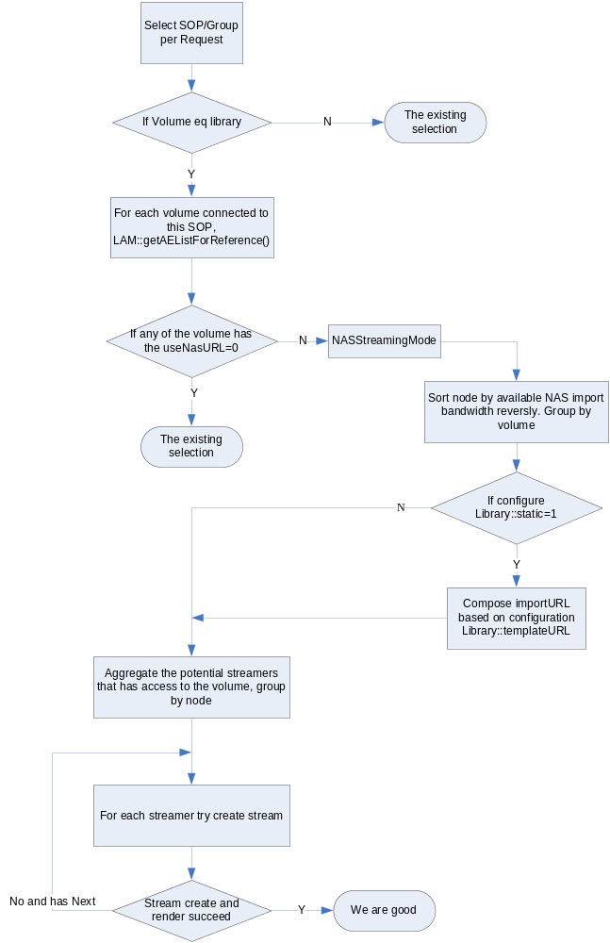
The scenarios that could not cover are:
- If any of LAM responds it has local content, the server will only try those local streaming. In other words, there may be a potential streaming from NAS if all the local streaming fails, but the server will not retry this potential NAS streaming
- If a NAS streaming node is selected successfully during SETUP, but that selected node failed to import the content later when it start streaming, the server will not retry on other nodes although some of those left nodes can potentially stream the session successfully

StreamSmith Extensions

Stream Control Restrictions
StreamSmith keeps all the parameters when an item is being added into a playlist, see RTSP fields and parameters for more details about the parameters

For each later stream control operation, StreamSmith will test the restriction flags of TianShanIce::Streamer::PlaylistItemSetupInfo::flags, and will reject the invocation if the flags forbid the operations by throw an InvalidArtOfState exception with error code 9901 to ssm_NGOD2, the caller.

NAS and Pass-thru Streaming
For a playlist item, if its TianShanIce::Streamer::PlaylistItemSetupInfo::privateData[“Volume”] indicates that is a “library”, StreamSmith will invoke VstreamAPI to perform a NAS streaming by passing the importURL given in TianShanIce::Streamer::PlaylistItemSetupInfo::privateData[“ImportURL”].
Otherwise, StreamSmith will perform the legacy streaming from local MediaCluster

Session Events for Cache Management
StreamSmith is a data source about the stream session activities. StreamSmith will fire events to the TianShan event channel minimally for each session start or end. Per the CME’s expection, StreamSmith may define more events or let the existing event carry more parameters
To be detailed in stage 2

EventGateway for CME
In a deployment, multiple StreamSmith instances post their local stream session events to a shared TianShan event channel, which is hosted in the IceStorm service. This EventGateway is a module running on the NGOD gateway server to subscribe the session events and forward the events to CME. It translates those ICE events into related SOAP APIs of CME to notify those session events. With this shared TianShan event channel, the system provide m to n communication from StreamSmith instances to the CME instance(s)
To be detailed in stage 2

CPE and cph_import Design Specifications
For the caching execution, the on-node CPE will load a newly created content provision helper plugin cph_import to cache a pre-trick-generated file set from an external NAS storage.
To be detailed in stage 2

Key to Document status Codes: Work in Progress (W)An incomplete document, designed to guide discussion and generate beedback that may include several alternative requirements for considerationDraft (D)A document in specification format considered largely complete, but lacking review by other vendors. Drafts are susceptible to substantial change during the review processIssued (I)A stable document, which has undergone rigorous vendor review and is suitable for product desing and development, cross-vendor interoperability, and for certification tesing.Released (R)A stable document, reviewd, tested and validated, suitable to enable cross-vendor interoperability
The reason why the RTSP server doesn’t refuse this directly is because the trick restriction were defined as per-playlist-item instead of per-playlist.

