以下为ContentClient新增加功能的列表以及Test结果：
all variables in this document need to invoke command 'set'
eg: set <key>=<value>

1.export Content as Stream
Function | Command Line Format:  export <ContentName> <subfile> <stream Timeout> <CacheStoreDepth>
Input | variables:  lowBandwidth highBandwidth sessionInterface destIP  param:  contentName: the name of content to export  subfile: the subfile extension name of content to export in this stream  streamTimeout: session timeout in millisecond  cacheStoreDepth: to indicated whether this invocation is from forwarded by another CacheStore  0 - the invocation is issued originally by a ServiceEdge  non-0 the invocations may be forwarded form other CacheStores, usually it is not recommended to forward again from the invokeed
Output | Session URL of content
Test Result

2.Cache Content to Local
Function | Command Line Format:  cache <contentName> <srcCacheStoreEndPoint>
Input | param:  contentName:the name of content to cache  srcCacheStoreEndPoint:ice_endpoint,the source CacheStore to propage the content from,NIL if up to the CacheStore determine which source storage to pull the content from
Output | NULL
Test Result | Success

3.export Folder Name of content
Function | Command Line Format:  hashFolderr <contentName>
Input | param:  contentName:the name of content
Output | The folder name of content
Test Result

4.get Access Count of content
Function | Command Line Format:  accessCount <contentName>
Input | param:  contentName:the name of content
Output | The count of access,since and latest in UTL format
Test Result

5.add Access Count to a content
Function | Command Line Format:  addAccessCount <contentName> <countToAdd>
Input | variable:  since:the time, in the format of ISO8601, since when the content is counted by this CacheStore  param:  contentName:the name of content to query  coutToAdd:the amount of times that the content has been accessed from this CacheStore to add
Output | Count of content after added
Test Result

6.get the list of Missed Content
Function | Command Line Format:  listMissed <maxNum>
Input | param:  maxNum:the max number of ContentAccess wish to receive
OutPut | The list of Missed Content
Test Result

7.set Threshold of access count for missed contents
Function | Command Line Format:  setCacheWindow
Input | variables:  timeWinOfPopular:to specify the float time window, in seconds, to count the access  countOfPopular:in the resent time window specified by timeWinOfPopular, A content is known as popular if its access count exceeds what countOfPopular specifies  hotTimeWin:as the most recent part, in milliseconds, of timeWinOfPopular
Output | NULL
Test Result | 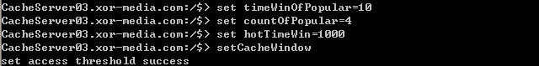

8.get Threshold settings of access count for missed contents
Function | Command Line Format:  cacheWindow
Input | NULL
Output | The info of Threshold
Test Result | 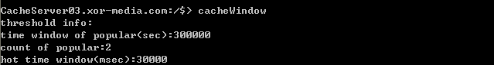

9.show distance between given content and a store netID
Function | Command Line Format:  storeDistance <contentName> <CacheSotreId>
Input | param:  CacheStoreId:the computer name of cacheStore
Output | The distance between content and a store netId
Test Result

10.show the local name of content
Function | Command Line Format:  localFn <contentName> <subfile>
Input | param:  subfile:the subfile extension name of Content to export in this stream
Output | The local name
Test Result

