Data On Demand

ContentStore Detail Design
Author: Ken Qian
Version: 1.3
Date: 2007-11-28
Contents
Data On Demand 1
ContentStore Detail Design 1
1. Introduction 5
1.1. Purpose 5
1.2. Scope 5
1.3. Definitions, Acronyms, and Abbreviations 5
1.4. References 5
1.5. Overview 6
2. Overall Architecture 7
2.1. Logical Component 7
2.2. Logical Workflow and Interchange 8
3. Data Wrapping Method 9
3.1. Data Structure Configuration 9
3.2. Semantic Definition 10
3.3. Object Definition 10
3.3.1. Syntax of Object 10
3.3.2. Semantic definition of fields in Object 11
4. DODContentStore 12
4.1. Interface 12
4.2. Inter-Operation with DODApplication 13
4.2.1. Content Provision 13
4.2.2. Content Destroy 14
4.3. Source URL 15
4.4. Navigation Data Export Format 16
4.5. Content Processing Framework 17
4.5.1. Graph and Filter 17
4.5.2. GraphPool 17
4.6. DODContentStore Class View 18
4.7. System Sequence View 18
4.7.1. DODDataSource Workflow 19
4.7.2. DataTSWrapperRender 21
4.7.3. NTFSFileIORender 21

Revision History
Version | Revise Date | Owner | Notes
1.0 | 2007-02-26 | Ken Qian | Initial document
1.1 | 2007-4-24 | Ken Qian | Revise the Graph
1.2 | 2007-11-28 | Ken Qian | Add details for table_id and table_id_extension

Introduction

Purpose
This document provides a detailed design of the project, intended to give a comprehensive understand on this project.

Scope
This detailed design is based on the “Software Architecture Document” of this project.
The project scope has been defined in SAD; the minute description of the external system will not be included in this document.

Definitions, Acronyms, and Abbreviations
DOD: Data on Demand
DODApp: Data on Demand Application
JMSDispatch: working as the client DODApp, fetching configuration/message from BackOffice’s JBOSS server, then invoke DODApp interface to deliver operations. It is a dll and integrated in DoDApp.
DODStreamService: Data on Demand Stream Service, it is responsible for allocating and managing DODStream.
Business Router: This component is to find the right TianShan Application based on the request according to the configuration.
Weiwoo: The Session Management system
PHO: Path Help Object, plug-in of Weiwoo to evaluation and narrow the ContentStore and Stream to get out the lowest load and destination reachable Stream.
DOD ContentStore: the component to complete the data wrapping.

References

Overview
Data on Demand is the product for one-way VOD solution, which is responsible for taking requests from OSS system, wrapping the requests (files/messages) to TS standards and broadcasting to corresponding destination. These broadcasted data includes: navigation data, post, setbox configuration, ticket information and so on.
Data On Demand ContentStore (DODContentStore) is a component of this solution. Which is responsible for content preparing – wrapper the data to TS standards.

Overall Architecture

Logical Component
The architecture is partitioned functionally into a number of logical components. Each component has interfaces that follow TianShan Interface architecture.
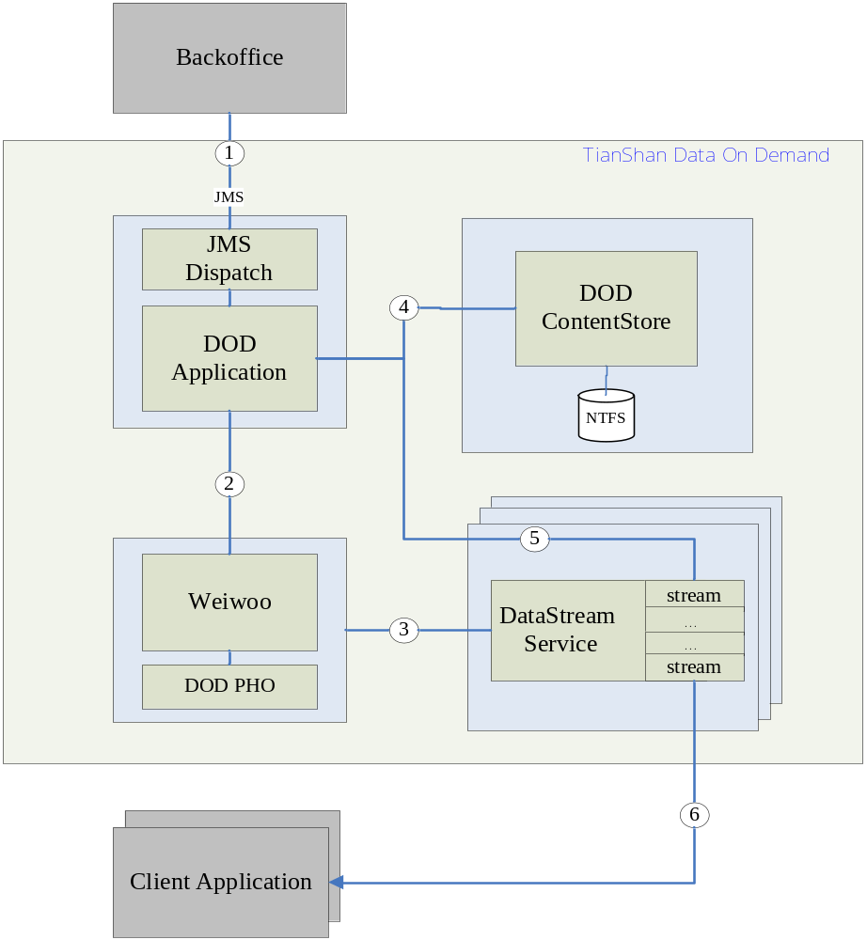

Logical Workflow and Interchange
- JMSDispatch get configuration, messages, files etc from BackOffice JBOSS Server, then call the interface provided by DODApp, there are two categories: one is for initialization, and another is update the message/files to specified destination.
- During DOD Initialization, DoDApplication create session for each destination.
- During DOD initialization, Weiwoo create the stream object for each session, and return the stream proxy to DoDApplication.
- DODApplication received new data, it request DODContentStore to wrap it to be TS file.
- After TS file is ready, DODApplication notify the corresponding stream object to broadcasting it.

Data Wrapping Method
The Data wrapping in DODContentStore is follow ISO/IEC13818-1 standards, all the messages and files that need to be broadcasted in Data On Demand solution are wrapped to Transport Stream private section.
The TS file in DODContentStore is actually are composed of Tables, and each Table maybe made of several privates sections. These sections belong to a Table whose table_id are with same table_id. Each section has its section_number, and the last_section_number. Each section is broken down to 188 bytes TS packet following ISO/IEC13818-1 standards. SetBox get the source data by rebuilding the TS packets to sections and then rebuilding sections to Tables.
In DODContentStore, the Object concept is introduced, as the logic unit to describe SeaChange self-defined data format, such as Hierarchy, Picture, Navigation, PO, etc.

Data Structure Configuration
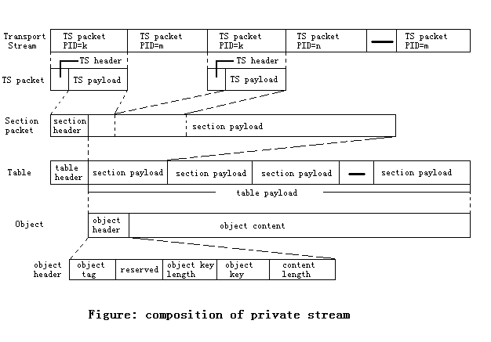

Semantic Definition
This section is to have a brief description on above configuration and highlight the key points. For details of data wrapping syntax, please see doc <DOD-STB protocol.doc>.
- Generally, an Object is represented by a table (determine by table_id+table_id_extension). To Hierarchy Content Object, it could be composed of multiple Tables, but they have the same table_id with increased table_id_extension as the index.
- Each Table is broken down to sections, since section have limitation of length, its max length of a section is 4096 bytes. So each Table is composed of one or multiple sections.
- Section consists of Section Header and Section Payload. section_number and last_section_number in Section Header is able to compose different sections to be one Table. Section Payload is consists of the real object data information.
- Section is broken down to TS packet payload follow the standards. TS packet payload with TS packet header total length is 188 bytes.
- Transport Stream is composed of TS Packets.

Object Definition

Syntax of Object
Syntax | No. of bits
object(){
object_tag | 32 bits
reserved | 32 bits
object_key_length | 8 bits
for (i = 0; i < object_key_length; i++) {
object_key | 8 bits
}
object_content_length | 32 bits
for (i = 0; i < object_content_length; i++) {
object_content | 8 bits
}

Semantic definition of fields in Object
object_tag – 4 bytes to indicate the object type, which was as a string end with ‘\0’. For example, string ‘pic’ represents that current object is Picture Object.
object_key_length – This is 8 bit field which indicates the length, in bytes, of the object_key field.
object_key – This is the unique key to identify this object. It is composed by table_id and table_id_extension.
object_content_length – This is 32 bit field which indicate the length, in bytes, of the object_content field.
object_content – The field of real object data

DODContentStore

Interface
DODContentStore interface inherits from TianShan ContentStore interface, and additional functions were added to meet DOD requirement. Since DODContentStore is focusing on TS data wrapping, so many of the interface functions are not implemented, including the event publishing.
The key interface function is provision – which is responsible for wrapping the specified data to TS standards file. To accomplish the data wrapping, additional parameters are required, so DODContent inherits from Content interface with additional function to provide these detail parameters. Since provision is designed as asynchronous call with provision schedule information, and provision result is published by event. To make it simple, DODContentStore regards this call as synchronous call and ignore the schedule parameters. So when provision function returns, the data wrapping also completed.
Following is the snapshot of DODContentStore interface:
struct DataWrappingParam
{
int esPID; // the PID of the element stream,
// it is specified by ChannelId
int subStreamCount; // the sub-stream count
// sub-stream’s PID is esPID+index[0, streamCount)
int dataType; // the channel type, such as navigation, EPG, portal, message, etc
int withObjIndex; // Whether add the object index info at the front of
// objects TS data, it is specified by
// SendWithDestination in the channel configuration
int objTag; // object Tag, ex ‘nav’, but convert to be 4byte type
int encryptType; // the encryption type, 0 – no encryption.
int versionNumber; // version of the wrapped data, from 0 to 31
};
Class DODContent extends TianShanIce::Storage::Content
{
/// set the data wrapping parameters before invoking provision.
setDataWrappingParam(DataWrappingParam param);
};

Inter-Operation with DODApplication

Content Provision
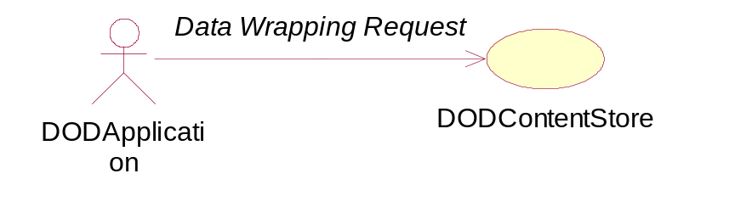
The Data Wrapping Request is fired by DODApplication when it received new data. There are three categories data:
- Single File
- ShareFolder
- Message
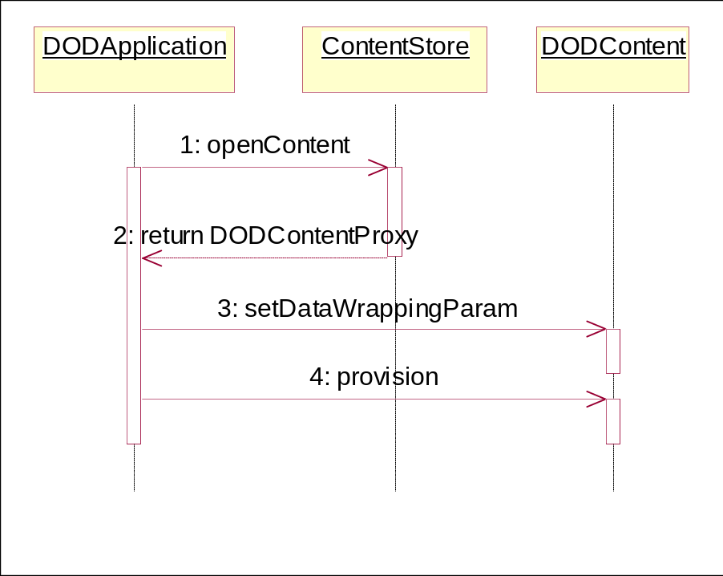
- DODApplication received new data, and invokes ContentStore’s openContent function, then ContentStore creates a DODContent object internally
- ContentStore return new object’s proxy to DODApplication.
- DODApplication provides the data wrapping parameters to the specified DODContent.
- DODApplication requests DODContentStore service to do the data wrapping.

Content Destroy
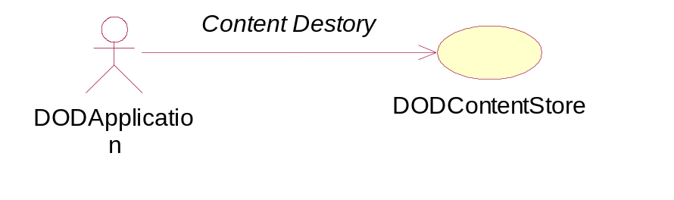
In DOD solution, each content has its life cycle, when the content reaches its end of life, DODApplicaiton needs to destroy the content from ContentStore’s storage and local database.

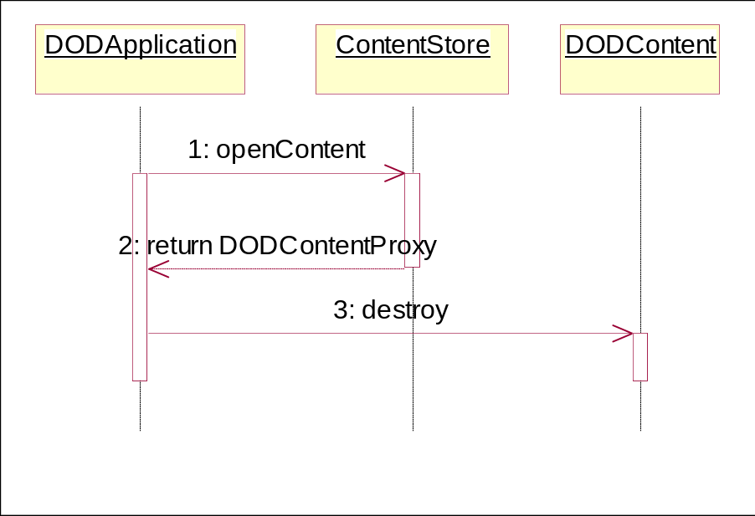
- DODApplication received new data, and invokes ContentStore’s openContent function, then ContentStore creates a DODContent object internally
- ContentStore return new object’s proxy to DODApplication.
- DODApplication destroy the specified DODContent object, DODConentStore service will delete the files from storage and content attribute information from local database.

Source URL
As mentioned above, there are 3 main categories data Single File, Folder and Message. In provision function, parameter sourceUrl is to specify the where the source data are.
- Single File and ShareFolder – DODContentStore only supports network file sharing mode. So the URL’s scheme must be file://host:port/path
- Message – new URL scheme “msg” was introduced to avoid DODApplication saves the message content to file and speed up the whole workflow. The message URL is like: msg://messagecontent. The messagecontent is message data DODApplication received.

Navigation Data Export Format
Attention: This format is not implemented in current DODContentStore.
In original solution, BackOffice export Navigation data to be files and structure them in hierarchy folders. Each navigation file is very small, but with volume count. This made the performance very low, coz both BackOffice and DOD have much write/read IO to these files. Also, moving and delete so many files are also low efficiency.
To avoid this issue, new export format was depicted as following.
- Navigation exported one IndexFile and one or multiple ContentFile. IndexFile description includes ContentFile name. Generally, if no special requirement, there is ONLY one ContentFile in a IndexFile.
- IndexFile name is fixed with “index”, the IndexFile and ContentFile are located in the same folder
- The full navigation data mode and update mode are using the same format.
- If there are attachment files in accompany with Navigation data, the attachments are also composed to be IndexFile/ContentFile mode.
- IndexFile Format
[Index]
Version=1.0

[ContentFileName1]
Name1; Offset; Length
Name2; Offset; Length
…

[ContentFileName2]
Name1; Offset; Length
Name2; Offset; Length
…
- To the index file
  - [ContentFileName] is representing the ContentFile name in the folder
  - Object name, which is same to original exported file name
  - The Offset is object offset position in content file in bytes
  - The Length is object’s length in content file in bytes
  - Newline/Return characters could be between objects to make it easier to be read by human eyes. But the Offset and Length did not includes the Newline/Return character.

DODContentStore supports original export type and the new IndexFile/ContentFile Mode.

Content Processing Framework

Graph and Filter
The Graph and Filter processing workflow is NOT same to Microsoft DirectShow Graph/Filter concept. In Microsoft DirectShow, each filter is a COM object, and the interface of filter is COM interface. But here the in Content Processing Framework, it is a just a C++ level interface.
Following is the Graph Diagram.
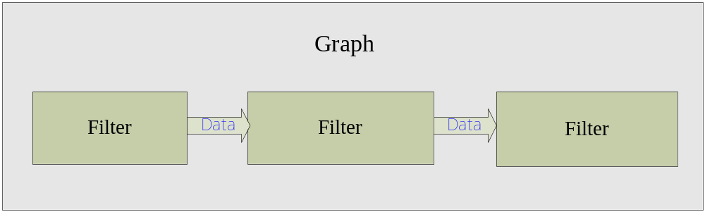
The purpose is just to provide a high performance, buff based, simple coding and reusable framework. The Filters in Graph are all inherited from a base class and implement unified interface. Graph is working as the container to manager all of content processing step objects. Each Filter processing is running in its own thread. And each Graph also is running in its own thread.
Above diagram is just a simple case, the real situation may more complex. That because one filter could connect to one or multiple filters.

GraphPool
One Graph represents one content processing at one time. To support concurrent content processing, multiple Graph are must. GraphPool is to manage these Graphs, and taking the content processing request, and pick up the free Graph to do content processing.

DODContentStore Class View
This section describes the primary classes and their static relationship.
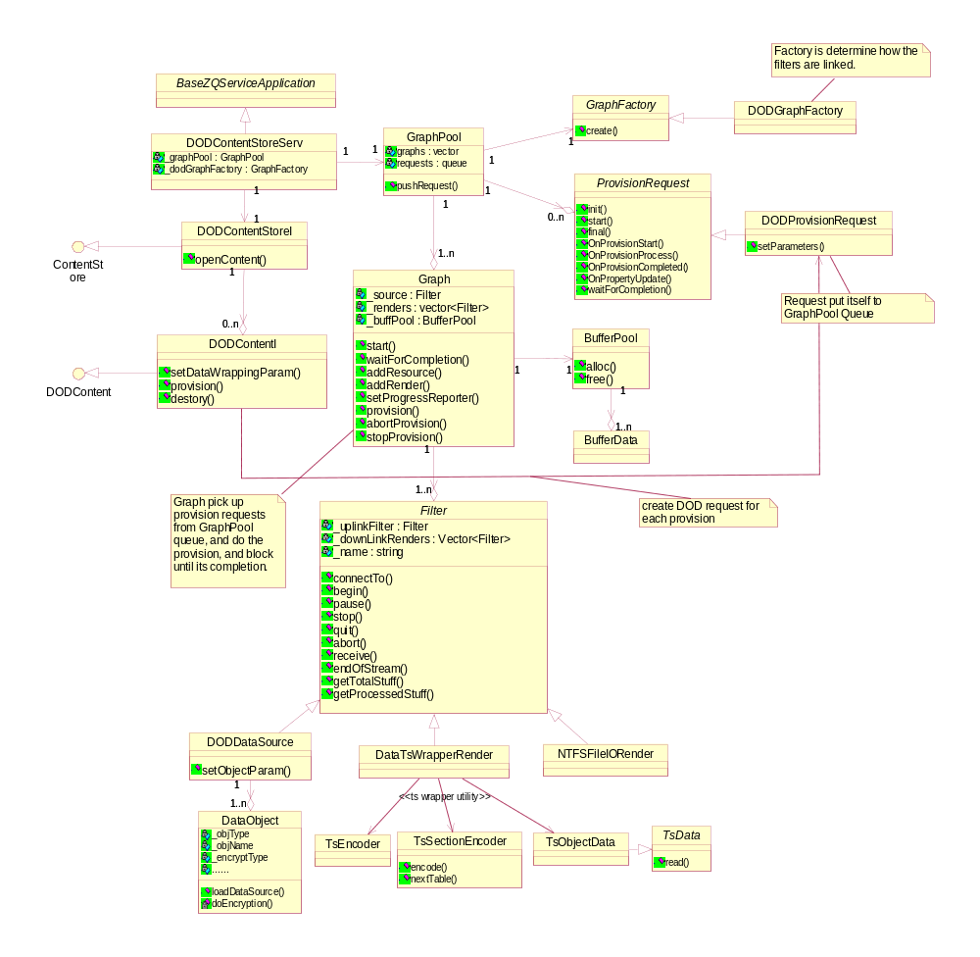

System Sequence View
This section explains the execution sequence or work flow of the system.
Currently, DODContent process 3 types source, Share Folder and Message.
Since DODContentStore’s kernel is TS data wrapping, so in section is also focusing on how to process SingleFile, ShareFolder and Message provision workflow.

DODDataSource Workflow
DODDataSourc process 2 type sources, one is ShareFolder and another is Message. For message, we introduced the msg URL as described in section 4.3.
In ShareFolder, there are specially logics according to configuration.
          - When withObjIndex is 1, that means index information of all these files are required to be located at the head of output TS file. The index information is composed of the each file (object) name. And the PID of IndexTable is esPID passed in.
          - When subStreamCount is more than 1, the output TS file will have number of subStreamCount different element stream, the PID for these element stream are from esPID to esPID+subStreamCount-1. Each file(object)’s PID is decided by following formula:
objectPID = esPID + ((FileName[last char] + FileName[last before last char])%subStreamCount)
The FileName does not include the extension.
          - table_id and table_id_extension
  - If wrapped object is a message, the table_id and table_id_extension generated based on 6 characters destination’s each character’s ASSIC value.
table_id = (ASSIC_destination[5] * 16 + AsiccValue of destination[4]) | 0x80.
table_id_extension = ASSIC_destination[3]*16*16*16
+ ASSIC_destination[2]*16*16
+ ASSIC_destination[1]*16
+ ASSIC_destination[0]
  - BOOT EPG (dataType = 50)
table_id = 0x80
table_id_extension is ranged from 0x0001 to the total file count.
  - FULL EPG (dataType = 51)
The to wrapped File name formatted with YYYYMMDDhhmm, the table_id and table_id_extension is elapsed hours from 2000-01-01 00:00:00 to the time specified in the file name.
table_id = (elapsedhours >> 4) & 0x00FF
table_id_extension = elapsedhours & 0xFFFF
  - To the other data type besides 50, 51 and message
table_id and table_id_extension grows from base numbers, and when table_id_extension reaches the max, table_id will increase and table_id_extension reset to base value.
table_id range is 0x10 ~ 0xFF
table_id_extension range is 0x0100 ~ 0xFF00
  - To index table, the table_id and table_id_extension is fixed
table_id = 0x80
table_id_extension = 0x0080

Following is the Activity Diagram of DODDataSource processing the source data.
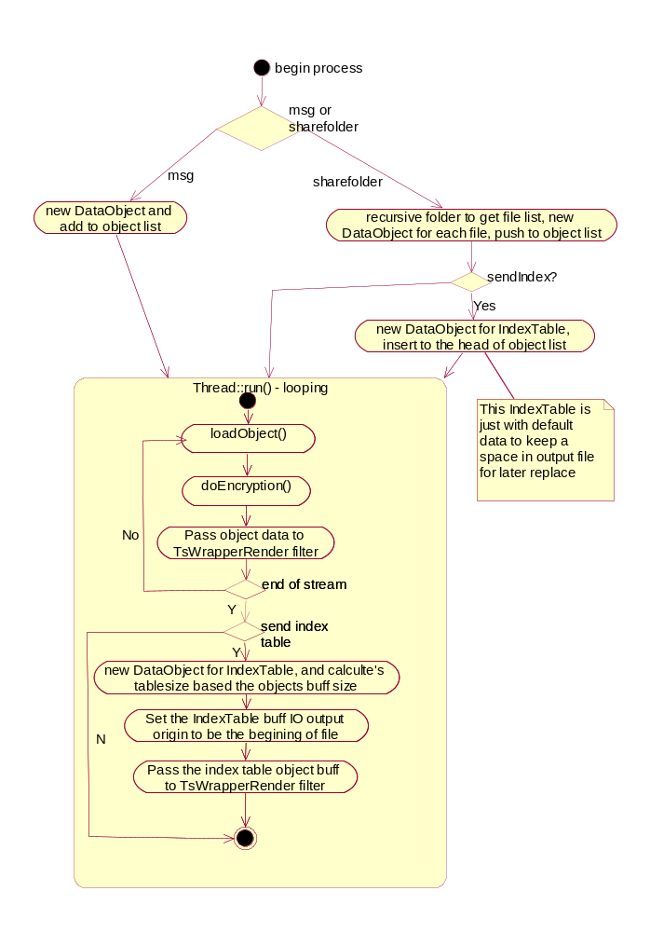

DataTSWrapperRender
This filter is intended to wrap the received BufferData from DODDataSource, the real wrapping procedure is completed by TS Wrapper Utility, which is provided by DataStreamService component.

NTFSFileIORender
This filter is just flush the received the buff to disk.

