Data On Demand Summary Design
Author: Ken Qian
Version: 1.1
Date: 2007-02-12
Contents
1. Introduction 4
1.1. Purpose 4
1.2. Scope 4
1.3. Definitions, Acronyms, and Abbreviations 4
1.4. References 4
1.5. Overview 5
2. Architecture 6
2.1. System Logical Structure 6
2.1.1. Overview 6
2.1.2. System Workflow Logic 9
3. DataOnDemand Components 12
3.1. DODApplication 12
3.1.1. JMSDispatch 12
3.1.2. DODApp 12
3.2. DataStreamService 13
3.3. DODContentStore 14
3.4. Weiwoo and DOD-PHO 14

Revision History
Version | Revise Date | Owner | Notes
1.0 | 2007-02-12 | Ken Qian | Initial document
1.1 | 2007-04-24 | Ken Qian | Revise document to be updated

Introduction

Purpose
This document provides a detailed design of the project, intended to give a comprehensive understand on this project.

Scope
This detailed design is based on the “Software Architecture Document” of this project.
The project scope has been defined in SAD; the minute description of the external system will not be included in this document.

Definitions, Acronyms, and Abbreviations
DOD: Data on Demand
DODApp: Data on Demand Application
JMSDispatch: working as the client DODApp, fetching configuration/message from BackOffice’s JBOSS server, then invoke DODApp interface to deliver operations. It is a dll and integrated in DoDApp.
DataStreamService: Data on Demand Stream Service, it is responsible for allocating and managing DataStream.
Business Router: This component is to find the right TianShan Application based on the request according to the configuration.
Weiwoo: The Session Management system
PHO: Path Help Object, plug-in of Weiwoo to evaluation and narrow the ContentStore and Stream to get out the lowest load and destination reachable Stream.
DODContentStore: the component to do data wrapping.

References

Overview
Data on Demand is the product for one-way VOD solution, which is responsible for taking requests from OSS system, wrapping the requests (files/messages) to TS standards and broadcasting to corresponding destination. These broadcasted data includes: navigation data, post, setbox configuration, ticket information and so on.

Architecture

System Logical Structure

Overview
The logical decomposition of this system and its context, described as package / module diagram as well.
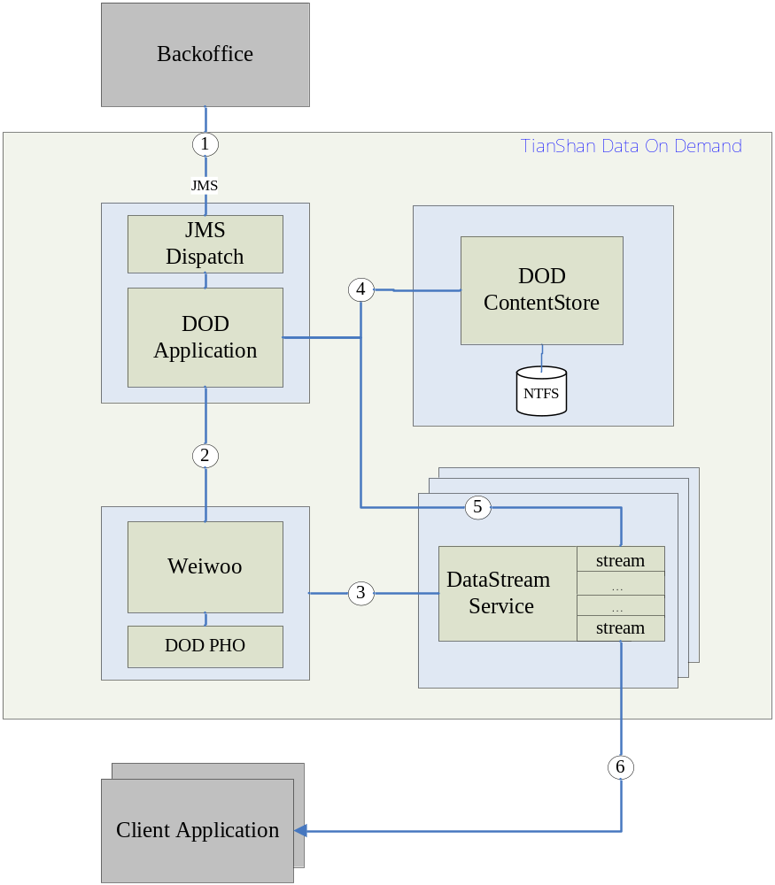
- JMSDispatch get configuration, messages, files etc from BackOffice JBOSS, then call the interface provided by DODApp, there are two categories: one is for initialization, and another is update the message/files to specified destination. JMSDispatch is a sub component DODApp.
- During DOD Initialization, DoDApplication create session for each destination.
- During DOD initialization, Weiwoo create the stream object for each session, and return the stream proxy to DoDApplication.
- DODApplication received new data, it request DODContentStore to wrap it to be TS file.
- After TS file is ready, DODApplication notify the corresponding stream object to broadcasting it.

System Workflow Logic
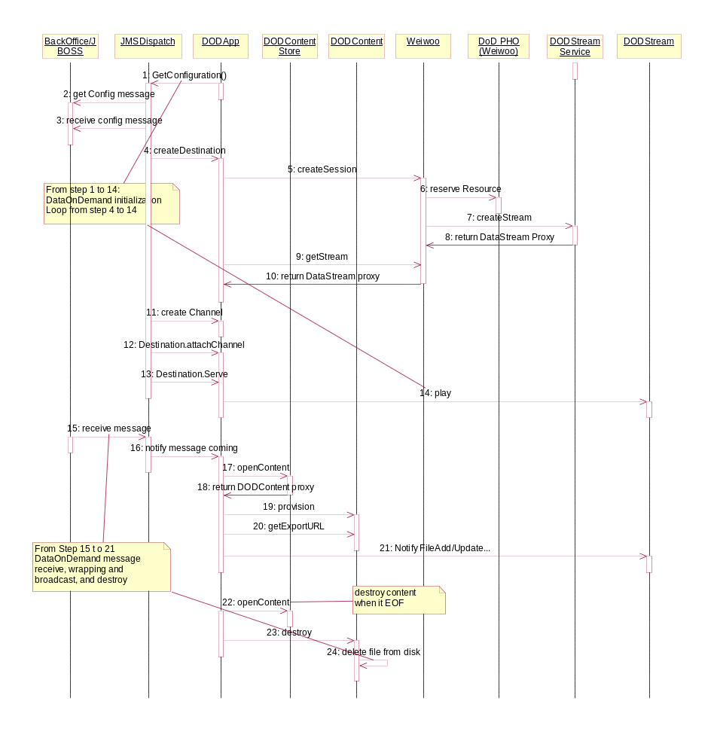

DataOnDemand Initialization
Step1. After DODApplication(JMSDispatch) starting, JMSDispatch send a fetching configuration JMS message to JBOSS to request BackOffice generate DataOnDemand configuration.
Step2. BackOffice generates configuration xml and put it to JBOSS queue.
Step3. JMSDispatch received the configuration xml message and parse it. From configuration file, it can get the destination information (one IP:PORT represents a destination), channel information and which channels belong to a destination.
Step4. JMSDispatch create destination object in DODApp for each destination in the configure
Step5. In DODApp createDestination implementation, it invoke Weiwoo interface to create a session.
Step6. Weiwoo invoke DODPHO to reserve resource for the session. DODPHO determine the gonna created stream located in which DataStreamService instance.
Step7-8. After resource fix, Weiwoo create a Data Stream object in DataStreamService, and return a DataStream object proxy to Weiwoo.
Step9-10. After createSession return, DODApp using getStream API to get the created stream proxy by Weiwoo. One DataStream object matches one destination in DODApp.
Step11. JMSDispatch create channel object in DODApp
Step12. JMSDispatch binds the one or multiple channels with one destination.
Step13-14. After channels attached to Destination, the Destination is ready to serve, JMSDispatch request the Destination to serve, consequently, the matched DataStream object’s play is initiated.

DataOnDemand Message Processing
Step15-16. JMSDispatch listening the JMS Queue, when message comes, it call DODApp’s interface to notify that there is new message coming.
Step17-18. DODApp does TS wrapping according to message type by invoke DODContentStore openContent interface.
Step19. After DODApp get the DODContent proxy, it request DODContent object to do provision, the provision is just doing the datawrapping. In DODContentStore, the provision() is synchronization call.
Step20. DODApp get the destination output content file location by getExportURL().
Step21. DODApp notify all the DataStream objects which related with this message to do updating, then DataStream objects will fetch the ts file to local by exported URL return in previous step, and update its own broadcast file list.
Step22-24. When DODApp get to know the content is end of life, it destroies the content via DODContentStore interface, then DODContentStore delete the represented file from disk.

DataOnDemand Components

DODApplication
DODApplication component includes two parts, one is JMSDispatch and another is DODApp. JMSDispatch is a DLL which loaded by DODApp. Even through, logically they are separated from function.

JMSDispatch
JMSDispatch function is working as a client of DataOnDemand, which is responsible for initiating the broadcast streams creation and driving these broadcast streams to pumping TS based on different application.
JMSDispatch headline functions are:
- Request BackOffice to send the DataOnDemand system configuration when it startup.
- Listening on JMS Queue to get the full configuration, and initialize DataOnStream system through DODApp interface.
- It is responsible for syncing the DODApp safestored configuration with the latest configuration, including destroys the outdated sessions/streams and creates the new sessions/streams.
- Listening on the JMS Queue, and receive JMS message from these queues, these message includes: ShareFolder type message, general message. And notify DODApp to process the message according to message type.

DODApp
  - It is responsible for create session and get the created DataStream through Weiwoo interface during DODApplication initialization period.
  - It is responsible for binding one or multiple channels to a DataStream, configures DataStream and initiating DataStream to pumping IP stream.
  - It is responsible for managing all the Destinations, Sessions and Channels relationship.
  - It is responsible for requesting DODContentStore to do sharefolder and general message TS wrapping. The TS data wrapping is channel based instead of destination/stream based, and one output file is available for multiple Destinations/Streams.
  - DODApp is responsible for updating related DataStream objects’ pumping file list when the received message has been wrapped.
  - DODApp is responsible for destroy the content from DODContentStore when the content end of life.
  - DODApp is responsible to do safestore of all the Destination, Channel, Session in local db, and when DODApp restarts, it could reload the information from db and driving Weiwoo, DataStreamSerivce and DODContentStore, in stead of waiting for the JMSDispatch’s full configuration driving.
  - DODApp is responsible for keep heartbeat with Weiwoo and DataStream to keep the session and stream alive. If DODApp found the heartbeat can not send to the session or stream, that means something wrong with the session or stream, such as the Weiwoo or DataStreamService was restarted, then DODApp will re-create the session and stream.

DataStreamService
DataStreamService is the component to pump the wrapped TS file to specified unicast IP:PORT after adding PAT/PMT information. It manages all DataStream objects’ life cycle and each DataStream object’s TS files management.
  - It is responsible for pumping the stable IP steam with high performance and support as much as possible streams.
  - It is responsible for manage TS file, including the adding new file to the list and deleting out-dated file from the list.
  - It is responsible for managing each DataStream object’s lifecycle, if it does not receive the heartbeat from DODApp in the specified time duration, the stream object will be destroyed.
  - It is responsible for compose PAT/PMT package into the pumping stream and make sure the interval of PAT/PMT packages are in 33 ms.
  - It actively gets the TS content file from DODContentStore’s home directory according to the URL provided by DODApp.
  - DataStreamService does not have safestore of stream information for case of DataStreamService restart or crash. Once this case happens, DODApp could detect it and recreate them in a short period time.

DODContentStore
DODContentStore component function is focusing on wrapping single file, files in a folder or message content to TS file.
    - It is responsible for TS data wrapping based on the parameters provided by DODApp.
    - Each TS data wrapping is a synchronization call, that means DODApp ts data wrapping request did not return until the wrapping work is done.
    - DODContentStore does not manage content file lifecycle, which is managed by DODApp.
    - DODContentStore does not have safestore to keep its ongoing wrapping job for reload after restarting or crash.
    - DODContentStore does not transfer content files to DataStreamService, but it provide interface to get the content URL.

Weiwoo and DOD-PHO
Weiwoo is a key component in TianShan solution, which is responsible session management, linkage management between Application and ContentStore, ContentStore and StreamService, etc. PHO is Weiwoo’s standard plug-in interface. PHO is taking the responsibility to do network resource management and reserve network resource for session. One Weiwoo instance could load one or multiple PHOs, different PHO could accomplish different resource management.
In DataOnDemand solution, DOD-PHO is responsible for managing one multiple DataStreamServices’ resource. Since in DataOnDemand, each stream is pumping to a specified destination IP:PORT, which DataStreamService instance(s) could reach the specified destination, that depends on the network configuration. And each DataStreamService has the limitation of bandwidth to pumping stream. So the physical network interface and the max bandwidth are the two key factors to PHO to determine which DataStreamService will be selected when it received a stream creation operation.
DOD-PHO’s arithmetic scores each DataStreamService instance and selects the lowest load one to create the stream and reserve the used bandwidth. And when the stream reaches its end of life, the reserved bandwidth is released.

