

OpenVBO/eventIS Integration

TianShan Statement of Work, Version 1.0

Last Saved: 7-Jan-10
Commercial in Confidence

File Name: | 0000.doc
Version: | 0.1
Document Reference:
Author: | Hui Shao
Contact Details:

© Copyright SeaChange International 2010
Content

1 Document Administration 3
1.1 Revision History 3
1.2 Document Distribution and Approval 3
2 Introduction 4
3 Statement of Work 4
3.1 OSTR-like Resource Manager and Selection 4
3.2 Support of EventIS 5d Interface 4
3.2.1 TRAXIS.SRM → StreamingServer 4
3.2.2 Stream Control 4
4 Overall Design 5
4.1 Model of Load Balancing 5
4.1.1 Configuration Schema 5
4.1.2 Prepare for Selection 7
4.1.3 Per CacheLevel Selection 8
4.2 Ssm_OpenVBO 11
4.2.1 Streamer Resources Management 11
4.2.2 Asset Query and Replica Determination 12
4.2.3 General eventIS 5d Request Handling 12
4.2.4 SETUP 12
4.2.5 TEARDOWN 13
4.2.6 PLAY 13
4.2.7 PAUSE 14
4.2.8 Session-Oriented GET_PARAMETER 14
4.2.9 Non-Session GET_PARAMETER 14
4.2.10 ANNOUNCE 15
4.3 StreamSmith 15
4.3.1 Streamer Replica Report 15
5 Open Issues 15
6 Tentative Schedule 16

Document Administration

Revision History
Name | Date | Reason For Changes | Version
Hui Shao | 01/05/2010 | Document Creation | 0.1

Document Distribution and Approval
Company and Role | Name | Signature | Date
SCC SE1 Department Manager | Andy Shao
SCC General Manager | Kaity Yu

Introduction
This document includes all features that are being implemented in TianShan product in order to integrate with SeaChange OpenVBO architecture, and also include engineer overall design for different modules. The version 1.0 is for the initial trial purpose

Statement of Work

OSTR-like Resource Manager and Selection
This OpenVBO integration inherit the design of the existing OSTR package on the resource management and selection

Support of EventIS 5d Interface

TRAXIS.SRM → StreamingServer
Refer to the chapter 3 of eventIS 5d specification

Stream Control
This concerns multiple sections across the eventIS 5d specification
- Section 2.8 STB – Streaming Server RTSP message syntax
- Section 2.7.5 and 2.7.6 STB – Streaming Server GET_PARAMETER
- Section 2.7.7 and 2.7.8 STB – Streaming Server ANNOUNCE
- Chapter 4 Stream Control Proxy
TianShan must support stream control operations such as PLAY, PAUSE, GET_PARAMETER and the notification via ANNOUNCE
TianShan must support the stream control via direct mode (messaging between STB and StreamingServer) and proxy mode (messaging between TRAXIS.SRM and StreamingServer)

Overall Design
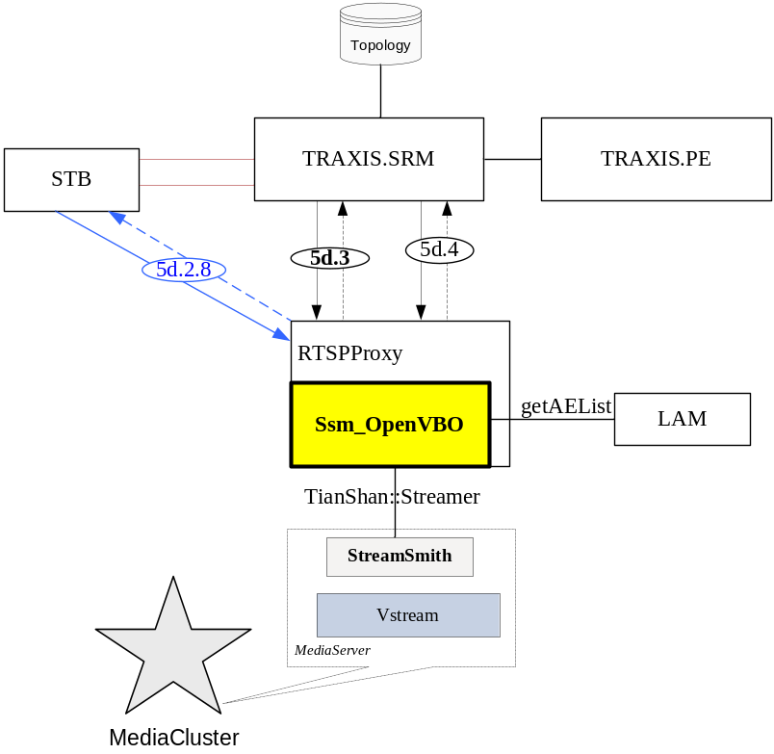
Figure 1 Overview

Model of Load Balancing

Configuration Schema
StreamingResource vs SOP

Unlike the OSTR defines SOP on the StreamingResource, eventIS 5d doesn’t take aggregation on the multiple streaming interfaces of the managed StreamingServer. So in ssm_OpenVBO, a unique configuration element <StreamingResource> is defined to aggregate all the Streamer interfaces it manages. This list appears as a filter on the Streamer replica reports collected from all the managed StreamService, only the listed Streamers can contributes it streaming power in this OpenVBO-StreamingServer

<!-- Configurations on StreamingResource:
attributes:
enableWarmup - if this configuration is turned on(set it to 1), ssm_OpenVBO will connect to streamer when it startup turn it off if you do not want it to connect to streamer when plugin startup
retryCount - [0, 100] the max number of the retries if failed to setup streams
maxPenaltyValue - [0, 10000] the penalty to apply if failed to setup a stream
replicaUpdateTimeout - in msec, to specify how often the StreamService should report the status of replica
-->
<StreamingResource enableWarmup="1" retryCount="0" maxPenaltyValue="2" replicaUpdateTimeout="1">
<!-- Configurations on streamer:
attributes:
netId - the netId of streamer aggregated by the ssm_OpenVBO
serviceEdnpoint - endpoint to the StreamsService that controls this Streamer
volume - to indicate the local volume that this
totalBW - total bandwidth in Kbps that this Streamer can supply
maxStream - max stream count that this Streamer can supply
importChannel - name of importChannel thru that this streamer can cache the contents from a remote storage
-->
<Streamer netId="SEACnnnnn-N0/Spigot00" serviceEndpoint="StreamSmith:tcp -h SEACnnnnn-N0 -p 10700" volume="CL2/*" totalBW="700000000" maxStream="10000" importChannel="SEACnnnnn-Ny_PG" />
<Streamer netId="SEACnnnnn-N0/Spigot01" serviceEndpoint="StreamSmith:tcp -h SEACnnnnn-N0 -p 10700" volume="mjtest/*" totalBW="375000000" maxStream="10000" importChannel="SEACnnnnn-Ny_PG" />
</StreamingResource>

ImportChannels for Pass-thru Streaming
ImportChannel limits the max sessions and max bandwidth of an interface that the FMS server can import the contents from external NAS storages to perform pass-thru streaming. This configuration stays unchanged as of OSTR
<PassThruStreaming enabled="1" >
<!-- Configurations on pass-thru import channel:
attributes:
name - to specify a unique name to index an import channel, it is recommanded to use the node ID for SeaChange MediaCluster
bandwidth - the max bandwidth in Kbps if use this import channel
maxImport - the max count of importing capacity of this import channel
-->
<ImportChannel name="SEAC10007-N0-PG" bandwidth="100000000" maxImport="25" />
<ImportChannel name="SEAC10007-N1-PG" bandwidth="100000000" maxImport="25" />
</PassThruStreaming>

LAM Instances vs Volumes

Minor renaming is introduced in ssm_OpenVBO by comparing that of OSTR:
<!-- Configurations on AssetManagement:
attributes:
type - "LAM" if SeaChange LAM is the implementation of asset management
enableWarmup - "1" if try to connect to LAM when ssm_OpenVBO starts up, "0" to connect only when it is needed
-->
<AssetManagement type="LAM" enableWarmup="0">
<!-- Configuration of the commucation to LAM instance
attributes:
name - unique name to identify to the instance of LAM
endpoint - the endpoint to connect to the LAM instance
-->
<LAMServer name="OSTR01" endpoint="tcp -h OSTR01_SS_CL -p 20089" >
<!-- Configuration of the Volume that the LAM manages
attributes:
name - name of the volume, wildcard is supported
cache - "1" to indicate the volume can work as a cache of the library storage to be candidate for the orders for reference assets. default "0", the volume can be the persistent storage of asset, i.e. HDS cluster
cacheLevel - the priority to sort LAM instances to query for asset existance. acceptable range [0, 100] 0 - highest, 100 - lowest; default 50 i.e. FMS cacheLevel="20" and HDS cacheLevel="10"
supportNasStreaming - "1" to indicate the volume is bind with streaming device(s) that can perform pass-thru streaming directly from the external storage. default "0"
-->
<Volume name="CL2/*" cache="1" cacheLevel="50" supportNasStreaming="0" />
<Volume name="SEACmmmmm/*" cache="1" cacheLevel="60" supportNasStreaming="1" />
</LAMServer>
</AssetManagement>

Element <Volume> has been moved out as a child-element of <LAMServer>, unique names are introduced to the both two elements <LAMServer> and <Volume>.

The name of Volume allows the wildcast “*” as the sample blow:
<LAMServer name="NGODGW02" endpoint="tcp -h NGODGW02_SS_CL -p 20085" >
<Volume name="SEAC91003/*" cache="0" cacheLevel="" supportNasStreaming="0" />
</LAMServer>
Which means the LAM instance NGODGW02 associates all the volumes of the nPVR server SEAC91003, such as SEAC91003\VOL1, SEAC91003\VOL2 and so on.

Caution
The volumes associated by a same LAM instance are either all cache-able or all non-cache-able

Prepare for Selection
Prior to the selection, the RTSPServer with ssm_OpenVBO plugin will translate the playlist required in the 5d SETUP request to the list of content files, and perform initial preparation.

Query for AEs to build up the Playlist
For each playlist_item in the 5d SETUP request from TRAXIS.SRM like below, the ssm_NGOD2 would query LAM to translate the PID PAID into a list of AE (the media content in the ContentStore)
SETUP rtsp://streamingserver32.openvbo.com:554 RTSP/1.0
…
playlist_item:openvbo.comabcd1234567890123456;ordinal=1;in=1000;out=6000
playlist_item:openvbo.comabcd1234567890123999;ordinal=2;in=1000;out=6000
…

Ssm_OpenVBO will compile the AE lists of playlist_item into a Playlist. For example,

openvbo.comabcd1234567890123456 |  | → | Playlist
ContentA replicas | CL10001, CL10002 | → | ContentA replicas | CL10001, CL10002
ContentB replicas | CL10001 | → | ContentB replicas | CL10001
+ |  | → | ContentC replicas | CL10001, CL10003, CL10002
openvbo.comabcd1234567890123999 |  | →
ContentC replicas | CL10001, CL10003  CL10002 | →

Narrow AE replication to Playlist replication

The per-content replica information would be narrowed to the replica of playlist:
The above sample would be as below

Playlist
ContentA replicas | CL10001, CL10002 | → | 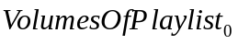 | CL10001
ContentB replicas | CL10001 | →
ContentC replicas | CL10001, CL10003, CL10002

Per CacheLevel Selection
After the preparation, the program enters the selection logic

Add the Volumes that support Pass-Thru Streaming

For each volume in the current cacheLevel that supports pass-thru streaming, if all its absent contents all have NASURL provided in the query result from LAM, such a volume would be counted as a QualifiedPassThruVolume. The selection would add the collection of QualifiedPassThruVolume into the 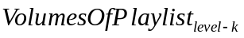 as the for the selection of this cache level-k.
Each replica of the playlist in would be described via a descriptor including:
volumeName | The volume name of this playlist replica
bLocalPlaylist | True if ANY content(s) of this playlist replica need to perform pass-thru streaming from external storage
initCost | Reserved as 0 in this version

The sample in this doc could be:
Volume | CL10001
bLocalPlaylist | true

If the CL10002 can perform NAS streaming and the ContentB has a NasURL to be imported, then the CL10002 is also valid as a potential volume, the adjusted playlist replica () can be:
Volume | CL10001 | CL10002
bLocalPlaylist | true | false

Caution
For a volume that supports pass-thru streaming, if any AE of the playlist is not at local and need to perform pass-thru streaming, the entire playlist will be considered as bLocalPlaylist=false. The load consideration would be based on this worst case

Populate Streamers by Playlist Replica and Source IP address
The playlist replica () would be converted to Streamers based on the StreamingResource configuration defined in section 4.1Model of Load Balancing.
- All the streamers reported as disabled by StreamSmith will be eliminated from this populating
- All the streamers that StreamSmith failed to update its status in time will be eliminated from this populating
- The widecast “*” will be considered to match the volume attribute of the configuration element <streamer>
- The key difference from SOP selection of OSTR here is that ssm_OpenVBO will be based on source IP and subnet matching by taking the test condition
Let’s alternate the above sample as:
Volume | CL10001/VOL1 | CL10001/VOL2 | CL10002/VOL1 | CL10003/VOL3
bLocalPlaylist | true | false | false | true
And assuming the streamer and volume were configured as
Volume | Streamers
CL10001/* | Streamer01, Streamer02
CL10002/* | Streamer03, Streamer04
CL10003/* | Streamer05

The result of this populating lead to the following collection:
No. | Streamer | Volume | bLocalPlaylist | ImportChannel | Cost
1 | Streamer01 | CL10001/VOL1 | true | - | -
2 | Streamer01 | CL10001/VOL2 | false | CL10001-N0-PG | -
3 | Streamer02 | CL10001/VOL1 | true | - | -
4 | Streamer02 | CL10001/VOL2 | false | CL10001-N0-PG | -
5 | Streamer03 | CL10002/VOL1 | false | CL10002-N0-PG
6 | Streamer04 | CL10002/VOL1 | false | CL10002-N0-PG
7 | Streamer05 | CL10003/VOL3 | true |  | -

The above table will be merged by Streamer, any non-local playlist would be overwritten by the local playlist if there is any. The new table would be narrowed as below:
No. | Streamer | Volume | bLocalPlaylist | ImportChannel | Cost
1 | Streamer01 | CL10001/VOL1 | true | - | -
2 | Streamer02 | CL10001/VOL1 | true | - | -
3 | Streamer03 | CL10002/VOL1 | false | CL10002-N0-PG
4 | Streamer04 | CL10002/VOL1 | false | CL10002-N0-PG
5 | Streamer05 | CL10003/VOL3 | true |  | -

Evaluate Streamer Costs

The selection then will evaluate the cost of each row of the table from previous section. The cost would be based on the formulas.

Select Streamer By Considering Costs

Assuming the costs collected in the earlier section are:
No. | Streamer | Volume | bLocalPlaylist | ImportChannel | Cost | Availability
1 | Streamer01 | CL10001/VOL1 | true | - | 1000
2 | Streamer02 | CL10001/VOL1 | true | - | 3000
3 | Streamer03 | CL10002/VOL1 | false | CL10002-N0-PG | 7000
4 | Streamer04 | CL10002/VOL1 | false | CL10002-N0-PG | 3333
5 | Streamer05 | CL10003/VOL3 | true |  | 2000

The availability of the rows would be defined via the following formulas:
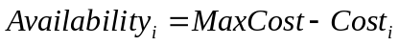
Where the MaxCost is 10000 here, the above sample would be:
No. | Streamer | Volume | bLocalPlaylist | ImportChannel | Cost | Availability
1 | Streamer01 | CL10001/VOL1 | true | - | 1000 | 9000
2 | Streamer02 | CL10001/VOL1 | true | - | 3000 | 7000
3 | Streamer03 | CL10002/VOL1 | false | CL10002-N0-PG | 7000 | 3000
4 | Streamer04 | CL10002/VOL1 | false | CL10002-N0-PG | 3333 | 6667
5 | Streamer05 | CL10003/VOL3 | true |  | 2000 | 8000

The selection will be based on the availabilities; a random drop would be issued:
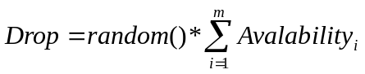
The streamer that its range covers the drop would be selected to create the session on. Based on this selection, the possibility of a given streamer to be selected would be:
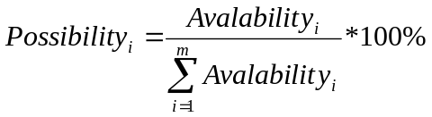

Employ the Streamer and Retry

Once a streamer is select in the previous section, the associated StreamService will be called to create a streaming session based on this streamer. If this session is successfully created and rendered with the give playlist on, the selection will be committed as succeed. Otherwise, all the resource bound of this selection will be released, and the program will retry the next streamer selection as described in the previous section until one gets succeeded or all the streamers of the cache level failed to host the session

If all the streamers of the current cache level failed to host the session, the program will repeat from section until the session is created successfully or there are no more cache levels

RTSPProxy
TODO: Support of UDP on stream controls

Ssm_OpenVBO
Ssm_OpenVBO will be introduced as a new plugin of RTSPProxy for this OpenVBO integration solution. Similar to the OSTR ssm plugin, it implements
- The RTSP extensions according to eventIS 5d specification
- Streamer resource management
- RTSP session life cycle management

Streamer Resources Management
Ssm_OpenVBO acts as an aggregator of Streamer resources; it takes the interface collects the Streamer information and status from the distributed StreamSmith instances on each MediaCluster node. It books sessions on those Streamer resources by applying load balancing (see section 4.1 for more details).
In addition to what OSTR collects, ssm_OpenVBO will collect the IP address and net mask of each Streamer or Spigot

Asset Query and Replica Determination
See section 4.1.2

Session Life Cycle Management
Same as on in OSTR
How to determine the timeout of an unattended session is an open issue

General eventIS 5d Request Handling
To be detailed

SETUP
See eventIS 5d specification section 3.4.1
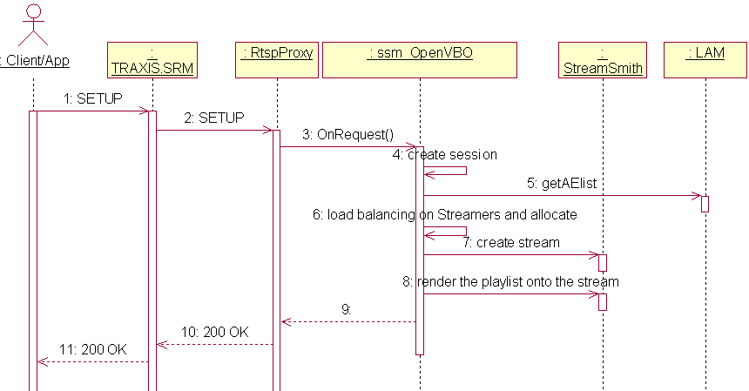
Figure 2 SETUP Handling

The ssm_OpenVBO should perform the following steps in handling a SETUP request from TRAXIS.SRM:
- Create a new CRGSession record into the database,
- Backup the current connection ID “SYS#ConnId” as “SRMReq.ConnId” in CRGSession record, overwrite the plugin-wide SRMReqConnId with this connection ID
- Keep the URI of the request into the CRGSession::metadata[“SRMReq.URI”], take the asset as the first playlist item to insert to CRGSession::playlist
- Reads the header Transport of the SETUP and parses for the necessary parameters
Transport Field | CRGSession::metadata | Comment
client | metadata[“SRMReq.client”] | The identification of the on-demand client
source | metadata [“SRMReq.source”] | The wished source IP of the streamer, optionally with a subnet mask. The following formats are refer to a same range:  172.100.100.0/24  172.100.100.0/255.255.255.0
destination | metadata [“SRMReq.destination”] | the IP address where media is streamed to. If the given value is a domain name, ssm_OpenVBO must translate it to decimal IP address before filling it to the stream session after selection
client_port | metadata [“SRMReq.client_port”] | the port where the media is streamed to
bandwidth | metadata [“SRMReq.bandwidth”] | Optional, the bandwidth requirement in bits per second

- Chops the request body for the playlist parameters. Takes the asset of CRGSession::metadata[“SRMReq.URI”] if the playlist in message body is absence
Playlist Field | Comment
asset | The identification of the on-demand client
ordinal | The position of the asset in the playlist
in | Optional, the offset in NPT (decimal in sec, RFC_2326) to start playing the asset from
out | Optional, the last frame in NPT of the asset that is playable by the StreamService
trickmode | Optional, the flags to limit trick play:  - 0x01 . PAUSE disallowed  - 0x02 . FF disallowed  - 0x04 . REW disallowed  - 0x08 . PLAY disallowed
- Prepares for the selection by following section 4.1.2. In which, the metadata [“SRMReq.bandwidth”] needs to be set to the maximal value from LAM query if the SETUP request doesn’t specify
- Performs the selection by following section 4.1.3. A stream session on the selected Streamer should be created if this step succeeded. Keep the selection result into CRGSession::metadata[“StreamerNetId”], CRGSession::metadata[“StreamServiceEndpoint”], CRGSession::metadata[“StreamId”]
- Renders the stream by inserting the content sequence with the restrictions CueIn, CueOut, ControlFlags
- Composes and send the RTSP response back to the TRAXIS.SRM. The following highlights those generated by RTSP/SSM
Header | Comment
Session | The unique RTSP session Id at StreamingServer
Location | Optional

A sample SETUP request as below:
...

A sample response will be sent as below:
...

TEARDOWN
See eventIS 5d specification section 3.4.3, 3.4.4

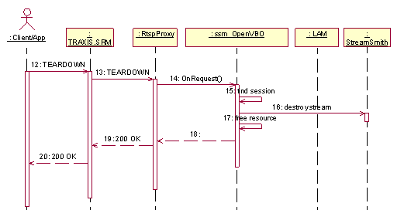
Figure 3 TEARDOWN Handling

PLAY
See eventIS 5d specification section 2.8.1, 2.8.2

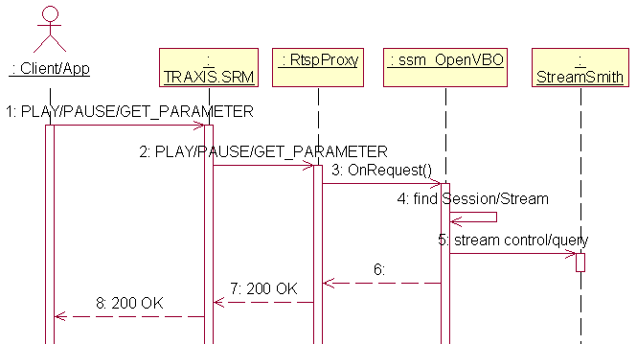
Figure 4 Stream Control Proxy Mode

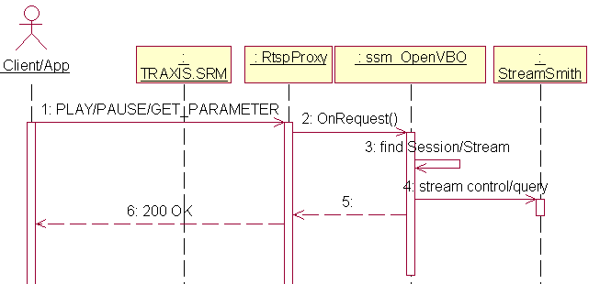
Figure 5 Stream Control

In additional to the regular implementation of RTSP PLAY handling, ssm_OpenVBO must cover following highlights:
- Backup the current connection ID “SYS#ConnId” as “CtrlReq.ConnId” in CRGSession record

PAUSE
See eventIS 5d specification section 2.8.3, 2.8.4

In additional to the regular implementation of RTSP PAUSE handling, ssm_OpenVBO must cover following highlights:
- Find out the CRGSession record by the RTSP sessionId
- Backup the current connection ID “SYS#ConnId” as “CtrlReq.ConnId” in CRGSession record

Session-Oriented GET_PARAMETER
See eventIS 5d specification section 2.7.5, 2.7.6

In additional to the regular implementation of RTSP GET_PARAMETER handling, ssm_OpenVBO must cover following highlights:
- Backup the current connection ID “SYS#ConnId” as “CtrlReq.ConnId” in CRGSession record

Non-Session GET_PARAMETER
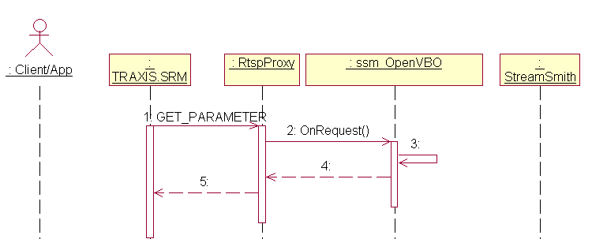
Figure 6 Non-Session GET_PARAMETER
To be detailed

Parameter | Comment
session_count | Returns the size in the SessionWatchDog
session_list | ?? should be grouped to reach bigger session size?
SRM_ID | ?? can it be borrowed

ANNOUNCE

To TRAXIS.SRM
See eventIS 5d specification section 3.4.7, 3.4.8

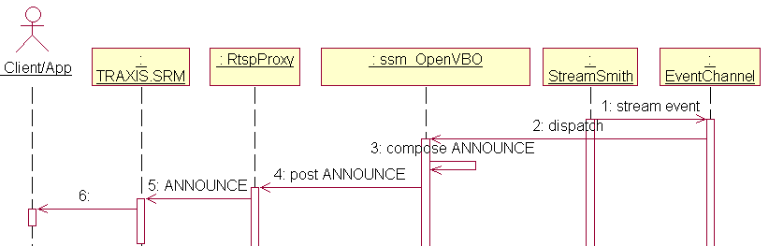
Figure 7 ANNOUNCE to SRM

To STB
See eventIS 5d specification section 2.7.7, 2.7.8

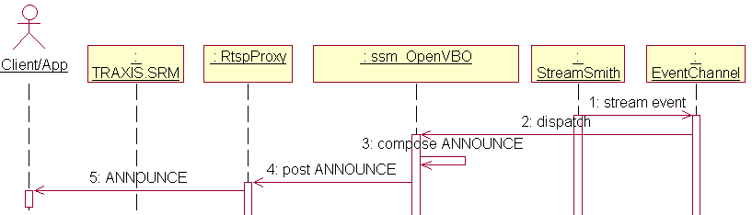
Figure 8 ANNOUNCE to STB
In the Stream Control Mode, this category of ANNOUNCE is forwarded by TRAXIS.SRM, please refer to the sequence diagram of the previous section.

StreamSmith

Streamer Replica Report
To be detailed: collect and report the IP/mask of Spigots to the SSM

Open Issues
- RTSP messaging samples are appreciated for us to reduce surprises in the future integrations
- How to ensure the SETUP is from TRAXIS.SRM but not any others, as the spec requested? The header User-Agent of the RTSP request or some other efforts?
- An OSTR is supposed to cover up to two clusters and supply up to 18K streams in the current installation, more will be in the future. Without a mechanism like OSTR’s session_group, the session_list would be huge to be acceptable
- eventIS 5d spec 0.92 page21 3.1 TCP-connections “All individual session setup and teardown requests shall be addressed to the Streaming server via this SINGLE TCP-connection” in the proxy mode. In an instance that supplies up to 18K sessions, so many sessions shares the same SINGLE connection would lead to a significant performance down
- In the mode of stream control mode, will TRAXIS.SRM relies on the GET_PARAMETER heartbeats from STBs then forward to the StreamingServer to keep the session alive. If yes, it appears not very effective and lead to a big traffic at the load such as 18K+ sessions
- Supported RTSP status codes in TRAXIS.SRM
- Without a specified volume name equals “library”, will we assume all the orders can fetch contents from the CDN?
- EventIS 5d spec 0.92 has very few details/codes about the ANNOUNCE in its Section 2.7.7 and 2.7.8 to STB
- EventIS 5d spec 0.92 page31: 4.3.4 RTSP TEARDOWN “See [2.7.3] and [2.7.4]”. In either “stream control proxy” mode or not, TEARDOWN from STB should only go to TRAXIS.SRM and the Stream Server should never receive any TEARDOWN directly from STB, right?
- In stream control proxy mode, how TRAXIS.SRM will share the connection among multiple sessions about their stream control operation? Will TRAXIS.SRM indicates a stream control operation is forwarded by itself in a clear manner?
- 303 Redirection is a non-goal in this phase
- The method for StreamSmith to get the IP address, subnet mask and gateway of spigot from Vstrm. What if the spigot gains IP from DHCP?
- the test condition to match spigot with source IP and net mask in section 4.1.2 needs confirmation
- The “bandwidth” does not appear as an input parameter in the SETUP request from TRAXIS.SRM. It is okay to stream from local because the SSM would take the max bitrate of concerned contents. However, if the system tries to stream off CDN, the local ContentStore would not be able to tell the bitrate of the contents that have not yet been cached
- Is the UDP on stream control a MUST in this phase?

Tentative Schedule
To be determined

To be confirmed
Bandwidth is required when move to stream off from CDN

