nPVR

Statement of Work

Last Saved: 29-Jul-13
Commercial in Confidence

File Name: | 0000.doc
Version: | 0.7
Author: | Ken Qian
Contact Details:

© Copyright XOR Media 2013
Content

1 Document Administration 3
1.1 Revision History 3
1.2 Document Reference 3
2 Requirement 4
2.1 Demo Target and Functional requirement 4
2.2 Hardware requirement 4
3 Statement of Work 5
3.1 System Diagram 5
3.2 Requirement 6
3.2.1 Source and Transcode 6
3.2.2 3d server for nPVR recording 7
3.2.3 Per-sub-per-copy Recording 7
3.2.4 HLS streaming and 5i signature 7
3.2.5 10b interface for backoffice to query nPVR recording / playback capacity. 8
4 Overall Design 8
4.1 TianShan (Andy – 3d server, CPE, CDNSS, 5i signature) 8
4.1.1 3d server 8
4.1.2 CPE/CPM_AquaRec 10
4.1.3 CDNSS as HLS 11
4.2 CloudAqua (Xia – CloudAqua) 13
4.2.1 Summary 14
4.2.2 Features 15
4.2.3 Folder Structure 16
4.2.4 Policy Metadata 16
4.2.5 Policy Script 17
4.2.6 Constrain 18
4.2.7 Implementation 18
4.3 Transcode & Packaging (Zhang Shaoliang) 21
5 Development Schedule 22
5.1 Resources 22
5.1.1 Aqua 22
5.2 Deliveries 23
6 Issues Discussions 23

Document Administration

Revision History
Name | Date | Reason For Changes | Version
Ken Qian | 23/6/2013 | Document Creation | 0.1
Kaity Yu | 2013-07-03 | Update requirements after 2nd round internal discussion  Added document reference and issue discussion  Merged CloudAqua high-level design on wiki page | 0.2
Andy shao | 7/4/2013 | Initial draft of TianShan efforts | 0.3
ZhangShaoLiang | 7/8/2013 | Transcode and packager part | 0.4
Aihua Tao | 2013-07-10 | Aqua part | 0.5
Ken Qian | 2013-7-10 | Add hardware requirement | 0.6
Xia Zhang | 2013-7-11 | Update 4.2.7 for detail of implementation and 5.1.1 for development plan | 0.7
Andy Shao | 7/29/2013 | Updated per the discovered notification that Aqua would not perform recursive sub-tree replication | 0.8

Document Reference
eventIS VOD - Interface Part 3d - Content propagation interface.pdf
eventIS VOD - Interface Part 5d - TRAXIS-SRM VideoServer _1_.pdf
eventIS VOD - Interface Part 5i- URL signing and validation v1.7.pdf
eventIS VOD - Interface Part 5j - Session Management V1.5.pdf
SeaChange VOD - Interface Part 10b - Recorder status interface.pdf
npvr_June_demo.ppt
nPVR Architecture Diagram (1).png

Requirement

Demo Target and Functional requirement
The initial project requirement is SeaChange internal demo in July 2013.

- Equipment available in Acton MA by 6/30
- Integration in July, Internal demo by 7/31
- Recoder/Streamer Interface to Adrenalin 6.3 BO via the following specifications:
  - IF-3d: Content propagation
  - IF-5d: Session Resource Management
  - IF-10b: Recorder Status Interface
  - IF-5j: Session Management Interface
  - IF-5i: URL Signing and Validation
- Support individual copy nPVR
- shared copy nPVR support NOT required for demo
- Support unencrypted streaming to HLS client
  - Support 4 bit rates (HD, SD, 2 lower bit rates)
- Support for HFC STB client NOT required for demo
- Support 100 Subs
- Support 1 hour HD storage per sub
- Support 10 simultaneous ingests
- Support 10 simultaneous play-outs
- Multicast H.264 live feed available
- Need to understand partner’s transcoding & packaging requirements if any?

Hardware & Source requirement
Storage
- N16, with 4 Gig NICs, two on the mother board, two on the PCI.
- Purpose of 4 NICs
* server-to-server network, connect to backoffice for 3d and 5j (in the future)
* recording network, transcode & packaging write HLS files onto Aqua
* propagation network, cross all Aqua nodes
* streaming network, connect to client to response m3u8 and segments files

Transcode & Packaging server
- 3 virtual machine run on 1 physical machine, Esxi v5
- each virtual machine: windows 2003 server 32bit
- each virtual machine: 4 core CPU
- each virtual machine: 4G RAM
- each virtual machine: support 4 channels and 4 bitrates HLS transcode and packaging
- each virtual machine: (6.5+2+1.5+0.5)*4=42Mbps read and 42Mbps write
- each virtual machine: 100GB

Physical machine spec
PowerLeader PR2310R basic chassis
- 1U Chassis, SuperMicro X9DTL motherboard
- Intel E5-2600 chipset, Romley 6C/12T E5-2630 2.3G 15MB 7.2GT
- Embedded 2 GigE Server Network Adaptor (2*Intel82574L Gigabit Platform LAN)
- Embedded Matrox G200eW 16M Graphics
Intel E5-2600 chipset, Romley 6C/12T E5-2630 2.3G 15MB 7.2GT
INTEL E1G42 two GigE network adaptor
DDR3 2G 1066MHz
2T SATA300 Hard Drivers (SATA Raid up to 3 HD, RAID 0、1、10)

Need 3 NICs for each VMWare
- Server-to-server network, control network
- Channel source network, sniff multicast IP stream (H.264 HD)
- Recording network, connect to Aqua to write HLS files

Source requirement for Transcode and Packaging
- H264 HD 8M
- N format
- Resolution 1920x1080

Statement of Work

System Diagram
Following is the nPVR diagram, the Video Recording / Playback and Linear Content Feed are provided by XOR Media

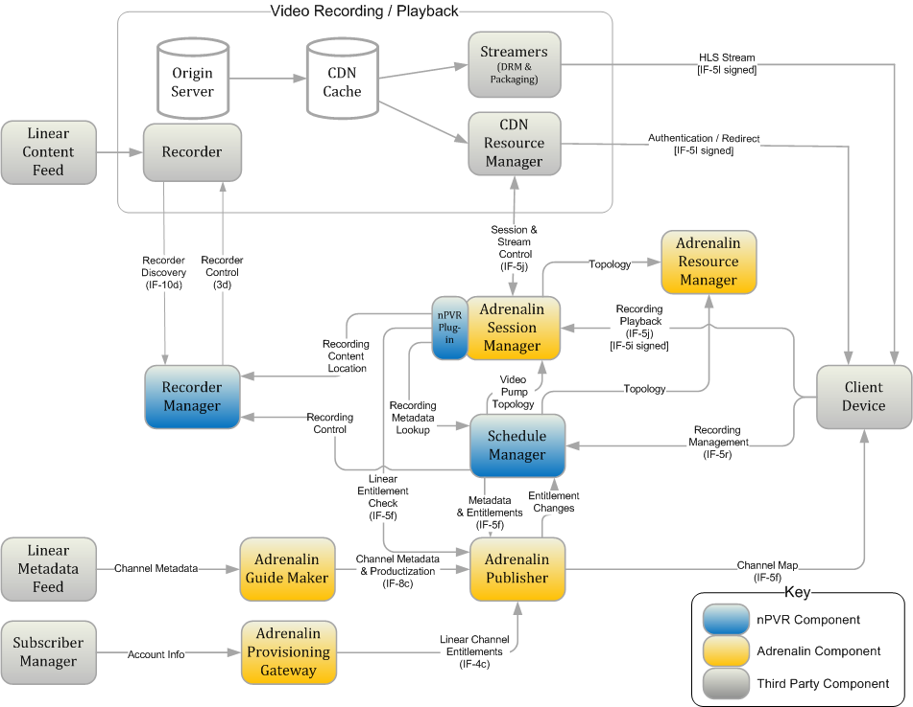

Requirement
Following are the current functions that XOR Media need to implemented:

Source and Transcode
- Capture multicast source, which is H.264 HD TS (SeaChange will provide source feed)
- Transcode to 4 different speed for H264, 6.5Mbps, 2Mbps, 1.5Mbps and 0.5Mbps
- Packaging content files in10 seconds a segment in HLS
- Transcode and Packaging is always there, if there is nobody requests for recording the source segments will be deleted at once, if there is somebody requested for recording the source segments will be deleted once is has been copied to individual copies. In any case, the segments need to be deleted from source container within 30 seconds.
- There is no need for live m3u8 streaming, so no live m3u8 generated / updated
- Source container structure
  - npvr/sources/[channelid]/bitrate1
  - npvr/sources/[channelid]/bitrate2
  - npvr/sources/[channelid]/bitrate3
  - npvr/sources/[channelid]/bitrate4

3d server for nPVR recording
- The recording is per subscriber per copy.
- BO sends individual recording request for each subscriber and program.
- There is no program id / schedule id is used in 3d to identify different recordings for the same program.
- Client application may support early / late start / stop for the same program.
- 3d recording start-time and end-time update
- 3d recording status update: initiate, ingesting, playable, complete, error.
- 3d content list
- 3d deletion

Per-sub-per-copy Recording
- set policy on source bitrate container to indicate startime, endtime and contentid
- create content containers for each recording
- set metadata on content containers
- handles status change during recording
- remove policy from bitrate container after endtime
- content container structure
  - npvr/contents/[contentid]/bitrate1
  - npvr/contents/[contentid]/bitrate2
  - npvr/contents/[contentid]/bitrate3
  - npvr/contents/[contentid]/bitrate4
- CloudAqua trigger policy on file creation, start copying after file closing
- CloudAqua delete source

HLS streaming and 5i signature
- HLS web application server for m3u8
- 5i verification on m3u8 request
- Dynamic generate m3u8 depends on bitrate container children
- No 5i signature required for each segment in m3u8
- The source URI in m3u8 directly pointed to CloudAqua
- Aqua generate a token for 4 hours

10b interface for backoffice to query nPVR recording / playback capacity.
- As our recording / playback system is implemented in Cloud, so we only provide the system’s total capacity.

Overall Design

TianShan (Andy – 3d server, CPE, CDNSS, 5i signature)

3d server
is a HTTP server side in respond to eventIS 3d messaging, will be implemented by proxying Aqua data directly. It serves the root URI /Content/, and minimally covers the following major 3d commands

Schedule a recording thru PUT

>>>> PUT /Content/4d854d85-4e6c-d06f-b15b-d06fa6d85edf/ HTTP/1.1
<?xml version="1.0" encoding="utf-8" ?>
<Content id="4d854d85-4e6c-d06f-b15b-d06fa6d85edf" xmlns="urn:eventis:cpi:1.0">
<Name>The nine o'clock news</Name>
<Provider>BBC</Provider>
<SourceUri>ChannelName</SourceUri>
<IngestStartTime>2013-07-01T21:00:00Z</IngestStartTime>
<IngestEndTime>2013-07-01T22:00:00Z</IngestEndTime>
<BitrateInBps>4500000</BitrateInBps>
</Content>

<<<< HTTP/1.1 200 OK

When the 3d server accepts such a request, it creates a subcontainer npvr/contents/<contentid> by calling
cdmi_createContainer(uri="<cdmiroot>/npvr/contents/<contentid>")
and taking the field mapping:
- Content::id will be taken to name the child container <contentid> under Aqua container npvr/contents/
- <Name> will be put as a user-defined metadata["npvr_name"] of container npvr/contents/<contentid>/
- <Provider> will be put as a user-defined metadata["npvr_provider"] of container npvr/contents/<contentid>/
- <SourceUri> will be put as a user-defined metadata["npvr_source"] of container npvr/contents/<contentid>/, and will be taken to address the subcontainer [channel]/ under the Aqua container npvr/sources/
- <IngestStartTime> will be put as a user-defined metadata["npvr_recording_start"] of container npvr/contents/<contentid>/, will be passed to CPE as the recording start time
- <IngestEndTime> will be put as a user-defined metadata["npvr_recording_end"] of container npvr/contents/<contentid>/, will be passed to CPE as the recording end time
- <BitrateInBps> will be ignored

It calls the attached CPE server to create a new Content Provision Session,
session = ContentProvisionService::createSession(contentKey={ content="npvr/contents/<contentid>"}, "AquaRecord);
session->addResource(URL="npvr/sources/<channel>");
session->setup(startTimeUTC, endTimeUTC)
the latter starts the session life time management and apply policies onto Aqua Container npvr/sources/[channel]/, see the section of CPE

Exceptions:
Any PUT to an existing contentId with different <Provider> or <SourceUri> will be rejected via 403, otherwise will be considered as a schedule update, see later sections

Update start/end time of a recording
Request is same as above.
For an existing npvr/contents/<contentid>/, after verified the channel source and provider if 3d server can find the linked provision session running on the CPE service, instead of calling API provision(), it will call updateSchedule() to the provision session and up to CPE's schedule change validation

Delete a content and/or stop a recording
>>>>DELETE /Content/4d854d85-4e6c-d06f-b15b-d06fa6d85edf/ HTTP/1.1

<<<HTTP/1.1 200 OK

For a content being recorded, 3d server double checks CPE and destroy the provision session if exists. Then call Aqua to a) move the npvr/contents/<contentid>/ to npvr/contents/trash_<contentid>/, then b) delete npvr/contents/trash_<contentid>/
No rejection per in-use is designed unless Aqua respond failure at step a) or b)

Get details of a content

>>>>GET /Content/4d854d85-4e6c-d06f-b15b-d06fa6d85edf/ HTTP/1.1

<<<<HTTP/1.1 200 OK
<?xml version="1.0" encoding="utf-8" ?>
<Content id="4d854d85-4e6c-d06f-b15b-d06fa6d85edf" xmlns="urn:eventis:cpi:1.0">
<Name>Spiderman 3</Name>
<Provider>Sony</Provider>
<SourceUri>ftp://10.0.0.10/Spiderman3.mpg</SourceUri>
<IngestStartTime>2009-09-13T13:11:00Z</IngestStartTime>
<IngestEndTime>2009-09-13T13:13:00Z</IngestEndTime>
<BitrateInBps>3750000</BitrateInBps>
<Status id=”Ingested”/>
</Content>

>>>>GET /Content/4d854d85-4e6c-d06f-b15b-d06fa6d85edf/Status HTTP/1.1

<<<<HTTP/1.1 200 OK
<?xml version="1.0" encoding="utf-8" ?>
<Content id="4d854d85-4e6c-d06f-b15b-d06fa6d85edf" xmlns="urn:eventis:cpi:1.0">
<Status id="Ingesting">
<IngestPercentage>20</IngestPercentage>
</Status>
</Content>

3d server queries Aqua about npvr/contents/<contentid>/ and its child container Bn, it takes the user's metadata as defined in Schedule a recording thru PUT
To determine Ingestion status and percentage, it takes the following calculation
a) state mapping
Status | Condition
Initial | the current time is earlier than metadata["npvr_recording_start"]
Ingesting | The current time falls in the range between metadata["npvr_recording_start"] and metadata["npvr_recording_end"]
IngestingAndPlayable | The current time falls in the range between metadata["npvr_recording_start"] and metadata["npvr_recording_end"], AND ANY bitrate subcontainers include one or more data objects
Ingested | The current time is later than ["npvr_recording_end"], and ANY bitrate subcontainers include one or more data objects
b) progress calculation
3d server take the largest "createtime" chopped from child data objects names from all bitrate subcontainers, and determine the percentage by taking
(max(createtime) - metadata["npvr_recording_start"]) / (metadata["npvr_recording_end"] - metadata["npvr_recording_start"]) * 100%

List contents in the state of ingesting
3d server enumerates the ingestion sessions from CPE and details the responses by querying Aqua
>>>>GET /Contents?Status=Ingesting HTTP/1.1

<<<HTTP/1.1 200 OK
<?xml version="1.0" encoding="utf-8" ?>
<Contents xmlns="urn:eventis:cpi:1.0">
<Content id="4d854d85-4e6c-d06f-b15b-d06fa6d85edf" statusId="Ingesting"/>
<Content id="34854e55-1e7d-e06a-a15a-a06fa6a55fff" statusId="Ingesting"/>
</Contents>

CPE/CPM_AquaRec
CPM_AquaRec is a new CPE plugin duplicated from existing CPM_nPVR.dll. It inherits from existing nPVR at mapping a lead session to a source channel and virtual sessions for each recording. Each lead session take a thread while virtual sessions do not.
In addition to the existing CPM_nPVR logic, when session created, CPM_AquaRec queries Aqua or read from its cached metadata of npvr/sources/[channel]/ up to its cache rule; group the virtual sessions by the same source channel build up the subscriber list by indexing its known recording sessions.

Aqua Update Procedure
For any changes detected from the grouped subscriber list of a same source channel, CPM_AquaRec would start a round of updating to Aqua Storage:
1) it calls cdmi_ReadContainer(uri="<cdmiroot>/npvr/sources/<channel>/") for its existing subcontainers
2) if the subcontainer list has no changes as last known, jump to step 4)
3) for each newly known subcontainer, loop by the old subscribers to add the new subcontainer under their destination content container; for those disappeared subcontainers, simply ignore
4) for a new session joined if there is any, CPM_AquaRec creates container <cdmiroot>/npvr/contents/<contentid>; AND under it, create all known subcontainers
5) loop for each subcontainer under <cdmiroot>/npvr/sources/<channel>, compose the subscriber list metadata by putting rows like

{start: "2013-07-01T21:00:00Z", end: "2013-07-01T22:00:00Z", id: "<cpesessid>", cid: "<contentid/<subcontainer>", destName: "${grandpName}${parentName}_${createTime}" }

Then calls
cdmi_UpdateContainer(uri="<cdmiroot>/npvr/sources/<channel>/<subcontainer>", metadata["npvr_subscribers"]= <subscribersList>);

When a session finishes up to CPE session management, CPM_AquaRec query Aqua or read from its cached metadata of npvr/sources/[channel]/, build up the subscriber list by eliminating this finished session. then update Aqua container npvr/sources/[channel]/ by calling cdmi_UpdateContainer() like above as well

New CPE Session
By joining a new virtual session in, CPM_AquaRec will lead to subscriber list change of a source channel, and therefore triggers the above Aqua Update Procedure

Update Schedule of an Existing Session
Update schedule of an existing session is also a soft trigger to execute Aqua update procedure

Session Completion or Gone
Session completion or gone will also be known as subscriber list change and triggers Aqua update procedure as well

CDNSS as HLS
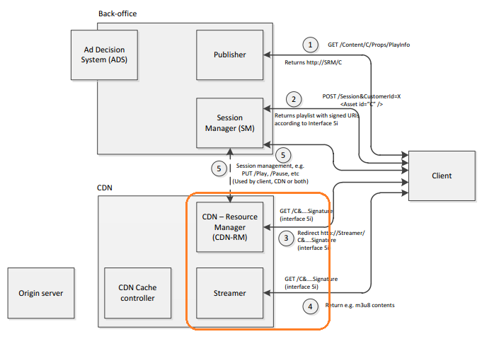

In the above picture of eventIS streaming, CDNSS doesn't the place as highlighted, it responds the highlighted interface combination of 3) and 4) but doesn't involves interface 5) about BO session based creation delete and stream control.

To respond interface 3) and 4), CDNSS accepts the GET requests in the format of
GET http://<server>:<port>/assets/<contentid>[_<subname>].m3u8?I=<session ID>&K=<key ID>&E=<validity end>&A=<IP address>&H=<signature>

A content will be defined in two layer

Layer I. <contentid>.m3u8 refers to a Master Playlist m3u8 file
This layer of m3u8 enumerates all available bitrates available of the content by querying Aqua container npvr/contents/<contentid>/

An sample output would be like:
#EXTM3U
#EXT-X-STREAM-INF:PROGRAM-ID=1,BANDWIDTH=1280000
/assets/<contentid>_<bitrate1>.m3u8?I=<session ID>&K=<key ID>&E=<validity end>&A=<IP address>&H=<signature1>
#EXT-X-STREAM-INF:PROGRAM-ID=1,BANDWIDTH=2560000
/assets/<contentid>_<bitrate2>.m3u8?I=<session ID>&K=<key ID>&E=<validity end>&A=<IP address>&H=<signature2>
#EXT-X-STREAM-INF:PROGRAM-ID=1,BANDWIDTH=7680000
/assets/<contentid>_<bitrate3>.m3u8?I=<session ID>&K=<key ID>&E=<validity end>&A=<IP address>&H=<signature3>

For an received request in this format of <contentid>.m3u8, CDNSS will
a) verify the request per eventIS 5i spec, reject if failed
b) query Aqua container npvr/contents/<contentid>/ for the child containers as the available bitrates
c) query each subcontainer of bitrate for metadata["stream_inf"] the describe the playlist of the bitrate
d) sign each URI of bitrate by inheriting the same session ID and validity end but random pick new key Id from the key file

Layer II. <contentid>_<bitrate1>.m3u8 refers to a playlist of a given bitrate
This layer of m3u8 enumerates all available recorded segment files available under a given bitrate

An sample output would be like:
#EXTM3U
#EXT-X-VERSION:3
#EXT-X-MEDIA-SEQUENCE:7794
#EXT-X-TARGETDURATION:10

#EXT-X-KEY:METHOD=AES-128,URI="https://priv.example.com/key.php?r=52"

#EXTINF:10.0,
http://<aqua_cdmifrondend>:<port>/aqua/rest/cdmi/npvr/contents/<contentid>/<bitrate>/seg_120130701120010.ts?aquatoken=000059370018352707B74B34B1BDEB4BEF88AAEC4A5F9C247D:9WVp6SYVKzaEMYnhs5qX0AIxRQ8%3D&xaquadate=1369296542221

#EXTINF:10.0,
http://<aqua_cdmifrondend>:<port>/aqua/rest/cdmi/npvr/contents/<contentid>/<bitrate>/seg_20130701120020.ts?aquatoken=00025937001333307B74B34B1BDEB4BEF88AAEC4A5F9C247D:9WVp6SYVKzaEMYnhs5qX0AIxRQ8%3D&xaquadate=1369296542221

#EXTINF:10.0,
http://<aqua_cdmifrondend>:<port>/aqua/rest/cdmi/npvr/contents/<contentid>/<bitrate>/seg_30130701120020.ts?aquatoken=000444440018352707B74B34B1BDEB4BEF88AAEC4A5F9C247D:9WVp6SYVKzaEMYnhs5qX0AIxRQ8%3D&xaquadate=1369296542221

For an received request in the format of <contentid>_<bitrate1>.m3u8, CDNSS will
a) verify the request per eventIS 5i spec, reject if failed
b) query Aqua container npvr/contents/<contentid>/<bitrate>/ for the child data object as the available segement files, sorted by file name
c) take metadata[sequence_start] of npvr/contents/<contentid>/<bitrate>/ as the #EXT-X-MEDIA-SEQUENCE if exists, otherwise 0; take the metadata[xkey_since_<time>]s if exists, insert them before the segment with equal or later create time stamp
d) for each segment seg_<createtime>, take the current time plus 4hour as xaquadate, then generate Aqua tokan and compose the URL in the following way:
http://<aqua_cdmifrondend>:<port>/aqua/rest/cdmi/npvr/contents/<contentid>/<bitrate>/<segment filename>?aquatoken=<aquatoken>&xaquadate=<currentime+4hr>
In which, if the URI has ever known in the local cache about the redirect location, take it; otherwise the default interface to the Aqua frontend

CloudAqua (Xia – CloudAqua)
Online location of design can be found at http://192.168.87.16/mediawiki/index.php/Object_copy_-_Policy_-_High_Level_Design_-_Aqua

Key requirement:
- Subscriber request record on specified channel with a specified time range. There is no merge concept among records. So output of every record is considered as different file. One input will be record thousands time, so single source file will be copied to thousands files.
- For every record, 4 bitrate streams will be recorded. It are always 4 and bit rate is fixed.
- Channel stream are recorded as files, and every files are small and each file is 10 seconds video.
- No other file can be recorded. Any temp file can not be stored on server longer than 30 seconds.

Summary
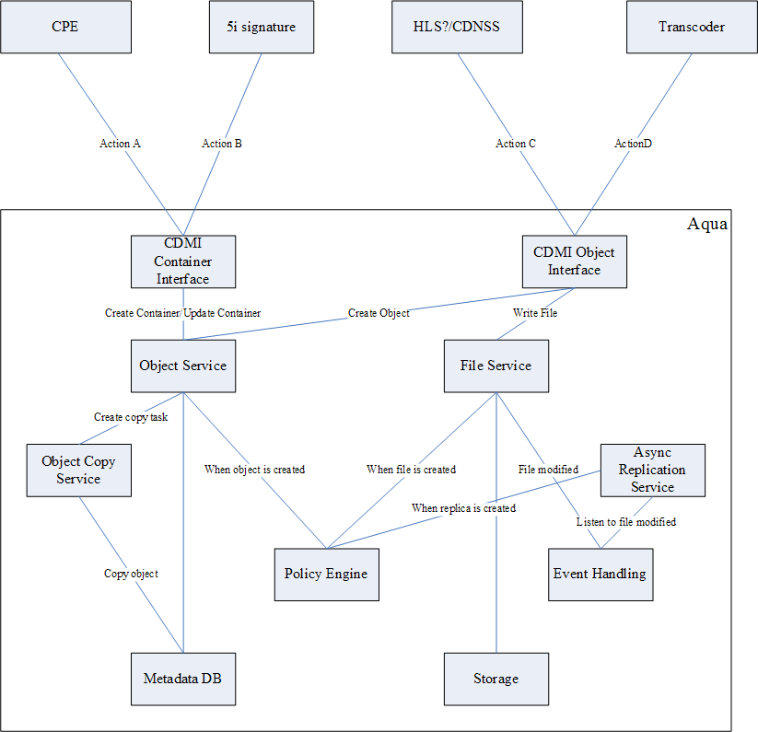
Action A
- Update bit rate container metadata under source container for Recording
- Create content containers structure for Recording
- Delete content container for Cancel Recording
- Get content container metadata and children for Recording Status
Action B
- Get children of content container for m3u8
Action C
- Non-CDMI read for streaming
Action D
Non-CDMI write for recording

Transcorder
Capture network input and record it as 4 bit rate output, segment streaming into 10 seconds files. Files are written into Aqua via non-CDMI PUT interface.

CPE
Handle record request. It send request via CDMI PUT interface to Aqua to create container and set container metadata.

Create content container structures (include bit rate container) for particular recording and update npvr policy metadata on bit rate containers under source container.
- Regularly remove expired item from npvr policy metadata on bit rate containers under source container.
- Manage status of recording. Keep status of recording as metadata on content container.
- Map content list request to Aqua get container method.
- Map delete content request to Aqua to rename deleted container before delete container.

Aqua
- Provide Non-CDMI interface for file write and has copy logic (including object copy and file content copy) in background.
- Provide CDMI interface to set policy (update entire metadata, no ability to control it).

Features
- All standard CDMI features, CDMI PUT, Non-CDMI PUT/GET.
- When object is created under a container with policy set, copy object to containers specified by policy, and copy content of file as well. All copy actions are asynchronous and it will not impact speed of source file ingest. But there will be latency between source file and copied file.
- For now file is only copied to local machine. It is doable to copy file to another machine.
- Policy can be saved on metadata value, saved as Aqua object, or file in web application. Now we will use file in web application.
- (Future) Location of file is decided by metadata on parent container. When content container is created, Aqua can decide location of this content base on some policy, and bit rate container under it will inherit this location information. When object is created under bit rate container, its location is decided by information on container.
- When source file is not in-used (no need to be copied or all copied are finished), source file will be automatically deleted. It is expected to be deleted within 30 seconds after file is completely written.
- When recording is cancel by subscriber, content container for subscriber will be deleted by CPE, and it is possible that some file in that container is still be written. Aqua will accept the delete request and delete it later. CPE should rename first so it can create container with same content id if there is need.
- (Future) Provide interface to translate sid (id object replica location) to server id. So the one who build m3u8 can build URL base on location information on content container.

Folder Structure
- npvr/sources/[channelid]/bitrate1
- npvr/sources/[channelid]/bitrate2
- npvr/sources/[channelid]/bitrate3
- npvr/sources/[channelid]/bitrate4
- npvr/contents/[contentid]/bitrate1
- npvr/contents/[contentid]/bitrate2
- npvr/contents/[contentid]/bitrate3
- npvr/contents/[contentid]/bitrate4

/ (Root folder) (No policy)
npvr/ (Root folder for NPVR application, manually created) (No policy)
sources/ (Root folder of sources, manually created) (No policy)
channel##/ (Root folder of particular channel, maybe created by recorder?) (No policy)
bitrate##/ (Input folder of particular bitrate, maybe created by recorder?) (Policy on it, updated by CPE)
##### (File written by recorder, 10 seconds per file, file name is TBD, should be defined by recorder) (Deleted by Aqua)
contents/ (Root folder of contents, manually created) (No policy)
####/ (Root folder of content, created by CPE, container name is content id in A3 request) (No policy)
bitrate##/ (Folder of particular bitrate, created by CPE, container name is fixed, from source) (No policy)
#### (File copied by Aqua, name is same as source file)
policies/ (Root folder of policy scripts)
npvr_recording.js (policy script)

Policy Metadata

Metadata of bit rate container - /npvr/sources/channel01/bitrate01

{
name: "/npvr/sources/channel01/bitrate01",
...
metadata: {
policy_on_create: "resource::npvr_recording.js",
npvr_subscribers: [
{id: “1”, start: "2013-07-01T10:00:00Z", end: "10:29:59", cid: "1001"},
{id: “2”, start: "2013-07-01T10:00:00Z", end: "10:29:59", cid: "1002"},
{id: “3”, start: "2013-07-01T10:00:00Z", end: "10:29:59", cid: "1003"},
...
{id: “137”, start: "2013-07-01T10:30:00Z", end: "10:59:59", cid: "1105"}

]
}

Value of policy_on_create is “resource::npvr_recording.js”. Value should be fixed at most time. And “resource::” means policy script is located under specific folder of web application. Script should be shipped with application.
For data under npvr_subscriber:
Id - control id defined by CPE to identify a row
start - start time of a recording
end - End time of a recording, represented in HH:MI:SS to reduce data in policy. If end time is smaller than time part of start time, that means corss day recording. For example, start is 2013-07-01T23:30:00, end time "00:30:00" means 2013-07-02T00:30:00
cId - content id from recording request

Policy Script
Content of npvr_recording.js:

var targetList = new Array();
var parentMD = parent.getMetadata();
for (var item in parentMD.getValues("npvr_subscribers")) {
if (self.getCreateTime() >= item.getValue("start") || self.getCreateTime() < item.getValue("end")) {
var path = "/NPVR/Contents/" + item.getValue("cid") + "/" + util.getLastFolder(parent.getName());
targetList.push(path);
}
}
self.copyTo(targetList);

It is a JavaScript. Some variable is defined by system and can be used by one who write script:

Self: current object which is creating, major fields and metadata can be accessed in script. And copyTo action is used to copy object to target containers.
Parent: parent container that current object is creating in, major fields and metadata can be accessed.
Util. provide some methods that help to handle path.

Constrain

Policy need to be set on container with object
Considering that a channel has 4 inputs with different bit rate, and it has 4 containers. Same policy must be duplicated to all 4 containers.
The reason of this is: it is difficult for Aqua to load grand parent container data when modify an object. It can only easily load directly parent container and direct parent domain datat of target object.

No synchronized copy yet
Now it is not require to synchronized copy to meet 30 seconds limitation. Aqua will copy file in source folder to all subscribers and then delete it. Maybe it takes times longer that 30 seconds and the file in source folder will last longer than 30 seconds.
It is OK for demo.

CPE will generate m3u8
It is because there may be some application level requirement. http://192.168.87.16/mediawiki/index.php/Special:Categories

Implementation
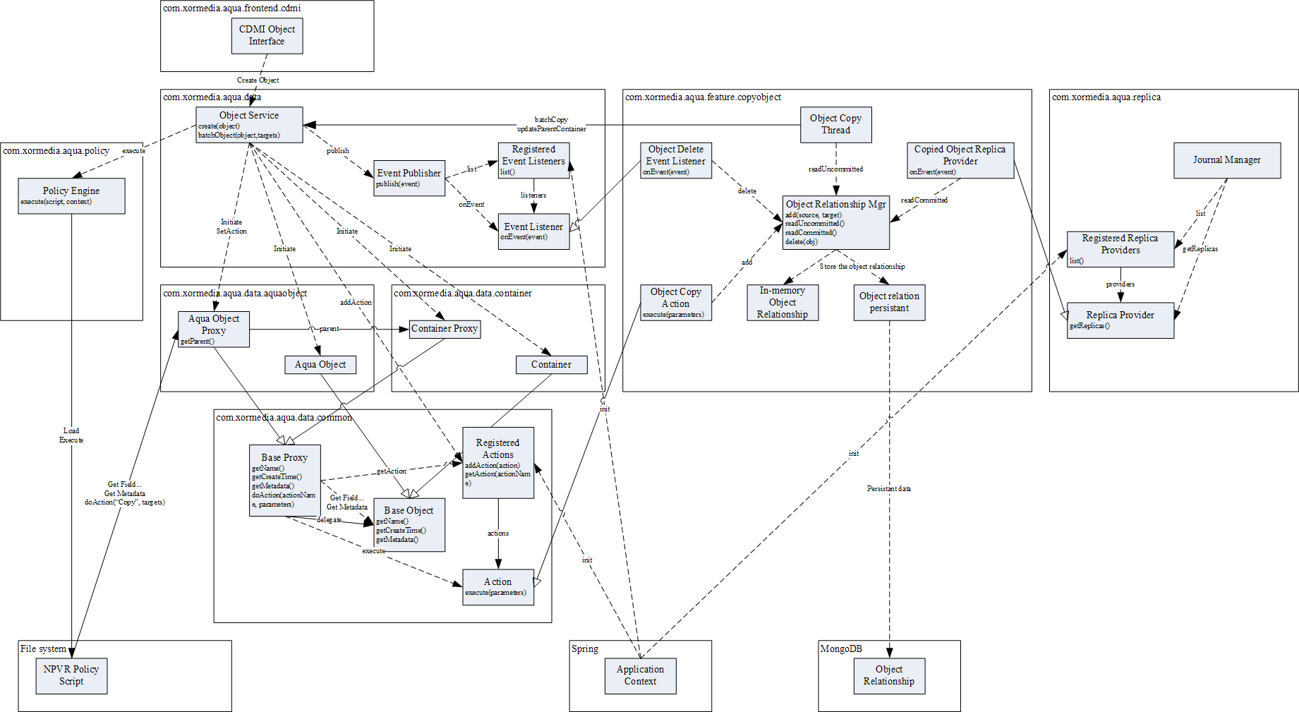

Policy Engine
Provide script execution feature. It use Java JavaScript engine and it will cache compiled script to speedup execution of policy.

Engine provide single interface for Object Service to execute a script. A script could be a raw Java Script, a file path point to a file on file system (value start with “file::”), or a file path relative to root of web application which usually point to a file packaged in WAR (value start with “resource::”). For wow we will use “resource::..” like value.

Engine caches loaded script and compare lastModifiedTime of script file on storage and time in cached script. If there is no time change, engine will reuse script.

Engine also need to provide a easy way to debug execution of script.

Object Service
Object Service invoke Policy Engine after object creation successful. And it also provide Proxy object and set them into context of script so script can access current operating object. It also provide function to do object copy at database level.

Object Service will call Policy Engine at particular point and send particular policy value. For example, after object creation, it will load “policy_on_create” from parent container and domain of current object, and if there is value, send to Policy Engine and execute it. And if both parent container and domain has policy, policy on container will be used and policy on domain will not be used. And before run policy, Object Service also set context variable like self, parent, domain so script can access these objects with script.

Object Service defined Proxy object and send these object into script context. These Proxy objects will delegate method call to backend like AquaObject. It major responsibility is to hide unnecessary method and secure the backend object.

There is an Action interface in Object Service so 3rd party module can register action into system. These actions can be access via Proxy.

Object Service also provides batchCopy function. It is in synchronized call and can not be used by script directly or it will delay response of object PUT request.

Object Copy Service
This service provides a way to create object copy in asynchronous way.

It defined an Object Service Action Implementation to do batch object copy. And it will add object relationship into its MongoDB collection. A single document in this collection has source object id as key, and list of target object as value.

A task will scan new document (INIT object) in this collection, and call Object Service to copy object.

A replica provide of Replication module is also implemented, when a file change event is ready to submit, Journal Manager will ask replica provide the target file to be copied. And provide will check if object of changed file has any target object which is ready for replica (only load CREATED object).

Document sample looks like:
{
_id: %sourceObjectId%,
targets: [{id:%targetObjectId%, status:INIT}, {id:%targetObjectId%, status:INIT}]
}

Status:
INIT: Item is just created and target object is not created yet
CREATED: Target object is created and ready for replication. There is no succeed status since this connection between source and target object will be kept until source or target object is deleted.

Object Copy Service listens to object delete event from Object Service to remove corresponding item from its collection.

Object Copy Service also listens to file replication event from Replica Service and if a replication is finished, it will update version of target object.

Replica Service

It is existing service which is used to do asynchronous replication. And it will be reused for object copy.

When a file change event is merged and ready to be submitted, Journal Manager will get target file list from Object Copy Server. And similar as logic in asynchronous replication, it will decide it is a partial copy or full copy base on version on source object and target object. And it will submit replication job to writer.

A new local file writer will be added to handle object copy business. It will copy file one by one since now it seems the fastest way to copy one file to 100 files. It is faster than read a single block and write to 100 files and read next. We plan to start maybe 10 threads to do copy same file so we can reuse file cache in page cache.

After file copy is finished, Replica Service will send event to notify Object Copy Service.

Transcode & Packaging (Zhang Shaoliang)
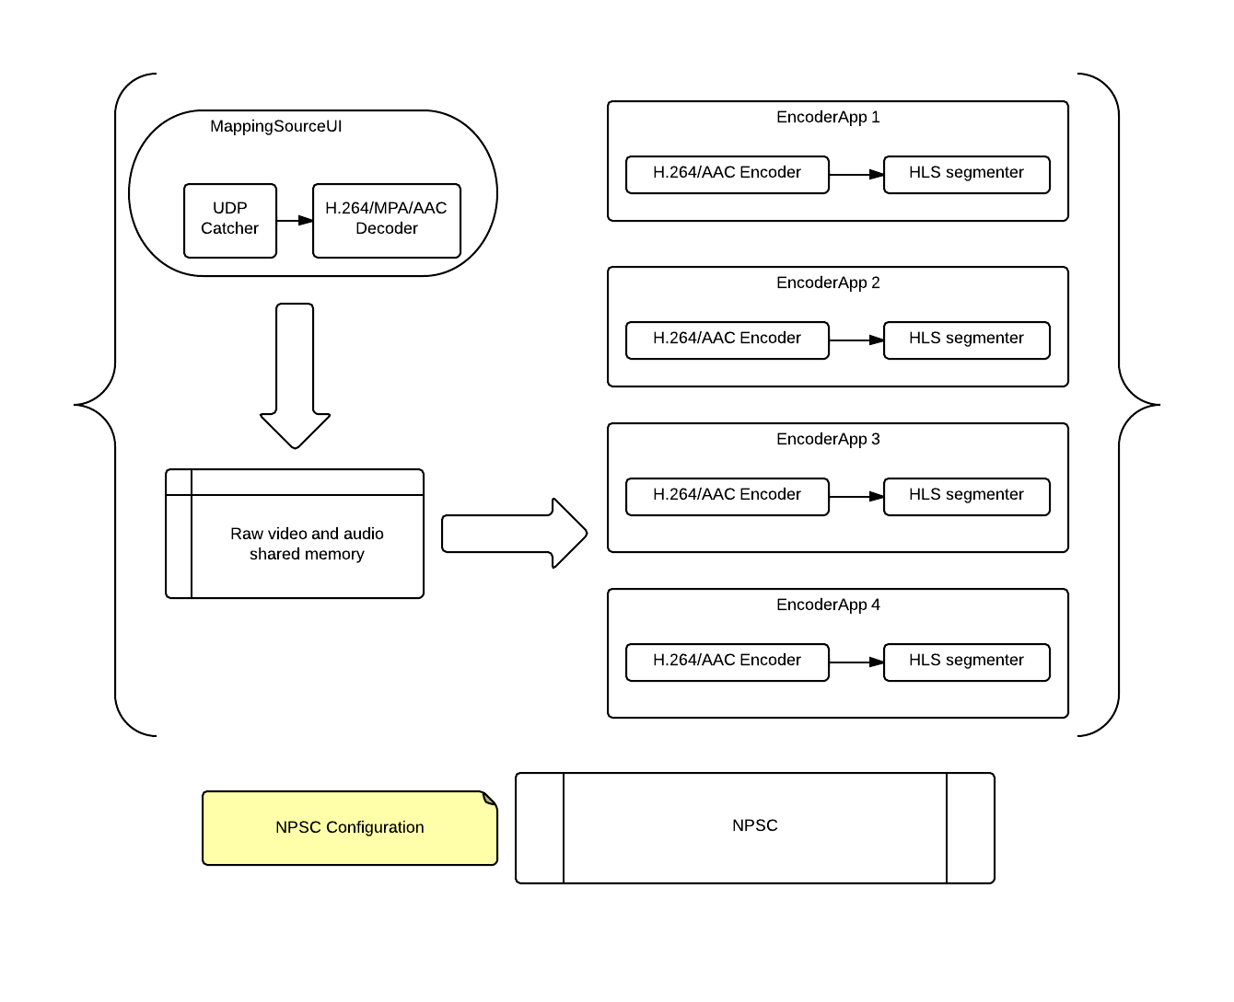
Figure 4-1

- NPSC loads NPSC configuration (json format).
- NPSC starts MappingSourceUI/EncoderApp 1~ 4. Then NPSC exits.
- MappingSourceUI creates file mapping object to share raw video frame or audio data.
- EncoderApp [x] opens file mapping object. Then it reads raw video frame or audio data.
- EncoderApp [x] put HLS segment TS files to cloudaqua.

NPSC Configuration example:
{
"channel":[
{
"id":4321,
"src": {
"ip":"",
"port":4321,
"local_ip":"",
"v_width":1920,
"v_height":1080,
"v_block_count":30,
"a_freq":48000,
"a_channel":2,
"a_bitcount":16,
"a_block_count":64
},
"process": {
"encoder_profile":
["hd1", "sd1", "mobile1", "mobile2"],
"hls_seg_duration":10,
"hls_cache_count":0
},
"des": {
"cloudaqua_cdmiroot":"http://172.16.20.131:8080/aqua/rest/cdmi/npvr/sources",
"container":
["bitrate1","bitrate2","bitrate3","bitrate4"]
}
}
]
}

Expected segment names under npvr/sources/<channel>/ will be in the format of:
<PREFFIX>_<YYYYMMDDHHmmSS>[.<EXTName>]
where <PREFFIX> is any string consists of non-under-dash, it is up to this module to name
<YYYYMMDDHHmmSS> is the create time of the segment, it may be referenced as the recording start time of the segment too
<EXTName> optional, is up to this module to name

Development Schedule

Resources

TianShan
3d server: 3 man weeks (1p x 3 w)
new provision method: 2 man weeks (1p x 2w)
5i and HLS: 3man weeks (1.5p x 2w)
integration: 2man weeks (2p x 1w)

Aqua
Core function: 3 man weeks
Core function integration: 2 man weeks
Automatically delete file from source folder and cancel recording: 2 man weeks

Transcode & Packaging
All modules code and unit test: 10 days
Union test: 5 days
Setup package and release: 1 day

Deliveries

Issues Discussions
1) We would like to double confirm that 5d streaming is a non-requirement for July. Sadry's presentation list the 5d spec on the goals page put then says HFC STB client is not required for demo on the second page.
Kaity>> confirmed.

2) For 5j interface we plan to support option 1, where client sends all 5j messages to BO-SM. In this case, 5j is not required between BO-SM and CDM-RM. Is this OK for the integration demo?
Kaity>> confirmed.

3) Does segments' URI in m3u8 need to be 5i signed? If so, how is the signature end time set?

Kaity>> 5i signature is not required. And no authentication is required for segments file in July demo purpose. But production requirement need control session lifecycle.

4) How long is segment file in HLS?

Kaity>> 10 second.

5) Please confirm that integration is with SeaChange HLS client only?
Kaity>> iPAD, SmartTV. Will use HLS player be available on that device.

6) When CDN-RM receives request for delivery (GET), besides the 5i signature verification, is there any other authentication required?
Kaity>> For demo only need 5i. Real world need additional authentication.

7) Please provide the HLS encoded bitrates for HD, SD and two lower bitrates for the integration demo. We need this to properly size system configuration for bandwidth and storage.
Kaity>> open for our recommendation. Ralph recommended 6.5Mbps, 2Mbps, 1.5Mbps, 0.5Mbps.

8) Does your client and BO support ability to support late start (in the middle of a program)? Is this required for the demo in July?
Kaity>> pauseTV is not in the scope, but record now function is required on STB client. Start early and stop late is also required.
9) Does you client and BO support ability to extend a recording (beyond a program’s scheduled end time)? When / if extend a recording, is this done on a per-subscriber basis or a per-program basis? Is this required for the demo in July?
Kaity>> yes. prior to start recording can update the program schedule. Per-subscriber basis.

10) will provide transcode and packaging in our solution, no on-the-fly solution

11) As nPVR recording involves multiple bitrate, how to response the XML element <BitrateInBps> defined in 3d spec

12) merge two modification requirement on policy schema: a) user ctrl-id, b) allow to rename other than taking the file naming by the recorder

13) user's metadata on Aqua to reserve
Location | Metadata | Type
npvr/contents/<contentid>/ | npvr_name | string
npvr/contents/<contentid>/ | npvr_source | string
npvr/contents/<contentid>/ | npvr_recording_start | string
npvr/contents/<contentid>/ | npvr_recording_end | string
npvr/contents/<contentid>/B<n> | stream_inf | string
npvr/contents/<contentid>/B<n> | sequence_start | int
npvr/contents/<contentid>/B<n> | xkey_since | Array of {startTime:string, keystring:string}

