Content & Cache Domain
Design Specification

Version: 0.4
Author: Hui Shao
Document Status: |  | WorkInProgress (W) |  |  | Draft (D) | Issued (I) | Released (R)
Revision History:
Date | Version |  | By | Description
12/1/2011 | 0.1 |  | Hui Shao | Initial Draft
12/6/2011 | 0.2 |  | Hui Shao | Software component details
12/10/2011 | 0.3 |  | Hui Shao | Curves and algorithm
12/28/2011 | 0.4 |  | Hui Shao | P2P propagation

Contents

1. Introduction 4
1.1 Purpose 4
1.2 Scope 4
1.3 Conformance Notation 4
1.4 Definitions, Acronyms, and Abbreviations 5
1.5 References 5
1.5.1 Supplemental Documents 5
1.5.2 Normative References 6
1.5.3 Informative References 6
2. Background and Goals 7
2.1 Background 7
2.2 Services to Be Supported 7
2.3 Goals of Content & Cache Domain 7
2.3.1 Capacity Contractions 8
2.3.2 Open Interfaces to Source Storage and Consumers 8
2.3.3 Graceful Upgrade and Downgrade 8
2.3.4 Virtualized Access 9
2.3.5 Shared Content Cache 9
2.4 Constrains & Assumptions 9
2.4.1 Constrains 9
2.4.2 Assumptions 9
2.4.3 Open Issues 9
3. Overall Architecture 10
3.1 Reference Architecture Description 10
3.1.1 CacheServer Farm/Domain 10
3.2 Logical Components and Interfaces 11
3.3 Asset Stacking and Dispatching 12
3.3.1 Raw Distance between Content and CacheServer 12
3.3.2 Distance with Load Considered 13
3.4 Content Popularity and Cache Lifecycle 14
3.4.1 Long Tail of MOD Contents 15
3.4.2 Daily User Requests Rate in a Week 16
3.5 Content Provision to Replicate Cache 16
3.6 Cache Work Flows 17
3.6.1 Not Cached in the Domain 17
3.6.2 Cached by ContentEdge 18
3.6.3 ContentEdge Loads High 19
3.6.4 CacheServer Lost 19
3.6.5 CacheServer Joins 20
4. Component Design Specification 20
4.1 Software Components 20
4.2 CacheStore 21
4.2.1 CacheStore in CDNSS 21
4.2.2 Class Diagram of Remote API 21
4.2.3 Advertising and Auto Discovery 22
4.2.4 Cache Folder Structure 23
4.2.5 Near Most Un-popular Content List 24
4.2.6 Content Access Frequency vs Popularity 24
4.2.7 Export Content as Stream 25
4.2.8 Selection Logic 26
4.2.9 Missed Content List 27
4.2.10 Stream for Propagation 29
4.2.11 Statistic and Client 30
4.3 StreamService for CacheServer 30
4.3.1 NAT and PassThru 30
4.3.2 Create Stream by Resource 31
4.3.3 Stream Events 32
4.3.4 Multiple downloads of a Stream Session 32
4.4 CPE and CPH_CDN 32
4.4.1 Import from External Storage 32
4.4.2 Peer-to-Peer Propagation within Local Domain (optional) 33
4.5 HttpCRG and CRM_Locator 35
4.6 HttpCRG and CRM_A3 35
4.6.1 Content Name Pattern 35
4.6.2 Persistent Contents 35
4.6.3 GetVolumeInfo & GetContentInfo 36
4.6.4 TransferContent & TransferStatus 37
4.7 Event Rule Engine (EventRE) 37
5. Architectural Recommendations 38
5.1 Support of FUSE Access 38
5.1.1 Sample Sequence of File Read thru Samba 38
5.1.2 fstat(), file lock 38
5.1.3 Simulate File Access 39
6. Appendix 39
6.1 Requirement Acknowledges 39

Introduction

Purpose
The objective of this specification is to detail the Content & Cache Domain within TianShan On-Demand Architecture.

Scope
This document is primarily focus on the infrastructure architecture and interfaces among different headend components and the interfaces between headend cache storage and content consumers at edge or client devices (e.g., video server, http server at the edge deployments or file server). This document does NOT address the following aspects:
- End user applications (e.g. user interfaces)
- Entertainment oriented asset management

Conformance Notation
Through this document, words that are used to define the significance of particular requirements are capitalized. These words are:
“MUST” | This word or the adjective “REQUIRED” means that the item is an abosolute requirement of this specification. The word “MANDATORY” may be used in lieu of “MUST” in certain circumstances
“MUST NOT” | This phrase means that the item is an absolute prohibition of this specification
“SHOULD” | This word or the adjective “RECOMMENDED” means that there may exist valid reasons in particular circumstatnces to ignore this item, but the full implications should be understood and the case carefully weighed before choosing a different course.
“SHOULD NOT” | This phrase means that there may exist valid reasons in particular circumstances when the listed behavior is acceptable or even useful, but the full implications should be understood and the case carefully weighed before implementing any behavior described with this label/
“MAY” | This word or the adjective “OPTIONAL” means that this item is truly optional. One vendor may choose to include the item because a particular marketplace requires it or because it enhances the product. For example, another vendor may omit them same item.

Definitions, Acronyms, and Abbreviations
The following acronyms are used throughout this specification document:
TianShan | The TianShan On-Demand architecture
Streamer | - A device on the Stream Server that can be used to pump network streaming traffic with one physical connection to the successor component in a network topology. It is also called as streamer device  - A descriptor refer to a streamer device in Stream Transport network abstraction
Stream Server | A machine that consists of one or a number of streamer devices.
Stream Service | A software service that implements TianShan StreamService interface definition, it may run on a Stream Server
Storage | - A physical storage, refer to one single file volume if there are no additional indications.  - A descriptor refer to a ContentStore instance in Stream Transport network abstraction
Content Store | A software service that implements TianShan ContentStore interface definition. It refers to a single file volume
Session | An entity describes the context and lifecycle of an on-demand order. It refers to a server session if there are no additional indications
Client Session | An entity describes the content and lifecycle of a client order existing in client request gateway

References

Supplemental Documents
[S-1] TianShan Architecture SDK Documentation, TianShanSDK.chm, Hui Shao
[S-2] TianShan Architecture / The Video Server, Hui Shao
[S-3] TianShan Architecture / Content Provisioning, Hui Shao

Normative References
[N-1] Content Distribution Network Cache Gateway SOW
[N-2] ISO/IEC 13818-1: MPEG-2 System
[N-3] ISO/IEC 13818-2: MPEG-2 Video

Informative References
[I-1] Distributed Programming with Ice, ZeroC
[I-2] Window-Based Popularity Caching for IPTV On-demand Services, Hsuan Chiu, Chi-He Cahng, Chao-Wei Tseng and Chi-Shi Liu

Background and Goals

Background

Services to Be Supported
Video Servers that based on UDP streaming and import content via NGOD C2 specifications today, such as SeaChange MediaCluster w/ Vstream V6.3+ and SeaChange OSTR, must be supported in Cache Domain

Goals of Content & Cache Domain

It is a key goal of Content & Cache Domain is to define an open architecture and interfaces among various video components. In addition, the architecture shall be flexible to support various business applications, and shall be scalable, cost effective, and high performance.

The following summarizes the overall goals of Content & Cache Domain:

Openness and Portable Components
The architecture is required to support open interfaces among different components. In addition, it should allow the portable modules to be introduced into the system. This implies that each functional component in the system can be supplied by multiple vendors; and any functional component in the system that scales with multiple modules can be provided by a mixture of vendors in a heterogeneous environment.

Standard Compliance
It is desirable that the interfaces be based on the existing open standards wherever they apply. It may be necessary to provide extensions to the existing standards as long as the proposed extensions are intended to be open

Mature Technology
The system shall take advantage of mature technology that has already been proven in deployments, whenever possible. New technology such as storage or network transport can be introduced as long as it provides added benefits and is practical to be implemented in a cost effective manner.

Object-Oriented Interface Definition
It is desirable that the interfaces between the various components are defined in an object-oriented language, which could provide lot of pleasure for the vendor to follow. It shall cut much engineering cost and reduce the engineering duration to meet business needs

Scalability/Performance
The architecture and interface shall be highly scalable to large number of simultaneous users and large amount of media assets. Centralized, distributed, or hybrid architectures can be suggested.
The system shall support fault tolerance and load balancing capabilities.

Low Cost
It is desired that proposed architecture and interfaces can be implemented in a cost effective manner. The system shall be implement-able based on the commodity and/or specialized hardware and software as long as they are cost-effective. However, it is not expected to evaluate the exact cost of each specific product implementation as part of this specification.

Operational Feasibility
Another important consideration is the operational feasibility of the architecture.
Examples are how to provide centralized network management, or how to ease system upgrade while adding additional system capacity.

Capacity Contractions
The CacheServer initially will be based on MDS1000 hardware platform, which has approximate 50TB each with RAID controller. In other words, the NN TB would be mounted as a single volume accessible from the CacheServer as the storage for cache files. To efficiently be benefitted by the cache in a VOD deployment, the subtotal space of cache servers in a location should be greater than that of edge VOD streamers, which is known typically has 6TB storage adapted such as MDS1000.

Open Interfaces to Source Storage and Consumers
The architecture must provide open interface for the consumer to download contents, typically the NGOD C2 specification.
When the CacheServer replicate cache copies from the source storage (potentially the persistent storage or another uplink cache storage), it should also take open interface to communicate the source storage that may be from other vendors.

Graceful Upgrade and Downgrade
The Cache in a deployment usually consists of multiple CacheServer as a farm/domain. Such a server farm should be able to upgrade gracefully to offer more power by adding new server(s). During the maintenance, an offline CacheServer should only reduce some capacity of the system but should never damage overall functions and performance

For the upgrade procedures of a deployment in its lifecycle, instead of a full replacement, the long time between different upgrade events may expect to mix different CacheServer products or generations in a farm. It would be a plus if the design allow this.

Virtualized Access
The system should provide a virtualized access to the clients, the latter should not be required to knowledge the topologic, space and load although the Content Cache could potentially consists of different servers

Shared Content Cache
The Content Cache should provide access for cross-function multiple content consumers instead of exclusive utilization. For example, UDP Streamers, HTTP Streamers and File Share clients can potentially be the consumers of a same Content Cache

Constrains & Assumptions

Constrains
C1 | For a typical storage, the disk write may reduce the read capacity at a trade-off ratio 1:4
C2 | A FMS2500 or FMS5000 typically is able to stream up to total 3Gbps if it take pure pass-thru from uplink to downlink with no benefited by its local cache storage

Assumptions
A1 | In the first stage, the storage adapted on CacheServer for the purpose of content cache is known as a RAID-ready and a single volume under one mount point. A single disk failure will not lead to file oriented access failure
A2 | The downlink streams are pumped thru 10Gbps Ethernet port from CacheServer
A3 | The cache storage of CacheServer is significantly greater than the space of Edge StreamServer or cluster volume if it is clustered
A4 | The downlink subnet of CacheServer domain are fully switched, and the client to the CacheServer farm can communicate any CacheServer in the domain equally
A5 | The uplink subnet of CacheServer domain are fully switched, and the CacheServers in the domain can communicate the external storage equally
A6 | Benefited by the local cache, the need of content import from external storage is up to around 20% of total downlink capacity. The content import can be translated into disk write which is also limited by the storage performance

Open Issues
I1 | BWFS’s FUSE API entries to cover
I2 | The interface to support file write/publish from FUSE
I3 | The statistic variables to define
I4 | When the RAID is at a difficult situation such as rebuild, how to gracefully downgrade the CPE importing accordingly and how to recover after RAID is back to health

Overall Architecture
This chapter described there provides a basic architectural framework describing the logical modules and interfaces as well as the core functional work flows.

Reference Architecture Description
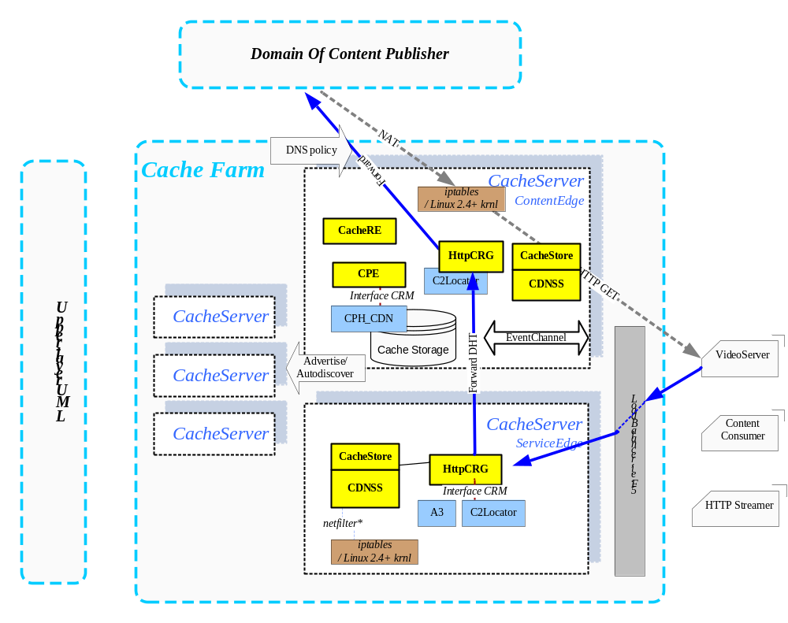
Figure 1 Cache Domain Overview

The above figure gives an overview of the components scoped in the architecture.

CacheServer Farm/Domain
A CacheServer is a machine powered by TianShan components that provides the downlink consumers high throughput capacity with well reduced uplink bandwidth allocation. It is based on the local caches of some common contents with higher popularites.

For the scenarios of video-on-demand, usually the CacheServer is deployed on the headend near to the edge streaming servers. When the needs of content consumers get higher, the headend usually consists of multiple CacheServers, which made up a CacheServer farm or Cache Domain.

For an individual transaction of content download to the downlink consumers, the CacheServers in a CacheFarm may acts as one of the following:

ServiceEdge (SE) | The CacheServer that edge content consumer first query/locate for acquiring a content or some subfiles/segements of the content
ContentEdge (CE) | For a given content, the CacheServer within a cache farm who has highest priority, according to DHT-based algorithm, to cache the content, it usually is the CacheServer who acquires the content copy from the external domain
ContentEdge (CEn) | The CacheServer who host a given transfer session. Normally it will be the ContentEdge, but also can be the rest if the ContentEdge loads high

Logical Components and Interfaces
The cache domain of TianShan On-Demand Architecture is partitioned functionally into a number of logical components. Each component is defined in a way that the interchangeable module implementation the common interfaces can be introduced to work with the rest of the system. For example, multiple CacheServers can be introduced into the system as long as they implement the defined interfaces. On other hand, it is anticipated that in some cases, implementations may integrate several components into a single product or solution.

The key logical components involved in cache domain include:

Stream Service (SS) | A software module manages the local video stream devices, takes the stream setup and stream control commands to drive the stream behavior
ContentStore (CS) | A software module manages file-based volume(s) for media contents. A Content may consists of multiple member files
CacheStore | A software module extends ContentStore by considering the local content as cache copies. It manages and maintenances the liftcycle of cache copies and dispatches the tranfering sessions among the CacheStore instances within a cache domain
ContentProvision Engine (CPE) | A software module covers content provision that includes content fetching, transcoding or processing, saving to the destination storage
ContentProvision Helper (CPH) | A plugin of CPE to implements an individual or multiple content provision methods
HTTP Client Request Gateway (HttpCRG) | A software module as one implementation of the TianShan Client Request Gateway covers the HTTP-based communication with clients. It translate TianShan communication into HTTP-based protocol
ClientRequest Module (CRM) | A plugin of ClientRequestGateway to implement client defined extension specification to the base protocol specification

Asset Stacking and Dispatching
This section describes the DHT-base algorithm on how to dispatching the requests to the ContentEdge by considering asset stack and graceful farm upgrade and downgrade.

This design takes md5 checksum as the base of various hash key used. The md5 checksum is a well-accepted manner for the DHT purpose for the following reasons:
- It can covers any input value to a 16-byte fixed length md5 checksum value
- The md5 checksum values are known have a wide distribution
- The calculation of md5 checksum take a fair cost of CPU

Raw Distance between Content and CacheServer
In this document, distance is a concept to represent the preference for a server to host an object. Especially for the content object and CacheServer instance, the distance between them shows such a preference of asset stacking.

For a content A, assuming the md5 checksum of its name is 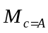, where = 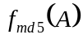.
So for a CacheServer whose unique netId is X, 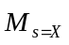=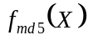.
And both are fixed 16-byte values. We divide the 16 bytes into 4 groups with 4 bytes each.
byte0 | 1 | 2 | 3 | 4 | 5 | 6 | 7 | 8 | 9 | 10 | 11 | 12 | 13 | 14 | 15
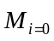 |  |  |  | 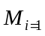 |  |  |  | 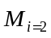 |  |  |  | 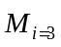

Thus the above md5 checksum can be represents as:
- The checksum of Content A consists of four 4-byte groups: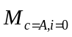, 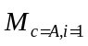, 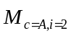, 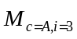
- The checksum of CacheServer X consists of four 4-byte groups: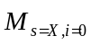, 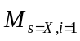, 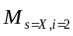, 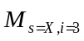

The raw distance between Content A and CacheServer X would be defined as:
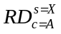= 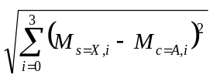

For a cache domain that has CacheServer X, Y, Z, …, the server has the least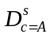will be considered as the ContentEdge for Content A..

Distance with Load Considered
Once the raw distances between the content and CacheServers are calculated, the CacheServer candidates can be ranked by sorting the raw distances from the least to the highest. The system takes a reversed Zipf’s law to reach expectation on how frequently a CacheServer would be selected for a given Content.

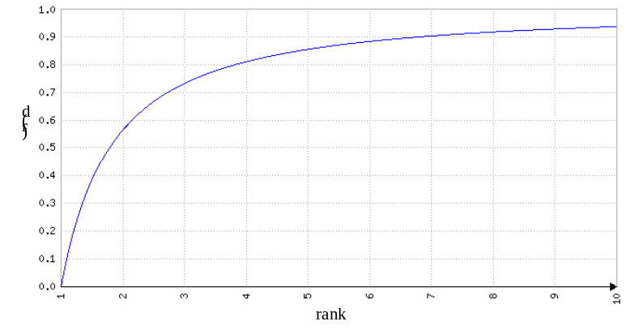
The above curve was based on a formulate
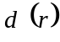 = 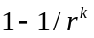 where k=1.2
where the rank-based distances of ContentServers are in a range of [0, 1). And the ContentEdge, who ranks top, has 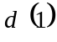 = 0 to the given content, while the secondary ContentEdge has 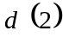 near 0.6 in the sample and so on. This represents the preference to take it to serve the downloading the given content much than the other CacheServers.

Due to the popularities of some hot contents, the ContentEdge of a given content may be well allocated and running busy. The secondary ContentEdge (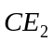below) is wished to serve the downloading of the content. So the loads of ContentServers are considered in the selection of candidate server. There are various factors to measure the load of a server, for the purpose of a CacheServer, the following loads are prioritized:

Import bandwidth | The bandwidth of uplink taken by the CacheServer to replicate a local cache from the external storage. The same bandwidth usage can link to that of disk write with a defined ratio so that this factor also reflects the usage of disk write
Local stream bandwidth | The bandwidth subtotal of the stream session pumped from local cache storage to downlink clients. On CacheServer, this is also the primary usage of disk read
NAT stream-thru bandwidth | The subtotal bandwidth of NAT stream-thru sessions. This normally doesn’t affect disk io but do employ the throughput of both uplink and downlink Ethernet ports of CacheServer
Besides them, some other factors are potentially added in up to the learned lesions from the tests, such as the CPU, memory usage and so on. The different variables of load factors will be integrated into one load value, in a range of [0, 1], up to the CacheServer’s implementation. This integrated load values (IL) are advertised by every ContentServer via heatbeats. Any single ContentServer therefore will be able to maintenances a list of servers in the neighborhood. Whenever the ServiceEdge tries to forward a request it will evaluate the rank-based distances by considering the load of the servers.

The rank-based distance and the integrated load value 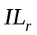are considered as two dimensions for the selection. The final distance 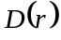 of a ContentServer 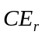to the given content takes the following formulate:
= 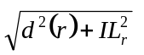

The selection also provides a schema among the multiple ContentServers by the following statement:

For a given content, the load 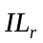= 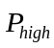 of ContentEdge can be considered equally as the load 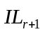= 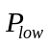 of ContentEdge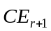, or 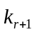 *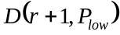 = 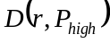. In which, is constant and 0 << < 1.

For given constants r and, because *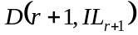 and 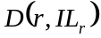 only has one point of intersection and both grow by 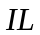, thus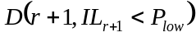 < 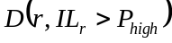

For example, if = 80% and =20% upon the configuration, when the ContentEdge 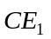loads higher than 80% and the secondary ContentEdge loads no more than 20%, the secondary ContentEdge is responsible to take the place of to serve the new request. So on for the 3rd to contribute power when also loads high

Content Popularity and Cache Lifecycle
This section describes how the content popularity is measured, and how it affects the caching.

The popularity basically is the rank of the contents according to how often they are accessed. However, computing or ranking millions of contents can hardly be an option.
Many research shows than content access frequency and the popularity ranking follows Zipf’s law, the following was from the data collected from one of the large-size site:
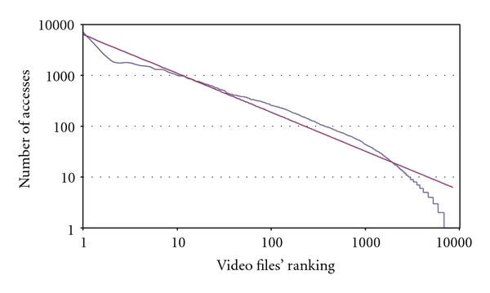

Thus, in this design, the system takes Zipf’s law to measure the popularity via the access frequency of the contents.

The measure of popularity of content helps on two purpose:
- To determine whether it is necessary to cache the content into local CacheStore from the external storage
- When the server is running out the space, which is the most unpopular content to delete to free space for new caches

The first primarily focus on the missed contents and the other requires the historical access counts of cached contents. The system offers two different ways to cover them according to the focus.

For the first, the CacheStore has an in-memory list about the missed contents. To prevent the list from growing to infinite, the server defines a time window to expire old counts and evict the item from the list.

For the second, the CacheStore saves the count in DB recording by taking delayed-write technique to minimal the needs of disk write. To find out the most unpopular contents among millions of contents, the server groups the content by hash distribution, and caches a smaller list of near most unpopular contents. Also the list would be refreshed by exchange data with the on disk DB records. If a good hash algorithm is selected, the content groups can be at a fair distribution with near amount of contents each. The in-group cache exchange between the new content and old unpopular content reflects the overall need of exchange on the server. This grouping helps the list refresh and quick determination of evicting.

Long Tail of MOD Contents
It was well known in the VOD area that most of contents follow long tail about their access count during the lifecycles. Omitted

Daily User Requests Rate in a Week
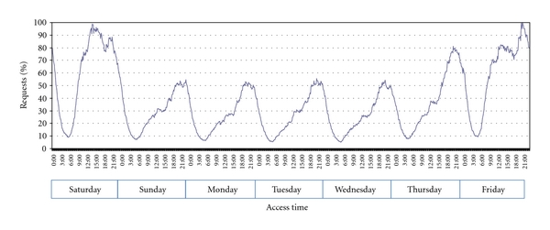
The above figure describes user VOD watching behavior in a week according to the data collected from a large-size live site. The curve oscillates fiercely during weekend but smoothly on the work days.

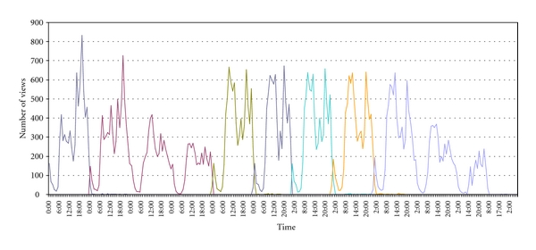
The next figure was the daily access about a typical MOD content in its short life period, which also confirms the hourly pattern.

Content Provision to Replicate Cache
This section describes how the content gets cached to local storage of CacheServer.

When content is missed in the cache domain but is recognized as a popular one in the CacheStore, the selected ContentEdge is responsible for downloading the content from the source external storage and then replicate the content on local storage. The CacheStore here borrows ContentStore attached to drive CPE to perform content provisioning. For the most on-demand assets completed on the source storage, CacheStore drives CPE to propagate content by copying all the member files down at a faster speed, which is known cost less. For the incomplete assets that are recording on the source storage, CacheStore drives CPE to only download the main file and perform NGOD-compatible trick generation on fly. In such a way, the local cache replicas can become available for the downlink clients to access before they get completed.

As described above, when the ContentEdge loads high continuously, the secondary ContentEdge may serve the clients and reaches the popularity threshold as well. Natively, can take the above same way of to replicate the content cache from the external storage. Especially in the deployment that the uplink bandwidth is considered as the most expensive, as an option, may try to replicate the cache copy from if the latter’s load allows.

Cache Work Flows
This section describes the reference work flow of some core operations as a design guide. The implemented work flow may have more details or some minor optimizations up to the integration and is beyond the scope of this specification.

Not Cached in the Domain
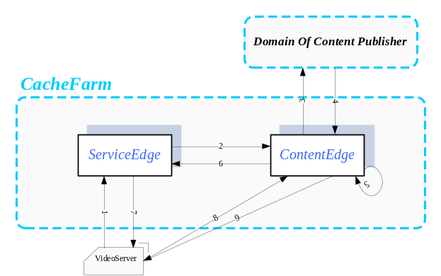

N1 | A video server at head end, the content consumer, calls its ServiceEdge to locate a content for transferring
N2 | Up to the DHT based selection, the ServiceEdge determines which the ContentEdge is and forward the request to it
N3 | The ContentEdge finds the requested content is missed in local cache storage, then it forward the request to the external storage up to its definition maps to the content provider’s domain
N4 | The external storage provides the URL to transfer the content
N5 | The ContentEdge setup a transferring thru its NAT to the external storage and translates the URL of S4 to its NAT interface
N6 | The ContentEdge passes the translated URL to the ServiceEdge
N7 | The ServiceEdge forwards the translated URL to the client
N8 | The client takes the URL to download content thru the NAT of ContentEdge
N9 | The content is transferred thru the NAT

Cached by ContentEdge
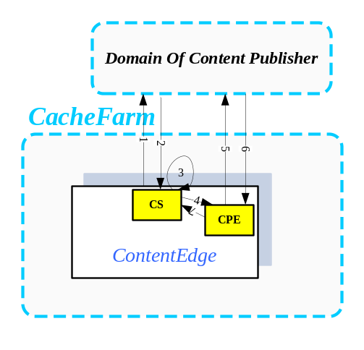
E1 | Upon the popularity of a certain content, the CacheStore of ContentEdge determines to cache a content from external, it issue Content locate request to the external
E2 | The external storage responds with transferring URL, the PWE state and other status data of the content
E3 | On ContentEdge, the CPC links to the CacheStore/ContentStore determines the provision method to take (i.e. PWE for c2pull)
E4 | Setup the Content Provision Session on the local CPE instance
E5 | CPE takes the URL of S2 to fetch the content from external
E6 | CPE receives and saves the content down into the cache storage, with trick generation on fly if PWE

Once the Content has been cached by ContentEdge, it can then stream the cached copies with no uplink utilization to the external
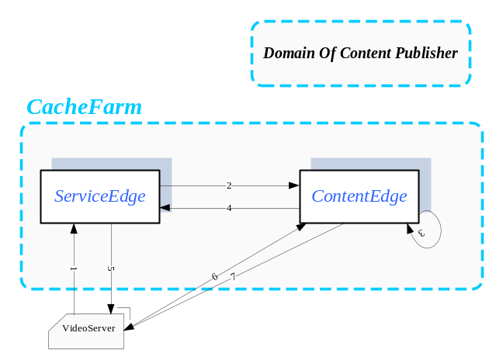
The work flow would be changed to the following
L1 | A video server at head end, the content consumer, calls its ServiceEdge to locate a content for transferring
L2 | Up to the DHT based selection, the ServiceEdge determines which the ContentEdge is and forward the request to it
L3 | The ContentEdge finds content in its local cache storage, then it create a stream session on its local attached StreamService
L4 | The access to stream session would be passed back to the ServiceEdge
L5 | The ServiceEdge takes the URL of stream session and compose the response to send to the client
L8 | The client takes the URL to download content thru the stream session of ContentEdge
L9 | The StreamService of ContentEdge pumps the HTTP stream to the client

ContentEdge Loads High
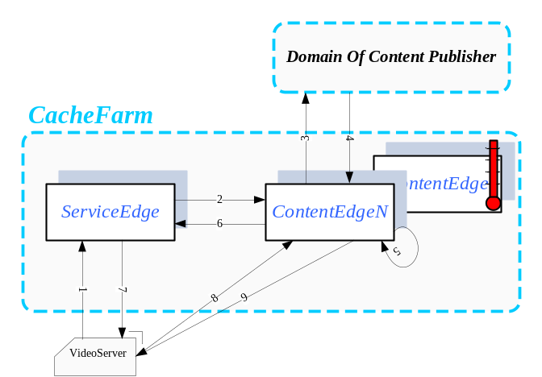

For certain content, when its DHT-based ContentEdge loads high, the ServiceEdge will consider the CacheServer with second shortest distance to the Content as the candidate server to host the transferring. The one with third shortest distance if both loads high and so on. We name this secondary or further as ContentEdgeN. The work flow in such cases is similar with that of ContentEdge described in the previous sections

CacheServer Lost
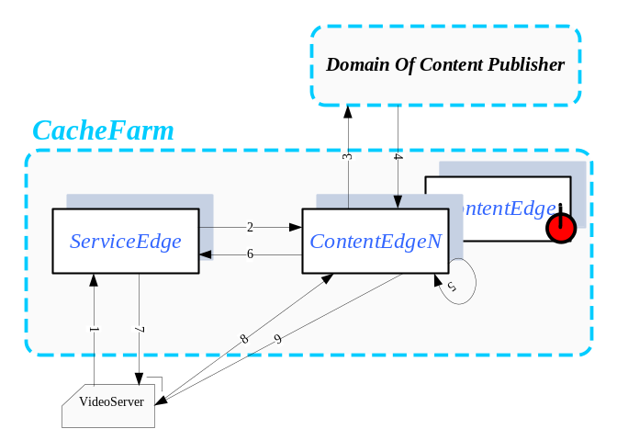

If a CacheServer gets lost or offline, benefited by the advertising and auto discovery, all other CacheServers in the cache farm will detect such a lost per event published or heartbeat timeout. If the lost CacheServer happened to be the ContentEdge of a certain content, the CacheServer with second shortest distance to the content will be picked as the new ContentEdge of the content.

The work flow of the new ContentEdge will be same as the previous section described on ContentEdge.

CacheServer Joins
If a CacheServer is back or newly added, it properly can be the ContentEdge of some contents and ContentEdgeN of the rest.

For those contents that take the new CacheServer as the ContentEdge, the contents may be re-propagated shortly to build up the cache upon to the popularities. On the other hand, the existing ContentEdge becomes the one with second shortest distance, it can continue to contribute if the newly joined ContentEdge loads high, gets lost or goes offline.

Component Design Specification

Software Components
In this design specification, the key logical components are arranged into the following software components as shown in figure 1
- CDNSS | An NT service or Linux daemon that consists of the logical module of:  ContentStore – manages the cached content copies  CacheStore – extends ContentStore on the cache-oriented logic  StreamService – the HTTP based stream pump
- CRM_C2Locator | A plugin of HttpCRG to cover NGOD C2 specification or C2-like content locate/query specification
- CRM_A3 | A plugin of HttpCRG to cover NGOD A3 specification by translating TianShan ContentStore API and events

CacheStore
CacheStore appears as a new layer over ContentStore, it covers the functions to turn a normal storage into cache storage. This section describes the design specification of the layer of CacheStore, which logically can be divided into:
- Remote API | The API interface for the clients to interact with CacheStore
- AutoDiscovery | The internal module that advertises self and collect the status of other CacheStore instances in the neighborhood
- Cache/Folder/Popularity and Space Management | The internal module that extends ContentStore to manage the cache copies’ lifecycle, popularity of content, distribution among folders, storage spaces
- Selection Logic | The internal module that do the selection for the new content transferring session
- Propagation Task Management | The internal module that covers the running propagation tasks up to the cache determination

CacheStore in CDNSS
In the deployment of Cache Domain, the CacheStore will be as a part of new version of CDNSS as shown in the figure below:

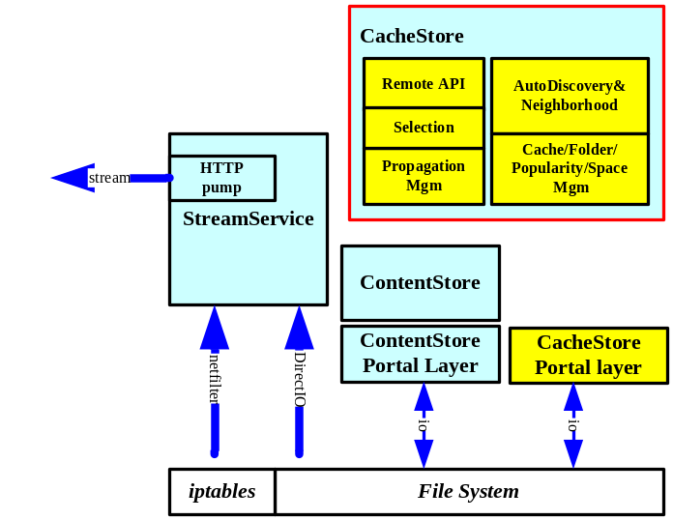

Class Diagram of Remote API

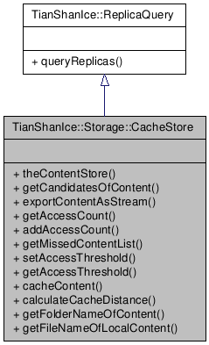

Advertising and Auto Discovery
When an instance of CacheServer is up to running, it advertising its existence via multicast heartbeats to its neighborhood, which minimally including the information listed in the following structure:
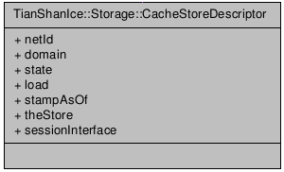

- netId | The unique netId of the CacheStore within the domain
- domain | The domain name of the CacheStore that belongs to
- state | The state of the CacheStore
- load | The load value of CacheStore as of the moment of stampAsOf, quantized within a range of [0, 10000]  This load value minimally covers the downstream load but may be not limited to cover those such as disk read, cpu and memory
- loadImport | The load value of the CacheStore’s import capacity
- loadCacheWrite | The load value of the CacheStore’s capacity to save cache files
- stampAsOf | the timestamp of load advertized
- theStore | Access to the CacheStore interface
- sessionInterface | The interface that can setup stream sessions of contents to export from the CacheStore

Each CacheStore also works as a listener to collect the advertisement messages from the neighborhood. By taking those information, each CacheStore will be able to build up a list of knowing CacheStore instances near by. The information would be referenced by the selection logic when it determines the CacheStore instance to host a new transfer stream session

Cache Folder Structure

The CacheServer is designed to hold up to millions of different contents, and each content may has multiple member files. When file segments involves, the number of files will again multiplied well. If save the files all in one single folder or directory, the known file systems would be extremely challenged at their performances. Thus, CacheStore internally organize the huge amount of content in a 2-layer folder structure, each parent folder has 256 subfolders. In other words, the top home directory has 256 1st layer subfolders and each 1st-layer subfolder has 256 2nd-layer subfolders, and the latter we may call as leaf folders.

Files of contents will only be saved under the leaf folders, and no member files of a same content will be put across different subfolders. CacheStore converts md5 checksum of content name to the hash key to dispatch locating cache of content among the two-layer subfolder structure, and it also exports the following utility API at this conversion.

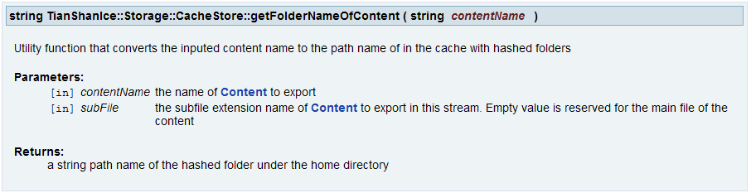

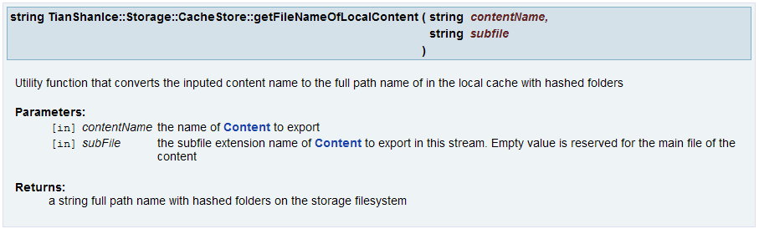

With such a folder structure, for a 2-million contents cache storage with each content has 4 member files, a typical leaf folder will averagely hold 256 files (=2M*4/256/256).

The CacheStore lies on the top of ContentStore. It invokes ContentStore API to cover Content based operation such as create, open, destroy and so on. Also it takes the ContentStore database to store its cache-oriented metadata.

With this internal module, the CacheStore provides a transparent layer for those clients who access content only via unique content names.

Near Most Un-popular Content List
Additionally, the CacheStore has its own automation about keeping and monitoring the content popularity in assistant to cache determination and space releasing. The factors to measure content popularity will be stored as meta data of content object in ContentStore DB. (Please see the next section about the data how to calculate the popularity of content.) The CacheStore has tasks to periodically scan the contents from the 1st-layer folder down, each of such scan will fresh a list that includes the most un-popular contents at a given percentage of total contents under the 1st layer folder. The scan tasks can be executed simultaneously up to their own timers.

Once the most un-popular content list is refreshed per the scan, the items in the built up list will have two ways to be eliminated from the list:
- When the content is recently ordered as a stream session
- When the free space is about run out, CacheStore determines to flush out the most un-popular content, it calls ContentStore to destroy the cache copy and erase it from the list end

The list would only be decreased but increased between the two scan and refresh. When the list is reduced to half of its original size, the CacheStore will trigger an instant scan to refresh the list of that 1st-layer folder regardless its timer. In such a way, the most un-popular contents all over the millions of cache copies will nearly be enumerated in multiple lists maintenance by CacheStore for fast indexing but with lower cost

Content Access Frequency vs Popularity
To determine the popular content to cache and the most unpopular content to free space, it is a function of CacheStore to measure the popularity of the content. The popularity basically is the rank of the content of the total known contents. The computing for popularities among millions of contents can hardly be an option. Instead, CacheStore takes the frequency that a content is accessed recently to determine the popularity of the content by following Zipf’s law-like rule.

The access frequency of a content is measured by counting the times that the content has been accessed within a float time window with fixed time length. The recent frequency means the count in the float time till the current time. ContentStore allows the operator to configure the length of float time window.

The CacheStore also represent the popularity of a content via the matter of the original data how it measures the frequency in the API below:

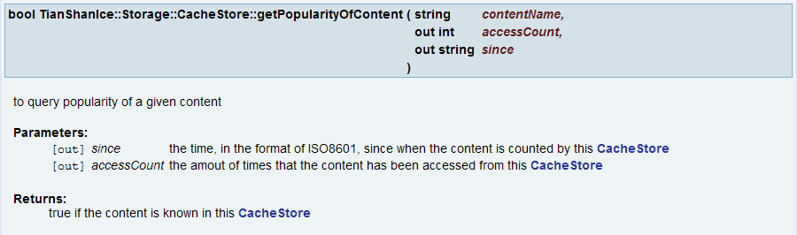

Export Content as Stream
As the major API, CacheStore introduced a concept of exporting content stream, which provide an effective way on content locate queries and export integrative-ly and transparently. It also connects the CacheStore instances in the domain and the other components, such as ContentStore and CPE. The following is its prototype

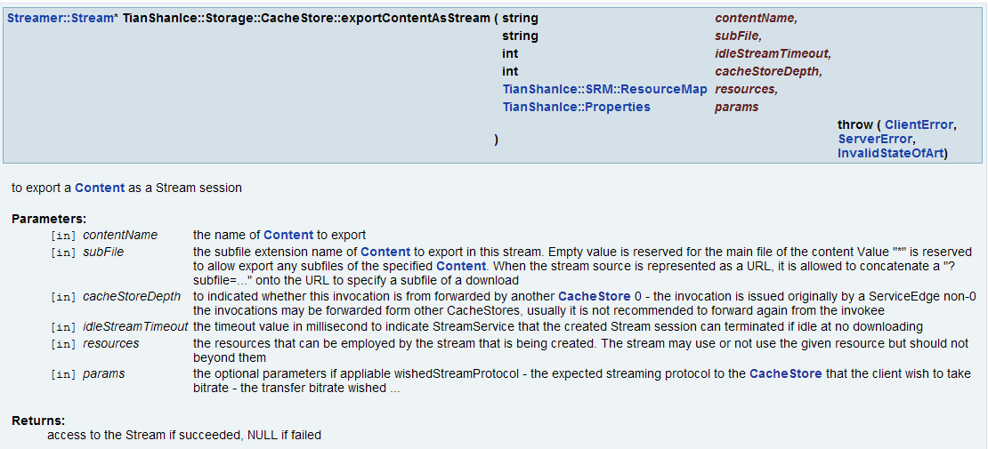

A reference sequence diagram is also shown as below, which has the forward from ServiceEdge to ContentEdge involved.
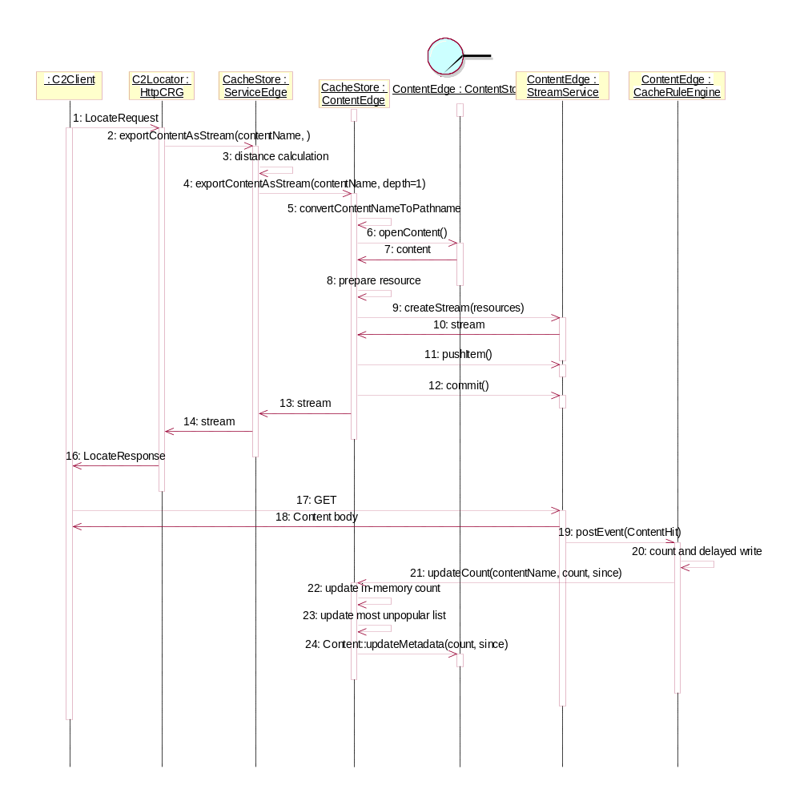

Selection Logic
This section describes the selection logic of the CacheStore according to the sequence diagram shown in the previous section

SL0 | Before the selection, the CacheServer has a list of its neighbor instances collected by the internal module of Advertising and Auto Discovery. Each of the instance has a unique netId, which can be converted to unified 16-bytes md5 checksum
SL1 | When a content C is requested, the ServiceEdge converts the content name to unified 16-byte md5 checksum, and then
SL2 | calculate the load-applied distances that from the content to CacheServer instance, Assume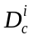 means the distance of content C to CacheServer i. From a neighbor that includes ContentServer 1..n, the CacheServer therefore will have 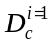, 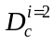, …, 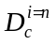.
SL3 | By sorting by the distances, the that has the least value will be picked as the ContentEdgeN to serve the request. Most likely it will be the ContentEdge of the content, because has considered the load as well, in the case that the ContentEdge loads high, i could be the secondary ContentEdge
SL4 | If CacheServer i isn’t the ServiceEdge itself, jumps to SL7
SL5 | ServiceEdge forwards the exportContentAsStream() request to the CacheServer i by indicates forward depth=1; Otherwise, jumps to SL6
SL6 | CacheServer i takes the request, because of forward depth=1, it will not prefer to do more forwarding
SL7 | CacheStore of CacheServer i checks it local ContentStore if the content exists, jumps to SL10 if yes
SL8 | CacheStore of CacheServer i maps the providerId to the URL to the external storage. Upon available NAT resource, it issues a LocateRequest (probably follows NGOD C2 spec) to the external.
SL9 | CacheStore takes the parameters from a successful response of LocateRequest, including the URL to the transfer session, PWE and so on, in order to append a resource structure
SL10 | CacheStore prepares a resource structure that minimally covers the client interface (IngressCapacity in NGOD), timeout. If SL9 is applicable, the resource structure will include them as well
SL11 | CacheStore calls StreamService to create a stream with the resource prepared in S10.
SL12 | If SL11 failed for some reason, NULL stream will be returns, jumps to SL15
SL13 | CacheStore insert the content into the created stream instance and commit
SL14 | The StreamService prepare the stream session ready by taking the parameters in resources. For those streams in NAT mode, the StreamService update the access URL by mapping them to the local URL
SL15 | If this is the forwarded exportContentAsStream(), the forwardee returns the stream object to the ServiceEdge
SL16 | If ServiceEdge receives a NULL stream from the forwardee, it jumps to SL3 for the next candidate CacheServer j, unless the max retry count has been reached
SL17 | The CacheStore of ServiceEdge pass the stream object to the requester, (C2Locator of ServiceEdge here). The latter may read the parameters from the stream object and compose the response to the client

Missed Content List
In order to cache content to local, the CacheStore drive the CPE runs on CacheServer to hosts content provision session indirectly via ContentStore interfaces.

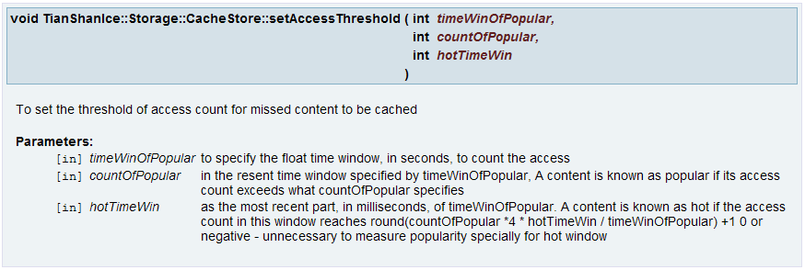
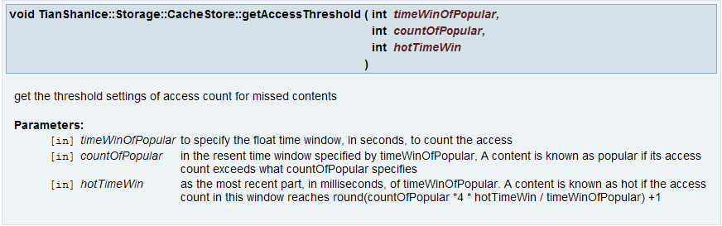

The API setAssetThreshold also reserves a way to meet user’s request pattern described in Section 3.4.2 Daily User Requests Rate in a Week. The Administration tool or rule-based utility will be able to adjust the hot window for the hours during a day/week.

CacheStore can also respond a query for the missed content list by provide the following API:
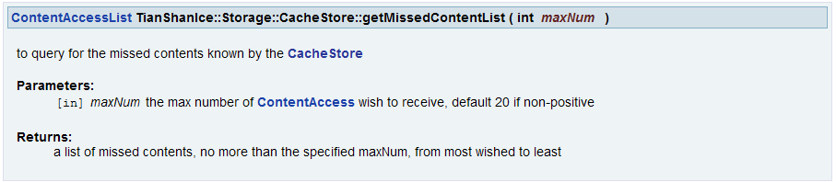
An administrative tool or rule executer can take this list to pick content to force the CacheStore to perform a caching in addition to the built-in automation:
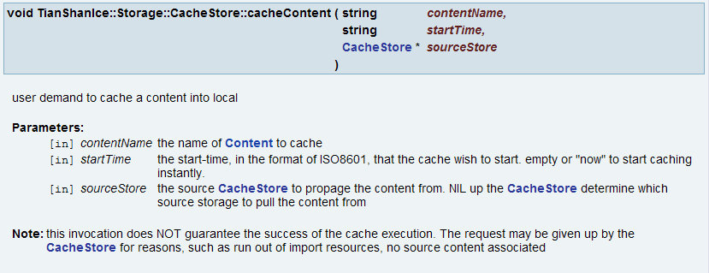

Stream for Propagation
In order to cache a content to local, the CacheStore drive the CPE runs on CacheServer to hosts content provision session indirectly via ContentStore interfaces.

When the content has to be cached from the external storage, CacheStore will call ContentStore API Content::provision() to ask CPE to import by giving a URL to the session interface of the external storage. The CacheStore has a configured table to dispatches the external source storage by the provider Id of the contents, which usually is represented as a domain name. A configuration table may be defined like:
<ContentDomains defaultSessionInterface=”c2http://172.12.23.54:8099/” natPort=”28790”>
<Provider name=”hbo.com” sessionInterface=“c2http://10.122.5.34:8080/” natPort=”28791” />
<Provider name=”news[1-3].cnn.com” sessionInterface=“c2http://172.12.23.54:8080/” natPort=”28792” />
<Provider name=”news[4-9].cnn.com” sessionInterface=“c2http://172.12.23.55:8080/” natPort=”28793” />
</ContentDomains>

In this sample, when a content asset of the provider hbo.com is requested for and it appears missed in the local cache domain. One CacheServer, normally the ContentEdge, will try to download from the external storage via the session interface c2http://10.122.5.34:8080/. And if the content was of provider news7.cnn.com, the CacheServer communicate c2http://172.12.23.55:8080/ to download it, and so on. If it was of a provider unlisted above, i.e. Warnerbros.com, the CacheStore would try to communicate c2http://172.12.23.54:8099/ for the assets.

For the case that ContentEdgeN takes the place of a heavy loaded ContentEdge, see section for more details, it is more preferred to duplicate replica in the local network. In this case the internal propagation management module of CacheStore will firstly call API exportContentAsStream() to the source CacheStore, and then drive the local Content to provision from the URL read from the Stream of the source CacheStore. During the lifetime of the provision, the CacheStore who issued the provision demand will
- Keep the stream session of source CacheStore alive
- Listens the provision events from the CPE to track the progress of the processing

When the provision gets completed, notified by CPE, the CacheStore will teardown the stream session from the source CacheServer to release resource instantly for new sessions

Statistic and Client

ContentHitrate | Each CacheStore represent the local content hitrate as a measureable variable, which including the local content hit counts and the request forwarded to external storage. This should be able to refresh the counters via float time window
Null streams | When the API exportContentAsStream() returns null streams, CacheStore should be able to count such failures, also via a float time window manner
Latency of forwarding | CacheStore export the latencies of forwarding  - within the cache domain  - to the external storage
Propagations from external | CacheStore counts the running propagations from the external storage and the task in pending
Content numbers in folders | CacheStore exports the amount of files under the 1st layer folders via minimal, average and maximal numbers to help measuring the distribution of a large amount of contents

StreamService for CacheServer

NAT and PassThru
For those contents that have not yet been cached in the local domain, the CacheServer works as a NAT gateway to pass through the communication between the client and the external storage. In such a way, the CacheServer provides a transparent interface to the downlink content consumers as they are the source server of the contents like normal, and it also covered the networking considerations to avoid export background external content storage directly to the content consumers.

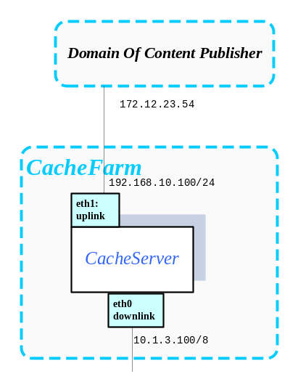

The CacheServer take iptables of Linux 2.4+ as the implementation of NAT, which leads to minimal cost and effective performance. To cover a the content domain table sampled like the previous section, the following NAT iptables rules would be applied:

iptables -t nat -A POSTROUTING -o eth1 -j SNAT --to-source 192.168.10.100

iptables -t nat -A PREROUTING -p tcp -i eth0 --dport 28790 -j DNAT --to 172.12.23.54:8099
iptables -t nat -A PREROUTING -p tcp -i eth0 --dport 28791 -j DNAT --to 10.122.5.34:8080
iptables -t nat -A PREROUTING -p tcp -i eth0 --dport 28792 -j DNAT --to 172.12.23.54:8080
iptables -t nat -A PREROUTING -p tcp -i eth0 --dport 28793 -j DNAT --to 172.12.23.55:8080

Where the first line was to cover the uplink interface that communicates to the external storages, and the rest reflect each ContentDomain defined in the table, including the default interface.

The StreamSerivce of CacheServer, an internal module of CDNSS here, takes netfilter to hook the traffic usage of each iptables rule as a new type of resource usage. Its allocation logic for new stream sessions would not only consider the downlink streams pumped by itself, but also consider the NAT usage that have been taken from the NIC bandwidth.

At the first stage that we can read snapshot of NAT bandwidth, the StreamService take an approach to calculate NAT usage: Assume the query thru netfilter API gets bandwidth usage as W, and a new NAT stream session with bitrate b is created recently, the StreamService counts the new NAT usage as W+b. Because the client will soon start download or the created stream session on the source external storage would be expired, W+b would be shortly reflected in the next couple round of netfilter queries. At that moment, the NAT allocation in the StreamService may be counted as W+b+b and there is a overlap of one session’s usage. However, the NAT stream created in the local StreamService would not receive any touches from the client thus it would be soon expired locally, the StreamService therefore collects the above overlap soon to the true W+b.

Create Stream by Resource
In CacheServer, the CacheStore takes the Resource structure instead of PathTicket to setup stream. And the streams are unnecessary to renew tickets back to the caller. When the StreamService runs out of resource to supply a new stream setup, it can simply reject by returning a null stream

In addition to the resource parameters listed in section 4.5.1 LocateRequest Parameters to exportContentAsStream(), StreamService also takes the resource [rtTsUpstreamBandwidth] as the permission to perform importing for either pass-thru sessions or CPE ingestion. The StreamService can ignore this resource if the local content replica has been fully residential. The following are the definition of the fields of resource[rtTsUpstreamBandwidth]:

bandwidth | The bandwidth limitation can be taken to import the content from source storage
sessionInterface | When the local replica of the content is not available, this parameter indicates the external storage where to locate the content to import
sessionURL | This parameter indicates an already-generated transfer session for the StreamService to take for its importing content. If this parameter is available, the StreamService should ignore sessionInterface but taking this session instead

The Used Resource
StreamService should support the inquiry of the used resource of a given Stream.
rtTsDownstreamBandwidth | StreamService confirms the used resource minimally including the following:  - bandwidth – the bandwidth confirmed booked to guarantee the stream session  - sesssionURL – optional but required for CacheServer, to indicate where the receiver can catch the stream traffic
rtEthernetInterface | StreamService confirms the used resource minimally including the following:  - srcIP  - srcPort  - destMac  - destIP  - destPort
rtTsUpstreamBandwidth | StreamService confirms the resource if the importing is really employed in the session. If applicable, it minimally including the following:  - bandwidth – the bandwidth confirmed booked to guarantee the stream session  sesssionURL – optional to echo the usage of the input

Stream Events

Multiple downloads of a Stream Session
- multiple download by reusing a stream session
- to specify idle timeout for streamservice

CPE and CPH_CDN
TODO: Gracefully downgrade/recover cpe capacity per long write at disk io

Import from External Storage
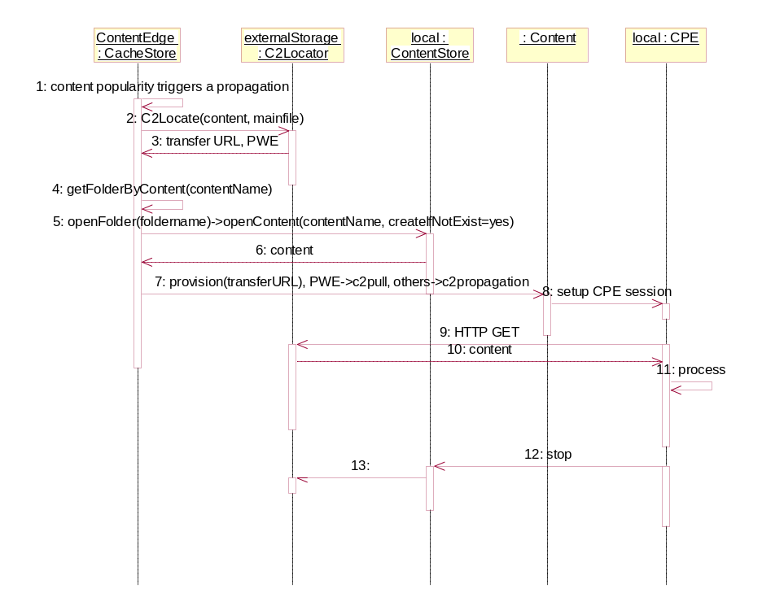
The CPE takes the existing content provision methods to import content from the external storage
C2Propagation | The method is identified by the URL protocol prefix c2http://  In the implementation of this method, CPE will issue C2 LocateRequest for each member file of the content, index file first and then the main file and the trick files learned from the index file, and download them each via a separate C2 transferring session
C2Pull | The method is identified by the URL protocol prefix c2pull://  In the implementation of this method, CPE will download the main file only thru the NGOD C2 specification. During the downloading, CPE will perform trick generation on fly and save the member files of the content to the local storage

As shown in the above sequence diagram, CacheStore issues C2 LocateRequest to the external storage first. Upon the status of “OpenForWrite” status returned in the LocateResponse, CacheStore will dispatch to take the two different provision methods:
- C2Propagation for those contents at the external source storage with OpenForWrite equals false, which cost less for the local CacheServer
- C2Pull for those contents at the external storage with OpenForWrite equals true. CPE of the CacheStore performs trick generation on fly, which cost more but may make the cache copy available instantly for downlink access

Peer-to-Peer Propagation within Local Domain (optional)
Both content provisioning methods described in the previous section will consume the uplink bandwidth to the external storage, which may cost expensive to go thru the networking such as WAN or internet. When a ContentEdgeN is chosen to assistant the busy true ContentEdge, a wish may be raised to propagate the content thru the local and faster LAN, as shown in the following sequence diagram.

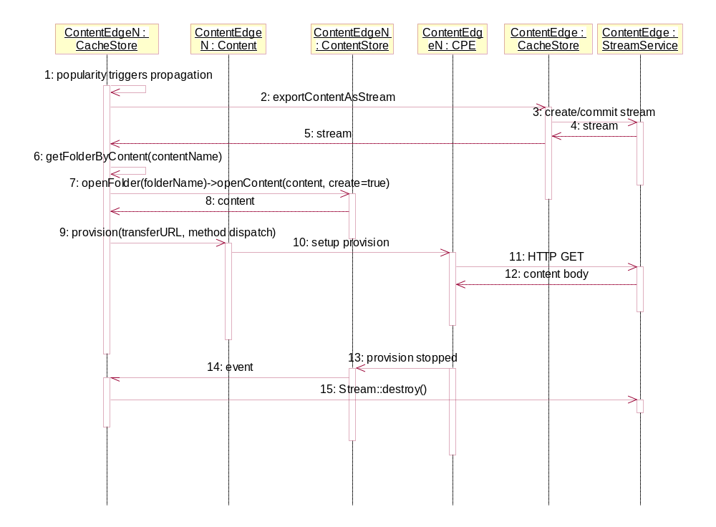
In this case, a clone of C2Propagation will be needed, while that of C2Pull appears not so necessary because it is better for ContentEdgeN to directly pull the content from the source external storage

To support propagate within the local cache domain, the new C2Propagation will need to cover:
C2 LocateRequest for each member file become unnecessary, the required parameters will be prepared in the stream object return from invocation to exportContentAsStream() from the source ContentEdge. Instead of the existing C2 URL in the format of c2http://<server>:<port>/, the new URL read from the stream returned by exportContentAsStream() will be C2 transferring session oriented in the format of:

c2http://<server>:<port>/[<path>/]<transfer-session-id>?fileset=true

Where the flag fileset=true indicates the transfer session is reuseable to download any member files of the file set of content. The new provisioning method therefore does not have to take different transferring session for each member file. Instead, all the member files of the content can share the same C2 transferring session to download. The HTTP GET takes the transferring session for member files by appending subfile=extfilename in the transferring URL. Some keywords are reserved for the extfilename:
subfile=index | Indicates to download the index file of Content of the transfer session.
subfile=forwardx,or subfile= | Both value forwardx1 or empty indicates to download the main file of the content

In the case that the true file extname does not equal to the above reserved keywords, the true file name of the file set is echo-ed via echo-ed via the header of Content-Disposition the HTTP response

For example, assume CPE received an URL from Content::provision() invocation:
c2http://<server>:<port>/[<path>/]<transfer-session-id>?fileset=true

Firstly it would issue an HTTP GET for the index file:
GET c2http://<server>:<port>/[<path>/]<transfer-session-id>?fileset=true&subfile=index HTTP/1.1

The StreamService of CacheServer would respond:
HTTP/1.1 200 OK
Accept-Ranges: bytes
Cache-Control: no-cache
Connection: close
Content-Disposition: attachment;filename=ASSET01112233445566_HBO2.com.VVX
Content-Range: 0-90881/90882
Content-Type: application/octet-stream
Date: Tue, 24 May 2011 04:28:42 GMT
Server: CDNSS/1.20
Transfer-Encoding: chunked
…
In which filename=ASSET01112233445566_HBO2.com.VVX will be the true name of the index file for CPE to save as
Like the existing C2Propagation method, CPE will download the head of index, parse and enumerate the member files of the content, then it tries to download the member files till the all the content files are propagated.
For the main file
GET c2http://<server>:<port>/[<path>/]<transfer-session-id>?fileset=true&subfile= HTTP/1.1

For the FF file:
GET c2http://<server>:<port>/[<path>/]<transfer-session-id>?fileset=true&subfile=FF HTTP/1.1

For the FR file:
GET c2http://<server>:<port>/[<path>/]<transfer-session-id>?fileset=true&subfile=FR HTTP/1.1

and so on.

HttpCRG and CRM_Locator
As shown in the sequence diagram of section 4.2.7 Export Content as Stream, with the new API exportContentAsStream, the logic of CRM_Locator is extremely simplized.

LocateRequest Parameters to exportContentAsStream()
subtype | Will be passed via the parameter subfile of the API
URI | The original URI in the client’s request.  Passed thru the parameter resourceRequirement[rtURI].resourceData[“uri”]
Client  TransferAddress | Will be passed via the parameter resourceRequirement[rtEthernetInterface].resourceData[destIP]
Server  TransferAddress | Optional in CacheServer, will be passed via parameter  resourceRequirement[rtEthernetInterface].resourceData[srcIP]
TransferRate | Will be passed via parameter  resourceRequirement[rtTsDownstreamBandwidth].resourceData[bandwidth][0]
Client  IngressCapacity | Optional. If this is applicable, the parameter resourceRequirement[rtTsDownstreamBandwidth] will be a range. Besides the minimal value resourceData[bandwidth][0] indicates the requested TransferRate, the maximal value resourceData[bandwidth][1] indicates the client’s IngressCapacity
Range | Optional. If this is applicable, the parameter params[“Range”] passes the value
CDN Type | Optional, can potentially be recognized from the URI.  When it is applicable, it is passed thru params[“CDNType”]
TransferDelay | Optional. When it is applicable, it is passed thru params[“TansferDeplay”] in milliseconds

HttpCRG and CRM_A3

Content Name Pattern
Comcast NGOD Specification identifies a content by Provider Id(PID) and Provider AssetId (PAID). The system takes the combination of PAID_PID as the unique content name

Persistent Contents
Those contents that imported via A3 interface will be considered as persistent contents in the CacheServer if an additional Content MetaData[“user.AssetExpiration”] is specified thru the meta data extension of NGOD A3 Specification. The CacheStore will exclude such contents from its most non-popular contents list to prevent them from deleting for free space

GetVolumeInfo & GetContentInfo
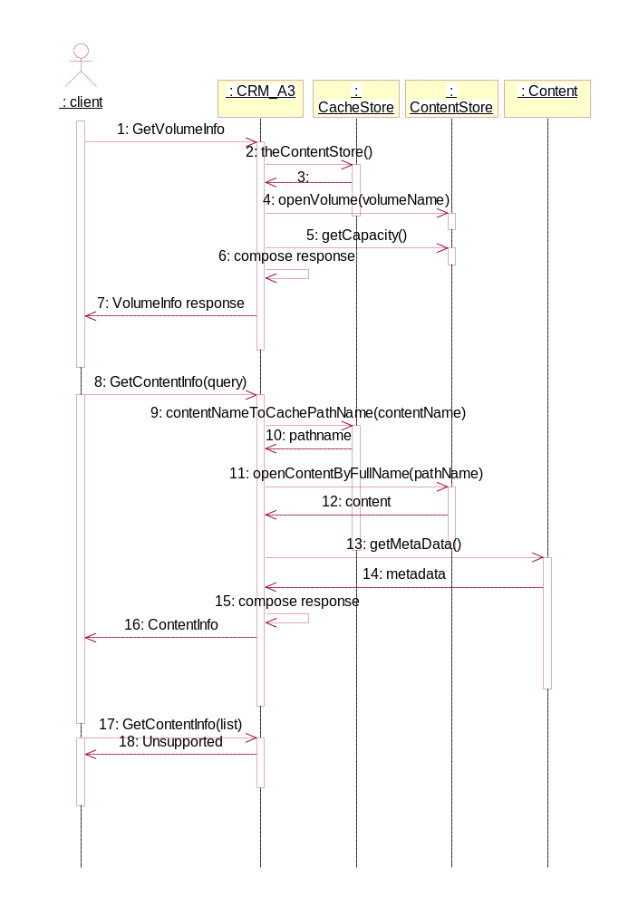

TransferContent & TransferStatus
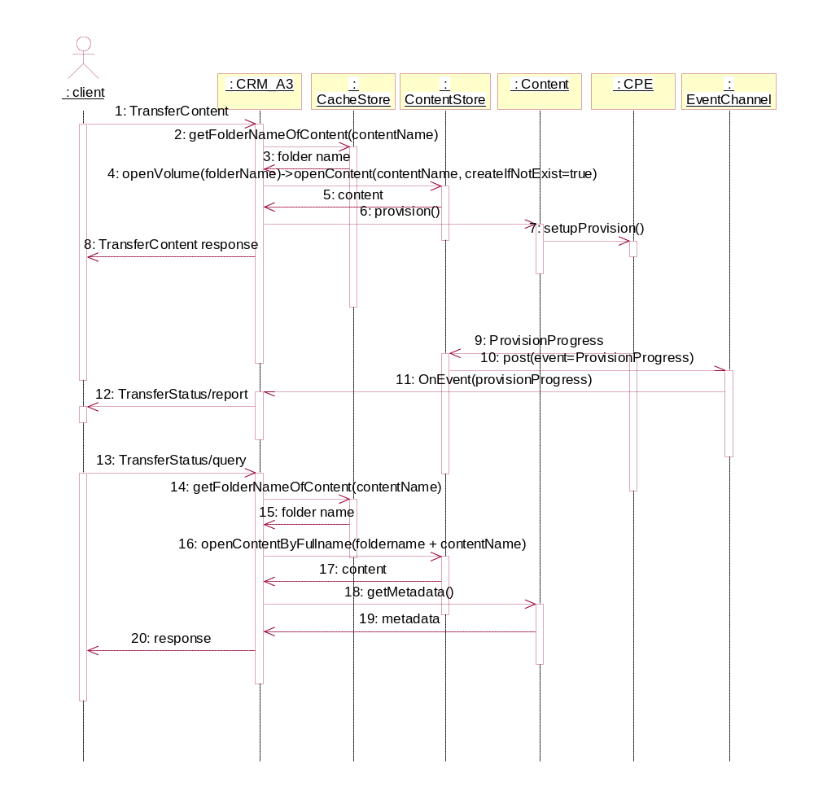

Event Rule Engine (EventRE)

Architectural Recommendations
This chapter describes some recommendations on the deployment and some scenario other than CacheServers for video-on-demad.

Support of FUSE Access

Sample Sequence of File Read thru Samba
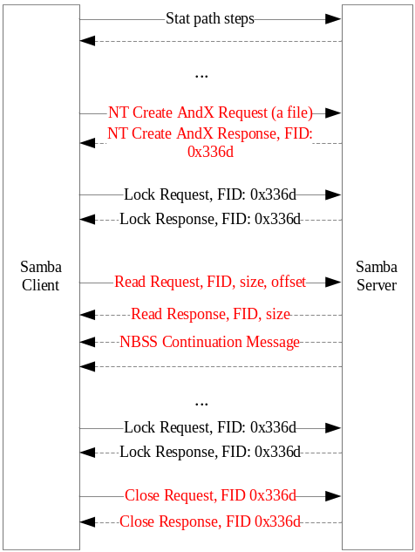

fstat(), file lock

Simulate File Access
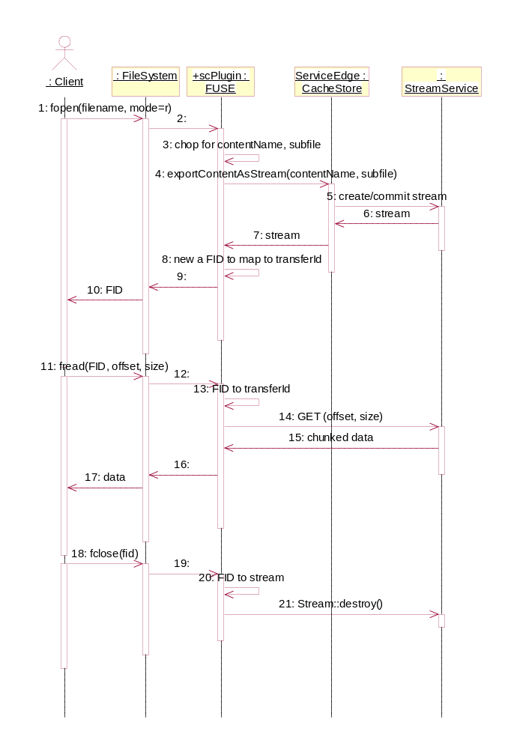

Appendix

Requirement Acknowledges
This section lists the acknowledges according to the requirement items of [N-1] CDN CacheGateway SOW:

Requirement ID | Description | Acknowledge
R1.1 | Compliant with C2 Locate and C2 HTTP Transferring | Section 2.3.2, 4.3, 4.4
R1.2 | Can work with different Stream Server vendors, including SeaChange FMS | Section 2.3.2, 4.3, 4.4
R1.3 | Understand local inventory of cache gateway. If content exist in local cache, directly provide C2HTTP streaming. | Section 3.3, 3.6
R1.4 | If content does not exist in local cache, still support C2Locate forwarding feature, and establish C2HTTP session getting the content from central CDN Library (e.g. through TCP tunnel) | Section 3.3, 3.6
R1.5 | Multiple volumes and streamers, streamer selection logic: asset stack and load balance | Section 3.3, 3.6
R1.6 | Can support multiple C2Locate forwarding points (SCS1.X only support one) | Section 4.3.1
R2.1 | Use cache methodology calculate content popularity based on all C2 locate requests |  | Section 3.3.1, 4.2.9
R2.2 | Send propagation request to mini-PS to request for new content |  | n/a
R2.3 | Delete non-popular content off from local cache storage |  | Section 4.2.5
R2.4 | Support manual delete contents |  | See ContentStore API
R2.5 | C2 propagation method does not support PWE.  C2 pull method does support PWE. |  | Section 4.4
R2.6 | Various cache methodology to manage VOD, and RTI contents, pro-active and re-active contents, |  | Section 4.6
R2.7 | Storage quota for different content types |  | Section 4.6
R2.8 | Configurable content source(s) |  | Section 4.6
R2.9 | Multiple replica in one cache gateway, e.g. at least 2 copies, 3 copies |  | Section 3.6.3
R2.10 | Multicast propagation |  | n/a
R2.11 | P2P, auto find content source. |  | Section 3.3 covered content locating but not via P2P manner  Section 4.4.2 covered P2P propagation (phase II)
R2.12 | Multiple segmented propagation |  | n/a
R3.1 | Policy based pro-active propagation  Metadata rule based policy |  | Section 3.3, 4.7
R3.2 | Resource based pro-active propagation  Network, capacity |  | Section 3.3
R3.3 | Policy requirements, more... |  | Section 3.4, 4.7
R4.1 | Cache local hit statistics |  | Section 4.2.11
R4.2 | C2Locate performance statistics |  | Section 4.2.11
R4.3 | SNMP query and trap |  | Section 4.2.11
R5.1 | Multiple Layer cache |  | Section 2.3.2, 3.6.1
R10.1 | Content count: at least 1M |  | Section 4.2.5
R10.2 | Cache Gateway Capacity 25%,  If Central CDN Library 200T, single cache gateway is 50T. |  | Section 2.3.1
R10.3 | Cache Gateway C2HTTP Streaming bandwidth is hardware dependent.  UML, two heads, 3000 @ 3.75Mbps across two UML heads. |  | Section 4.3

Key to Document status Codes: Work in Progress (W)An incomplete document, designed to guide discussion and generate beedback that may include several alternative requirements for considerationDraft (D)A document in specification format considered largely complete, but lacking review by other vendors. Drafts are susceptible to substantial change during the review processIssued (I)A stable document, which has undergone rigorous vendor review and is suitable for product desing and development, cross-vendor interoperability, and for certification tesing.Released (R)A stable document, reviewd, tested and validated, suitable to enable cross-vendor interoperability

