**Udacity Free Trial Screener A/B Testing**

**Experiment Overview**

At the time of this experiment, Udacity courses currently have two options on the course overview page: "start free trial" and "access course materials".

* If the student clicks "start free trial", they will be asked to enter their credit card information, and then they will be enrolled in a free trial for the paid version of the course. After 14 days, they will automatically be charged unless they cancel first.
* If the student clicks "access course materials", they will be able to view the videos and take the quizzes for free, but they will not receive coaching support or a verified certificate, and they will not submit their final project for feedback.

**Experiment Description**

In the experiment, Udacity tested a change where if the student clicked "start free trial", they were asked how much time they had available to devote to the course.

* If the student indicated 5 or more hours per week, they would be taken through the checkout process as usual.
* If they indicated fewer than 5 hours per week, a message would appear indicating that Udacity courses usually require a greater time commitment for successful completion and suggesting that the student might like to access the course materials for free. At this point, the student would have the option to continue enrolling in the free trial or access the course materials for free instead.

**Experiment Setup**

**Primary Aim:** improve the overall student experience and improve coaches' capacity to support students who are likely to complete the course.

**Null Hypothesis:** not make a significant change and might not be effective in reducing the early Udacity course cancellation.

**Alternative Hypothesis:** reduce the number of frustrated students who left the free trial because they did not have enough time, without significantly reducing the number of students to continue past the free trial and eventually complete the course.

**Experiment Design**

## Unit of Diversion

Cookies. Although if the student enrolls in the free trial, they are tracked by user-id from that point forward. The same user-id cannot enroll in the free trial twice. For users that do not enroll, their user-id is not tracked in the experiment, even if they were signed in when they visited the course overview page.

## Metric Choice

**Invariant metrics:** used for sanity checks and will remain invariant throughout the experiment.

* Number of cookies: number of unique cookies to view course overview page (dmin=3000).
* Number of clicks:number of unique cookies to click the "Start free trial" button which happens before the free trial screener is trigger (dmin=240).
* Click-through-probability: number of unique cookies to click the "Start free trial" button divided by number of unique cookies to view the course overview page (dmin=0.01).

**Evaluation metrics:** must be observed for consideration in the decision to launch the experiment.

* Gross conversion:number of user-ids to complete checkout and enroll in the free trial divided by number of unique cookies to click the "Start free trial" button (dmin= 0.01).
* Retention:number of user-ids to remain enrolled past the 14-day boundary and thus make at least one payment divided by number of user-ids to complete checkout (dmin=0.01).
* Net conversion:number of user-ids to remain enrolled past the 14-day boundary and thus make at least one payment divided by the number of unique cookies to click the "Start free trial" button (dmin= 0.0075).

**Unused metrics:**

* Number of user-ids: who enroll in the free trial (dmin=50). The number of user-ids would be lower in the experiment group, since the same user-id cannot enroll in the free trial twice. For users that do not enroll, their user-id is not tracked in the experiment, even if they were signed in when they visited the course overview page. This metric is not normalized.

**Measuring Standard Deviation**

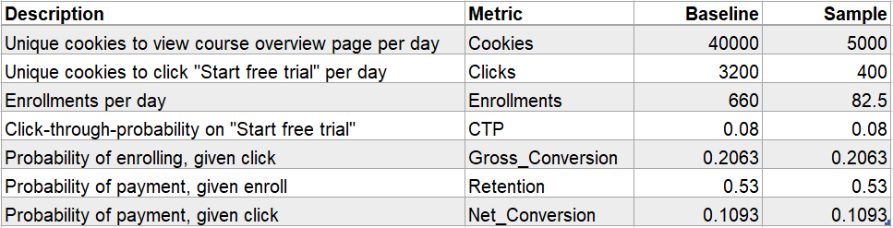

Udacity provided the baseline values for each metric and given a sample size of 5000 cookies visiting the course overview page, for each metric selected as an evaluation metric, I made an analytic estimated of its standard deviation (SE):

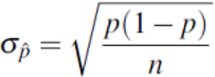

* **Gross Conversion:** n = 5000*0.08 = 400, p = 0.20625, SE = 0.0202
* **Retention:** n = 5000*(660/40000) = 82.5, p = 0.53, SE = 0.0549
* **Net Conversion:** n = 5000*0.08 = 400, p = 0.109313, SE = 0.0156

**Sizing**

### Number of Samples vs. Power

Given alpha = 0.05 and beta = 0.2 for selected evaluation metric, the sample size is based on the distribution of metrics, alpha (significance level), beta (false negative probability or type II error), baseline conversion rate and minimum detectable effect (practical significance or dmin).

Here I do not use Bonferroni Correction in the analysis phase, since the evaluation metrics in this experiment are closely related to each other, Bonferroni Correction would be too conservative.

According to the following conditions, every evaluation metric (gross conversion, retention, net conversion) is binomial distribution.

* Outcome either success or failure
* Independent events
* Constant probability
* Fixed number of events

By using the [online calculator](https://www.evanmiller.org/ab-testing/sample-size.html), I got the sample size 25,839 for each group (e.g. gross conversion):

* **Gross Conversion**

Baseline Conversion: 20.63%

Minimum Detectable Effect: 1%

Alpha: 5%

Beta: 20%

Statistical Power or Sensitivity (1-beta): 80%

Sample Size = 25839 enrollments/group

Number of groups = 2 (experiment and control)

Total sample size = 25839*2 = 51,678 enrollments

Clicks/Pageview: 3200/40000 = 0.08 clicks/pageview

Pageviews = 51678/0.08 = 645,975

* **Retention**

Baseline Conversion: 53%

Minimum Detectable Effect: 1%

Alpha: 5%

Beta: 20%

Statistical Power or Sensitivity (1-beta): 80%

Sample size = 39155 enrollments/group

Number of groups = 2 (experiment and control)

Total sample size = 39155*2 = 78230 enrollments

Enrollments/pageview: 660/40000 = 0.0165 enrollments/pageview

Pageviews = 78230/0.0165 = 4,741,212

* **Net Conversion**

Baseline Conversion: 10.93%

Minimum Detectable Effect: 0.75%

Alpha: 5%

Beta: 20%

Statistical Power or Sensitivity (1-beta): 80%

Sample size = 27413 enrollments/group

Number of groups = 2 (experiment and control)

Total sample size = 27413*2 = 54826 enrollments

Clicks/pageview: 3200/40000 = 0.08 clicks/pageview

Pageviews = 54826/0.08 = 685,325

Pageviews require the maximum of pageviews, in order to have enough power for each evaluation metric (gross conversion, retention and net conversion). Therefore, the required pageviews is 4,741,212.

### Duration vs. Exposure

*Q: What percentage of Udacity’s traffic would you divert to this experiment (assuming there were no other experiments you wanted to run simultaneously)? Is the change risky enough that you would not want to run on all traffic?*

Based on the required pageviews 4,741,212, if divert 100% of traffic, given 40,000 pageviews per day, the experiment would take 119 days, which is too long and presents both a business risk, potential for frustrated students, lower conversion and retention, inefficient use of coaching resources and an opportunity risk (performing other experiments).

*Q: Given the percentage you chose, how long would the experiment take to run, using the analytic estimates of variance? If the answer is longer than a few weeks, then this is unreasonably long, and you should reconsider an earlier decision.*

Since the experiment indicates that payments are made 14 days after enrollment, I expect it to run for at least 14 days. Therefore, I choose to reduce the required pageviews to 685,325 and an 18-day experiment with 100% diversion or 35-day given 50% diversion. For Gross Conversion and Net Conversion, if use 100% of the traffic, the experiment will take 18 days and the duration is short. If divert 80% of the traffic, the experiment will last 21 days. In general, an 18-day experiment is more reasonable, but percentage diversion may be scaled down depending on other experiments of interest to be performed concurrently.

**Experiment Analysis**

## Sanity Checks

Sanity check is primarily for invariant metrics, including number of pageviews (cookies), number of clicks (on “Start free trial”), click-through-probability (clicks/pageviews). It should expect equal diversion into control and experiment groups, the data for analysis can be found here.

After evaluated the data, I suppose all three invariant metrics are binomial distribution. According to the following information, we can see observed probability of both pageviews and clicks are within their intervals, given 95% of confidence interval. Therefore, these two metrics passed the sanity check.

Similarly, I calculated the lower and upper bounds of click-through-probability, the interval includes 0, which means there is no significant difference between control and experiment groups. CTP passed the sanity check.

**Result Analysis**

## Effect Size Tests

Since all sanity checks were passed, it is time to decide whether Udacity should launch the experiment or not. Before that, we need to test is there a statistical or practical significant difference in each of evaluation metrics (Gross Conversion, Retention, Net Conversion) between control and experiment groups.

Based on the above summarized data, I got the confidence intervals for all metrics. A metric is statistically significant if the confidence interval does not include 0 (can be confident there was a change) and it is practically significant if the confidence interval does not include the practical significance boundary (can be confident there is a change that matters to the business). From the following table, we can see only gross conversion is significant different, there is no big difference in either retention or net conversion.

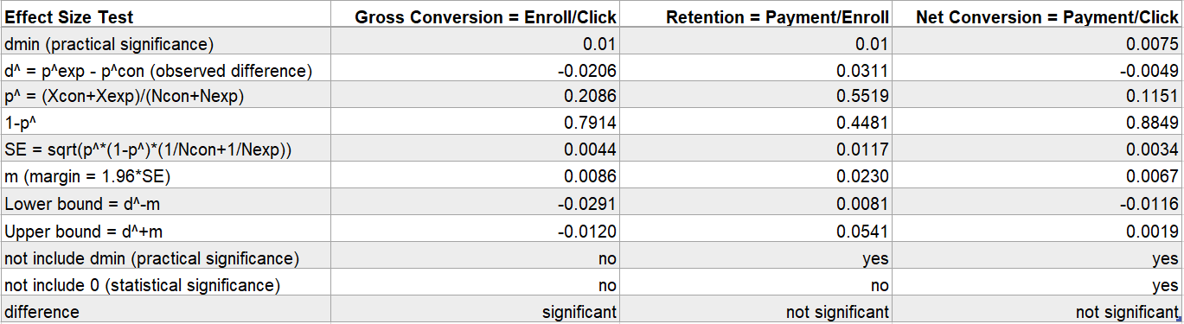

## Sign Tests

Sign test is another method to validate the results, here I use the [online tool](https://www.graphpad.com/quickcalcs/binomial1/) to run the tests. Suppose the hypothetical probability of success in each trial is 0.5, because if there is no difference, it should be 50% chance of positive change in each trail.

According to the Udacity data, there are total 23 trials in each group and I observed rates from experiment group are higher than control group for 4 times in gross conversion, 13 times in retention and 10 times in net conversion. The p-value is as below:

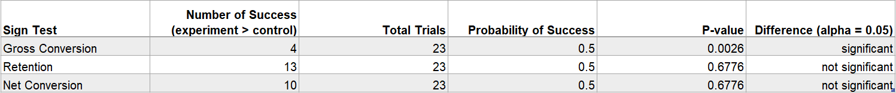

Given alpha = 0.05, only gross conversion p-value = 0.0026 < 0.05, we can say there is a significant difference in this metric, but not for the other two.

## Bonferroni Correction

The Bonferroni Correction is a method for controlling for type I errors (false positives) when using multiple metrics in which relevance of ANY of the metrics matches the hypothesis, here I use it to test three evaluation metrics.

Based on the new z score = 2.395, the analysis results are same as effect size test and sign test. Compare with control and experiment groups, there is a significant difference only in gross conversion.

**Recommendation**

This experiment is designed to understand whether the free trail screener will help to filter out students who would not commit to the study time, without reducing the number of students who will make the payments after 14 days free trial.

The results show that Gross Conversion will be reduced significantly, which means when screener requires student to input enough study time before enrolling, it does help filter out significant number of students who are not ready for studying.

However, there are no significant changes in Retention and Net Conversion, which means the screener only help reduce the enrollments, but not enough evidence to show that more students will stay till the end of the free trial and trigger the final payments.

Therefore, I would not recommend to launch this screener, but rather to pursue other experiments.

**Follow-Up Experiment**

In order to increase the number of final payments, we want students to be clear about that the course is worth the money and is going to be very helpful to get a job.

* Is the tuition competitive?
* Any available financial aid?
* If students regret and cancel, how much money can they get refund?
* What accredited certificates can students get after finishing the course?
* Any discount on bundle sales, like coach service or professional badges?
* Is this a high-quality course and are the instructors professional?
* How is the course review and what are the comments from other students?
* What pre-requisite requirements can help students achieve the goal?
* What job do students want to apply, is this course going to be the right help?

We can add these information after the enrollment and setup a new experiment:

* Setup: randomly assign enrollment students into control and experiment groups.
* Null Hypothesis: no significant increase in retention and payments after 14 days free trail.
* Unit of diversion: user-ids, since the changes take place after the student creates an account and enrolls in a course.
* Invariant Metrics: number of user-ids, number of clicks, click-through-probability.
* Evaluation Metrics:retention, net conversion.

If there are statistically and practically significant positive changes in retention and net conversion, then we would consider to launch the experiment.