NANYANG TECHNOLOGICAL UNIVERSITY
School of Electrical and Electronic Engineering
Final Year Project: Project Plan and Strategy
Modular vs. End-to-End Vision-Language-Action Models for Embodied Robotic Manipulation
Project code | A1005-261
Student | Tay Juen Jie
Supervisor | Assoc Prof Cheah Chien Chern, School of EEE
Laboratory | Robotics I (shifting labs, to be confirmed)
Project cycle | AY2026 Semester 1 to AY2027 Semester 2 (Aug 2026 to May 2027)
Date of this plan | 14 September 2026

1. Aim and Objectives

1.1 Aim
The aim of this project is to compare two architectures for spoken natural-language control of a Universal Robots (UR) UR5e manipulator, on the same physical cell and against the same task suite, and to report the strengths and weaknesses of each. The user speaks a command, for example "place that red cube into that metal tray", and the system executes it. The deliverable is the comparison, not a working robot on its own.

1.2 Objectives
Each objective below has a condition that we can check to verify its complete.
Commission the physical cell. Install the fixed RGB-D camera, which returns colour and depth, and the wrist RGB camera, which returns colour only, on the UR5e cell, solve the camera-to-base transform, and validate it by commanding the arm to a measured physical point and reporting the residual in millimetres.
Implement Architecture A, the modular pipeline. An open-vocabulary object detector, depth back-projection into three dimensions, a hand-eye transform into the robot base frame, and a large language model (LLM) that plans over a schema of scripted motion primitives. The whole pipeline is not trained or fine-tuned. It also includes a clarification channel, so the system can ask the user a question when an instruction is under-specified.
Implement Architecture B, the end-to-end policy. Fine-tune SmolVLA, a compact vision-language-action model, on demonstrations recorded on the same UR5e and scene, and drive the arm through the same controller interface behind a safety envelope. None of the motion is written by hand.
Design and freeze the evaluation. Write a tiered task suite, a layout randomisation table, a scripted set of spoken commands and a success criterion per tier, and freeze all of it before either pipeline is tuned.
Run the comparison and report it. Run both architectures over the frozen suite with identical layouts and identical spoken commands, and report where each succeeds, how each fails, and what each costs in demonstration data, compute, money and engineering effort.

1.3 Scope
Every result in this project comes from real hardware. Simulation was removed from the project on 11 August 2026 and no simulated result will be reported. Also out of scope: mobile manipulation, multi-arm work, learned grasp synthesis, training a vision-language-action model from scratch, training or fine-tuning any speech model, and always-on listening. Speech recognition is a off-the-shelf component and is used as it is, behind a push-to-talk trigger.

2. Background

2.1 Two ways to turn language into robot motion
Work on natural-language control of manipulators has settled into two families. The modular family places an LLM in front of a fixed library of scripted motion primitives. The model reads the instruction, chooses primitives, and fills in their arguments, while a separate perception stack supplies the coordinates. Behaviour is changed by editing prompts, schemas and primitives. The end-to-end family trains a single vision-language-action model that maps camera images, robot state and an instruction string directly to actions. Behaviour is changed only by collecting more demonstrations and retraining.

2.2 Related work
Shan and Cheah [1] give a recent instance of the modular design and are the direct anchor for this project. Their system pairs a GPT-4o communication agent with a physical agent holding a skill bank of five primitives on a UR5e, and applies it to power cable manipulation. Perception is a closed-vocabulary detector fine-tuned on thirty labelled images, and the language-to-robot interface is keyword scraping from free text.
Their discussion states that the modular design gives flexibility beyond what a single vision-language-action model can achieve. The case they make for that flexibility is architectural. The modules are interchangeable building blocks, so a skill can be replaced or added without retraining anything. The case is not an empirical one. No vision-language-action model is implemented or run as a baseline anywhere in the paper, the experiment section describes itself as a proof-of-concept demonstration, the evidence offered is one time-lapse of a single cable insertion, and the fine manipulation step is a mock function. Measuring that claim on real hardware is what this project does.
Their closed-vocabulary detector also motivates a design choice here. A detector trained on a fixed set of classes needs new labelled images and a new training run for every new object. This project uses an open-vocabulary detector instead, where a new object is a new text query and nothing is retrained. That difference is one of the axes the comparison measures.
On the end-to-end side, SmolVLA [2] is a compact vision-language-action model of roughly 450 million parameters, designed to fine-tune and run on a single consumer GPU. It consumes multi-view RGB images, a robot state vector and a language string, and emits action chunks, which are short sequences of future actions predicted in a single pass, with a horizon of 50 steps. It has no depth input, which constrains the camera configuration below. Reported practice is that around fifty demonstrations per task is a workable starting point, and that the density of the demonstrated workspace matters more than the raw episode count. Open X-Embodiment [3] is the closest thing to a survey of action and observation conventions across robot datasets and informs the choice of action space. Real-time chunking [4] addresses the latency of executing action chunks and is the basis for the asynchronous inference loop.
Perception in the modular pipeline uses OWLv2 [5], an open-vocabulary detector. OWLv2 encodes each text query into one embedding using a text encoder from CLIP [6], a model trained to place images and text in a single embedding space, matched against per-patch embeddings of the image. A full sentence therefore becomes a single embedding for the whole sentence, and no region of the image corresponds to it. The detector has no mechanism for splitting a sentence into the objects it mentions. Something must therefore convert "place that red cube into that metal tray" into the noun phrases "red cube" and "metal tray" before the detector can be asked anything. In this project that step is performed by the same LLM that plans, and it is logged as its own stage. Architecture A carries two penalties for this step: an extra model call for every instruction, and a failure mode where the wrong noun phrase ends the run before perception begins. Architecture B has neither, because it consumes the instruction string directly. The speech front end uses Whisper [7], run locally.

2.3 The gap
Published comparisons between the two families vary the robot, the task, the camera setup and the training data all at once, so it is not possible to attribute a difference in outcome to the architecture. This project holds every one of those constant. The two architectures share the same physical cell, one controller interface, one speech front end and one frozen task suite. What remains different is the architecture, which is the variable under study. The research question is therefore: on the same robot and the same tasks, what are the strengths and weaknesses of a modular LLM pipeline compared with an end-to-end vision-language-action policy?

3. Proposed Approach

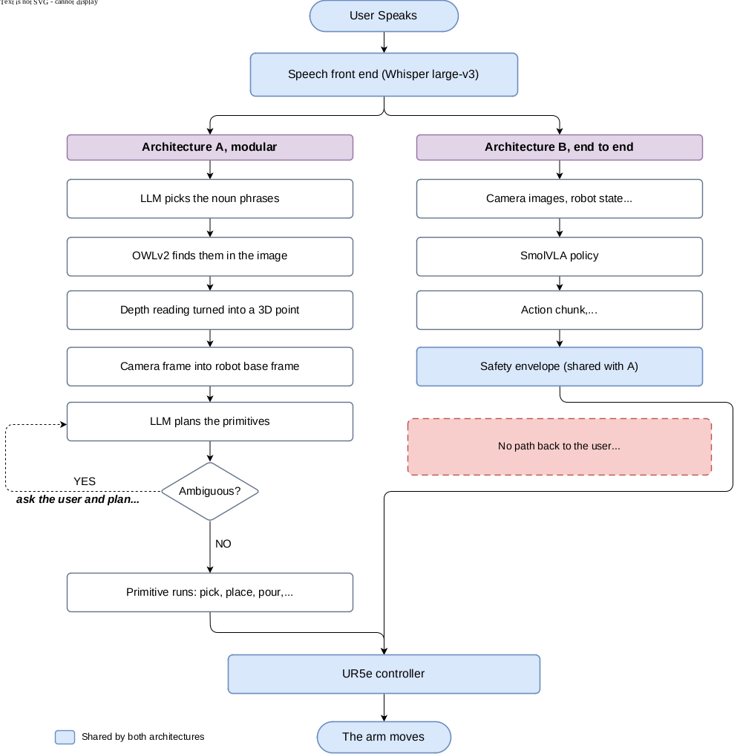
Figure 1. Two architectures on the same cell.

3.1 Controlling the comparison
The value of the result depends entirely on the two architectures being given the same problem. Four things are therefore held identical by construction.
Same physical cell and one controller interface. Both architectures drive the arm through the same controller class. Neither is allowed to bypass it and call the robot driver itself. The driver offers extra features, such as force control, and if one architecture used them the other would be at a disadvantage.
One speech front end, outside both architectures. A single microphone and a single local speech model produce one transcript, which is handed to A and to B unchanged. Nothing is cleaned up for one and not the other.
One frozen task suite. Tiers, spoken commands, object layouts and success criteria are written into source before either pipeline is tuned. Any later change is recorded with a date and a reason and will be declared in the final report.
One action space. The action space that Architecture B learns matches what Architecture A’s primitives command, as described below.
These rules are enforced by the software. Code is shared between the two architectures only when both use it while running, and an automated test checks it. The evaluation harness, which is the program that runs the trials and records the results, is not allowed to import either architecture, and a second test checks that too.
Moreover, every tunable value can be found in one configuration file, so the two architectures will always have the same settings. Architecture B’s ceiling on movement per control step is derived from the same speed limit that Architecture A obeys and a test asserts that the two agree.

3.2 Architecture A, modular
The spoken transcript reaches the LLM, which extracts the noun phrases the detector should look for. OWLv2 finds them in the fixed camera image. Depth from the same camera back-projects each detection into three dimensions, and the hand-eye transform carries it into the robot base frame. The LLM planner then plans an ordered sequence of primitives over a schema of four skills, which are pick, place, pour and open drawer, together with a fifth non-motion tool that asks the user a question. Every plan is validated against the schema before it reaches the controller, rejecting unknown skills, coordinates outside the workspace and malformed arguments. Every stage writes a tagged log entry, so a failure can be attributed to extraction, detection, depth, transform, planning or execution. That per-stage log is the evidence for one of the hypotheses and is built once, properly, rather than added later.

3.3 Architecture B, end-to-end
Demonstrations are recorded on the same UR5e with a teleoperation device, and exported to a dataset in the format used by LeRobot, which is the open-source robot learning library this project trains and runs the policy with. SmolVLA is fine-tuned on them. At run time the policy receives the two camera views, the robot state and the instruction string, and emits an action chunk. A safety envelope clamps every predicted action against workspace bounds and a velocity limit before it reaches the controller, because a policy under an unfamiliar observation can emit a chunk that moves the arm hard. Inference runs asynchronously so the arm is not idle during the forward pass.
One risk is specific to demonstration capture and is easy to underestimate. Hand-guiding the arm to record demonstrations puts the operator’s hands and arms in both camera views on every frame, and a visuomotor policy can learn to depend on them, although they are absent at test time. The training set will be recorded with a six-degree-of-freedom input device that keeps the operator out of frame.

3.4 The action space (still to be confirmed)
Both architectures command the arm in the same way. An action is a change of tool pose in the robot base frame together with an absolute gripper target, which is seven numbers. Tool poses were chosen because Architecture A’s primitives already command them. They also keep the inverse kinematics inside the controller, so the policy learns the task rather than the kinematics, and they make the safety envelope a direct check on where the hand is allowed to be.
The part still to be confirmed is settled by a read-only check that takes ten seconds, with the arm parked and the gripper facing down. The default gripper-down orientation has a rotation magnitude of pi, which is the wrap point of both rotation formats in use. A turn of pi about one axis equals a turn of pi about the opposite axis, so the recorded numbers can change sign while the physical pose is unchanged. The action deltas are immune, because they are computed through rotation matrices. The robot state vector is not, and a sign change would put a jump of 6.28 into one of the policy’s seven inputs, at the exact pose used for every grasp. If the check shows this happens on the real controller, rotation is stored as the first two columns of the rotation matrix instead. This must be settled before the first episode is recorded, because changing it afterwards means the dataset has to be exported again.

3.5 Working in a shared laboratory
The cell is shared with other students, so the camera cannot be permanently mounted. Its position is marked with tape, and the rig is set up and taken down each session, which means the camera returns only roughly to the same place. The camera-to-base transform is therefore re-solved at the start of every session rather than once, and the calibration routine is written to be quick and repeatable for that reason.
This shapes the two architectures differently, and both effects are planned for. For Architecture A it is a fixed cost at the start of each session. For Architecture B the small change of viewpoint between sessions is a risk, because a policy trained from one viewpoint can fail from another. The response is to record demonstrations across the range of positions the tape allows, so the variation becomes training data rather than a surprise at test time, and to keep the viewpoint used for the final demonstration inside that range.

3.6 Task suite
Five tiers, ordered so that each one tests something the tier below does not. Twenty trials per architecture per tier, over the same twenty object layouts in the same order, with the same scripted spoken commands. Half of the commands use phrasings present in the demonstration data and half are held out, so that robustness to phrasing can be measured rather than assumed.

Tier | Task | What it tests
0 | Static pick and place | Verification that both pipelines are wired correctly. Not a headline result.
1 | Pouring, unambiguous | Motion that is hard to script. A needs a hand-authored tilt profile, and B must learn the tilt from demonstration.
2 | Ambiguous instruction | A can ask which drink is meant and re-plan. B has no output that can produce a question, so it must act. Measuring which bottle it picks, and how consistently, quantifies an end-to-end policy substituting its training prior for the user’s intent.
3 | Dynamic drawer | The drawer is closed again by a human mid-task. Tests reactive re-planning, where the prediction reverses: the closed-loop policy should be the stronger of the two.
4 | Generalisation | Objects and phrasings never seen in the demonstrations or the prompt examples.

The asymmetry at Tier 2 is a result rather than a fairness problem, and it will be reported as one rather than papered over with a wrapper around Architecture B.

3.7 Measurements
Recorded for every trial: architecture, tier, trial index, layout identifier, the spoken utterance and its transcript, the outcome, the failure stage, the wall-clock duration and any human intervention. Keeping the transcript is what allows a speech error to be separated from a robotics error. Reported per tier: success rate, time to completion, whether failure is attributable to a stage, whether ambiguity was resolved correctly, recovery from a mid-task change, and robustness to held-out phrasing. Reported once per architecture: demonstration episodes and hours of laboratory time, GPU-hours, monetary cost per command, and engineering effort. The cost axis is cheap to measure and is rarely reported, and it is where the two architectures differ most plainly. Architecture A costs cents per command for ever, and Architecture B costs GPU-hours once and nothing per command.

4. Work Completed to Date
The project began before the official start date, and the software is further ahead than the schedule requires. This section states what already exists, because the schedule that follows compresses the hardware work into seven weeks, and that compression is only credible if the software is already written and waiting.

4.1 Preparation before Week 1, 28 June to 9 August 2026
Six weeks were spent before the semester began on the parts of the system that need no laboratory access. Two simulators were used as scaffolding during that period, and both have since been retired.
URSim, the UR controller simulator, stood in for the arm while the control stack was written. Built against it: the interface to the arm over Real-Time Data Exchange (RTDE) and URScript, which are the two protocols a UR controller accepts, a square trajectory running end to end, error handling, a custom RTDE recipe for joint state logging, a dashboard client, and the controller class with its gripper methods and first tests.
MuJoCo, a physics simulator, with a model of the Robotiq 2F85 gripper, stood in for the cell while the data path was written. Built against rendered frames and simulated episodes: the demonstration recorder, the episode store, which uses the HDF5 scientific data format, the converter that exports episodes to a LeRobot dataset, the hand-eye calibration module and the base-frame transform. The detector was chosen in the same period. OWL-ViT base returned correct boxes at confidence scores near 0.008 with the wrong colour labels, which is unusable, so OWLv2 was selected instead and its threshold set to 0.3.
One fault was found and fixed in this period. The demonstration recorder counted simulation steps rather than watching the clock, so it recorded at roughly 4 Hz where 20 Hz was intended, and the interval was uneven as well. A wall-clock gate replaced the step count, and the recorder now holds 20 Hz through a compute spike instead of bursting afterwards.
Both simulators were retired as the real cell came into reach. MuJoCo was quarantined on 28 July when the repository was restructured around the real UR5e, the simulation folder was removed from version control on 11 August, and URSim was dropped on 31 August. Nothing in the live tree references either of them, and no simulated result appears anywhere in this project. What the six weeks returned is a software stack that was finished before hardware access existed, and that is what makes the compressed schedule possible.

4.2 Weeks 1 to 5, 10 August to 13 September 2026
Week 1. The repository was restructured into the Architecture A, Architecture B and shared layers, with an automated test enforcing the boundary between them. A precision fault was found and fixed in the rotation conversion, which had divided by the sine of the rotation angle and lost roughly seven digits as that angle approached pi. Pi is the default gripper-down orientation, so every grasp passed through the worst case. A quaternion method replaced it, exact to 1e-15, with a regression test.
Weeks 2 and 3. Architecture A was written in full: the motion primitives, the tool schemas, the planner, plan validation before dispatch, the clarification loop and query grounding. The speech front end was written alongside it and wired in as the default input, together with the held-out paraphrase sets that the task suite depends on.
Week 4. The robot side of Architecture B was built, running on LeRobot’s policy server and robot client through a UR5e adapter. A non-blocking servo command was added to the controller, because the blocking move call cannot sustain a 20 Hz policy loop. The unit suite reached 173 tests, all passing without hardware.
Two further faults were found and fixed in this period, and both are worth recording because neither was visible from the outside.
The first is the camera axis convention, fixed on 31 August. The code that turns a pixel and a depth reading into a three-dimensional point used the axis convention of the simulator the project started in, in which two of the three axes point the opposite way from the convention the RealSense depth camera reports. Nothing had caught it, because the inverse function used the same convention and the round trip stayed exact. It would not have stayed harmless. A fitted transform absorbs a fixed axis flip silently, but the calibration decision taken in August is to measure the transform from the mount geometry rather than fit it, and a measured transform cannot absorb a flip that is not physically there. Every point would have landed mirrored and behind the camera, and it would have read as a bad calibration. The fix changed three functions together, and two guards were added: a unit test that pins the sign of each axis, and a printed check in the camera script that reports whether the depth axis is positive.
The second is speech on the GPU, also fixed on 31 August. The speech backend loads two CUDA libraries by bare name, which are the libraries NVIDIA supplies for running work on the GPU, and they are normally installed by a deep learning framework that this project’s environment deliberately does not install. The documented remedy is an environment variable set before the program starts. That was rejected, because a variable someone has to remember is a demonstration that fails in front of an examiner. The two libraries are now declared as dependencies and loaded by absolute path from inside the program, before the backend starts.
Three things outside the code also belong in this period. The supervisor, Prof Cheah, sent the paper by Shan and Cheah, which is the anchor for the related work above, on 28 August. The depth camera was collected from Xing Ge, a PhD student in the laboratory, on 1 September. The rules for working in the shared cell were obtained from Koji, another of the supervisor’s PhD students, and they are the reason the per-session calibration requirement above exists. The supervisor also updated the project title on 31 August.

4.3 Results measured on real equipment
Week 4 produced the first two results measured on real equipment, and they are the only two so far.
Speech, 31 August. The front end was tested with live speech on the GPU using Whisper large-v3. Both recordings transcribed correctly, and each was written to the log with its audio file and its latency, which is the per-trial record the evaluation protocol requires.
Camera, 1 September. A RealSense D435i depth camera was benched without the arm. The session measured 30 frames per second sustained at 1280 by 720 with depth-to-colour alignment enabled, which settles an open design question: Architecture B can run its control loop at full resolution and needs no reduction. It also confirmed that aligned depth carries the colour intrinsics rather than the depth ones, that both streams are rectified and carry no distortion, and that the depth scale is one millimetre.

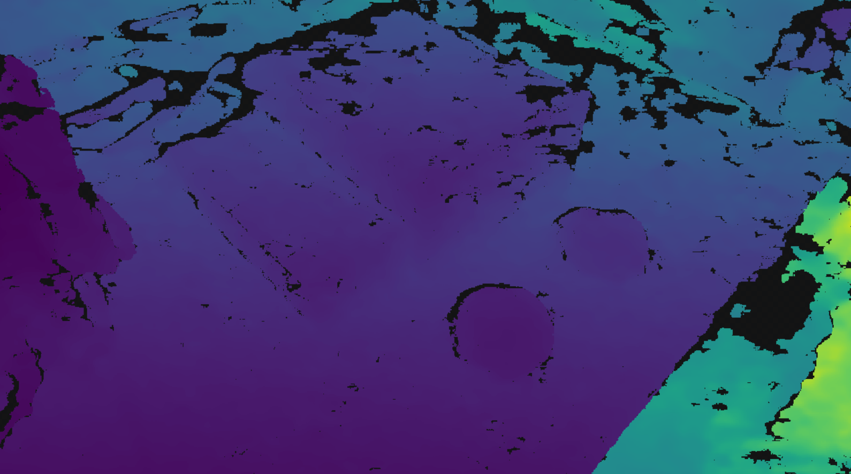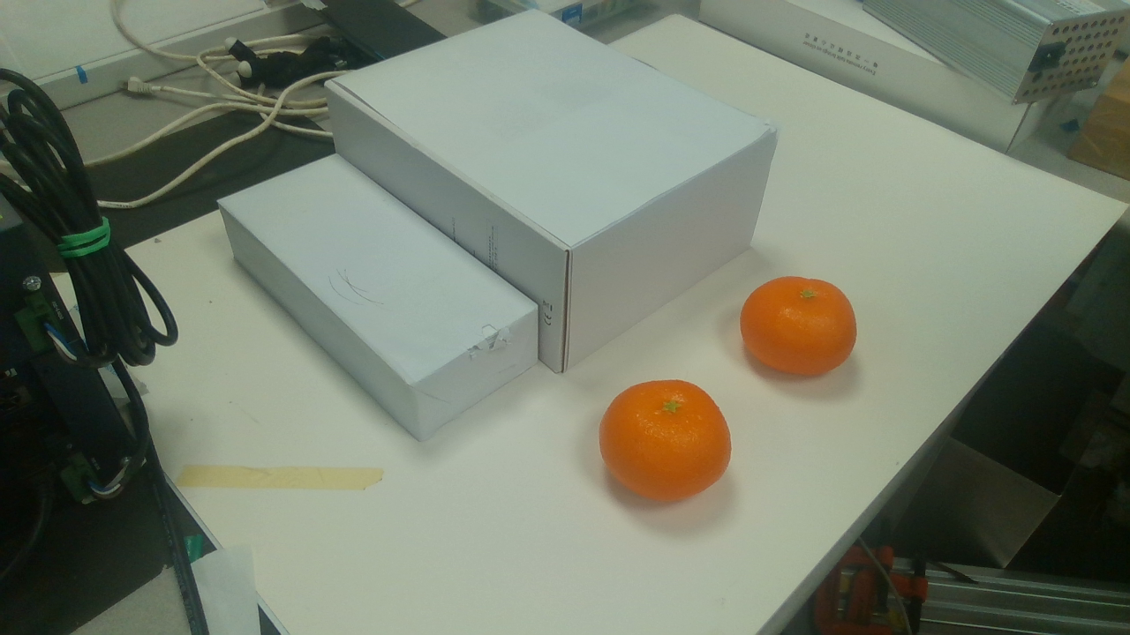
Figure 2. Two oranges placed side by side, which is the Tier 2 ambiguity case.
Twenty-eight scenes were captured using an orange, a blue kettle and a red button magnet borrowed from the laboratory, covering distance sweeps at 0.5 and 0.9 metres, occlusion cases, two identical oranges for the Tier 2 ambiguity case, an object on a box against the same object on the table, and a pair with the room lights on and off. Five scenes were re-captured as raw arrays, because the colourised depth image is lossy and cannot drive the depth stage.
Two findings from that session carry into the design. Glossy surfaces return holes in the depth map, which the red magnet does and the blue kettle does not, so the choice of objects for the task suite is a real decision rather than an arbitrary one. Depth is also close to independent of room lighting, because the sensor projects its own infrared pattern, and the capture made with the room lights off was among the cleanest of the session.

4.4 What does not yet exist
No demonstration episode has been recorded, so the dataset count starts at zero. The calibration file is not written, because the transform needs the physical work cell. No fine-tuned checkpoint exists. The detector has not yet been run on the captured frames, and doing so is the first task in the two blocked weeks below. Apart from the speech front end, nothing in either architecture has run against real hardware.

5. Weekly Schedule

5.1 Basis
Week 1 was the week of 10 August 2026. The technical work is planned to be complete by 10 November 2026, which is an internal target. This leaves a buffer if the plan overruns, so the work is not rushed close to the deadline.
The schedule is re-baselined against a known constraint. The laboratory relocates in mid-September 2026 and is set up only after the move, so arm access is treated as unavailable until approximately 22 September 2026. The original plan placed calibration in the week of 31 August, and that is no longer possible. The response is to pull every task that does not need the arm forward into the two blocked weeks, and to compress the hardware-gated sequence afterwards. All of Architecture A, the speech front end, the evaluation harness and the robot side of Architecture B are already written and are waiting on hardware, which is what makes the compression credible.
NTU assesses this project through seven deliverables, labelled D1 to D7, and the full list with dates is at the end of this document. Two of them fall inside the chart below and are marked on it. D1 is this project plan, due 14 September 2026. D2 is the interim report and its accompanying video, due 10 November 2026.

5.2 Gantt chart
Workstream | Prep  Jun-Aug | W1  10 Aug | W2  17 Aug | W3  24 Aug | W4  31 Aug | W5  7 Sep | W6  14 Sep | W7  21 Sep | Recess  28 Sep | W8  5 Oct | W9  12 Oct | W10  19 Oct | W11  26 Oct | W12  2 Nov | W13  9 Nov
Preparation: control stack, recorder, converter
Architecture split and repository reset
Architecture A software
Speech front end and paraphrase sets
Evaluation harness
Architecture B robot side and safety envelope
Speech and camera tested on real equipment
Laboratory relocation, no arm access
Off-lab work: detector on captured frames, recorder, conventions
D1 project plan (submit 14 Sep) |  |  |  |  |  |  | ◆
Cell setup, action space check, hand-eye calibration
Architecture A on hardware, Tier 0
Demonstration capture, Tiers 0 and 1
Architecture B fine-tune and inference
Tier 2 ambiguity and Tier 3 drawer
Evaluation sweep, Tier 4, freeze results
Final report writing and figures
D2 interim report, video, demonstration rehearsal |  |  |  |  |  |  |  |  |  |  |  |  |  |  | ◆

Complete | Planned work | No arm access | ◆ Submission

5.3 Milestones
Week | Dates | Milestone
W6 | 14 Sep | D1 project plan submitted. Detector run over the captured frames. Hardware recorder and dataset conventions settled off-lab.
W7 | 21 to 27 Sep | Cell commissioned. Action space check completed. Camera-to-base transform written and validated, reach residual reported in millimetres.
Recess | 28 Sep to 4 Oct | Architecture A runs end to end on the real arm and passes Tier 0 over twenty trials.
W8 | 5 to 11 Oct | First demonstration batch recorded and exported. First SmolVLA fine-tune complete.
W9 | 12 to 18 Oct | Architecture B drives the arm behind its safety envelope and passes Tier 0. Tier 1 running on both.
W10 | 19 to 25 Oct | Tiers 2 and 3 run on both architectures.
W11 | 26 Oct to 1 Nov | Full evaluation sweep complete. Results frozen.
W12 | 2 to 8 Nov | Final report drafted and sent to the supervisor early for feedback. Demonstration rehearsed end to end.
W13 | 9 to 15 Nov | D2 interim report and video submitted on 10 Nov.

The period from December 2026 to March 2027 is not idle time. A hardware demonstration that has not been run since November will not work in April, so the full demonstration is re-run once a month through that window and whatever has drifted is repaired. The same window absorbs supervisor feedback on the early draft and adds trials to whichever tier produced the most interesting result.

6. Risks and Contingency
Risk | Impact | Response
Laboratory access slips beyond late September | Compresses the critical path further | Every task that does not need the arm is already pulled forward. Each further week of delay drops one rung of the descope ladder below.
Camera returns to a slightly different place each session | Calibration is a recurring cost, and Architecture B can see a viewpoint it was not trained on | Re-solve the transform at the start of every session with a routine written to be quick. Record demonstrations across the range of positions the tape allows, and keep the demonstration viewpoint inside that range.
Operator visible in demonstration frames | Policy learns a cue that is absent at test time, and the set must be recorded again | Record the training set with a teleoperation device rather than by hand-guiding. Inspect the frames of the first five episodes before recording two hundred.
Calibration residual too large to grasp reliably | Architecture A fails everywhere, and B is unaffected | Validate numerically and report the residual. The transform is measured from mount geometry, so a systematic bias of one to three centimetres is expected. A fallback fitting procedure is already in the repository.
Policy does not converge on fifty episodes | No comparison at all | Constrain the demonstrated workspace first, because density matters more than count, and widen only once the constrained set works.
Spill damages the arm or a camera | Project-ending | Tinted water rather than juice, everything inside a shallow tray, arm speed capped during the pour.
GPU memory too tight for the fine-tune | Stalls the critical path | Run a short fine-tune as soon as the first batch of episodes exists, before the full dataset is recorded. Gradient accumulation, gradient checkpointing and a frozen vision backbone are the fallbacks.

6.1 Descope ladder
If time runs short, work is dropped from the bottom of this list rather than thinned across all of it. Tier 2 is deliberately ranked above Tier 3, because it is cheaper to run and produces the more distinctive result.
1. Architecture B on Tier 0, establishing that both pipelines exist and are comparable.
2. Tier 1 pouring on both architectures.
3. Tier 2 ambiguity experiment.
4. Tier 3 dynamic drawer.
5. Tier 4 generalisation sweep.

7. Deliverables and Supervision
The seven deliverables below are the assessed items. The date in the third column is the internal target for having the item finished, which is earlier for everything from the draft final report onward.
Deliverable | Submit on | Internally complete by
D1 Project plan and strategy | 14 Sep 2026 | 14 Sep 2026
D2 Interim report and video | 10 Nov 2026 | 10 Nov 2026
D3 Draft final report | 25 Mar 2027 | 2 Nov 2026
D4 Final report | 9 Apr 2027 | 9 Nov 2026
D5 Demonstration | 12 to 16 Apr 2027 | Demo-ready Nov 2026, rehearsed monthly
D6 Oral presentation | 10 to 12 May 2027 | Slides outlined Nov 2026
D7 Full text to library and revised report | 19 May 2027 | Post-oral revision only

A short written progress update goes to the supervisor every two weeks for the duration of the project. The demonstration date is agreed with the examiner in January 2027 rather than in April.

References
[1] S. Shan and C. C. Cheah, "A Large-Language-Model-Enabled Robotic System with Application to Power Cable Manipulation," CPEEE 2026. DOI: 10.1109/CPEEE69412.2026.11521580.
[2] M. Shukor et al., "SmolVLA: A Vision-Language-Action Model for Affordable and Efficient Robotics," 2025.
[3] A. Padalkar et al., "Open X-Embodiment: Robotic Learning Datasets and RT-X Models," 2023.
[4] K. Black et al., "Real-Time Execution of Action Chunking Flow Policies," 2025.
[5] M. Minderer, A. Gritsenko and N. Houlsby, "Scaling Open-Vocabulary Object Detection," Advances in Neural Information Processing Systems, 2023.
[6] A. Radford et al., "Learning Transferable Visual Models from Natural Language Supervision," Proceedings of the 38th International Conference on Machine Learning, 2021.
[7] A. Radford et al., "Robust Speech Recognition via Large-Scale Weak Supervision," 2022.

