NANYANG TECHNOLOGICAL UNIVERSITY
School of Electrical and Electronic Engineering

Final Year Project Interim Report

Modular vs. End-to-End
Vision-Language-Action Models
for Embodied Robotic Manipulation

Project code | A1005‑261
Student | Tay Juen Jie
Matriculation no. | U2322880A
Supervisor | Assoc Prof Cheah Chien Chern
Laboratory | Robotics I (S2‑B6a‑01)
Date | 10 November 2026

1. Introduction

1.1 Background
Large language models now let a person instruct a robot arm in everyday language [1], [2]. Two families of systems do this. The modular family puts a large language model (LLM) in front of pretrained perception and scripted motions [1]. The end-to-end family trains one vision-language-action (VLA) model that maps camera images, robot state and an instruction straight to motion [2].
Each family reports results on its own robot, tasks and data, so a reader cannot tell how much of a difference comes from the architecture. Shan and Cheah [3] built a modular LLM system on a UR5e for power cable manipulation. They argue that the modular design gives flexibility beyond a single VLA model. No VLA model was run as a baseline in that work, so the claim is still untested. This project tests it on real hardware.

1.2 Aim
The aim is to compare a modular LLM agent (Architecture A) with an end-to-end VLA model (Architecture B) on the same UR5e cell. The user says an utterance such as "place that orange into that red container", and the arm carries it out. The deliverable is the comparison. It reports where each architecture succeeds, how each fails, and what each costs in data, compute, money and engineering effort.

1.3 Objectives
Each objective has a condition that can be checked. Table 1 lists the objectives, their conditions and their status. An unscored check is a set of practice attempts off the layout crosses that are never logged as trials. It confirms that an architecture works end to end before its scored trials start.
ID | Objective | Done when | Status
T1 | Calibrated cell | Camera-to-base transform from a ball fit, checked by a reach test, with the error in mm | [Done 21 Oct 2026]  Reach error 2 to 7 mm after the reach correction (Section 6.4)
T2 | Evaluation harness | Frozen suite, and a harness that imports neither architecture and logs the outcome, time and cost of each trial | [Done 11 Aug 2026]  Time and cost per trial added later
T3 | Architecture A on Tiers 0 to 3 | Pour and drawer skills and the perceive tool built, an unscored check passed on every tier, then A frozen | [In progress]  Tier 0 pick and place has run on the arm since 21 Oct 2026
T4 | Demonstration dataset | At least 50 teleoperated demonstrations per tier for Tiers 0, 1 and 3, recorded off the layout crosses, that load in LeRobot | [In progress]  Recorder and exporter written
T5 | Architecture B trained | SmolVLA fine-tuned on the T4 dataset, running behind the envelope, with an unscored check passed on every tier | [In progress]  Robot side written
T6 | Comparison result | 20 scored trials per tier for each architecture through the harness, with no tuning or training between them. Per tier: success rate, failure stage of each failed A trial, time and cost | [Not started]
Table 1. Technical objectives and their status.

1.4 Scope
Every result comes from the real UR5e. Simulation was used only as scaffolding before the semester, and no simulated result is reported. Mobile manipulation, multiple arms, learned grasp planning, training a VLA from scratch and training a speech model are out of scope. Speech recognition is an off-the-shelf model used as it is.

1.5 Purpose of this report
This report records the work of Semester 1 and the plan for Semester 2. Section 2 places the project among related work. Section 3 explains how the comparison is kept fair. Sections 4 and 5 describe Architecture A and Architecture B. Section 6 reports the work so far, and Section 7 gives the plan.

2. Related Work
Table 2 places this project among the works it builds on. Code as Policies [1] is closest to Architecture A as it is today: both use pretrained perception and scripted motion with no training. AgenticLab [4] is the closest work to the completed project. It runs a vision-language agent on a UR5e in a closed loop of grounding, planning, execution, verification and replanning. It also compares its agent with a π0.5 VLA [5] fine-tuned on 30 to 40 demonstrations, and the fine-tuned VLA sometimes picked the wrong object, which the authors trace to unreliable instruction grounding. That comparison is one experiment in a benchmark of agents. This project makes it the main study, with a frozen suite, tiers for ambiguity and for mid-task change, a failure stage for every failed trial of A, and the cost of each architecture.
Two works frame Tier 2, the Ambiguity tier (Section 3.4). KnowNo [6] showed that an LLM planner can tell when it is unsure and ask a person for help. This project measures the cost of not asking, because Architecture B cannot ask a clarifying question on an ambiguous instruction (Section 5.1). BayesianVLA [7] found that VLA models often learn a shortcut from the image alone and ignore the instruction, and that this fails when one scene fits several tasks. Tier 2 is built on this case: two bottles stand on the table, and the instruction fits both.
Work | What it does | Limitation or role for this project
Code as Policies [1] | An LLM writes programs that call perception and control functions | No training needed. The current stage of Architecture A
SmolVLA [2] | Compact VLA of about 450 million parameters that outputs chunks of 50 actions | The model fine-tuned for Architecture B
Shan and Cheah [3] | GPT-4o agent with a bank of five skills on a UR5e, applied to power cable manipulation | Claims modular flexibility beyond a VLA, but runs no VLA baseline. Closed-vocabulary detector trained on 30 images
AgenticLab [4] | Closed-loop vision-language agent on a UR5e. Also beats a fine-tuned π0.5 VLA on two tasks | Closest work to the completed project. Its VLA test is a side experiment, while here the comparison is the main study
KnowNo [6] | Conformal prediction tells an LLM planner when to ask for help | The prior work on asking is useful, since this project measures the cost of not asking
BayesianVLA [7] | Shows VLAs can ignore the instruction and act on the image alone | Backs the prediction for B in Tier 2
Table 2. Related works.

3. Method

3.1 System overview
To test the claim of Section 1.1 fairly, both architectures run on one cell under the same controls. Figure 1 shows them. A shared speech front end, faster-whisper large-v3 [8] behind push-to-talk, turns the operator's utterance into a transcript, which is the instruction. Both architectures receive that same instruction. Architecture A is an LLM agent that loops through planning, perceiving and acting with one tool call per turn (Section 4). Architecture B is SmolVLA [2], which turns the instruction, two camera views and the robot state into a chunk of actions (Section 5). Both send every motion through the same envelope and the same controller. A snowflake marks a pretrained part used as it is. A flame marks a part trained on our demonstrations.

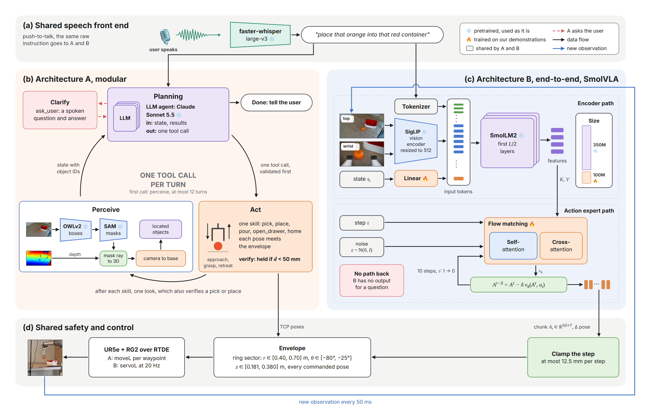
Figure 1. Both architectures on the same cell. (a) One speech front end gives both the same instruction. (b) Architecture A loops through planning, perceiving and acting, one tool call per turn. (c) Architecture B runs an encoder path and a flow-matching path to output an action chunk. (d) Both pass through the same envelope and controller.

3.2 Fairness in comparison
Five controls keep the comparison fair. Each is the same for both architectures and is enforced in code (Table 3).
Control | What is the same | How it is enforced
Same cell | One UR5e, one OnRobot RG2 gripper, one fixed RGB-D camera, one table | Every tunable value lives in one configuration file
Same shared modules | One speech front end, one controller, one envelope | Code is shared only if both architectures use it at runtime
Same action space | Tool centre point (TCP) pose in the base frame plus a gripper target | One speed ceiling in the envelope caps A’s moveL and sets B’s servoL step limit
Same frozen suite | Tiers, utterances, 20 layouts on five layout crosses, and success rules | The suite is frozen. Any change gets a dated entry in its changelog and is declared in the report
Blind harness | Trials run through one call, run(instruction), that gives the outcome | The harness imports neither architecture
Table 3. The five controls that keep the comparison fair.
Figure 2 shows how the code keeps these controls. A module goes into shared/ only if both architectures use it at runtime. A unit test fails on imports across the boundary. The harness reaches an agent only through run(instruction), so it cannot bias either A or B.
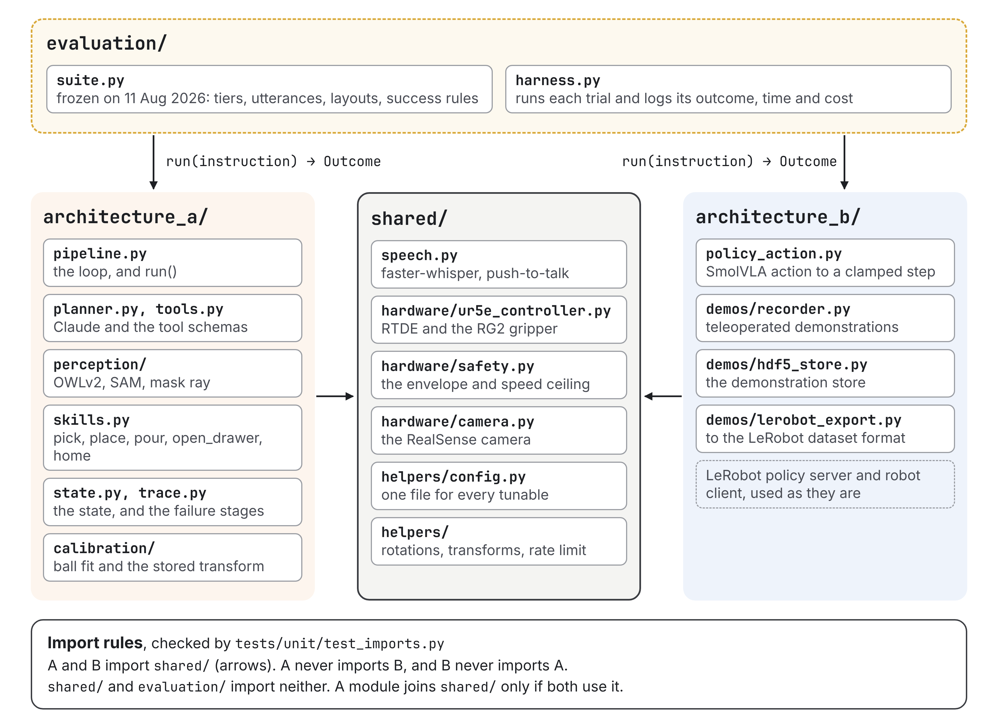
Figure 2. The code boundary. Both architectures import the shared modules, neither imports the other, and the harness imports neither.
The envelope sets where the arm may go. It is a ring sector around the base, with a radius of 0.40 to 0.70 m, a bearing of −80° to −25° and a height of 0.181 to 0.380 m. The −25° edge keeps the arm away from the camera tripod. Every pose either architecture commands is checked against it.

3.3 Known differences
Two differences cannot be removed. Table 4 states them and how each is handled.
Difference | Why it exists | How I handle it
Extra wrist camera | Reference SmolVLA setups use an overhead view plus a wrist view. Architecture A uses depth from the fixed camera, which B cannot read | Each side gets the sensors its design requires. Nothing depends on wrist depth, and the report states the bias
Prior knowledge vs demonstrations | Architecture A carries knowledge in its pretrained LLM, its detector and its hand-written skills. B learns from about 50 demonstrations per tier | Both costs are logged and shown side by side: A's hours, lines of code and API cost, and B's demonstrations, lab hours and GPU hours
Table 4. Known differences between the architectures.

3.4 Frozen suite and predictions
The frozen suite has five tiers (Table 5), and each architecture runs 20 trials per tier. Objects stand on five layout crosses on the table, the same five for every tier, and each object keeps one fixed orientation. A layout is the starting arrangement for one trial: it sets which object stands on which cross. Within a tier, the 20 layouts put each object that moves on each cross four times. Both architectures get the same 20 layouts in the same order. B’s demonstrations and A’s tuning stay off the crosses, so neither architecture has seen a position of a scored trial before. The utterances are scripted, and half of them are held-out utterances, never used to record demonstrations or shown to A as examples. Each trial logs the instruction, so a speech error is never blamed on A or B.
Tier | Task | Example utterance | Prediction
0 | Pick-place | "Place that orange into that red container" | Both succeed. Checks the wiring only
1 | Pour | "Pour the orange juice into the glass" | B may win. The tilt is hard to script
2 | Ambiguity | "Pour me a drink" with two drinks on the table | A should win. It can ask, and B falls back on its training data
3 | Dynamic | "Put the snack in the drawer", and a person closes the drawer mid‑task | B may win. It reacts at 20 Hz without a fixed plan
4 | Generalisation | Objects and phrasings never seen before | A should win. Its detector is open‑vocabulary
Table 5. Task tiers and the prediction for each.
In short, A should win on ambiguity and on traceability, since every failure of A is logged against a failure stage (Section 4.2) and a failure of B has no stage to point to. B may win on motion that is hard to script, such as a pour or a drawer that closes again.

4. Architecture A: Modular LLM Agent
Architecture A is a loop in which an LLM chooses one tool call at a time (Section 4.2). Section 4.1 first explains why it replaced a fixed pipeline.

4.1 From a pipeline to a loop
On 7 October 2026 I decided to change how Architecture A works. In the first design, A was a fixed pipeline with a planner at the end. It perceived the table once, and the LLM then planned every step before any step ran. A review of that design against the frozen suite found three problems.
- A clarification answer could not be acted on. After the user said "orange juice", the pipeline could not look again for that object, because its queries were fixed at the start. This broke Tier 2.
- The planner could chain several skills in one reply. It saw the result of a pick only after the place had already run.
- Nothing verified a step after it ran. A failed grasp went unnoticed, and Tier 3 depends on noticing one.
The change keeps the comparison fair. A comparison is only as strong as its weaker side, and recent modular systems act one step at a time and verify each step [4]. If A had stayed a dated pipeline, B would have won against a weak baseline, and the result would say little. I made the change before any trial was scored, so no result was lost.

4.2 Perception, planning and skills
The current Architecture A is a loop of plan, perceive and act, with one tool call per turn (Figure 3). A run starts with grounding. The planner's first call must be perceive, and in it the planner turns the instruction into queries. A query is a short noun phrase such as "orange" or "red container", because the detector takes phrases, not sentences. The planner also gives a count for each query, 1 by default, so it can ask for two bottles when a task needs both.
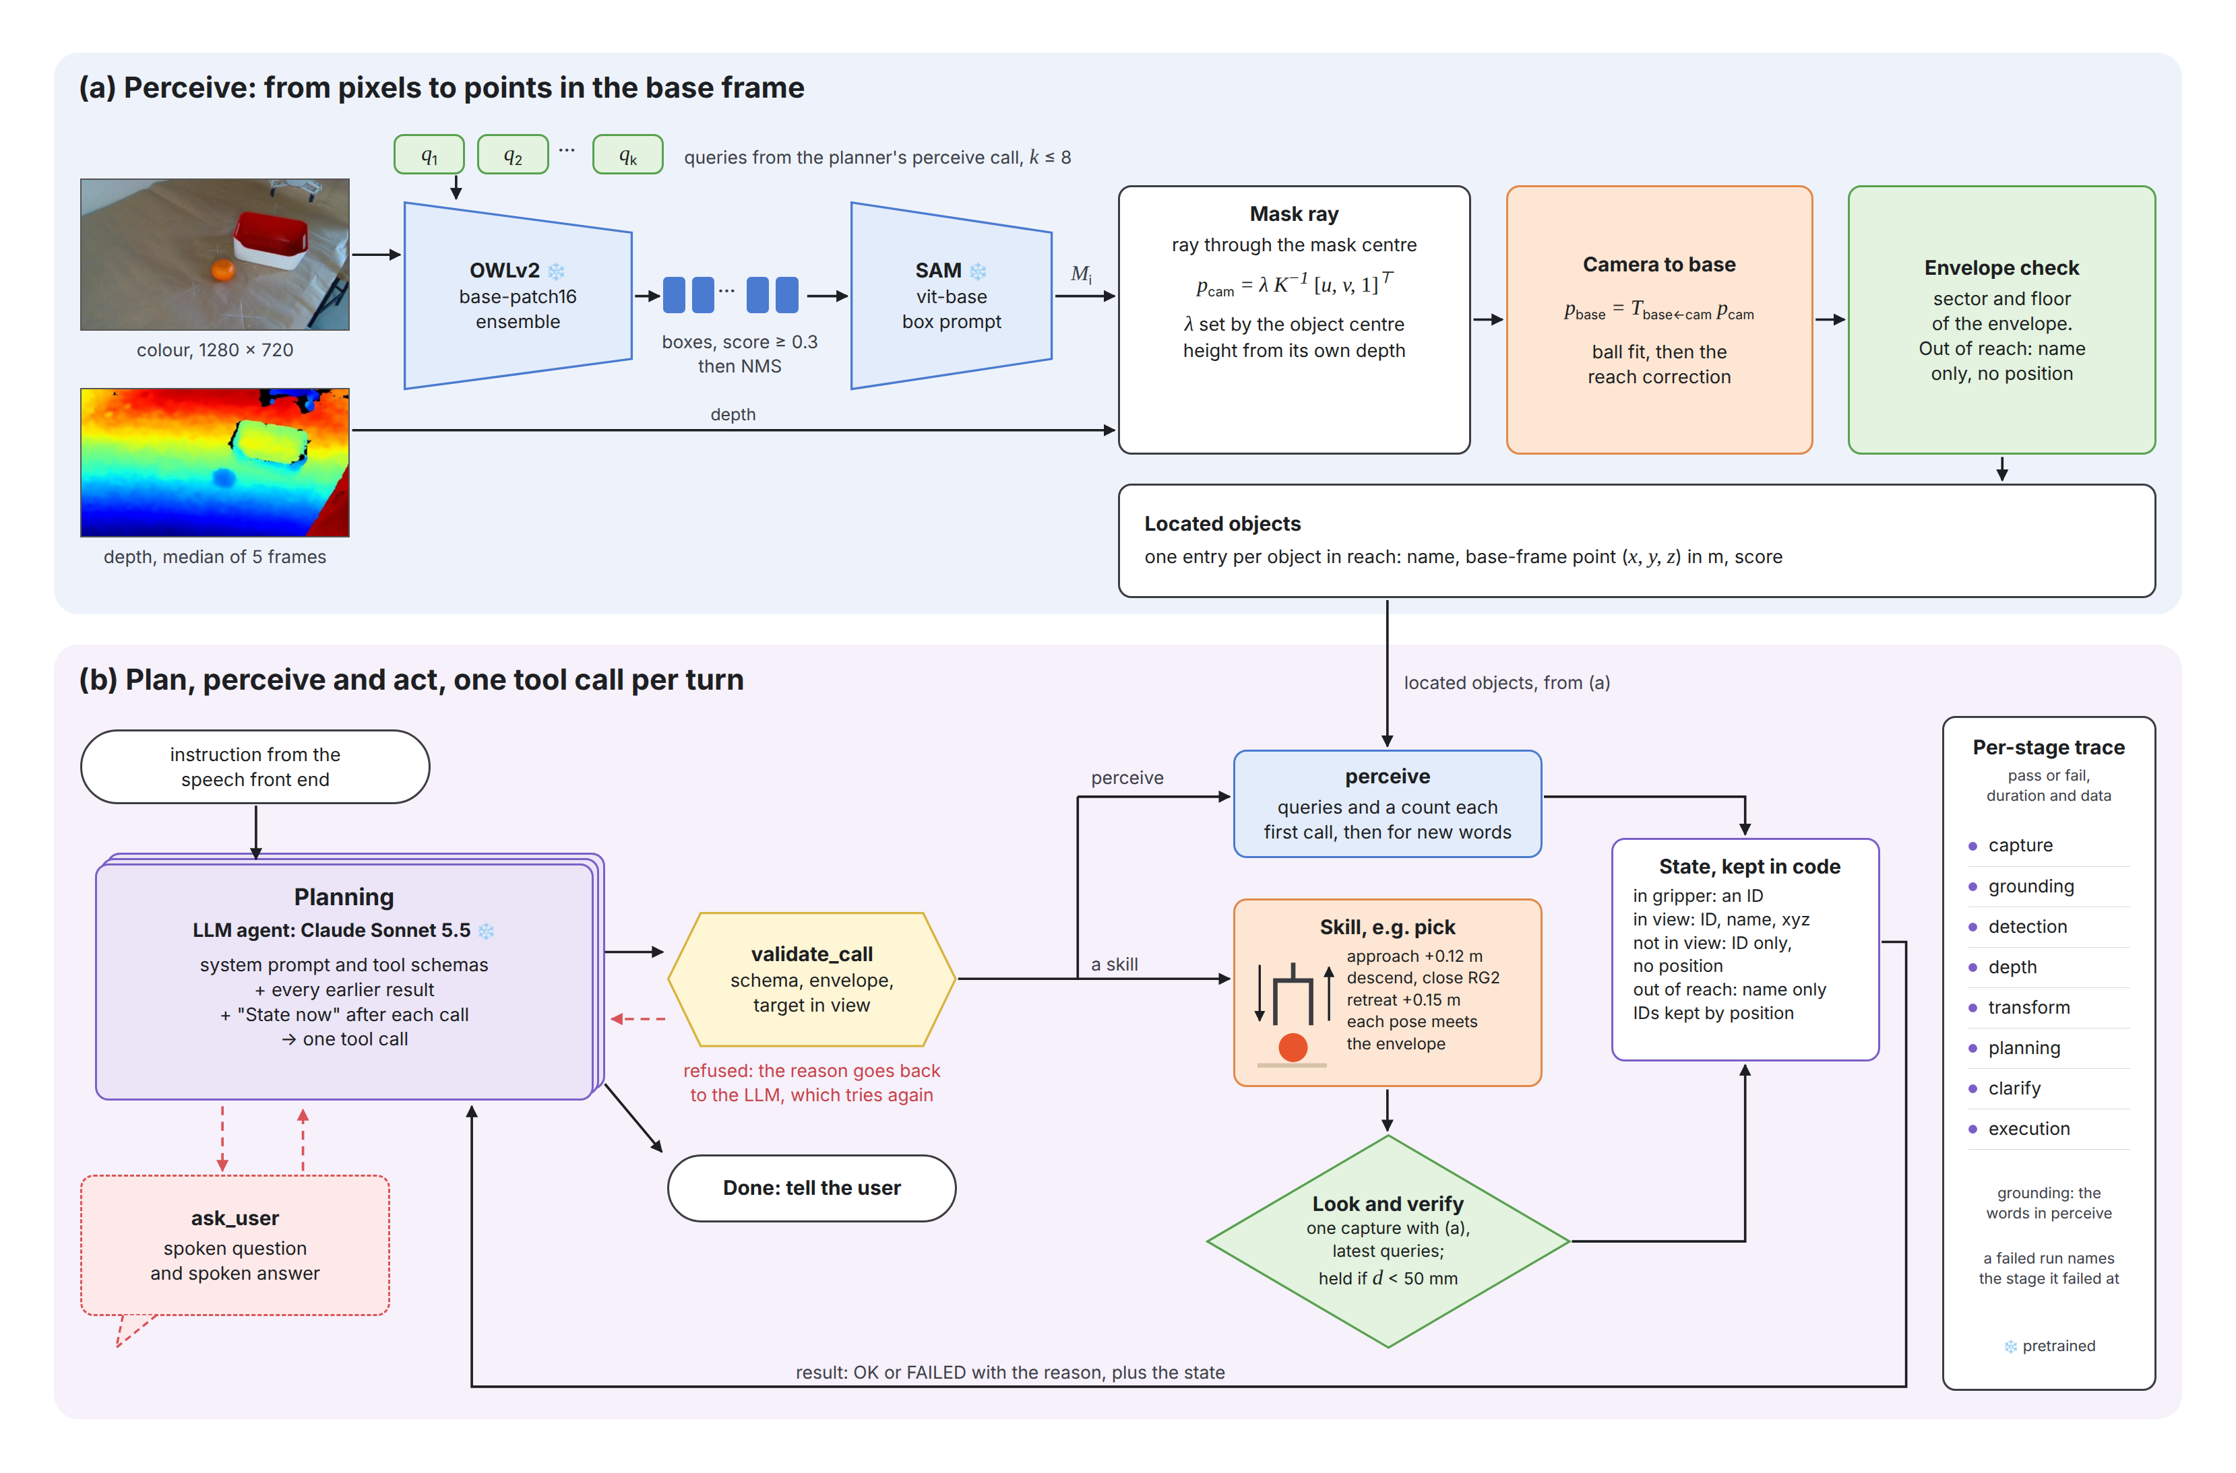
Figure 3. Architecture A. (a) Perception turns pixels into located objects in the base frame, for the queries of the planner's perceive call. (b) The planner makes one tool call per turn. After each skill, one look updates the state and verifies a pick or place.
Perception turns the camera frames into located objects in the base frame. OWLv2 [9] finds a box for each query, and SAM [10] cuts a mask of the object inside the box. The ray from the camera through the mask centre is followed down to the height of the object's centre, which comes from the depth of the object's own pixels. The camera-to-base transform (Section 6.3) gives that ray and height in the base frame. An object outside the envelope is reported as out of reach. Figure 4 shows the colour and aligned depth frames that perception starts from.
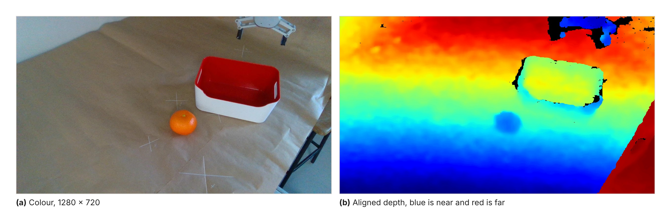
Figure 4. Colour and aligned depth frames from the fixed camera on the real cell.
The planner is Claude Sonnet 5.5. Each turn it sees the instruction, every earlier result and the state, and it returns one tool call. The state is kept in code, not by the LLM. It lists the object in the gripper, the objects in view with an ID and a base-frame position, the objects no longer in view (with no position), and the objects out of reach. An object keeps its ID from look to look, matched by its position. The call is checked against its schema, the envelope and the state before it runs, so a pick must aim at an object in view. A refused call goes back to the planner with the reason. The planner can also ask the user a question, answered by voice, and then call perceive again with the words of the answer. A run ends when the planner says it is done, or after 12 turns.
Each skill is a scripted motion. A pick moves the TCP through three poses: an approach pose 12 cm above the pick position, a grasp pose at the object and a retreat pose 15 cm above it. A place uses the same three poses over the place position. A home skill returns the arm to its home pose. After every skill, A makes one look with the latest queries and updates the state, so the next planning turn sees the table as it is now. After a pick or place, the same look verifies the step. It reports the object held after a pick if it lies within 50 mm of the TCP, or released after a place if it lies farther away. A failed step does not end the run, and the planner may retry. Every stage, from capture, grounding, detection, depth and transform to planning, clarify and execution, writes a trace record with pass or fail, duration and data, so each failure has a failure stage.
This design fixes the three problems of Section 4.1. Perceive is a tool, so the planner can look for a drink that the user named in a clarification (problem 1). Each reply holds one tool call, set in the API request and checked in code (problem 2). The look after a pick or place verifies the step (problem 3). This version has run the pick and place of Section 6.5 on the arm end to end.

5. Architecture B: Fine-tuned SmolVLA

5.1 Design
Architecture B is SmolVLA [2], fine-tuned on demonstrations recorded on this cell (Figure 5). An encoder path reads two camera views, the robot state and the instruction. SmolVLA keeps its vision-language model frozen by default and trains the action expert and the state projection. The action expert uses flow matching. Starting from noise, ten Euler steps follow a learned velocity field to a chunk of 50 actions. Each action lies in the shared action space of Table 3.
Inference runs on LeRobot's own policy server and robot client [11], so the arm keeps moving while the model computes the next chunk [12]. B has no path back to the user, because it has no output that can form a question.
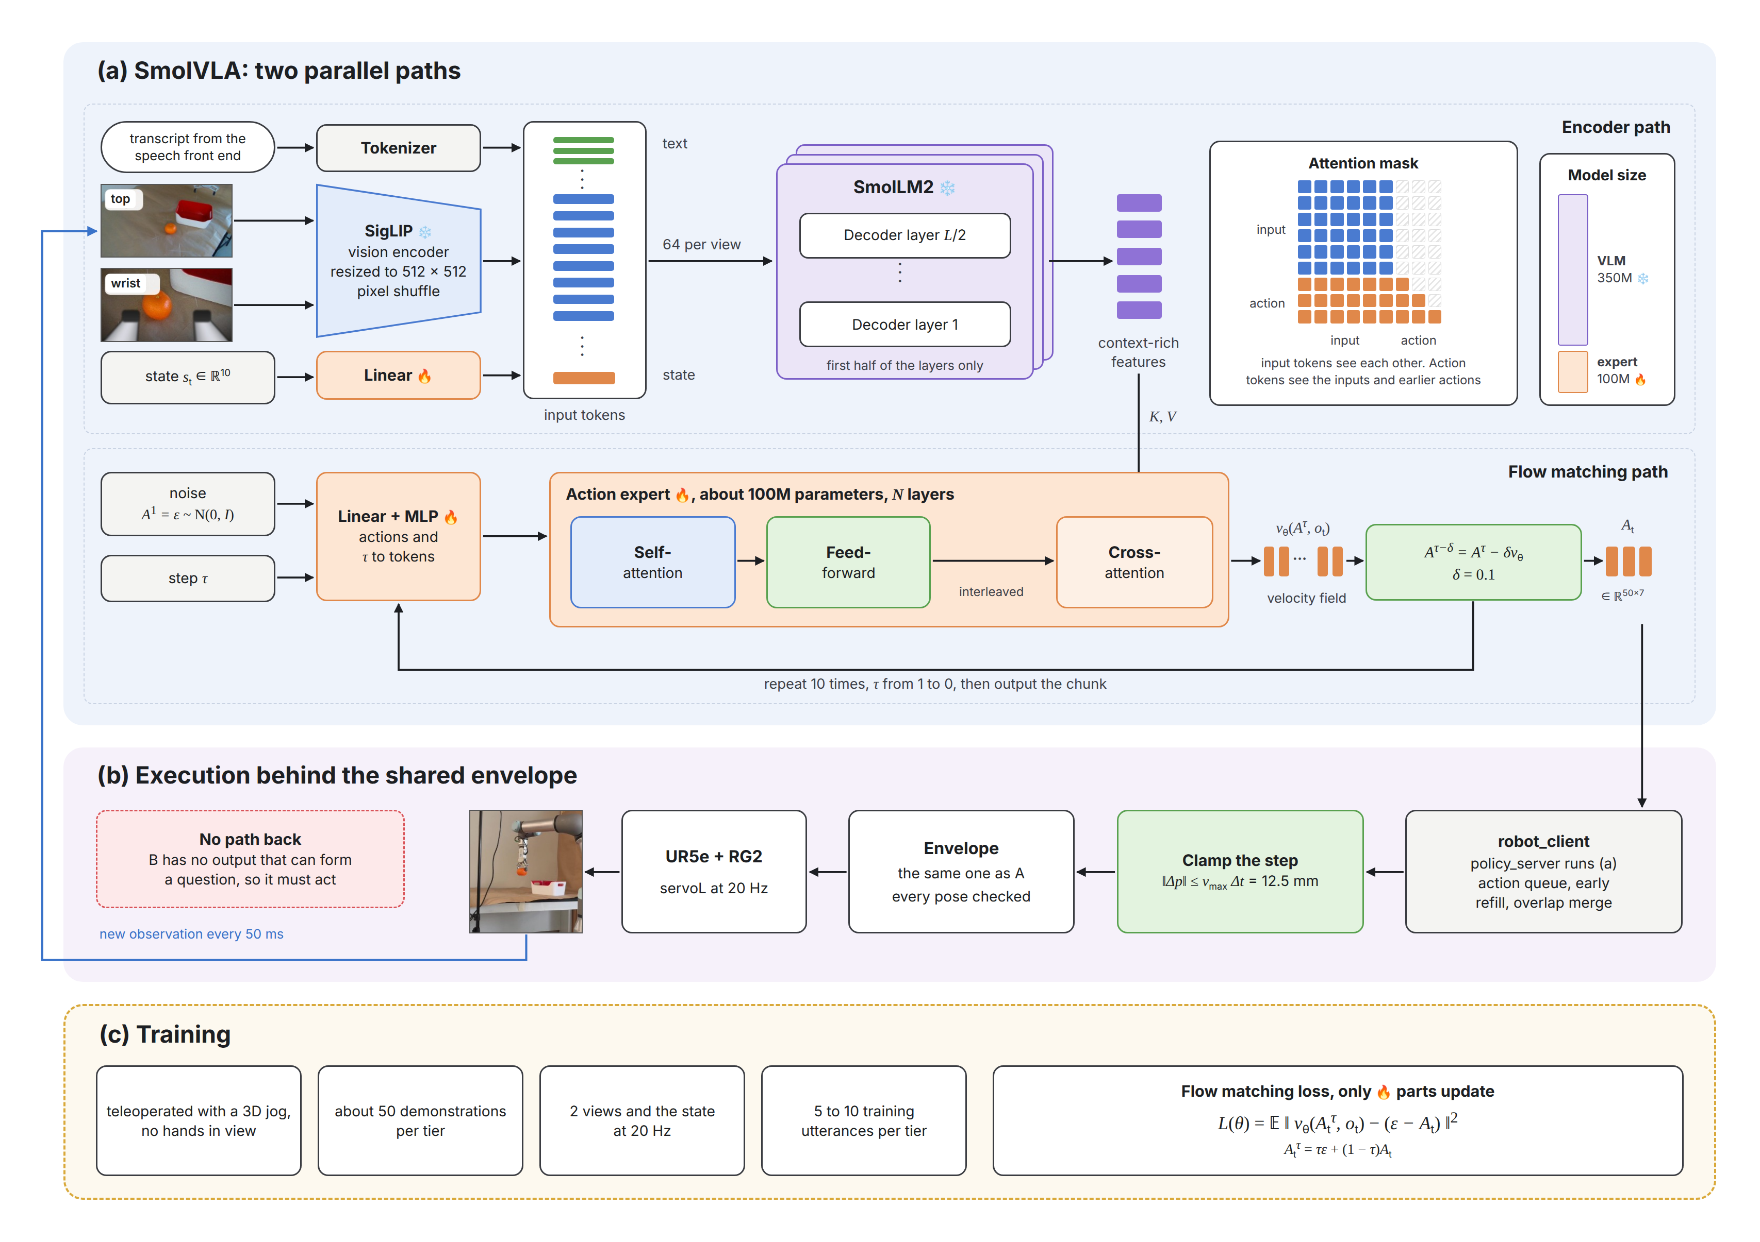
Figure 5. Architecture B. (a) The encoder path turns two views, the state and the instruction into features. The flow-matching path predicts a velocity field, and ten Euler steps turn noise into a chunk of 50 actions. (b) Each action is clamped and checked before the arm moves. (c) Training starts in Semester 2, and only the parts marked with a flame are trained.

5.2 Training plan
Recording and training start after A is frozen, and the plan follows a fixed order.
- Record teleoperated demonstrations on the UR5e with a 3D jog device, so that no hands appear in the camera views
- Record about 50 demonstrations for each of Tiers 0, 1 and 3, and none for Tier 2, so that no demonstrator choice teaches B which drink to pour
- Log two camera views and the robot state at 20 Hz
- Use 5 to 10 training utterances per tier, so that held-out utterances can be tested
- Start with Tier 0 over a small region of the table
- Fine-tune SmolVLA on the recorded demonstrations
- Widen the region once Tier 0 works

5.3 Safety on the arm
Safety comes before the first run on the arm. Every predicted action is clamped to the shared speed ceiling and checked against the same envelope as A. A model that sees an unfamiliar view can output a chunk that moves the arm sharply, and the speed ceiling and the envelope stop it.

6. Work Done So Far

6.1 Before the semester
I started on this project on 28 June 2026, six weeks before the official start. That time went to the parts that need no lab access. I also completed the UR e-Series Core Track from Universal Robots Academy, which covers the setup, programming and safety settings of e-Series arms such as the UR5e.
Two simulators served as scaffolding (Figure 6). URSim, the UR controller simulator, stood in for the arm while I wrote the control stack. This covered the RTDE and URScript interfaces, a custom RTDE recipe for joint logging, a dashboard client and the controller class. MuJoCo stood in for the cell while I wrote the data path: the demonstration recorder, the demonstration store, the converter to the LeRobot dataset format and the camera-to-base calibration module. In MuJoCo, OWL-ViT base gave correct boxes at a confidence near 0.008 with the wrong colour labels, so I chose OWLv2 instead. Both simulators were retired once the real cell was available.
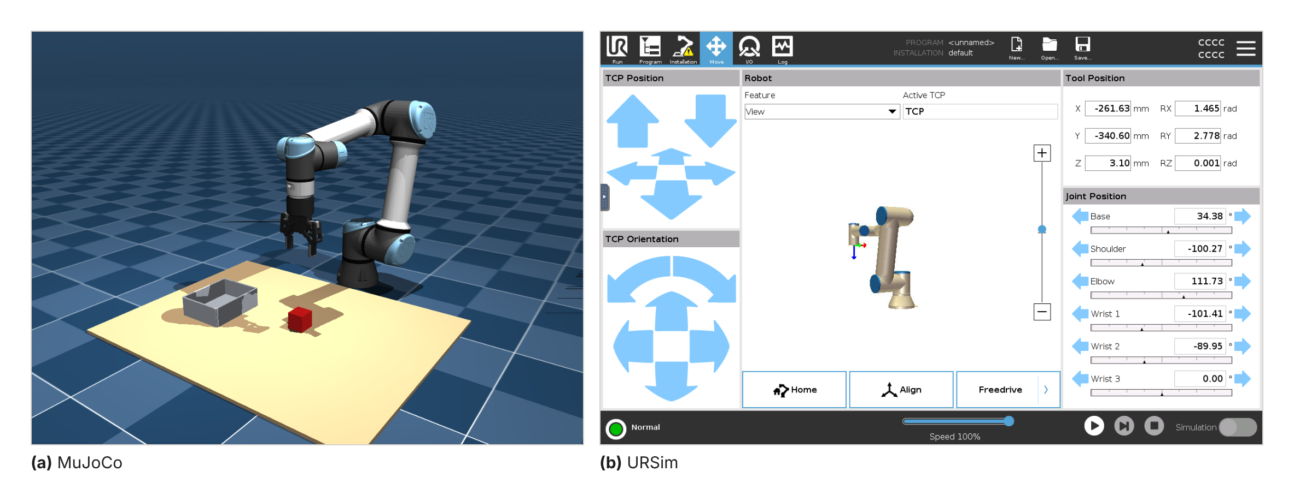
Figure 6. Simulation used before the semester. (a) MuJoCo with the UR5e and Robotiq 2F-85 models. (b) URSim running the PolyScope interface.

6.2 Software in Weeks 1 to 5
From 10 August to 13 September I split the code into Architecture A, Architecture B and shared modules, with a test that guards the boundary. I wrote Architecture A in full, the speech front end, and the robot side of Architecture B on LeRobot's policy server and robot client. I froze the evaluation harness on 11 August, before either architecture was tuned. The unit test suite now has 358 passing tests, and none of them needs the arm.

6.3 Calibration without markers
Work on the real cell started with the calibration, because every pick depends on it. The cell uses no printed marker. Instead, the arm holds a ball and moves it through 16 to 39 poses. The detector finds the ball in each image, and a rigid fit gives the camera-to-base transform in one to two minutes. A second step then levels the transform against the table plane. Figure 7 shows the five steps of each session, what each one measures and what it cannot see. Table 6 shows the calibration of 21 October, after the arm was moved.
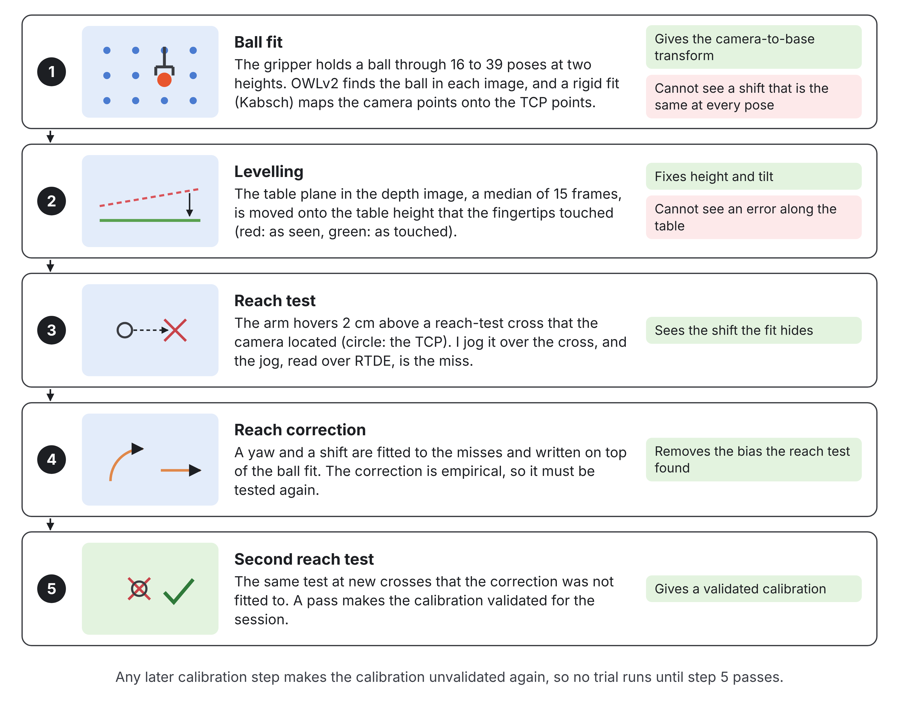
Figure 7. The calibration of each lab session. No trial runs until the second reach test passes.
Order | Step | Error | What it showed
1 | Ball fit after the arm was moved | Fit error 7.3 mm | The fit looked good
2 | Levelling against the table plane | Corrected 16.8 mm in height and 2.1° of tilt | The table came out flat
3 | Reach test at 4 reach-test crosses | Missed by 18 to 36 mm, mostly along base x | A bias the fit error could not show
4 | Reach correction fitted to those 4 misses (a yaw of 3.3° plus a shift) | 2.3 to 6.8 mm at the 4 points, 4 to 12 mm at a point left out of the fit | The bias removed
5 | Reach test at 3 new crosses | Under one 2 mm jog step | Ready for the first full pick and place
Table 6. Calibration history of the camera-to-base transform on 21 Oct.
These five steps open every lab session. The reach test finds what the ball-fit error cannot: a fit with an error of 7.3 mm still missed by up to 36 mm. The reach correction removes that bias. It is empirical, so a second reach test at new reach-test crosses checks it before any run.

6.4 Grasp failures and diagnosis
The first picks on the real arm, on 1 and 13 October, all missed (Figure 8). Three observations narrowed the search, and they pointed to two causes.
- The gripper closed behind the object. The fingers came down past the far side of the orange.
- The misses were all alike. A random error would scatter, so a common offset pointed to a systematic error.
- The logs showed correct detections. OWLv2 found the orange in the right place in the image, so the fault came after the detector.
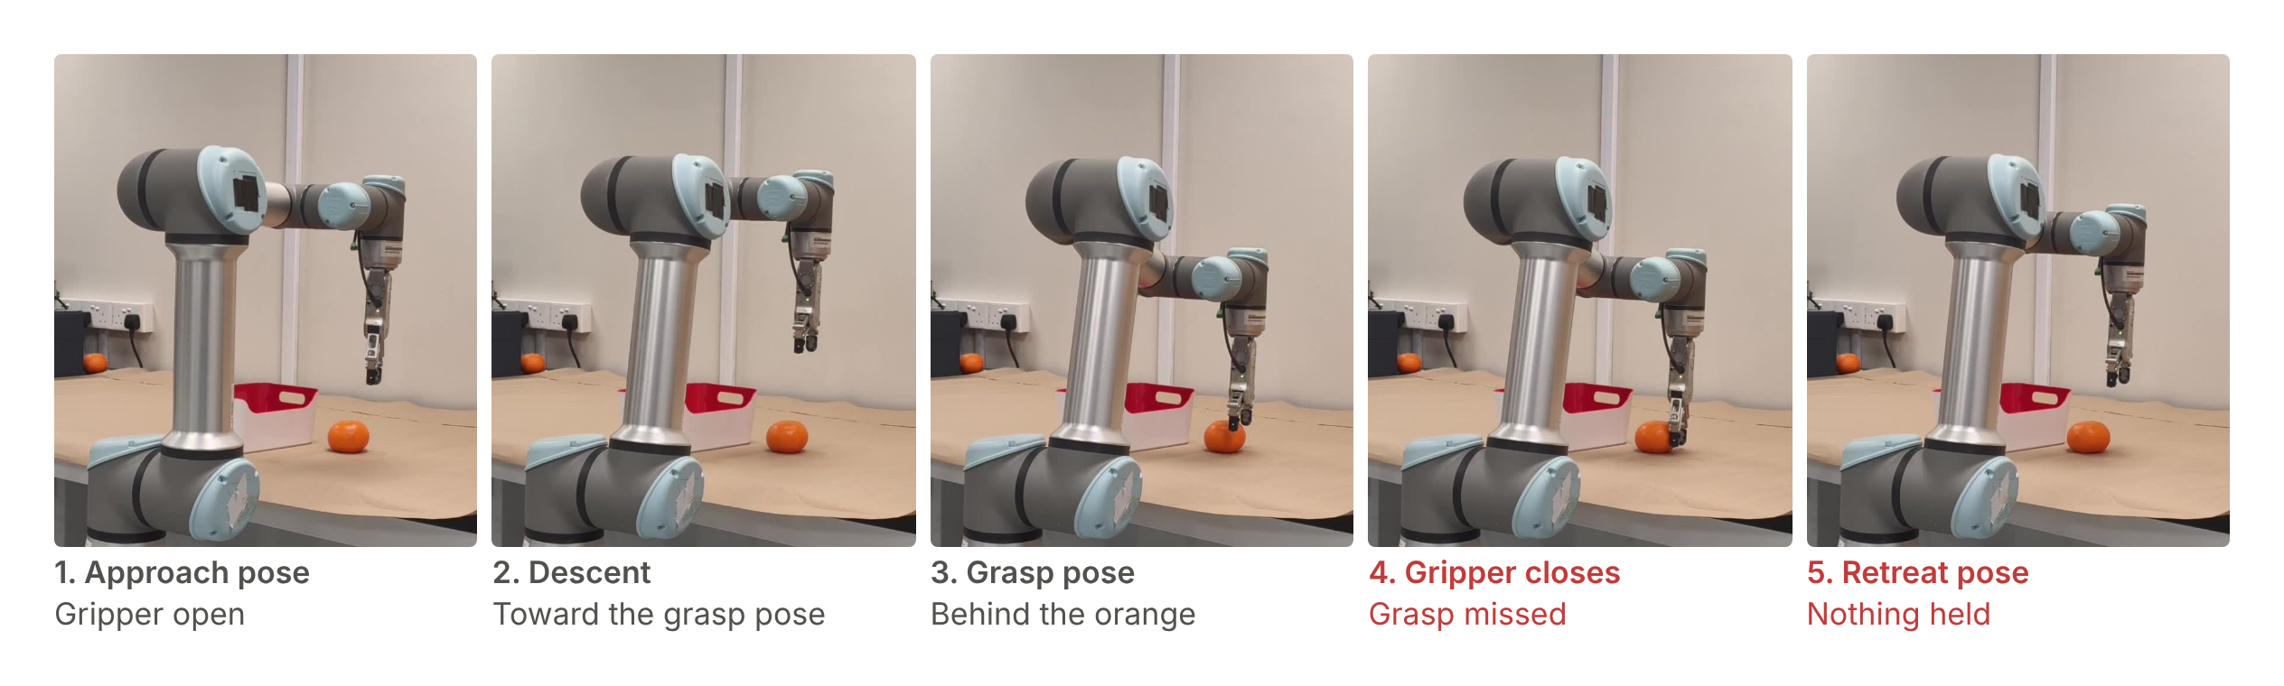
Figure 8. A failed pick on the real arm before the fixes, from phone video. The fingers close behind the orange.
The first cause was a wrong depth reading. The depth of the object was the average of the depth values inside the detection box. A round object does not fill its box, so the corners hold table pixels. With the camera looking down at an angle, those pixels lie farther away than the object. The average moved the pick position along the camera ray to behind the orange (Figure 9). The fix uses SAM [10] to cut a mask of the object inside the box, and the pick position now comes from the mask, so it lies on the object.
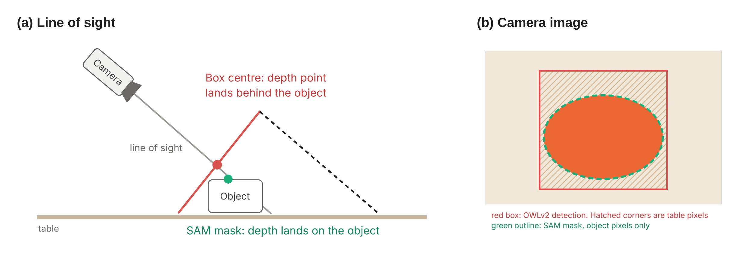
Figure 9. Why the box depth put the pick position behind the object. (a) Along the camera line of sight, with the face of the detection box the camera sees in red. (b) The camera image: the detection box holds table pixels that the SAM mask leaves out.
The second cause was a bias in the camera-to-base transform. A shift that is the same at every fitting pose does not raise the fit residual, so the residual cannot reveal it. This is why each session now ends with the reach test and the reach correction of Section 6.3.

6.5 First pick and place
On 21 October 2026 Architecture A ran from speech to a full pick and place for the first time (Figure 10). That run used the earlier design of Section 4.1. The current A then ran the same task again, and Table 7 follows the trace of a clean run, which took 36.0 s in all. The instruction was "Pick up the orange and place it in the red container." Verifying the pick, A saw the orange 41 mm from the TCP, inside the 50 mm limit, and reported it held. Verifying the place, A saw it 158 mm from the TCP and reported it released. After each of the three steps I typed my own verdict at the bench, and I judged all three correct. A never sees these verdicts, and the time I took to type them is not in Table 7.
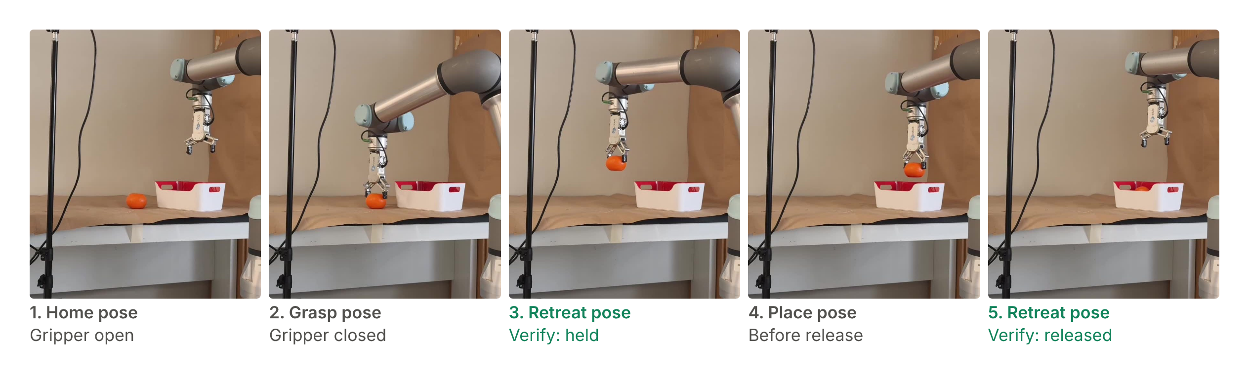
Figure 10. The full pick and place on the real arm on 21 October 2026, from phone video.
Stage | What the trace records | Time
Plan, turn 1 | perceive(["orange", "red container"]), one box for each | 2.31 s
Perceive | Capture (5 depth frames), detection, depth and transform. orange_1 at (0.552, −0.301, 0.207) m, score 0.78. red_container_1 at (0.470, −0.440, 0.201) m, score 0.61 | 5.62 s
Plan, turn 2 | pick(xyz=[0.552, −0.301, 0.207]), aimed at orange_1 | 1.97 s
Pick, look and check | Grip closed at 70 mm. Look after the pick: orange_1 41 mm from the TCP, inside the 50 mm limit, so held. Operator: y | 9.38 s
Plan, turn 3 | place(xyz=[0.470, −0.440, 0.201]), the centre of red_container_1 | 2.14 s
Place, look and check | Released. Look after the place: orange_1 158 mm from the TCP, so released. Operator: y | 6.41 s
Plan, turn 4 | home() | 1.83 s
Home and look | Arm at home. State unchanged. Operator: y | 4.57 s
Plan, turn 5 | No call. The planner reports done | 1.69 s
Whole run | 5 planner turns, no rejections. About 21k input and 0.9k output tokens, about US$0.05. Operator judged all three steps correct | 36.0 s
Table 7. Trace of a clean run of the current Architecture A, stage by stage.

7. Future Work

7.1 Remaining work
Table 8 lists the work that is left, in the order it must be done. Each step names the objective of Table 1 that it completes and the step it waits for. Table 1 gives the condition that marks each objective done.
Step | Work | Objective | Starts after
1 | Write the pour skill for Tier 1 and finish the drawer skill for Tier 3 | T3 | Now
2 | Pass an unscored check on Tiers 0 to 3, then freeze A | T3 | Step 1
3 | Record about 50 demonstrations each for Tiers 0, 1 and 3, off the layout crosses | T4 | Step 2
4 | Fine-tune SmolVLA in the order of Section 5.2, then pass an unscored check on every tier | T5 | The first Tier 0 demonstrations
5 | Run 20 scored trials per tier for each architecture through the harness | T6 | Steps 2 and 4
Table 8. Remaining work, in the order it must be done.

7.2 Schedule
Figure 11 places the steps of Table 8 in time: A in December, B in January and the scored trials in February. The order follows from the fairness rules. A is frozen before the scored trials, and the trials start only once B is trained, so nothing is tuned after the first scored result. A buffer week then fills any gaps before the results are frozen at the end of February. That date does not move, because the final report needs the four weeks after it. If a step slips, whole tiers are cut, Tier 4 first and then Tier 3, rather than running every tier with fewer trials. The reports follow on the NTU dates.
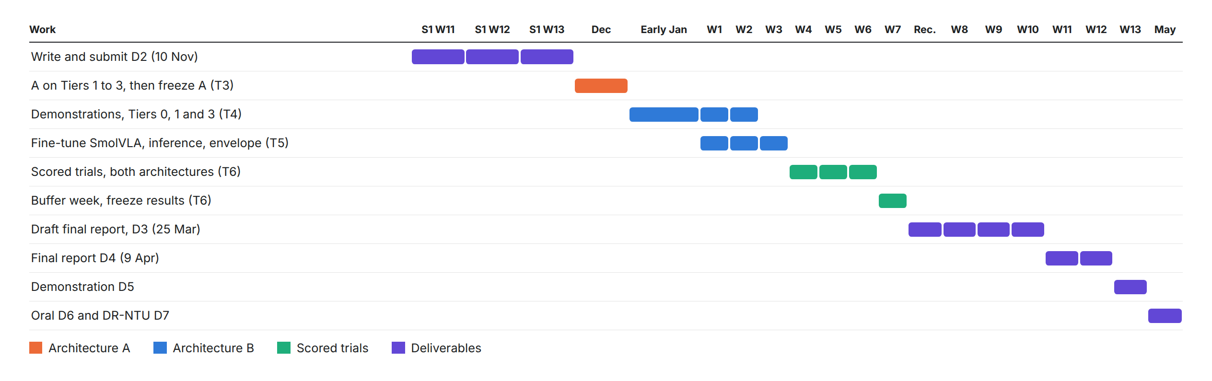
Figure 11. Schedule from Semester 1 Week 11 to the oral presentation in May 2027.

7.3 Changes to the original requirements
Three changes were made in Semester 1, and each is recorded with a date. On 7 October, Architecture A became a loop (Section 4.1). On 13 October, speech became the only input, so no instruction can be typed. On 17 October, the plan to finish every result by November 2026 was dropped, and the work now follows the NTU dates (Section 7.2).

7.4 Risks
Risk | Effect | Response
Demonstration coverage | B fails outside the region it was shown | Start over a small region of the table, where density matters more than count, then widen
Demonstration quality | Hands in view or uneven motion teach the wrong cues | 3D jog device instead of hand guiding. Inspect the first five demonstrations before recording more
Calibration drift | B sees a view it was not trained on | Ball fit and reach test each session. Record demonstrations across the small range of camera positions
Fair comparison | An unequal setting biases the result | Shared modules, the frozen suite, a blind harness and a dated changelog
Learned actions | A predicted chunk can move the arm unsafely | Speed ceiling and envelope on every action. Test the e-stop recovery before any scored trial
Table 9. Risks for Semester 2 and the response to each.

8. Conclusion
Architecture A now runs on the real arm from an utterance to a full pick and place. Getting there took most of October. The grasps missed for two systematic reasons, a depth point taken from a box average and a transform bias that the fit residual could not show. Both were found from three plain observations and fixed with SAM masks, and with a reach test and reach correction after every fit.
The fairness controls are written into code, and the harness has been frozen since August. The calibration still depends on the reach correction, and no trial has been scored yet, because the scored trials start only once A is frozen and B is trained. Architecture B has its robot side written but no demonstration recorded yet. Its demonstrations and training in January are the largest risk to the schedule, and the order of work in Section 7.1 is set to meet it.

9. Acknowledging the Use of GAI
Generative AI was used in this project. Claude, a model by Anthropic, helped write code and helped draft this report. All design decisions, bench work and results are my own. An LLM is also part of Architecture A, where it is the object of study.

References
[1] J. Liang, W. Huang, F. Xia, P. Xu, K. Hausman, B. Ichter, P. Florence and A. Zeng, "Code as policies: Language model programs for embodied control," in Proc. IEEE Int. Conf. Robotics and Automation (ICRA), 2023.
[2] M. Shukor et al., "SmolVLA: A vision-language-action model for affordable and efficient robotics," arXiv:2506.01844, 2025.
[3] S. Shan and C. C. Cheah, "A large-language-model-enabled robotic system with application to power cable manipulation," in Proc. 16th Int. Conf. Power, Energy, and Electrical Engineering (CPEEE), Osaka, Japan, 2026, doi: 10.1109/CPEEE69412.2026.11521580.
[4] P. Guo et al., "AgenticLab: A real-world robot agent platform that can see, think, and act," arXiv:2602.01662v1, Feb. 2026.
[5] Physical Intelligence, K. Black, N. Brown et al., "π0.5: A vision-language-action model with open-world generalization," arXiv:2504.16054, Apr. 2025.
[6] A. Z. Ren et al., "Robots that ask for help: Uncertainty alignment for large language model planners," in Proc. Conf. Robot Learning (CoRL), PMLR vol. 229, pp. 661-682, 2023.
[7] S. Lian et al., "BayesianVLA: Bayesian decomposition of vision language action models via latent action queries," arXiv:2601.15197v1, Jan. 2026.
[8] A. Radford, J. W. Kim, T. Xu, G. Brockman, C. McLeavey and I. Sutskever, "Robust speech recognition via large-scale weak supervision," in Proc. Int. Conf. Machine Learning (ICML), PMLR vol. 202, pp. 28492–28518, 2023.
[9] M. Minderer, A. Gritsenko and N. Houlsby, "Scaling open-vocabulary object detection," in Advances in Neural Information Processing Systems (NeurIPS), 2023.
[10] A. Kirillov et al., "Segment anything," in Proc. IEEE/CVF Int. Conf. Computer Vision (ICCV), 2023.
[11] R. Cadene et al., "LeRobot: An open-source library for end-to-end robot learning," in Proc. Int. Conf. Learning Representations (ICLR), 2026, arXiv:2602.22818.
[12] K. Black, M. Y. Galliker and S. Levine, "Real-time execution of action chunking flow policies," in Advances in Neural Information Processing Systems (NeurIPS), 2025.

