**Crime Analysis**

**Project#: 001**

**Business Requirements Document (BRD)**

**Prepared by: Ashwajeet Gajre**

**Prepared for: ABC Analyst Pvt. Ltd.**

**Date Submitted: 05/12/2016**

**Project Sponsor: Yu Fan**

**Client Acceptor: Bill Smith**

**Project Manager: Jaikit Jilka**

**Document Number:3129-243/01/BRD**

**Security Classification: Low**

**Version:01**

**Last Updated: May 12, 2016**

**Creation Date:May 01, 2016**

# Table of Contents

Table of Contents 1

1. Introduction 2

1.1. Document Purpose 2

1.2. Intended Audience 2

1.3. Project Background 2

1.4. Purpose of the Business Requirements 2

1.5. Business Goals/Objectives to be achieved 2

1.6. Benefits of Business Requirement 3

1.7. Stakeholders 3

1.8. Dependencies on existing systems 3

2. Functional Requirement. 3

2.1. Actor Profiles Specification 3

3. Use case. 4

4. Data Requirements 7

4.1. Data Architecture 7

4.1.1. Dimensional Model 8

4.2. Data Volumes 8

4.3. Data Retention and Archiving 8

5. Non-Functional requirements 8

5.1. Security Requirements 9

5.1.1. Authentication 9

5.1.1. Authorization and Access Controls 9

5.1.1. Information Security Classification and labelling 9

5.4. Performance Requirements 10

5.5. Scalability Requirements 10

5.5.1. User Scalability 10

5.5.2. Application Scalability 10

1. **Introduction**

## Document Purpose

The purpose of this document is to describe business requirements of an Application completely, accurately and unambiguously in Technology-independent manner. All attempts have been made in using mostly business terminology and business language while describing the requirements in this document. Very minimal and commonly understood Technical terminology is used. Use case is used in modeling the business requirements in this document.

* 1. **Intended Audience**

The intended audience for this document are the business owners of the proposed system. This document should be readable by business owners of the proposed system. They must be able to verify that their business requirements have been documented here completely, accurately and unambiguously.

* 1. **Project Background**

The Business Requirements have been composed based on information from the previous kick-off meeting as well as business interviews.

* 1. **Purpose of the Business Requirements**

The purpose of the Business Requirements is to get the business requirement to build the new application development and also to build the new application for the data analysis.

## Business Goals/Objectives to be achieved

The Objective to be achieved are :

Total Crimes happened in Different Cities from 2012-2015.

• What crimes more happens in specific cities.

• Fine obtained according to the crime.

• Is the crime reduced or increased.

* 1. **Benefits of Business Requirement**

The benefits of business requirement will allow our organisation to have the clear idea to the employee about having which case are still under investigation and which case are completed and how much the fine is been collected from specific crime.

## Stakeholders

Stakeholders are the individuals or groups who have a vested interest in this project and whose interests need to be considered throughout the project. This section lists the Stakeholders of the Application / Project for which these Business requirements are documented.

DW ABC Analyst Pvt. Ltd. will help the analyst to observe the fine collected to the specific crime in the given area code in the whole LA county.

The IT analyst of the ABC Analyst Pvt. Ltd. will give them the access to make a report by seeing the database.

* 1. **Dependencies on existing systems**

The is no dependencies on the present existing system. It can have uploaded by employee at any given time.

1. **Functional Requirement.**

This section describes what are the functional requirement in the given business requirement. The functional requirement will provide the actor specification. It also provide the use case approach in the text form.

* 1. **Actor Profiles Specification**

This section describes the actors and their profile specification. An Actor is a person, organization or an external system/sub-system/program that has interactions with the Application. Actors, by definition, are external to the system with which they are having interactions. Actors have goals that are achieved by use cases. Typically, Actors have behaviour and are represented by the roles they play in the use cases. An Actor stimulates the system by providing input and/or receiving something of measurable value from the system.

|  |  |  |  |
| --- | --- | --- | --- |
| **Actor Name** | **Actor Type** | **Access Type needed** | **Comments** |
| Jaikit Jilka | Project Manager  ETL Developer | * Create * Read * Export * Update * Delete |  |
| Ashwajeet | BI developer | * Read * Create * Update * Delete |  |
| Hamad | CEO, System Analyst | * Read * Update |  |
| Yu Fan | Business Sponsor | * Read * Update * Other |  |

1. **Use case.**

We worked under the Software tableau and came out with interesting observation .

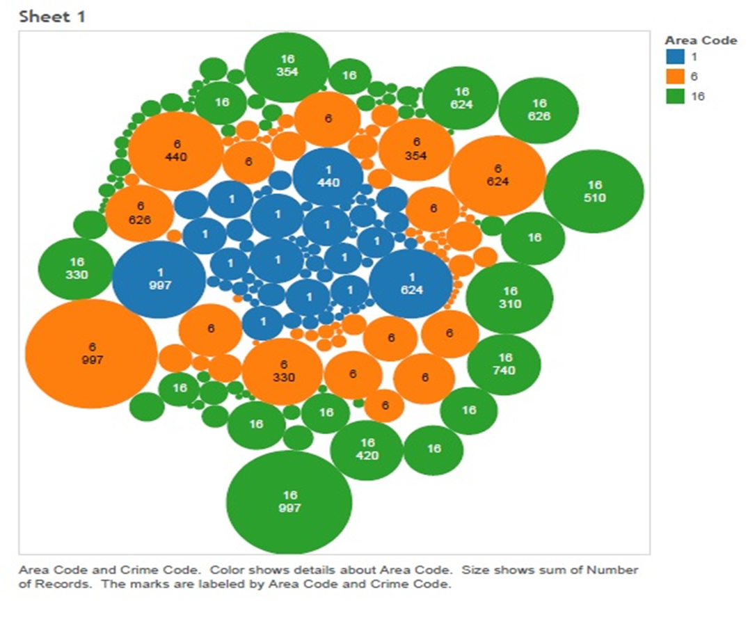

The above graph shows bubble diagram of area code against the crime code. As the bubble size is increased the crime is increased.

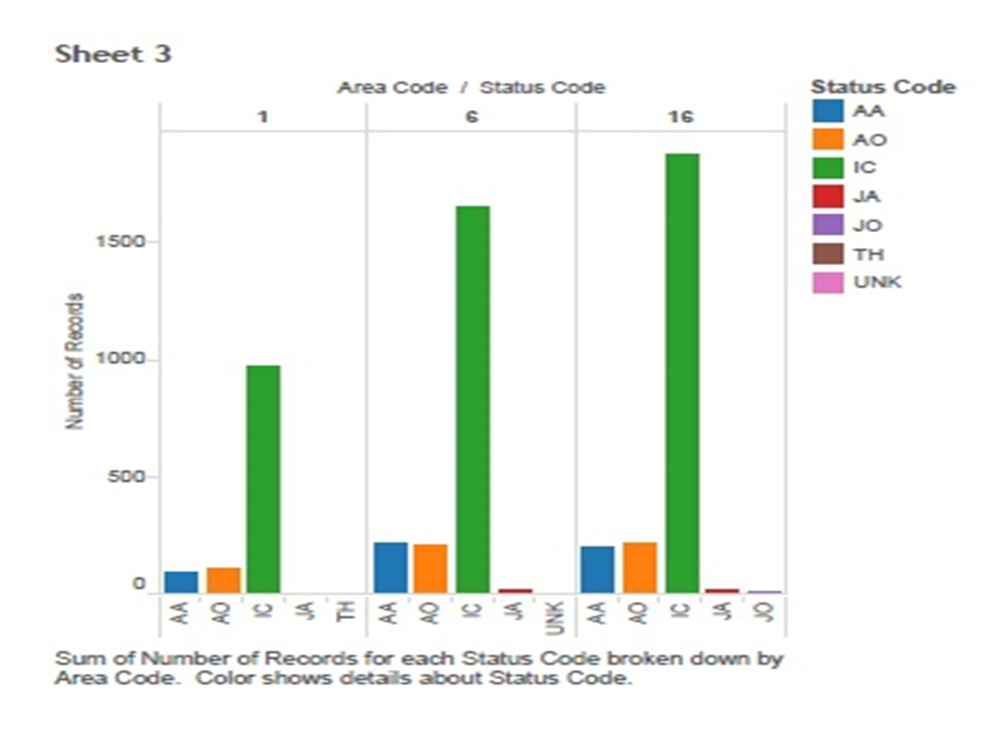

The graph presents the status of the crime with respect to the reports.

The different kinds of status are

* Adult Arrest
* Adult other
* Investigation continued
* Juvenile Arrest
* Juvenile Unkown
* Others

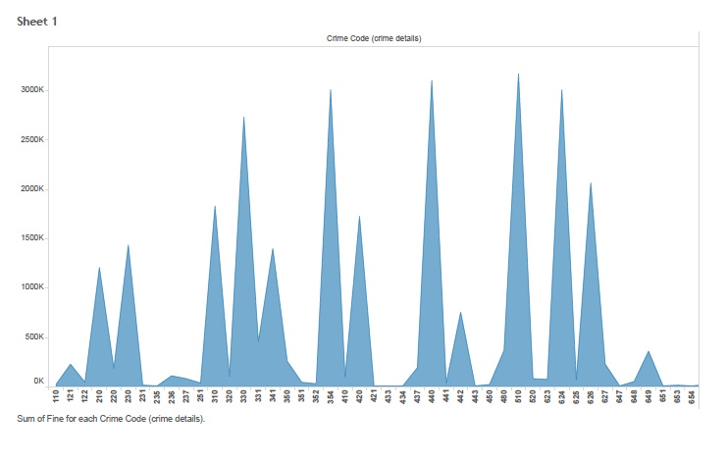

This report gives us the sum of fines for each crime Code from 2012 to 2015.

T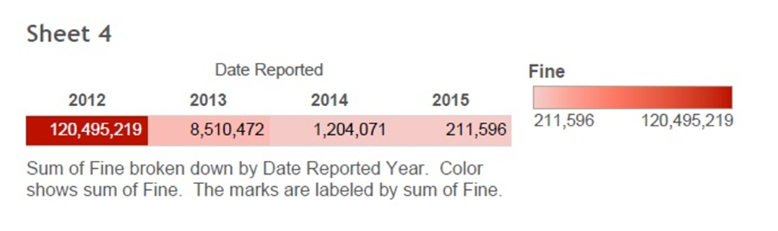

The reports give the information of total no of fines collected on each year.

1. **Data Requirements**

This section describes what are data requirement parts in the business requirement.

## Data Architecture

This section talks about the data requirement parts in the given business requirement.

* + 1. **Dimensional Model**

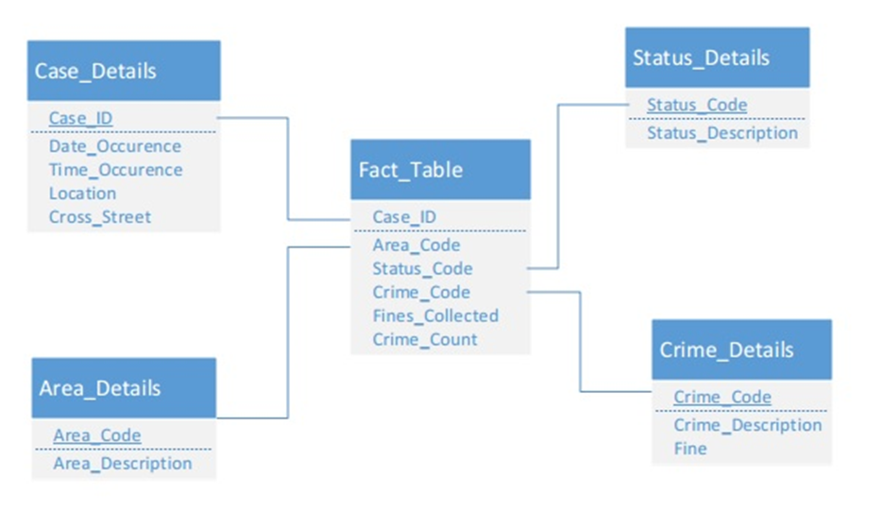

* 1. **Data Volumes**

The total data entries to analyze is 5606. There are three source file which are:

* CentralData.xls which are 1179 rows.
* Hollywooddata.xls which are 2099 rows.
* Foothilldata.xls which are 2328 rows.
  1. **Data Retention and Archiving**

This section describes the Data retention and also the archiving requirements.

This section involves data to be analysed on crime in three different cities in LA county from 2012-2015.

*.*

# Non-Functional requirements

This section describes the non-functional requirements section of the Business Requirements. A non-functional requirement is known as a special requirement that is not easily or naturally specified in the text of the use cases or function’s event flow.

* 1. **Security Requirements**

This section describes the Security requirements part of the Business Requirements.

* + 1. **Authentication**

This section describes the Authentication specification part of the Business Requirements. Authentication is the process of verifying the genuineness of claims that a person/group makes to establish identity/eligibility for access to services. In order to ascertain the Authentication requirements of the Application, it is required to analyse the type of transactions that different Use cases/Business Functions trigger within the Application. The following criteria is used in determining transaction types of each use case/function (in line with the Government Core Policy Manual):

***Level 0: Anonymous transaction*** *– This kind of transaction allows which gives the flexibility for avoiding the authentication. well known examples is the information about the program on the government service which gives the liberty to hide the identity of the person.*

***Level 1: Pseudonymous transaction*** *–This kind of transaction will also does not require the information identy*

*triggers transactions that do not require a person to be identified but do require a means for further contact to deliver a product or service. For example, a note from someperson@internet. cannot be readily translated into an individual’s name, but it may be sufficient to request information, to provide some services, or on-going follow up.*

***Level 2 : Identified transaction*** *– triggers transactions that require that a person be specifically identified. The nature of the transaction may require confirmation of a person's identity (e.g., name, address, birth date, etc.) and/or data linking the person to a transaction (e.g., invoice number, personal health number, etc.).*

***Level 3 : Verified transaction*** *– triggers transactions that require: the person to be specifically identified; verification of the integrity of the data exchanged and the exchange itself; and, the creation of sufficient evidence to indicate that the person agreed to be bound by the transaction. For example, a note signed with a digital certificate, audit trails and security logs may provide sufficient evidence that a specific person intended to conduct a transaction.*

* + 1. **Authorization and Access Controls**

This section describes the Authorization and Access Control requirements part of the Business Requirements at a high-level. Authorization is the process of determining if the person/group, once identified through the “Authentication process”, is permitted to have access to certain services. The Authorization and Access Control requirements are best described through a matrix.

* + 1. **Information Security Classification and labelling**

This section is for informational purposes only.

The “*Information security classification and labeling* of information assets” is a process published and managed by OCIO. According to this process, all government “records” as defined in the Interpretation Act need to be classified. (“record” includes books, documents, maps, drawings, photographs, letters, vouchers, papers and any other thing on which information is recorded or stored by any means whether graphic, electronic, mechanical or otherwise).

There are no business requirements (functional or non-functional requirements) applicable to the *Information security classification* of the application/project/initiative for which the BRD is being written. Hence there is no need to fill-in anything in this section.

However, please be aware that the finished application/initiative/project and all its output deliverables (such as documents, models, diagrams etc) need to be classified and labelled in accordance with the OCIO guidelines. This will help in determining how much protection the finished application and its data will need commensurate with its sensitivity levels determined during information security classification process. It will also help in evaluation of risks associated with authorized and unauthorized disclosures of the application’s data.

This section describes the system usability requirements. A usability requirement specifies how easy the system must be to use. Usability is a non-functional requirement, because in its essence it doesn't specify parts of the system functionality, but specifies only how that functionality is to be perceived by the user, for instance how easy it must be to learn and operate the system.

The usability of this system should be moderately easy to learn, very efficient for the tasks expected for it, and moderately easy to understand. Since there are a low number of expected users, they can be extensively trained and infrequent retraining should be required.

* 1. **Performance Requirements**

This section describes system performance expectation levels (response times).

All use cases’ response times are expected to be less than one minute.

* 1. **Scalability Requirements**

This section describes how the system is expected to scale to new higher or lower levels. Both user and application scalability requirements are described here.

* + 1. **User Scalability**

This system’s user volume should remain at around 3-4 users over the next year.

* + 1. **Application Scalability:**

Not Required.