Class Level Information
Class | Levels | Values
GRP | 4 | 1 2 3 4

Number of Observations Read | 250
Number of Observations Used | 250
Source | DF | Sum of Squares | Mean Square | F Value | Pr > F
Model | 3 | 10.1523650 | 3.3841217 | 3.46 | 0.0171
Error | 246 | 240.6710750 | 0.9783377
Corrected Total | 249 | 250.8234400

R-Square | Coeff Var | Root MSE | socdom Mean
0.040476 | 977.3810 | 0.989110 | 0.101200

Source | DF | Type I SS | Mean Square | F Value | Pr > F
GRP | 3 | 10.15236497 | 3.38412166 | 3.46 | 0.0171

Source | DF | Type III SS | Mean Square | F Value | Pr > F
GRP | 3 | 10.15236497 | 3.38412166 | 3.46 | 0.0171

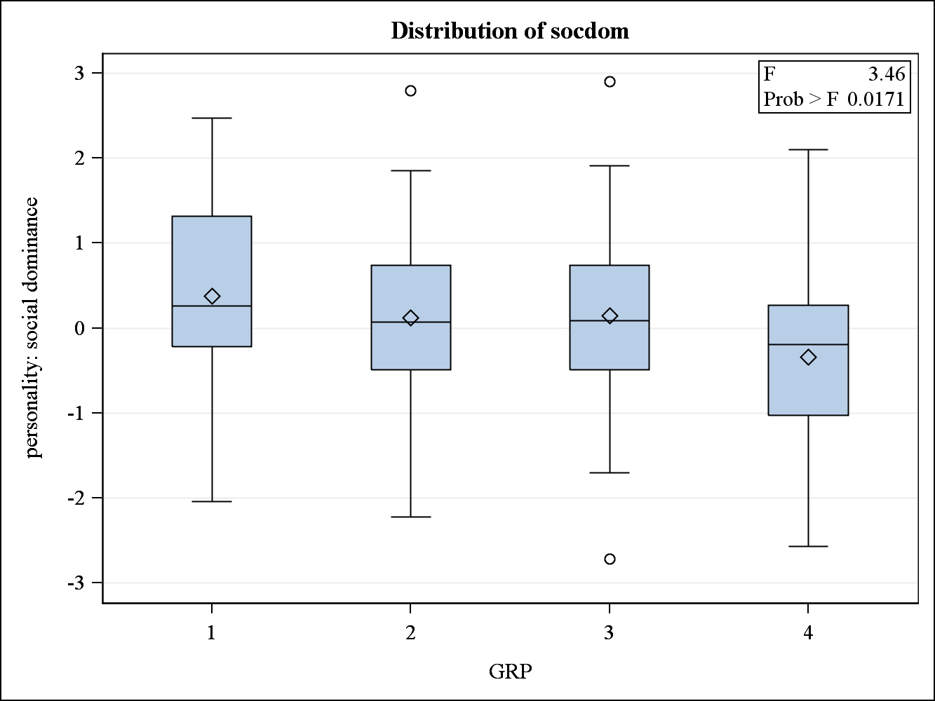
Source | DF | Sum of Squares | Mean Square | F Value | Pr > F
Model | 3 | 9.6463331 | 3.2154444 | 3.15 | 0.0257
Error | 246 | 251.3380413 | 1.0216994
Corrected Total | 249 | 260.9843744

R-Square | Coeff Var | Root MSE | sociabty Mean
0.036961 | 1693.685 | 1.010791 | 0.059680

Source | DF | Type I SS | Mean Square | F Value | Pr > F
GRP | 3 | 9.64633311 | 3.21544437 | 3.15 | 0.0257

Source | DF | Type III SS | Mean Square | F Value | Pr > F
GRP | 3 | 9.64633311 | 3.21544437 | 3.15 | 0.0257

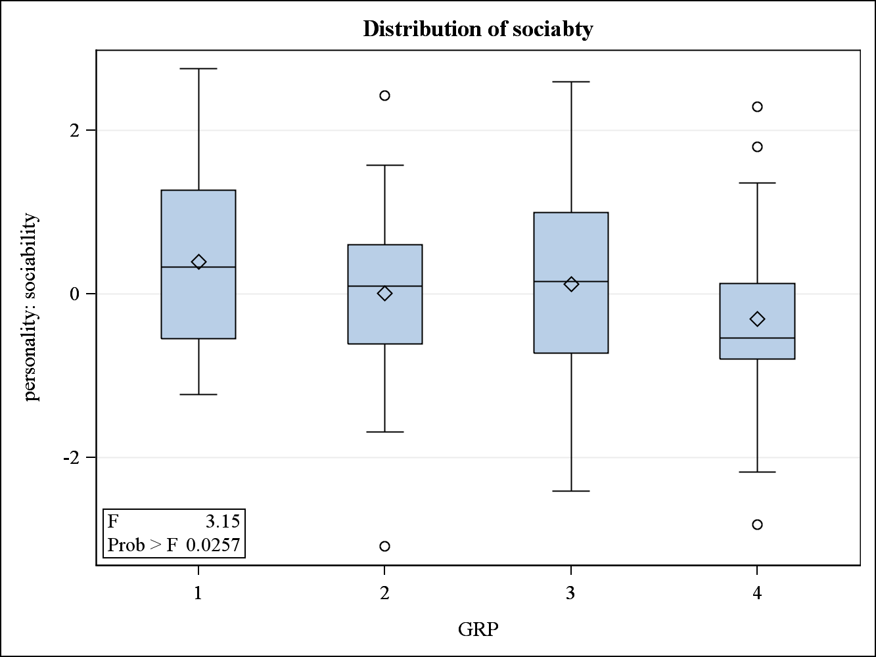
Source | DF | Sum of Squares | Mean Square | F Value | Pr > F
Model | 3 | 1.8896201 | 0.6298734 | 0.71 | 0.5445
Error | 246 | 217.0186695 | 0.8821897
Corrected Total | 249 | 218.9082896

R-Square | Coeff Var | Root MSE | stress Mean
0.008632 | -5538.028 | 0.939250 | -0.016960

Source | DF | Type I SS | Mean Square | F Value | Pr > F
GRP | 3 | 1.88962014 | 0.62987338 | 0.71 | 0.5445

Source | DF | Type III SS | Mean Square | F Value | Pr > F
GRP | 3 | 1.88962014 | 0.62987338 | 0.71 | 0.5445

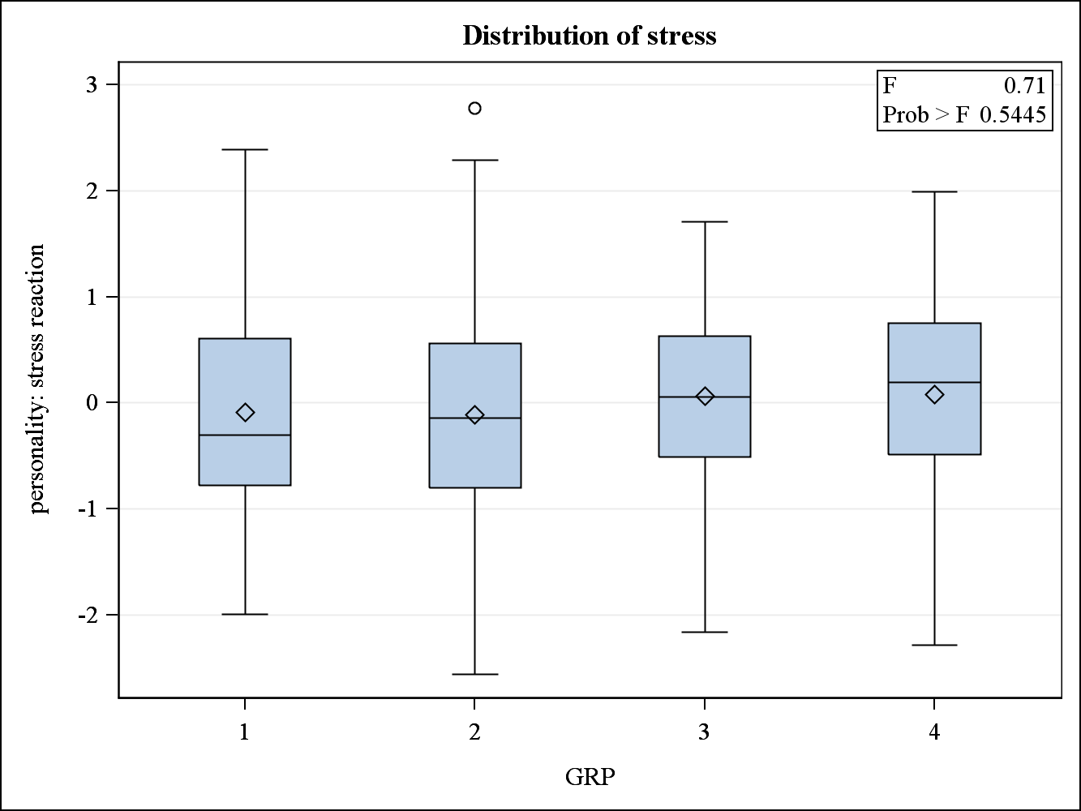
Source | DF | Sum of Squares | Mean Square | F Value | Pr > F
Model | 3 | 0.2791392 | 0.0930464 | 0.09 | 0.9650
Error | 246 | 251.9376064 | 1.0241366
Corrected Total | 249 | 252.2167456

R-Square | Coeff Var | Root MSE | worry Mean
0.001107 | 45178.41 | 1.011996 | 0.002240

Source | DF | Type I SS | Mean Square | F Value | Pr > F
GRP | 3 | 0.27913919 | 0.09304640 | 0.09 | 0.9650

Source | DF | Type III SS | Mean Square | F Value | Pr > F
GRP | 3 | 0.27913919 | 0.09304640 | 0.09 | 0.9650

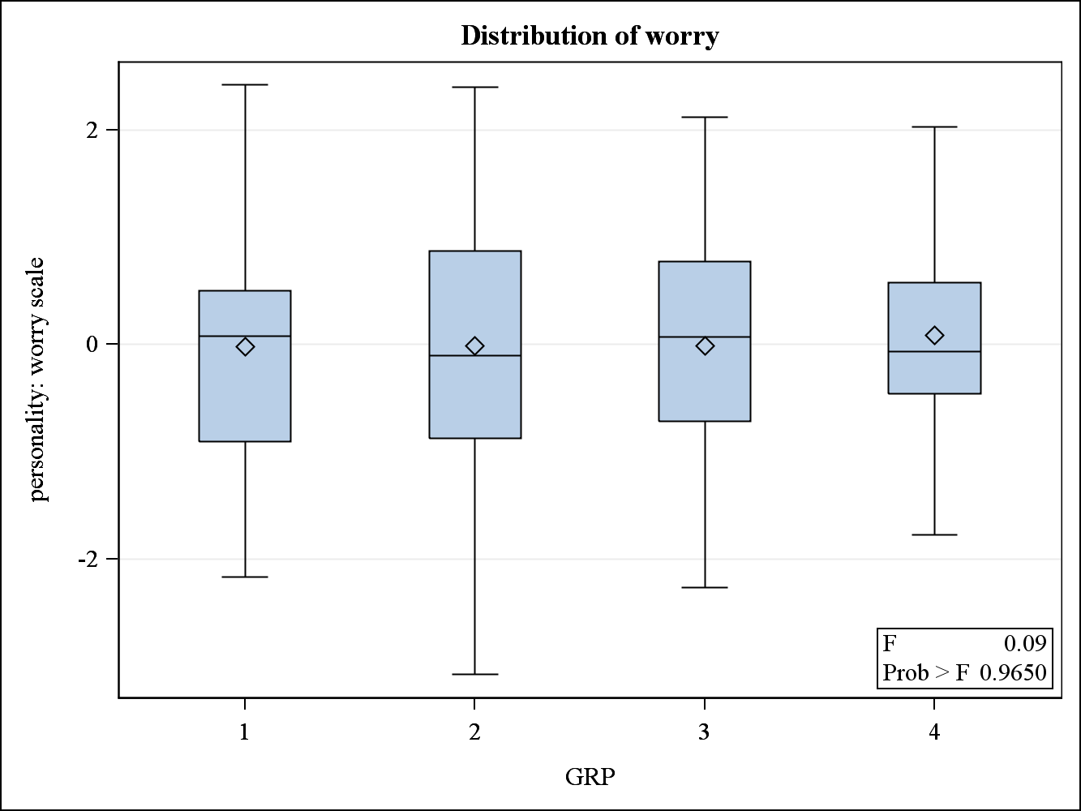
Source | DF | Sum of Squares | Mean Square | F Value | Pr > F
Model | 3 | 10.9531075 | 3.6510358 | 3.86 | 0.0100
Error | 246 | 232.7425549 | 0.9461079
Corrected Total | 249 | 243.6956624

R-Square | Coeff Var | Root MSE | impulsve Mean
0.044946 | 1853.431 | 0.972681 | 0.052480

Source | DF | Type I SS | Mean Square | F Value | Pr > F
GRP | 3 | 10.95310748 | 3.65103583 | 3.86 | 0.0100

Source | DF | Type III SS | Mean Square | F Value | Pr > F
GRP | 3 | 10.95310748 | 3.65103583 | 3.86 | 0.0100

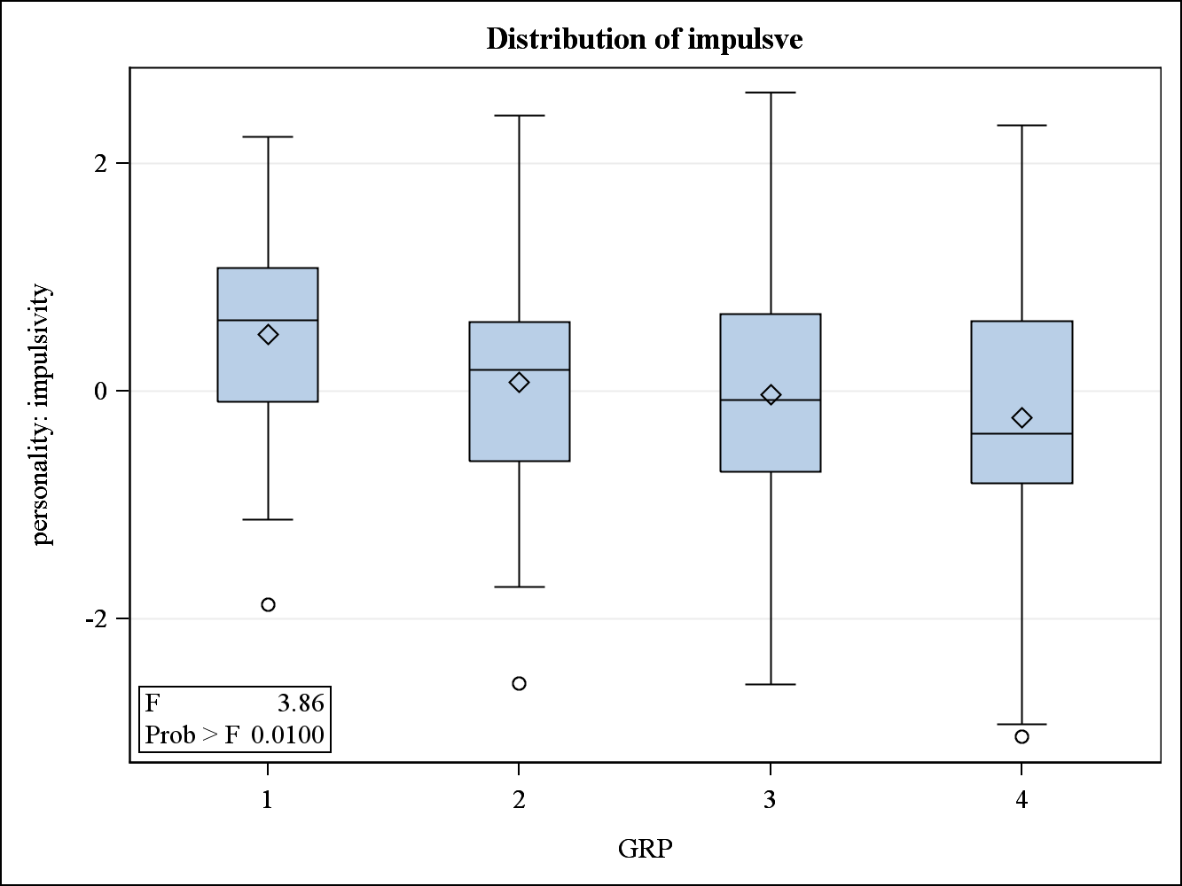
Source | DF | Sum of Squares | Mean Square | F Value | Pr > F
Model | 3 | 7.5079332 | 2.5026444 | 2.37 | 0.0714
Error | 246 | 260.0652364 | 1.0571758
Corrected Total | 249 | 267.5731696

R-Square | Coeff Var | Root MSE | thrillsk Mean
0.028059 | 729.4201 | 1.028191 | 0.140960

Source | DF | Type I SS | Mean Square | F Value | Pr > F
GRP | 3 | 7.50793325 | 2.50264442 | 2.37 | 0.0714

Source | DF | Type III SS | Mean Square | F Value | Pr > F
GRP | 3 | 7.50793325 | 2.50264442 | 2.37 | 0.0714

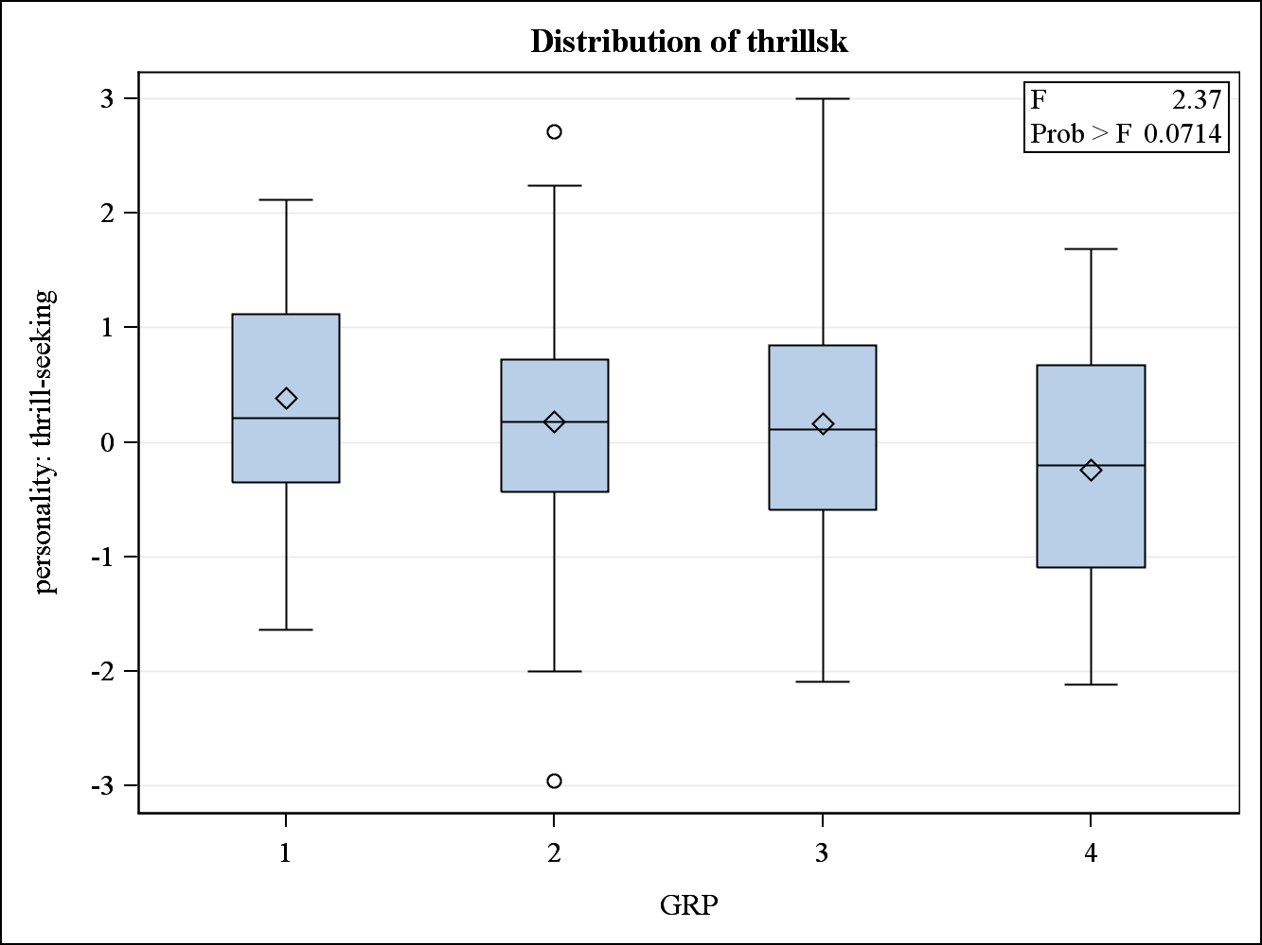
E = Error SSCP Matrix
 | socdom | sociabty | stress | worry | impulsve | thrillsk
socdom | 240.67107503 | 139.77327355 | 1.6462878073 | -0.855518503 | 2.0152138454 | -9.874741397
sociabty | 139.77327355 | 251.33804129 | -21.07969484 | -9.652793924 | 7.3467992979 | -4.186707153
stress | 1.6462878073 | -21.07969484 | 217.01866946 | 110.15704873 | -6.890552921 | -13.39826935
worry | -0.855518503 | -9.652793924 | 110.15704873 | 251.93760641 | -21.76584655 | -30.47192875
impulsve | 2.0152138454 | 7.3467992979 | -6.890552921 | -21.76584655 | 232.74255492 | 121.05479565
thrillsk | -9.874741397 | -4.186707153 | -13.39826935 | -30.47192875 | 121.05479565 | 260.06523635

Partial Correlation Coefficients from the Error SSCP Matrix / Prob > |r|
DF = 246 | socdom | sociabty | stress | worry | impulsve | thrillsk
socdom | 1.000000 | 0.568307  <.0001 | 0.007204  0.9103 | -0.003474  0.9567 | 0.008515  0.8941 | -0.039471  0.5370
sociabty | 0.568307  <.0001 | 1.000000 | -0.090258  0.1573 | -0.038360  0.5485 | 0.030376  0.6347 | -0.016376  0.7979
stress | 0.007204  0.9103 | -0.090258  0.1573 | 1.000000 | 0.471104  <.0001 | -0.030660  0.6316 | -0.056397  0.3775
worry | -0.003474  0.9567 | -0.038360  0.5485 | 0.471104  <.0001 | 1.000000 | -0.089886  0.1590 | -0.119045  0.0617
impulsve | 0.008515  0.8941 | 0.030376  0.6347 | -0.030660  0.6316 | -0.089886  0.1590 | 1.000000 | 0.492043  <.0001
thrillsk | -0.039471  0.5370 | -0.016376  0.7979 | -0.056397  0.3775 | -0.119045  0.0617 | 0.492043  <.0001 | 1.000000
H = Type III SSCP Matrix for GRP
 | socdom | sociabty | stress | worry | impulsve | thrillsk
socdom | 10.152364967 | 9.4652224492 | -2.074599807 | -1.586553497 | 8.8486421546 | 8.6977533969
sociabty | 9.4652224492 | 9.6463331118 | -1.256461959 | -1.344026876 | 8.8166991021 | 7.9868839534
stress | -2.074599807 | -1.256461959 | 1.889620138 | 0.3454488706 | -2.948031879 | -2.064260248
worry | -1.586553497 | -1.344026876 | 0.3454488706 | 0.2791391881 | -1.129642251 | -1.360808852
impulsve | 8.8486421546 | 8.8166991021 | -2.948031879 | -1.129642251 | 10.953107482 | 7.8265091471
thrillsk | 8.6977533969 | 7.9868839534 | -2.064260248 | -1.360808852 | 7.8265091471 | 7.5079332461

Characteristic Roots and Vectors of: E Inverse * H, where
H = Type III SSCP Matrix for GRP
E = Error SSCP Matrix
Characteristic Root | Percent | Characteristic Vector V'EV=1
Characteristic Root | Percent | socdom | sociabty | stress | worry | impulsve | thrillsk
0.09702180 | 77.86 | 0.03045661 | 0.01974062 | -0.00980927 | 0.00457444 | 0.03210055 | 0.01967837
0.01726020 | 13.85 | 0.01188722 | 0.01913020 | 0.04401496 | -0.02444126 | -0.05391818 | 0.03643940
0.01032065 | 8.28 | -0.04418056 | 0.04979508 | 0.04485475 | -0.01080491 | 0.03175540 | -0.03002987
0.00000000 | 0.00 | -0.00094640 | 0.01369070 | -0.01651820 | 0.06630678 | -0.01404024 | 0.00864480
0.00000000 | 0.00 | 0.04108946 | -0.05038994 | 0.04004474 | 0.00126044 | 0.02333888 | -0.00708734
0.00000000 | 0.00 | -0.03830368 | 0.00019869 | 0.00842222 | 0.00587055 | -0.00123271 | 0.04882719

MANOVA Test Criteria and F Approximations for the Hypothesis of No Overall GRP Effect
H = Type III SSCP Matrix for GRP
E = Error SSCP Matrix
S=3 M=1 N=119.5
Statistic | Value | F Value | Num DF | Den DF | Pr > F
Wilks' Lambda | 0.88693840 | 1.64 | 18 | 682.14 | 0.0451
Pillai's Trace | 0.11562365 | 1.62 | 18 | 729 | 0.0488
Hotelling-Lawley Trace | 0.12460265 | 1.66 | 18 | 476.03 | 0.0427
Roy's Greatest Root | 0.09702180 | 3.93 | 6 | 243 | 0.0009
NOTE: F Statistic for Roy's Greatest Root is an upper bound.

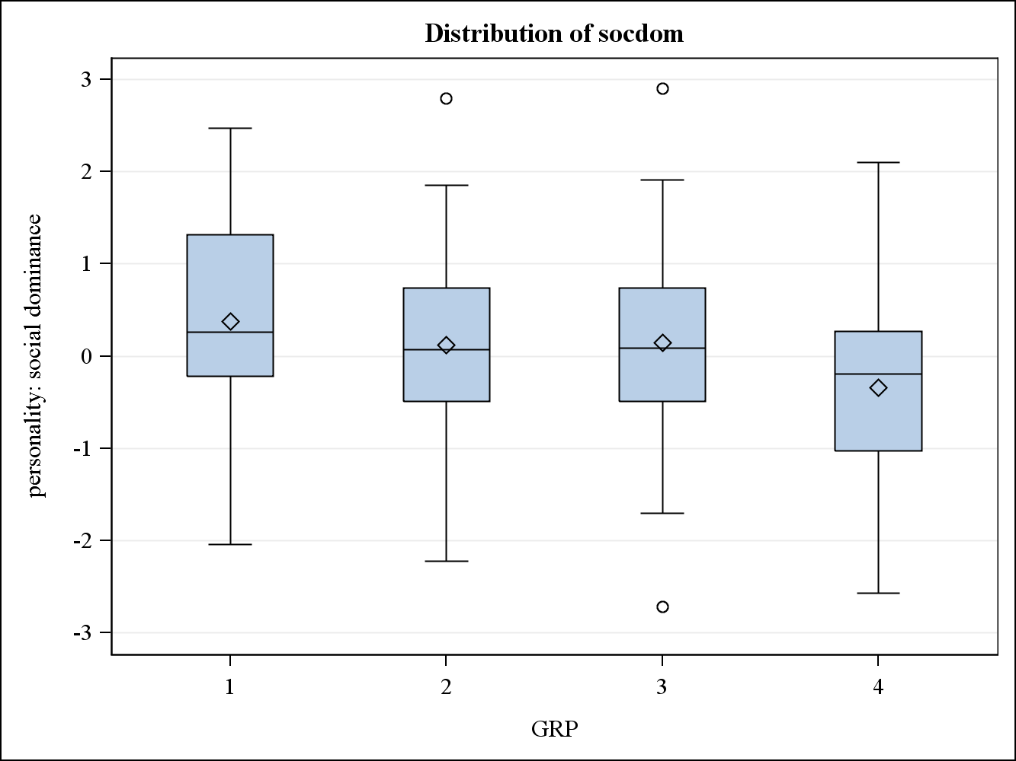
Note: | This test controls the Type I experimentwise error rate.

Alpha | 0.05
Error Degrees of Freedom | 246
Error Mean Square | 0.978338
Critical Value of Studentized Range | 3.65811

Comparisons significant at the 0.05 level are indicated by ***.
GRP  Comparison | Difference  Between  Means | Simultaneous 95% Confidence Limits
1 - 3 | 0.2286 | -0.2710 | 0.7283
1 - 2 | 0.2521 | -0.2500 | 0.7543
1 - 4 | 0.7196 | 0.1206 | 1.3185 | ***
3 - 1 | -0.2286 | -0.7283 | 0.2710
3 - 2 | 0.0235 | -0.3612 | 0.4081
3 - 4 | 0.4909 | -0.0136 | 0.9955
2 - 1 | -0.2521 | -0.7543 | 0.2500
2 - 3 | -0.0235 | -0.4081 | 0.3612
2 - 4 | 0.4675 | -0.0395 | 0.9745
4 - 1 | -0.7196 | -1.3185 | -0.1206 | ***
4 - 3 | -0.4909 | -0.9955 | 0.0136
4 - 2 | -0.4675 | -0.9745 | 0.0395

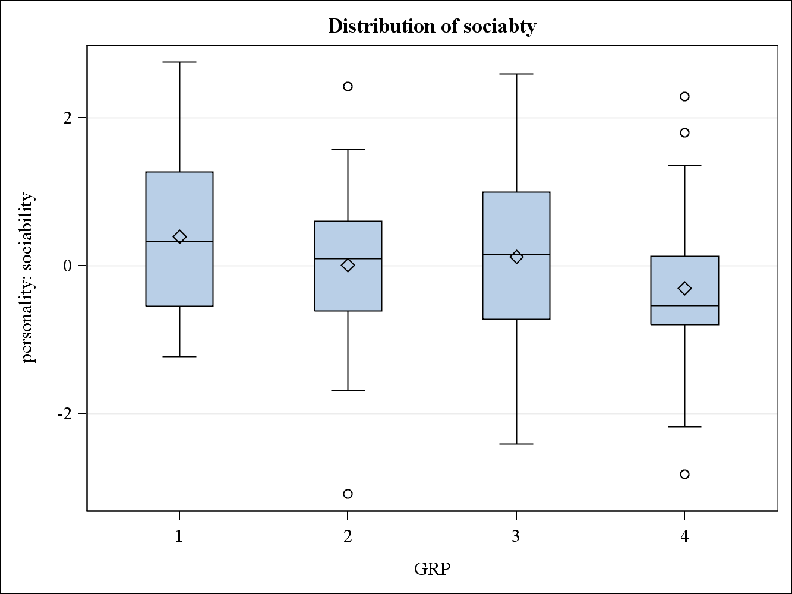
Note: | This test controls the Type I experimentwise error rate.

Alpha | 0.05
Error Degrees of Freedom | 246
Error Mean Square | 1.021699
Critical Value of Studentized Range | 3.65811

Comparisons significant at the 0.05 level are indicated by ***.
GRP  Comparison | Difference  Between  Means | Simultaneous 95% Confidence Limits
1 - 3 | 0.2752 | -0.2354 | 0.7858
1 - 2 | 0.3892 | -0.1239 | 0.9024
1 - 4 | 0.7046 | 0.0925 | 1.3167 | ***
3 - 1 | -0.2752 | -0.7858 | 0.2354
3 - 2 | 0.1140 | -0.2791 | 0.5071
3 - 4 | 0.4293 | -0.0863 | 0.9449
2 - 1 | -0.3892 | -0.9024 | 0.1239
2 - 3 | -0.1140 | -0.5071 | 0.2791
2 - 4 | 0.3153 | -0.2028 | 0.8335
4 - 1 | -0.7046 | -1.3167 | -0.0925 | ***
4 - 3 | -0.4293 | -0.9449 | 0.0863
4 - 2 | -0.3153 | -0.8335 | 0.2028

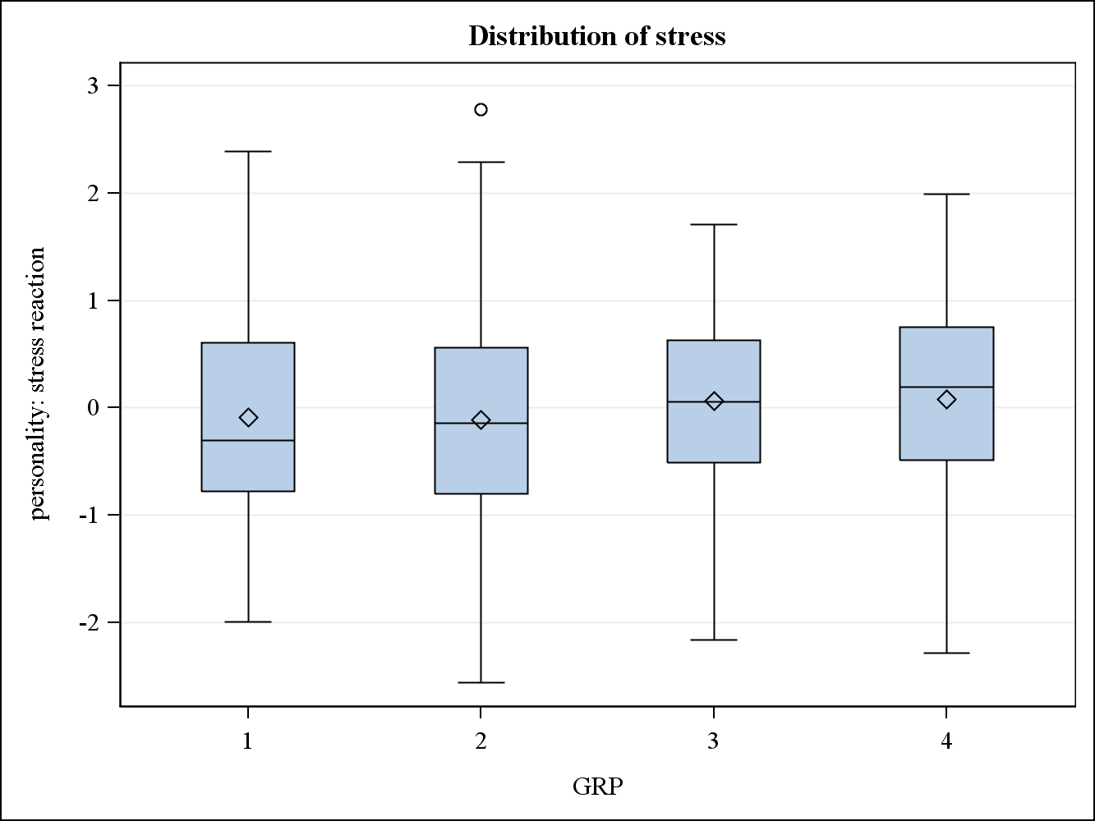
Note: | This test controls the Type I experimentwise error rate.

Alpha | 0.05
Error Degrees of Freedom | 246
Error Mean Square | 0.88219
Critical Value of Studentized Range | 3.65811

Comparisons significant at the 0.05 level are indicated by ***.
GRP  Comparison | Difference  Between  Means | Simultaneous 95% Confidence Limits
4 - 3 | 0.0104 | -0.4687 | 0.4895
4 - 1 | 0.1661 | -0.4026 | 0.7349
4 - 2 | 0.1868 | -0.2946 | 0.6683
3 - 4 | -0.0104 | -0.4895 | 0.4687
3 - 1 | 0.1557 | -0.3187 | 0.6302
3 - 2 | 0.1765 | -0.1888 | 0.5417
1 - 4 | -0.1661 | -0.7349 | 0.4026
1 - 3 | -0.1557 | -0.6302 | 0.3187
1 - 2 | 0.0207 | -0.4561 | 0.4976
2 - 4 | -0.1868 | -0.6683 | 0.2946
2 - 3 | -0.1765 | -0.5417 | 0.1888
2 - 1 | -0.0207 | -0.4976 | 0.4561

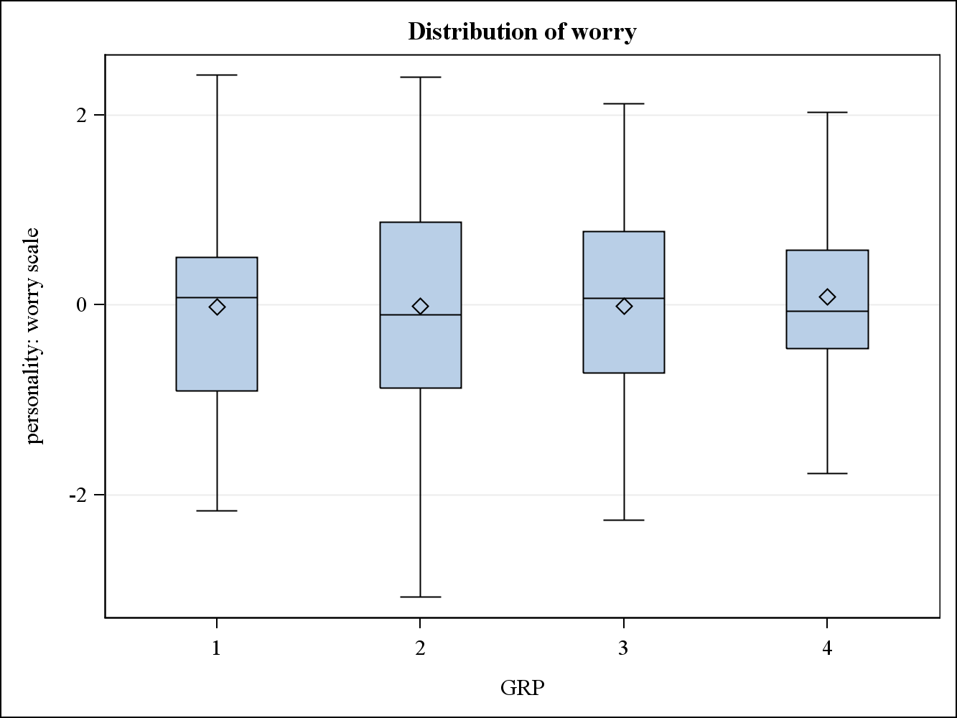
Note: | This test controls the Type I experimentwise error rate.

Alpha | 0.05
Error Degrees of Freedom | 246
Error Mean Square | 1.024137
Critical Value of Studentized Range | 3.65811

Comparisons significant at the 0.05 level are indicated by ***.
GRP  Comparison | Difference  Between  Means | Simultaneous 95% Confidence Limits
4 - 3 | 0.0927 | -0.4236 | 0.6089
4 - 2 | 0.0937 | -0.4251 | 0.6124
4 - 1 | 0.1023 | -0.5106 | 0.7151
3 - 4 | -0.0927 | -0.6089 | 0.4236
3 - 2 | 0.0010 | -0.3926 | 0.3946
3 - 1 | 0.0096 | -0.5016 | 0.5208
2 - 4 | -0.0937 | -0.6124 | 0.4251
2 - 3 | -0.0010 | -0.3946 | 0.3926
2 - 1 | 0.0086 | -0.5052 | 0.5223
1 - 4 | -0.1023 | -0.7151 | 0.5106
1 - 3 | -0.0096 | -0.5208 | 0.5016
1 - 2 | -0.0086 | -0.5223 | 0.5052

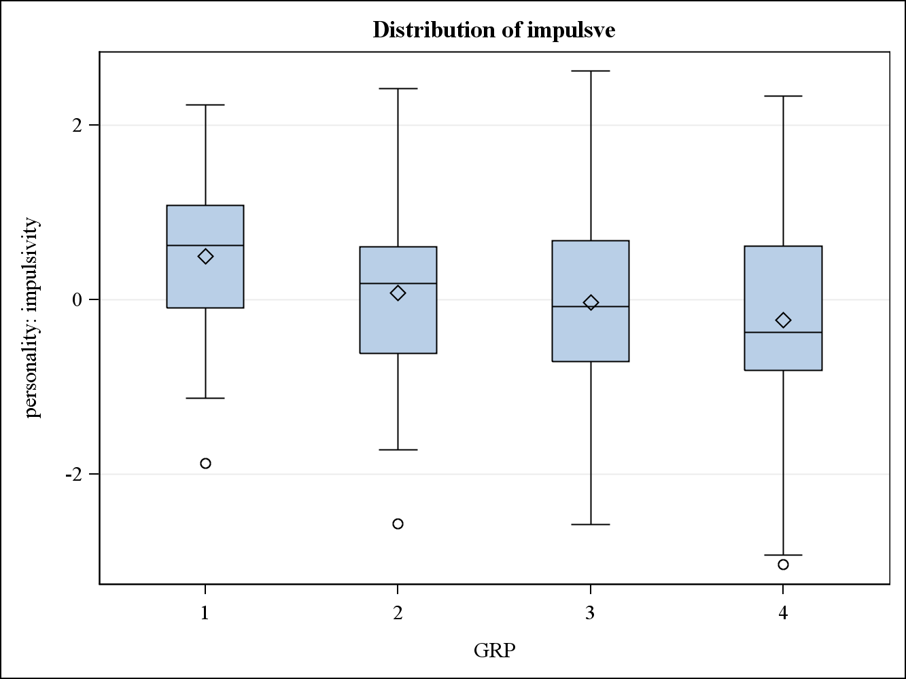
Note: | This test controls the Type I experimentwise error rate.

Alpha | 0.05
Error Degrees of Freedom | 246
Error Mean Square | 0.946108
Critical Value of Studentized Range | 3.65811

Comparisons significant at the 0.05 level are indicated by ***.
GRP  Comparison | Difference  Between  Means | Simultaneous 95% Confidence Limits
1 - 2 | 0.4235 | -0.0703 | 0.9173
1 - 3 | 0.5261 | 0.0347 | 1.0174 | ***
1 - 4 | 0.7335 | 0.1445 | 1.3225 | ***
2 - 1 | -0.4235 | -0.9173 | 0.0703
2 - 3 | 0.1026 | -0.2757 | 0.4809
2 - 4 | 0.3100 | -0.1886 | 0.8086
3 - 1 | -0.5261 | -1.0174 | -0.0347 | ***
3 - 2 | -0.1026 | -0.4809 | 0.2757
3 - 4 | 0.2074 | -0.2888 | 0.7036
4 - 1 | -0.7335 | -1.3225 | -0.1445 | ***
4 - 2 | -0.3100 | -0.8086 | 0.1886
4 - 3 | -0.2074 | -0.7036 | 0.2888

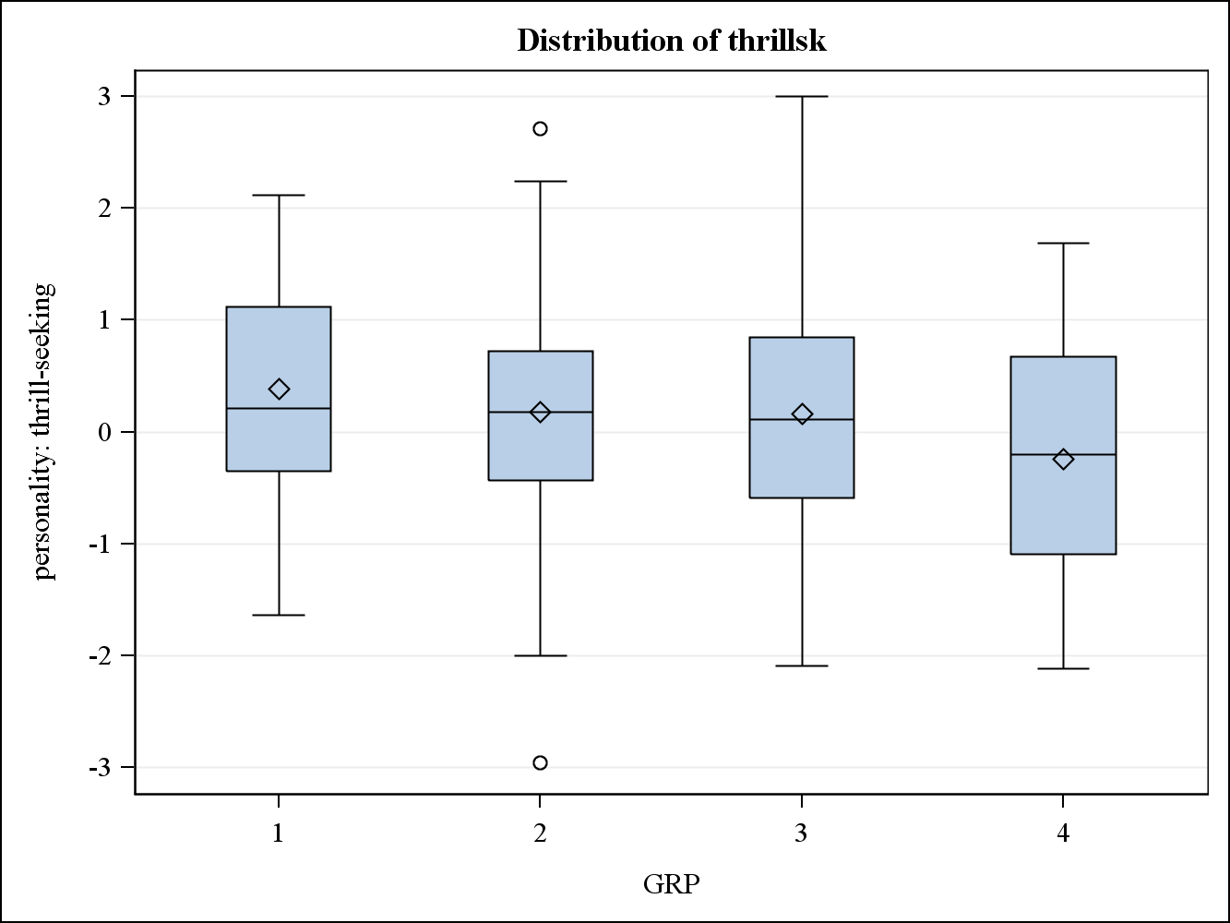
Note: | This test controls the Type I experimentwise error rate.

Alpha | 0.05
Error Degrees of Freedom | 246
Error Mean Square | 1.057176
Critical Value of Studentized Range | 3.65811

Comparisons significant at the 0.05 level are indicated by ***.
GRP  Comparison | Difference  Between  Means | Simultaneous 95% Confidence Limits
1 - 2 | 0.2043 | -0.3177 | 0.7263
1 - 3 | 0.2195 | -0.2999 | 0.7389
1 - 4 | 0.6211 | -0.0015 | 1.2437
2 - 1 | -0.2043 | -0.7263 | 0.3177
2 - 3 | 0.0152 | -0.3847 | 0.4151
2 - 4 | 0.4168 | -0.1103 | 0.9438
3 - 1 | -0.2195 | -0.7389 | 0.2999
3 - 2 | -0.0152 | -0.4151 | 0.3847
3 - 4 | 0.4016 | -0.1229 | 0.9260
4 - 1 | -0.6211 | -1.2437 | 0.0015
4 - 2 | -0.4168 | -0.9438 | 0.1103
4 - 3 | -0.4016 | -0.9260 | 0.1229
MANOVA Tests for the Hypothesis of No Overall GRP Effect
H = Type III SSCP Matrix for GRP
E = Error SSCP Matrix
S=3 M=1 N=119.5
Statistic | Value | P-Value
Wilks' Lambda | 0.88693840 | 0.0451
Pillai's Trace | 0.11562365 | 0.0478
Hotelling-Lawley Trace | 0.12460265 | 0.0427
Roy's Greatest Root | 0.09702180 | 0.0149

