PROG-8215 Assignment 1

Jinny Jin

7545783

Original screen

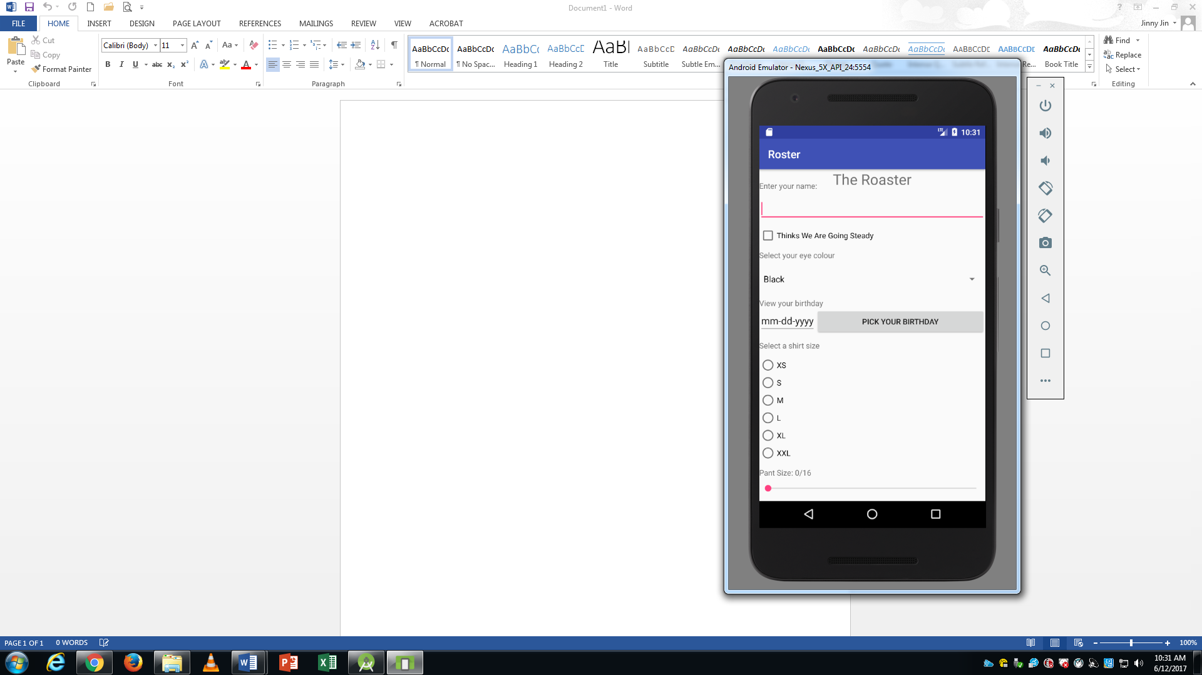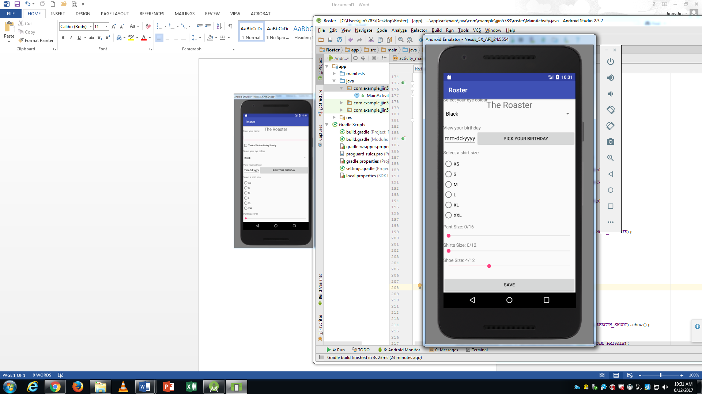

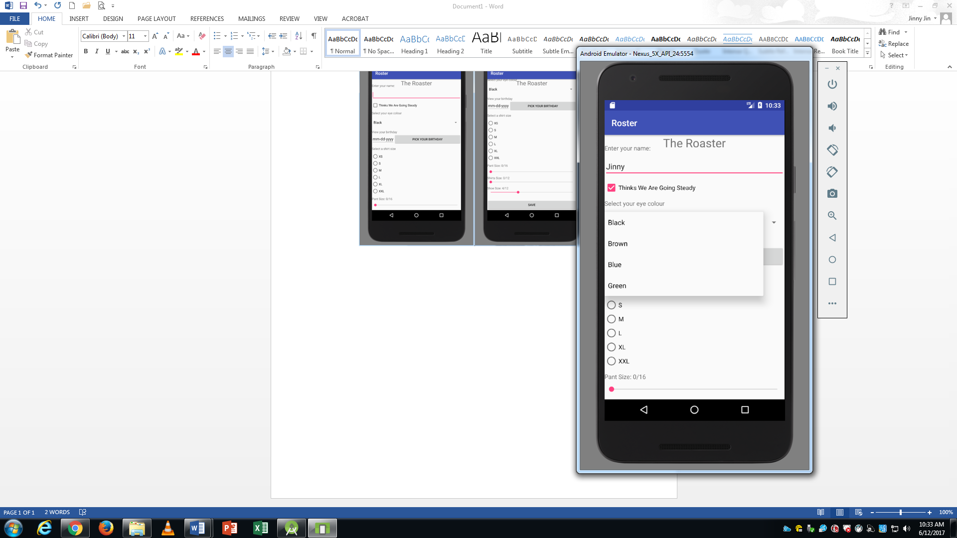

Input username

Click checkbox

Select eye color

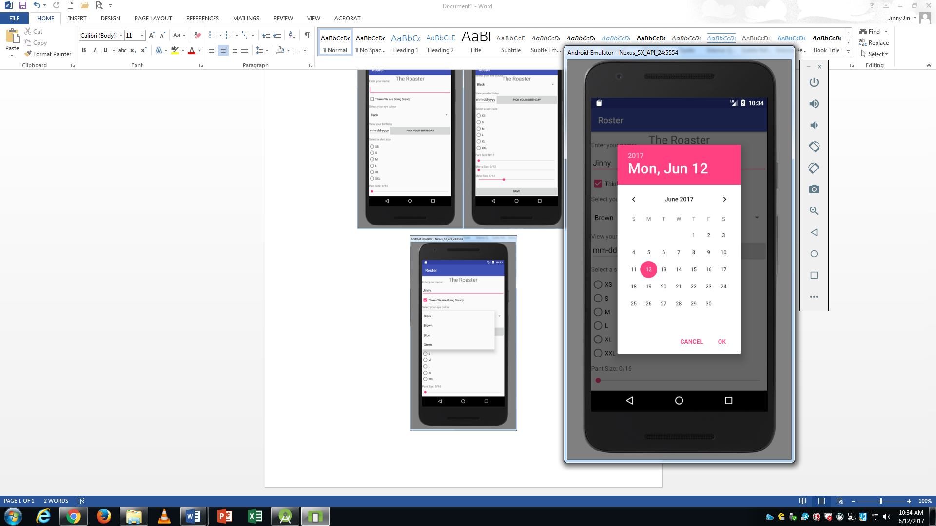

Pick Date

Default date is today

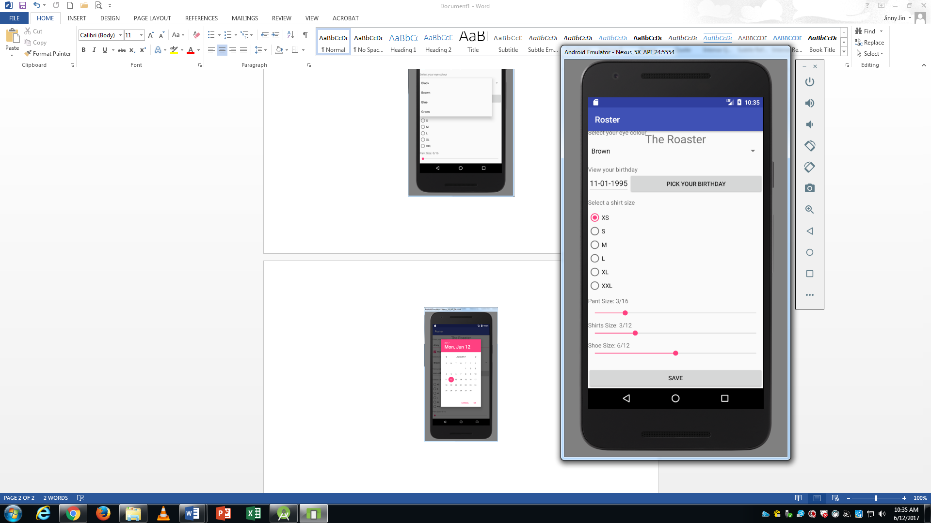

Choose shirts, pants and shoe size with radio button and seek bar

Close and open it again(load data)

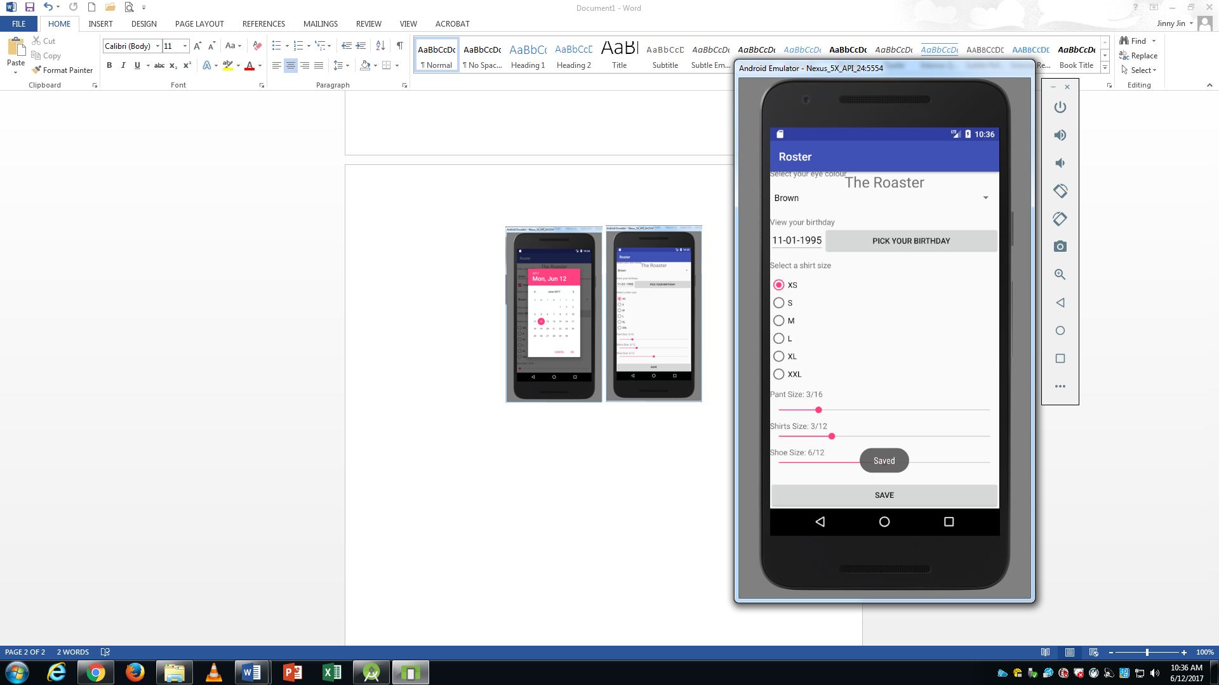

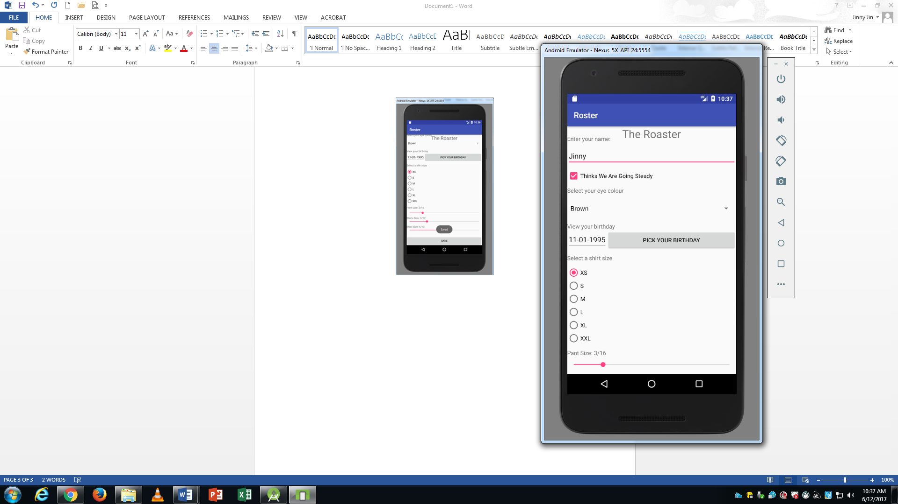

activity_main.xml

*<?***xml version="1.0" encoding="utf-8"***?>*<**android.support.constraint.ConstraintLayout xmlns:android="http://schemas.android.com/apk/res/android"  
 xmlns:app="http://schemas.android.com/apk/res-auto"  
 xmlns:tools="http://schemas.android.com/tools"  
 android:layout_width="match_parent"  
 android:layout_height="match_parent"  
 tools:context="com.example.jjin5783.roster.MainActivity"**>  
  
 *<!-- Roaster title -->* <**TextView  
 android:layout_width="wrap_content"  
 android:layout_height="wrap_content"  
 android:text="The Roaster"  
 android:textSize="12pt"  
 app:layout_constraintLeft_toLeftOf="parent"  
 app:layout_constraintRight_toRightOf="parent"  
 app:layout_constraintTop_toTopOf="parent"** />  
  
 *<!-- Scrollview including every part inside -->* <**ScrollView xmlns:android="http://schemas.android.com/apk/res/android"  
 android:layout_width="fill_parent"  
 android:layout_height="wrap_content"** >  
 <**LinearLayout  
 android:layout_width="fill_parent"  
 android:layout_height="wrap_content"  
 android:orientation="vertical"** >  
  
 *<!-- User name -->* <**TextView  
 android:id="@+id/enterName"  
 android:text="Enter your name:"  
 android:layout_width="match_parent"  
 android:layout_height="wrap_content"  
 android:layout_marginTop="20dp"** />  
  
 <**EditText  
 android:id="@+id/inputName"  
 android:layout_width="match_parent"  
 android:layout_height="wrap_content"  
 android:inputType="textPersonName"  
 android:ems="12"  
 android:layout_marginTop="10dp"** />  
  
 *<!-- Check box -->* <**CheckBox  
 android:id="@+id/checkBox"  
 android:layout_width="match_parent"  
 android:layout_height="wrap_content"  
 android:text="Thinks We Are Going Steady"  
 android:layout_marginTop="10dp"  
 android:checked="false"** />  
  
 *<!-- Select eye color -->* <**TextView  
 android:id="@+id/select"  
 android:layout_width="match_parent"  
 android:layout_height="wrap_content"  
 android:text="Select your eye colour"  
 android:layout_marginTop="10dp"** />  
  
 <**Spinner  
 android:id="@+id/selectEyeColor"  
 android:layout_width="match_parent"  
 android:layout_height="wrap_content"  
 android:layout_marginTop="10dp"  
 android:spinnerMode="dropdown"** />  
  
 *<!-- Select Birthday-->* <**TextView  
 android:id="@+id/birthday"  
 android:layout_width="match_parent"  
 android:layout_height="wrap_content"  
 android:text="View your birthday"  
 android:layout_marginTop="10dp"  
 android:clickable="false"** />  
  
 <**LinearLayout  
 android:id="@+id/calendarLayout"  
 android:layout_width="match_parent"  
 android:layout_height="wrap_content"**>  
  
 <**EditText  
 android:id="@+id/textBirthday"  
 android:layout_width="wrap_content"  
 android:layout_height="wrap_content"  
 android:text="mm-dd-yyyy"**>  
 </**EditText**>  
  
 <**Button  
 android:id="@+id/chooseDate"  
 android:layout_width="match_parent"  
 android:layout_height="wrap_content"  
 android:text="Pick your birthday"** />  
 </**LinearLayout**>  
  
 *<!-- Select shirt size(XS,S,M,L,XL,XXL) -->* <**TextView  
 android:id="@+id/selectShirtSize"  
 android:layout_width="wrap_content"  
 android:layout_height="wrap_content"  
 android:text="Select a shirt size"  
 android:layout_marginTop="10dp"  
 android:clickable="false"** />  
  
 <**RadioGroup  
 android:id="@+id/radioGroup"  
 android:layout_width="fill_parent"  
 android:layout_height="fill_parent"  
 android:layout_marginTop="10dp"  
 android:textAppearance="?android:attr/textAppearanceMedium"**>  
   
 <**RadioButton  
 android:id="@+id/XS"  
 android:layout_width="match_parent"  
 android:layout_height="wrap_content"  
 android:text="XS"** />  
 <**RadioButton  
 android:id="@+id/S"  
 android:layout_width="match_parent"  
 android:layout_height="wrap_content"  
 android:text="S"** />  
  
 <**RadioButton  
 android:id="@+id/M"  
 android:layout_width="match_parent"  
 android:layout_height="wrap_content"  
 android:text="M"** />  
 <**RadioButton  
 android:id="@+id/L"  
 android:layout_width="match_parent"  
 android:layout_height="wrap_content"  
 android:text="L"** />  
 <**RadioButton  
 android:id="@+id/XL"  
 android:layout_width="match_parent"  
 android:layout_height="wrap_content"  
 android:text="XL"** />  
 <**RadioButton  
 android:id="@+id/XXL"  
 android:layout_width="match_parent"  
 android:layout_height="wrap_content"  
 android:text="XXL"** />  
 </**RadioGroup**>  
  
 *<!-- Seekbar for shirt,pants,shoe size -->* <**TextView  
 android:id="@+id/pants"  
 android:layout_width="match_parent"  
 android:layout_height="wrap_content"  
 android:text="Pants size"  
 android:layout_marginTop="10dp"  
 android:clickable="false"** />  
 <**SeekBar  
 android:id="@+id/seekBar1"  
 android:layout_width="match_parent"  
 android:layout_height="wrap_content"  
 android:layout_gravity="center_horizontal"  
 android:layout_marginTop="10dp"  
 android:max="16"** />  
  
 <**TextView  
 android:id="@+id/shirts"  
 android:layout_width="match_parent"  
 android:layout_height="wrap_content"  
 android:text="Shirts size"  
 android:layout_marginTop="10dp"  
 android:clickable="false"** />  
  
 <**SeekBar  
 android:id="@+id/seekBar2"  
 android:layout_width="match_parent"  
 android:layout_height="wrap_content"  
 android:layout_gravity="center_horizontal"  
 android:max="12"** />  
  
 <**TextView  
 android:id="@+id/shoe"  
 android:layout_width="match_parent"  
 android:layout_height="wrap_content"  
 android:text="Shoe size"  
 android:layout_marginTop="10dp"  
 android:clickable="false"** />  
 <**SeekBar  
 android:id="@+id/seekBar3"  
 android:layout_width="match_parent"  
 android:layout_height="wrap_content"  
 android:layout_gravity="center_horizontal"  
 android:progress="4"  
 android:max="12"** />  
  
 *<!-- Save button -->* <**Button  
 android:id="@+id/buttonSave"  
 android:layout_width="match_parent"  
 android:layout_height="wrap_content"  
 android:text="Save"  
 android:layout_marginTop="25dp"** />  
 </**LinearLayout**>  
 </**ScrollView**>  
  
</**android.support.constraint.ConstraintLayout**>

MainActivity.java

**package** com.example.jjin5783.roster;  
  
**import** android.app.DatePickerDialog;  
**import** android.content.SharedPreferences;  
**import** android.icu.text.SimpleDateFormat;  
**import** android.icu.util.Calendar;  
**import** android.os.Build;  
**import** android.support.annotation.RequiresApi;  
**import** android.support.v7.app.AppCompatActivity;  
**import** android.os.Bundle;  
**import** android.view.View;  
**import** android.widget.ArrayAdapter;  
**import** android.widget.Button;  
**import** android.widget.CheckBox;  
**import** android.widget.DatePicker;  
**import** android.widget.EditText;  
**import** android.widget.RadioButton;  
**import** android.widget.RadioGroup;  
**import** android.widget.SeekBar;  
**import** android.widget.Spinner;  
**import** android.widget.TextView;  
**import** android.widget.Toast;  
  
**import** java.util.ArrayList;  
**import** java.util.List;  
**import** java.util.Locale;  
  
**import static** com.example.jjin5783.roster.R.id.***selectEyeColor***;  
  
**public class** MainActivity **extends** AppCompatActivity {  
  
 @RequiresApi(api = Build.VERSION_CODES.***N***)  
 @Override  
 **protected void** onCreate(Bundle savedInstanceState) {  
 **super**.onCreate(savedInstanceState);  
 setContentView(R.layout.***activity_main***);  
 *//Retrieve data from last time* LoadPreference();  
 *//Spinner method(select eye color)* addSpinner();  
  
 *//3.5 Manipulate a Picker Calendar UI Control The user must be able to view a person’s birthday and manipulate it using a Picker Calendar UI element.  
 //Add pickdate button and calendar* Button pickDate = (Button) findViewById(R.id.***chooseDate***);  
 **final** Calendar myCalendar = Calendar.*getInstance*();  
  
 *//Set default date(get today's date)* **final** DatePickerDialog.OnDateSetListener date = **new** DatePickerDialog.OnDateSetListener() {  
 @Override  
 **public void** onDateSet(DatePicker view, **int** year, **int** monthOfYear,  
 **int** dayOfMonth) {  
  
 myCalendar.set(Calendar.***YEAR***, year);  
 myCalendar.set(Calendar.***MONTH***, monthOfYear);  
 myCalendar.set(Calendar.***DAY_OF_MONTH***, dayOfMonth);  
 updateDate();  
 }  
 *//Pick birthday* @RequiresApi(api = Build.VERSION_CODES.***N***)  
 **private void** updateDate() {  
 *//Create birthday format* String myFormat = **"MM-dd-yyyy"**;  
 SimpleDateFormat sdf = **new** SimpleDateFormat(myFormat, Locale.***US***);  
 *//Update new date on Edittext* EditText birthday =(EditText) findViewById(R.id.***textBirthday***);  
 birthday.setText(sdf.format(myCalendar.getTime()));  
 }  
 };  
 *//Pop the datepicker when click the button* pickDate.setOnClickListener(**new** View.OnClickListener(){  
 @Override  
 **public void** onClick(View v){  
 **new** DatePickerDialog(MainActivity.**this**,date,myCalendar.get(Calendar.***YEAR***), myCalendar.get(Calendar.***MONTH***),  
 myCalendar.get(Calendar.***DAY_OF_MONTH***)).show();  
 }  
 } );  
  
 *//3.6 Manipulate a Radio Button Group The user must be able to select a shirt size using a series of interconnected radio buttons (XS,S,M,L,XL,XXL).  
 //Add radio button group* RadioGroup rg = (RadioGroup) findViewById(R.id.***radioGroup***);  
 rg.setOnClickListener(**new** View.OnClickListener(){  
 @Override  
 **public void** onClick(View v){  
 **boolean** checked = ((RadioButton) v).isChecked();  
 RadioButton rb;  
 *//Check which radio button is selected(XS,S,M,L,XL,XXL)* **switch** (R.id.***radioGroup***){  
 **case** R.id.***XS***:  
 rb = (RadioButton)findViewById(R.id.***XS***);  
 **break**;  
 **case** R.id.***S***:  
 rb = (RadioButton)findViewById(R.id.***S***);  
 **break**;  
 **case** R.id.***M***:  
 rb = (RadioButton)findViewById(R.id.***M***);  
 **break**;  
 **case** R.id.***L***:  
 rb = (RadioButton)findViewById(R.id.***L***);  
 **break**;  
 **case** R.id.***XL***:  
 rb = (RadioButton)findViewById(R.id.***XL***);  
 **break**;  
 **case** R.id.***XXL***:  
 **default**:  
 rb = (RadioButton)findViewById(R.id.***XXL***);  
 **break**;  
 }  
 rb.toggle();  
 }  
 });  
  
 *//3.7 Manipulate Three Sliders The user must be able to manipulate a slider for Pant Size (0 to 16), a slider for shirt size (0 to 12) and a second slider for Shoe Size (4 to 12).  
 //Add pants seekbar* SeekBar pants = (SeekBar)**this**.findViewById(R.id.***seekBar1***);  
 **final int**[] slider1 = {0};  
 pants.setProgress(slider1[0]);  
 TextView textPants = (TextView)findViewById(R.id.***pants***);  
 *//Set default seekbar progress* textPants.setText(**"Pant Size: "** + slider1[0] + **"/"** + pants.getMax());  
 pants.setOnSeekBarChangeListener(**new** SeekBar.OnSeekBarChangeListener() {  
 @Override  
 *//Change progress when slide the seekbar* **public void** onProgressChanged(SeekBar seekBar, **int** progressValue, **boolean** fromUser) {  
 slider1[0] = progressValue;  
 TextView textPants = (TextView)findViewById(R.id.***pants***);  
 *//New selection* textPants.setText(**"Pant Size: "** + slider1[0] + **"/"** + seekBar.getMax());  
 }  
 @Override  
 **public void** onStartTrackingTouch(SeekBar seekBar) {  
 }  
 @Override  
 **public void** onStopTrackingTouch(SeekBar seekBar) {  
 }  
 });  
  
 *//Add shorts seekbar (same as pants)* SeekBar shirts = (SeekBar)**this**.findViewById(R.id.***seekBar2***);  
 **final int**[] slider2 = {0};  
 shirts.setProgress(slider2[0]);  
 TextView textShorts = (TextView)findViewById(R.id.***shirts***);  
 textShorts.setText(**"Shirts Size: "** + slider2[0] + **"/"** + shirts.getMax());  
 shirts.setOnSeekBarChangeListener(**new** SeekBar.OnSeekBarChangeListener() {  
 @Override  
 **public void** onProgressChanged(SeekBar seekBar, **int** progressValue, **boolean** fromUser) {  
 slider2[0] = progressValue;  
 TextView textShorts = (TextView)findViewById(R.id.***shirts***);  
 textShorts.setText(**"Shirts Size: "** + slider2[0] + **"/"** + seekBar.getMax());  
 }  
 @Override  
 **public void** onStartTrackingTouch(SeekBar seekBar) {  
 }  
 @Override  
 **public void** onStopTrackingTouch(SeekBar seekBar) {  
 }  
 });  
  
 *//Add shoes seekbar(similar as pants)* SeekBar shoe = (SeekBar)**this**.findViewById(R.id.***seekBar3***);  
 **final int**[] slider3 = {0};  
 *//Shoe size start from 4* shoe.setProgress(4);  
 TextView textShoe = (TextView)findViewById(R.id.***shoe***);  
 textShoe.setText(**"Shoe Size: "** + 4 + **"/"** + shoe.getMax());  
 shoe.setOnSeekBarChangeListener(**new** SeekBar.OnSeekBarChangeListener() {  
 @Override  
 **public void** onProgressChanged(SeekBar seekBar, **int** progressValue, **boolean** fromUser) {  
 slider3[0] = progressValue;  
 TextView textShoe = (TextView)findViewById(R.id.***shoe***);  
 textShoe.setText(**"Shoe Size: "** + slider3[0] + **"/"** + seekBar.getMax());  
 }  
 @Override  
 **public void** onStartTrackingTouch(SeekBar seekBar) {  
 }  
 @Override  
 **public void** onStopTrackingTouch(SeekBar seekBar) {  
 }  
 });  
  
 *//3.8 Click on a Command Button The user must be able to click on a Command Button to archive the states and data contained within the UI elements to the Preferences Store. When the App relaunches, the data must be auto populated by reading it back from the Preferences Store and setting the default UI element states during initialization.  
 // save data to preference* Button save = (Button) findViewById(R.id.***buttonSave***);  
 save.setOnClickListener(**new** View.OnClickListener(){  
 @Override  
 *//Create method for displaying textfield content* **public void** onClick(View v)  
 {  
 *//3.2 Enter Text in a Textbox the user must be able to enter and view a person’s name in a text box located on the view space.  
 //Username* EditText et = (EditText) findViewById(R.id.***inputName***);  
 *//3.3 Check a Checkbox The user must be able to view and manipulate a Boolean condition checkbox with the Thinks We Are Going Steady text tag associated with it.  
 //Checkbox* **final** CheckBox check = (CheckBox) findViewById(R.id.***checkBox***);  
 *//Spinner(eyecolor)* **final** Spinner s = (Spinner) findViewById(R.id.***selectEyeColor***);  
 **int** eyeColor = s.getSelectedItemPosition();  
 *//Birthday* EditText birthday = (EditText) findViewById(R.id.***textBirthday***);  
 *//RaduiGroup(shirt size)* RadioGroup rg = (RadioGroup)findViewById(R.id.***radioGroup***);  
 **int** shirtSize = rg.getCheckedRadioButtonId();  
  
  
 *// save data to shared preferences* SharedPreferences prefs = getSharedPreferences(**"User"**, ***MODE_PRIVATE***);  
 SharedPreferences.Editor editor = prefs.edit();  
 *// Save User Name* editor.putString(**"Username"**, et.toString());  
 *// Save Check Box* editor.putInt(**"check"**, check.isChecked() ? 1 : 0);  
 *// Save Eye Color* editor.putInt(**"eye color"**,eyeColor);  
 *//Save date* editor.putString(**"birthday"**,birthday.toString());  
 *// Save shirts size(Radio Selector)* editor.putInt(**"shirt size"**, shirtSize);  
 *// Save shirts, shorts and shoe size in three Slider* editor.putInt(**"pants size"**, slider1[0]);  
 editor.putInt(**"short size"**, slider2[0]);  
 editor.putInt(**"shoe size"**, slider3[0]);  
 editor.apply();  
 editor.commit();  
 Toast.*makeText*(getApplicationContext(), **"Saved"**, Toast.***LENGTH_SHORT***).show();  
 }  
 });  
  
 }  
 *//3.4 Manipulate a Spinner Control The user must be able to view and manipulate a Spinner Dropdown list to select a person’s eye color.  
 // Create spin control* **private void** addSpinner() {  
 *//Create eye color menu* List eyeColor = **new** ArrayList<String>();  
 eyeColor.add(**"Black"**);  
 eyeColor.add(**"Brown"**);  
 eyeColor.add(**"Blue"**);  
 eyeColor.add(**"Green"**);  
  
 Spinner spinner = (Spinner) findViewById(***selectEyeColor***);  
 ArrayAdapter<String> adapter = **new** ArrayAdapter<String>(**this**, android.R.layout.***simple_spinner_dropdown_item***, eyeColor);  
 *//Property of spinner* spinner.setPrompt(**"Select your eye colour"**);  
 spinner.setAdapter(adapter);  
 }  
 *//Load preference(retrieve data when reopen the roaster)* **private void** LoadPreference(){  
 *//Create variable date* String userName;  
 **int** checkbox;  
 **int** eyecolor;  
 String birthday;  
 **int** shirt;  
 **int** slider1;  
 **int** slider2;  
 **int** slider3;  
 *//Create sharedPreference to get data from preference* SharedPreferences load = getSharedPreferences(**"User"**, ***MODE_PRIVATE***);  
 *//Retrieve data* userName = load.getString(**"Username"**,**""**);  
 checkbox = load.getInt(**"check"**,1);  
 eyecolor = load.getInt(**"eye color"**,0);  
 birthday = load.getString(**"birthday"**,**""**);  
 shirt = load.getInt(**"shirt size"**, 0);  
 slider1 = load.getInt(**"pants size"**,0);  
 slider2 = load.getInt(**"short size"**,0);  
 slider3 = load.getInt(**"shoe size"**,0);  
 }  
}