# Overview

This document is intended for CICD person who would use this to setup the environment to be used for a Technical Challenge.

# Initial Setup

# Clone Repository

Use git or github or any other client to clone the repository:

<https://github.com/Unisys/verfut-project>

This document assumes that you have cloned the repository at VERFUT-PROJECT-HOME

# Setup Clients

Setup a DOS shortcut and make VERFUT-PROJECT-HOME the directory to start in.

Open the DOS Window as administrator

|  |
| --- |
| cd \infra\workspace  space-setup.bat |

After the script is completed, open a new window and test AWS using the following command

|  |
| --- |
| Aws |

Note: if aws is not setup, run choco install awscli to

# Download aws keypair

Create a new Key Pair with name such as verfut-us-west-1-keypair-ssh save the file under %USERPROFILE%\.ssh directory.

Note: do not change the file name or directory extension

# Configure AWS Client

Open a dos window

|  |
| --- |
| >aws configure  AWS Access Key ID [None]: <aws access key>  AWS Secret Access Key [None]: <aws secret access key>  Default region name [None]: us-west-1  Default output format [None]: |

Note : by default , 20 ec2 instances are allowed. Make sure whatever region is selected has no ec2 instances currently in place.

# Create Infrastructure

Open a GIT Bash window (installed as a part of Initial Setup.

Verify that the key is already in place in the proper directory



cd <VERFUT-PROJECT-HOME>/infra

./infra-boot.sh -k <aws-key-pair> -w m4.xlarge -m t2.medium -e <s3bucketname>

Make sure aws-key-pair is set as the file name without .pem

s3bucketname need to be as needed

after running the above command, open the stack and make sure the status of 3 stacks is successful.

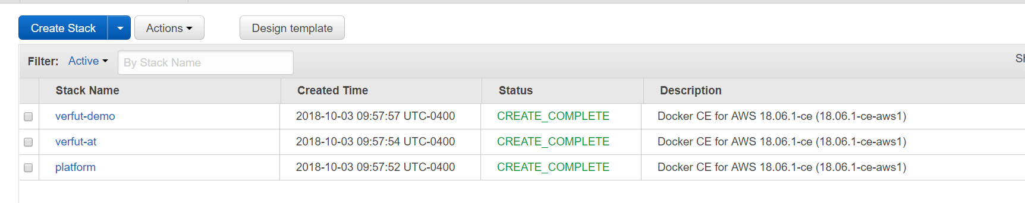

Note: if error occurs and re-run is required, the stacks will need to be delete.

|  |  |  |  |  |  |  |  |
| --- | --- | --- | --- | --- | --- | --- | --- |
| |  |  | | --- | --- | | Name | value | | unisys aws url | https://unisysfedsystechchallenge000.signin.aws.amazon.com/console | |  |  | |  |