**Live face recognition**

Overview

Live face recognition is a type of computer vision program in which the computer detects the face of the person given only few training data about that persons face. Its based on deep neural network which ensures efficiency and accuracy. It is used in mobile phone by google photos. It is also used by police to identify faces of criminals. The camera scans every frame of the video and tries to detect the face. This synopsis is about the combination of face detection and face recognition techniques.

Steps

1)Face detection and data gathering:

Capturing a face in the given video frame is the first step towards building a live face recognition. The algorithm used must be able to detect faces i.e differentiating favorable data from the given data . Haar cascade is the most preferable algorithm used due to its high efficiency and accuracy.

Haar Cascade

Step1: To implement haar cascade we must first preprocess the data. We first resize the photos into

favorable size by using ***cv2.resize*** function from cv2 library in python.

Step2: Now, we have resized the image into favorable size , we now convert the image into grayscale image by using ***cv2.cvtColor*** function. Converting the image to grayscale reduces the size to **one-third** compared to normal RGB image. A RGB image is stored in the form of three dimensional image. The third dimension has three channels corresponding to pixel intensity of red , green and blue. Converting it to grayscale converts it to two-dimensional matrix representing only black-white intensity of each pixel. This reduces the size of data thus increasing the efficiency of algorithm

Step3: Now we have grayscale image, we try to draw boxes or rectangles around faces to be detected. We do it by using ***detectMultiScale*** function from open cv2 library. It inputs scale factor(parameter specifying how much the image size is reduced) and min neighbors(Parameters specifying how many neighbors each candidate rectangle must have to retain it).This outputs an image with all the faces boxed.

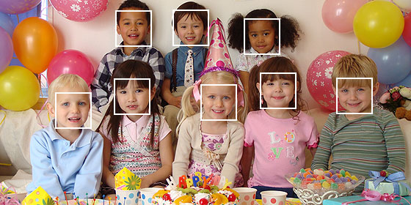

[This Photo](http://stackoverflow.com/questions/15526964/face-recognition-using-android-sdk-not-opencv) by Unknown Author is licensed under [CC BY-SA](https://creativecommons.org/licenses/by-sa/3.0/)

2)Training an algorithm for recognition of face:

Now we have already drawn bounding bounding boxes around faces, we’ll zoom into each face and try to recognize the identity of that person. Remember we are doing it live so efficiency of the algorithm must be the main concern. We only have couple of images for each of these faces as it is highly impractical for a company to have hundreds of images of each employees for building a face detection software.

One-shot learning

Step1: Deciding which algorithm to be selected. There are many algorithms available to us .Each having their own inputs, their own unique parameters .Each has its own merits and demerits depending on the storage capacity required, efficiency and accuracy. Two commonly used algorithm are standard-CNN(convolutional neural network) and one-shot learning technique. We will use one-shot learning technique as it requires less data for training compared to CNN’s i.e we cannot have hundreds of photos of a single person for live face detection.

**More about one-shot learning:** the standard way used for building a face recognition system is ((Photo---------CNN-----------Softmax))-------This is not a good approach as a number of images are required for training CNN and moreover if a new person joins or the number of outputs has to be increased, we have to re-train the entire network. So we use one-shot learning which works on the basis of similarity function. Moreover, adding a margin adds to accuracy of this function.

Step2: Now, we have selected one-shot learning technique as our soul algorithm. It works on the principle of similarity function that finds similarity between two given features .This algorithm is supported by Siamese neural network. In short, this image compares the live photo from each person in our database.

**More about Siamese neural network:** Siamese neural network consists of two pre-trained CNN with the same parameters two different images are fed into each of these CNN and its helps us find similarity between each image.

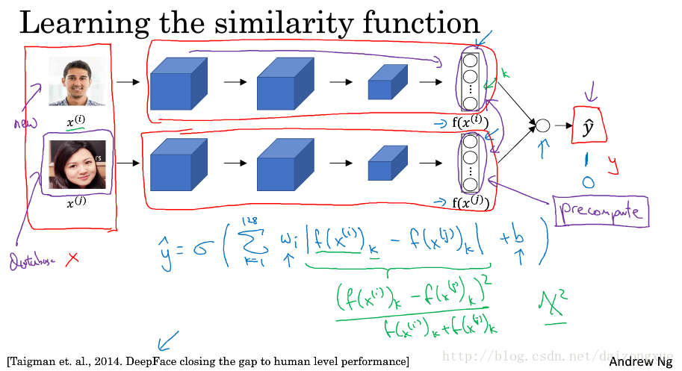

[This Photo](https://blog.csdn.net/daizongxue/article/details/78485507) by Unknown Author is licensed under [CC BY-SA](https://creativecommons.org/licenses/by-sa/3.0/)

The above image shows the basic outline of a Siamese neural network. Two different images are fed into the same pre-trained CNN. The functions shown above (f(xi) and f(xj)) are the measure of some features and the last value y is the measure of similarity in features. The output of this value y can be 1 or 0. 1 if the similarity factor is above the given margin and 0 if the similarity feature is below the margin.

Step3: Now we know the basic components of the one-shot learning technique .We try to train the CNN’s of the above Siamese neural network. To train the CNN’s for the above Siamese network we use 3photos for each person(negative image, positive image and abstract image).We first feed all the photos in network and try backpropogating-frontpropogating till we get desired output with desired accuracy. The cost calculated for each cycle is not the normal cost but the triple loss function. For calculating triple loss function , we set a margin according to the desired accuracy. The cost has the formula:

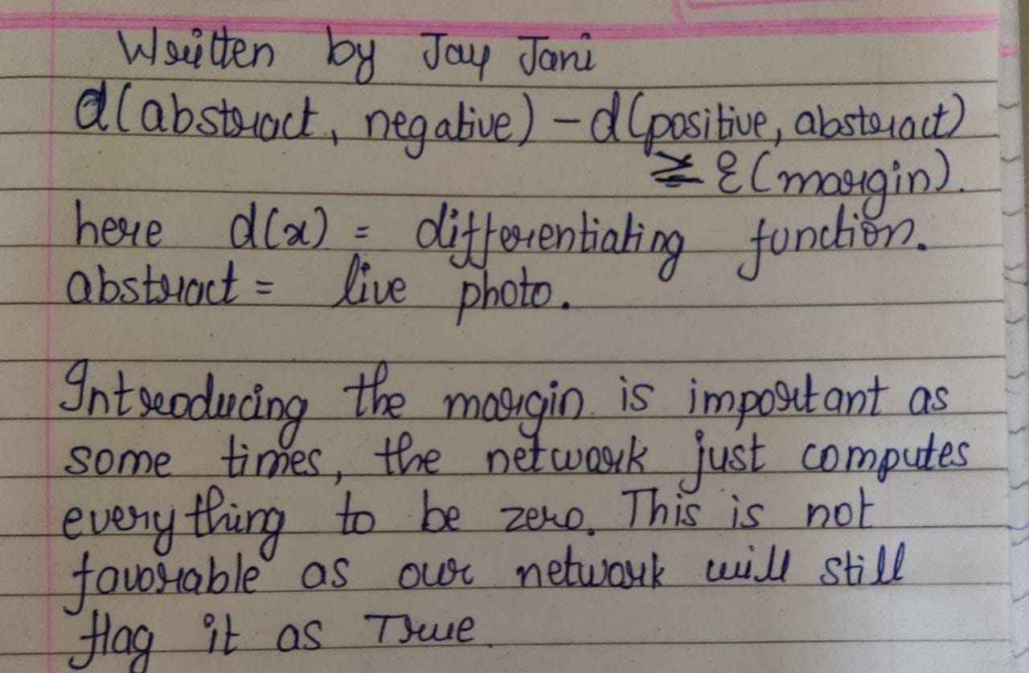

Here is a diagram to better understand how the triplet loss function is actually computed:

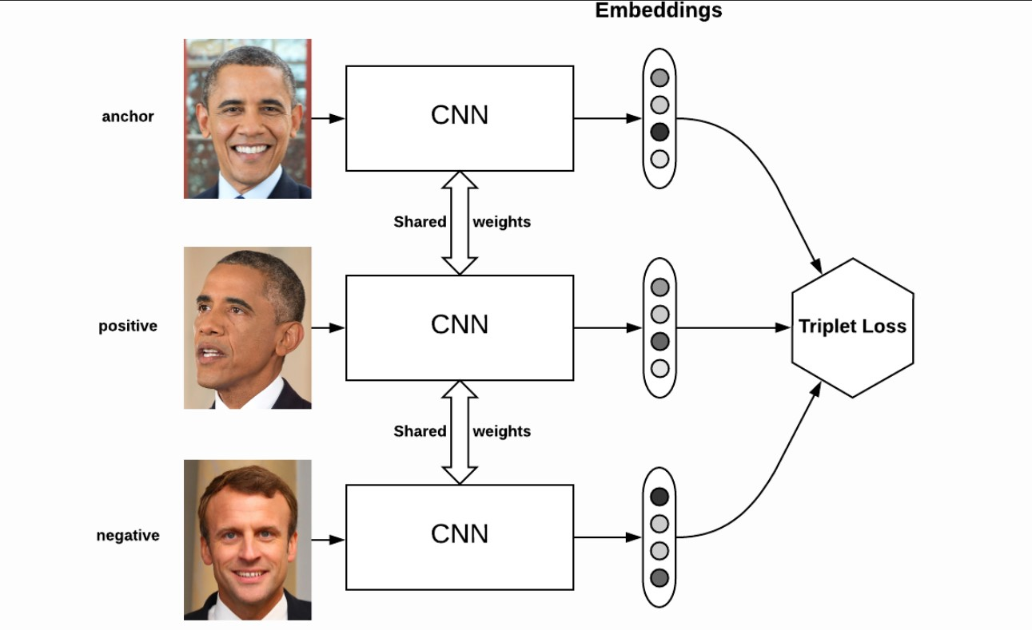j

Step3:Now we have trained the Siamese neural network we will test it. For testing we’ll first attach this program to a small database containing few images. A new abstract image would be fed into the network and network would be tested for appropriate outputs. Corner conditions can be determined by testing and again the performance of the network can be improved.

Summary:

The face recognition system can be divided into two parts:

1)face detection: We try to identify the faces in the given image .When the faces are identified, we try to fit this faces into bounding boxes.

2)face recognition: The faces detected are then zoomed into and then we try to identify the person.There are some basic features related to face like eyes ,shape of mouth, size of forehead . Our network too tries to identify the faces based on these features.