**1. Is your browser running HTTP version 1.0 or 1.1? What version of HTTP is the server running?**

**Ans :Browser: 1.1, Server: 1.1**

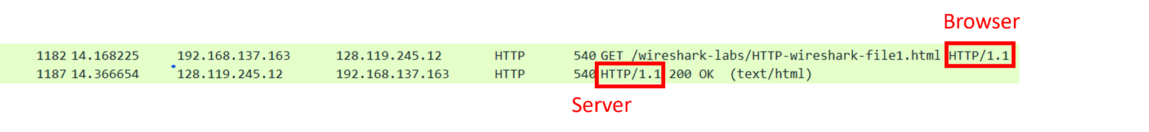

**2. What languages (if any does your brwowser indicate that it can accept to the server?**

**Ans: zh-Tw**

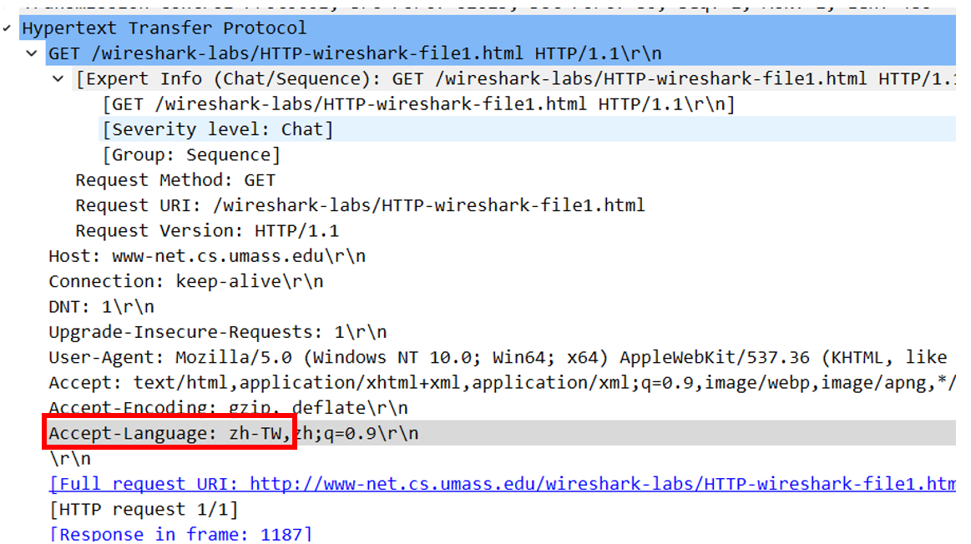

**3.What is the IP adderss of your computer? Of the gaia.cs.umass.edu server?**

**Ans: My computer IP: 192.168.137.163,**

**gaia.cs.umass.edu server IP: 128.119.245.12**

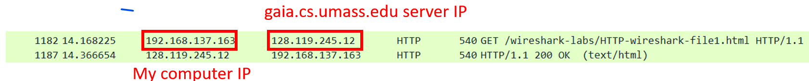

**4. What is the status code returned from the ser to your browser?**

**Ans: 200 OK**

**5. When was the HTML file that you are retrieving last Modified at the server?**

**Ans: Fri, 10 Nov 2023 06:59:01**

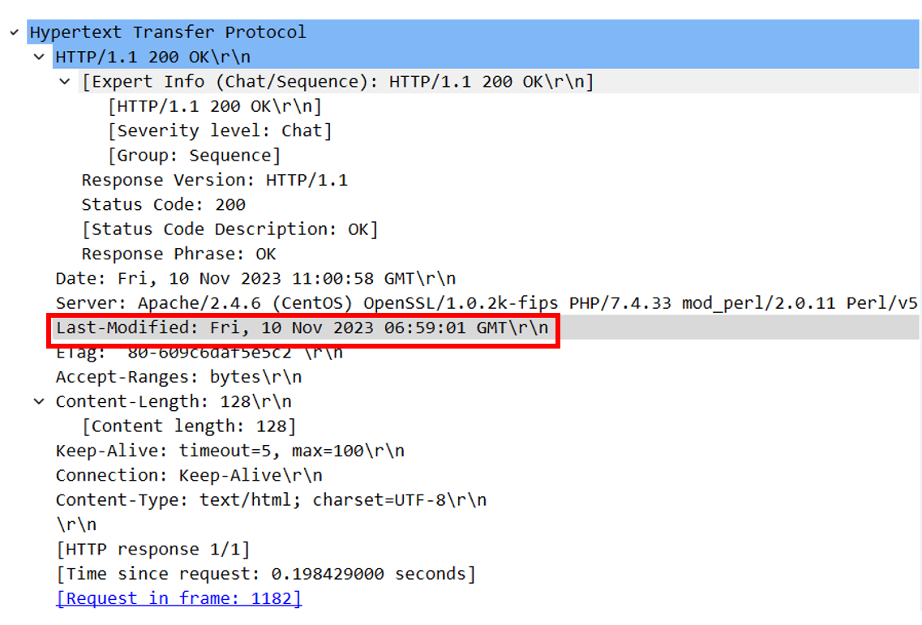

**6. How many bytes of content are begin returned to your browser?**

**Ans: 128**

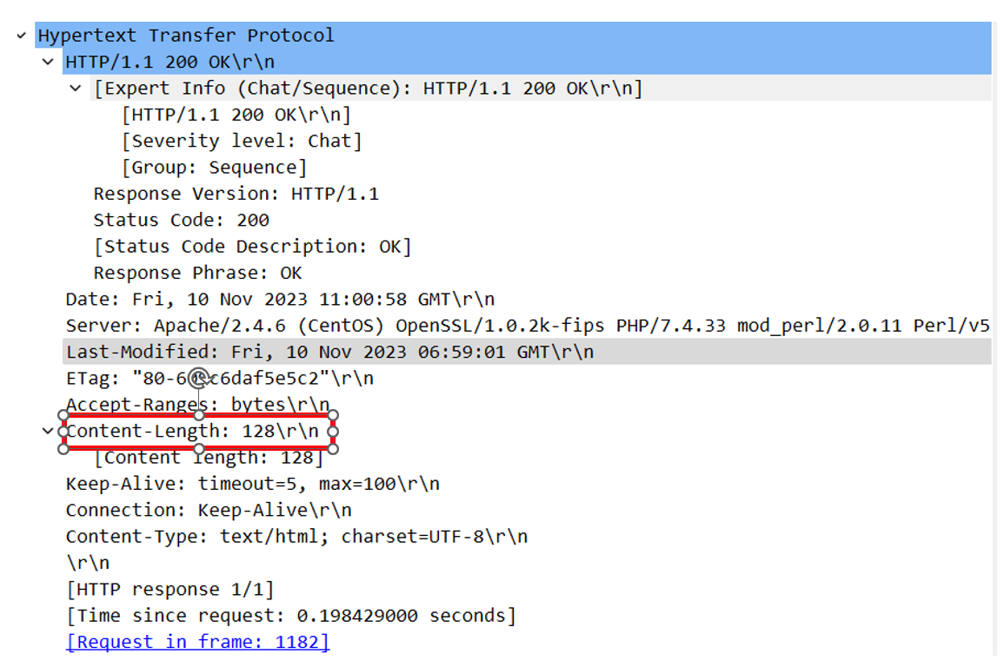

**7. By inspecting the raw data in the packet content window, do you see any headers within the data that are not displayed in the pack-listing window? If so, name one.**

**Ans: No, nothing is not displayed**

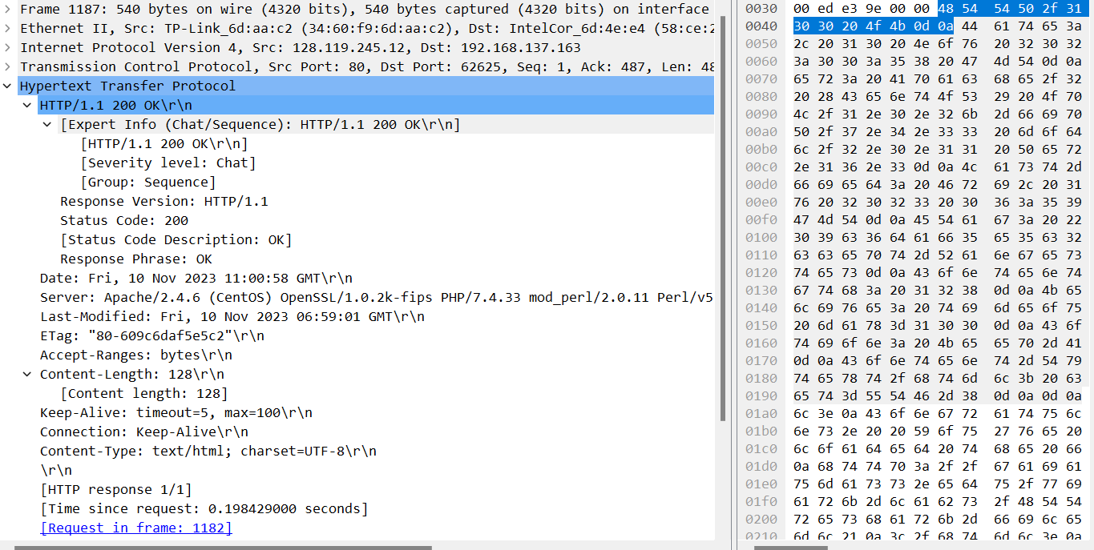

**8. Inspect the contents of the first HTTP GET request from your browser to the server.**

**Do you see an “IF-MODIFIED-SINCE” line in the HTTP GET?**

**Ans: NO, there is no such thing**

**  
9. Inspect the contents of ther server response.**

**Did the server explicitly return the contents of the file? How can you tell?**

**Ans: Yes**

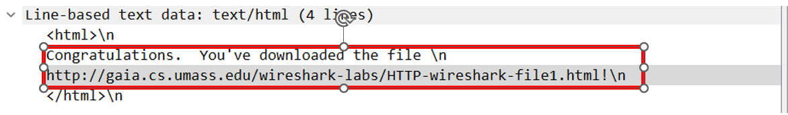**10.Now inspect the contents fof the seond HTTP GET request from your browse to the server. Do you see an “IF-MODIFIED-SINCE:”line in the HTTP GET? If so, what information follows the “IF-MODIFIED-SINCE:”header?**

**Ans: 10 Nov 2023 06:59:01**

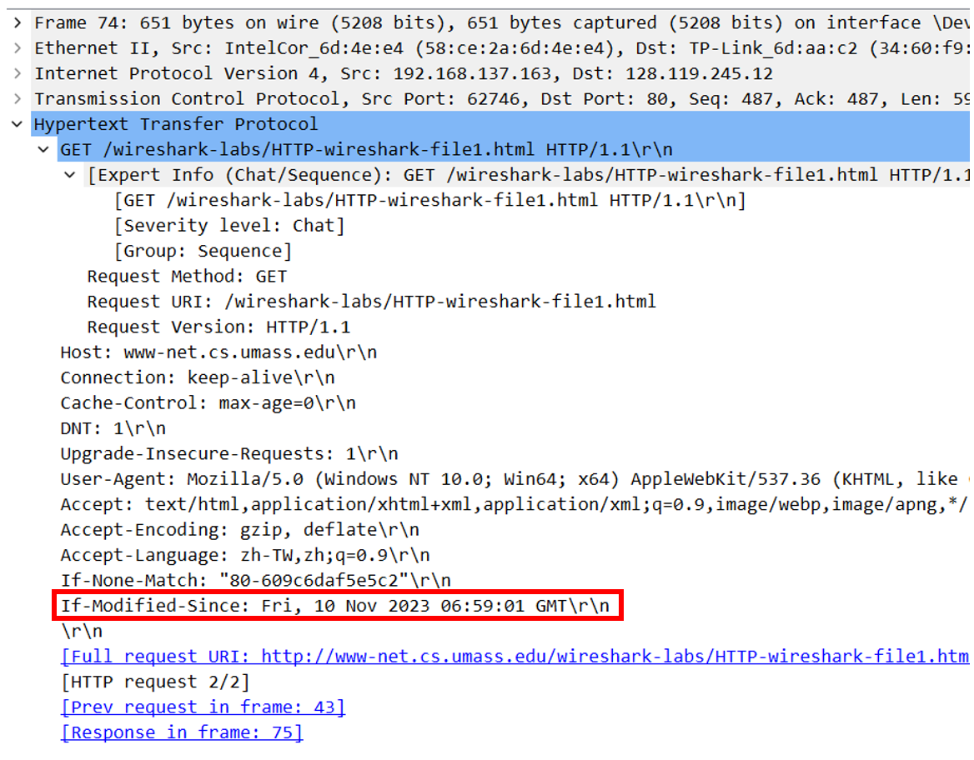

**11.What is the HTTP status code and phrase returned from the server in response to this second HTTP GET? Did the serve rexplicitly return the contents of the file? Explain**

**Ans: It response HTTP/1.1 304 Not Modified. Server didn’t return the contents of the file, since it already exist in cache**

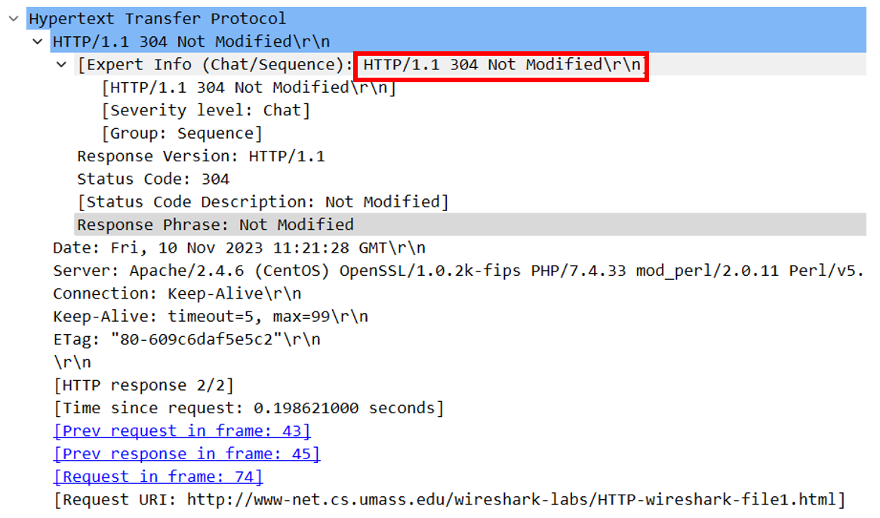

**12.How Manny HTTP GET request messages did your browser send?**

**Which packet number in the trace contains the GET message for the Bill or Rights?**

**Ans: 1 request message, packet number is 43**



**13.Which packet number in the trace contains the status code and phrase associated with the response to the HTTP GET request?**

**Ans: 45**



**14. What is the status code and phrase in the response?**

**Ans: 200 OK**



**15. How many data-containing TCP segments were needed to carry the single HTTP response and the text of the Bill of Rights?**

**Ans: 2**

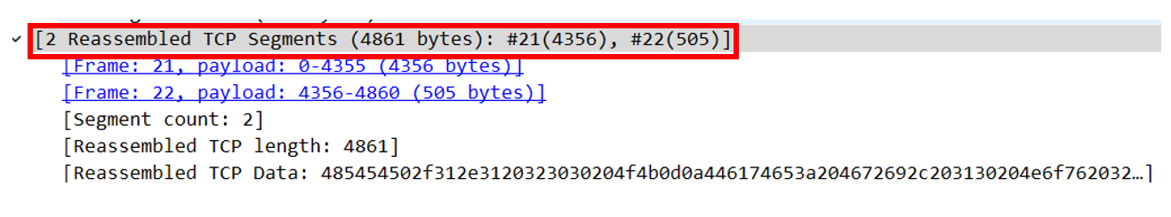

**16. How many HTTP GET request messages did your browser send?**

**To which Internet addresses were these GET requests sent?**

**Ans: 3 requests**

**Web Page: 128.119.245.12**

**Pearson.png: 128.119.245.12**

**8E Cover small.jpg: 178.79.137.164**

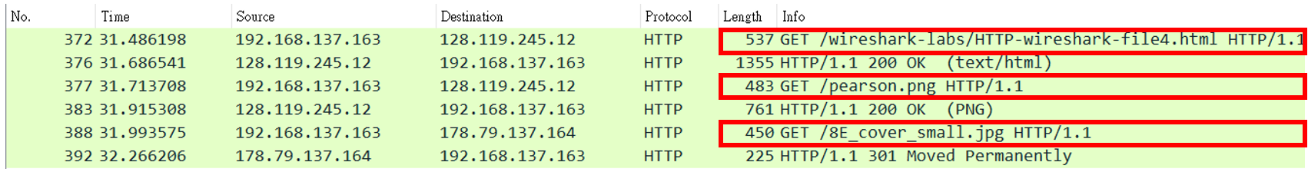

**17. Can you tell whether your browser downloaded the two images serially, or whether they were downloaded from the two web sites in parallel? Explain**

**Ans:They were serially, since the time response are different, if it’s parallel, then it should be returned at the same time   
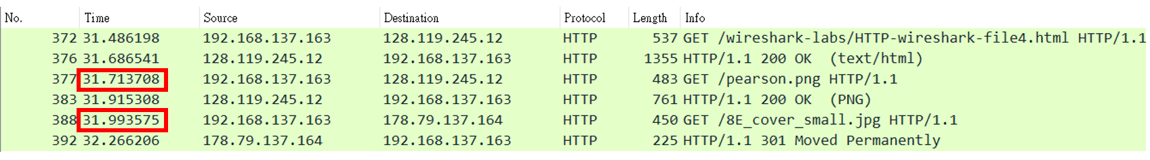**

**18.What is the server’s response (status code and phrase) in response to the initial HTTP GET message from your browser?**

**Ans: 401 Unauthorized**



**19. When your browser’s sends the HTTP GET message for the second time,**

**what new field is include in the HTTP GET message?**

**Ans: Authoriaztion field**