1. Is your browser running HTTP version 1.0 or 1.1? What version of HTTP is the server running?
Ans :Browser: 1.1, Server: 1.1
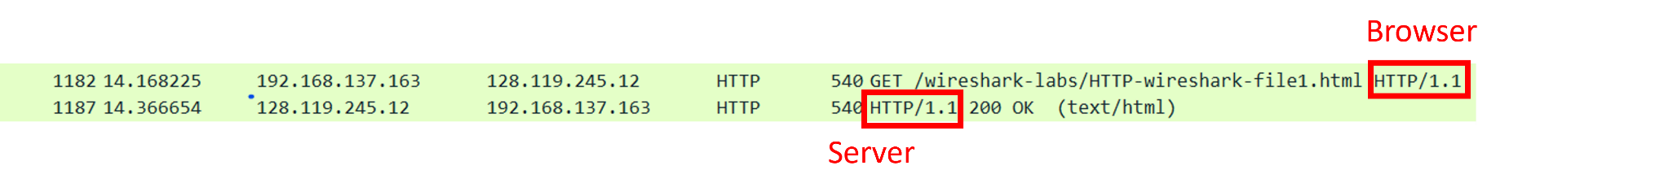
2. What languages (if any does your brwowser indicate that it can accept to the server?
Ans: zh-Tw
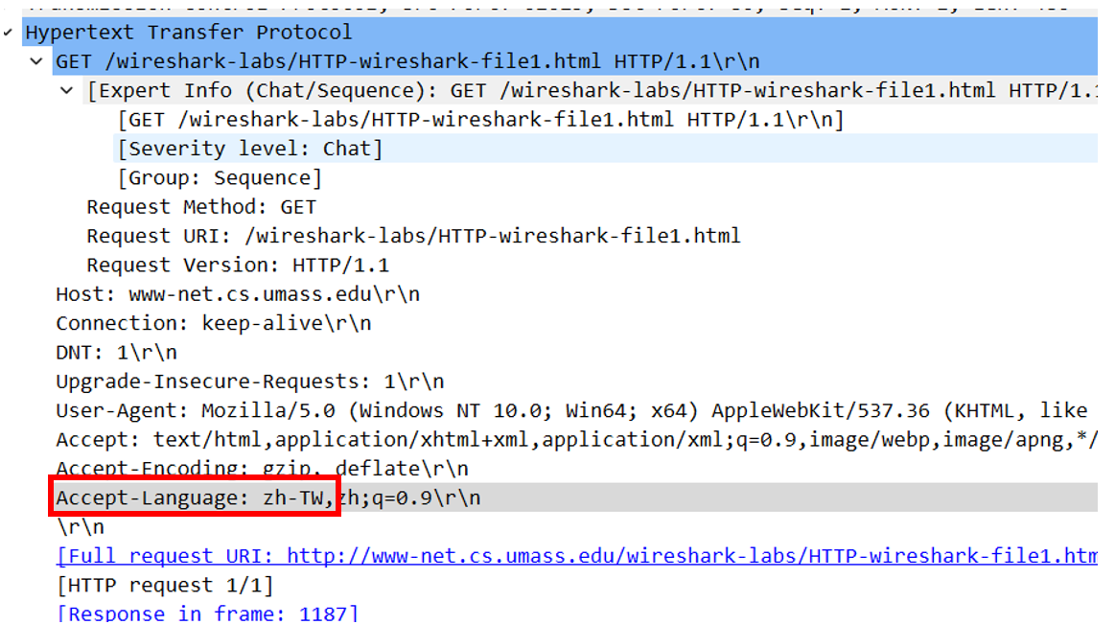
3.What is the IP adderss of your computer? Of the gaia.cs.umass.edu server?
Ans: My computer IP: 192.168.137.163,
gaia.cs.umass.edu server IP: 128.119.245.12
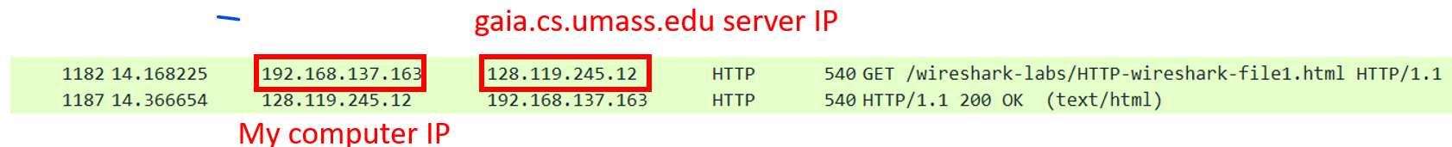
4. What is the status code returned from the ser to your browser?
Ans: 200 OK
5. When was the HTML file that you are retrieving last Modified at the server?
Ans: Fri, 10 Nov 2023 06:59:01
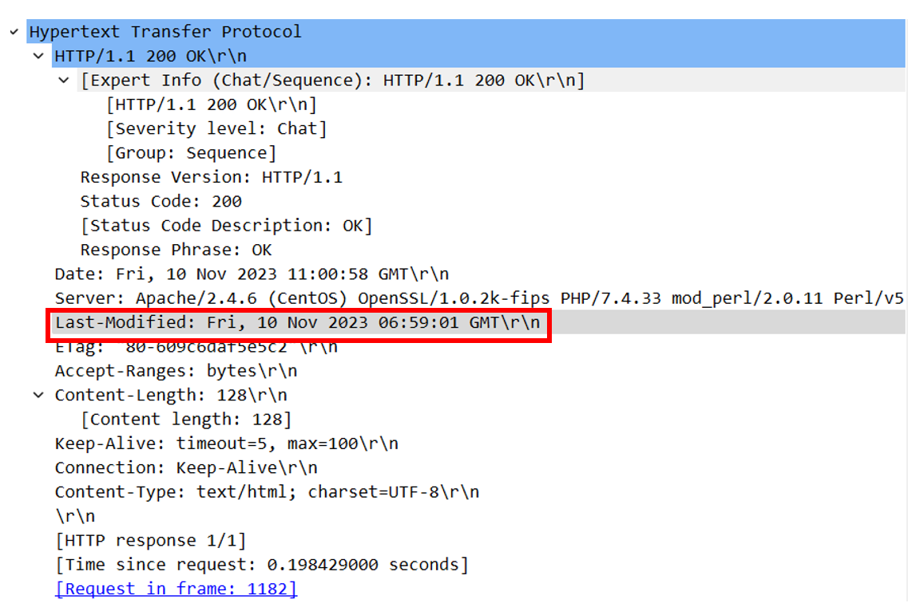
6. How many bytes of content are begin returned to your browser?
Ans: 128
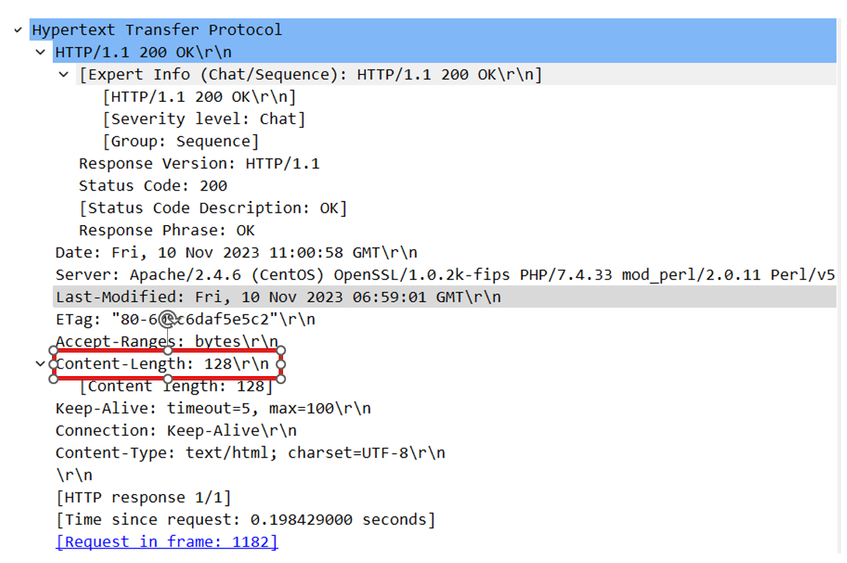
7. By inspecting the raw data in the packet content window, do you see any headers within the data that are not displayed in the pack-listing window? If so, name one.
Ans: No, nothing is not displayed
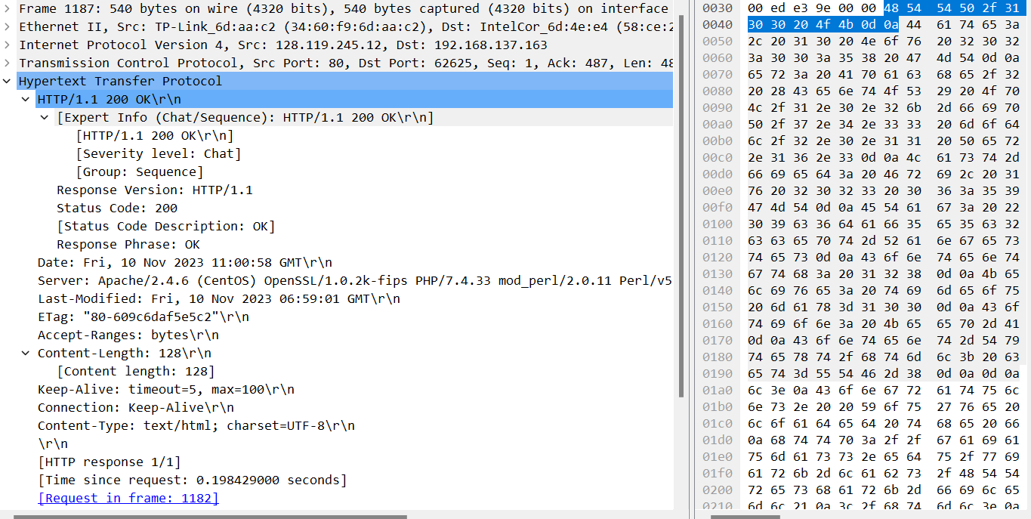
8. Inspect the contents of the first HTTP GET request from your browser to the server.
Do you see an “IF-MODIFIED-SINCE” line in the HTTP GET?
Ans: NO, there is no such thing

9. Inspect the contents of ther server response.
Did the server explicitly return the contents of the file? How can you tell?
Ans: Yes
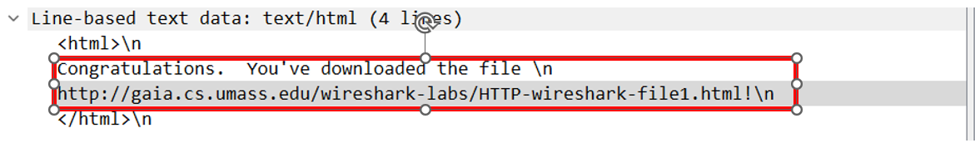10.Now inspect the contents fof the seond HTTP GET request from your browse to the server. Do you see an “IF-MODIFIED-SINCE:”line in the HTTP GET? If so, what information follows the “IF-MODIFIED-SINCE:”header?
Ans: 10 Nov 2023 06:59:01
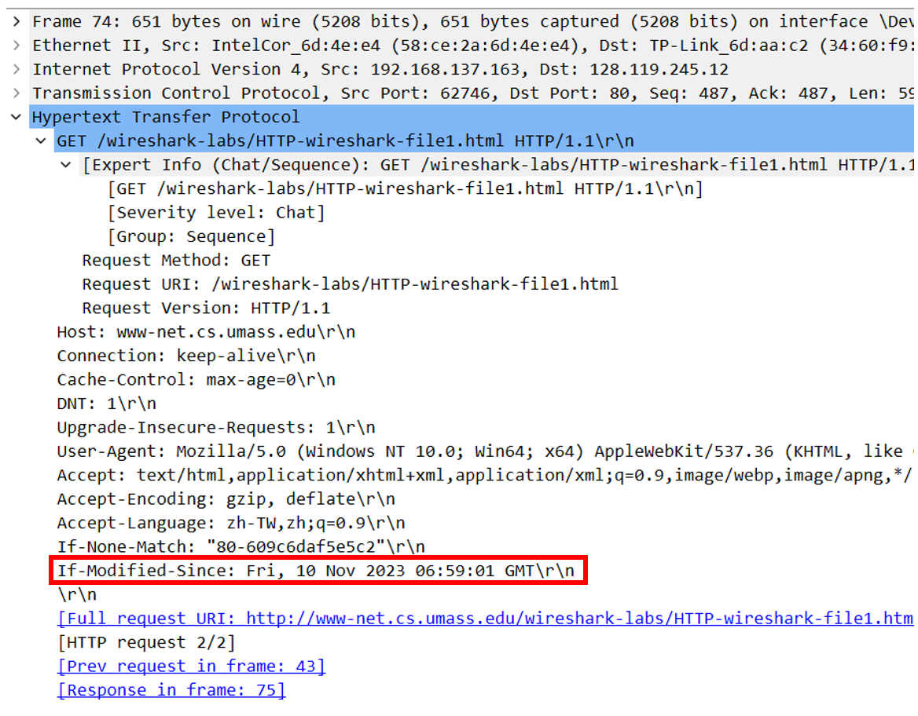
11.What is the HTTP status code and phrase returned from the server in response to this second HTTP GET? Did the serve rexplicitly return the contents of the file? Explain
Ans: It response HTTP/1.1 304 Not Modified. Server didn’t return the contents of the file, since it already exist in cache
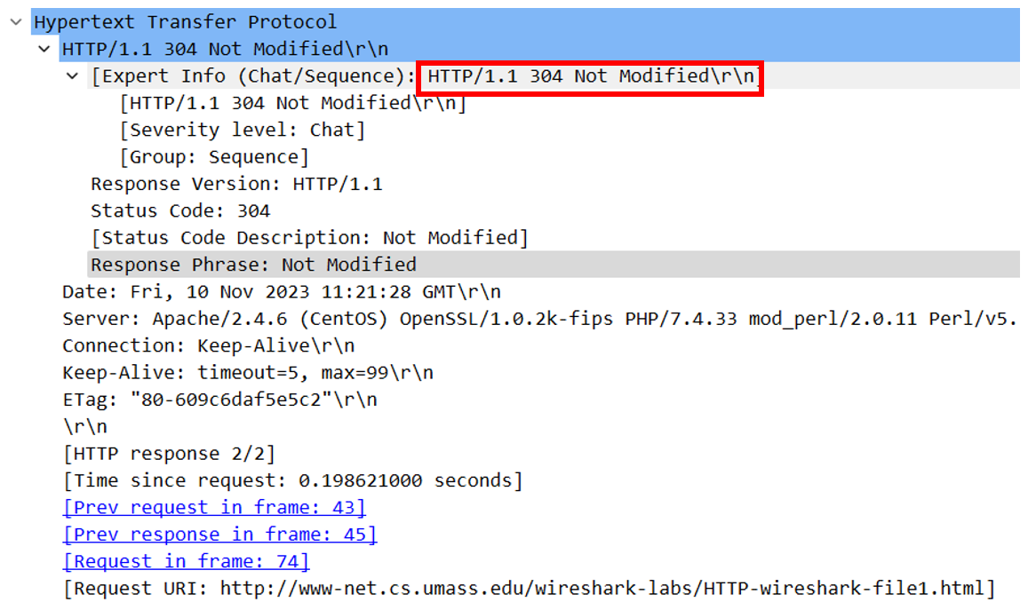
12.How Manny HTTP GET request messages did your browser send?
Which packet number in the trace contains the GET message for the Bill or Rights?
Ans: 1 request message, packet number is 43
13.Which packet number in the trace contains the status code and phrase associated with the response to the HTTP GET request?
Ans: 45
14. What is the status code and phrase in the response?
Ans: 200 OK
15. How many data-containing TCP segments were needed to carry the single HTTP response and the text of the Bill of Rights?
Ans: 2
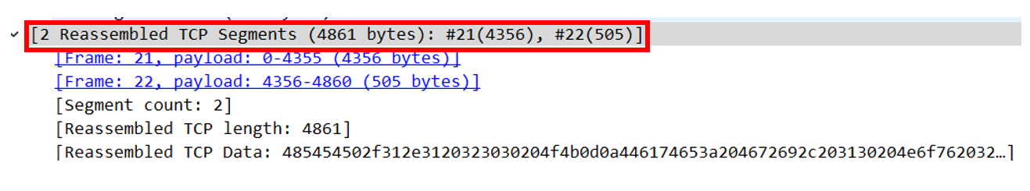
16. How many HTTP GET request messages did your browser send?
To which Internet addresses were these GET requests sent?
Ans: 3 requests
Web Page: 128.119.245.12
Pearson.png: 128.119.245.12
8E Cover small.jpg: 178.79.137.164
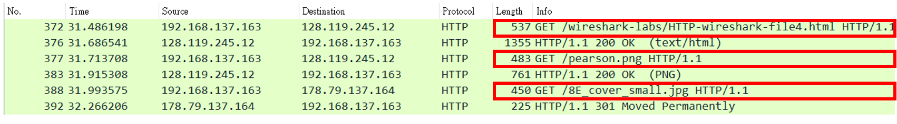
17. Can you tell whether your browser downloaded the two images serially, or whether they were downloaded from the two web sites in parallel? Explain
Ans:They were serially, since the time response are different, if it’s parallel, then it should be returned at the same time
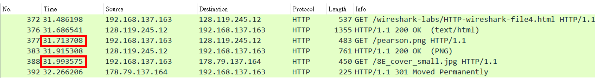
18.What is the server’s response (status code and phrase) in response to the initial HTTP GET message from your browser?
Ans: 401 Unauthorized
19. When your browser’s sends the HTTP GET message for the second time,
what new field is include in the HTTP GET message?
Ans: Authoriaztion field