1. Describe four approaches (i.e., Thinking Humanly, Thinking Rationally, Acting Humanly, and Acting Rationally) of AI based on your understandings. Name one you prefer most. Why? If you have another approach, welcome to explain it in detail.

Thinking Humanly: It requires theories of internal activities of the brain. It’s a cognitive modelling approach. Trying to understand and model how the human mind works.

Thinking Rationally: The use of logic, the laws of thought approach. It is a modeling thinking as a logical process.

Acting Humanly: is acting like a human. The example of this is the Turing Test.

Acting Rationally: It is the rational agent approach (eg. A robot). Performing actions that increase the value of the environment where the agent is acting.

What I prefer is to act rationally because it is more general than the “laws of thought” approach because correct inference is just one of several possible mechanisms for achieving rationality. Secondly, its more amenable to scientific development than are approaches based on human behavior or human thought. The standard of rationality is well defined and completely general. q(book, 5)

2. Describe the following potential agents using the PEAS format, and justify why or why not each is an agent:

Google's AlphaGo Zero

Performance measure: play go Game, percentage of wins

Environment: a GO board, player

Actuators: placing stone

Sensors: Program interface, Turns, Game board placement

Siri

P: understand user voice queries, answer questions

E: Cell phone device(iOS)

A: Voice input, text output/voice output of answers

S: Voice input

Mars Rover

P: Performance of taking pictures and data, efficiency of exploring mars

E: Mars

A: data collection tools (ie. Camera)

S: Camera recordings, sensors of temperatures and wind

Ducks' Quarterback

P: Lead to win, yards gain

E: Football game

A: Hands, Legs

S: Eyes

3. a) In a particular uninformed search, the branching factor of an uninformed search tree is 4. The shallowest solution can be found at depth 5 in the rightmost node, though there is another one at depth 7 in the leftmost node. Assume the goal test is applied when a node is selected for expansion. If it is a goal, no need for further expansion. Give the exact total number (i.e., not just big O) of nodes expanded, the exact total number of nodes generated, as well as the maximum needed space requirements (i.e., the exactly maximum number of nodes stored in the memory) for each of the following uninformed searches:

Breadth-first

Depth-first

Depth-limited (Limited to a depth of 6)

Iterative deepening

1. Breadth-first:

The total number of nodes expanded:

40 +41 +42 +43 +44 +45 -1 = 1364

Total number of nodes generated:

4^0 + 4^1+4^2+4^3+4^4+4^5+4^6-4 = 5457

Maximum needed space:

4^0 + 4^1+4^2+4^3+4^4+4^5+4^6-4 = 5457

1. Depth-first

Total number of nodes expanded:

7

Total number of nodes generated:

1 + 7\*4 = 29

Maximum needed space:

1 + 7\*4 = 29

1. Depth-limited

Total number of nodes expanded:

40 +41 +42 +43 +44 +45 -1=1364

Total number of nodes generated:

4^0 + 4^1+4^2+4^3+4^4+4^5+4^6-4 = 5457

Maximum space requirement:

1+6\*4 = 25

1. Iterative deepening:

total number of nodes expanded:

5\*4^0 + 4\*4^1+3\*4^2+2\*4^3+1\*4^4=453

Total number of nodes generated:

4^0 + 5\*4^1+4\*4^2+3\*4^3+2\*4^4 +4^5=1813

Maximum space requirement:

1+5\*4 = 21

b) Which search appears to be the best for this problem? Which would be the best if the only solution was found following the rightmost child at every expansion, assuming an infinite depth?

In this case, the breadth first search seems to be the best solution because it requires less number of node expanded and generated.

 If the only solution was found following the rightmost child at every expansion, iterative-deepening search would be the best because of its efficient memory requirement.

4. The information used for this problem is taken from the Romanian map (figure 3.2, pp. 68) and the straight-line distances to Bucharest (figure 3.22, pp. 93). In addition, the direct road from Rimnicu Vilcea to Pitesti has been destroyed by a flash flood, and the new traveling distance between them using a detour is 155. The flood also destroyed the direct road from Pitesti to Bucharest, and the new detour distance between them is 115.

Create a diagram of the search tree from Arad to Bucharest (similar to part f in figure 3.24, pp 94) which shows the final expansion of the search tree using the A\* search algorithm and the straight-line heuristic. Each node should have the name of the city, the value of the f=g+h function, and the order in which the node was expanded. (i.e., the root node of the tree would have the name "Arad", the values "366=0+366", and the value "1," since it is the first node expanded.)

f(n) = g(n)+ h(n) | g(n) = cost to reach the node, h(n) = the cost to get from the node to the goal)

-See image file

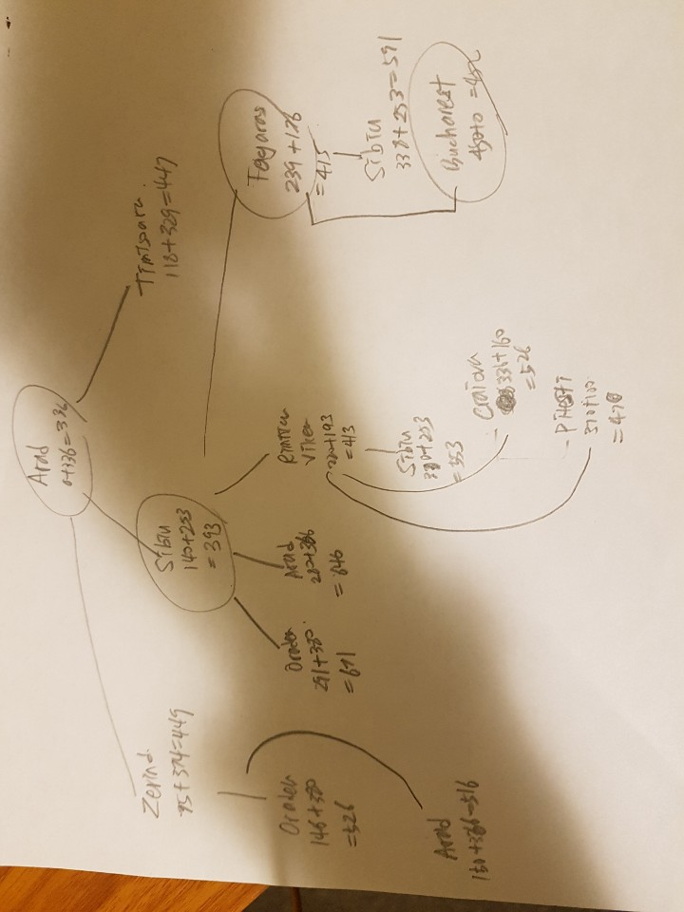

5. Prove that Greedy best-first search is not optimal.

Say,

f(G2) = h(G2) = 0

f(n) = h(n) >0

f(n) > f(G2)

The greedy best first search expands the node that has the smallest f(n). Because of that, the algorithm will expand the suboptimal goal G2 and it never reach to the optimal goal G because it will return suboptimal goal for the answer. Therefore, greedy best first search is not optimal.

6. Create another two admissible heuristics for the 8-puzzle problem. Explain why they are admissible.

1.

Let H = number of tiles out of row + number of tiles out of column

From the picture of the 8-puzzle, there are 5 tiles that are out of row and 8 tiles that are out of columns. So h = 5 + 8 = 13. h is an admissible heuristic because every tils that are out of position has to move. (i.e. out of column or row => must move at least once, and out of both column and row => must move at least twice.)

2.

Euclidean distance

Formula of Euclidean distance = sqrt(p1-q1)^2 + (p2-q2)^2)

By using this formula, we know that each tile needs to be moved by the distance from the one to another (say, we move 7 to the right position and the coordinate of 7 would be -1,1, then the coordinate of the right place would be (0,-1)). Therefore, h=sqrt(5)+1+sqrt(2)+sqrt(2)+2+sqrt(5)+2 = 14.536 is admissible heuristic.