XIORVE Website Blueprint V1.0

Navigation
HOME
PRODUCTS
BUSINESS
CONTACT

HOME
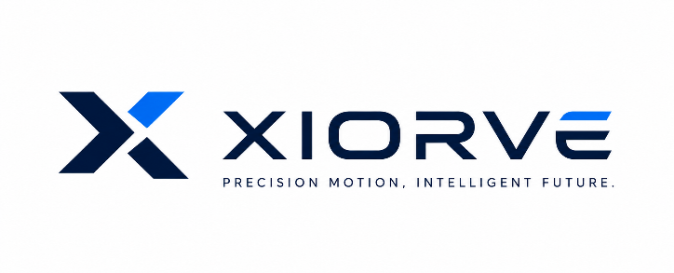
Precision Motion Components for Robotics & Automation
We provide high-performance precision motion components for robotics and industrial automation.
Designed for engineers.
Built for long-term reliability.
Product Overview
┌────────────────────────┐
│ Harmonic Gearboxes │
└────────────────────────┘

┌────────────────────────┐
│ Planetary Gearboxes │
└────────────────────────┘

┌────────────────────────┐
│ Robot Joint Modules │
└────────────────────────┘

PRODUCTS
├── Harmonic Gearboxes
│
├── Planetary Gearboxes
│
└── Robot Joint Modules

Every Product Page
Downloads
✔ Brochure
✔ Datasheet
✔ STEP
✔ Installation Guide
✔ Warranty
✔ Technical Notes

Bottom
Additional models available upon request.
OEM service available.
Compliance documents available where applicable.
Button
Request Quote

BUSINESS

① Sample Program

Standard Sample Pricing
Model | Sample Price
XHG-14 | USD 300
XHG-17 | USD 450
XHG-20 | USD 600
XPG-60 | USD 150
XPG-90 | USD 250
XJM-70 | USD 900
XJM-80 | USD 1,100
XJM-90 | USD 1,400
MOQ：1 PieceVolume and project pricing available upon request.

② Payment

Flexible & Secure Payment Options

Bank Transfer
Recommended
No additional charge

Pay by Bank
Fast Payment Link
Recommended for sample orders
No additional charge

Card Payment
Supports internationally accepted payment methods available in your region.
Price Adjustment
+3%

PayPal
Available upon request.
Price Adjustment
+8%

Payment instructions will be provided after order confirmation.

③ Lead Time
Standard Lead Time
As fast as1 Week*
Production schedule confirmed before production.
*Depending on product and stock availability.

④ Shipping
Worldwide Shipping
Courier
Air Freight
Sea Freight
Incoterms
EXW
FCA upon request
Tracking information provided when available.

⑤ Warranty
Warranty
12 Months

CONTACT
Email
sales@xiorve.com （超链接能进入邮箱）

WhatsApp
Business Surpport
+852 (附二维码)

Company
XIORVE
Suzhou,Jiangsu
China

Business Hours
Monday-Friday
09:00-18:00(GMT+8)

Response Time
We normally reply
within 12 hours.

Business Services
✓ Product Consultation
✓ OEM & ODM
✓ Technical Support
✓ After-sales Service

