M1122507孫詳恩

Add window.addEventListener to use keyboard control taxi move forward or backward.

When press Arraydown, taxi will moving backward

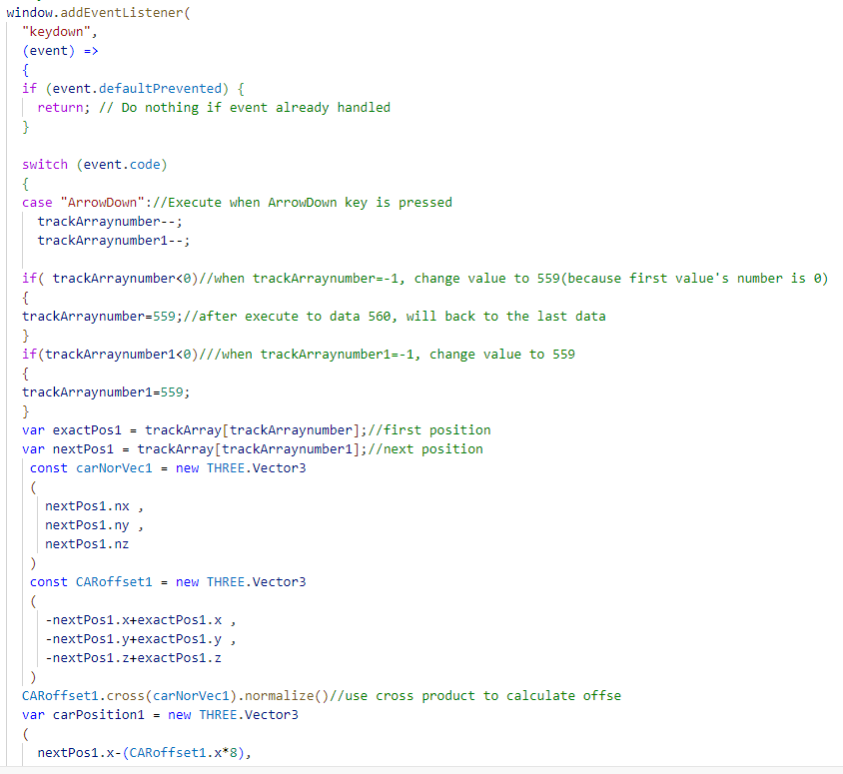

When press Arrayup, taxi will moving forward

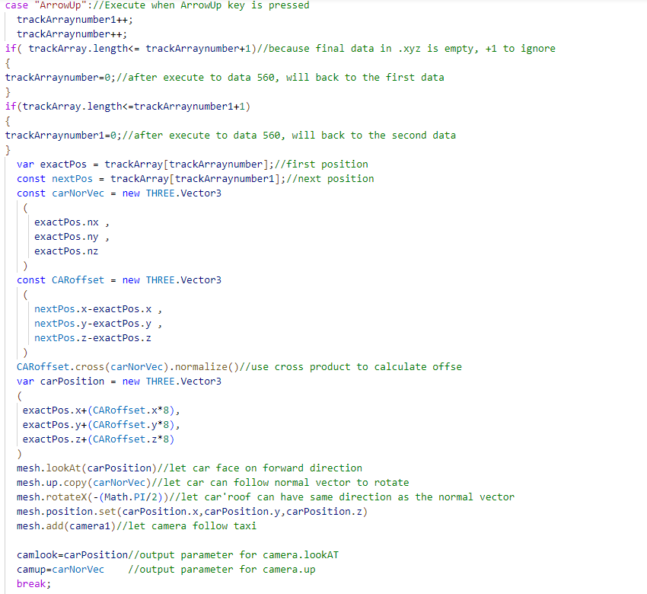

Add event.preventDefault() to detect press one time

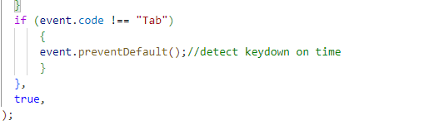

Load hdr file and render it as enviorment

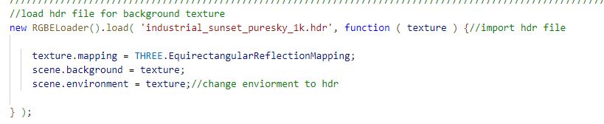

Add stereo camera to have vr headset view

