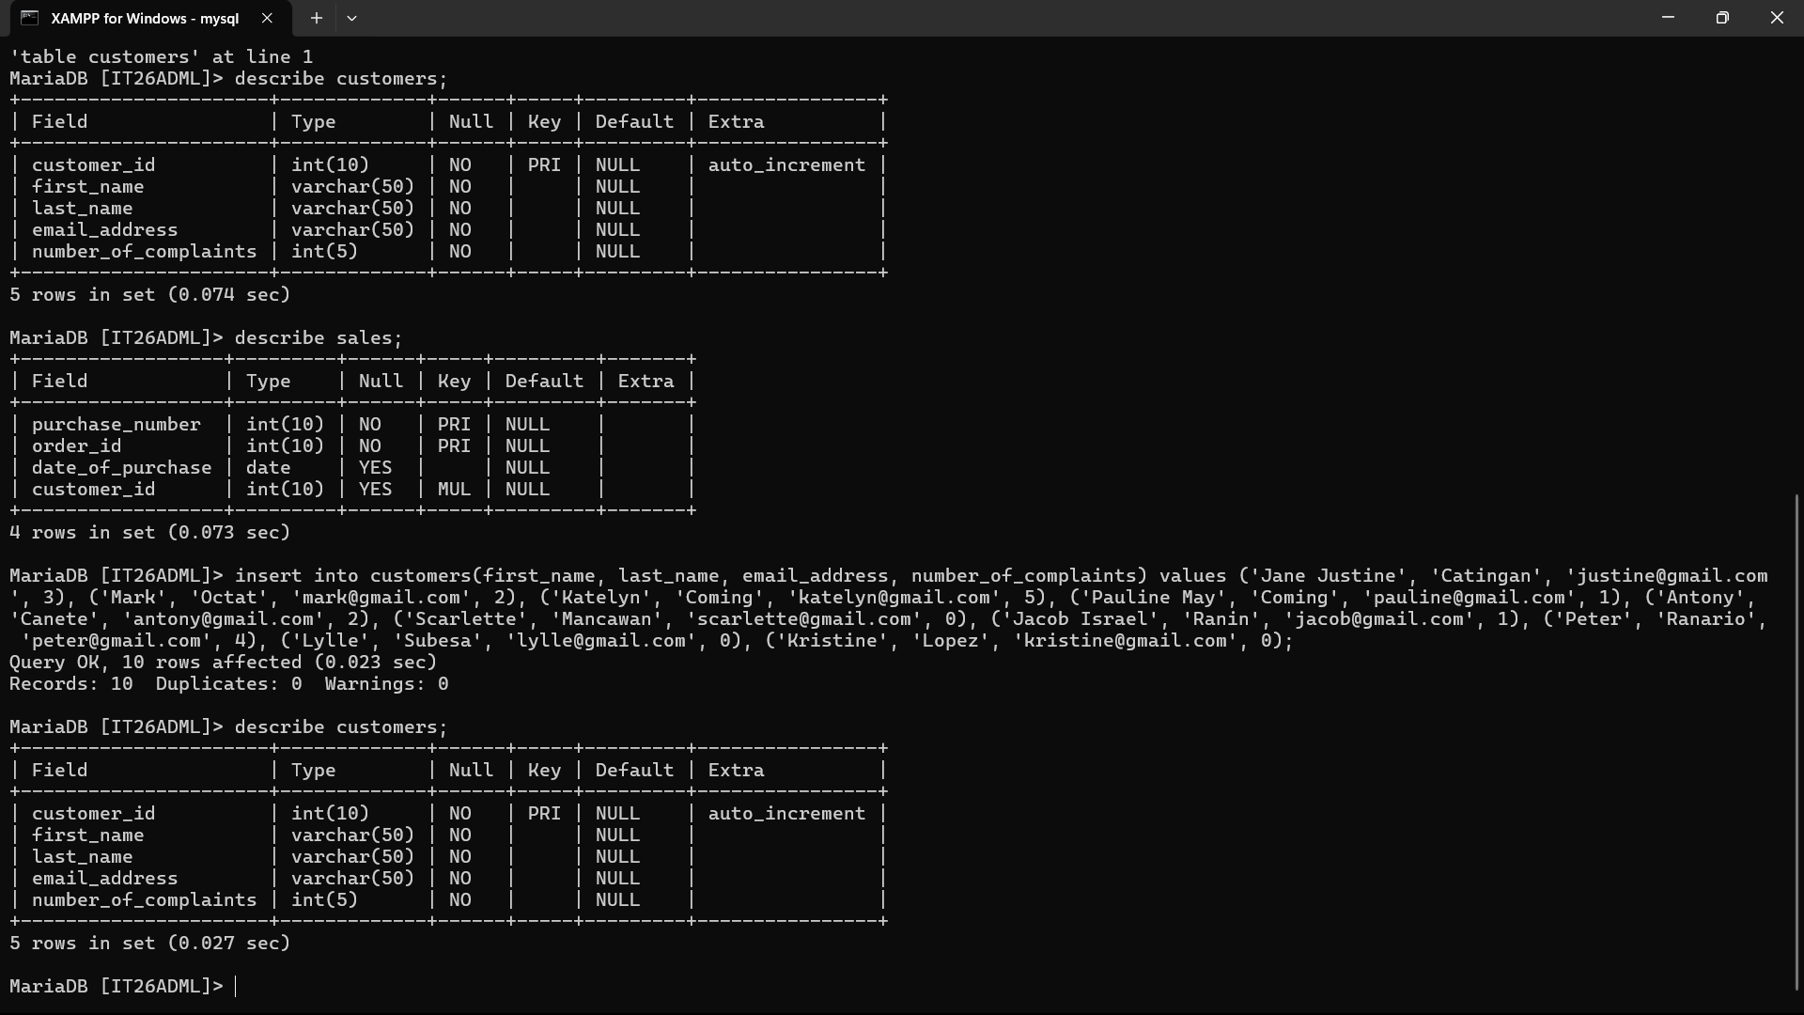
INSERT

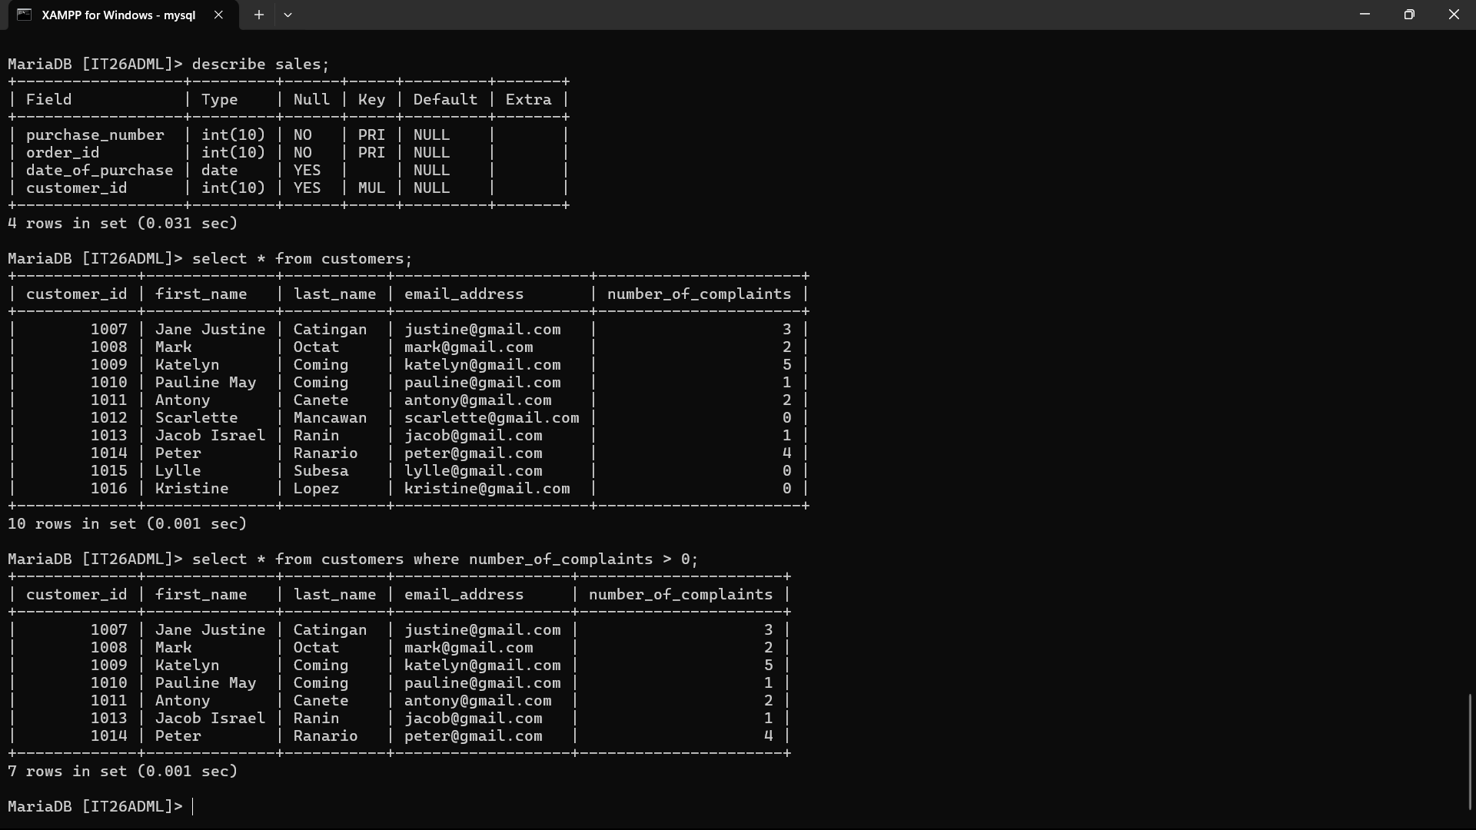
SELECT

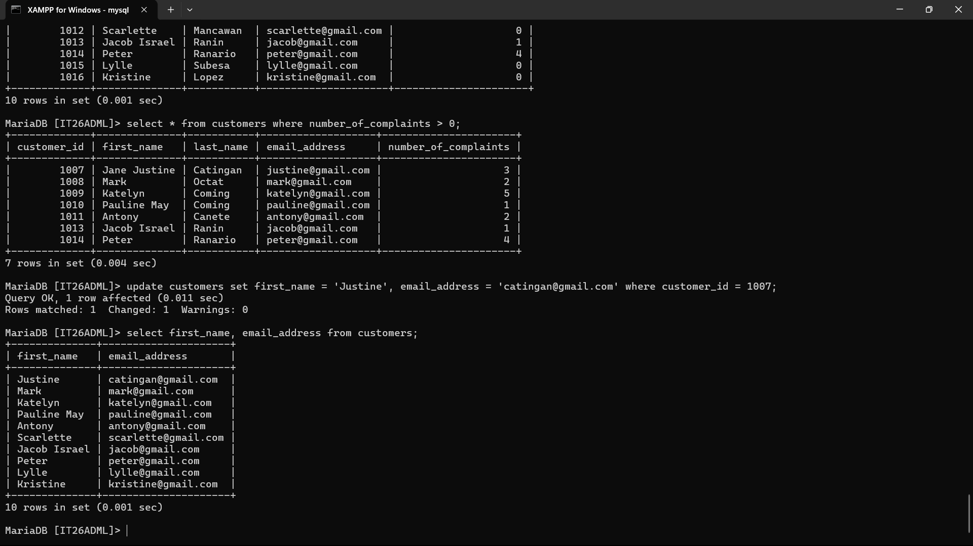
UPDATE

DELETE
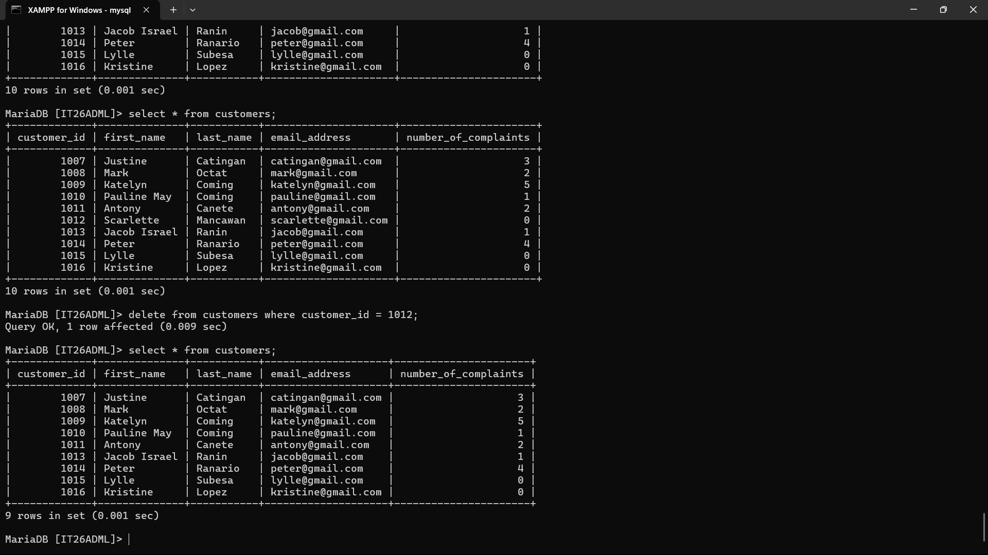

CASCADING
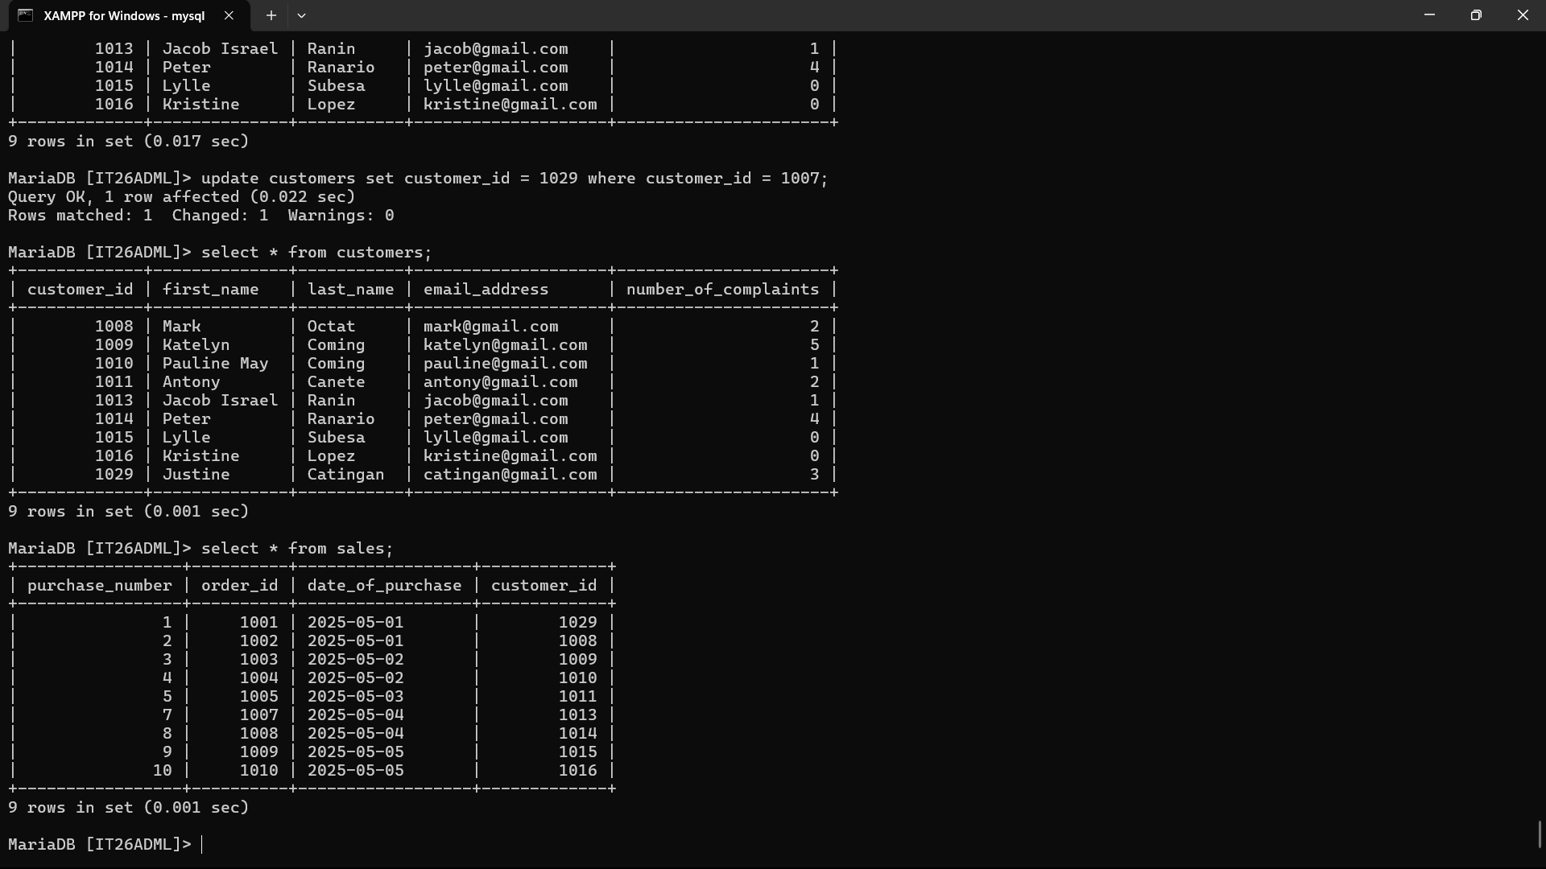
Good day, Ma'am. I checked the table using SHOW CREATE TABLE sales, and I saw that the foreign key constraint for customer_id already had ON DELETE CASCADE and ON UPDATE CASCADE. Because of this, the cascading behavior was already active. That's why I only performed an UPDATE command, Ma’am. Thank you.
