Computer Vision HW4 Report
R08921040 徐均筑
• Part 1
• Let d = X_{L} – X_{R}
• Prove d = (hint: similar triangles)
• Write down your proof.

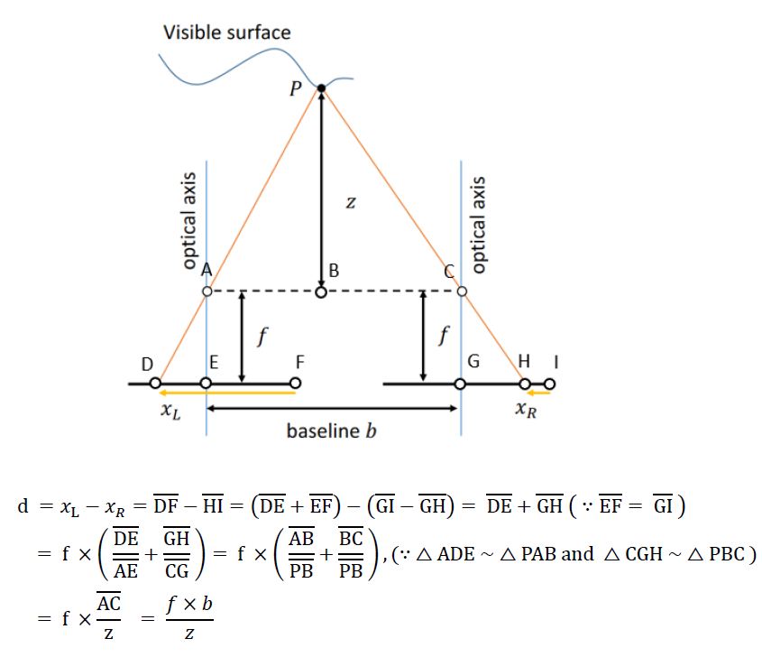

• Part 2
• Explain your algorithm in terms of the standard 4-step pipeline.

1. Cost computation:
For each pixel, the census costs for each possible match are calculated.
2. Cost aggregation:
Apply cost-volume filtering. In this case, we choose bilateral filter with kernel size 9.
3. Disparity optimization:
Simply choose the label of the lowest cost at each pixel.
4. Disparity refinement:
(1) Left-right consistency check:
Detect mismatch points and occlusion points.
(2) Hole filling:
First, search for the closest valid candidate points along some specific directions. For a mismatch point, replace its label with the label of the candidate with the most similar color. As for a occlusion point, replace its label with the label of the closest candidate.
(3) filtering:
Apply weighted median filter twice and median filter once to get more accurate and smoother result.

• Show your output disparity maps in the report.

Tsukuba


Venus


Teddy


Cones


• Show your bad pixel ratio of each disparity maps in the report.
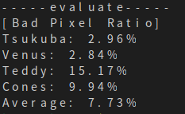

• Your reference papers or websites.

Ma et al. Constant time weighted median filtering for stereo matching and beyond. In ICCV 2013.
https://www.itread01.com/content/1548533730.html

