Task 2

|  |  |  |
| --- | --- | --- |
| Method | URL | Description |
| GET | /api/v3/products | Get all products |
| /api/v3/products/{id} | Get product by id |
| /api/v3/products/?category={categoryname} | Get product by category |
| POST | /api/v3/products | Create new product |
| PUT | /api/v3/products/{id} | Update product details by id |
| DELETE | /api/v3/products/{id} | Delete product by id |

Get All Products **(GET)**

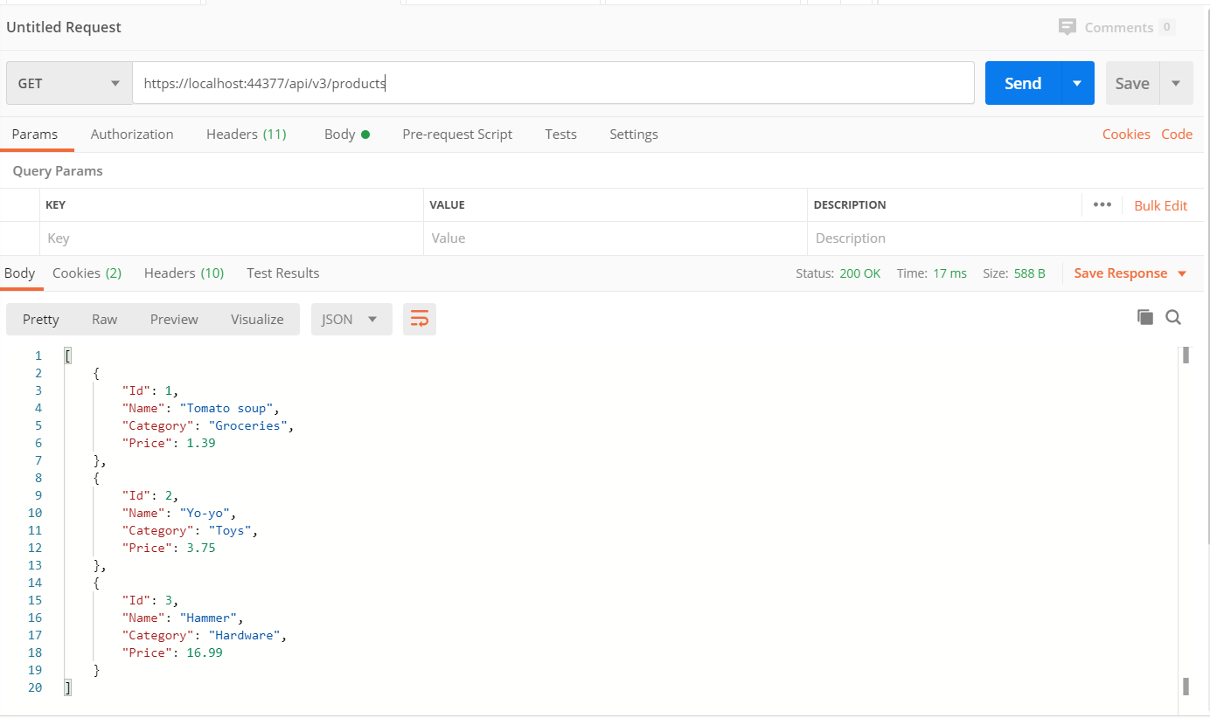

Get By Id **(GET)**

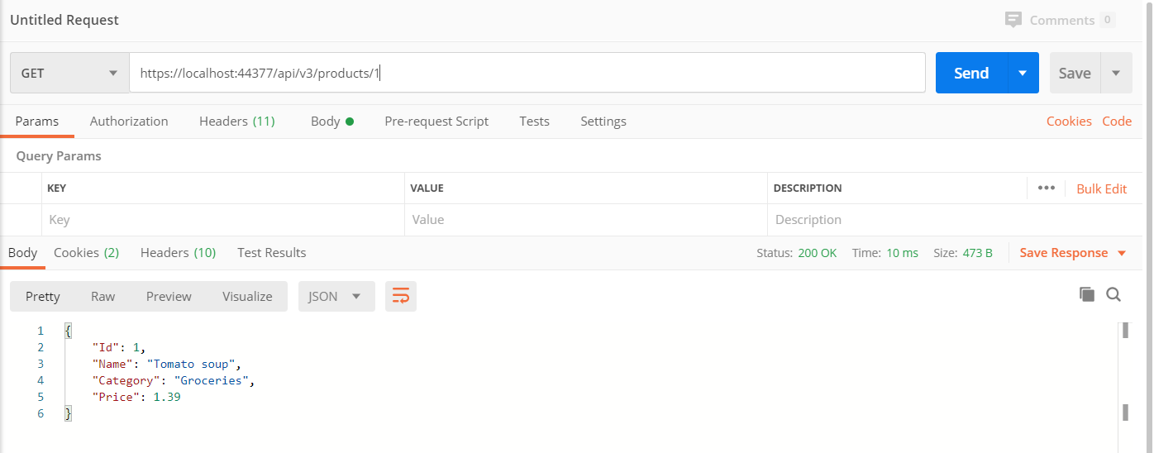

Get By Category **(GET)**

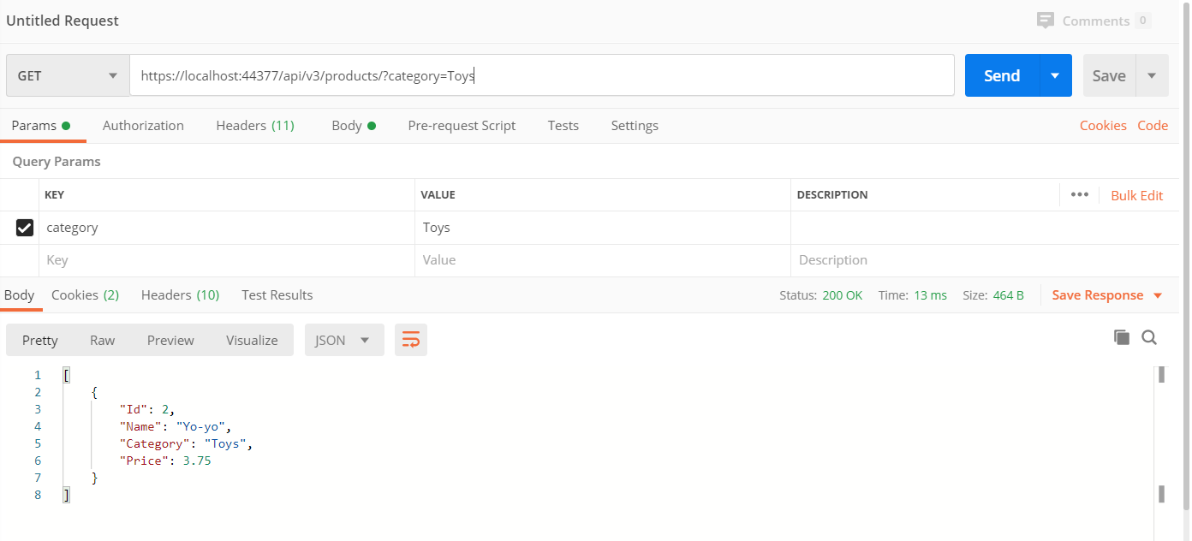

Create New Product **(POST)**

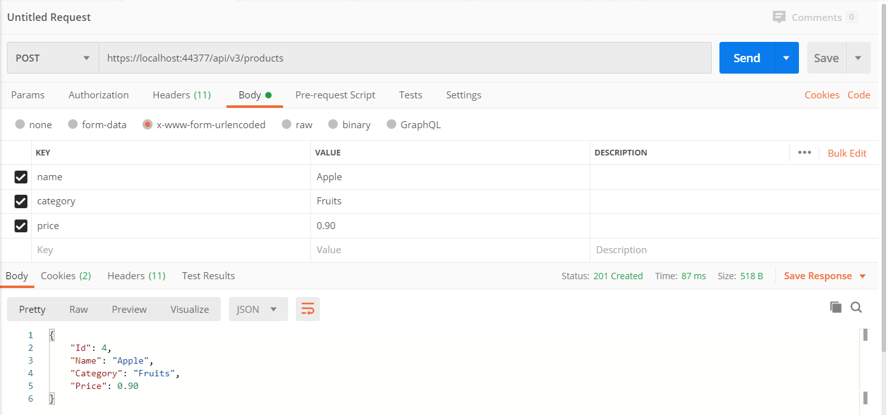

Update Product Details By Id **(PUT)**

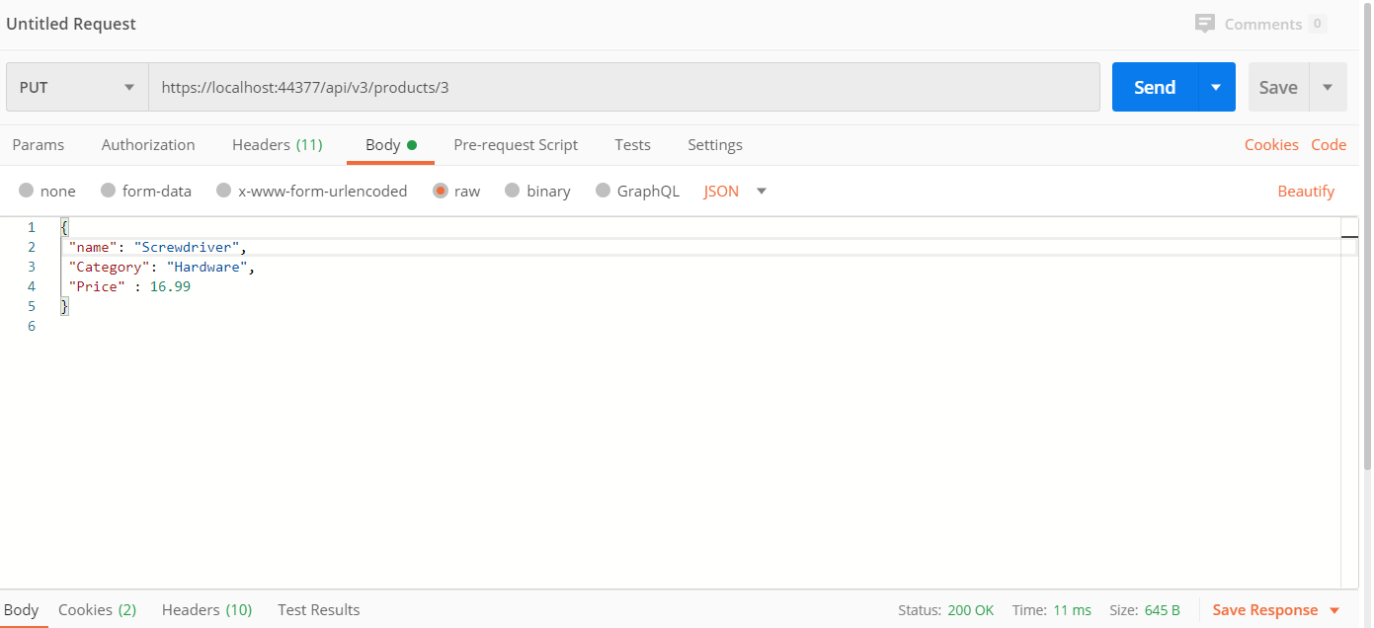

After updating Product Details By Id **(PUT Result)**

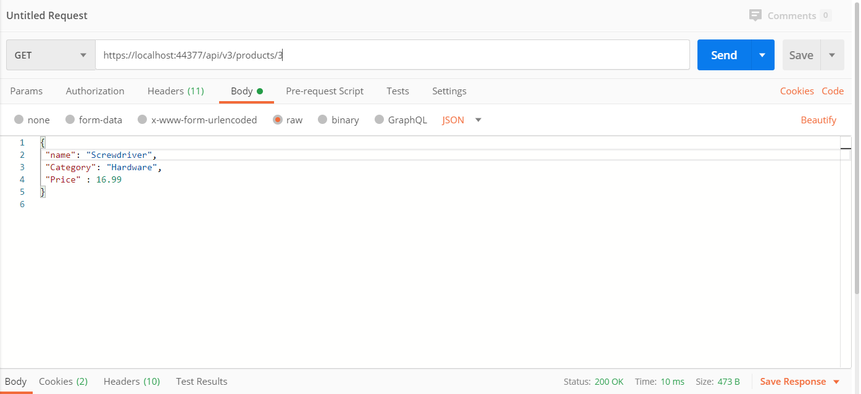

Delete Product By Id **(DELETE)**

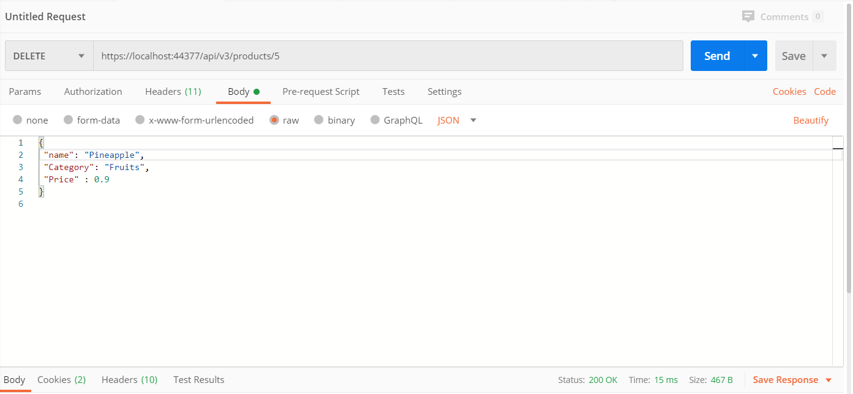

After deleting product by id **(DELETE Result)**

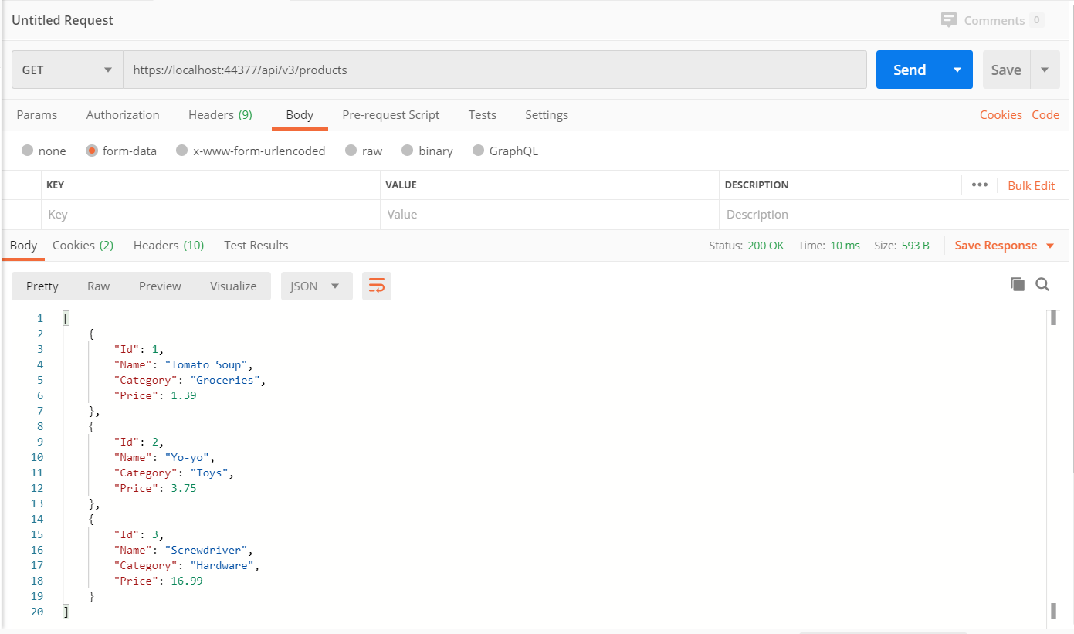

**Over-Posting**

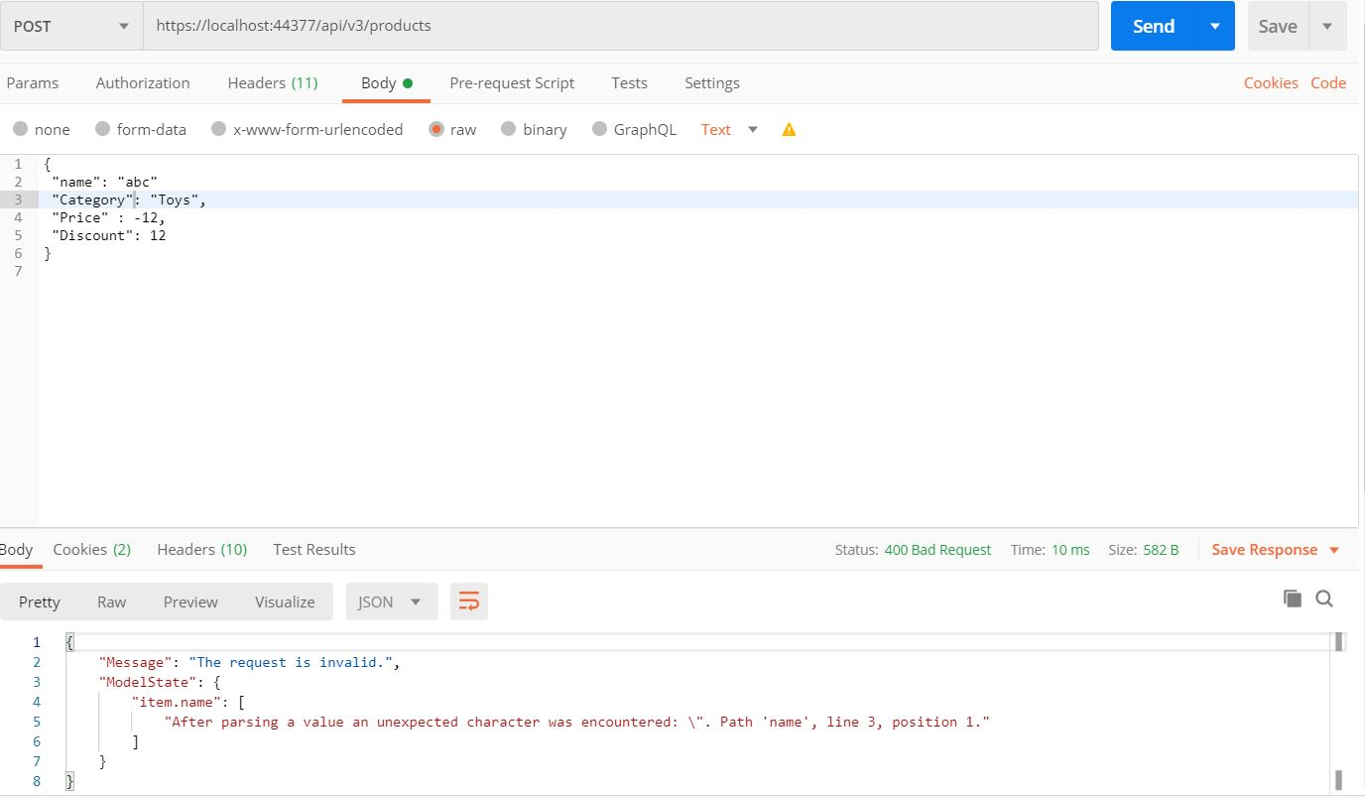

**Under-Posting**

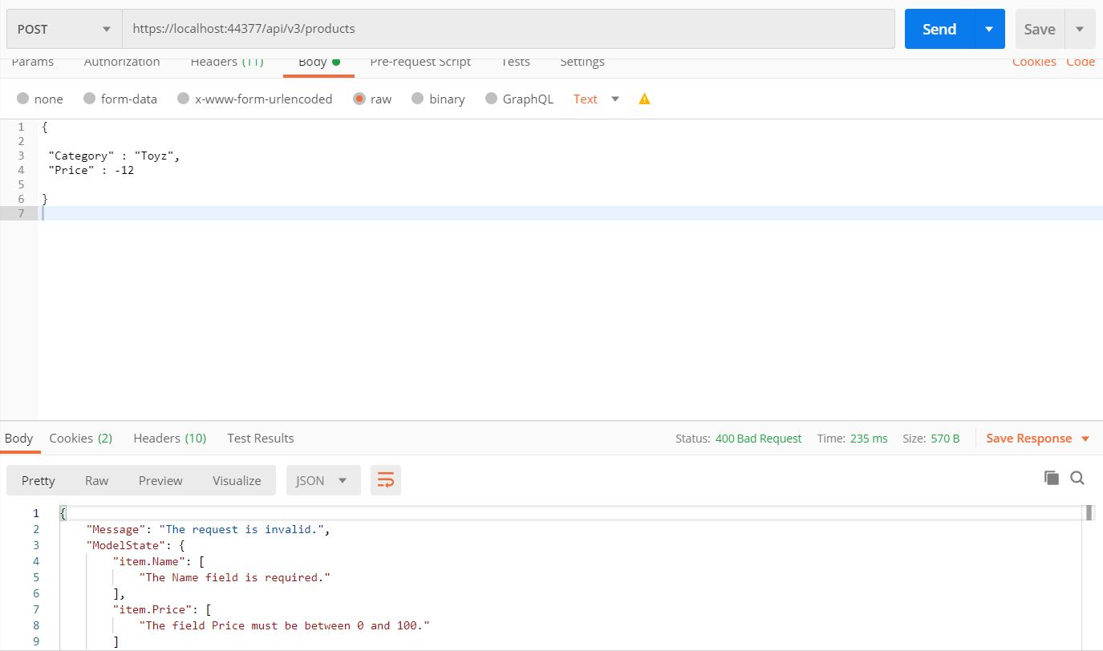

Task 3

|  |  |  |
| --- | --- | --- |
| Method | URI | Description |
| POST | /api/account/register | Create new user |
| GET | /api/values | Get username |
| GET | /api/account/userinfo | Get user information |
| POST | /api/account/logout | Remove token |
| POST | /api/account/changepassword | Change password |
| POST | /api/account/setpassword | Set password |

Create New User **(POST)**

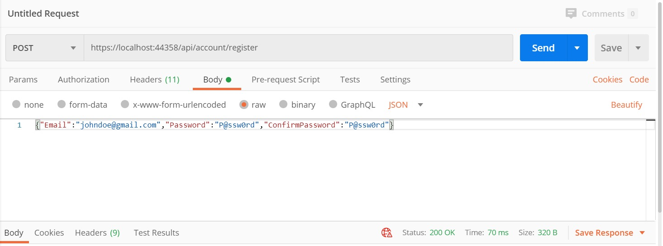

After creating new user **(POST Result)**

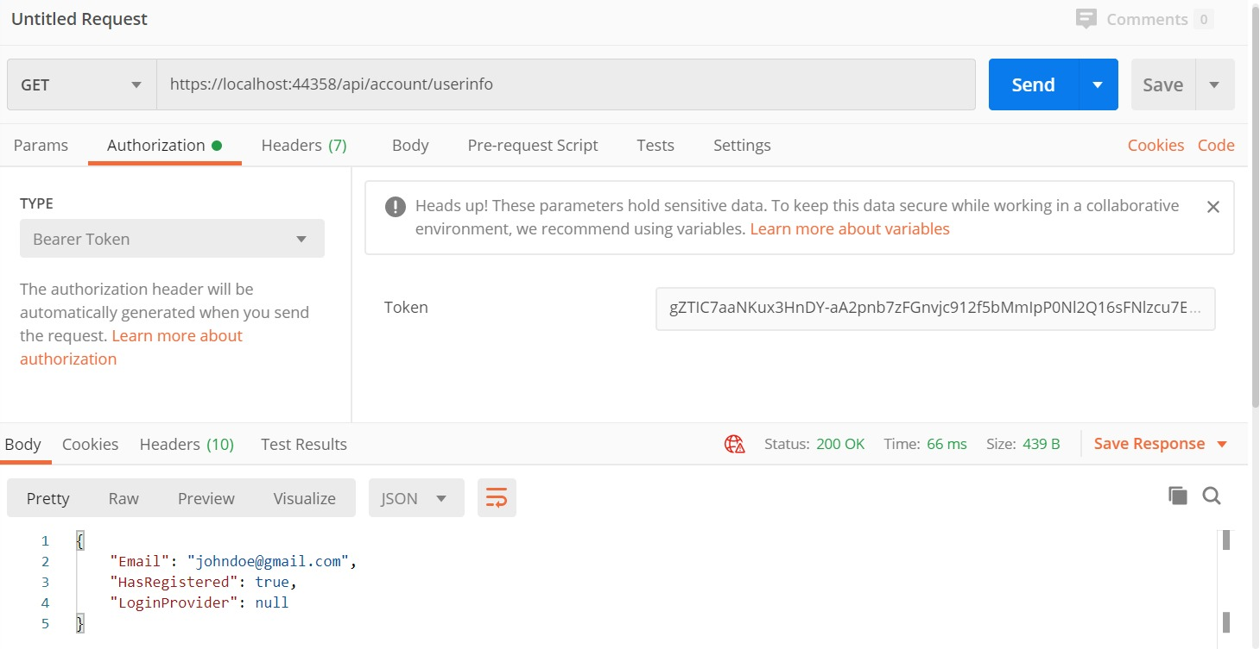

Get User Name **(GET)**

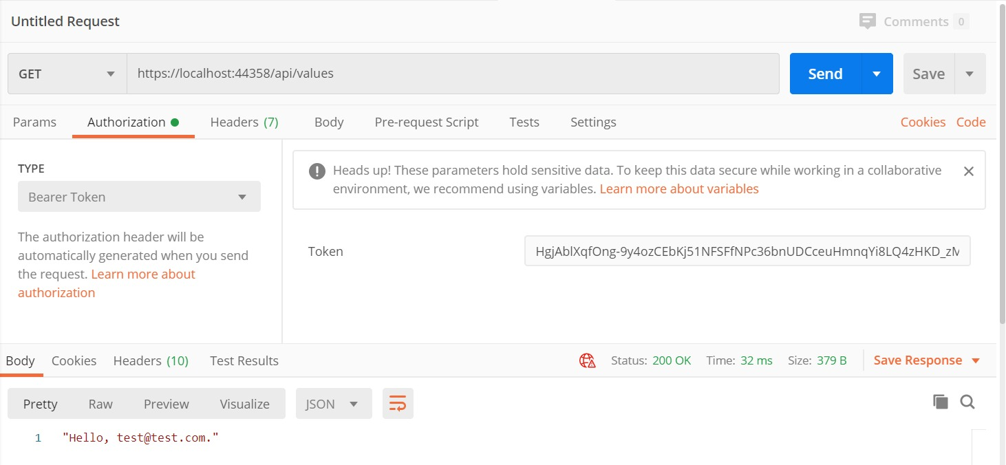

Get User Information **(GET)**

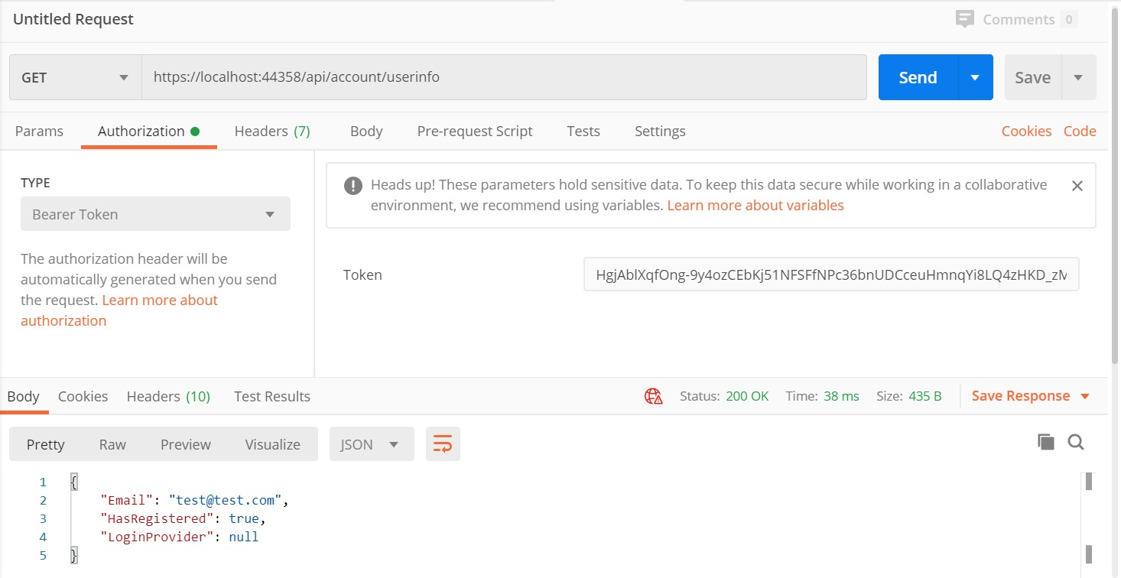

Remove Token **(POST)**

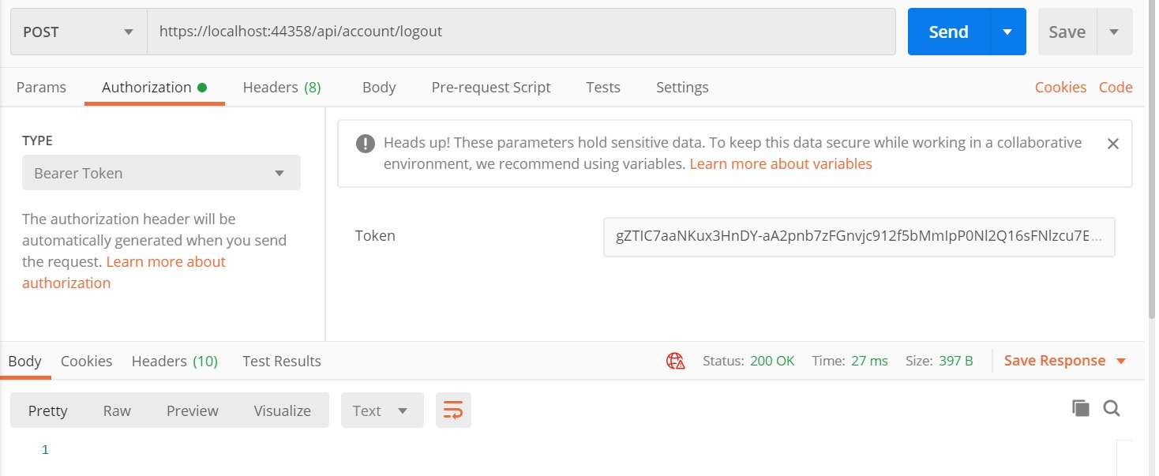

Change Password **(POST)**

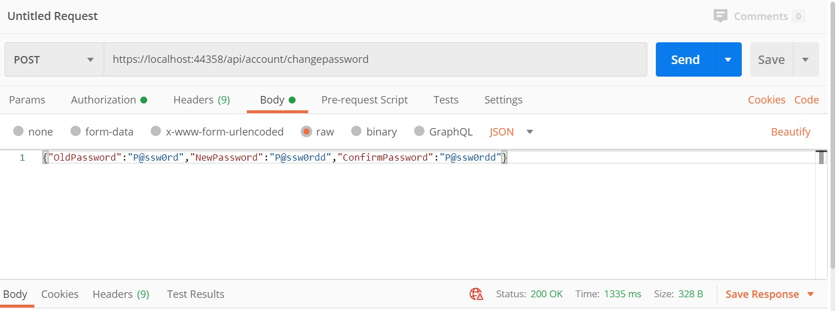

Set Password **(POST)**

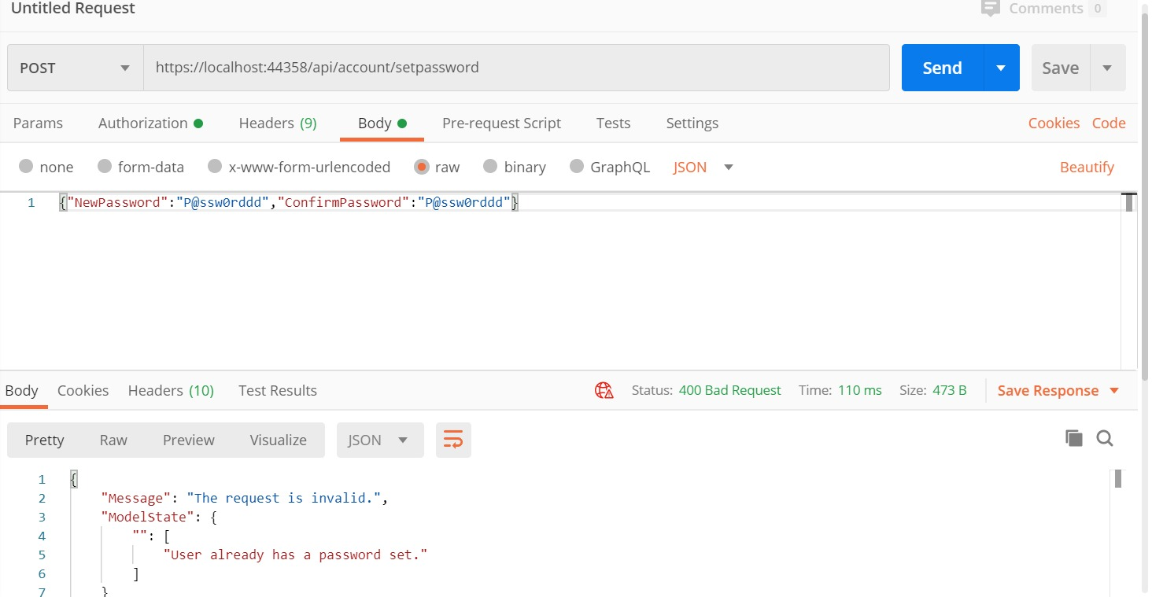

Task 4

|  |  |  |
| --- | --- | --- |
| Method | URI | Description |
| GET | /api/talents | Get all talents |
| GET | /api/talents/{id} | Get talents by id |

Get All Talents **(GET)**

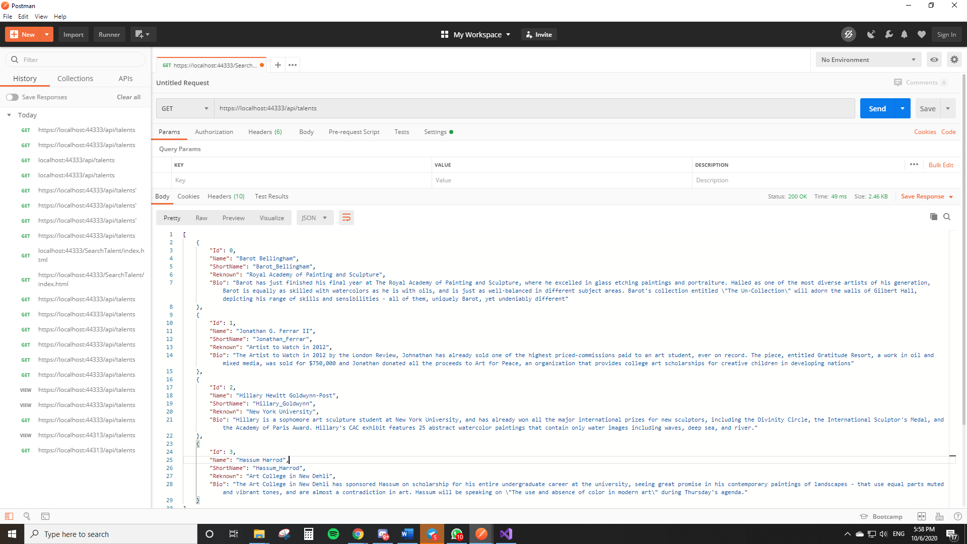

Get Talents By Id **(GET)**

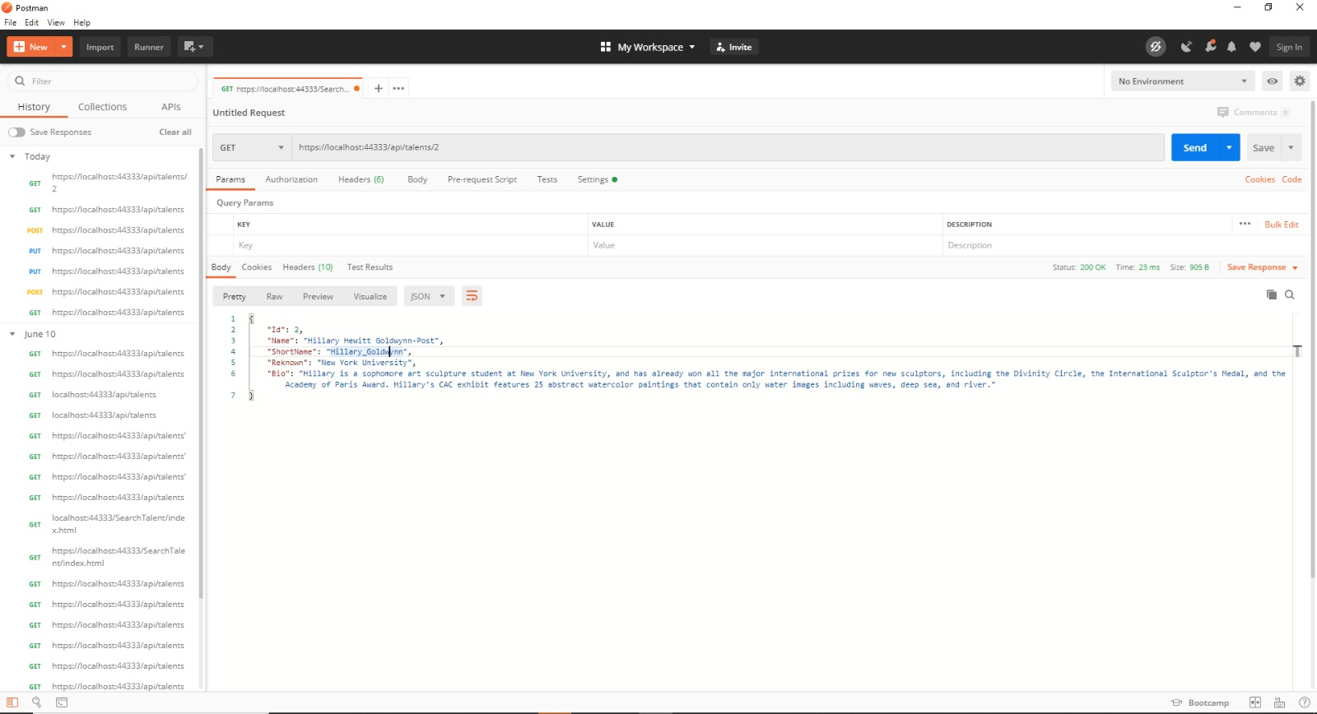

**Demo Talent Search Function**

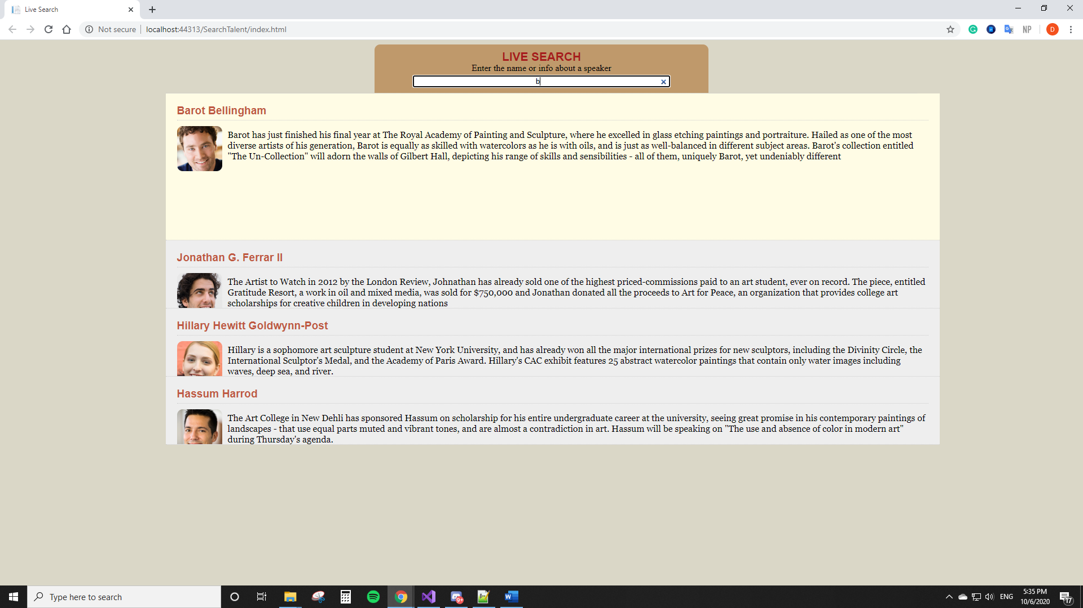

**Demo Access to HTTPS Secured Talent Search**

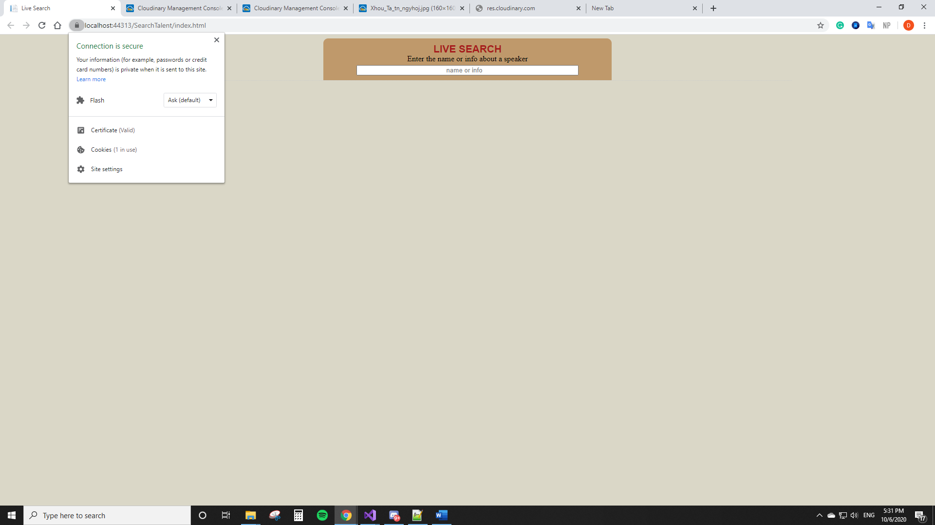

**Demo From Unsecured Talents Search Will Be Redirected To Secured Talent Search**

