Jongjin Kim

December 13, 2021

IT FDN 110 A

Assignment 09 – Modules

<https://github.com/jjkim97/IntroToProg-Python-Mod09.git>

INTRO TO PROGRAMMING (PYTHON)

# Intro

In this 9th week, I learned modules. Modules organize classes and functions and make code simple.

I modified given scripts as Mod09Listings.zip.

* Modified **DataClasses.py** file by adding two classes
  + **Person class** (Listing 6) and **Employee class** (Listing 9)
* Modified **TestHarness**.py file by adding code to test
  + **Person class** (Listing 8) and **Employee class** (Listing 10)
* Modified **ProcessingClasses.py** file by adding a class
  + **FileProcessor** class (Listing 7)
* Modified **IOClasses.py** file by adding a class
  + **EmployeeIO** class (Listing 11)
* Modified **TestHarness**.py file by adding code to test
  + **FileProcessor class** (Listing 10) and **EmployeeIO class** (Listing 12)
* Create the main module using the code in **Listing 13 into Main.py**.
  + Import the above 3 classes **DataClasses.py, ProcessingClasses.py**, and **IOClasses.py**
  + Add codes to make the application work. (similar with assignment 08)

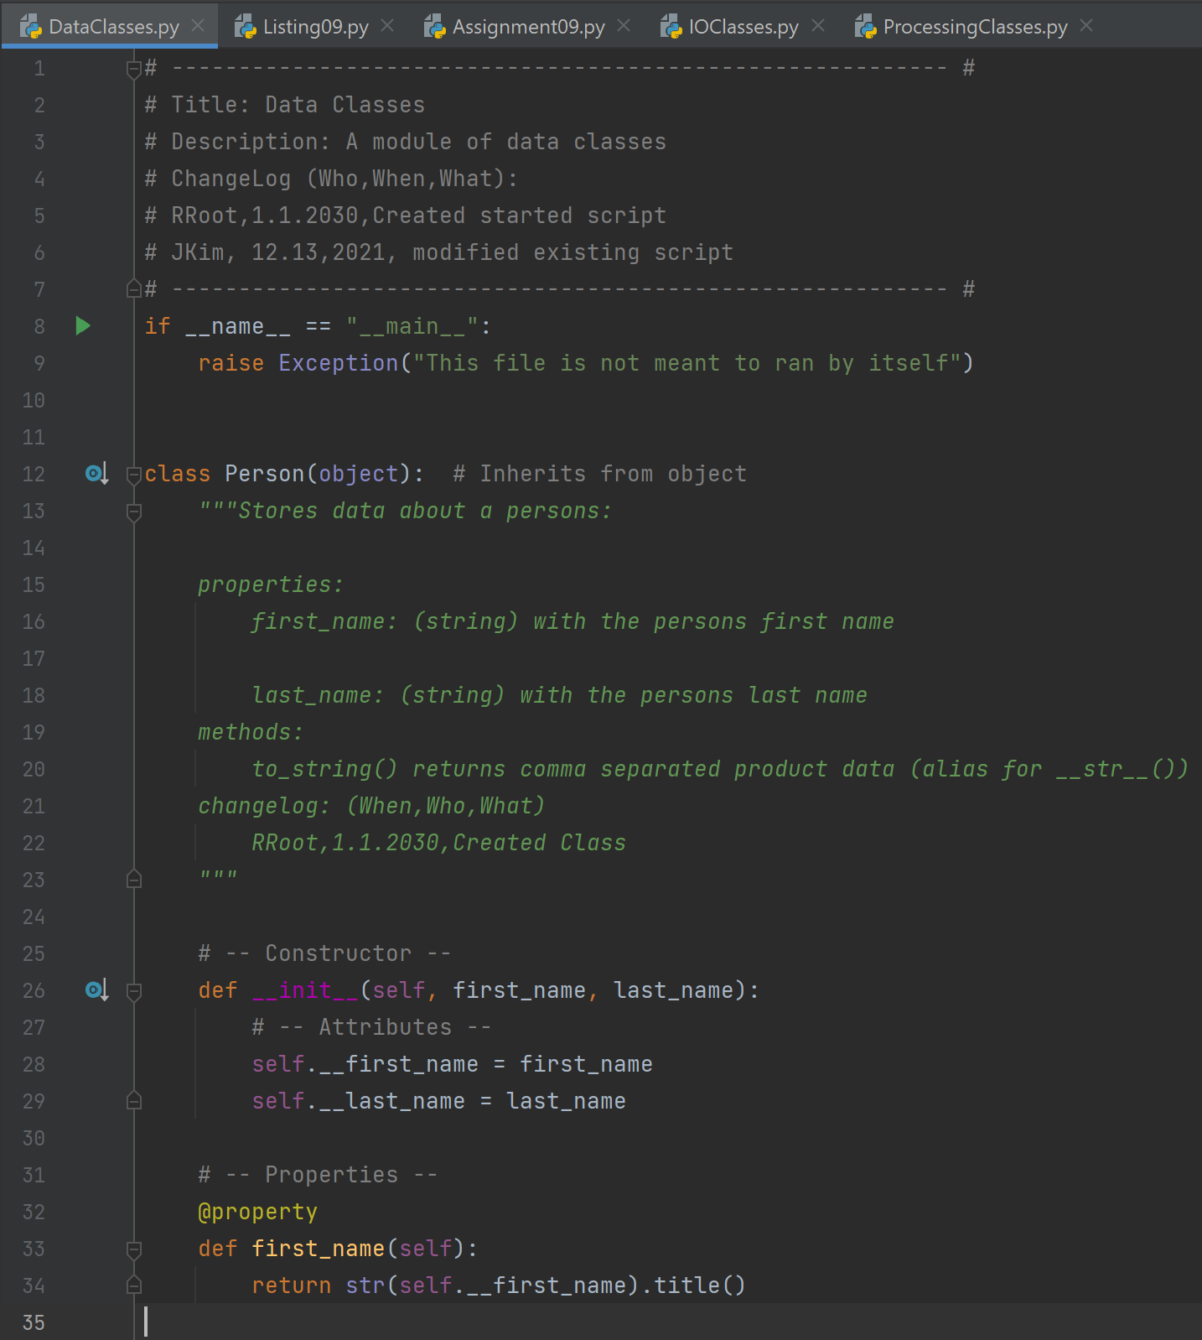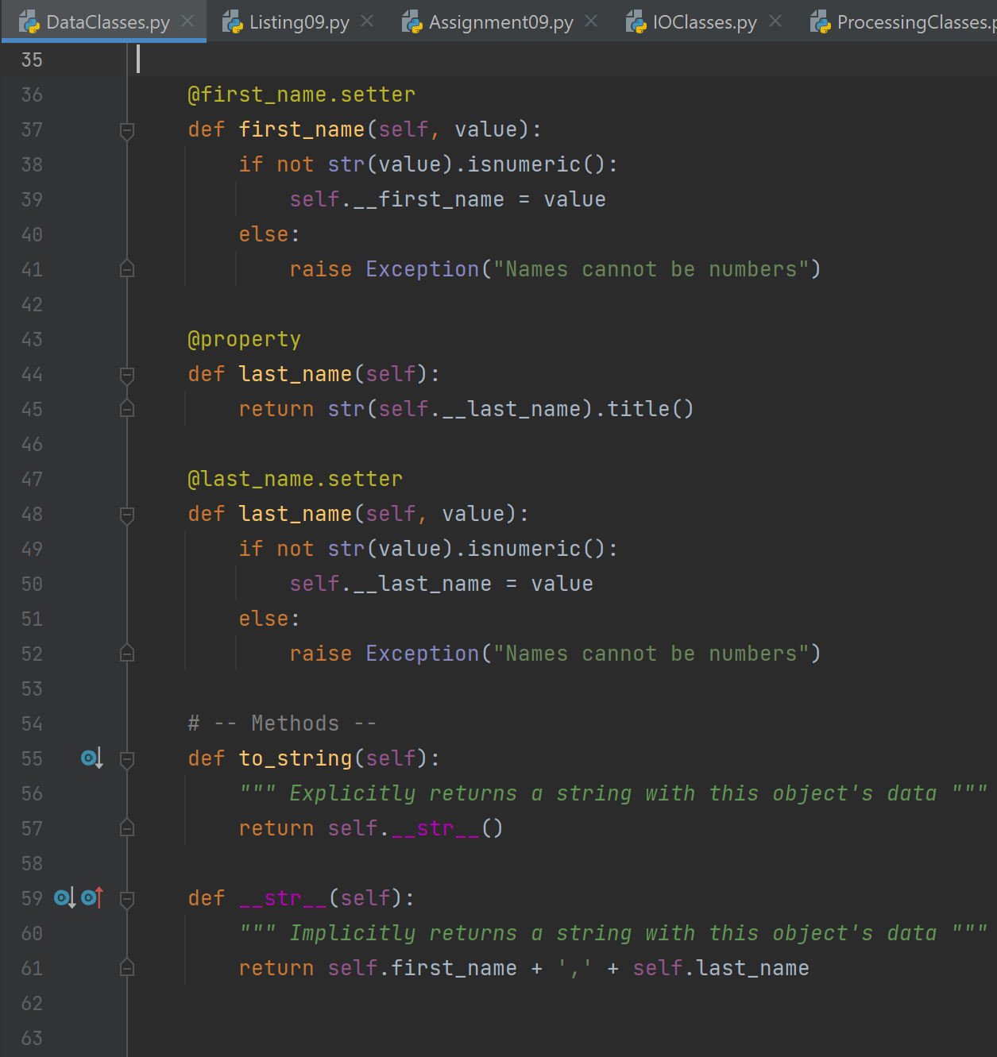

Figure 1 Person class in **DataClasses.py**

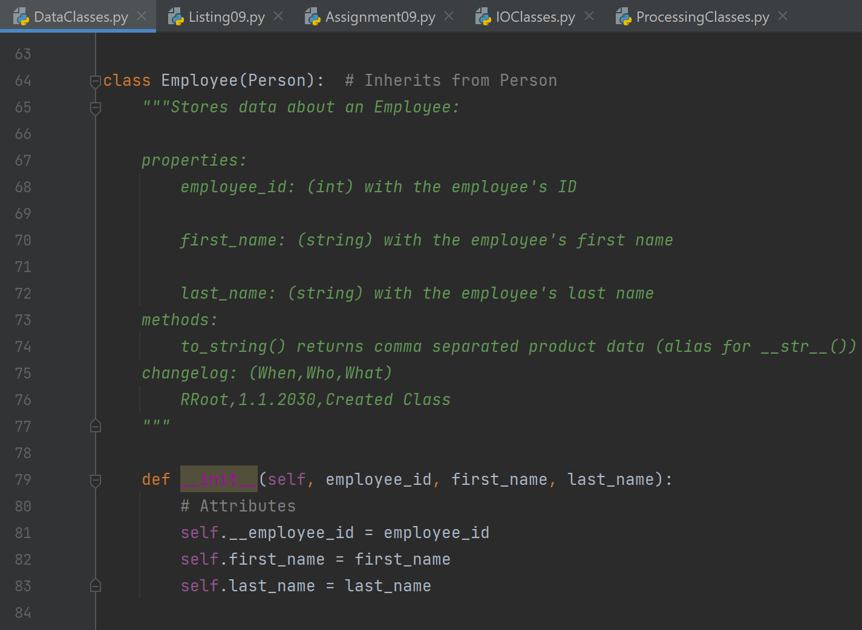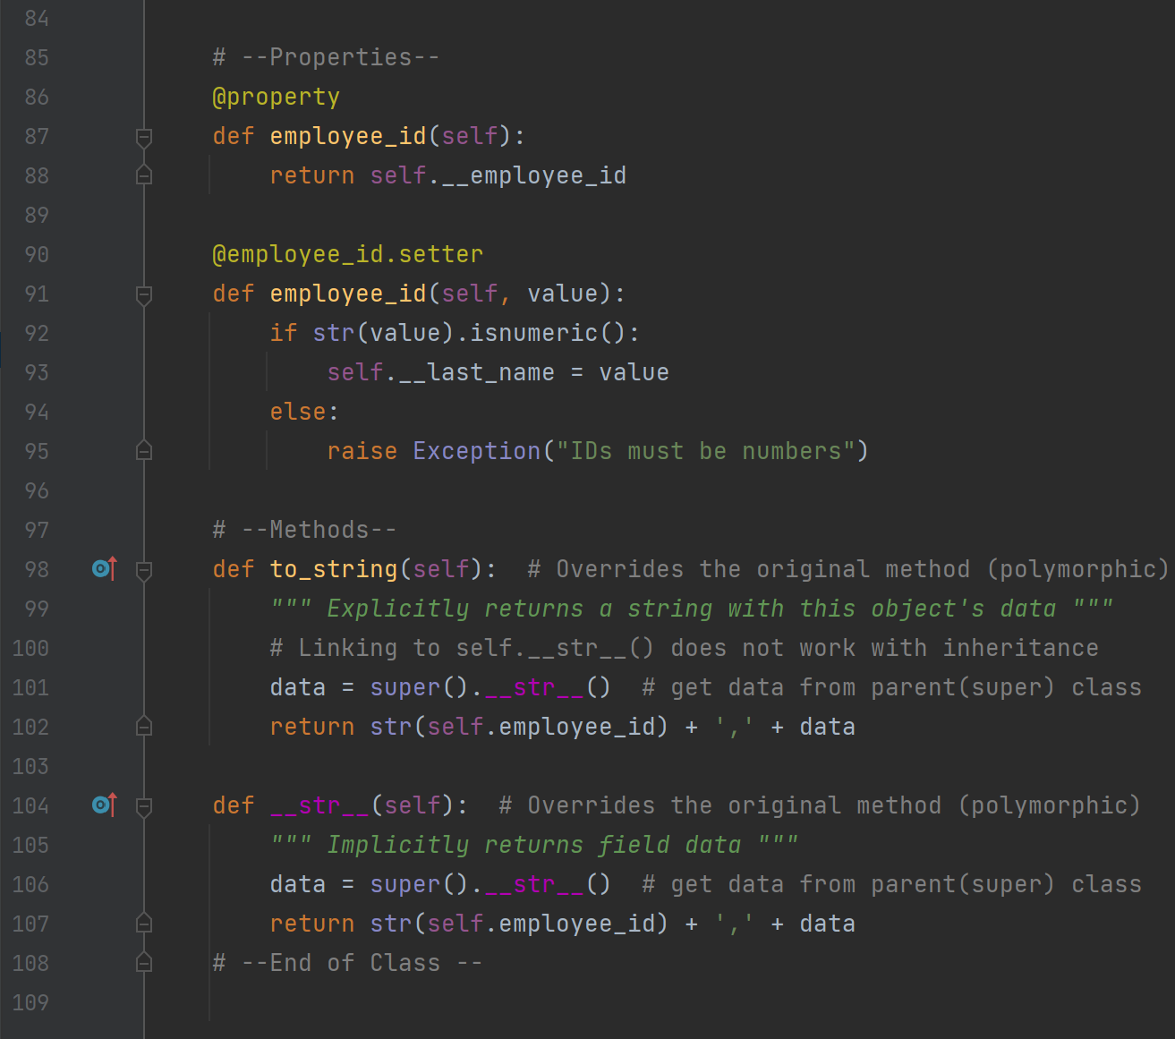

Figure 2 Employee class in **DataClasses.py**

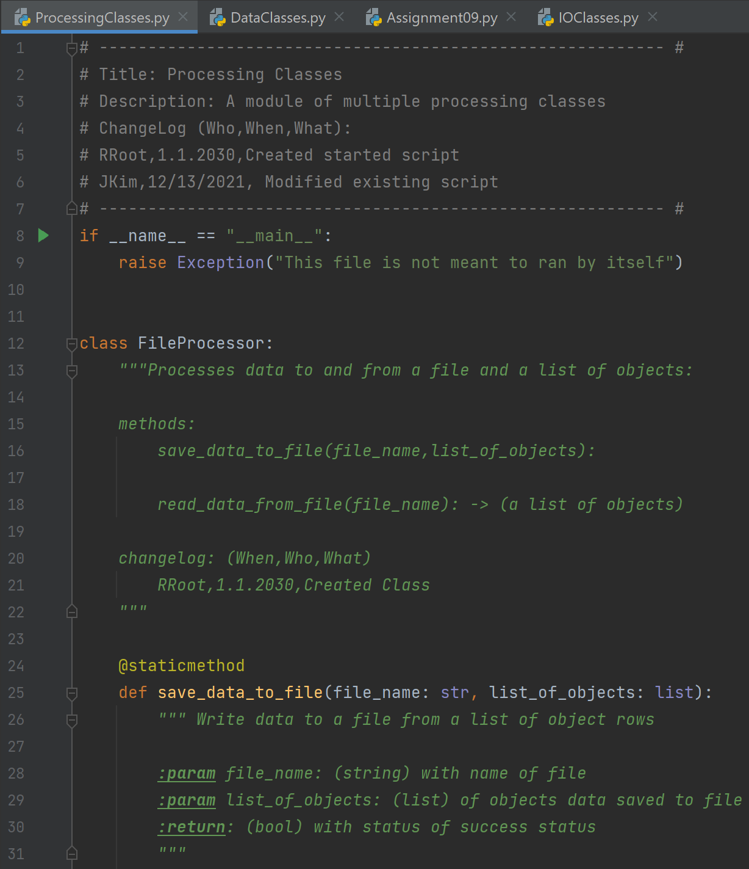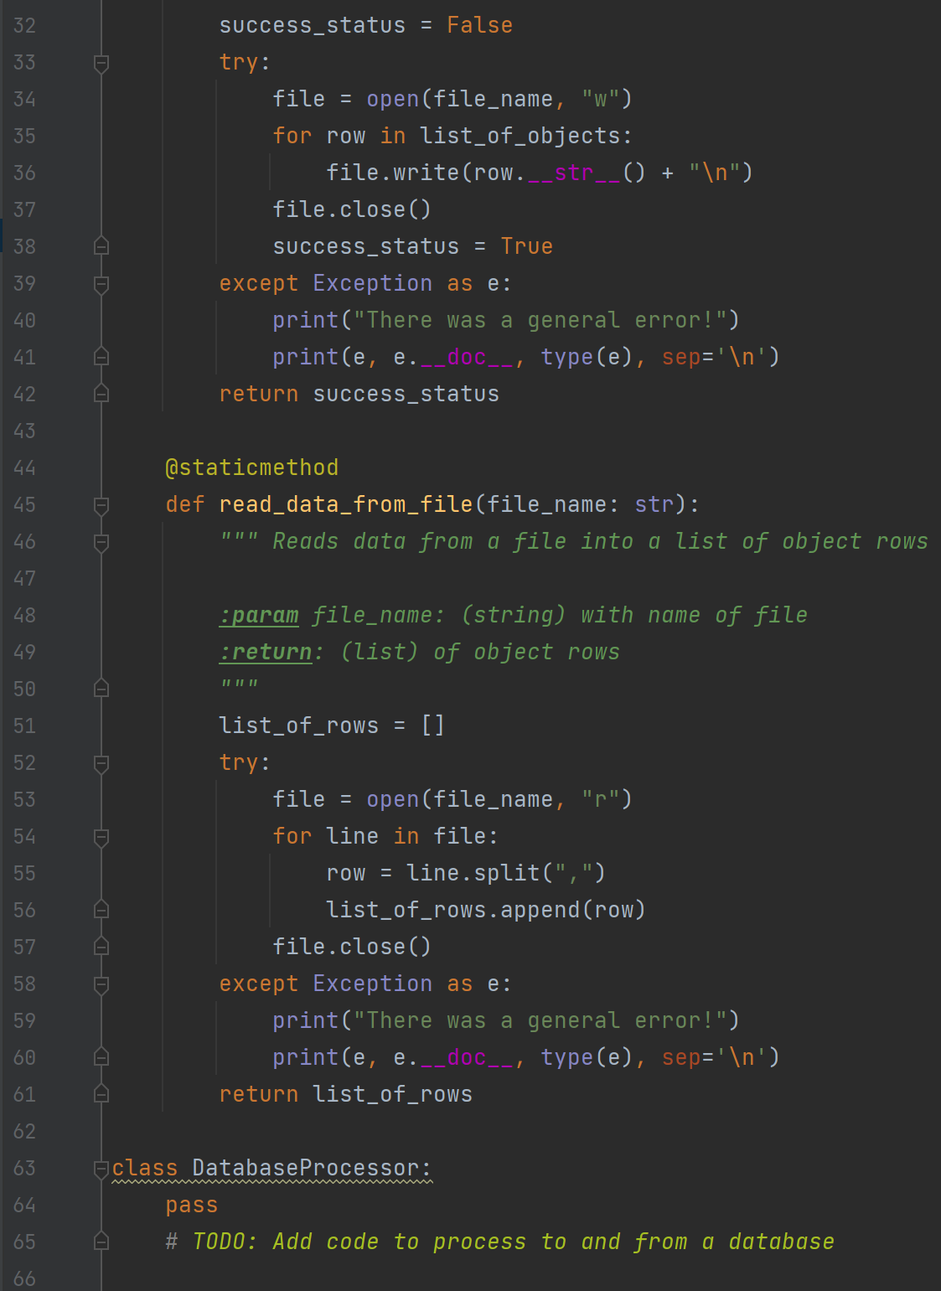

Figure 3 FileProcessor class in **ProcessingClasses.py**

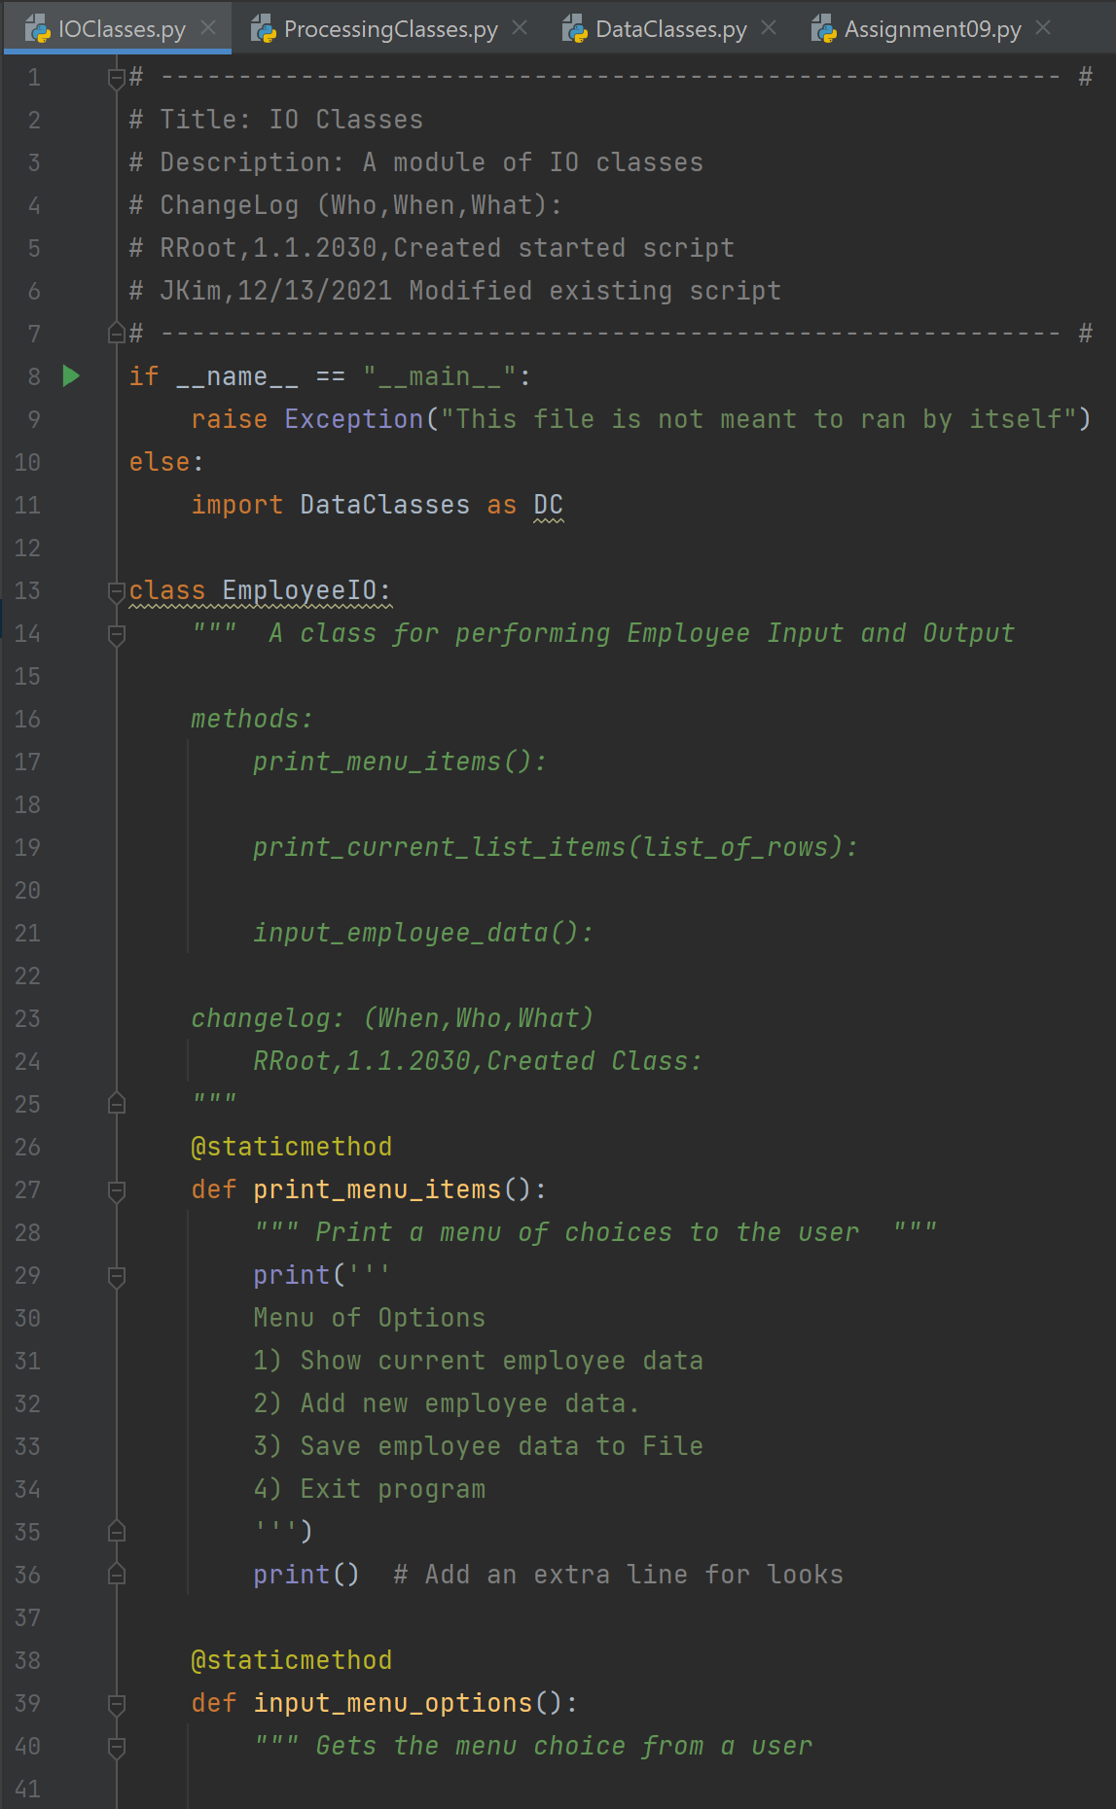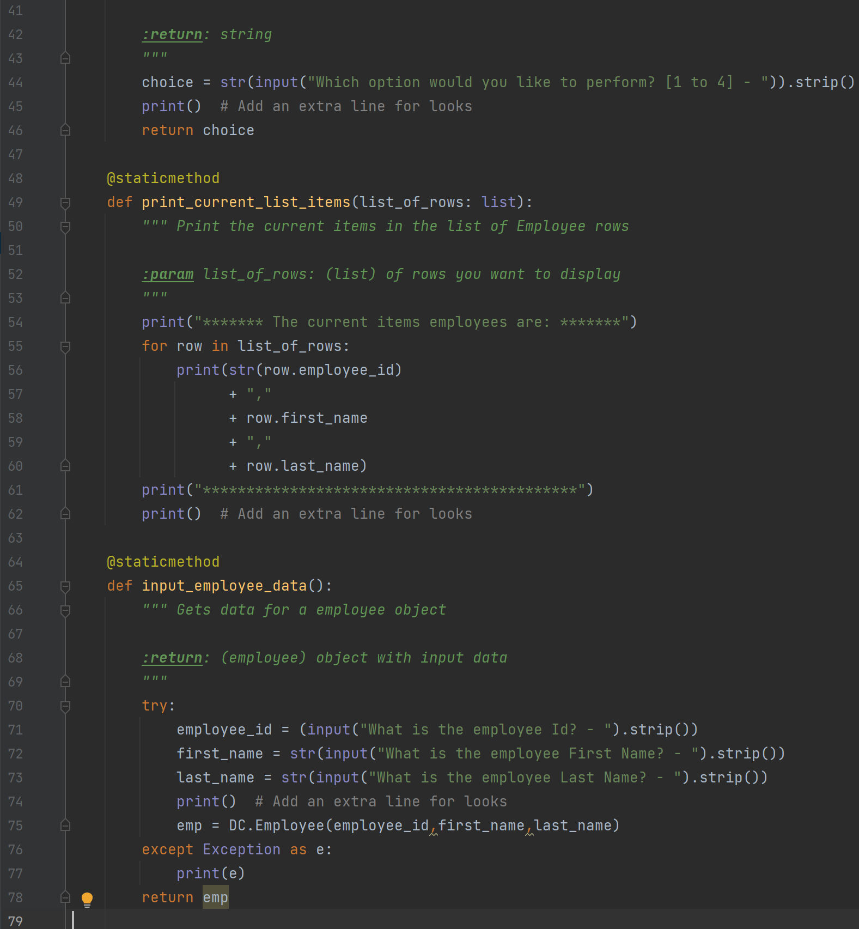

Figure 4 EmployeeIO class in **IOClasses.py**

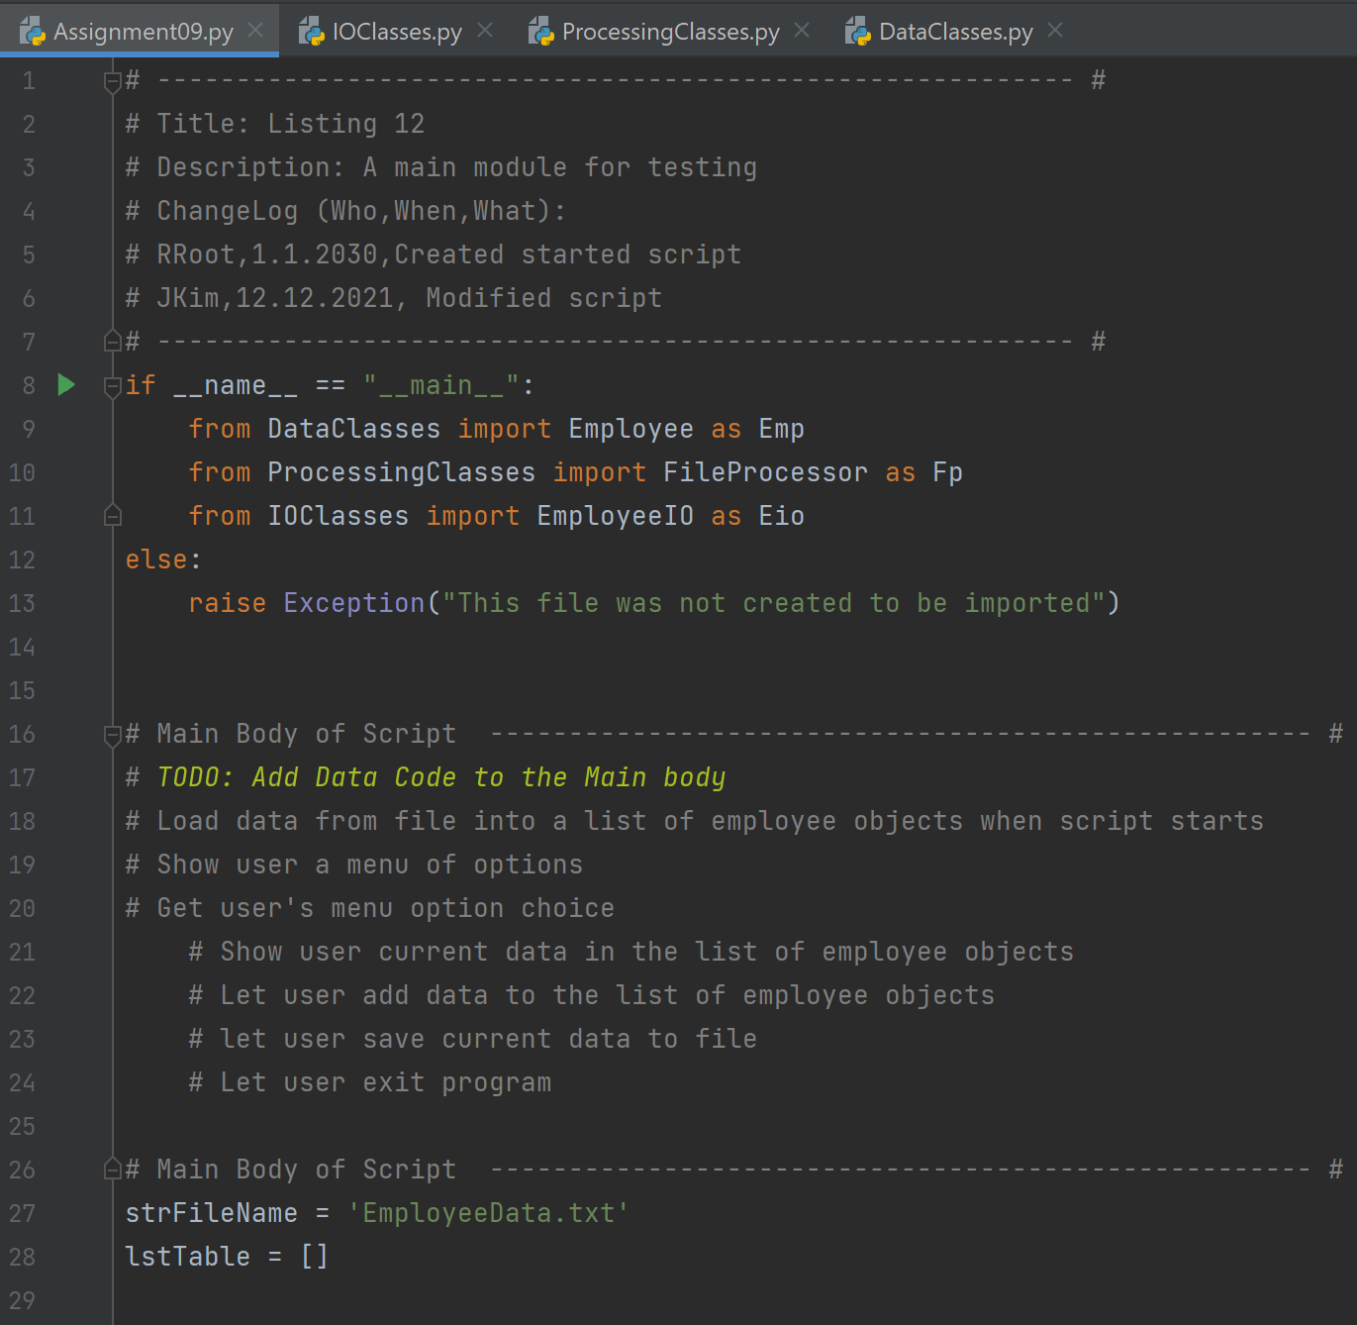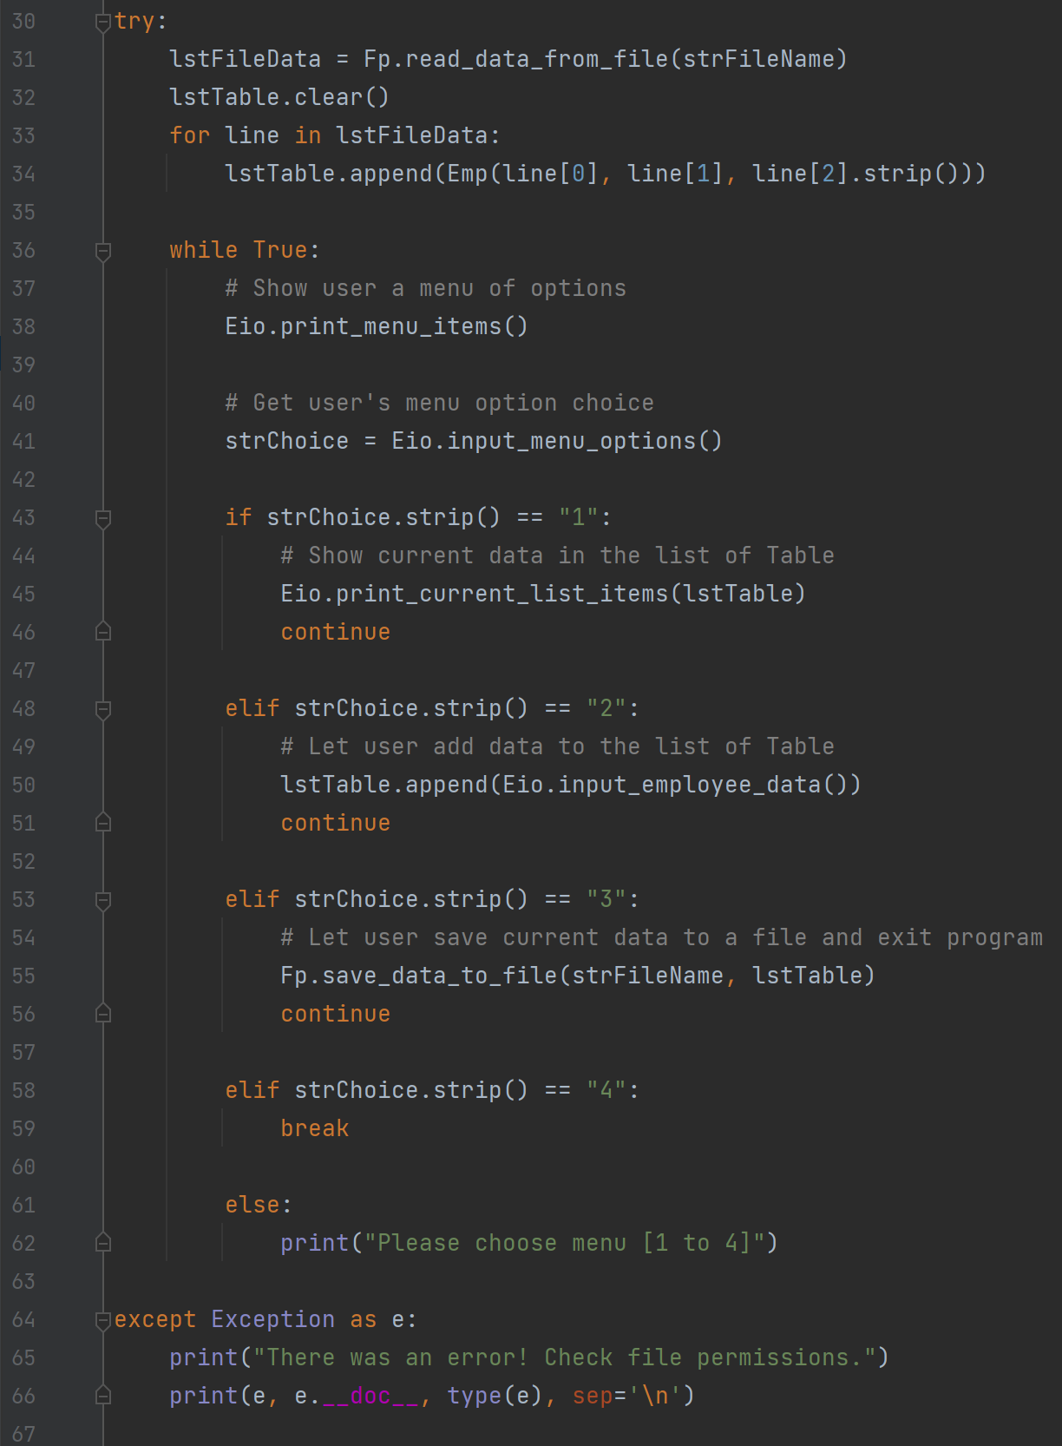

Figure 5 Create main body of program in **Assignment09.py**

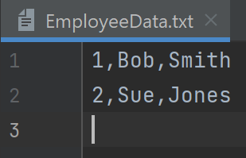

Figure 6 EmployeeData.txt (before run the Assignment09.py

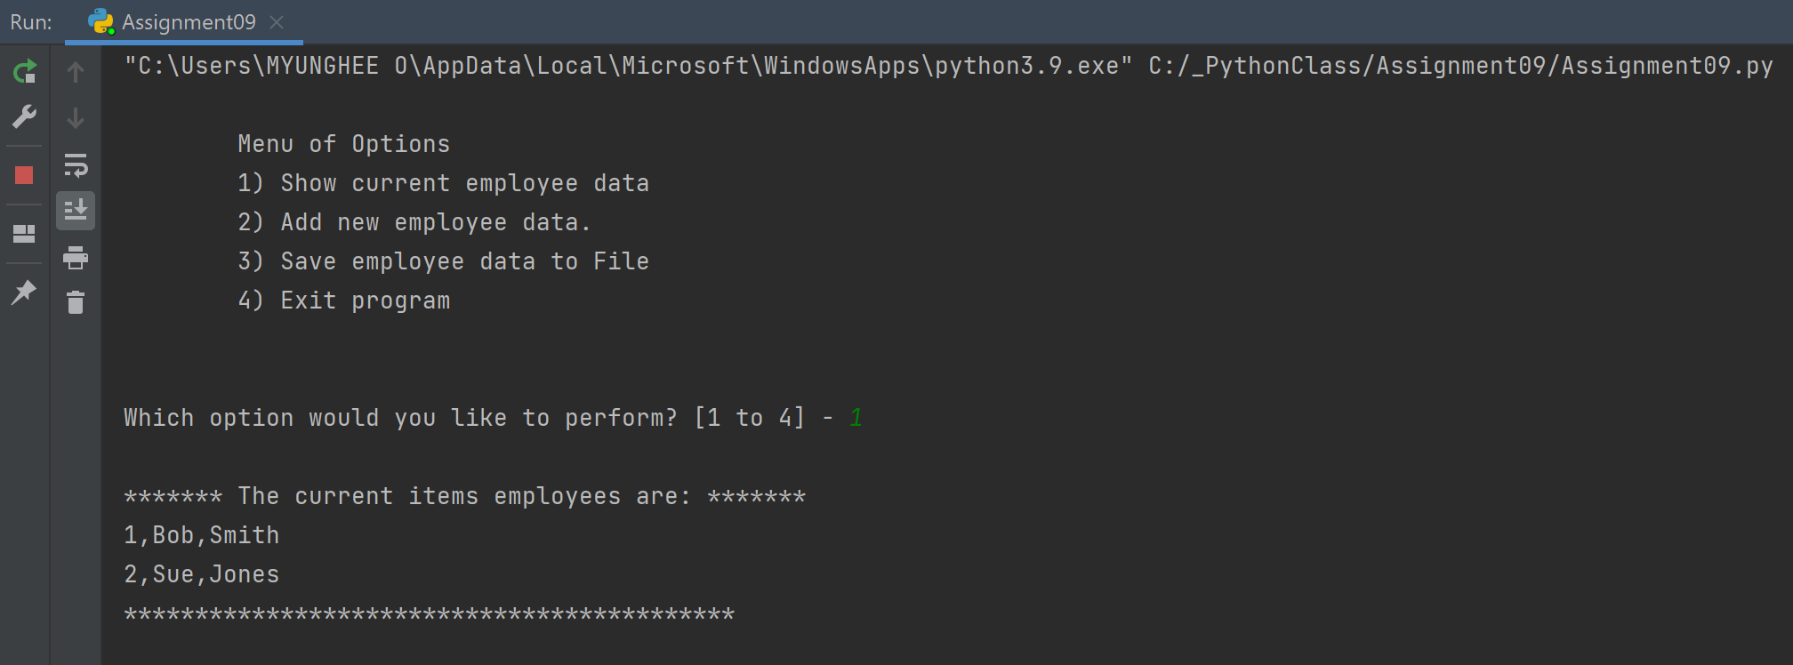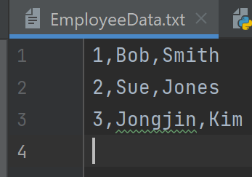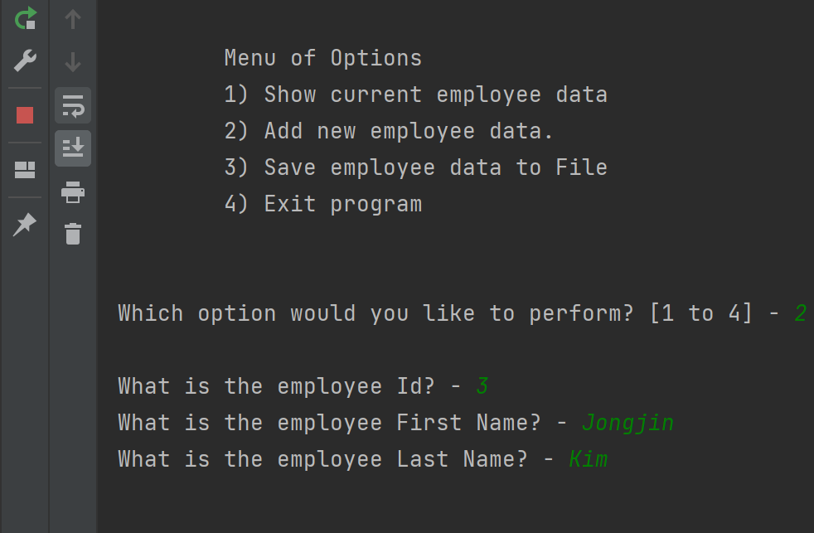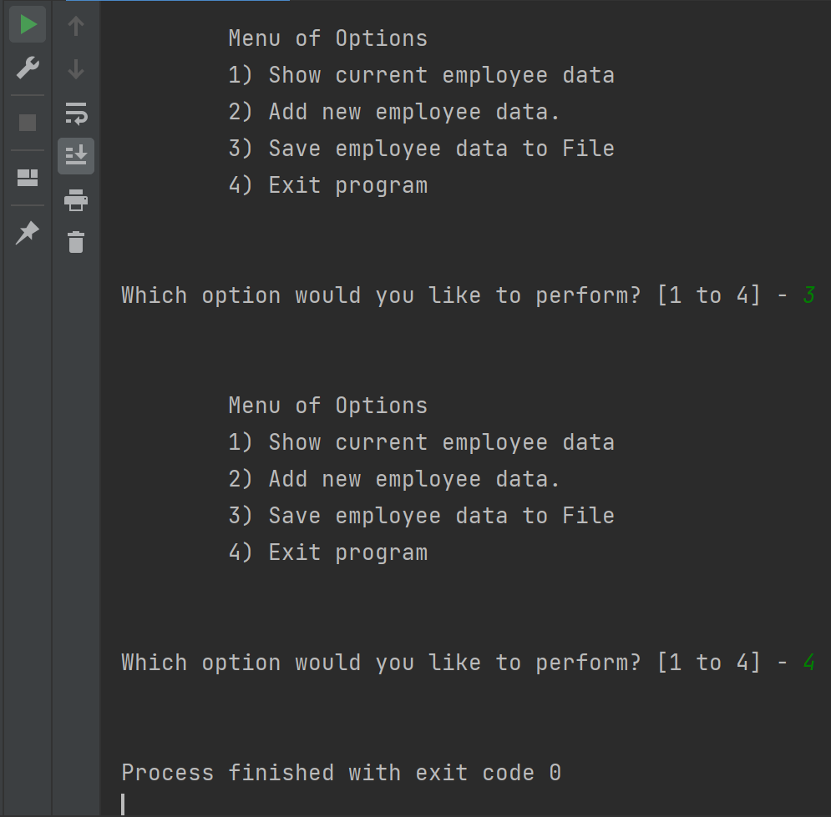

Figure 6 Output using **PyCharm**

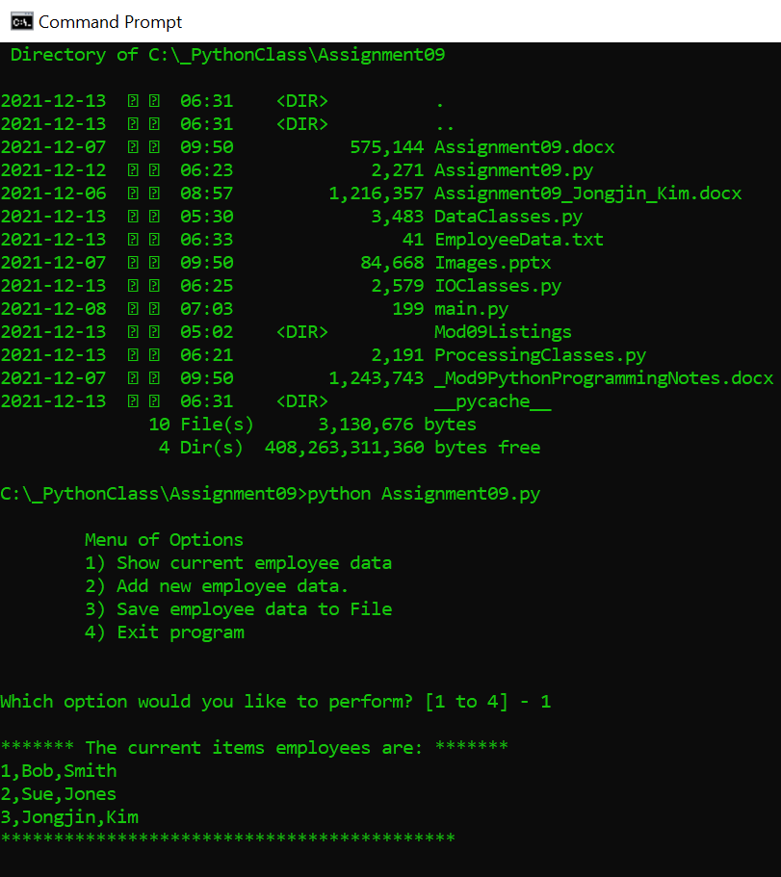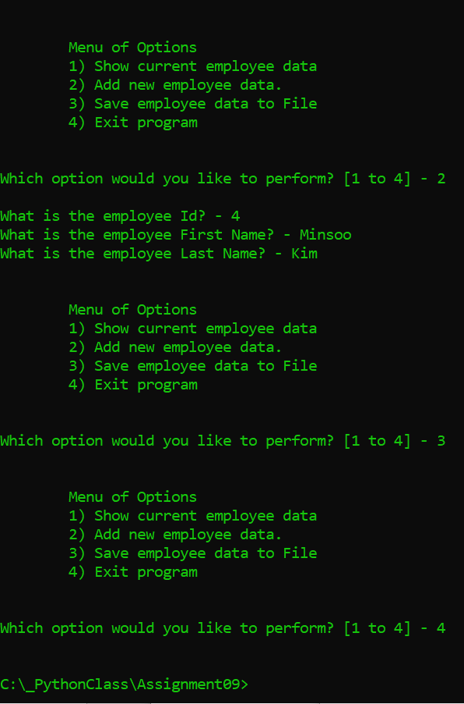

Figure 7 Output using **Command Prompt**

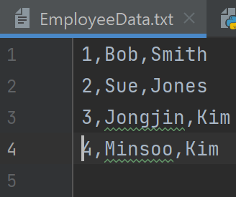

Summary

In Module 9 I learned how to connect one module to another, main module and class inheritance.