Using Autoruns, Powershell and MySQL
To Identify Malware

By Jim Kirn
Jim.Kirn@computer.org
6/17//2018

Version 2

Abstract
This paper discusses how to monitor multiple Windows 7 hosts for areas that are used to start processes at boot up. These areas are where malware often modifies to achieve persistence. The paper describes how use scripts (using PowerShell), Microsoft Sysinternals “autoruns” application, and a MySQL database to perform daily checks on these locations to identify changes. Baselines of each host are stored in a Linux MySQL database. The scripts are used each day to compare the daily run to the baseline for purposes of identifying changes.

Description
First some background.

In the SANS Institute InfoSec Reading Room there is a paper - Utilizing “AutoRuns” To Catch Malware, by Jim McMillan. The paper is dated 2010. The paper explains the usefulness of running the Sysinternals “autoruns” application written by Mark Russinovich. The paper goes on to explain how to automate the command line version of “autoruns” application (autorunsc) to be run remotely from a central computer to get “snapshots” of any changes to these computers from a specific “baseline” using a command diff.exe. The paper describes a VBScript to perform some of the automation. The paper is a good reference for a method to catch malware that imbeds itself into the autoruns area for persistence.

Josh Brower created Perintax in Sept. 2016 (https://groups.google.com/forum/#!topic/security-onion/agrweZfrhGA) which was a similar approach that was later integrated into Security Onion (https://securityonion.net/ ). As best I can find, Josh never wrote any paper on his approach but there is some documentation on his github site (https://github.com/defensivedepth/Pertinax ). Josh did present the approach at a SOC Augusta in 2016 titled “Uncovering Persistence with Autoruns & Security Onion”. Josh’s approach utilized a “Collector” computer that summarized the Autoruns data from all the client hosts. The Collector then used an OSSEC Client to send this summary of a daily delta to an OSSEC parser which was part of a Security Onion install (https://github.com/Security-Onion-Solutions/security-onion/wiki/QuickISOImage ).
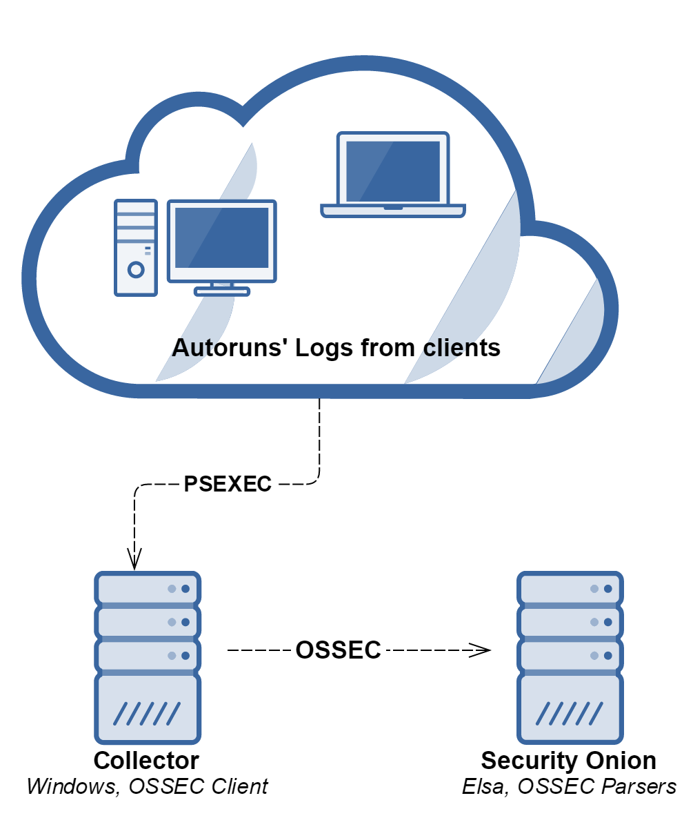
Pertinax
Josh’s approach was to use PowerShell scripts (ar-diff.ps1 and ar-normalize.ps1) to perform the comparisons for the daily deltas. Setting all this up was in my opinion not as clear as I would hope, so I decided to modify his approach.

This document describes a variation to the Perintax approach that uses both Windows PowerShell based scripts and a Linux based MySQL database to store the baselines. Using the MySQL database makes checking the difference from the baseline less of a text comparison operation. In this system all machines are running either Windows 7 Pro or Windows 2012. The system does not use an Active Directory server – every machine has local administration. This is a configuration that many small offices may be using. As of this writing, I have not completed the integration of this approach with Security Onion.

..Put my diagram here….

Contents:
- Preparing the Windows 7 hosts
  - Create Directory Folders
  - Set “path” Variable
  - Installing “AutoRuns”
  - Verify Hosts are Running PowerShell v5.1
  - Enable PowerShell Remoting
- Select a Windows 7 Host to be the Collector
  - Install PowerShell Scripts
  - Create a List of Computers to Include
  - Install the MySQL ODBC Connector
  - Configure the MySQL ODBC Connector
- Create an Ubuntu 16.04 LTS hosts that runs a MySQL server
- Configuring the MySQL server
- References

1. Preparing the Windows 7 hosts
There are several steps necessary on all the hosts and the Collector host where the PowerShell scripts are installed.

Create Directory Folders
Create the following folders at C:\
- ar_archive
- ar_baselies
- ar_latest
- ar_scripts
- sysinternals\autoruns
- sysinternal\pstools

Set “path” Variable
Select Control Panel -> All Control Panel Items -> System

Then select Advanced system settings. A System Properties popup should be displayed. Click on the Environment Variable… button. In the bottom area labeled System variables highlight the Variable Path and click the Edit... button. An Edit System Variables popup should be displayed. In the Variable value: area add the following (make sure you have the leading ; )

;C:\sysinternals\autoruns\;C:\sysinternals\pstools\

Click OK to update the variable.

Installing “AutoRuns”
Download the latest version of “autoruns” from https://docs.microsoft.com/en-us/sysinternals/downloads/autoruns .

Unzip the files and copy them to C:\sysinternals\autoruns. The following is a list of files:
- autoruns.chm
- Autoruns.exe
- Autoruns64.exe
- autorunsc.exe
- autorunssc64.exe
- Eula.txt

Installing “PsTools”
Download the latest version of “pstools” from https://docs.microsoft.com/en-us/sysinternals/downloads/pstools

Unzip the files and copy them to C:\sysinternals\pstools. The following is a list of files:
- Eula.txt
- PsExec.exe
- PsExec64.exe
- psfile.exe
- psfile64.exe
- PsGetsid.exe
- PsGetsid64.exe
- PsInfo.exe
- PsInfo64.exe
- pskill.exe
- pskill64.exe
- pslist.exe
- pslist64.exe
- PsLoggedon.exe
- PsLoggedon64.exe
- psloglist.exe
- pspasswd.exe
- pspasswd64.exe
- psping.exe
- psping64.exe
- PsService.exe
- PsService64.exe
- pshutdown.exe
- pssupend.exe
- pssupend64.exe
- Pstools.chm
- Psversion.txt

Verify hosts are Running PowerShell v5.1

PS C:\> $PSVersionTable.PSVersion

Major Minor Build Revision
----- ----- ----- --------
5 1 14409 1012

If the hosts are not running v5.1, update them to at least this version. Microsoft refers to this as Windows Management Framework 5.1. You can directly download it from https://www.microsoft.com/en-us/download/details.aspx?id=54616

Enable PowerShell Remoting
PS C:\> Enable-PSRemoting –Force

See Appendix A if you have problems setting up remoting.

Select a Windows 7 Host to be the Collector
This host is where all the PowerShell scripts are installed and executed. It is also the host that interacts with the MySQL database.

Install PowerShell Scripts
Download all the PowerShell scripts from https://github.com/jjkirn/Autoruns-Powershell and place them at C:\ar_scripts\

Create List of Computers to Include
Create a file host-list.txt that contains a list of the Windows 7 client computers you want to run the scripts against and place them at C:\ar_scripts\. Below is an example of my file contents:

hp-envy
hp-win2012
lulu777

Install MySQL ODBC Connector
Download mysql-connector-odbc-5.3.10 from https://dev.mysql.com/downloads/connector/odbc/5.3.html

Install it.

Configure the MySQL ODBC Connector
From the Start menu >Administrative Tools>Data Sources (ODBC) launch the ODBC Data Source Administrator Tool:
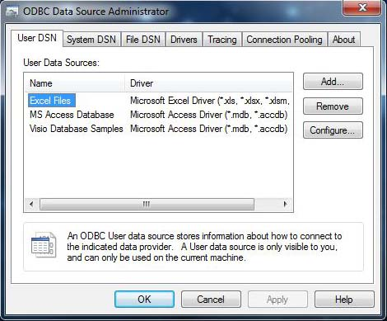

Select “System DSN” and then “Add” to add your MySQL DSN. When you are done it should look like the figures below. You can test the connection as well from this page.
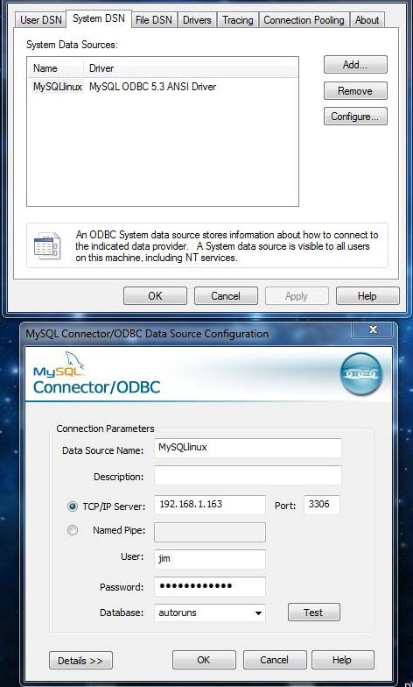

You can click on the Test button to verify that the connection to the Linux MySQL DB is working. This assumes that you already went through the Linux install and configure of the MySQL DB.

Create an Ubuntu 16.04 LTS Host that Runs a MySQL server
You can download the ISO at http://releases.ubuntu.com/16.04/ubuntu-16.04.4-desktop-amd64.iso

Configure a Static IP
Stuff goes here…

Install MySQL DB
$ sudo apt-get update
$ sudo apt-get install mysql-server

Create a MySQL DB User (jim) and Allow Remote Access
Find the following in the Mysql config file (/etc/mysql/my.cnf) and change it your Ubuntu static IP:

Was:
bind-address = 127.0.0.1

In my case I changed it to:
bind-address = 192.168.1.163

Then create a user (my case I used jim and password secure123):
#> mysql –p

mysql> CREATE USER 'jim'@'localhost' IDENTIFIED BY 'secure123';
mysql> CREATE USER 'jim'@'%' IDENTIFIED BY 'secure123';

Then grant user remote access:

GRANT ALL ON *.* TO 'jim'@'localhost';
GRANT ALL ON *.* TO 'jim'@'%';
Once you have finalized the permissions that you want to set up for your new users, always be sure to reload all the privileges.
mysql> FLUSH PRIVILEGES;

Create a MySQL DB (as root)
#> mysql –p
mysql> create database autoruns;
mysql> quit

Create DB Table (ar_data)
Download the file create2.sql from https://github.com/jjkirn/Autoruns-Powershell
Use the following MySQL command line:
mysql> use autoruns;
mysql> source create2.sql;

Refer to Appendix B for contents of create2.sql

MySQL Notes
In your testing you will need to clear out the table from time to time. There are two ways to delete all the data in a MySQL database table.
mysql> TRUNCATE TABLE tablename; This will delete all data in the table very quickly. In MySQL the table is actually dropped and recreated, hence the speed of the query. The number of deleted rows for MyISAM tables returned is zero; for INNODB it returns the actual number deleted.
mysql> DELETE FROM tablename; This also deletes all the data in the table, but is not as quick as using the "TRUNCATE TABLE" method. In MySQL >= 4.0 the number of rows deleted is returned; in MySQL 3.23 the number returned is always zero.
You can use the following to list all the contents of the table ar_data:
mysql> select * from ar_data;

Space for more

5. References:
1. “Uncovering Persistence with Autoruns & Security Onion”, Josh Brower, SOC 2016 presentation, https://defensivedepth.com/2016/09/10/integrating-autoruns-with-security-onion/
2. “Utilizing ‘autoruns’ To Catch Malware, Jim McMillan, SANS Institute 2010, https://www.sans.org/reading-room/whitepapers/malicious/utilizing-autoruns-catch-malware-33383
3. “Autoruns for Windows”, Mark Russinovich, v13.82 at time of this paper, 5/16/17, https://docs.microsoft.com/en-us/sysinternals/downloads/autoruns

4. “PowerShell”, v5.1, Microsoft, https://docs.microsoft.com/en-us/powershell/scripting/powershell-scripting?view=powershell-5.1
APPENDIX A
https://stackoverflow.com/questions/40248408/powershell-remoting-to-a-workgroup-computer

- Run Enable-PSRemoting on the server machine
  - This will start the WinRM service and set its startup to automatic
  - It will create an HTTP listener
    - You can verify this by running winrm enumerate winrm/config/listener
  - It will enable the Windows Remote Management firewall rules
  - It will create and configure the LocalAccountTokenFilterPolicy registry key
  - It will reset the permissions on the four sessions hosts
    - You can verify this by running Get-PSSessionConfiguration
- Start the WinRM service on the client machine via PoweShell:
Enable-PsRemoting -Force
- Using PowerShell – Run:
Set-Item WSMan:\localhost\Client\TrustedHosts -Value <hostname or FQDN or server>
Example: For my system the server name is win7prolab
Set-Item WSMan:\localhost\Client\TrustedHosts -value win7prolab
- You can add –Concatenate to the end of Set-Item if you're trying to add a server to the list
- Run $Cred = Get-Credential I just entered a username and password (not servername\username)
- Run a command such as $S = New-PSSession -ComputerName <same name exactly that you put in the TrustedHosts> -Credential $Cred
For my system:
$S = New-PSSession -ComputerName win7prolab -Credential $Cred
- If everything is working properly the command should just return
- If you get an error that mentions Kerberos check that you're using the same name in your ComputerName parameter and the TrustedHosts
- If you get an access denied error check that the LocalAccountTokenFilterPolicy is configured on the server
Alternate directions are available at:
https://howtogeek.com/117192/how-to-run-powershell-commands-on-remote-computers

APPENDIX B

Contents of create2.sql
autoruns DB table: ar_data

CREATE TABLE ar_data (
fname VARCHAR(64) NULL,
mydate DATE,
mytime TIME,
id_hash VARCHAR(64),
ar_entryloc VARCHAR(256),
ar_entry VARCHAR(128),
ar_enabled VARCHAR(32),
ar_category VARCHAR(64),
ar_profile VARCHAR(32),
ar_desc VARCHAR(512),
ar_signer VARCHAR(256),
ar_company VARCHAR(64),
ar_ipath VARCHAR(256),
ar_ver VARCHAR(32),
ar_lstr VARCHAR(256),
ar_hash VARCHAR(256),
PRIMARY KEY (id_hash)
);

