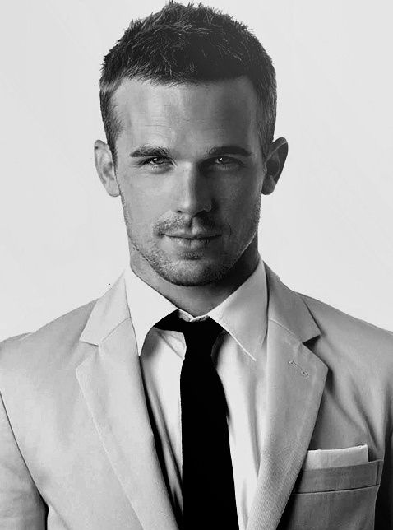

Education

ABOUT ME

Professional

08 Jan 1996

Changsha Hun an

135-0000-0000

22324242@qq.com

Creativity

Teamwork

Hard work

Communication

2017.12 Certified Fitness instructor

2016.11 Certified Body of Lesmiles'News

2016.09 Rehabilitation

SKILLS

**2014.09–2018.07 Hunan Normal University**

* Candidate for Bachelor degree in Education , Majored in Sports
* Language：Native Mandarin , Excellent English (CET-6)
* Computer：Skilled user of Microsoft & Office.

**2017.07-2018.03 Nobel fitness**

* fitness instructor manager,help the company to promote the market,help the team to make more money.
* Worked as a waitress in a western restaurant.
* Get familiar with the working condition of this restaurant,prepare for the table,check spare tableware,eat stage vessels and so on.
* initiative patience,enthusiasm,improve the service work.

**2016.07-2016.08 PHYSICAL CLUB In Changsha**

* A fitness instructor for body building,give private session to the guest.
* help them with body building and weight losing,dance,yoga.
* Designed look and feel for German Ariel Actilift product website.
* Provided design support for PGA European Tour pitch work.
* Developed mock site for usability testing for Shell dotcom.

**2015.06-2015.12 PHYSICAL CLUB In Changsha**

* Worked as a receptionist,perform a variety of registration,record,seriously people account formalities and consulting work,and accurately answer the guest about the related problems of service project.
* Easy-going and congenial, with a strong sense of responsibility and good team-spirit.
* Having a wide range of hobbies, including oral English,music,dance,workout ,yoga and literature .Very adaptable and Good at leaning.
* Having a wide range of hobbies, including oral English,music,dance,workout ,yoga and literature .

interests

YOUMI

Objective : Fitness Trainer

personal