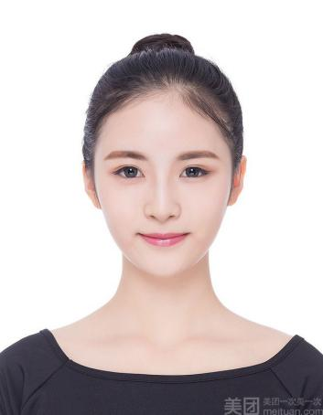

ABOUT ME

AWARDS

EXPERIENCE

**Bachelor of Art Design** (2014.09-2018.06)

**Jinan University**

GPA 3.9/4.0, Jinan University Scholarship(top 20% students of Art Institute in 2013, 2014and 2015)

Majors: Introduction to Art Design, Graphic Composition and Design, Color Composition and Design

**Graphic design intern** (2018.03 - 2018.06)

**Beijing Zhishang Media Co., Ltd.**

Designed look and feel for German Ariel Actilift product website.

Provided design support for PGA European Tour pitch work.

Developed mock site for usability testing for Shell dotcom.

**Art designer** (2017.06-2017.08)

**XX Taobao Shop**

Responsibleforcreating media assets forthedepartment.

Assisting inthe general operations of theopenstudios.

**Vice president** (2016.07-2016.10)

**Seven Leaves Anime Club**

Responsibleforcreating media assets forthedepartment.

Assisting inthe general operations of theopenstudios.

Poster Design: Zhongcui 25th Anniversary poster (2017.02)

Logo Design: Jingyuan Hall Jinling Restaurant Logo (2016.10)

Logo Design: Happy Drink Tea Shop Logo (2015.05)

Lorem ipsum dolor sit amet, adipingelit,sed do eiusmod tempor incididunt ut labore et dolore magnas aliqua. Ut enim ad minim veniam,quis nostrud exercitation ul laboris nisi ut aliquip. Ut enim ad minim veniam,quis nostrud exercitation ul laboris nisi ut aliquip.

EDUCATION

SKILLS LEVELS

YOUXIAOMI

Graphic Designer

CONTACT

**Name**

Anna Willians

**Address**

No. 113 Renaissance Road, Haidian District, Beijing

**Phone**

+86 135-0000-0000

**Email**

anna1982@gmail.com

Photoshop

Illustrator

Office

Dreamweaver