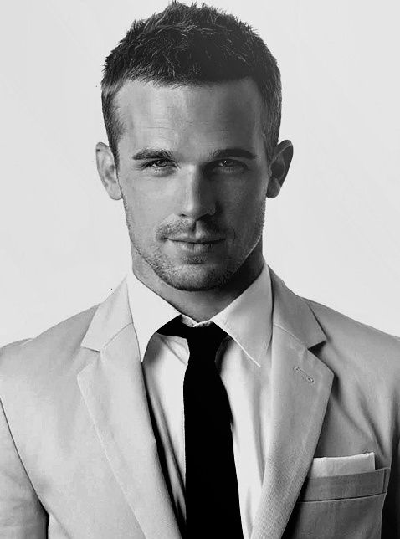

**Birthday:** August 10, 1989

**Mobile:** 13500135000

**E-mail:** service@163.me

**Living place:** Guangzhou, Guangdong

GET INTOUCH

**YOUXIAOMI**

TARGET: SENIOR IT LEADER

Being familiar with accounting theory

Mastering share option,futures and foreign currency hedge.

Mastering risk management.

SPECIAL SKILLS

**Sun Yat-sen University/2012.09-2016.06**

Accounting

Western economics, accounting computerization, marketing, international finance.

**Sun Yat-sen University/2012.09-2016.06**

Accounting

Western economics, accounting computerization, marketing, international finance.

EDUCATION

WeChat

Movies table tennis music

HOBBIES

Travel photography reading

CREARIVE

LEADERSHIP

TEAMWORK

CONFIDENT

PROFESSIONAL SKILLS

PHOTOSHOP

ILLUSTRATOR

HTML & CSS

JAVA SCRIPT

JOOMLA

MS SQL

Microsoft LINQ

SKILLS

**Bank of China/2015.07-2015.09**

Customer service

In the cases of which clients’ problems could not be solved online, transfer the information to the back staff to settle, and track the settlements before communicating with the clients.

**Bank of China/2015.07-2015.09**

Customer service

In the cases of which clients’ problems could not be solved online, transfer the information to the back staff to settle, and track the settlements before communicating with the clients.

**Bank of China/2015.07-2015.09**

Customer service

In the cases of which clients’ problems could not be solved online, transfer the information to the back staff to settle, and track the settlements before communicating with the clients.

EXPERIENCE

Qualification Certificate of Junior Accountant

Qualification Certificate of Accounting Profession

Having passed the English test of Certified Management Accountant (CMA)P1

Certificate of Level 2 in National Computer Rank Examination

CERTIFICATE

Talks I've done on various

Computer engineering topics.

SELECTED TALKS