Soil texture class transforms

### This R notebook provides the code used to transform the soil textural class data presented in the following two studies from their national textural class systems (ASNIE and AU) to the USDA system.

Richer-de-Forges, A. C., Arrouays, D., Chen, S., Dobarco, M. R., Libohova, Z., Roudier, P., … & Bourennane, H. (2022). Hand-feel soil texture and particle-size distribution in central France. Relationships and implications. Catena, 213, 106155.

Minasny, B., McBratney, A. B., Field, D. J., Tranter, G., McKenzie, N. J., & Brough, D. M. (2007). Relationships between field texture and particle-size distribution in Australia and their implications. Soil Research, 45(6), 428-437.

Load packages

library(dplyr)

##   
## Attaching package: 'dplyr'

## The following objects are masked from 'package:stats':  
##   
## filter, lag

## The following objects are masked from 'package:base':  
##   
## intersect, setdiff, setequal, union

library(soiltexture)

Create point grid within soil textural triangle. This creates a point for every possible particle size class combination (e.g., [sand=22,silt=10,clay=68])

sand <- seq(0, 100, 1)  
clay <- seq(0, 100, 1)  
txt <- expand.grid(x = sand, y = clay)  
txt <- txt %>% rowwise() %>% mutate(silt = (100 - (x + y))) %>% ungroup() %>% purrr::set_names("SAND", "CLAY", "SILT") %>% filter(SILT >= 0)

### Transform AISNE textural class data to USDA textural class data

Plot Aisne and USDA texture triangles

old.par <- par(no.readonly=T)  
par("mfcol" = c(1,2),"mfrow"=c(1,2))  
TT.plot(class.sys = "USDA-NCSS.TT",main = "Texture triangle: USDA", cex=0.5,cex.axis = 0.7, cex.lab = 0.7, cex.main = 0.7, grid.show=F)  
TT.plot(class.sys = "FR.AISNE.TT",main = "Texture triangle: Aisne (FR)", cex=0.5,cex.axis = 0.7, cex.lab = 0.7, cex.main = 0.7, grid.show=F, class.line.col = "red", class.lab.col = "red")

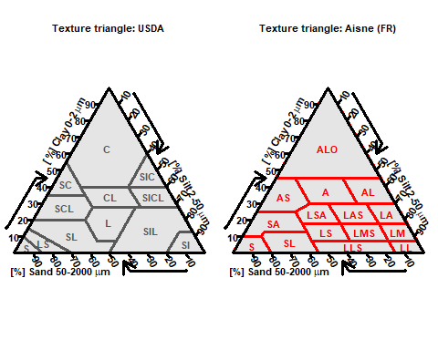

Overlay AISNE and USDA

geo <- TT.plot(class.sys = "USDA-NCSS.TT",main = "FR-USDA Texture Class Overaly", cex=0.5,cex.axis = 0.7, cex.lab = 0.7, cex.main = 0.7, grid.show=F)  
TT.classes(  
geo = geo,  
class.sys = "FR.AISNE.TT",  
# Additional "graphical" options  
class.line.col = "red",  
class.lab.col = "red",  
lwd.axis = 2, cex.lab = 0.7  
)

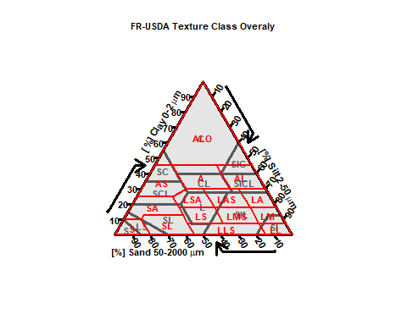

Assign each point to its corresponding AISNE class and USDA class

AISNE <- txt %>% rowwise() %>% mutate(txt = TT.points.in.classes(  
tri.data = data.frame(SAND, CLAY, SILT),  
class.sys = "FR.AISNE.TT", PiC.type = "t", collapse=",")) %>% ungroup()  
#extract only first texture label  
AISNE <- AISNE %>% rowwise() %>% mutate(AISNE = strsplit(txt, "[,]")[[1]][1]) %>% ungroup() %>% as.data.frame()  
AISNE <- AISNE %>% rowwise() %>% mutate(txt = TT.points.in.classes(  
tri.data = data.frame(SAND, CLAY, SILT),  
class.sys = "USDA-NCSS.TT", PiC.type = "t", collapse=",")) %>% ungroup()  
#extract only first texture label  
AISNE <- AISNE %>% rowwise() %>% mutate(USDA = strsplit(txt, "[,]")[[1]][1]) %>% ungroup() %>% as.data.frame()  
AISNE <- AISNE %>% dplyr::select(-c(txt))

Load in class accuracies (e.g., Producer’s accuracy [PA]) for each AISNE class from Richer-de-Forges et al. (2022), join to our texture grid, and summarize by USDA texture class

AISNE_PA <- data.frame(c("A","AL","ALO","AS","LA","LAS","LL","LLS","LM","LMS","LS","LSA","S","SA","SL"),  
c(69, 64, 83, 74, 76, 66, 100, 30, 84, 72, 54, 64, 95, 73, 70)) %>% purrr::set_names("AISNE", "PA")  
AISNE_PA_adj <- data.frame(c("A","AL","ALO","AS","LA","LAS","LL","LLS","LM","LMS","LS","LSA","S","SA","SL"),  
c(96, 97, 99, 98, 94, 94, 100, 100, 97, 95, 92, 91, 100, 98, 99)) %>% purrr::set_names("AISNE", "PA_adj")  
AISNE <- AISNE %>% left_join(AISNE_PA, by="AISNE") %>% left_join(AISNE_PA_adj, by="AISNE")  
  
# This effectively gives us an area weighed average for each USDA texture class based on the relative area of each AISNE texture class that intersects USDA texture classes  
USDA_AISNE_txt_class_PA <- AISNE %>% group_by(USDA) %>% summarise(PA = mean(PA) %>% round(digits = 0))  
USDA_AISNE_txt_class_PA_adj <- AISNE %>% group_by(USDA) %>% summarise(PA_adj = mean(PA_adj) %>% round(digits = 0))

Aproximate the number of AISNE texture class samples that would fall into USDA texture classes

# Calculates the area of each AISNE texture class that falls within a USDA texture class  
USDA_AISNE_class_count <- AISNE %>% group_by(USDA) %>% count(AISNE)  
  
# Calculate the gridded area of the textural triangle occupied by each AISNE texture class  
AISNE_class_count <- AISNE %>% group_by(AISNE) %>% count(AISNE) %>% ungroup() %>% purrr::set_names("AISNE", "txt_tri_area")  
  
# Add the number of samples analyzed for each AISNE texture class  
AISNE_class_count$txt_samples <- c(1723, 2270, 2487, 870, 1723, 1331, 3, 10, 346, 532, 815, 1315, 1210, 1561, 1192)  
  
# Join table of AISNE texture class area and corresponding sample numbers per class  
USDA_AISNE_class_count <- USDA_AISNE_class_count %>% left_join(AISNE_class_count, by="AISNE")  
  
# For each intersection area of an AISNE class that falls within a USDA texture class, calculate the relative proportion of samples from that AISNE class based on its relative area.   
  
#For example, the USDA CL-Clay Loam texture class intersects three AISNE textural classes (A-clay, AL-silty clay, and ALO-heavy clay). ~32% of the AISNE clay class falls within the USDA clay loam class and there were 1723 clay samples in the Richer-de-Forges et al. 2022 study. Thus we attribute 556 of these samples (32%) to the USDA clay loam class. This procedure is applied to each intersecting AISNE class within each USDA texture class.   
  
USDA_AISNE_class_count <- USDA_AISNE_class_count %>% rowwise() %>% mutate(prop_samp = (n/txt_tri_area)*txt_samples) %>% ungroup()  
  
USDA_AISNE_samp_count <- USDA_AISNE_class_count %>% group_by(USDA) %>% summarise(USDA_samp = sum(prop_samp) %>% round(digits = 0)) %>% ungroup()  
  
#combine PA, PAadj, and USDA_samp  
  
USDA_AISNE_summary <- USDA_AISNE_samp_count %>% left_join(USDA_AISNE_txt_class_PA, by="USDA") %>% left_join(USDA_AISNE_txt_class_PA_adj, by="USDA") %>% purrr::set_names("USDA", 'n', "PA (%)", "PA-adj (%)")

knitr::kable(USDA_AISNE_summary, align = "lccrr")

| USDA | n | PA (%) | PA-adj (%) |
| --- | --- | --- | --- |
| C | 2829 | 82 | 99 |
| CL | 1387 | 68 | 95 |
| L | 1985 | 61 | 92 |
| LS | 876 | 82 | 99 |
| S | 664 | 95 | 100 |
| SC | 493 | 76 | 98 |
| SCL | 1336 | 73 | 97 |
| SI | 111 | 92 | 99 |
| SIC | 868 | 75 | 98 |
| SICL | 1853 | 66 | 96 |
| SIL | 2946 | 61 | 96 |
| SL | 2039 | 66 | 98 |

### Transform Australian (AU) textural class data to USDA textural class data

Plot Australian and USDA texture triangles

old.par <- par(no.readonly=T)  
par("mfcol" = c(1,2),"mfrow"=c(1,2))  
TT.plot(class.sys = "USDA-NCSS.TT",main = "Texture triangle: USDA", cex=0.5,cex.axis = 0.7, cex.lab = 0.7, cex.main = 0.7, grid.show=F)  
TT.plot(class.sys = "AU2.TT",main = "Texture triangle: Autralia (AU2)", cex=0.5,cex.axis = 0.7, cex.lab = 0.7, cex.main = 0.7, grid.show=F, class.line.col = "red", class.lab.col = "red")

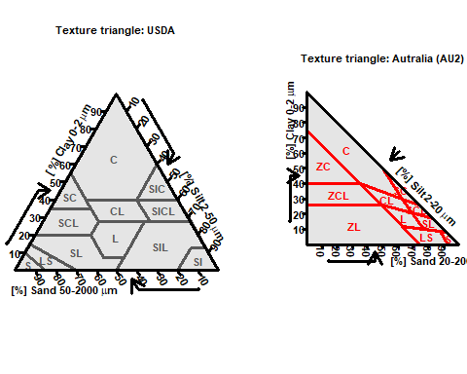

Overlay AU and USDA

geo <- TT.plot(class.sys = "USDA-NCSS.TT",main = "AU2-USDA Texture Class Overaly", cex=0.5,cex.axis = 0.7, cex.lab = 0.7, cex.main = 0.7,grid.show=F)  
TT.classes(  
geo = geo,  
class.sys = "AU2.TT",  
# Additional "graphical" options  
class.line.col = "red",  
class.lab.col = "red",  
lwd.axis = 2, cex.lab = 0.7  
)

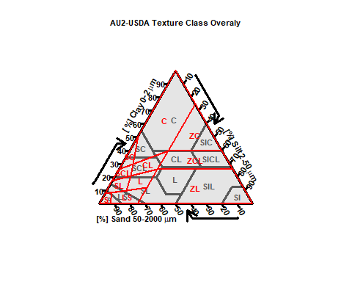

Assign each point to its corresponding Australian class and USDA class

AU <- txt %>% rowwise() %>% mutate(txt = TT.points.in.classes(  
tri.data = data.frame(SAND, CLAY, SILT),  
class.sys = "AU2.TT", PiC.type = "t", collapse=",")) %>% ungroup()  
#extract only first texture label  
AU <- AU %>% rowwise() %>% mutate(AU = strsplit(txt, "[,]")[[1]][1]) %>% ungroup() %>% as.data.frame()  
AU <- AU %>% rowwise() %>% mutate(txt = TT.points.in.classes(  
tri.data = data.frame(SAND, CLAY, SILT),  
class.sys = "USDA-NCSS.TT", PiC.type = "t", collapse=",")) %>% ungroup()  
#extract only first texture label  
AU <- AU %>% rowwise() %>% mutate(USDA = strsplit(txt, "[,]")[[1]][1]) %>% ungroup() %>% as.data.frame()  
AU <- AU %>% dplyr::select(-c(txt))

Load in Producer accuracies for each Australian class from Minasny et al., 2007, join to our texture grid, and summarize by USDA texture class

AU_PA <- data.frame(c('S', 'LS', 'SL', 'L', 'ZL', 'SCL', 'CL', 'ZCL', 'SC', 'ZC', 'C'),  
c(78, 32, 40, 35, 14, 37, 15, 6, 40, 6, 86)) %>% purrr::set_names("AU", "PA")  
AU_PA_adj <- data.frame(c('S', 'LS', 'SL', 'L', 'ZL', 'SCL', 'CL', 'ZCL', 'SC', 'ZC', 'C'),  
c(94, 94, 92, 63, 55, 77, 66, 24, 86, 84, 96)) %>% purrr::set_names("AU", "PA_adj")  
AU <- AU %>% left_join(AU_PA, by="AU") %>% left_join(AU_PA_adj, by="AU")  
  
# This effectively gives us an area weighed average for each USDA texture class based on the relative area of each Australian texture class that intersects USDA texture classes  
USDA_AU_txt_class_PA <- AU %>% group_by(USDA) %>% summarise(PA = mean(PA) %>% round(digits = 0))  
USDA_AU_txt_class_PA_adj <- AU %>% group_by(USDA) %>% summarise(PA = mean(PA_adj) %>% round(digits = 0))

Aproximate the number of Australian texture class samples that would fall into USDA texture classes

# Calculates the area of each AU texture class that falls within a USDA texture class  
USDA_AU_class_count <- AU %>% group_by(USDA) %>% count(AU)  
  
# Calculate the gridded area of the textural triangle occupied by each AU texture class  
AU_class_count <- AU %>% group_by(AU) %>% count(AU) %>% ungroup() %>% purrr::set_names("AU", "txt_tri_area")  
  
# Add the number of samples analyzed for each AU texture class  
AU_class_count$txt_samples <- c(1278, 1060, 1748, 1339, 557, 858, 1745, 635, 456, 704, 7599)  
  
  
# Join table of AU texture class area and corresponding sample numbers per class  
USDA_AU_class_count <- USDA_AU_class_count %>% left_join(AU_class_count, by="AU")  
  
# For each intersection area of an AU class that falls within a USDA texture class, calculate the relative proportion of samples from that AU class based on its relative area.   
  
#For example, the USDA C-Clay Loam texture class intersects two AU textural classes (C-clay and ZC-silty clay). ~66% of the AU silty clay class falls within the USDA clay class and there were 456 silty clay samples in the Minasney et al. 2007 study. Thus we attribute 304 of these samples (66%) to the USDA clay class. This procedure is applied to each intersecting AU class within each USDA texture class.   
  
USDA_AU_class_count <- USDA_AU_class_count %>% rowwise() %>% mutate(prop_samp = (n/txt_tri_area)*txt_samples) %>% ungroup()  
  
USDA_AU_samp_count <- USDA_AU_class_count %>% group_by(USDA) %>% summarise(USDA_samp = sum(prop_samp) %>% round(digits = 0)) %>% ungroup()  
  
USDA_AU_summary <- USDA_AU_samp_count %>% left_join(USDA_AU_txt_class_PA, by="USDA") %>% left_join(USDA_AU_txt_class_PA_adj, by="USDA") %>% purrr::set_names("USDA", 'n', "PA (%)", "PA-adj (%)")

knitr::kable(USDA_AU_summary, align = "lccrr")

| USDA | n | PA (%) | PA-adj (%) |
| --- | --- | --- | --- |
| C | 1388 | 64 | 93 |
| CL | 451 | 10 | 30 |
| L | 1600 | 13 | 51 |
| LS | 957 | 33 | 91 |
| S | 726 | 62 | 94 |
| SC | 662 | 73 | 93 |
| SCL | 3609 | 29 | 70 |
| SI | 838 | 14 | 55 |
| SIC | 152 | 6 | 84 |
| SICL | 277 | 6 | 24 |
| SIL | 3741 | 14 | 53 |
| SL | 3577 | 24 | 67 |

library(Hmisc)

## Loading required package: lattice

## Loading required package: survival

## Loading required package: Formula

## Loading required package: ggplot2

##   
## Attaching package: 'Hmisc'

## The following objects are masked from 'package:dplyr':  
##   
## src, summarize

## The following objects are masked from 'package:base':  
##   
## format.pval, units

exact_match <- read.csv('C:/R_Drive/Data_Files/LPKS_Data/Projects/Ghana/Soil Map Variability/Hand_Txt_Lit_Summary_Exact_Match.csv')  
adj_match <- read.csv('C:/R_Drive/Data_Files/LPKS_Data/Projects/Ghana/Soil Map Variability/Hand_Txt_Lit_Summary_Adj_Match.csv')  
  
txt <- c('S', 'LS', 'SL', 'SC', 'SCL', 'L', 'SiL', 'CL', 'SiCL', 'SiC', 'C', 'Si')  
txt_num <- c('S_n', 'LS_n', 'SL_n', 'SC_n', 'SCL_n', 'L_n', 'SiL_n','CL_n', 'SiCL_n', 'SiC_n', 'C_n', 'Si_n')  
  
  
mean_exact <- list()  
std_exact <- list()  
  
for(i in 1:length(txt)){  
 mean_exact[i] <- wtd.mean(exact_match[txt[i]], exact_match[txt_num[i]], na.rm=T)  
 std_exact[i] <- base::sqrt(wtd.var(exact_match[txt[i]], exact_match[txt_num[i]], na.rm=T))  
}  
  
exact_match_summary <- data.frame(txt, unlist(mean_exact) %>% round(digits=0), unlist(std_exact) %>% round(digits=0)) %>% purrr::set_names("USDA", "PA" , "std")   
  
mean_adj <- list()  
std_adj <- list()  
  
for(i in 1:length(txt)){  
 mean_adj[i] <- wtd.mean(adj_match[txt[i]], adj_match[txt_num[i]], na.rm=T)  
 std_adj[i] <- base::sqrt(wtd.var(adj_match[txt[i]], adj_match[txt_num[i]], na.rm=T))  
}  
  
adj_match_summary <- data.frame(txt, unlist(mean_adj) %>% round(digits=0), unlist(std_adj) %>% round(digits=0)) %>% purrr::set_names("USDA", "PA_adj" , "std_adj")  
  
match_summary <- exact_match_summary %>% left_join(adj_match_summary, by="USDA")

knitr::kable(match_summary, align = "lccrr")

| USDA | PA | std | PA_adj | std_adj |
| --- | --- | --- | --- | --- |
| S | 73 | 7 | 89 | 3 |
| LS | 45 | 12 | 94 | 3 |
| SL | 57 | 11 | 91 | 8 |
| SC | 28 | 22 | 71 | 21 |
| SCL | 41 | 19 | 81 | 18 |
| L | 54 | 10 | 91 | 8 |
| SiL | 79 | 8 | 98 | 6 |
| CL | 57 | 7 | 86 | 8 |
| SiCL | 69 | 4 | 95 | 3 |
| SiC | 59 | 7 | 93 | 2 |
| C | 74 | 4 | 93 | 2 |
| Si | 19 | 16 | 80 | 19 |

ghana_txt_freq <- data.frame(c("C", "CL","L","LS","S","SC","SCL","SL","SiL","SiC","SiCL"),c(107, 1283, 1274, 9213, 10605, 440, 2380, 6205, 1226, 524, 1157), c(0.003100461, 0.037176552, 0.036915766, 0.266958361, 0.307293327, 0.012749558, 0.068963519, 0.179797746, 0.035524905, 0.015183565, 0.033525543)) %>% purrr::set_names("USDA", "n", "prop")  
  
#calculate weighted mean accuracy based on sample texture distribution  
match_summary_ghana <- match_summary %>% left_join(ghana_txt_freq, by="USDA")  
match_summary_ghana <- match_summary_ghana %>% mutate(ghana_PA = PA*prop) %>% mutate(ghana_PA_adj = PA_adj*prop) %>%   
 mutate(ghana_H_PA = (PA+std)*prop) %>% mutate(ghana_H_PA_adj = (PA_adj+std_adj)*prop) %>%  
 mutate(ghana_L_PA = (PA-std)*prop) %>% mutate(ghana_L_PA_adj = (PA_adj-std_adj)*prop)  
  
sum(match_summary_ghana$ghana_PA, na.rm=T)

## [1] 58.23601

sum(match_summary_ghana$ghana_PA_adj, na.rm=T)

## [1] 90.21935

sum(match_summary_ghana$ghana_H_PA, na.rm=T)

## [1] 68.32552

sum(match_summary_ghana$ghana_H_PA_adj, na.rm=T)

## [1] 95.8326

sum(match_summary_ghana$ghana_L_PA, na.rm=T)

## [1] 48.1465

sum(match_summary_ghana$ghana_L_PA_adj, na.rm=T)

## [1] 84.6061

ghana_txt_freq_fg <- data.frame(c('C', 'CL', 'L', 'LS', 'S', 'SC', 'SCL', 'SL', 'SiL', 'SiCL'), c(1, 254, 22, 11, 35, 1, 223, 102, 1, 22), c(0.001488095, 0.377976190, 0.032738095, 0.016369048, 0.052083333, 0.001488095, 0.331845238, 0.151785714, 0.001488095, 0.032738095)) %>% purrr::set_names("USDA", "n", "prop")  
  
#calculate weighted mean accuracy based on sample texture distribution  
match_summary_ghana_fg <- match_summary %>% left_join(ghana_txt_freq_fg, by="USDA")  
match_summary_ghana_fg <- match_summary_ghana_fg %>% mutate(ghana_PA = PA*prop) %>% mutate(ghana_PA_adj = PA_adj*prop) %>%   
 mutate(ghana_H_PA = (PA+std)*prop) %>% mutate(ghana_H_PA_adj = (PA_adj+std_adj)*prop) %>%  
 mutate(ghana_L_PA = (PA-std)*prop) %>% mutate(ghana_L_PA_adj = (PA_adj-std_adj)*prop)  
  
sum(match_summary_ghana_fg$ghana_PA, na.rm=T)

## [1] 52.6369

sum(match_summary_ghana_fg$ghana_PA_adj, na.rm=T)

## [1] 85.85119

sum(match_summary_ghana_fg$ghana_H_PA, na.rm=T)

## [1] 64.32738

sum(match_summary_ghana_fg$ghana_H_PA_adj, na.rm=T)

## [1] 96.67113

sum(match_summary_ghana_fg$ghana_L_PA, na.rm=T)

## [1] 40.94643

sum(match_summary_ghana_fg$ghana_L_PA_adj, na.rm=T)

## [1] 75.03125