Lesson 21
Other PICs

Overview
Introduction |  | There are a large number of PIC16 parts, most of which are more capable than the 16F84A, and many of which are less expensive. In this lesson, we will examine the differences between the 18-pin PICs, and learn how to write library code we can use on any PIC in the family.
In this section |  | Following is a list of topics in this section:
 | Description |  | See Page
 | Overview |  | 2
 | The Timer Interrupt |  | 6
 | A Note about the Example Code |  | 9
 | Macros |  | 12
 | Data Memory Banking |  | 15
 | Saving the count to EEPROM |  | 17

Overview
Introduction | When the designer sets out to design a project, each part should be selected to best fit the project. Many hobbyists learn the PIC16F84A and never consider another part. In fact, there are a large number of PICs which might well be less expensive than the F84A in many applications. Many PICs have peripherals that are lacking on the 84A which can make the programmer’s job easier. In many cases, it is possible to have more features and more memory at a lower price.  Because of the additional peripherals and memory, there are often slight differences between the various PICs. However, it is quite possible to write code that will work on any PIC. Since we often do some of the same things from one project to the next, it would be helpful to be able to write common routines once, and use them again and again regardless of the PIC we choose for a particular project.
18 pin parts | The chart below shows the available PIC16F parts that are available in an 18 pin DIP package. Since Microchip maintains the pinout across parts in the same family, these are candidates to use in the PIC-EL:  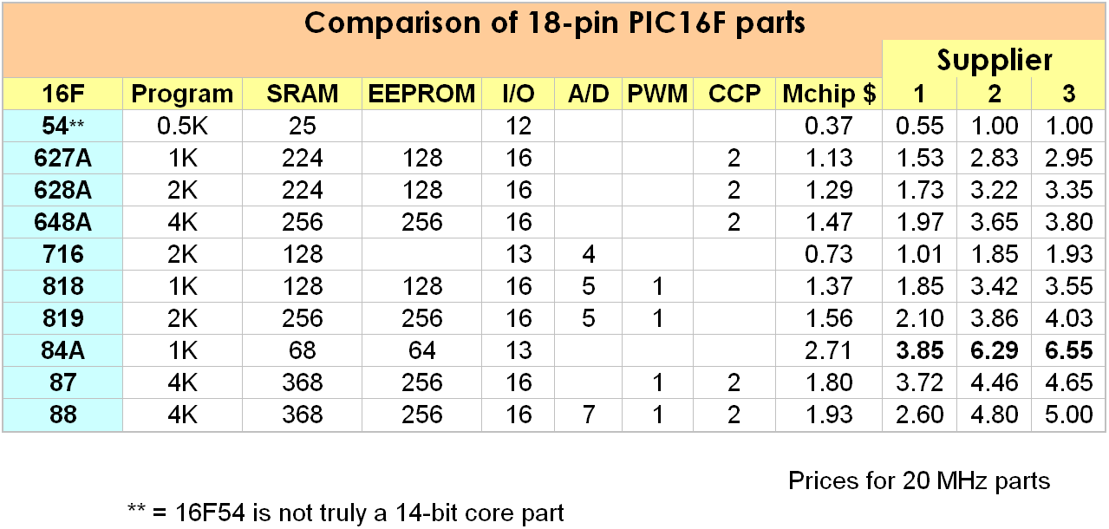  Notice that the PIC16F84A is the most expensive of the 18 pin parts. It also has less memory than any of the other parts except the PIC16F54, which is actually a different family. This is because the 84A is an older part using older technology memory, and thus more expensive to manufacture. The 16F627 and 16F628 (without the A) are no longer shown on the Microchip product selector, although still available. These parts have been replaced by the “A” versions, which are less expensive.  This chart doesn’t tell the whole story. There are other peripherals on most of the PICs that also differ between models. Most of the parts include a UART, which is lacking in the 84A. Most also have additional timers. Some are capable of SPI and/or I2C, which can be handy if the project will involve a PLL, DAC or some other kinds of peripheral chips. The Microchip product selector is the quickest way to narrow down the part selection for a project, but ultimately, one must read the datasheet to see what peripherals are available and what limitations may affect the project.
Hobbyist part selection | When a professional designer does a project, he will calculate the necessary memory, determine the needed peripherals, and select the least expensive part with the necessary assets for the project.  But the hobbyist most likely will keep only a one or two PIC models in the parts drawer and use them. Many hobbyists simply use the PIC16F88 whenever they need an 18 pin PIC. It has almost all the peripherals available, the most memory, and although it is relatively expensive, it is not prohibitively expensive.  However, some will not be comfortable with deploying a PIC that might cost three times as much as one that will do the job. The 16F716 is a very low cost part, but it does lack EEPROM, which is useful in many projects. For this reason, many hobbyists prefer the 16F628A. While slightly more expensive, it does have EEPROM and most of the peripherals one might want.
PIC18 parts | The PIC18 family is a surprisingly easy step up from the PIC16. The PIC18 parts share the key features of the pinout of the PIC16 parts, but the port pins are reassigned. So while writing new code for the 18F is barely different that the 16F, porting existing code can be tedious.  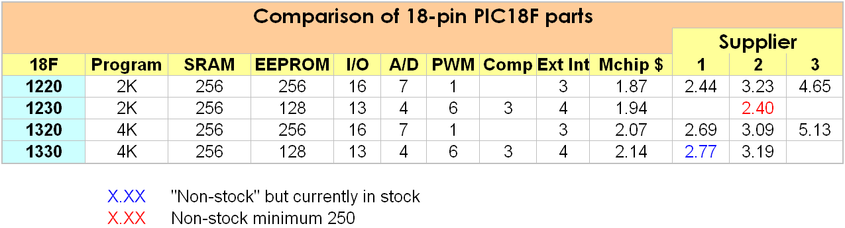  The PIC18 has mostly the same instruction set as the PIC16, but with a few added instructions. There is no paging, and banking is greatly simplified. The 18F family can also run at twice the clock speed as the 16F by virtue of a PLL on the chip to multiply the crystal frequency.
 | Continued on next page
Overview, Continued
Saving Context | On entry to the interrupt service routine (ISR), some registers must be saved so that when the ISR returns control to the main program, the program can pick up where it left off.  Thus on exiting from the ISR, the original context must be restored. In addition, the interrupt flag must be cleared to prevent the same interrupt from being reprocessed.  On entry to the ISR, the GIE flag is cleared automatically, and on executing a return from interrupt instruction, retfie, the flag is set again. This prevents getting interrupted while in the ISR.  The STATUS and W registers are almost always saved and restored in an ISR. Since doing almost anything changes the STATUS, this can be a little tricky. The solution is a bit of boilerplate code that almost always begins and ends the ISR.  Isr:  movwf w_temp ; Save off the W register  swapf STATUS,W ; And the STATUS (use swapf  movwf status_temp ; so as not to change STATUS)  Here goes our interrupt handling code  bcf (interrupt flag)  swapf status_temp,W ; Restore the status  movwf STATUS ; register  swapf w_temp,F ; Restore W without disturbing  swapf w_temp,W ; the STATUS register  retfie  Notice that the movwf instruction doesn’t influence the status, so "W" can be easily saved directly. Next the swapf allows moving the contents of the register into W without affecting the status bits. The nybbles of STATUS are reversed in the saved version, but get reversed again in the restore process.  The STATUS register is restored with a simple movwf. However restoring W this way would affect the status bits. So the swapf trick is used again, this time twice. The first time to get the nybbles backward so the second swapf ends up with the correct result in W.  There may be other registers that must also be saved and restored depending on what assets of the PIC that the ISR uses. These might include the FSR and PCLATH
 | Continued on next page
Overview, Continued
Saving Context | On the 16F84A, all the file register locations are duplicated in all the banks. However, this is not the case on most other PICs. On those parts, we must take care to locate our temporary registers in cells that are duplicated (usually the last 16).  On processors with more than 2K of program memory, the ISR might be in a different page than the interrupt vector. Customarily, some programmers place a goto at location H’04’ to point to the ISR. Should the ISR be at some higher address, the page must be selected first (usually using the lgoto pseudo-instruction). However, depending on the application, the PCLATH may need to be saved. For this reason, it is generally better to at least save context right at location H’04’. If there is some compelling reason to locate the ISR at some other memory location, the goto or lgoto can follow the context save.
Interrupt Priority | On complex instruction set processors, there are usually a number of interrupt priorities; that is, an interrupt can itself be interrupted by a higher priority interrupt. On the PIC, all interrupts have the same hardware priority, but the effective priority can be managed by the software.  When an interrupt occurs, the software must determine which device caused the interrupt by examining the interrupt flags. The order in which this is done essentially determines the priority of an interrupt.  In many applications, especially on the F84, there will be only one interrupt enabled; in this case, the checking of other interrupt flags is normally skipped.

The Timer Interrupt
Introduction | For our first experiment, we will examine the TMR0 interrupt. We have seen in earlier lessons how we can use the TMR0 register to keep track of elapsed time while we are off doing something else. The TMR0 interrupt, when enabled, causes an interrupt whenever the TMR0 register overflows.
Overall view of our program | Our program will consist of a tight loop that checks a “dirty” flag to see whether a value in memory has been updated. If the flag is set, we will display the value, otherwise we will go back and check the flag again:  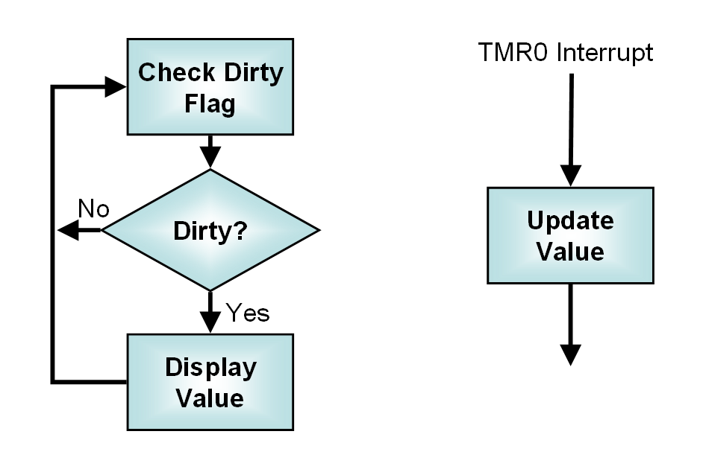  We will rely on the LCD routines from Lesson 17 as well as the decimal conversion routine from Lesson 18.
Displaying a 16-bit value | Because all of our experiments in this lesson will require displaying a 16 bit value on the LCD, it makes sense to make a subroutine to do that which we can simply call in each of our programs.  Our ConvBCD2 routine takes a two byte value and returns a 5 byte result. To display this, we will need to loop through each of the characters, sending them to the LCD. Since we will be sending the same number of characters each time, we won’t need to erase the LCD each time; instead we can simply set the LCD cursor, which is slightly faster. Faster is good because we would like to be able to update the values quickly, and the flashing caused by erasing the display is a little annoying.
 | Continued on next page
The Timer Interrupt, Continued
Displaying a 16-bit value (continued) | The code for the display routine will then look something like this:  Disp16:  call ConvBCD2 ; Convert the value to BCD  call LCDzero ; Cursor to left of LCD  movlw digits ; Pick up address of output  movwf FSR ; into FSR  movlw H'05' ; Count of number of  movwf count ; digits to display  Disp16L  movf INDF,W ; Get current digit  call LCDletr ; Display it  incf FSR,F ; Point to next digit  decfsz count,F ; Count down one we just did  goto Disp16L ; Done? No, do it again  movf LEDflg,W  movwf PORTB  clrf dirty ; Value is now current  return  We’ve done something else a little unusual here. The LEDs flash when the LCD is updated. To reduce that flashing, we will turn off the LEDs every time we write the LCD. This write to PORTB doesn’t affect the LCD since we are careful not to raise the LCD enable pin. Instead of simply storing a literal, we have used a variable so that later we can use the LEDs as an output.  Also note that we have taken care to clear the “dirty” flag after the write. Our ISR will set the dirty flag whenever the value is changed. In this way, we can be sure that we update the LCD whenever the data changes, and only when the data changes.
The main program loop | The main program loop is pretty straightforward. We will display the value, then spin on the dirty flag until it becomes true, at which time we will display the value again:  Loop  call Disp16 ; Display the value in memory  Loop1  movf dirty,W ; Test whether a new value  btfsc STATUS,Z  goto Loop1 ; No, check again  goto Loop ; Yes, go do display
Initialization | Most of the initialization code is fairly obvious. We initialize the LCD, and the values for the dirty flag, the binary value to count, and the LEDflg. Since we will reuse the timer initialization, we will put that in a separate routine, but that initialization is essentially the same as in Lesson 13.  After initialization, it is now safe to turn on interrupts. We must not only turn on the timer interrupt, but we must then enable interrupts in general:  bsf INTCON,T0IE ; Allow timer interrupt  bsf INTCON,GIE ; Enable interrupts
 | Continued on next page
The Timer Interrupt, Continued
The Interrupt Service Routine | The interrupt service routine is responsible for incrementing the counter. The routine gets called whenever the timer overflows and causes an interrupt. From an application perspective, we must increment the counter and set the dirty flag.  However, there are also some “housekeeping” tasks. Since we have no idea of the processor’s state at the time the interrupt occurred, the STATUS and W registers must be saved before the ISR changes them. Of course, these must be restored on exit.  Since the state of the bank bits when the interrupt occurred is unknown, we need to select the bank before accessing any file registers, even if they are in bank 0. (Actually, this is only necessary on the F84 for special function registers; on the F84 all the general purpose registers are accessible in all the banks.) Finally, the timer interrupt flag must be cleared before exiting; otherwise the timer interrupt will re-assert itself the instant we try to exit the ISR.  Saving the status is done in a somewhat “rote” fashion:  IRQSVC code  movwf w_temp ; Save off the W register  swapf STATUS,W ; And the STATUS  movwf status_temp ;  The actual work we need to do in the ISR is pretty basic:  ; Bump up the two-byte value we will display  incf binary+1,F ; Increment low byte  btfsc STATUS,Z ; Overflow? (incf doesn't affect C)  incf binary,F ; Increment high byte  incf dirty,F ; Note that value changed  The restore is again pretty much copied from the datasheet, except we must remember to clear the interrupt flag  bcf INTCON,T0IF ; Clear the old interrupt  swapf status_temp,W ; Restore the status  movwf STATUS ; register  swapf w_temp,F ; Restore W without disturbing  swapf w_temp,W ; the STATUS register  retfie

A Note about the Example Code
Other PICs | As you look at the sample code, you will notice that the code is cluttered up with a lot of IF PROC== or IF PROC!=. A number of students have begun experimenting with other 18-pin PICs. The example code is set up to work with most of the popular 18-pin 16F’s. The examples have been tested on the 16F84A, 16F628, 16F648A, 16F88 and 16F819. The code should also work on the 16F84, 16F87, 16F627, 16F627A, 16F628A and 16F818. It will not work on the 16F716, since in the later examples we will use the EEPROM and the 716 includes no EEPROM.  There are only small differences between any of the 16F parts, but there are differences. In the example code, these differences have been handled by conditionalizing the code. Remember that these IF statements are only evaluated at assembly time. They only determine what code will be ultimately loaded into the PIC. They are not useful for making run-time decisions.
Saving the W and STATUS registers | On most of the other parts, the general purpose registers are banked. Since we cannot predict the bank settings when we are interrupted, and we must save the STATUS register before disturbing the bank settings, the w_temp and status_temp variables must be stored in non-banked memory. On most PICs, this is the high 16 bytes of the file register space.
Accessing the general purpose registers | Again, since most PICs have banked general purpose registers, we must select the bank before accessing any of the GP registers. We don’t need to restore the bank on exit since restoring the STATUS register will do this for us.
Special function register banks | Some of the SF registers are in different banks on different processors. Although this is not true of most registers, it is the case for the registers affecting the EEPROM, which will be used in examples B and C of this lesson.
Timer interrupt enable | On some PICs, the program FLASH memory may be read and written in the same manner as the EEPROM. This can be useful for a large table, for example. On those PICs, the T0IE flag is called TMR0IE, and the T0IF flag is called TMR0IF.
EEPROM write completion interrupt | On some processors the bits controlling the EEPROM write completion interrupt are stored in different registers than on the 16F84A. This becomes an issue in example C of this lesson.
Macros and Banks | We will take a little side trip from our examination of interrupts to refresh our knowledge of macros, and to examine banking in a little more detail.
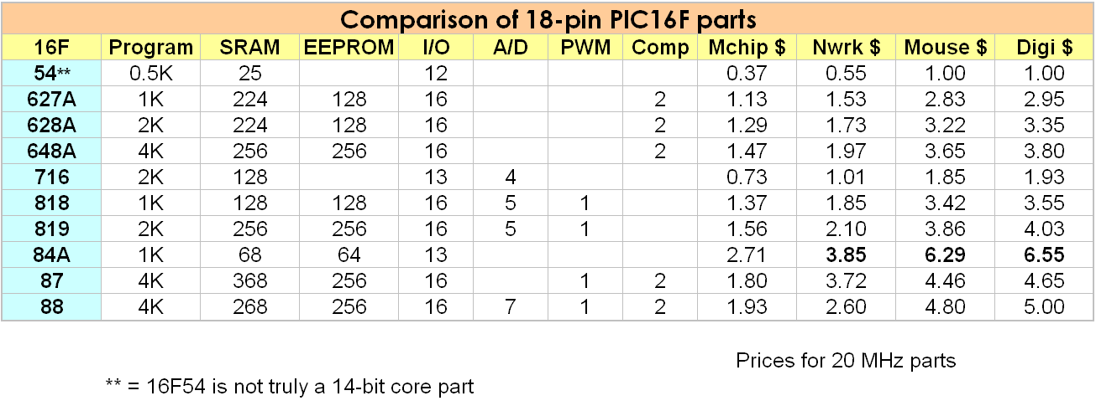

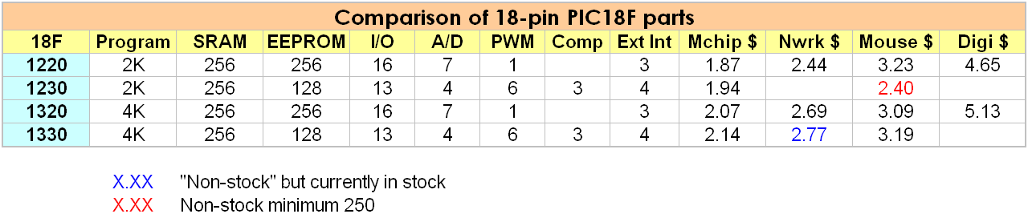

Macros
Introduction | We touched on macros briefly in Lesson 9, and in a little more detail in Lesson 12, but we avoided some aspects of the topic, as we didn’t need them at that time. Let’s review the basics, and look at a couple of other macro features.
#define | The very simplest macro, and the one we have used the most frequently, is the #define. All macros are nothing more than assembly-time text substitutions. The #define allows us to define a symbol and assign it a value. However, unlike the equ directive, which assign a numeric value to the symbol, #define assigns a text string. For example, using equ, you might do something like:  LED3 equ 1  LEDPORT equ PORTB  bsf LEDPORT,LED3  But your code might be a little easier to read if you did something like:  #define LED3 PORTB,1  bsf LED3  Notice that using the equ, we had to define LEDPORT to have a numeric value (even if that value was some other equ … in this case, 6). But the #define allowed us to use some arbitrary string.
macro and endm | We can also define a number of instructions with the macro and endm directives. Let’s assume (a silly example here) that we have a need to put lots of nops in our code. We might define a macro, bignop, which means three nops:  bignop macro  nop  nop  nop  endm  Then we could later say something like:  bignop  bignop  bignop  Which would result in 9 nops. Notice that this is a pure text substitution. Although the source code is smaller, and hopefully more readable, the actual code stored in the PIC is just as long as if we had typed all 9 nops.
Passing arguments | The macro and endm directives allow even more flexibility. We can include arguments to our macro. These are also text substitutions. The arguments in the macro are replaced with those we pass in when we use the macro, prior to the macro text being expanded in our code.
 | Continued on next page
Macros, Continued
Passing arguments (continued) | For example, suppose we want a macro which takes 2 file register locations and stores their sum in a third. We could define a macro like:  myadd macro a,b,c  movf a,W  movwf c  movf b,W  addwf c,W  endm  We could call the macro by:  myadd x,y,z  The actual code placed in the PIC would then be:  movf x,W  movwf z  movf y,W  addwf z,W  Notice that the a, b, and c were replaced by the x, y, and z, before the myadd was replaced by the string of instructions.
Conditional assembly | One of the more powerful features of the macro language is conditional assembly. Basically, this allows us to put instructions in our code that tell the assembler to assemble some instructions only under certain conditions.  The two most commonly used expressions are IF and IFDEF. (There are others, see the macro help in MPLAB). IF allows us to test whether some symbol has a particular value. IFDEF tests whether a symbol has ever been defined. Like most languages, the IF and IFDEF work with ELSE and ENDIF.  A common example is including different code for debugging. For example, when stepping through code in the MPLAB simulator, it is very annoying to encounter long delay loops. One solution to this is to include a symbol that we set for debugging, and then assign the loop counter different values depending on whether we want to simulate or actually run the code. For example:  #define DEBUG  IFDEF DEBUG  loopcnt equ H'01'  ELSE  loopcnt equ H'103'  ENDIF  We could simply comment out the #define for the “production” version.  Another common example would be to use symbols that are defined in the processor include file. Suppose, for example, we had code that we might want to use on a 16F84A or a 16F628. On the 628, we need to turn off the comparator to use those pins as digital. We might, then, include something like:  IFDEF __16F628  movlw H'07'  movwf CMCON  ENDIF
 | Continued on next page
Macros, Continued
Conditional assembly (continued) | The symbol __16F628 would only be defined if we had defined the processor as a 16F628.  When using the IF macro directive, all the normal C-style comparison and arithmetic operators are available. It is important here to remember that these must be evaluated at assembly time.  The include file, processor.inc, which is used in the examples and was used in the LCD library, defines a symbol PROC to have a value that depends on a family of processors. For example, the 16F627, 628, 627A, 628A and 648A all have similar register layouts. The include file assigns a value of 627 to the symbol PROC for all those processors. So if we wanted the code in the above example to be able to run on all those processors, we could instead do something like:  IF PROC == 627  movlw H'07'  movwf CMCON  ENDIF  Thus avoiding a long string if ifdef/else pairs.  The major difficulty with IF is that we must remember that it is evaluated at assembly time. It cannot be used to make run time decisions.
Summary | Macros allow us to simplify our written code, even though the actual code in the PIC is the same. It can help make our code a little more readable.  Perhaps more importantly, macros allow us to have several versions of our code in a single source file. By setting a value in the code, in an include file, or even passed in to the assembly command, we can select among the different versions, without making extensive revisions to the code.  This feature is especially useful when we are writing routines we want to include in a library. Although we have chosen the 16F84A as the basis for this course, the 84A is among the least capable and most expensive PICs. When we go beyond the course into our own designs, some other PIC is almost always a better choice. But each of those PICs has its own eccentricities. With conditional assembly, we can maintain one, tested, set of routines for the common tasks (such as the LCD), and reuse those routines, even if some other processor is a better choice for the current project.

Data Memory Banking
Introduction | One of the appealing features of the 16F84 for learning the PIC is that we can avoid understanding banking for a long time. All of the 84’s general purpose registers are duplicated in all the banks, as are the most commonly used special function registers. For most applications, we can use the rote:  banksel TRISA  movwf TRISA  banksel PORTA  And never really understand banks.  Indeed, many published F84 examples carefully avoid using any banking during interrupts, even disabling interrupts when bank 1 is selected, simply to avoid having to understand this very simple concept.  When we deal with the EEPROM, however, we need to be a little more cognizant of the banking situation, and when we move our applications to a more capable PIC, we find that banks also make themselves more obvious. Before we move to writing the EEPROM, let’s review banking.
Design Decisions | As we mentioned very early in the course, a microcontroller designer needs to make a number of tradeoffs. Having more bits in the program memory allows more instructions and greater addressing range, at additional cost. Complex processors often allow several program words for an instruction, but this comes at a performance price, and managing that performance price results in somewhat less predictable performance; a choice that might be good for a general purpose processor, but is a very poor choice for a microcontroller.  The PIC16 designers chose to use 7 bits of the instruction word for data memory addresses. This allows addressing 128 bytes of file register space. The PIC16F84A has 256 bytes of file register address space. The eighth bit is provided by the RP0 bit of the STATUS register. (Note that the 84A only has 68 general purpose registers, which are duplicated in both banks, and 16 special function registers, six of which are duplicated in both banks.  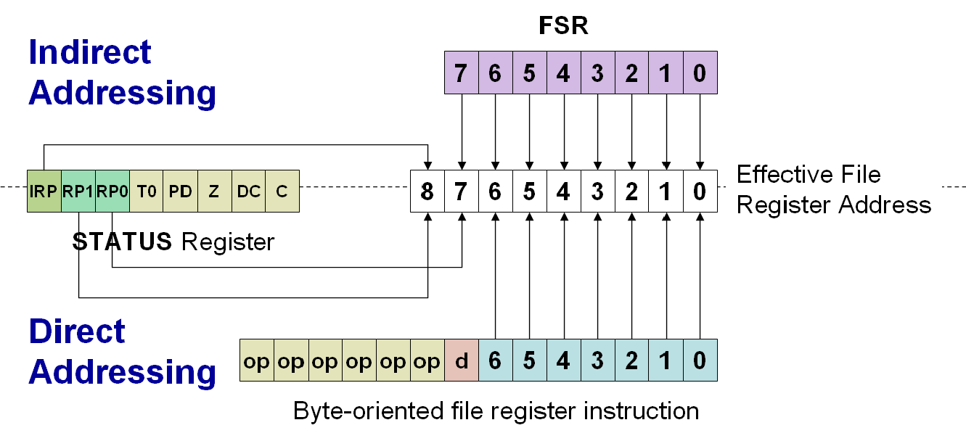
 | Continued on next page
Data Memory Banking, Continued
Design Decisions (continued) | Other processors have as many as four banks, with the additional address bit provided by RP1. Note that when we do indirect addressing, we don’t rely on the instruction’s address bits, but rather the FSR. Since the FSR register has 8 bits, we need a ninth bit for processors with four banks; this bit is provided by the IRP bit of the STATUS register.  On the F84, the RP1 and IRP bits should always be zero since file register memory above H’ff’ is not implemented.  It is important to note that there is nothing really special about the banks; they are simply an artifact of getting an extra address bit or two from another register.  Banking has existed in many processors; it is certainly not unique to the PIC. In many older processors, the banks were selected based on some sort of I/O register.
Banks across different processors | As we branch out beyond the F84, there are a number of differences, and the additional banks are the most obvious. In most of the other processors, not all the general purpose registers are duplicated in all banks as they are in the F84. Since we need a little RAM that is available in all banks to save status during an interrupt, these processors have some general purpose registers, usually the top 16, that are shared across banks.  Larger processors also have more peripherals. More peripherals spells more registers, and these registers may be in different banks. Trying to make these peripherals work in some reasonable fashion tends to mean that some other registers must get moved around.  Certain things can be taken as almost constant. The PORT registers are always in bank 0, the TRIS register in bank 1. The INTCON register is available across all banks, as are the STATUS, FSR and INDF registers.  Beyond this, however, the designer must consult the datasheet for a particular processor. Other registers may well be in other banks.

Saving the count to EEPROM
Introduction | In an earlier lesson, we examined reading the EEPROM. However, we avoided the problem of writing the EEPROM. It turns out that the EEPROM write is one of those interrupt sources we want to examine, so now we will look at writing the EEPROM.  The EEPROM is often used to store calibration constants, some of which may be quite important and difficult to recover. Because of this, it is important that a program not accidentally alter the contents of EEPROM. To make it difficult to inadvertently write to EEPROM, Microchip has the programmer “jump through hoops” to actually perform the write.  Writing to EEPROM isn’t difficult, but there are several steps whose only purpose is to prevent an accidental write.
The EEPROM writing sequence | To write to the EEPROM, the following sequence of steps must be executed:  - Check that a write is not in progress (EECON1 bit WR is clear)  - Write the desired EEPROM address to EEADR  - Write the data value to be stored to EEDATA  - For those processors that support writing to program flash memory, clear the EEPGD bit of EECON1  - Set the WREN bit of EECON1 to enable writing  - Disable interrupts if not already disabled  - Write a H’55’ to EECON2  - Write a H’AA’ to EECON2  - Set the WR bit of EECON1  - Enable interrupts (if being used)  - Clear the WREN bit of EECON1  Note that the steps between turning off interrupts and turning them back on must happen in the exact sequence with no interruption.  The write can take some time. When the write is complete, the WR bit will be cleared, and EEIF will be set. If interrupts are enabled and EEIE is set, an interrupt will occur.
 | Continued on next page
Saving the count to EEPROM, Continued
The EEPROM writing code | The above sequence, in the case where we are not using the EEPROM write completion interrupt, would look like the following:  banksel EECON1 ;  Wait1 btfsc EECON1,WR ; Wait for write complete  goto Wait1  banksel EEADR  movlw SAVADR ; Set address in EEPROM  movwf EEADR ; to be written  banksel binary  movf binary,W ; Set data to be written  banksel EEDATA  movwf EEDATA ;  banksel EECON1 ;  IFDEF EEPGD ; For processors that support  bcf EECON1,EEPGD ; it, ensure EEPROM not FLASH  ENDIF  bcf INTCON,GIE ; Turn off interrupts  bsf EECON1,WREN ; Enable write  movlw H'55' ; This sequence is  movwf EECON2 ; required before the  movlw H'AA' ; EEPROM may be written  movwf EECON2 ;  bsf EECON1,WR ; Start write  bsf INTCON,GIE ; Turn interrupts back on  Wait2 btfsc EECON1,WR ; Wait for write complete  goto Wait2  We have predefined a constant, SAVADR, that identifies the address in EEPROM where we want to store the value. In the example code, this is in an include file. Note that we have conditionalized the selection of EEPROM rather than flash to those processors where the EEPGD bit is defined. We could have left out those three lines in the case where we knew we weren’t going to move this code to another processor.  Also note that on some processors we might have avoided a few banksel directives. By simply selecting the bank for every general purpose register, we are sure we are covered for all processors. The one exception is that EECON1 and EECON2 are always in the same bank. The sequence of instruction between disabling and enabling interrupts must happen exactly as shown so there may be no additional instructions in the sequence.  Since the timing is critical, the EECON1 and EECON2 registers share a bank on all processors. Which bank that happens to be is different across processors, but since we are using the banksel directive, the assembler will sort out which bank that happens to be.  In our example, the above code needs to be duplicated for the second byte, since we have two bytes of count to store.
Reading the EEPROM | Reading the EEPROM is fairly simple; we did it back in Lesson 14. We simply store the address to read in EEADR, set the RD bit in EECON1, and read the result from EEDATA.  banksel EEADR  incf EEADR,F ; Now point to next EEPROM location  banksel EECON1  bsf EECON1,RD ; again command a read  banksel EEDATA  movf EEDATA,W ; grab the high byte  banksel binary  movwf binary+1 ; and store in high
 | Continued on next page
Saving the count to EEPROM, Continued
Bank Selection | In the above code, we selected the bank each time we accessed a register. While this is the “safest” thing to do, we might not need all those banksel directives. Each banksel adds one instruction for the PIC16F84A, two instructions for the other processors. In the example code, we developed a macro for each that made the decision based on the processor. Let’s examine how we could work through that.  The table below shows the banks for each of the relevant registers for the 18 pin processors, in the order we will access them. We enter the routine with bank 0 selected:  Cells where the bank must change are shown in pink. When accessing EEADR, we need to do a banksel for all processors except the 84A. For EECON1, we do a banksel for the 84A, 88 and 819, and likewise with EEDATA. When we go back to our data, again we need to do a banksel for all except the 84A.  In the example code, we end up with a number of macros that look like this:  SelectData MACRO  IF ( PROC == 84) || ( PROC == 88 ) || ( PROC == 819 )  banksel EEDATA  ENDIF  ENDM  Using these macros for bank selection avoids totally cluttering up the code with conditional assembly instructions, and it does save a few instructions for each processor except the 88 and 819, while allowing our code to port seamlessly across processors. There is a price in readability, however.  So we basically have three choices:  - Write our code for only a single processor  - Do a banksel for every register access  - Use conditional code to decide when to do a banksel  The choice depends to a degree on whether we want to easily pick up our code for the next project, and how much effort we want to spend, balanced against our interest in efficiency versus readability.
  Register | 16F84A | 16F88 | 16F628 | 16F648A | 16F819
  bank 0 | 0 | 0 | 0 | 0 | 0
  EEADDR | 0 | 2 | 1 | 1 | 2
  EECON1 | 1 | 3 | 1 | 1 | 3
  EEDATA | 0 | 2 | 1 | 1 | 2
  binary | 0 | 0 | 0 | 0 | 0
 | Continued on next page
Saving the count to EEPROM, Continued
Example B logic | So in the second example, we will add the ability to store and restore the count. In this example we won’t use the EEPROM interrupt yet, we will save that for example C. Here is the logic:  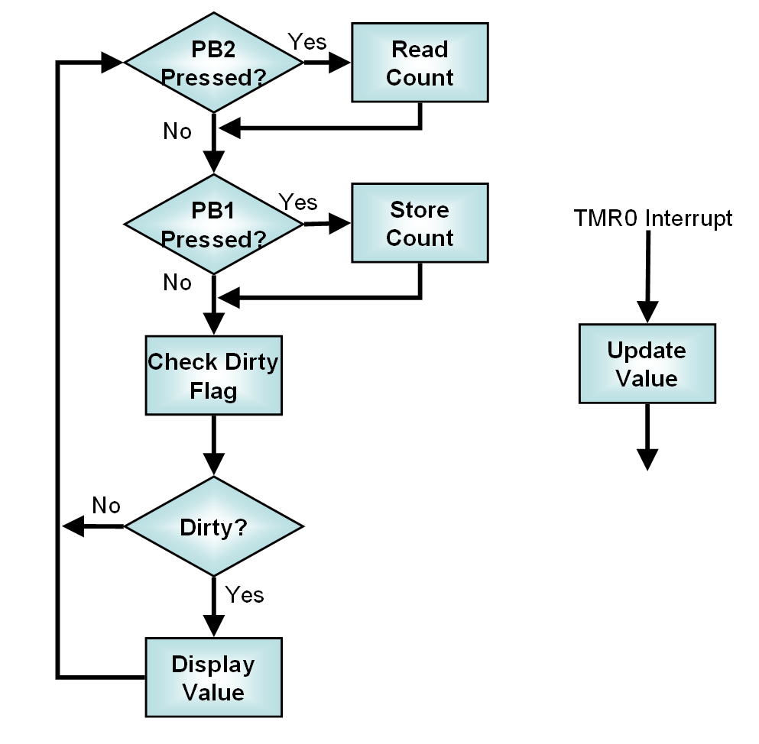  In the example code we haven’t taken time to debounce the buttons. In a real application this should be done to prevent excessive rewriting of the EEPROM.
Building the example code | Our project is getting more complex. To build the example code, you must include in your project:  - Source files:  - ConvBCD2  - Disp16  - InitTMR0  - L20b  - RestCnt  - SaveCntB  - Library files:  - LCDlib84A  - Linker Scripts  - Less20  The zip includes alternate versions of the library and linker script for other processors.

