Lesson 21
Other PICs

Overview
Introduction |  | There are a large number of PIC16 parts, most of which are more capable than the 16F84A, and many of which are less expensive. In this lesson, we will examine the differences between the 18-pin PICs, and learn how to write library code we can use on any PIC in the family.
In this section |  | Following is a list of topics in this section:
 | Description |  | See Page
 | Overview |  | 2
 | Differences Between PICs |  | 4
 | The Linker Script |  | 7

Overview
Introduction | When the designer sets out to design a project, each part should be selected to best fit the project. Many hobbyists learn the PIC16F84A and never consider another part. In fact, there are a large number of PICs which might well be less expensive than the 84A in many applications. Many PICs have peripherals that are lacking on the 84A which can make the programmer’s job easier. In many cases, it is possible to have more features and more memory at a lower price.  Because of the additional peripherals and memory, there are often slight differences between the various PICs. However, it is quite possible to write code that will work on any PIC. Since we often do some of the same things from one project to the next, it would be helpful to be able to write common routines once, and use them again and again regardless of the PIC we choose for a particular project.
18 pin parts | The chart below shows the PIC16F parts that are available in an 18 pin DIP package. Since Microchip maintains the pinout across parts in the same family, these are candidates to use in the PIC-EL:  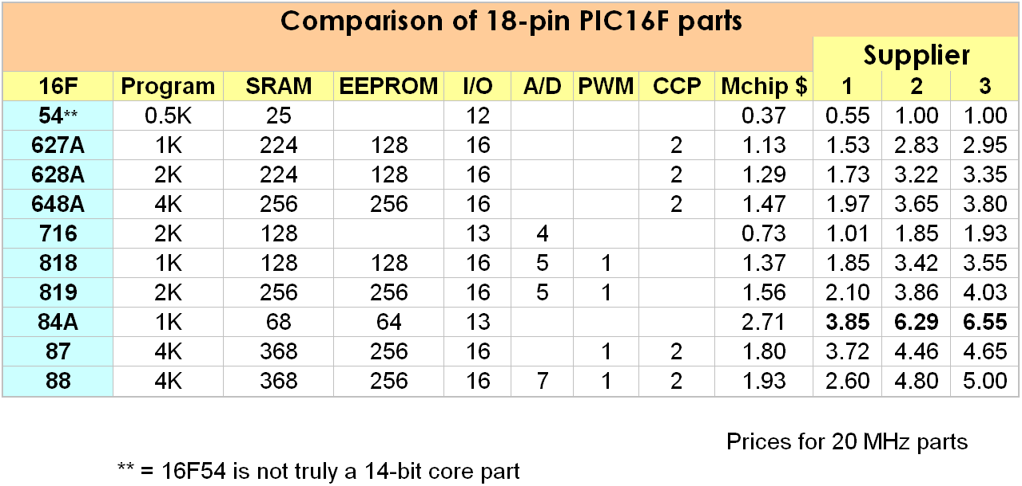  Notice that the PIC16F84A is the most expensive of the 18 pin parts. It also has less memory than any of the other parts except the PIC16F54, which is actually a different family. This is because the 84A is an older part using older technology memory, and thus more expensive to manufacture. The 16F627 and 16F628 (without the A) are no longer shown on the Microchip product selector, although still available. These parts have been replaced by the “A” versions, which are less expensive.  This chart doesn’t tell the whole story. There are other peripherals on most of the PICs that also differ between models. Most of the parts include a UART, which is lacking in the 84A. Most also have additional timers. Some are capable of SPI and/or I2C, which can be handy if the project will involve a PLL, DAC or some other kinds of peripheral chips. The Microchip product selector is the quickest way to narrow down the part selection for a project, but ultimately, one must consult the datasheet to see what peripherals are available and what limitations may affect the project.
 | Continued on next page
Overview, Continued
Hobbyist part selection | When a professional designer does a project, he will calculate the necessary memory, determine the needed peripherals, and select the least expensive part with the necessary assets for the project.  But the hobbyist most likely will keep only a one or two PIC models in the parts drawer and use them. Many hobbyists simply use the PIC16F88 whenever they need an 18 pin PIC. It has almost all the peripherals available, the most memory, and although it is relatively expensive, it is not prohibitively so.  However, some will not be comfortable with deploying a PIC that might cost three times as much as one that will do the job. The 16F716 is a very low cost part, but it does lack EEPROM, which is useful in many projects. For this reason, many hobbyists prefer the 16F628A. While slightly more expensive, it does have EEPROM and most of the peripherals one might want, except for an A/D converter.
PIC18 parts | The PIC18 family is a surprisingly easy step up from the PIC16. The PIC18 parts share the key features of the pinout of the PIC16 parts, but the port pins are reassigned. So while writing new code for the 18F is barely different that the 16F, porting existing code can be tedious.  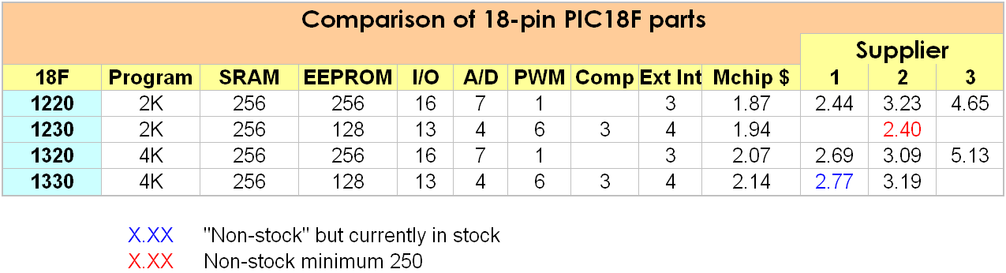  The PIC18 has mostly the same instruction set as the PIC16, but with a few added instructions. There is no paging, and banking is greatly simplified. The 18F family can also run at twice the clock speed as the 16F by virtue of a PLL on the chip to multiply the crystal frequency.

Differences Between PICs
Introduction | While all the PIC16s share the same instruction set and same general architecture, there are a number of differences that need to be accounted for when programming. There are basically four areas of concern:  - Configuration bits  - Banking  - Paging  - Peripherals  None of these turns out to be especially difficult, although if we overlook any of them the results can be quite confusing.
Configuration Bits | Each PIC has a set of configuration bits that affect the environment in which the program runs. On the PIC16F84A there are only 4 configuration settings:  - Code protect – we have generally ignored this, the default, code protection disabled, is good enough for us  - Power up timer – This gives our circuitry time to stabilize before the program starts. Generally we have turned this on, although in most cases it would make no difference  - Watchdog timer – We have always disabled this. Were we to enable it, the processor would reset periodically unless we took steps to prevent that in our code  - Oscillator selection – This one bears some discussion. On the 84A, there are four selections. If we did not set this, the default is to assume an RC oscillator. On the PIC-EL, we have a 4 MHz crystal, so we have generally chosen the XT oscillator setting. The crystal settings really refer to the oscillator drive current, and so are somewhat dependent on the activity of our particular crystal. Typically, we would use LP for less than 1 MHz, XT for 1-10 MHz, and HS for >10 MHz. Too much drive and we use more power than necessary; not enough drive and our crystal might not oscillate.
 | Continued on next page
Differences Between PICs, Continued
Configuration Bits (continued) | Other PICs have additional features that require additional configuration bits. The following table shows some of the possibilities:  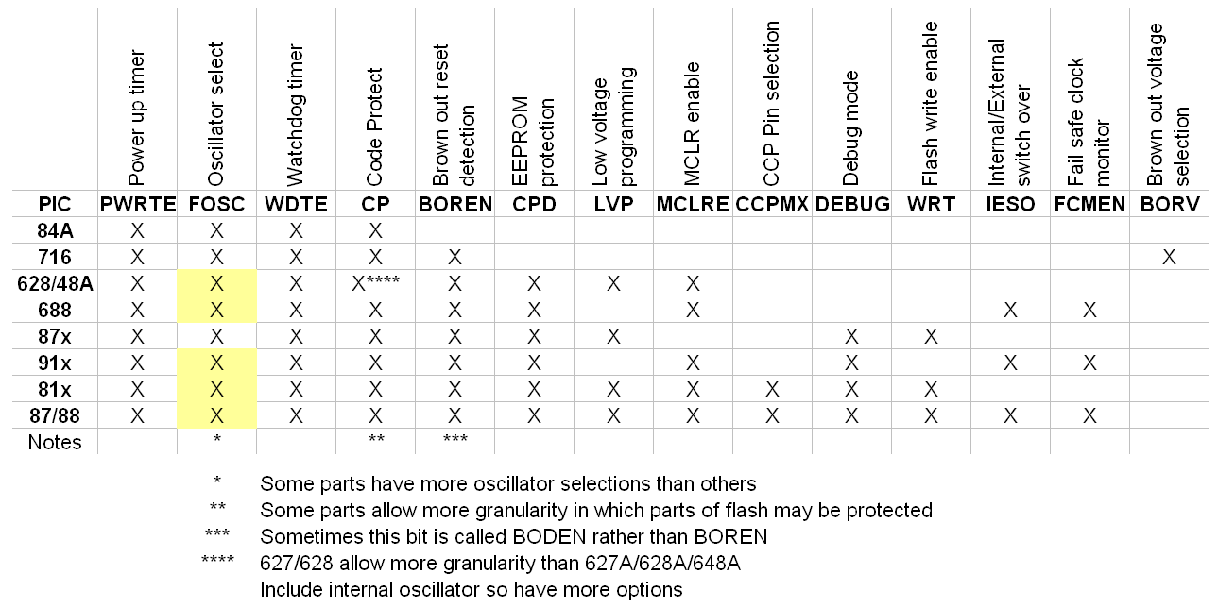  Any time you want to use a new PIC, you of course want to read the datasheet. In particular, the “Special Features of the CPU” section contains the description of the configuration bits for that particular PIC.  Most of these we can ignore, but some bear special attention.  LVP – This is one that probably gets most people. If a particular PIC supports low voltage programming, you almost always want to turn it off. In addition, there is a pin called PGM, usually shared with RB3 or 4, that must be kept low between the time the part is bulk-erased and the time the LVP bit is cleared.  MCLRE – On some PICs, the MCLR pin may be used as an I/O pin instead of an MCLR pin. This bit selects the usage.  BOREN – This bit can cause a reset when the voltage is too low. “Too low” might not be unusual for a battery powered application. Each part has a different brown-out voltage and some allow you to select the voltage.  Most of the others can be ignored unless some special feature is required.
 | Continued on next page
Differences Between PICs, Continued
Banking | In the PIC16F84A, there are only two banks, and for the most part, we can ignore them. Most of the time, we switch banks to set the TRIS bits, switch back, and never worry about banks again. In the previous lesson we had to do a little more bank switching to write to the EEPROM, but it was pretty limited.  Most other PICs have more general purpose registers and more special function registers. Because of this, not only will the SFR we need at the moment be more likely to be in another bank, but even the GPRs are banked. The additional GPRs are frequently one of the major reasons to select a more capable PIC, so banking is very much more an issue.  On the 16F84A, all the file register locations are duplicated in all the banks. However, this is not the case on most other PICs. On those parts, we must take care to locate our temporary registers in cells that are duplicated (usually the last 16).  On processors with more than 2K of program memory, the ISR might be in a different page than the interrupt vector. Customarily, some programmers place a goto at location H’04’ to point to the ISR. Should the ISR be at some higher address, the page must be selected first (usually using the lgoto pseudo-instruction). However, depending on the application, the PCLATH may need to be saved. For this reason, it is generally better to at least save context right at location H’04’. If there is some compelling reason to locate the ISR at some other memory location, the goto or lgoto can follow the context save.
Paging | If a PIC has more than 2K of program memory, then all instructions cannot be reached with the call or goto instructions. In these cases, the high one or two bits of the instruction address must be gotten from the PCLATH register. The lcall and lgoto pseudo-instructions are used for jumps that cross page boundaries. These simply set the PCLATH before executing the call or goto. In either case, the PCLATH must be set back on return. Since the lcall and lgoto instructions assemble into two or three instructions (depending on the processor), the programmer must be alert to this, and not attempt to skip one of these pseudo instructions (for example, with a decsfz instruction).
Peripherals | When our application requires some special feature, we would like to select a processor with a peripheral that can help. Many applications hard code serial communications or pulse width modulation on the PIC16F84. While this certainly works, the application could be much simpler with the help of a UART or PWM peripheral, which are available on many PICs.  If we are writing code to run across several processors, as we are in this lesson, peripherals aren’t too much of an issue. However, there is something we must consider. Whenever a pin might have an analog input, then that pin defaults to analog. If we wish to use that pin as a digital, we must first turn off the analog peripheral. This applies to parts with A/D converters or analog comparators, which means almost any part except the 16F84.

The Linker Script
Introduction | When writing a linker script for the PIC16F84A, there really aren’t a lot of meaningful choices as to where we put things. We may choose to rearrange the various segments depending on preference or readability, but except for putting tables in the first page for simplicity, it really doesn’t matter where we place out various code and data segments.  On PICs with more memory, however, it can make a difference
Code Segments | As mentioned earlier, calls and gotos across page boundaries encounter extra overhead. For this reason, we would like to place code with a lot of internal calls and gotos on the same page. When writing library code, we would like to develop that code so that it can be easily called from another page, allowing us the most freedom in using that library later.  For the 18-pin parts, none have more than 4K of memory, so we have either 1 or 2 pages:
  PIC | Memory | Pages
  627A | 1 | 1
  84A | 1 | 1
  818 | 1 | 1
  628A | 2 | 1
  819 | 2 | 1
  716 | 2 | 1
  648A | 4 | 2
  87 | 4 | 2
  88 | 4 | 2
Data Segments | Data gets more interesting. Again, things that are used together would like to be in the same bank. Different PICs have different amounts of RAM, and that RAM is arranged differently into banks:  Note that the 716 only has two banks. The 818, with the same amount of RAM, actually has four. The GPR space in the upper two banks accesses the GPRs in the first bank. Similarly, the on the 819, the GPR space on the upper bank accesses the lowest bank. Thus, a reference to 0x1a0 actually accesses 0x20. Similarly, on the 84A locations in the second bank reference RAM in the first bank. In all cases except the 16F84A, locations 0x70 through 0x7f are referenced by the last 16 locations in every bank.
  PIC | RAM | RAM  Banks | Total  Banks
  84A | 68 | 1 | 2
  716 | 128 | 2 | 2
  818 | 128 | 2 | 4
  627A | 224 | 3 | 4
  628A | 224 | 3 | 4
  648A | 256 | 3 | 4
  819 | 256 | 3 | 4
  87 | 368 | 4 | 4
  88 | 368 | 4 | 4

