Lesson 20
Interrupts

Overview
Introduction |  | In many of our earlier examples, the PIC has spent most of its time polling some input or timer. Interrupts allow us to do useful work, and be notified when some event occurs that we care about.
In this section |  | Following is a list of topics in this section:
 | Description |  | See Page
 | Overview |  | 2
 | The Timer Interrupt |  | 5
 | Saving the count to EEPROM |  | 8
 | Multiple Interrupt Sources |  | 11
 | Additional Experiments |  | 16
 | Wrap Up |  | 17

Overview
Introduction | In many applications we want the PIC to “walk and chew gum” at the same time. By periodically polling inputs or polling timers, the PIC can appear to carry out multiple tasks. However to be responsive to rapidly occurring events, the polling must be done very frequently. But more frequent polling means fewer compute cycles available for the "background" task. Using interrupts allows fast response to external events without wasting compute time on polling.  In theory, an interrupt is fairly simple. When an event happens that needs immediate attention, the interrupt taps the processor on the shoulder to go off and handle this new task. Once that task is done, the processor can return to what it was doing.
Mechanics | The mechanics of an interrupt are simple in concept. When some hardware event causes an interrupt; the current program counter is pushed onto the stack. Then the program counter is loaded with the address of the interrupt service routine. In the PIC16 family, this address is H'04'.  In practice, more than just the program counter must be saved and restored. If the interrupt service routine does much of anything, it will probably change the STATUS and "W" registers. Thus we need to save the values in those registers before proceeding with interrupt processing. The interrupt may also call on other assets within the PIC which also must be properly saved and restored. This is the most important, and sometimes the most difficult, part of interrupt processing
Interrupt Sources | The PIC16F84A has only 4 interrupt sources:  Other PICs have additional interrupts, appropriate to the peripherals contained on those PICs. Note that bit names ending in IE are Interrupt Enable, those ending in IF are Interrupt Flags.
  Name | Function | Enable Bit | Flag Bit
  RB0/INT | A transition of the RB0 pin | INTE | INTF
  TMR0 | An overflow of the TMR0 register | T0IE | T0IF
  PORTB | A change in PORTB bits 4-7 | RBIE | RBIF
  EEPROM | Completion of an EEPROM write | EEIE | EEIF
Controlling the interrupts | The INTCON register contains a bit, GIE (Global Interrupt Enable), which enables all interrupts. As long as GIE is false, no interrupt from any source will occur. INTCON also contains a bit to enable each of the individual interrupts as shown in the table above. To receive an interrupt, both the GIE bit and one of the interrupt enable bits must be set.  When the interrupt does occur, a flag is set to indicate the specific source. These flags are also shown in the table.
 | Continued on next page
Overview, Continued
Saving Context | When an interrupt occurs, a number housekeeping chores must be done. The PIC hardware automatically saves the program counter. The hardware also clears the global interrupt enable to prevent a second interrupt from occurring while the first is being processed. When a return from interrupt instruction, (retfie) is executed, the program counter is automatically restored and the GIE is turned back on.  However the programmer has certain responsibilities. The specific flag that caused the interrupt must be cleared to prevent the same interrupt from being reprocessed. The programmer must also determine which registers must be saved and restored so that the main program can pick up where it left off. Remember that an interrupt can occur at any place in the main program, so all possibilities must be covered.  The STATUS and W registers are most often saved and restored in an ISR. Since doing almost anything changes the STATUS, this can be tricky. The solution is a bit of boilerplate code that begins and ends most interrupt routines.  Isr:  movwf w_temp ; Save off the W register  swapf STATUS,W ; And the STATUS (use swapf  movwf status_temp ; so as not to change STATUS)  [Interrupt handling code goes here]  bcf (interrupt flag)  swapf status_temp,W ; Restore the status  movwf STATUS ; register  swapf w_temp,F ; Restore W without disturbing  swapf w_temp,W ; the STATUS register  retfie  Since the movwf instruction doesn’t influence the status, the "W" can be saved directly. Next the swapf allows moving the contents of the STATUS register into W without affecting the status bits. The nybbles of STATUS are reversed in the saved version, but get reversed again in the restore process.  The STATUS register is restored with a simple movwf. However restoring W this way would affect the status bits. So the swapf trick is used again, this time twice. The first time to get the nybbles backward so the second swapf ends up with the correct result in W.  There may be other registers that must also be saved and restored depending on what assets of the PIC the ISR uses. These might include the FSR and PCLATH. Also note that we must clear the flag for the interrupt we just handled. If we don’t the interrupt will re-assert itself as soon as we return from the ISR.
 | Continued on next page
Overview, Continued
Interrupt Priority | On complex instruction set processors, there are usually a number of interrupt priorities; that is, an interrupt can itself be interrupted by a higher priority interrupt. On all the PIC16Fxx and smaller parts, all interrupts have the same hardware priority, but the effective priority can be managed by the software.  When an interrupt occurs, the software must determine which device caused the interrupt by examining the interrupt flags. The order in which this is done essentially determines the priority of an interrupt.  In many applications, especially on the PIC16F84, there will only be one interrupt enabled; in this case, the checking of other interrupt flags is normally skipped.

The Timer Interrupt
Introduction | For our first experiment, we will examine the TMR0 interrupt. We have seen in earlier lessons how we can use the TMR0 register to keep track of elapsed time while we are off doing something else. The TMR0 interrupt, when enabled, causes an interrupt whenever the TMR0 register overflows.
Overall view of our Program | Our program will consist of a tight loop that checks a “dirty” flag to see whether a value in memory has been updated. If the flag is set, we will display the value, otherwise we will go back and check the flag again:  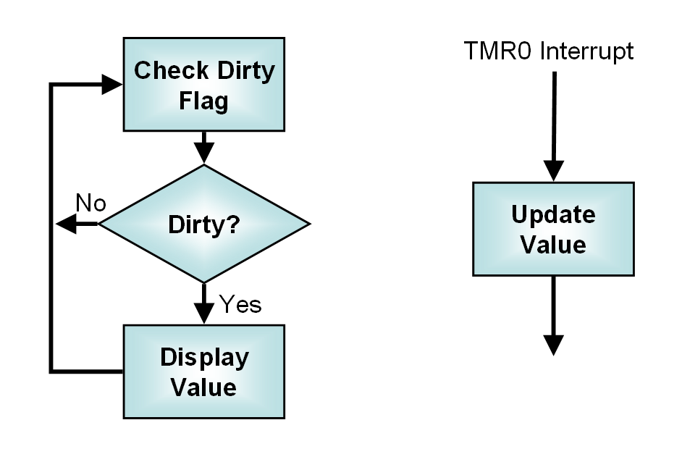  We will rely on the LCD routines from Lesson 17 as well as the decimal conversion routine from Lesson 18.
Displaying a 16-bit Value | Because all of the experiments in this lesson will require displaying a 16 bit value on the LCD, it makes sense to make a subroutine to do that which we can simply call in each of our programs.  The ConvBCD2 routine takes a two byte value and returns a 5 byte result. To display this, we will need to loop through each of the 5 characters, sending them to the LCD. Since the same number of characters are sent each time, the LCD need not be erased. Instead we can simply set the LCD cursor position, which is slightly faster. Faster is good because we would like to be able to update the values quickly, and the flashing caused by erasing the display is a little annoying.
 | Continued on next page
The Timer Interrupt, Continued
Displaying a 16-bit Value (continued) | The code for the display routine will then look something like this:  Disp16:  call ConvBCD2 ; Convert the value to BCD  call LCDzero ; Cursor to left of LCD  movlw digits ; Pick up address of output  movwf FSR ; into FSR  movlw H'05' ; Count of number of  movwf count ; digits to display  Disp16L  movf INDF,W ; Get current digit  call LCDletr ; Display it  incf FSR,F ; Point to next digit  decfsz count,F ; Count down one we just did  goto Disp16L ; Done? No, do it again  movf LEDflg,W ; Set the LEDs to the  movwf PORTB ; desired condition  clrf dirty ; Value is now current  return  Because the LCD and the LEDs share pins on the PIC-EL, the LEDs flash when the LCD is updated. To reduce that flashing, we will turn off the LEDs every time we write the LCD. This write to PORTB doesn’t affect the LCD since we are careful not to raise the LCD enable pin. Instead of simply storing a literal, variable LEDflg is used so that later we can use the LEDs as an output.  Also note that we have taken care to clear the “dirty” flag after the write. Our ISR will set the dirty flag whenever the value is changed. In this way, the LCD is rewritten whenever the data changes, and only when the data changes.
The main program loop | The main program loop is pretty straightforward. The value is displayed on the LCD, then spin on the dirty flag until it becomes true, at which time we will display the value again:  Loop  call Disp16 ; Display the value in memory  Loop1  movf dirty,W ; Test whether a new value  btfsc STATUS,Z  goto Loop1 ; No, check again  goto Loop ; Yes, go do display
Initialization | The LCD is initialized, along with the values for the dirty flag, the binary value to count, and the LEDflg. Since the timer initialization will be reused, it is put in a separate routine. That initialization is essentially the same as in Lesson 13.  After initialization, it is now safe to turn on interrupts. Both the timer interrupt and the global interrupt enable must be turned on:  bsf INTCON,T0IE ; Allow timer interrupt  bsf INTCON,GIE ; Enable interrupts
 | Continued on next page
The Timer Interrupt, Continued
The Interrupt Service Routine | The interrupt service routine is responsible for incrementing the counter. The routine gets called whenever the timer overflows and causes an interrupt. The routine must increment the counter and set the dirty flag.  However, there are also some “housekeeping” tasks. Since we have no idea of the processor’s state at the time the interrupt occurred, the STATUS and W registers must be saved before the ISR changes them. Of course, these must be restored on exit.  Since the state of the bank bits when the interrupt occurred is unknown, we need to select the bank before accessing any file registers, even if they are in bank 0. On the F84 this is only necessary for special function registers; the general purpose registers are accessible in all the banks. So far, all the registers we use in the ISR are also in all banks. However, later this could become an issue, and is one of the potential traps of interrupt handling. Finally, the timer interrupt flag must be cleared before exiting; otherwise the timer interrupt will re-assert itself the instant we try to exit the ISR.  Saving the status is done in a somewhat “rote” fashion:  IRQSVC code  movwf w_temp ; Save off the W register  swapf STATUS,W ; And the STATUS  movwf status_temp ;  The actual work we need to do in the ISR is pretty basic:  ; Bump up the two-byte value we will display  incf binary+1,F ; Increment low byte  btfsc STATUS,Z ; Overflow? (incf doesn't affect C)  incf binary,F ; Increment high byte  incf dirty,F ; Note that value changed  The restore is again pretty much copied from the datasheet, except we must remember to clear the interrupt flag  bcf INTCON,T0IF ; Clear the old interrupt  swapf status_temp,W ; Restore the status  movwf STATUS ; register  swapf w_temp,F ; Restore W without disturbing  swapf w_temp,W ; the STATUS register  retfie
Testing the code | Once we build and assemble the project, and run the code in our PIC-EL, we should see a five digit number incrementing quite quickly. Wait until the count exceeds 255 to be sure we have handled incrementing the second byte of binary correctly.

Saving the count to EEPROM
Introduction | In an earlier lesson, we examined reading the EEPROM. However, we avoided the problem of writing the EEPROM. It turns out that the EEPROM write is one of those interrupt sources we want to examine, so now we will look at writing the EEPROM.  The EEPROM is often used to store calibration constants, some of which may be quite important or difficult to recover. Because of this, it is important that a program not accidentally alter the contents of EEPROM. To make it difficult to inadvertently write to EEPROM, Microchip has the programmer “jump through hoops” to actually perform the write.  Writing to EEPROM isn’t difficult, but there are several steps whose only purpose is to prevent an accidental write.
The EEPROM writing sequence | To write to the EEPROM, the following sequence of steps must be executed:  - Check that a write is not in progress (EECON1 bit WR is clear)  - Write the desired EEPROM address to EEADR  - Write the data value to be stored to EEDATA  - Set the WREN bit of EECON1 to enable writing  - Disable interrupts if not already disabled  - Write a H’55’ to EECON2  - Write a H’AA’ to EECON2  - Set the WR bit of EECON1  - Enable interrupts (if being used)  - Clear the WREN bit of EECON1  Note that the steps between turning off interrupts and turning them back on must happen in the exact sequence with no interruption.  The write can take some time, a few milliseconds depending on the supply voltage and data to be written. When the write is complete, the WR bit will be cleared, and EEIF will be set. If interrupts are enabled and EEIE is set, an interrupt will occur.
 | Continued on next page
Saving the count to EEPROM, Continued
The EEPROM writing code | The above sequence, in the case where we are not using the EEPROM write completion interrupt, would look like the following:  banksel EECON1 ; Bank 1  Wait1 btfsc EECON1,WR ; Be sure no write in progress  goto Wait1 ;  banksel EEADR ; Bank 0  movlw SAVADR ; Set address in EEPROM  movwf EEADR ; to be written  banksel binary ;  movf binary,W ; Set data to be written  banksel EEDATA ;  movwf EEDATA ;  banksel EECON1 ; Bank 1  bcf INTCON,GIE ; Turn off interrupts  bsf EECON1,WREN ; Enable write  movlw H'55' ; This sequence is  movwf EECON2 ; required before the  movlw H'AA' ; EEPROM may be written  movwf EECON2 ;  bsf EECON1,WR ; Start write  bsf INTCON,GIE ; Turn interrupts back on  Wait2 btfsc EECON1,WR ; Wait for write complete  goto Wait2  bcf EECON1,WREN ; Disable write  We have predefined a constant, SAVADR, that identifies the address in EEPROM where we want to store the value. In the example code, this is in an include file.  In our example, the above code needs to be duplicated for the second byte, since we have two bytes of count to store.  In this example, we really didn’t require the banksel binary, although on other PICs, this is a real trap, so it isn’t a bad practice to ensure bank 0 before accessing our variable. Having selected bank 0, the banksel EEDATA is also redundant, although it would have been required had we eliminated the banksel binary.
Reading the EEPROM | Reading the EEPROM is fairly simple; we did it back in Lesson 14. We simply store the address to read in EEADR, set the RD bit in EECON1, and read the result from EEDATA.  movlw SAVADR ; Store the EEPROM address  banksel EEADR  movwf EEADR ; to the address register  banksel EECON1  bsf EECON1,RD ; again command a read  banksel EEDATA  movf EEDATA,W ; grab the high byte  movwf binary+1 ; and store in high
 | Continued on next page
Saving the count to EEPROM, Continued
Example B logic | In the second example, the ability to store and restore the count in EEPROM will be added. In this example the EEPROM interrupt is not yet used. It will be used in example C. Here is the logic:  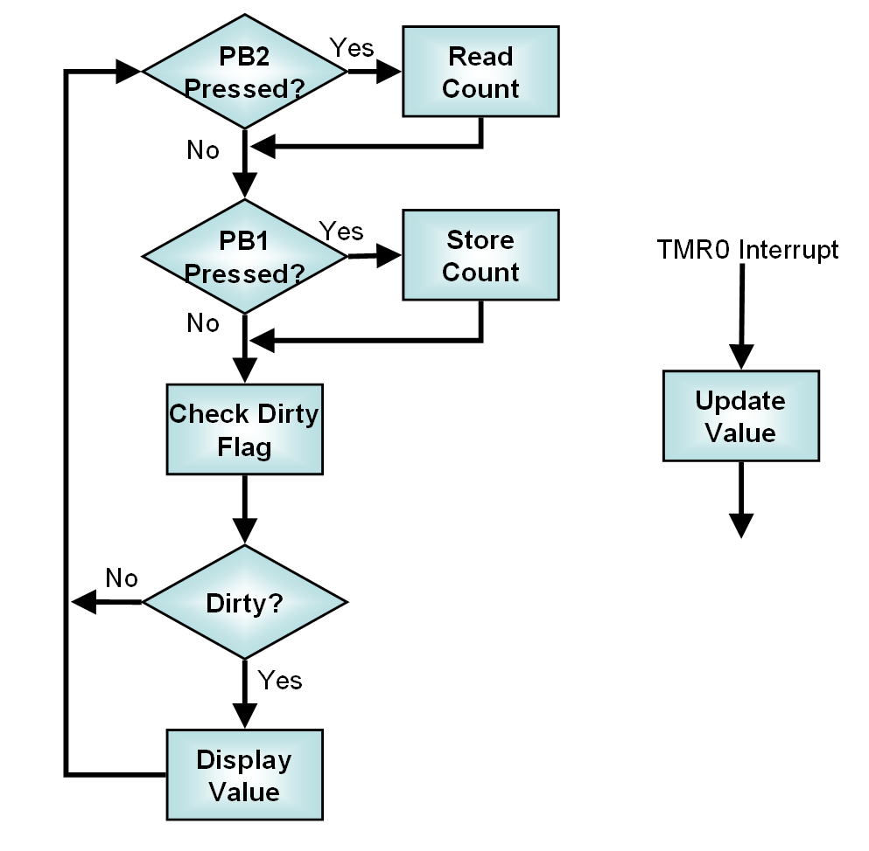  Note that the dirty flag gets set by the “Read Count” block and the “Update Value” block, and cleared by the “Display Value” block.  In the example code the buttons are not debounced. In a real application this should be done to prevent excessive rewriting of the EEPROM.
Building the example code | The project is getting more complex. To build the example code, you must include in your project:  - Source files:  - ConvBCD2  - Disp16  - InitTMR0  - ISRa  - L20b  - RestCnt  - SaveCntB  - Library files:  - LCDlib_84A  - Linker Scripts  - Lesson20

Multiple Interrupt Sources
Introduction | In the previous example, we stored our count in the EEPROM, but we had to spin in a tight loop waiting for the EEPROM write to complete. It would make sense to handle an EEPROM completion interrupt so that our application could be off doing something useful rather than waiting for a flag to change. (Admittedly, the example application is somewhat limited in the “useful” things it has to do).
Managing State | Unfortunately, it isn’t quite so simple. In this case, two bytes must be written to EEPROM. The program must write the first byte, wait for an interrupt, write the second byte, and then wait for another interrupt. All this while still processing timer interrupts. Sounds complicated.  Actually, it isn’t too bad. A state variable called eestate will keep track of what needs to be done next. The variable will be set to zero initially, then to 1 when we need to write the first byte, 2 awaiting completion of the first byte, 3 when the second byte can be written, 4 awaiting completion of that write, and 5 when the operation is done.  All the EEPROM operations, other than those handled by the interrupt service routine, will be consolidated in a subroutine called SaveCnt.  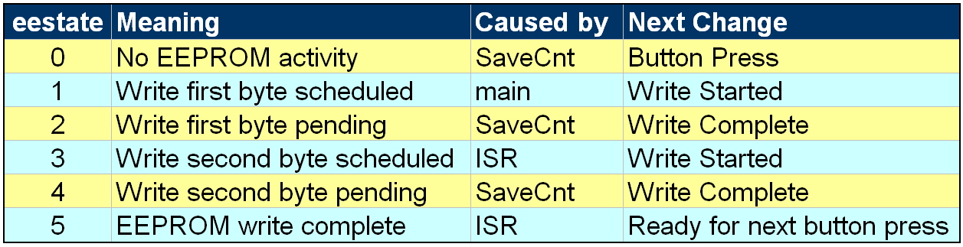
The Button | One detail to handle that wasn’t dealt with before. Since the write will be underway while the main program is looping, care must be taken not to initiate a write while one is already in progress. Since eestate already keeps track of that detail, this is easily handled:  movlw H'10' ; Now check whether PB1 pressed  andwf PORTA,W ;  btfss STATUS,Z ;  goto CheckDirty ; No, see if display dirty  movf eestate,W ; eestate must be zero to  btfss STATUS,Z ; initiate a write  goto CheckDirty ; not = 0, don't write  movlw h'01' ; Schedule a write because  movwf eestate ; we have a value to save
Calling SaveCnt | One “trick” that wasn’t mentioned in our definition of eestate. We have chosen to define it in such a way that our EEPROM handling routine gets called whenever the value of eestate is odd:  btfsc eestate,0 ; We call SaveCnt when bit 0  call SaveCnt ; is set (eestate = 1, 3, 5)
 | Continued on next page
Multiple Interrupt Sources, Continued
SaveCnt | The SaveCnt routine is called whenever eestate is odd. The routine will need to check this value and:  1 – Turn on LED and write first byte  3 – Write second byte  5 – Turn off LED and set eestate to 0  We can do this simply with a table:  movlw HIGH(SaveCnt) ; Setup PCLATH for  movwf PCLATH ; table call  rrf eestate,W ; Need to check only bits  andlw H'03' ; 1 and 2  addwf PCL,F ; Jump  goto FirstByte ; 1 (0)=First byte  goto NextByte ; 3 (1)=Second byte  goto Clearit ; 5 (2)=Done  Note that we know the value is odd since that is the only way we can get here, so we divide eestate by two and mask it (for safety) before adding it to the PCL.  The FirstByte and NextByte routines will be the same except for the locations used in the file register and EEPROM. For only two bytes, it isn’t worthwhile to try to index these through the FSR, so we will simply duplicate the first part of the code, and then jump to common code:  FirstByte  movlw H'06' ; Top LED on  movwf PORTB ; to indicate write in  movwf LEDflg ; progress  banksel EECON1 ; Check to be sure a write  btfsc EECON1,WR ; is not already in progress return ; Yes, we'll be back  movlw SAVADR ; Set address in EEPROM  banksel EEADR  movwf EEADR ; to be written  banksel binary  movf binary,W ; Set data to be written  banksel EEDATA  movwf EEDATA ;  goto ContWrite  Note that the top LED is turned on by setting a value in LEDflg, this is something not done for the second byte. For the second byte, SAVADR+1 and binary+1 are used, but otherwise the code is the same. Note that EECON1 is in bank 1, so a banksel is necessary before writing to it. Afterwards, switch back to bank 0. Again, some redundant bank switches are included in the code for clarity.  For both bytes we then jump to:
 | Continued on next page
Multiple Interrupt Sources, Continued
SaveCnt (continued) | ContWrite  banksel EECON1 ;  bcf INTCON,GIE ; Turn off interrupts  bsf EECON1,WREN ; Enable write  movlw H'55' ; This sequence is  movwf EECON2 ; required before the  movlw H'AA' ; EEPROM may be written  movwf EECON2 ;  bsf EECON1,WR ; Start write  bsf INTCON,EEIE ; Enable EEPROM Interrupt  bsf INTCON,GIE ; Re-enable interrupts  Note that interrupts are disabled while writing the H’55’ and H’AA’ to EECON2. This sequence must be performed exactly in order for the write to occur. An interrupt during this sequence would cause the write to fail. After writing the 55 and AA as we did in the non-interrupt version, the EEPROM write completion interrupt is enabled:  banksel eestate  incf eestate,F ; Ready for next step  When the write is complete, we want to disable the EEPROM interrupt, reset eestate to zero, and turn off the LED:  Clearit  bcf INTCON,EEIE ; Disable EEPROM Interrupt  clrf eestate ; Return to state 0  movlw H'0e' ; All LEDs off  movwf PORTB  movwf LEDflg  In the above cases, the various errorlevel directives have been omitted for clarity. When they are left out, a number of assembler warnings will be generated. These warnings occur whenever a non-bank 0 location is accessed, whether or not the bank bits have been set correctly.
The Interrupt Service Routine | The interrupt service routine (ISR) must still handle the timer, but it must also deal with the EEPROM interrupt. The interrupt flags must be tested to determine which interrupt caused the ISR to be called:  btfss INTCON,T0IF ; Timer interrupt flag  goto IRQEEPROM ; No, go check EEPROM  When the EEPROM interrupt is recognized, all that is required is to increment eestate (and, of course, clear the interrupt flag):  bcf IFREG,EEIF ; Clear the interrupt flag  incf eestate,F ; Remember we handled it
 | Continued on next page
Multiple Interrupt Sources, Continued
Overall EEPROM Flow | Handling multiple bytes can get a little confusing. The following figure shows the overall flow of the program logic:  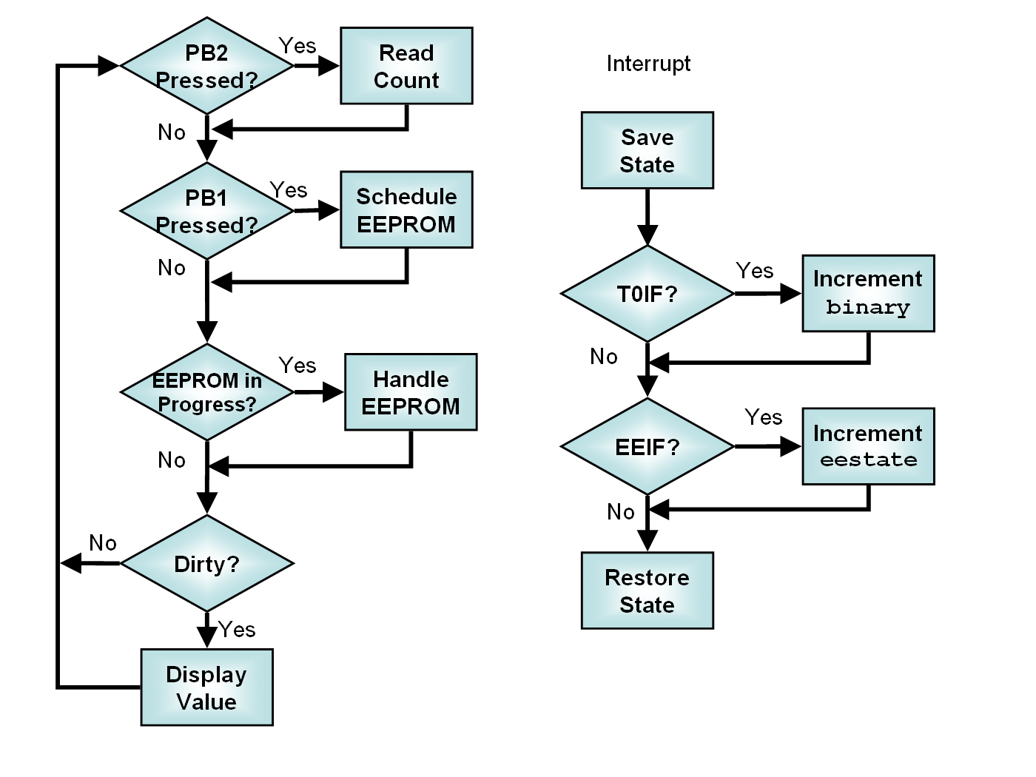  As in the previous example, we set the dirty flag whenever we update the count, and clear the dirty flag whenever we have displayed the count.  Note that the ISR has been kept as simple as possible. Whenever dealing with interrupts, the time that the interrupts are disabled should be kept as short as possible. Since interrupts are disabled while processing an interrupt, this means that the ISR should be as short as possible. Interrupts are also disabled while setting up the EEPROM writes. This was necessary since part of that sequence is critical. However, rather than disabling interrupts for the entire time, we only disabled them for the minimum time necessary. This delay in updating the count is unlikely to be noticed in our application. Note, however, that the TMR0 register continues counting, so while the display update might be put off for a short time, there is no cumulative error in the count.
 | Continued on next page
Multiple Interrupt Sources, Continued
Testing the Code | The modules that must be included in the project are very similar to the previous exercise, except for the main, the use of the more elaborate ISR, and the more elaborate EEPROM routine:  - Source files:  - ConvBCD2  - Disp16  - InitTMR0  - ISRc  - L20c  - RestCnt  - SaveCntC  - Library files:  - LCDlib_84A  - Linker Scripts  - Lesson20  As before, one should be careful to test all the conditions that might be encountered. Watch to see that the values increment into the second byte, store and restore the count, observe the LED behavior when storing and restoring, and be sure to test restoring a value less than 255 when the count is greater, and a value greater than 255 when the count is less. (Since the value is saved in EEPROM, the stored value should be preserved across reset and power down).

Additional Experiments
Introduction | The PIC-EL does not have inputs on the pins that may be used for other interrupts, so we were unable to run experiments demonstrating the RB0/INT and PORTB change interrupts. However, in Lesson 19, we built a board with a PIC16F87x which has some of those pins free.
RB0/INT | The RB0/INT interrupt allows the PIC to be interrupted when a transition is detected on the RB0 pin (pin 21 on the 872/3/6). This pin is free on the test circuit. The student wishing to test this interrupt might add some circuitry to this pin, perhaps a low speed oscillator such as a 555 to experiment with this interrupt.  Note that the pin is triggered either on a rising or falling edge, selectable by the program.
PORTB Change | The PORTB Change interrupt, when enabled, causes an interrupt whenever the input to bits 4 through 7 of PORTB are changed. The experimental board leaves bits 4 and 5 open, and bits 6 and 7 are only used for programming, so they may be used for the experiment provided they are lightly loaded during programming. Using a normally open pushbutton with a high-value pullup would be one way to do this.
Other Interrupts | In addition to the interrupts shared with the PIC16F84A, the PIC16F87x family has a number of other interrupts. There are two additional timers, each of which has an interrupt, there are two capture/compare ports which also have interrupts. These parts contain a serial port which can also notify the program of completion via an interrupt.  One of the more interesting interrupts is the A/D completion interrupt. Since we experimented with the A/D in Lesson 19, the interested student might modify the Lesson 19 code to utilize this interrupt.

Wrap Up
Summary | In this lesson we have examined interrupts on the PIC16F84A, and learned how to write to the EEPROM. Both the timer interrupt and the EEPROM write completion interrupt have been used in the examples. The PIC-EL hardware doesn’t give us an opportunity to test the 84A’s other two interrupt sources, the INT interrupt (transition of RB0) and the PORT B interrupt (change in bits 4-7).  Although there are a few things that must be considered, interrupt processing is not terribly difficult, and in some cases, can simplify our code. Interrupts allow writing code that is more responsive to external events, and avoid spending precious compute cycles polling for an event.
Coming Up | In the next lesson, these same 3 exercises will be ported to other processors. Virtually any 18 pin PIC can be used in the PIC-EL, but two of them, the PIC16F54 and the PIC16F716 do not have the on-chip resources to perform the exercises. Both lack EEPROM, and the 54 does not have enough memory.  The student wishing to perform the exercises in the next lesson might want to pick up a PIC16F628. The lesson will also examine the 648A, 819 and 88, however those parts are not supported by FPP, so other programming software must be selected. Your author uses DL4YHF’s WinPIC for those parts, but there are a large number of choices which can be configured to work with the PIC-EL. The interested student who has installed WinPIC might browse the catalogs of some parts suppliers and pick up other 18 pin PICs that look as if they might be candidates for future projects and can be had at attractive prices.

