#NBVAL_IGNORE_OUTPUT  
# Adding ignore due to (probably an np notebook magic) bug  
import numpy as np  
import matplotlib.pyplot as plt  
%matplotlib inline  
import pandas as pd

from devito import *

#NBVAL_IGNORE_OUTPUT  
from examples.seismic import Model, plot_velocity

from examples.seismic import Model, plot_velocity

import numpy as np  
import pandas as pd  
  
def capas_pre_devito(vel_original, no_capas, shape_z):  
 '''  
 Función para calcular la matriz de capas de entrada para hacer el campo de velocidades para devito  
 La entrada vel_original debe ser un dataframe con las siguientes columnas ['DEPTH', 'ACOUSTIC_INTERVAL_VEL', 'DELTA_DEPTH']  
 no_capas: Las capas que deseo para mi modelo  
 Shape_z= la dimención de  
 '''  
   
   
 depth_max = vel_original['DEPTH'].max()  
 intervalo = round(depth_max / (no_capas - 1), 2)  
   
 new_depth = np.arange(0, depth_max, intervalo)  
 new_df = pd.DataFrame({'DEPTH': new_depth})  
   
 # Interpolación de los valores de velocidad acústica  
 new_df['ACOUSTIC_INTERVAL_VEL'] = np.interp(new_df['DEPTH'], vel_original['DEPTH'], vel_original['ACOUSTIC_INTERVAL_VEL'])  
   
 # Cálculo de CAPA_INFERIOR  
 new_df['CAPA_INFERIOR'] = new_df['DEPTH'] + intervalo / 2  
 new_df.iloc[-1, new_df.columns.get_loc('CAPA_INFERIOR')] = new_df['DEPTH'].iloc[-1]  
   
 # Cálculo de FILA_INF  
 new_df['FILA_INF'] = np.round(new_df['CAPA_INFERIOR'] * (shape_z - 1) / depth_max + 1).astype(int)  
   
 # Creación de las capas con FILA_INF y ACOUSTIC_INTERVAL_VEL  
 capas = list(zip(new_df['FILA_INF'], new_df['ACOUSTIC_INTERVAL_VEL'] / 1000))  
   
 return capas

import numpy as np  
import pandas as pd  
  
def capas_pre_devito(vel_original, no_capas, shape_z):  
 '''  
 Función para calcular la matriz de capas de entrada para hacer el campo de velocidades para devito  
 La entrada vel_original debe ser un dataframe con las siguientes columnas ['DEPTH', 'ACOUSTIC_INTERVAL_VEL', 'DELTA_DEPTH']  
 no_capas: Las capas que deseo para mi modelo  
 Shape_z= la dimención de  
 '''  
   
   
 depth_max = vel_original['DEPTH'].max()  
 intervalo = round(depth_max / (no_capas - 1), 2)  
 vel_final= vel_original['ACOUSTIC_INTERVAL_VEL'].iloc[-1]  
   
 new_depth = np.arange(0, depth_max, intervalo)  
 new_df = pd.DataFrame({'DEPTH': new_depth})  
   
 # Interpolación de los valores de velocidad acústica  
 new_df['ACOUSTIC_INTERVAL_VEL'] = np.interp(new_df['DEPTH'], vel_original['DEPTH'], vel_original['ACOUSTIC_INTERVAL_VEL'])  
   
 # Cálculo de CAPA_INFERIOR  
 new_df['CAPA_INFERIOR'] = new_df['DEPTH'] + intervalo / 2  
 new_df.iloc[-1, new_df.columns.get_loc('CAPA_INFERIOR')] = new_df['DEPTH'].iloc[-1]  
   
 # Cálculo de FILA_INF  
 new_df['FILA_INF'] = np.round(new_df['CAPA_INFERIOR'] * (shape_z - 1) / depth_max + 1).astype(int)  
 if len(new_df) !=no_capas:  
   
   
 last_row = new_df.iloc[-1]  
 new_row = pd.DataFrame([last_row], columns=new_df.columns)  
 new_row['FILA_INF']=shape_z  
 new_row['ACOUSTIC_INTERVAL_VEL']=vel_final  
 new_row['DEPTH']=depth_max  
 new_row['CAPA_INFERIOR']=depth_max  
 new_df = pd.concat([new_df, new_row], ignore_index=True)  
   
   
   
 # Creación de las capas con FILA_INF y ACOUSTIC_INTERVAL_VEL  
 capas = list(zip(new_df['FILA_INF'], new_df['ACOUSTIC_INTERVAL_VEL'] / 1000))  
   
 #return new_df  
 return capas

def campo_velocidades_devito(shape, capas):  
 """  
 Genera un campo de velocidades con un número variable de capas.  
  
 Parameters:  
 - shape: Tuple que define la forma de la matriz (número de filas, número de columnas).  
 - capas: Lista de tuplas, donde cada tupla contiene dos valores:  
 (profundidad_final, velocidad), siendo profundidad_final la columna final de la capa  
 y velocidad la velocidad asignada a esa capa.  
  
 Returns:  
 - Vel_Devito: Matriz numpy con el campo de velocidades.  
 """  
 Vel_Devito = np.empty(shape, dtype=np.float32)  
   
 # Inicializar el índice inicial en 0  
 indice_inicial = 0  
   
 for profundidad_final, velocidad in capas:  
 Vel_Devito[:, indice_inicial:profundidad_final] = velocidad  
 indice_inicial = profundidad_final  
   
 return Vel_Devito

def print_registro(model,cant_capas):  
   
 #NBVAL_IGNORE_OUTPUT  
 from examples.seismic import RickerSource  
 f0 = 0.010 # Source peak frequency is 10Hz (0.010 kHz)  
 src = RickerSource(name='src', grid=model.grid, f0=f0,  
 npoint=1, time_range=time_range)  
  
 # First, position source centrally in all dimensions, then set depth  
 src.coordinates.data[0, :] = np.array(model.domain_size) * .5  
 src.coordinates.data[0, -1] = 20. # Depth is 20m  
  
 # We can plot the time signature to see the wavelet  
 #src.show()  
  
  
  
 f0 = 0.010 # Source peak frequency is 10Hz (0.010 kHz)  
 src = RickerSource(name='src', grid=model.grid, f0=f0,  
 npoint=1, time_range=time_range)  
  
 # First, position source centrally in all dimensions, then set depth  
 src.coordinates.data[0, :] = np.array(model.domain_size) * .5  
 src.coordinates.data[0, -1] = 20. # Depth is 20m  
  
  
 # We can plot the time signature to see the wavelet  
 #src.show()  
  
  
  
 f0 = 0.010 # Source peak frequency is 10Hz (0.010 kHz)  
 src = RickerSource(name='src', grid=model.grid, f0=f0,  
 npoint=1, time_range=time_range)  
  
 # First, position source centrally in all dimensions, then set depth  
 src.coordinates.data[0, :] = np.array(model.domain_size) * .5  
 src.coordinates.data[0, -1] = 20. # Depth is 20m  
  
 # We can plot the time signature to see the wavelet  
 #src.show()  
  
  
 #NBVAL_IGNORE_OUTPUT  
 from examples.seismic import Receiver  
  
 # Create symbol for 101 receivers  
 rec = Receiver(name='rec', grid=model.grid, npoint=101, time_range=time_range)  
  
 # Prescribe even spacing for receivers along the x-axis  
 rec.coordinates.data[:, 0] = np.linspace(0, model.domain_size[0], num=101)  
 rec.coordinates.data[:, 1] = 20. # Depth is 20m  
  
 # We can now show the source and receivers within our domain:  
 # Red dot: Source location  
 # Green dots: Receiver locations (every 4th point)  
 #plot_velocity(model, source=src.coordinates.data,  
 # receiver=rec.coordinates.data[::4, :])  
  
  
  
 from devito import TimeFunction  
 # Define the wavefield with the size of the model and the time dimension  
 u = TimeFunction(name="u", grid=model.grid, time_order=2, space_order=2)  
  
 # We can now write the PDE  
 pde = model.m * u.dt2 - u.laplace + model.damp * u.dt  
  
 # The PDE representation is as on paper  
 #pde  
  
  
 # This discrete PDE can be solved in a time-marching way updating u(t+dt) from the previous time step  
 # Devito as a shortcut for u(t+dt) which is u.forward. We can then rewrite the PDE as   
 # a time marching updating equation known as a stencil using customized SymPy functions  
 from devito import Eq, solve  
  
 stencil = Eq(u.forward, solve(pde, u.forward))  
 #stencil  
  
  
  
 # Finally we define the source injection and receiver read function to generate the corresponding code  
 src_term = src.inject(field=u.forward, expr=src * dt**2 / model.m)  
  
 # Create interpolation expression for receivers  
 rec_term = rec.interpolate(expr=u.forward)  
  
  
 #NBVAL_IGNORE_OUTPUT  
 from devito import Operator  
  
 op = Operator([stencil] + src_term + rec_term, subs=model.spacing_map)  
  
  
 #NBVAL_IGNORE_OUTPUT  
 op(time=time_range.num-1, dt=model.critical_dt)  
  
  
 #NBVAL_IGNORE_OUTPUT  
 from examples.seismic import plot_shotrecord  
   
   
 fig, ax = plt.subplots(figsize=(4, 2))  
  
 # Configurar el texto  
 ax.text(0.5, 0.5, f'Registro correspondiente a un modelo de {cant_capas} capas', fontsize=30, ha='center', va='center', color='blue')  
  
 # Configurar el estilo del gráfico  
 ax.set_xlim(0, 1)  
 ax.set_ylim(0, 1)  
 ax.axis('off') # Ocultar ejes  
  
 # Mostrar el gráfico  
 plt.show()  
   
   
  
 plot_shotrecord(rec.data, model, t0, tn)

Vel_Pozo= pd.read_csv('vel_pozo_edit.csv')

depth_max=Vel_Pozo.DEPTH.max()  
depth_max

np.float64(2506.17228)

# Define a physical size  
shape = (101, 101) # Number of grid point (nx, nz)  
dz=depth_max/(shape[1]-1)  
dz

np.float64(25.0617228)

dx=dz  
ncapas=2

capas=capas_pre_devito(Vel_Pozo,ncapas,shape[1])  
capas

[(51, 2.1070824), (101, 4.42668286624203)]

# Define a physical size  
  
spacing = (dx, dz) # Grid spacing in m. The domain size is now 1km by 1km  
origin = (0., 0.) # What is the location of the top left corner. This is necessary to define  
# the absolute location of the source and receivers

capas=capas_pre_devito(Vel_Pozo,ncapas,shape[1])  
capas

[(51, 2.1070824), (101, 4.42668286624203)]

v=v = campo_velocidades_devito(shape, capas)

# With the velocity and model size defined, we can create the seismic model that  
# encapsulates this properties. We also define the size of the absorbing layer as 10 grid points  
model = Model(vp=v, origin=origin, shape=shape, spacing=spacing,  
 space_order=2, nbl=10, bcs="damp")  
  
plot_velocity(model)

Operator `initdamp` ran in 0.01 s

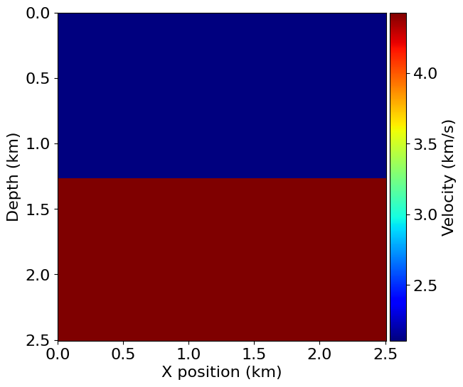

png

from examples.seismic import TimeAxis  
  
t0 = 0. # Simulation starts a t=0  
tn = 2000. # Simulation last 1 second (1000 ms)  
dt = model.critical_dt # Time step from model grid spacing  
  
time_range = TimeAxis(start=t0, stop=tn, step=dt)

print_registro(model,2)

Operator `Kernel` ran in 0.01 s



png

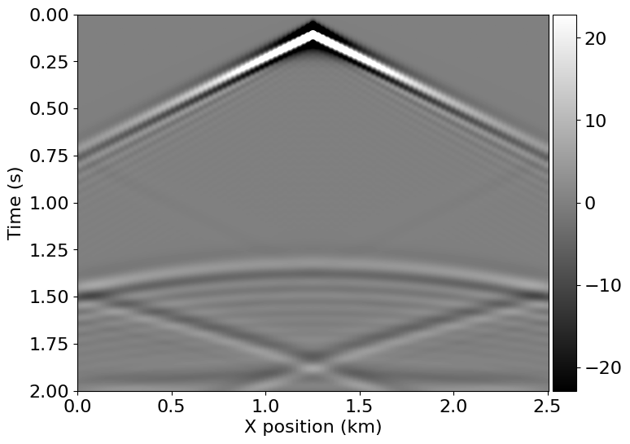

png

# Recurrencia

Vel_Pozo= pd.read_csv('vel_pozo_edit.csv')  
depth_max=Vel_Pozo.DEPTH.max()  
depth_max  
shape = (101, 101) # Number of grid point (nx, nz)  
dz=depth_max/(shape[1]-1)  
dz  
# Define a physical size  
dx=dz  
  
  
spacing = (dx, dz) # Grid spacing in m. The domain size is now 1km by 1km  
origin = (0., 0.) # What is the location of the top left corner. This is necessary to define  
# the absolute location of the source and receivers

Muticapa=[2,4,5,8,10,30,40,80]  
for ncapas in Muticapa:  
   
 capas=capas_pre_devito(Vel_Pozo,ncapas,shape[1])  
   
 v=v = campo_velocidades_devito(shape, capas)  
 # With the velocity and model size defined, we can create the seismic model that  
 # encapsulates this properties. We also define the size of the absorbing layer as 10 grid points  
   
 fig, ax = plt.subplots(figsize=(2, 2)) # Ajusta el tamaño de la figura aquí  
  
 # Configurar el texto  
 ax.text(0.5, 0.5, f'Modelo de {ncapas} capas planas', fontsize=30, ha='center', va='center', color='blue')  
  
 # Configurar el estilo del gráfico  
 ax.set_xlim(0, 1)  
 ax.set_ylim(0, 1)  
 ax.axis('off') # Ocultar ejes  
  
 # Mostrar el gráfico  
 plt.show()  
   
   
   
   
   
 model = Model(vp=v, origin=origin, shape=shape, spacing=spacing,  
 space_order=2, nbl=10, bcs="damp")  
  
 plot_velocity(model)



png

Operator `initdamp` ran in 0.01 s



png



png

Operator `initdamp` ran in 0.01 s

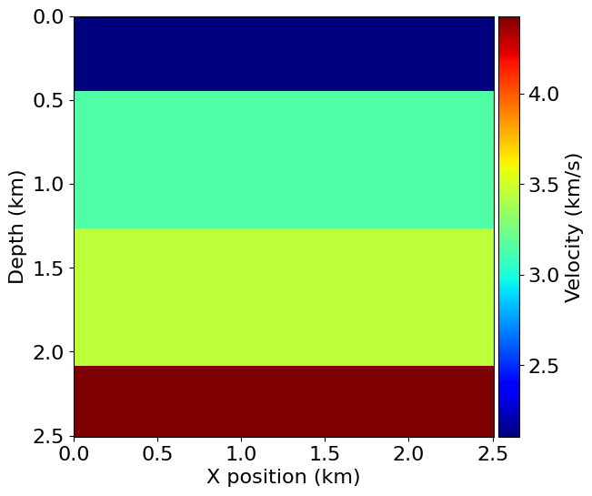

png



png

Operator `initdamp` ran in 0.01 s

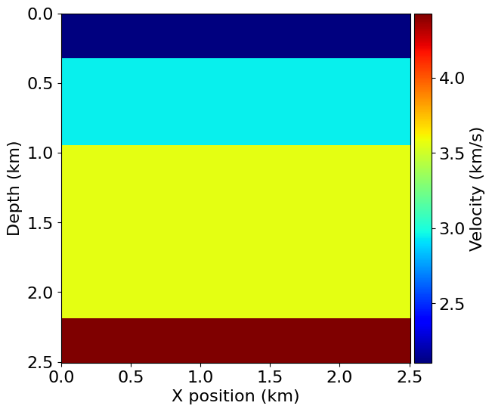

png



png

Operator `initdamp` ran in 0.01 s

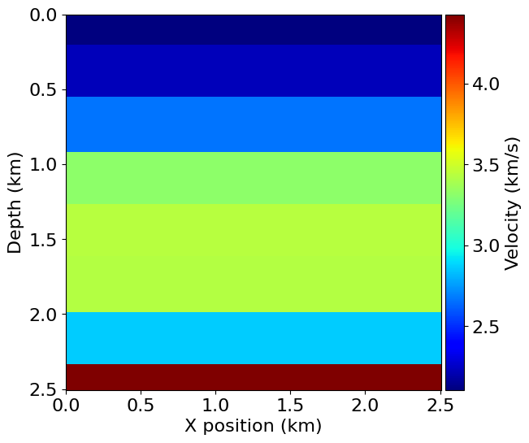

png



png

Operator `initdamp` ran in 0.01 s

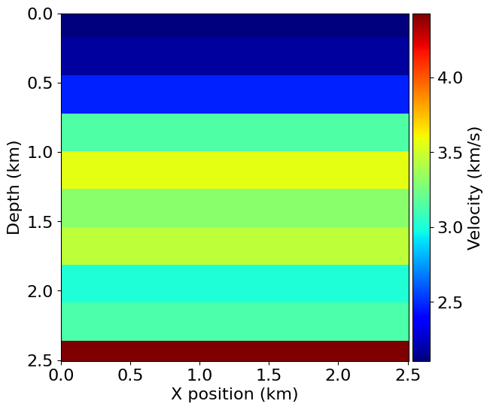

png



png

Operator `initdamp` ran in 0.01 s

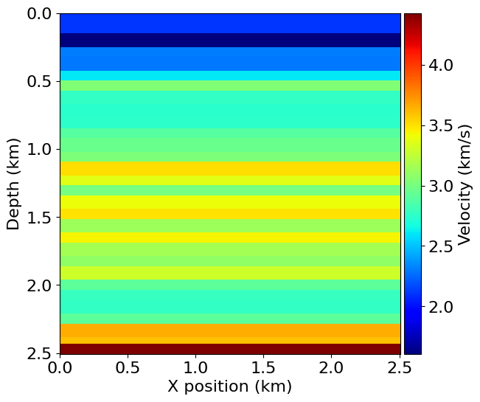

png



png

Operator `initdamp` ran in 0.01 s

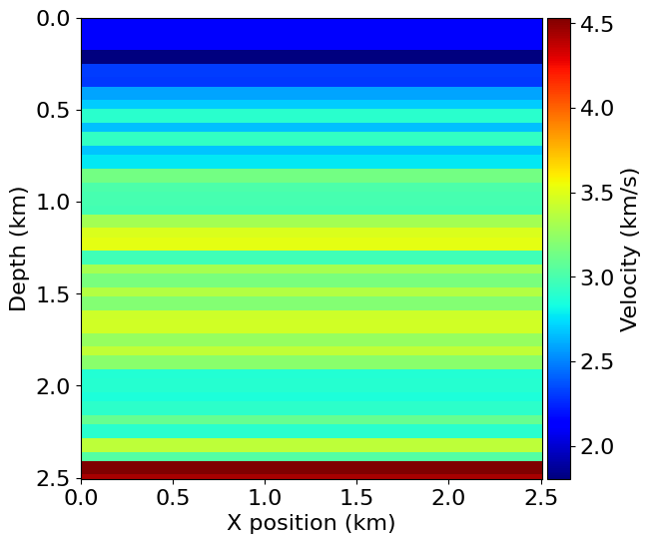

png



png

Operator `initdamp` ran in 0.01 s

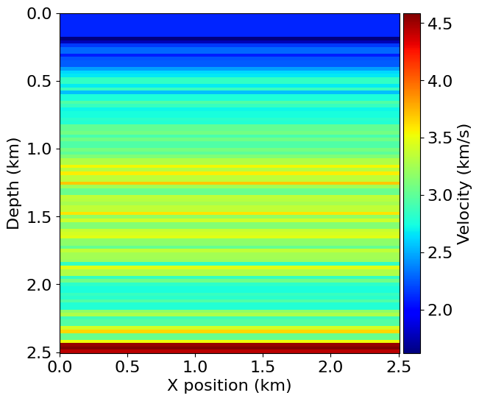

png

for ncapas in Muticapa:  
   
 capas=capas_pre_devito(Vel_Pozo,ncapas,shape[1])  
   
 v=v = campo_velocidades_devito(shape, capas)  
 # With the velocity and model size defined, we can create the seismic model that  
 # encapsulates this properties. We also define the size of the absorbing layer as 10 grid points  
   
   
   
   
   
   
 model = Model(vp=v, origin=origin, shape=shape, spacing=spacing,  
 space_order=2, nbl=10, bcs="damp")  
  
  
  
 from examples.seismic import TimeAxis  
  
 t0 = 0. # Simulation starts a t=0  
 tn = 2000. # Simulation last 1 second (1000 ms)  
 dt = model.critical_dt # Time step from model grid spacing  
  
 time_range = TimeAxis(start=t0, stop=tn, step=dt)  
 print_registro(model,ncapas)

Operator `initdamp` ran in 0.01 s  
Operator `Kernel` ran in 0.01 s



png



png

Operator `initdamp` ran in 0.01 s  
Operator `Kernel` ran in 0.01 s



png

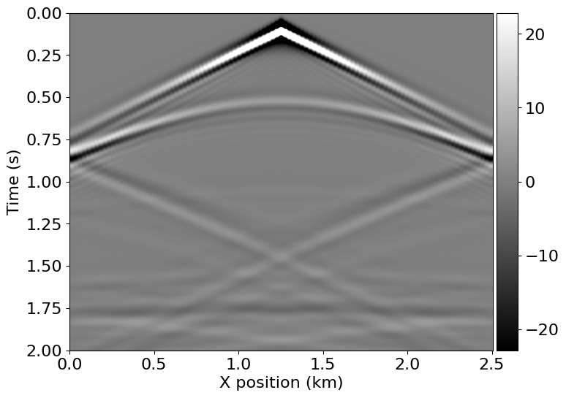

png

Operator `initdamp` ran in 0.01 s  
Operator `Kernel` ran in 0.01 s



png

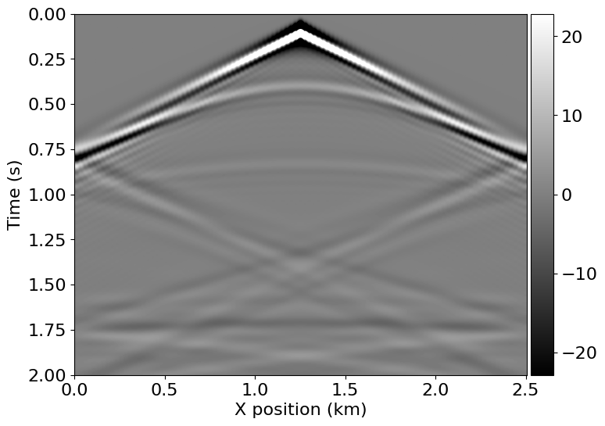

png

Operator `initdamp` ran in 0.01 s  
Operator `Kernel` ran in 0.01 s



png

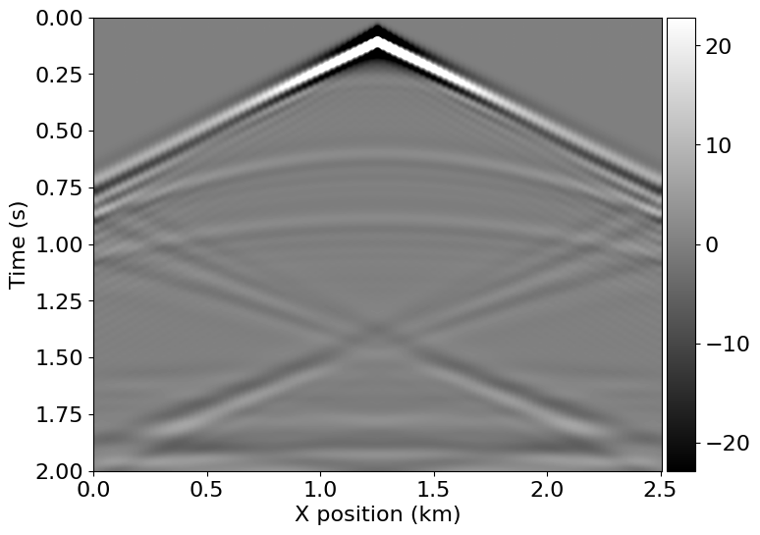

png

Operator `initdamp` ran in 0.01 s  
Operator `Kernel` ran in 0.01 s



png

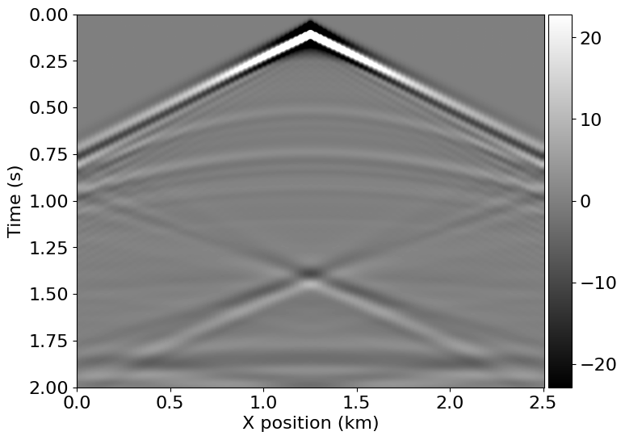

png

Operator `initdamp` ran in 0.01 s  
Operator `Kernel` ran in 0.01 s



png

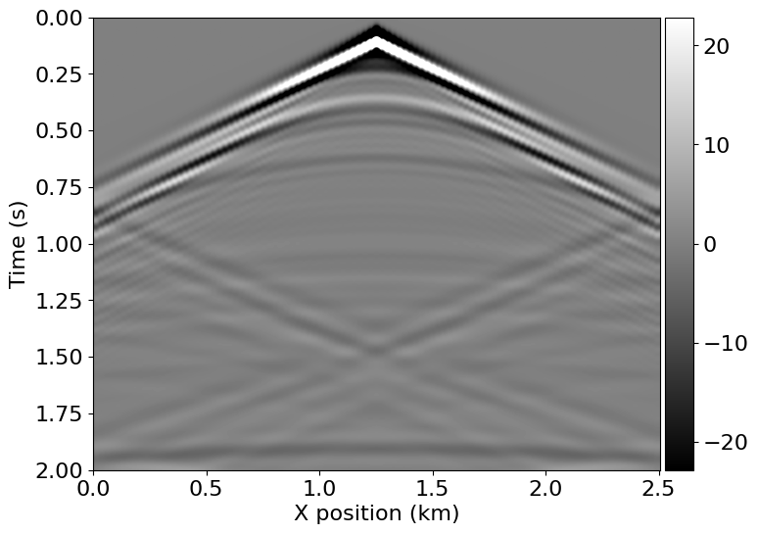

png

Operator `initdamp` ran in 0.01 s  
Operator `Kernel` ran in 0.01 s



png

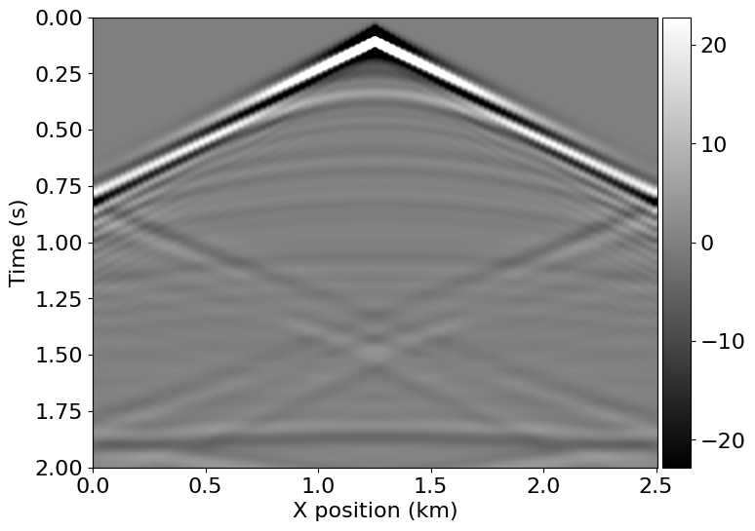

png

Operator `initdamp` ran in 0.01 s  
Operator `Kernel` ran in 0.01 s



png

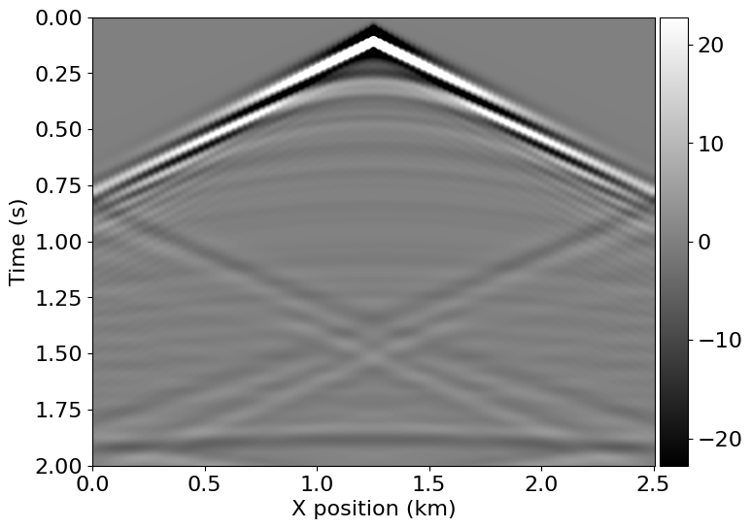

png