Assignment 5—Within Subjects and Higher Order ANOVA & Trend Analysis.

Yudhajit Ain

Student ID: 0123456789

University of Calgary

PSYC 615—Lab

TAs: Benjamin Moon & Christopher Davie

Assignment 5—Within Subjects and Higher Order ANOVA & Trend Analysis.

# Question 1

*From the data directory, please import assignment-5_q1.csv into R.*

data=readr::read_csv(here("data","assignment-5_q1.csv"),  
 col_types = "fffd")

*Background: We are interested in the effect of drinking beer and smoking marijuana on object recall over the course of three days. We collected data from 12 lucky participants who had nothing to do for two weeks. The participants were given a randomly selected set of objects (from a larger potential pool of objects) to memorize at the beginning of two separate weeks of testing. The day after memorization participants were provided either marijuana (1 brownie) or beer (4 pints) and asked to perform an object recall task. The recall task was administered for three consecutive days after administration of the beer/marijuana. The following week the participants performed the same task (based on a new set of randomly selected objects) for the substance that they were not tested on the week previously (i.e. 6 participants were provided beer the first week, marijuana the second week and vice versa).*

*We hypothesize that there will be a significant effect of substance type and day, with no significant interaction. Furthermore, we hypothesize that object recall will be significantly worse on the last day in both substance conditions, compared to the first and second days (separately). Perform the analyses on your data and answer the questions below.*

# Tests for normality  
d1 = dplyr::filter(data,drug=="Marijuana")  
d1d1=tidy(shapiro.test(dplyr::filter(d1,day=="One")$recall))  
d1d2=tidy(shapiro.test(dplyr::filter(d1,day=="Two")$recall))  
d1d3=tidy(shapiro.test(dplyr::filter(d1,day=="Three")$recall))  
d2 = dplyr::filter(data,drug=="Beer")  
d2d1=tidy(shapiro.test(dplyr::filter(d2,day=="One")$recall))  
d2d2=tidy(shapiro.test(dplyr::filter(d2,day=="Two")$recall))  
d2d3=tidy(shapiro.test(dplyr::filter(d2,day=="Three")$recall))  
mario = rbind(d1d1,d1d2,d1d3,d2d1,d2d2,d2d3)  
mario = cbind(tibble::tribble(~Group,"Marijuana, Day 1","Marijuana, Day 2","Marijuana, Day 3","Beer, Day 1","Beer, Day 2","Beer, Day 3"), dplyr::select(mario,1), tibble::tribble(~df,"12","12","12","12","12","12"), dplyr::select(mario,2))  
colnames(mario) = c("Group","Shapiro-Wilk's W","df","Significance")  
  
# Set day contrasts   
c1=c(1,0,-1)  
c2=c(0,1,-1)  
c = cbind(c1,c2)  
contrasts(data$day) = c  
  
# Run full ANOVA  
model <- afex::aov_car(  
 recall ~ drug * day + Error(id/(drug*day)),  
 type = 3,  
 data = data  
)  
  
# See full output (with sphericity tests)  
summary(model)  
#> Warning in summary.Anova.mlm(object$Anova, multivariate = FALSE): HF eps > 1  
#> treated as 1  
#>   
#> Univariate Type III Repeated-Measures ANOVA Assuming Sphericity  
#>   
#> Sum Sq num Df Error SS den Df F value Pr(>F)   
#> (Intercept) 115520 1 6333.8 11 200.6263 2.081e-08 ***  
#> drug 735 1 192.6 11 41.9599 4.565e-05 ***  
#> day 4742 2 94.9 22 549.7295 < 2.2e-16 ***  
#> drug:day 0 2 13.6 22 0.0902 0.9141   
#> ---  
#> Signif. codes: 0 '***' 0.001 '**' 0.01 '*' 0.05 '.' 0.1 ' ' 1  
#>   
#>   
#> Mauchly Tests for Sphericity  
#>   
#> Test statistic p-value  
#> day 0.98443 0.92451  
#> drug:day 0.98260 0.91597  
#>   
#>   
#> Greenhouse-Geisser and Huynh-Feldt Corrections  
#> for Departure from Sphericity  
#>   
#> GG eps Pr(>F[GG])   
#> day 0.98466 <2e-16 ***  
#> drug:day 0.98290 0.9113   
#> ---  
#> Signif. codes: 0 '***' 0.001 '**' 0.01 '*' 0.05 '.' 0.1 ' ' 1  
#>   
#> HF eps Pr(>F[HF])  
#> day 1.197692 1.655892e-19  
#> drug:day 1.194876 9.141173e-01  
effectsize::omega_squared(model)  
#> # Effect Size for ANOVA (Type III)  
#>   
#> Parameter | Omega2 (partial) | 95% CI  
#> -------------------------------------------  
#> drug | 0.09 | [0.00, 1.00]  
#> day | 0.40 | [0.12, 1.00]  
#> drug:day | -1.62e-04 | [0.00, 1.00]  
#>   
#> - One-sided CIs: upper bound fixed at [1.00].  
cat("\n")  
  
# Do planned comparisons and post-hoc follow-ups  
model_emm_day = emmeans::emmeans(model,specs="day")  
model_emm_drug = emmeans::emmeans(model,specs="drug")  
  
model_emm_day  
#> day emmean SE df lower.CL upper.CL  
#> One 47.8 3.02 11 41.1 54.4  
#> Two 43.6 2.75 11 37.5 49.6  
#> Three 28.8 2.76 11 22.7 34.9  
#>   
#> Results are averaged over the levels of: drug   
#> Confidence level used: 0.95  
model_emm_drug  
#> drug emmean SE df lower.CL upper.CL  
#> Marijuana 36.9 3.11 11 30.0 43.7  
#> Beer 43.2 2.61 11 37.5 49.0  
#>   
#> Results are averaged over the levels of: day   
#> Confidence level used: 0.95  
  
model_emm_day_contrast = emmeans::contrast(  
 model_emm_day,  
 method = list("Day 1 - Day 3"=c1, "Day 2 - Day 3"=c2),  
 adjust = "bonferroni",  
 infer = TRUE  
)  
  
model_emm_day_contrast=dplyr::mutate(broom::tidy(model_emm_day_contrast),  
 d_z = statistic/sqrt(df+1))  
  
model_emm_day_contrast  
#> # A tibble: 2 × 9  
#> term contrast null.value estimate std.error df stati…¹ adj.p.…² d_z  
#> <chr> <chr> <dbl> <dbl> <dbl> <dbl> <dbl> <dbl> <dbl>  
#> 1 day Day 1 - Day 3 0 18.9 0.633 11 29.9 1.39e-11 8.62  
#> 2 day Day 2 - Day 3 0 14.8 0.569 11 25.9 6.52e-11 7.48  
#> # … with abbreviated variable names ¹​statistic, ²​adj.p.value  
  
  
  
  
# t.test(recall~day,data=dplyr::filter(d1,day=="One" | day=="Three"),paired=TRUE)  
# t.test(recall~day,data=dplyr::filter(d1,day=="Two" | day=="Three"),paired=TRUE)  
# t.test(recall~day,data=dplyr::filter(d2,day=="One" | day=="Three"),paired=TRUE)  
# t.test(recall~day,data=dplyr::filter(d2,day=="Two" | day=="Three"),paired=TRUE)

## Question 1a

*Why do we need to test for Sphericity? What part of the ANOVA is corrected when we have a violation of sphericity and how does this influence our p value (2 marks)?*

The assumption of sphericity (for WS-ANOVA) stands in for the assumptions of independence and homogeneity of variance (for BS-ANOVA). Violations of sphericity can lead to inflated F-ratio estimates, making type-I errors more likely. The degrees of freedom for the critical- value is adjusted with multiplication by the appropriate when there is violation of sphericity. This decreases the critical -value (or -threshold) for significance, and reduces power, compared to the sphericity-assumed estimate.

## Question 1b

*Why is one of Mauchly’s W statistic and p-value missing from your output (1 mark)?*

Mauchly’s test for sphericity is missing for the within-subjects variable drug because there were only two levels. There must be at least three levels for Mauchly’s test to be applicable.

## Question 1c

*Based on the Mauchly’s test output, would you proceed with the planned contrasts required to test the hypotheses? Why or why not? (2 marks). Hint: You must provide reasoning for each of the main effects to receive full marks.*

We find significant main effects of both drug and day, and there is no significant violation of sphericity for any of the within-subjects variables, or the interaction between them. Hence, we can safely proceed with the planned contrasts probing the differences between levels of day. As for drug, it has only two levels, and hence neither does the assumption of sphericity apply to it, nor do we need further follow-ups after the omnibus-ANOVA to know the direction of mean difference.

## Question 1d

*What is the best option for a follow-up test when sphericity is violated (1 mark)?*

The best option for follow-up tests when sphericity is violated is to do trend-analysis, since trend-analysis does not assume sphericity.

## Question 1e

*Write an APA formatted results section (10 marks). This includes:*

* *A quick report on the assumptions of normality and sphericity. Hint: you may want to use tables to report these results – if you do, make sure they are APA formatted and that you refer to them in your results section.*
* *reporting the omnibus ANOVA main effects and interaction.*
* *interpreting/reporting appropriate main or simple main effects and follow-up tests.*
* *An APA formatted figure (referenced in text).*
* *Include effect sizes where needed (partial eta-squared is okay).*

# Results

To test if there is a significant effect of drug type or day on participants’ memory recall performance, we decide to run a two-way within-subjects ANOVA (). To make sure the assumption of normality was satisfied for all combinations of levels of our independent variables, we perform a Shapiro-Wilk’s test for every possible combination. The results (table 1) indicate that all groups were normally distributed. We also test for sphericity of the within-subjects variable day, as well as the interaction between day and drug. The Mauchly’s test for sphericity confirmed that there was no significant violation of sphericity for either day () or the interaction between day and drug (). With all assumptions met, we run the omnibus-ANOVA, and find that there is no significant interaction between day and drug (). There is however a significant main effect of Drug (), such that the memory recall performance of participants was better for Beer () compared to Marijuana () across all days. There is also a significant main effect of day () on participants’ memory recall performance. To follow up on the main effect of day, we run our planned contrasts, each at a Bonferroni-corrected -level of , since we test two contrasts. We find that memory recall performance for day 3 () is worse than both day 1 () (), and day 2 () (), across drugs administered (beer or marijuana). These results are visually summarised in figure 1.

apa_table(mario)

Table 1:

**

| Group | Shapiro-Wilk’s W | df | Significance |
| --- | --- | --- | --- |
| Marijuana, Day 1 | 0.92 | 12 | 0.31 |
| Marijuana, Day 2 | 0.93 | 12 | 0.36 |
| Marijuana, Day 3 | 0.90 | 12 | 0.16 |
| Beer, Day 1 | 0.94 | 12 | 0.44 |
| Beer, Day 2 | 0.97 | 12 | 0.94 |
| Beer, Day 3 | 0.94 | 12 | 0.55 |

model_emm = emmeans::emmeans(model,specs="day",by="drug")  
model_emm = broom::tidy(model_emm, conf.int = TRUE)  
source(here("R", "apa_legend.R"))  
ggpubr::ggline(  
 model_emm,  
 x = "day",  
 xlab = "Day",  
 y = "estimate",  
 ylab = "Recall Score",  
 color = "drug",  
 palette = "grey",  
 legend.title = "Drug"  
) +  
 ggplot2::geom_errorbar(  
 aes(ymin = conf.low, ymax = conf.high, color = drug),  
 width = 0.2  
 ) +  
 # Reminder, this is a custom function you have to source. See Help Yourself  
 # Assignment 1 if you forget how to do that.  
 apa_legend(position = "right")

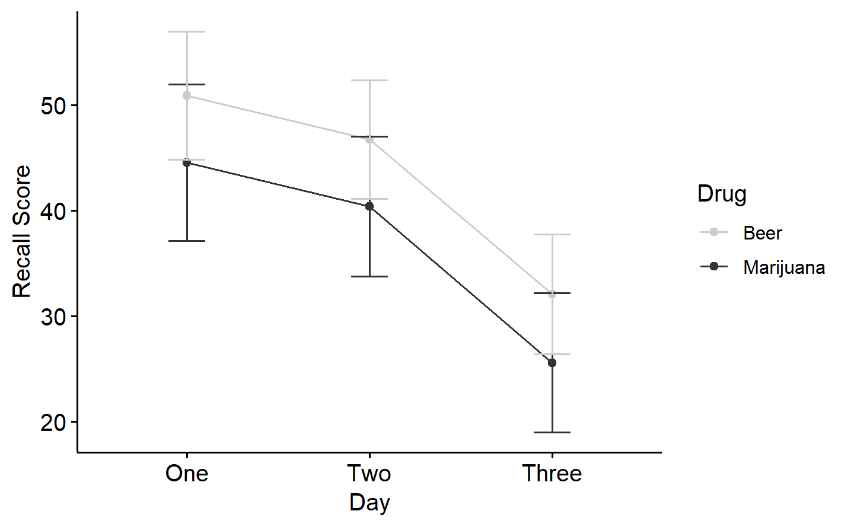

*Figure* *1.*  Effect of drinking beer and smoking marijuana on object recall over the course of three days

# Question 2

*Brittany, a mouthy celiac, had concerns that Kelsey’s experiment from Question 1 (refresh background if needed; 3 [days] x 2 [substance] within-subjects design) was not inclusive for everyone with dietary restrictions (“Beer is full of gluten you know!!”) and decided to replicate the study with a higher quality of marijuana and gluten free alcoholic cider (i.e., a different dataset from Question 1).*

## Question 2a

*The participants were in this study for a total of six days (3 days of marijuana and 3 days of cider). Would it be appropriate to analyze one trend across all six of these days in total? Why or why not? (1 mark)*

It is not appropriate to analyze a single trend across all six days because:

1. A trend analysis will treat the day number (1 to 6) as an ordinal variable. This will imply that day 4 is greater than day 1, day 5 is greater than day 2, and day 6 is greater than day 3. This would be desirable only if we were looking at an effect of being on drugs over days (irrespective of what drug) on memory recall. However, here we are interested in the effects of two separate independent variables (drug and day) on memory recall, and such a trend may be confounded by the effect of drug.
2. Going from day 3 to day 4, there may be a systematic effect of switching from one drug to another - an effect we are not interested in, but which will affect the results of the trend analysis.

## Question 2b

*During the analysis, Brittany found a significant trend interaction between day and substance (alpha level of .05). Referencing Figure 1 and statistics from the SPSS output below, report and describe the appropriate trend for each substance (in APA format) with any necessary corrections. (5 marks)*

# Results

Since there is a significant interaction between day and drug, Brittany decided to look at the simple main effect of day at each level of drug separately, using two separate sets of trend analyses. From the results of the trend analyses, we infer that when participants smoke marijuana, there is a significant quadratic trend in the effect of day on memory recall (), evaluating at an -level of .025). Specifically, when they smoked marijuana, there was a bigger decrease in memory recall performance going from day 1 () to day 2 (), than there was going from day 2 to day 3 (). We also infer that when participants drank cider, there is a significant negative linear trend in the effect of day on memory recall (). Specifically, when they drank cider, memory recall performance decreased consistently going from day 1 () to day 2 () and on to day 3 (). These results are visually summarised in figure 1.

knitr::include_graphics(here("images", "assignment-5_2b-tables.png"))

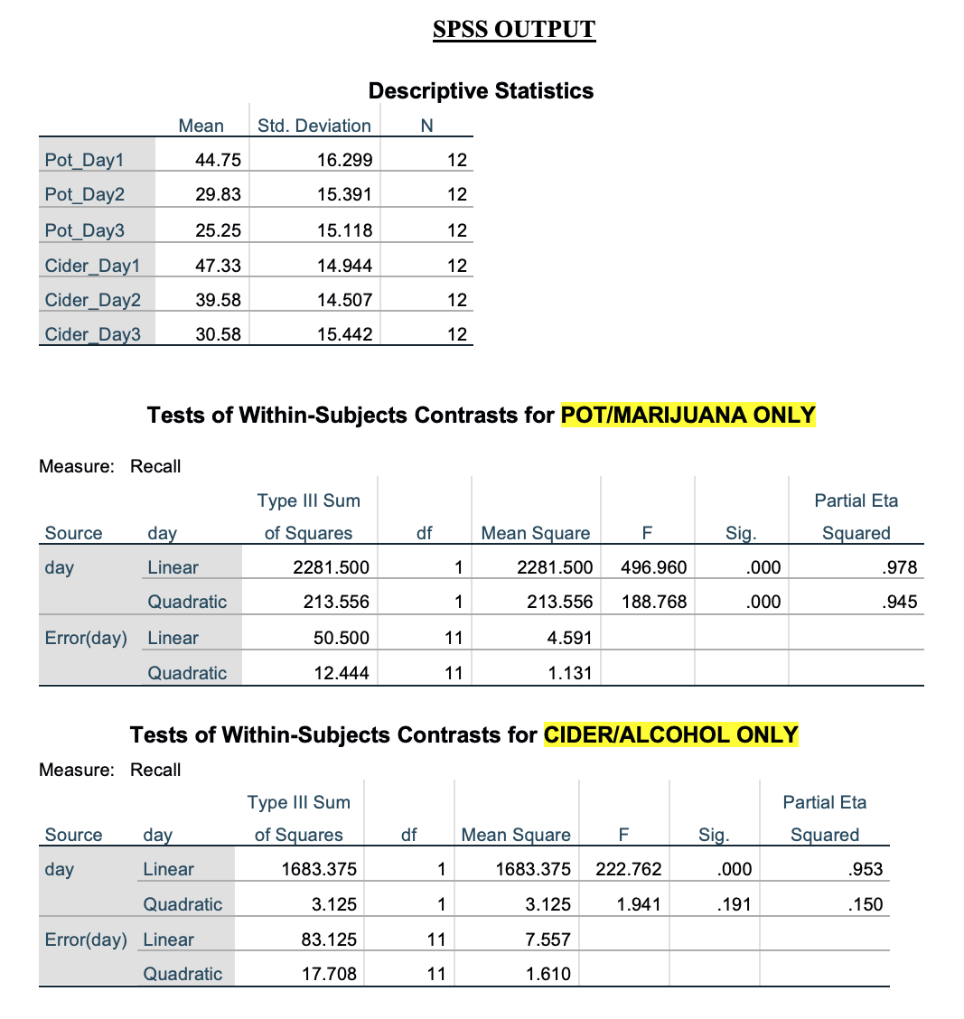

knitr::include_graphics(here("images", "assignment-5_2b-plot.png"))

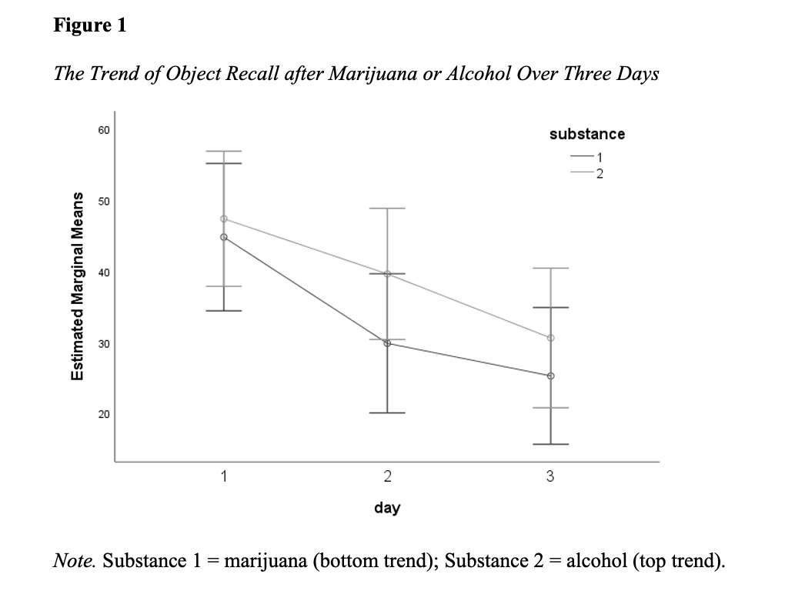

# Bonus

*For Question 2, could we statistically compare the most appropriate trend found for marijuana and the most appropriate trend found for alcohol? Explain why or why not.*

The significant trend in the effect of day for marijuana is quadratic, whereas the significant trend in the effect of day for cider is linear. Since the two significant trends are not of the same polynomial order, there is no meaningful way we can statistically compare the two trends (except looking at their effect sizes).

# All R Output

mget(ls())  
#> $c  
#> c1 c2  
#> [1,] 1 0  
#> [2,] 0 1  
#> [3,] -1 -1  
#>   
#> $c1  
#> [1] 1 0 -1  
#>   
#> $c2  
#> [1] 0 1 -1  
#>   
#> $d1  
#> # A tibble: 36 × 4  
#> id drug day recall  
#> <fct> <fct> <fct> <dbl>  
#> 1 p1 Marijuana One 37  
#> 2 p1 Marijuana Two 34  
#> 3 p1 Marijuana Three 19  
#> 4 p2 Marijuana One 62  
#> 5 p2 Marijuana Two 55  
#> 6 p2 Marijuana Three 41  
#> 7 p3 Marijuana One 37  
#> 8 p3 Marijuana Two 34  
#> 9 p3 Marijuana Three 18  
#> 10 p4 Marijuana One 24  
#> # … with 26 more rows  
#>   
#> $d1d1  
#> # A tibble: 1 × 3  
#> statistic p.value method   
#> <dbl> <dbl> <chr>   
#> 1 0.923 0.308 Shapiro-Wilk normality test  
#>   
#> $d1d2  
#> # A tibble: 1 × 3  
#> statistic p.value method   
#> <dbl> <dbl> <chr>   
#> 1 0.928 0.362 Shapiro-Wilk normality test  
#>   
#> $d1d3  
#> # A tibble: 1 × 3  
#> statistic p.value method   
#> <dbl> <dbl> <chr>   
#> 1 0.901 0.162 Shapiro-Wilk normality test  
#>   
#> $d2  
#> # A tibble: 36 × 4  
#> id drug day recall  
#> <fct> <fct> <fct> <dbl>  
#> 1 p1 Beer One 45  
#> 2 p1 Beer Two 45  
#> 3 p1 Beer Three 27  
#> 4 p2 Beer One 64  
#> 5 p2 Beer Two 56  
#> 6 p2 Beer Three 45  
#> 7 p3 Beer One 46  
#> 8 p3 Beer Two 42  
#> 9 p3 Beer Three 26  
#> 10 p4 Beer One 31  
#> # … with 26 more rows  
#>   
#> $d2d1  
#> # A tibble: 1 × 3  
#> statistic p.value method   
#> <dbl> <dbl> <chr>   
#> 1 0.935 0.437 Shapiro-Wilk normality test  
#>   
#> $d2d2  
#> # A tibble: 1 × 3  
#> statistic p.value method   
#> <dbl> <dbl> <chr>   
#> 1 0.973 0.944 Shapiro-Wilk normality test  
#>   
#> $d2d3  
#> # A tibble: 1 × 3  
#> statistic p.value method   
#> <dbl> <dbl> <chr>   
#> 1 0.944 0.548 Shapiro-Wilk normality test  
#>   
#> $data  
#> # A tibble: 72 × 4  
#> id drug day recall  
#> <fct> <fct> <fct> <dbl>  
#> 1 p1 Marijuana One 37  
#> 2 p1 Marijuana Two 34  
#> 3 p1 Marijuana Three 19  
#> 4 p1 Beer One 45  
#> 5 p1 Beer Two 45  
#> 6 p1 Beer Three 27  
#> 7 p2 Marijuana One 62  
#> 8 p2 Marijuana Two 55  
#> 9 p2 Marijuana Three 41  
#> 10 p2 Beer One 64  
#> # … with 62 more rows  
#>   
#> $mario  
#> Group Shapiro-Wilk's W df Significance  
#> 1 Marijuana, Day 1 0.9226019 12 0.3082066  
#> 2 Marijuana, Day 2 0.9282956 12 0.3623961  
#> 3 Marijuana, Day 3 0.9006426 12 0.1616776  
#> 4 Beer, Day 1 0.9350323 12 0.4365103  
#> 5 Beer, Day 2 0.9734711 12 0.9435520  
#> 6 Beer, Day 3 0.9437655 12 0.5483347  
#>   
#> $model  
#> Anova Table (Type 3 tests)  
#>   
#> Response: recall  
#> Effect df MSE F ges p.value  
#> 1 drug 1, 11 17.51 41.96 *** .100 <.001  
#> 2 day 1.97, 21.66 4.38 549.73 *** .417 <.001  
#> 3 drug:day 1.97, 21.62 0.63 0.09 <.001 .911  
#> ---  
#> Signif. codes: 0 '***' 0.001 '**' 0.01 '*' 0.05 '+' 0.1 ' ' 1  
#>   
#> Sphericity correction method: GG   
#>   
#> $model_emm  
#> # A tibble: 6 × 9  
#> day drug estimate std.error df conf.low conf.high statistic p.value  
#> <chr> <chr> <dbl> <dbl> <dbl> <dbl> <dbl> <dbl> <dbl>  
#> 1 One Marijuana 44.6 3.37 11 37.2 52.0 13.2 4.24e-8  
#> 2 Two Marijuana 40.4 3.02 11 33.8 47.1 13.4 3.78e-8  
#> 3 Three Marijuana 25.6 3.00 11 19.0 32.2 8.53 3.52e-6  
#> 4 One Beer 50.9 2.76 11 44.8 57.0 18.5 1.25e-9  
#> 5 Two Beer 46.8 2.56 11 41.1 52.4 18.3 1.39e-9  
#> 6 Three Beer 32.1 2.58 11 26.4 37.8 12.4 8.07e-8  
#>   
#> $model_emm_day  
#> day emmean SE df lower.CL upper.CL  
#> One 47.8 3.02 11 41.1 54.4  
#> Two 43.6 2.75 11 37.5 49.6  
#> Three 28.8 2.76 11 22.7 34.9  
#>   
#> Results are averaged over the levels of: drug   
#> Confidence level used: 0.95   
#>   
#> $model_emm_day_contrast  
#> # A tibble: 2 × 9  
#> term contrast null.value estimate std.error df stati…¹ adj.p.…² d_z  
#> <chr> <chr> <dbl> <dbl> <dbl> <dbl> <dbl> <dbl> <dbl>  
#> 1 day Day 1 - Day 3 0 18.9 0.633 11 29.9 1.39e-11 8.62  
#> 2 day Day 2 - Day 3 0 14.8 0.569 11 25.9 6.52e-11 7.48  
#> # … with abbreviated variable names ¹​statistic, ²​adj.p.value  
#>   
#> $model_emm_drug  
#> drug emmean SE df lower.CL upper.CL  
#> Marijuana 36.9 3.11 11 30.0 43.7  
#> Beer 43.2 2.61 11 37.5 49.0  
#>   
#> Results are averaged over the levels of: day   
#> Confidence level used: 0.95   
#>   
#> $params  
#> $params$firstname  
#> [1] "Yudhajit"  
#>   
#> $params$lastname  
#> [1] "Ain"  
#>   
#> $params$studentid  
#> [1] "0123456789"  
#>   
#> $params$TAs  
#> [1] "Benjamin Moon & Christopher Davie"  
#>   
#> $params$assignment  
#> [1] 5  
#>   
#> $params$show_output  
#> [1] TRUE