**CS22120: Software Engineering Group Project 10**

Design Specification

Author: Group 10

Conf. Ref: DesignGroup10_doc

Date: 24/3/2021

Version: 0.9

Status: Draft

Department of Computer Science

Aberystwyth University

Aberystwyth  
Ceredigion

SY23 3DB  
Copyright © of Aberystwyth University 2021

**Contents**

1 Introduction **3**

1.1 Purpose of this document 3

1.2 Scope 3

1.3 Objectives 3

2 Decomposition Description **3**

2.1 Programs in system 3

2.2 Significant classes in each program 3

*2.2.1 Significant classes in Program 1* *3*

2.4 Mapping from requirements to classes 4

3 Dependency Description **5**

3.1 Component Diagrams 5

*3.1.1 Component Diagram for program 1* *5*

4 Interface description **6**

4.1 Workout Activity Interface 6

4.2 Workout Config Interface 6

4.3 Exercise Interface 6

4.4 Workout Read Interface 6

4.5 Workout Storage Interface 6

4.6 App Interface 7

4.7 XMLio Interface 7

5 Detailed design **8**

5.1 Sequence diagrams 8

5.2 Significant algorithms 8

5.3 Significant data structures 8

6 References **8**

**7** Document Change History **8**

# 1 Introduction

## 1.1 purpose of this document

The purpose of this document is to provide the Design Specification which describes the different system components and how they fit together to accomplish the application requirements.

## 1.2 Scope

This document provides an accurate translation of the requirements into a clear description of the program components and the relationships between them.

The document should be read by all the group members who have any relation to the Design Specification document [2]. It is assumed the reader is already familiar with the introductory QA document [1] and the Operating Procedures and Configuration Management Standards document [3].

## 1.3 Objectives

The objective of this document is to provide a system description of the following aspects:

* Decomposition description: Programs and modules that make up the system, along with requirements that meet
* Dependency description: Relationships between system components
* Interface description: Information required to use the facilities provided by a module
* Detailed design**:** Further details for the modules whose internal workings are not self-evident).

# 2 Decomposition description

## 2.1 Programs in system

The entire workout application will be developed within the homeExcerciseApp directory that can be found in the project repository.

## 2.2 Significant classes in each program

### 2.2.1 Significant classes in Program 1

The program will be made up using the following classes, which will be divided into three main categories:

Main functionality:

* **App**: It initialises the program and contains the main logic to start-up workouts. This class serves as a bridge between the persistent storage using XML and the classes modelling Exercises and Workouts.
* **WorkoutActivity**: Allows us to keep track of the user workout history. It binds some interesting performance facts as the rest time or the number of exercises with the date on which the workout was performed.

Exercises and workouts:

* **Exercise:** This class models a typical exercise with the required parameters. An enumeration will be used to specify to which stage of the workout this exercise can be part of (Warm-up, Working exercises, Cold Down).
* **WorkoutRoutineConfig:** Workouts with their required parameters will be represented using this class. An enumeration will be used to differentiate them into 4 categories (Beginner, Advanced, LIIT, HIIT and Custom). This classification will be used to attend to the different users described in the User Interface Specification [4].

Persistent storage:

* **XMLio<abstract>**
* **ExerciseAndWorkouts**
* **WorkoutRead**

## 2.4 Mapping from requirements to classes

|  |  |
| --- | --- |
| *Functional Requirements* | *Classes* |
| FR 1 | Start-up | Application. |
| FR 2 | Configuring a set of exercises | Application, WorkoutRead, XMLio & WorkoutRoutineConfig. |
| FR 3 | Options after selecting a set of exercises | Application, WorkoutRead & XMLio |
| FR 4 | Warm up | Application, Exercise & WorkoutActivity. |
| FR 5 | Carrying out exercises | Application, Exercise, WorkoutActivity & WorkoutRead. ??? |
| FR 6 | Cool down | Application, Exercise & WorkoutActivity. |
| FR 7 | Exercise guidance | Exercise. |
| FR 8 | Timing and progress guidance | Application & WorkoutRoutineConfig. |
| FR 9 | Pausing | Application |
| FR 10 | Record Keeping | WorkoutRead & XMLio Class |

# 3 Dependency description

## 3.1 Component Diagrams

### 3.1.1 Component Diagram for program 1

### 

# 4 Interface description

## 4.1 Workout Activity Interface

**Access:** Public

**Methods:**

**public WorkoutActivity**()

This is a constructor method

**public warmUp()**

This method starts the warmup routine.

**public runWk()**

This method starts the main workout routine.

**public coolDown()**

This method starts the cooldown routine,

## 4.2 Workout Routine Config Interface

**Access:** Public

**Methods:**

**WorkoutRoutineConfig()**This is a constructor method.

**getter()**Method to return values of variables in the class.

**setter()**Method to set values of variables in the class.

## 

## 4.3 Exercise Interface

**Access:** Public

**Extended Classes:** No extended classes, this class is used to hold all the relevant information for each exercise. Used to allow the app class to access exercise information easily.

**Methods:**

**public Exercise(Not sure of the parameters)**

This is a constructor method.

**public String getExerciseName()**

This method will return the name of the exercise.

**public String getDescription()**

This method will return the exercise description.

**public getExerciseVideoFile()**

This method will return the exercise video file.

**public ExerciseType getExerciseType()**

This method will return the exercise type.

**public int getExerciseID()**

This method will return the exercise ID.

## 

## 4.4 Workout Read Interface

**Access:** Public

**Methods:**

**public getRecords()**

Returns list of exercises for a given month and year.

This will be used for the drop down selection.

**public getRecord()**

Returns information about a singular Record, including names of workouts performed.

This will be used for looking at a specific exercise

## 

## 4.5 Workout Storage Interface

**Access:** Public

**Extended Classes:** XMLio, it permits to save the data related to the workout history into an structured XML document.

**Methods:**

**public void WorkoutStorage(filename)**Constructor of the class. It requires the filename where the data will be stored.

**public void ExerciseSave(array exerciseListForWO)**It saves to the XML document the information already available when initialising a workout (exercises planned and rest times)

**Public void incQuantity()**This method will be called once per rest period. It allows the system to modify a variable within the XML document responsible for keeping track of the number of exercises completed by the user.

## 4.6 App Interface

**Access:** Public

**Extended Classes:** No extended classes, this class contains the main logic to populate a workout with random exercises and is used to bridge the gap between the persistent storage XML and the classes which model workouts.

**Methods:**

**public void runWk()**This is a method used to start a workout once the user has decided on either a preconfigured workout or configured their own workout.

**public void pauseWk()**Method used to allow the user to pause the workout at any time after it has started.

**Public void resumeWk()**Method used to allow the user to resume a workout anytime after it has been paused.

**Public void exerciseCreation()**This method is used to populate a workout routine with however many random exercises specified by the user when configuring their workout. This method will use the Random class for randomising the exercises.

**Public void workoutConfigCreation()**This method uses the workoutRoutinesConfig class to load preconfigured workouts to the application class so they can be run by the user.

## 4.7 XMLio Interface

**Access:** Public

**Extended Classes:**

*(no parent but intended to be extended to multiple other classes)*

**Methods:**

**Public XMLio(String filename)**

Constructor. This takes a directory as a string for the file to be read or written.

DocumentBuilder and XPathFactory libraries and corresponding instance variables are set up for use.

**Private nodeList xPathQuery(String xPath)**

Queries the file with the xPath parameter given. It uses a single *XPath.evaluate()*, however it is nice to have for abstraction purposes.

## 4.8 ExerciseAndRoutinesLoad

**Access:** Public

**Extended Classes:** XMLio

**Methods:**

**Public void exerciseAndWorkout()**This is a constructor method.

**Public NodeList getExercise()**This is a getter method used to access exercises from the XML document and load to the Exercise class.

**Public NodeList getWorkout()**This is a getter method used to access preconfigured workouts from the XML document and load to the WorkoutRoutineConfig class.

# 

# 

# 5 Detailed design

## 5.1 Sequence diagrams

Sequence for starting a workout:

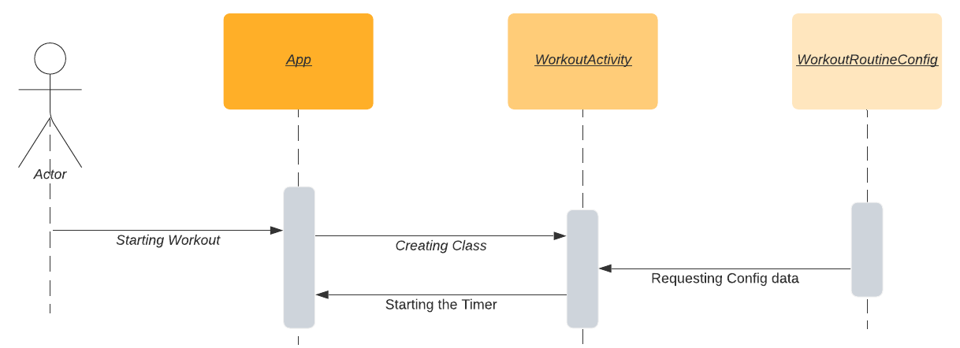

Saving information to File:

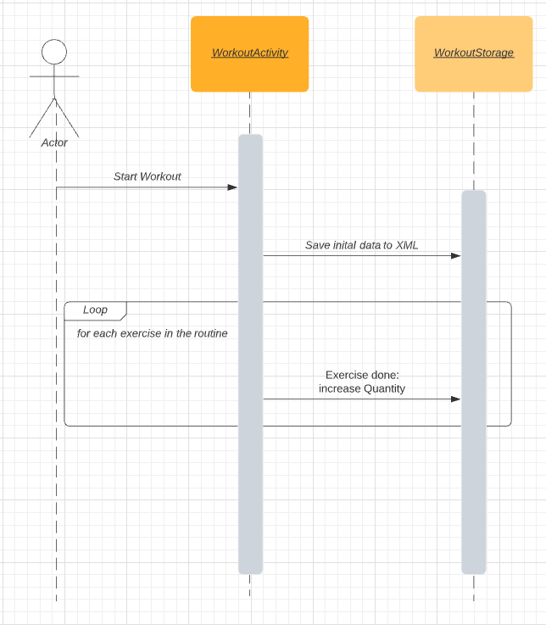

## 

## 

## 

## 

## 

## 

## 

## 

## 

## 

## 

## 5.2 Significant algorithms

**Random selection of exercises**

Algo for random exercise in pseudo / structural code. (need to use random library in java)

1. Workout Starts
2. Randomize the nodelist of exercises.
3. Run through nodelist (or array) of exercises

## 5.3 Significant data structures

NodeList:

While it is not going to be actively used, NodeList is an important data structure to mention. The primary way of querying the XML file is through the function *XPath.evaluate*, and parse the resulting NodeList into a more readable format.

Exercise and WorkoutRoutineConfig:

Exercise and WorkoutRoutineConfig are planned to be a struct-like classes, used to hold information. These will be put into an array in *App* for easy access.

Date:

obtaining the date will be necessary as it’s part of the information to be saved in each record. This is likely going to be done through the use of a library and any data structures that come with it.

# 

# 

# 6 References

[1] QA Document SE.QA.01 – Quality Assurance Plan.

[2] QA Document SE.QA.05 – Design Specification Standards.

[3] QA Document SE.QA.08 – Operating Procedures and Configuration Management Standards.

[4] Software Engineering Group Project 10 - User Interface Specification

# 7 Document Change History

|  |  |  |  |  |
| --- | --- | --- | --- | --- |
| *Version* | *CCF No.* | *Date* | *Changes made to document* | *Changed by* |
| 0.1 | N/A | 23/02/21 | Created layout; Intro section completed. | jmp16 |
| 0.2 | N/A | 10/03/21 | Intro modified; Decomposition description nearly done. | jmp16 |
| 0.3 | N/A | 13/03/21 | Modified document to google docs and added interface sections. | ahz1 |
| 0.4 | N/A | 15/03/21 | Added the Exercise interface specification section. | keg21 |
| 0.5 | N/A | 16/03/21 | Added Component diagram  Created 2.4 Table | isl7/ahz1 |
| 0.6 | N/A | 17/03/21 | Added App class and ExerciseAndWorkoutsLoad class interface specification sections. | keg21 |
| 0.7 | N/A | 18/03/21 | Added 5.3 Significant data structures info | alc72 |
| 0.8 | N/A | 18/03/21 | Added sequence diagram for starting a workout | isl7 |
| 0.9 | 41 | 24/03/21 | Formatted the table of contents | pid8 |