Apache Spark notes

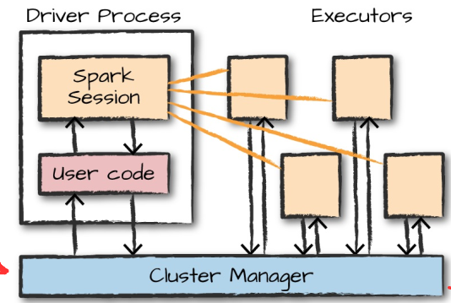
cluster manager that keeps track of the resources available

write Python and R code that Spark translates into code that it then can run on the executor JVM
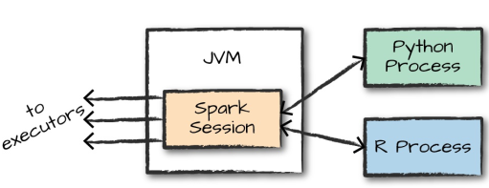

Spark has two fundamental sets of APIs:
the low-level “unstructured” APIs, and the higher-level structured APIs

Partitions
To allow every executor to perform work in parallel, Spark breaks up the data into chunks called
partitions. A partition is a collection of rows that sit on one physical machine in your cluster. A
DataFrame’s partitions represent how the data is physically distributed across the cluster of
machines during execution. If you have one partition, Spark will have a parallelism of only one,
even if you have thousands of executors. If you have many partitions but only one executor,
Spark will still have a parallelism of only one because there is only one computation resource

Transformations
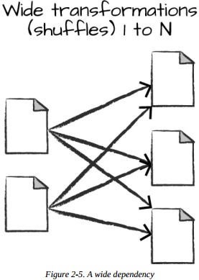
A wide dependency (or wide transformation) style transformation will have input partitions
contributing to many output partitions. (Shuffel) Spark writes the results to disk.

With narrow transformations, Spark will automatically perform an operation called pipelining. In-memory

Lazy evaulation means that Spark will wait until the very last moment to execute the graph of computation instructions.
Spark compiles this plan from your raw DataFrame transformations to a streamlined physical plan that will run as efficiently as
possible across the cluster.

spark.conf.set("spark.sql.shuffle.partitions", "5") // default 200
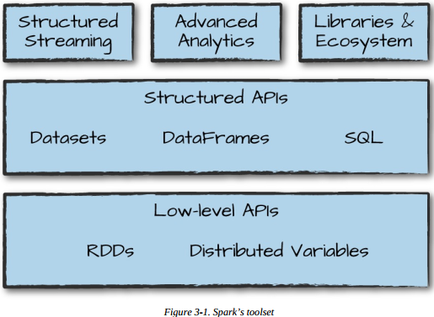
DataFrames: distributed collection of objects of type Row that can hold various types of tabular data

The Dataset API gives users the
ability to assign a Java/Scala class to the records within a DataFrame and manipulate it as a collection of typed objects, similar to a Java ArrayList or Scala Seq. The APIs available on Datasets are type-safe, meaning that you cannot accidentally view the objects in a Dataset as being of another class than the class you put in initially. This makes Datasets especially attractive for writing large applications, with which multiple software engineers must interact through well-defined interfaces. Only in Java and Scala.
The Dataset class is parameterized with the type of object contained inside Dataset[T].
One great thing about Datasets is that you can use them only when you need or want to. For
instance, in the following example, we’ll define our own data type and manipulate it via arbitrary
map and filter functions. After we’ve performed our manipulations, Spark can automatically turn
it back into a DataFrame, and we can manipulate it further by using the hundreds of functions
that Spark includes. This makes it easy to drop down to lower level, perform type-safe coding
when necessary, and move higher up to SQL for more rapid analysis. In Scala use case classes.

