Docker

Containers are specially encapsulated and secured processes running on the host system.
Containers leverage a lot of features and primitives available in the Linux OS. The most important ones are namespaces and cgroups. All processes running in containers share the same Linux kernel of the underlying host operating system. This is fundamentally different compared with VMs, as each VM contains its own full-blown operating system
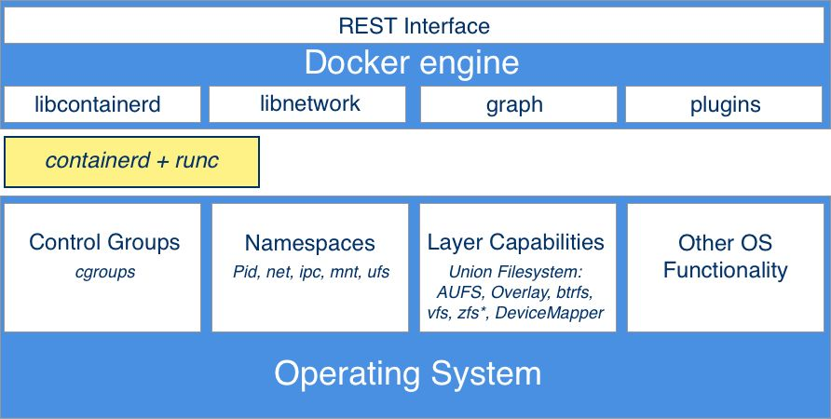
The Docker engine offers a RESTful interface to the outside world that can be accessed by any tool, such as the Docker CLI, Docker for Mac, and Docker for Windows or Kubernetes to just name a few.

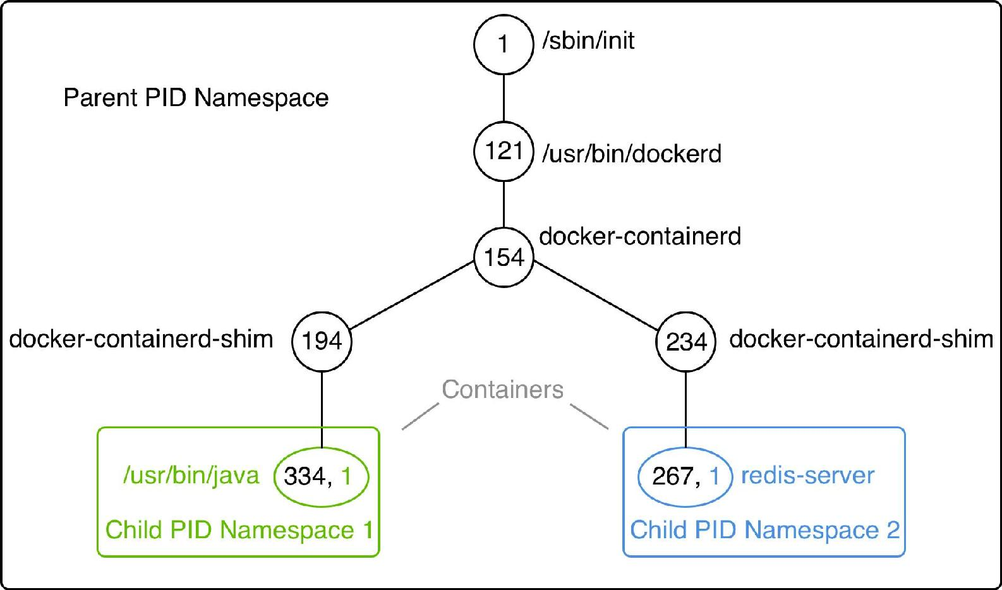
The PID namespace is what keeps processes in one container from seeing or interacting with processes in another container. A process might have the apparent PID 1 inside a container, but if we examine it from the host system, it would have an ordinary PID, say 334:

In a given namespace, we can run one to many processes. That is important when we talk about containers, and we have experienced that already when we executed another process in an already-running container.

Linux cgroups are used to limit, manage, and isolate resource usage of collections of processes running on a system. Using cgroups, administrators can limit the resources that containers can consume. With this, one can avoid, for example, the classical noisy neighbor problem, where a rogue process running in a container consumes all CPU time or reserves massive amounts of RAM and, as such, starves all the other processes running on the host, whether they're containerized or not.

The UnionFS forms the backbone of what is known as container images

In development environment:
connect docker to user account. Check the group of file docker.sock

In /etc/group this has to look like
docker:x:999:john
is NOT then
sudo usermod -a -G docker john
Repositories:
Local or https://hub.docker.com
docker search -s 1000 Ubuntu // search images with at least 1000 stars; image ubuntu
(case-insensitive)
docker images // list installed images
docker ps // what is running; shows also ip-address
// container states: created, restarting, running, removing, paused, exited, or dead
docker ps -a // what was running
docker pull <image-name> // get image from docker hub and install
docker pull centos:centos6 / version 6 of centos
docker pull centos // the latest
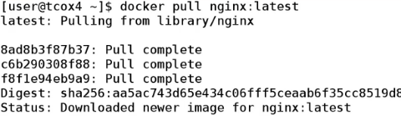
multiple pull requests => multiple layers

docker run docker/whalesay cowsay some text
docker run <IMAGE ID>

docker inspect <image | name> // output is a json with all build info
docker container inspect -f "{{json .State}}" <name> // only state section

docker run -it ubuntu ./bin/bash // run image ubuntu and run command ./bin/bash
// terminal session -i interactive -t terminal

docker run -d –name=my-container ubuntu:latest sleep 15
// run container ubuntu and command sleep 15
// after 15 seconds the container ends running
// -d means daemon

docker commit -a john <image id> ubuntu:0.1
docker commit a “name” CONTAINER-ID IMAGE-NAME:tag
// create a new image of existing container and give
// it a name and version
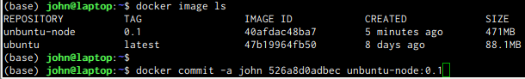
docker run -it -v /home/john/my_microservice:/host -p 9000:3000 unbuntu-node:0.1 ./bin/bash
// mount a local directory to volume host. Is temporary!!!
// redirect port 9000 to 3000 (latter is the service port)
run service => http://0.0.0.0:9000/api/sayhello

docker run -d -w /microservice -p 9000:3000 node-microservice:0.1 npm start
// run in directory /microservice
// in this directory lauch npm start
docker tag node-microservice:0.1 node-microservice:latest // rename tag

docker container life-cycle
docker attach CONTAINER-ID // see all what happens; when exit original container stops
docker stop CONTAINER-ID | name // stop the container running
docker exec -it CONTAINER-ID | name /bin/bash // get inside running container; mod running c
docker restart name // restart a stopped container

Logging
docker container logs --tail 5 <name>

docker container management
Look what has been running in the past with docker ps -a.
These are the problem when removing a container with docker rmi name.
To clean up and remove all dangling containers with docker rm `docker ps -a -q`
The command docker ps -a will return nothing anymore.
The container can now be removed with docker rmi repositoryname:tag

Typical error:
Error response from daemon: conflict: unable to remove repository reference "nginx:latest" (must force) - container 7d3653f11d3e is using its referenced image f09fe80eb0e7

This error is a warning: take care you don’t remove a container whoch you could need in the future.

docker rmi 07dab6f8a741 // remove based on image id
Ports
docker run -d --name=WebServer1 nginx
shows under ports
80/tcp

docker run -d --name=WebServer2 -P nginx // capital P
shows under ports
0.0.0.0:32768→80/tcp // so localhost port 32768 is forwarded to port 80 (with own ipaddress)

docker port WebServer2 $CONTAINERPORT // shows ports, next to docker ps will give
80/tcp -> 0.0.0.0:32768

docker run -d --name=WebServer3 -p8080:80 nginx:latest // redirect manually

Other way to abstract port mapping is through kubernetes or load-balancer. This practice is useful during development and testing.
The layered filesystem
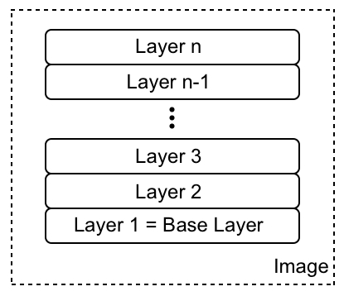
Container images are templates from which containers are created. The first layer in the image is also called the base layer.
Each individual layer contains files and folders. Each layer only contains the changes to the file-system with respect to the underlying layers. Docker uses a union file-system.
Working with Containers—to create a virtual file-system out of the set of layers. A storage driver handles the details regarding the way these layers interact with each other. Different storage drivers are available that have advantages and disadvantages in different situations.
The layers of a container image are all immutable. The only possible operation affecting the layer is the physical deletion of it. Each layer only contains the delta of changes in regard to the previous set of layers. The content of each layer is mapped to a special folder on the host system, which is usually a subfolder of /var/lib/docker/. Since layers are immutable, they can be cached without ever becoming stale.
When the Docker engine creates a container from such an image, it adds a writable container layer on top of this stack of immutable layers. Our stack now looks as follows:
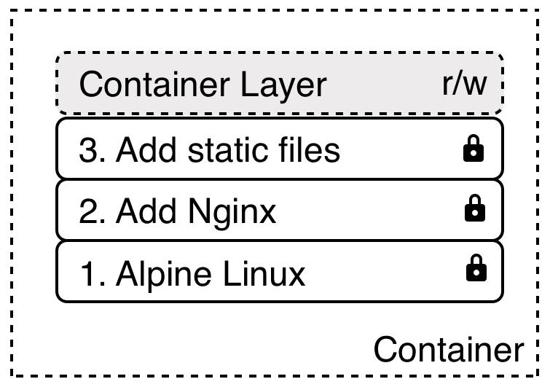
The container layer is marked as read/write. Another advantage of the immutability of image layers is that they can be shared among many containers created from this image. Results in a tremendous reduction of resources.
Copy-on-write: If a layer uses a file or folder that is available in one of the low-lying layers, then it just uses it. If, on the other hand, a layer wants to modify a file from a low-lying layer, then it first copies this file up to the target layer and then modifies it.
Graph drivers are what enable the union file-system. Controls how images and containers are stored and managed on the Docker host. Docker supports several graph drivers using a pluggable architecture. The preferred driver is overlay2 followed by overlay.
Creating images
- Interactively building a container that contains all the additions and changes one desires and then committing those changes into a new image. Helpful when doing exploration, creating prototypes, or making feasibility studies. Drawback: it is a manual process and thus is not repeatable or scalable
- use base image, make modifications, exit
- docker ps -a // shows the image is “Exited”
- docker diff <name> // shows the differences with previous layer.
- docker commit <name> <new name>
- Most important way is to use a Dockerfile.
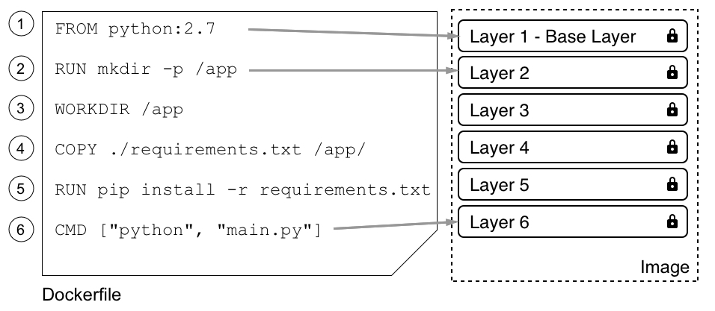
Every Dockerfile starts with the FROM keyword. With it, we define which base image we want to start building our custom image from. If from scratch then FROM scratch.
The argument for RUN is any valid Linux
command.
The COPY and ADD keywords are very important since, in the end, we want to add some content to an existing base image to make it a custom image. The two keywords are very similar, with the exception that the ADD keyword also lets us copy and unpack TAR files, as well as provide a URL as a source for the files and folders to copy.
COPY . /app // copies all files and folders from the current directory recursively
COPY ./web /app/web
COPY sample.txt /data/my-sample.txt
ADD sample.tar /app/bin/ // unpacks the sample.tar file into the target folder
ADD http://example.com/sample.txt /data/
COPY ./sample* /mydir/ // wildcards are allowed
Both COPY and ADD have user ID (UID) and a group ID (GID) of 0.
so better, as example
ADD --chown=11:22 ./data/files* /app/data/
The WORKDIR keyword defines the working directory or context that is used when a container is run from our custom image.
WORKDIR /app/bin // is persistant across layers
The CMD and ENTRYPOINT keywords. When the container runtime starts a container, it needs to know what the process or application has to run inside this container. That is exactly what CMD and ENTRYPOINT are used for—to tell Docker what the start process is and how to start that process.
exec form: ENTRYPOINT comamnd ie ENTRYPOINT ["ping"]
CMD values ie CMD ["-c", "3","8.8.8.8"]

shell form: only CMD is used ie CMD [“ping”,"-c", "3","8.8.8.8"]
(ENTRYPOINT is undefined: default value of /bin/sh -c)
docker image build -t pinger . // create image pinger
overrride ENTRYPOINT: docker container run --rm -it --entrypoint /bin/sh pinger
// option -rm automatically remove container on exit
- Creating an image is by importing it into the system from a tarball.
docker image save -o ./backup/my-alpine.tar my-alpine // create tar from container
docker image load -i ./backup/my-alpine.tar // load container

Multistep builds
example:
FROM alpine:3.7 AS build << this is important!!! AS BUILD
MAINTAINER john
RUN apk update && \
apk add --update alpine-sdk
RUN mkdir /app
WORKDIR /app
COPY . /app
RUN mkdir bin
RUN gcc hello.c -o bin/hello
FROM alpine:3.7 << this build contains only what is necessary to run the app
MAINTAINER john
COPY --from=build /app/bin/hello /app/hello
CMD /app/hello
A smaller image size has many advantages, such as a smaller attack surface area for hackers, reduced memory and disk consumption, faster startup times of the corresponding containers, and a reduction of the bandwidth needed to download the image from a registry
ENV MYVALUE MY-VALUE // environment variable MYVALUE is available in container
EXPOSE 22
EXPOSE 80 // ports are exposed and through them the container is accessible
Dockerfile best practices
- A container can be stopped and destroyed and a new one built and put in place with an absolute minimum of setup and configuration. That means that we should try hard to keep the time that is needed to initialize the application running inside the container at a minimum, as well as the time needed to terminate or clean up the application.
- We should order the individual commands in the Dockerfile so that we leverage caching as much as possible. Keep the build times at a minimum. The only layers that are rebuilt are the ones that have changed, but if one layer needs to be rebuilt, all subsequent layers also need to be rebuilt. This is very important to remember.
- Keep the number of layers that make up your image relatively small. The more layers an image has, the more the graph driver needs to work to consolidate the layers into a single root file-system for the corresponding container. The easiest way to reduce the number of layers is to combine multiple individual RUN commands into a single one. ie
RUN apt-get update \
&& apt-get install -y ca-certificates \
&& rm -rf /var/lib/apt/lists/*
- Use a .dockerignore file. We want to avoid copying unnecessary files and folders into an image to keep it as lean as possible. Works same as .gitignore.
- Avoid installing unnecessary package.
- Use multistage builds.
Sharing or shipping images
globally unique name. This action is often called tagging an image. Publish the image to a central location called image registries.
Each image has a so-called tag. A tag is often used to version images, but it has a broader reach than just being a version number. If we do not explicitly specify a tag when working with images, then Docker automatically assumes we're referring to the latest tag.
docker image pull alpine equal to docker image pull alpine:latest
or specific version: docker image pull alpine:3.5
Image namespaces
fully qualified name: <registry URL>/<User or Org>/<name>:<tag>
- <registry URL>: default is docker.io
Other repositories:
Google https://cloud.google.com/container-registry
Amazon AWS https://aws.amazon.com/ecr/
Microsoft Azure https://azure.microsoft.com/en-us/services/container-registry/
Red Hat https://access.redhat.com/containers/
Artifactory https://jfrog.com/integration/artifactory-docker-registry/
- <User or Org>: This is the private Docker ID of either an individual or an organization defined on Docker Hub, or any other registry for that matter, such as microsoft or oracle.
- <name>: This is the name of the image that is often also called a repository.
- <tag>: This is the tag of the image.
Official images
Official images are meant to provide essential base OS repositories, images for popular programming language run-times, frequently used data storage, and other important services.
Docker sponsors a team whose task it is to review and publish all those curated images in public repositories on Docker Hub. Furthermore, Docker scans all official images for vulnerabilities.
Pushing images to a registry
To be able to push an image to my personal account on Docker Hub, I need to tag it accordingly.
docker image tag alpine:latest johnwillems/alpine:1.0
Now, to be able to push the image, I have to log in to my account:
docker login -u gnschenker -p <my secret password>
After a successful login
docker image push gnschenker/alpine:1.0
For each image that we push to Docker Hub, we automatically create a repository. A repository can be private or public.
Data Volumes and System Management
stateful containers => containers that consume and produce data.
Volumes allow containers to consume, produce, and modify state. Volumes have a life cycle that goes beyond the life cycle of containers. When a container that uses a volume dies, the volume continues to exist.

docker volume create my-data

$ docker volume inspect my-data
[ { "CreatedAt": "2018-01-28T21:55:41Z",
"Driver": "local",
"Labels": {},
"Mountpoint": "/var/lib/docker/volumes/my-data/_data",
"Name": "my-data",
"Options": {},
"Scope": "local" } ]
Mount to container:
docker container run --name test -it -v my-data:/data alpine /bin/sh
docker run --rm -v "$(pwd)":/app -w /app java sh -c /bin/sh
The files in /data are available for other containers when they have also “-v my-data:/data” in the command line.

Remove volume:
docker volume rm my-data

Of course multiple container can use the volume but only one can write, to avoid inconsistency or race-conditions. The “readers” are configured as:
docker container run -it --name reader -v shared-data:/app/data:ro ubuntu:17.04 /bin/bash

In this way host volumes can be mounted:
docker run -d --name=WebServer5 -p8080:80 -v /home/john/work/docker/www/:/usr/share/nginx/html nginx:latest

Ie databases running in containers, need to persist their data beyond the lifetime of the container. In this case they can use volumes.

Keyword VOLUME in Dockerfile
ie
VOLUME /app/data
VOLUME /app/data, /app/profiles, /app/config << same
VOLUME ["/app/data", "/app/profiles", "/app/config"] << same
When a container is started, Docker automatically creates a volume and mounts it to the corresponding target folder of the container for each path defined in the Dockerfile. Since each volume is created automatically by Docker, it will have an SHA-256 as ID.

In order to get the mounting-points:
docker image inspect --format='{{json .ContainerConfig.Volumes}}' mongo:3.7 | jq
[
{
"Type": "volume",
"Name": "b9ea0158b5...",
"Source": "/var/lib/docker/volumes/b9ea0158b.../_data",
"Destination": "/data/configdb",
"Driver": "local",
"Mode": "",
"RW": true,
"Propagation": ""
}, …...
The Source field gives us the path to the host directory where the data produced by the MongoDB inside the container will be stored.

At container runtime, the folders defined as volumes in the Dockerfile are excluded from the union filesystem and thus any changes in those folders do not change the container layer but are persisted to the respective volume. It is now the responsibility of the operations engineers to make sure that the backing storage of the volumes is properly backed up.
Obtaining Docker system information
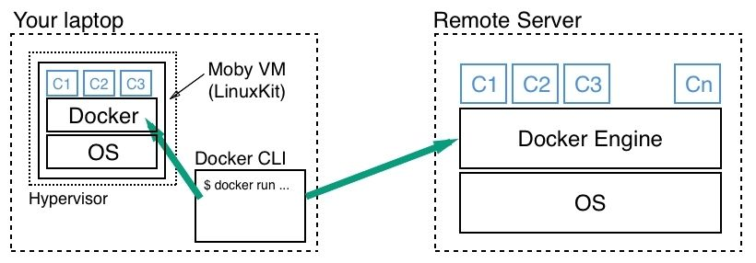
Docker client is the little CLI
The Docker host is the container runtime which hosts the containers and might run on the same machine as the CLI, or it might run on a remote server, on-premise or in the cloud.

If DOCKER_HOST, DOCKER_TLS_VERIFY, and DOCKER_CERT_PATH are not set, CLI connects to hosts Docker server.

docker system info
Info about what mode the Docker engine is operating in (swarm mode or not), what storage driver is used for the union filesystem, what version of the Linux kernel we have on our host, and much more.

docker system df
Listing resource consumption
TYPE TOTAL ACTIVE SIZE RECLAIMABLE
Images 5 0 603MB 603MB (100%)
Containers 0 0 0B 0B
Local Volumes 4 0 629.6MB 629.6MB (100%)
Build Cache 0 0 0B 0B

docker system df -v
will give very detail information

Pruning unused resources
docker container prune // removes all containers not in running mode.
docker container rm -f $(docker container ls -aq) // removes also the running containers

docker image prune // remove unused image layers. The appear through over and over rebuiding.
docker image prune --force --all // only images that are currently used by one or more
containers will remain in our local image cache.

docker volume prune // remove all volumes not in use
docker volume prune --filter 'label=demo' // only apply the command to volumes that have a label
with the demo value.

docker network prune // remove all unused networks

docker system prune // remove everything
Consuming Docker system events

docker system events // is a blocking command

In this output, we can follow the exact life cycle of the container. The container is created, started, and then destroyed.
Distributed Application Architecture.

Terminology
Node individual server used to run applications; fysical or vm.
Cluster group of nodes connected to a network to run distributed applications
Network Physical and software-defined communication paths between individual nodes of a cluster
and programs running on those nodes.
Port Channel on which an application such a web server listens for incoming requests.
Service is a piece of software that implements a limited set of functionality which is then used
by other parts of the application
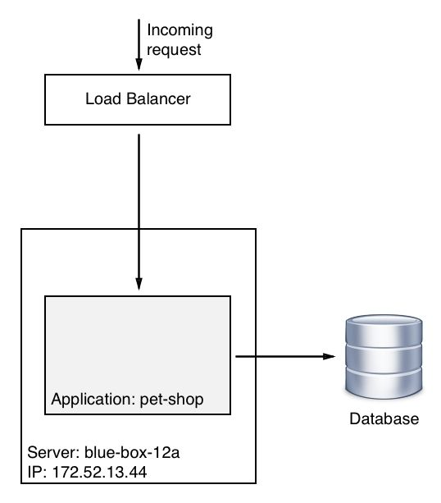
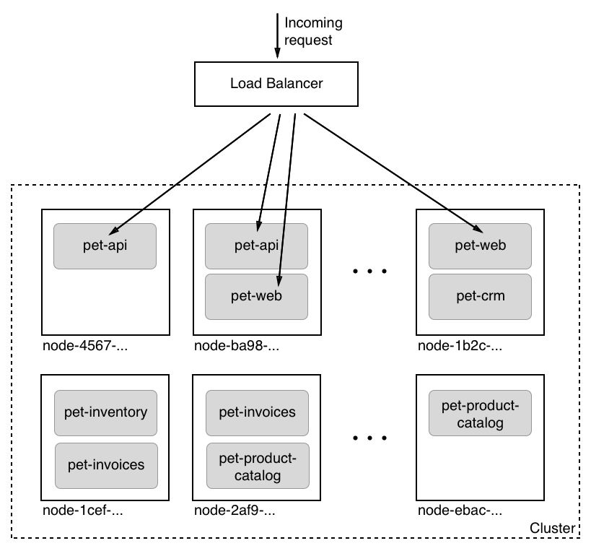
Monolithic application architecture

vs

Distributed application architecture
For nodes to identify:
universal unique identifier (UUID)

Each service runs in multiple instances in this cluster of servers or hosts

A distributed application architecture has many compelling benefits, but it has also one very significant drawback compared to a monolithic application architecture - the former is way more complex. To tame this complexity, the industry has come up with some important best practices and patterns.

Patterns and best practices to reduce complexity
Loosely coupled components:
What this means is that component A makes no assumptions about the inner workings of, say, components B and C, but is only interested in how it can communicate with those two components across a well-defined interface. During the development process, other components in the system can be replaced by stubs or mocks to allow us to test our component.
Stateful versus stateless:
Data is also called state. An application service that creates or modifies persistent data is called a stateful component. Typical stateful components are database services or services that create files. On the other hand, application components that do not create or modify persistent data are called stateless components. In a distributed application architecture, stateless components are much simpler to handle than stateful components. Stateless components can be easily scaled up and scaled down. They can also be quickly and painlessly torn down and restarted on a completely different node of the cluster—all this because they have no persistent data associated with them.
Service discovery:
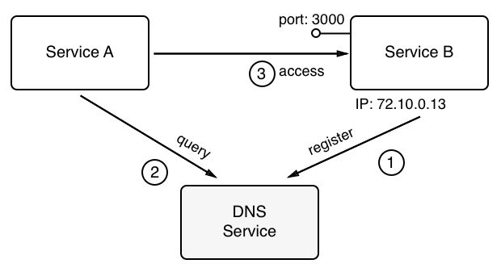
What is most commonly used is an external authority that is aware of the topology of the system at any given time. This external authority or service knows all the nodes and their IP addresses that currently pertain to the cluster; it knows all services that are running and where they are running. Often, this kind of service is called a DNS service, where DNS stands for Domain Name System. As we will see, Docker has a DNS service implemented as part of the underlying engine. Kubernetes also uses a DNS service to facilitate commu-nication between components running in the cluster.
Routing:
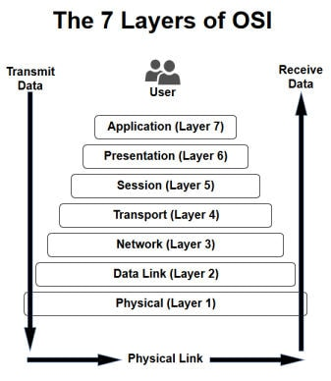
In the context of containers and container orchestration, routing at layers 2, 3, 4, and 7 is relevant.

Load balancing:
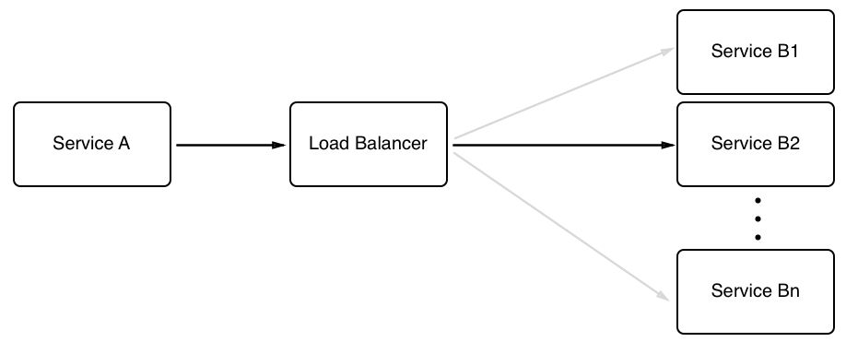
Load balancing is used whenever Service A requests a service from Service B, but the latter is running in more than one instance. We want to make sure that every, of those instances gets an equal amount of workload assigned to it. This task is a generic one, which means that we don't want the caller to have to do the load balancing, but rather an external service that intercepts the call and takes over the part of deciding to which of the target service instances to forward the call. Load balancers can use different algorithms to decide how to distribute the incoming calls to the target service instances. The most common algorithm used is called round robin.
Redundancy:
To avoid downtime when one of the many components in the system fails, each individual part of the system needs to be redundant. This includes the application components as well as all infrastructure parts. The easiest way to do that is to run multiple instances of this very service on different nodes of our cluster. The same applies, say, for an edge router or a load balancer.
Health checks:
Is the component healthy? The answer of each service is either Yes or No, or the health check times out if the instance is not responsive anymore. If the component answers with No or a timeout occurs, then the system kills the corresponding instance and spins up a new instance in its place. If all this happens in a fully automated way, then we say that we have an auto-healing system in place.
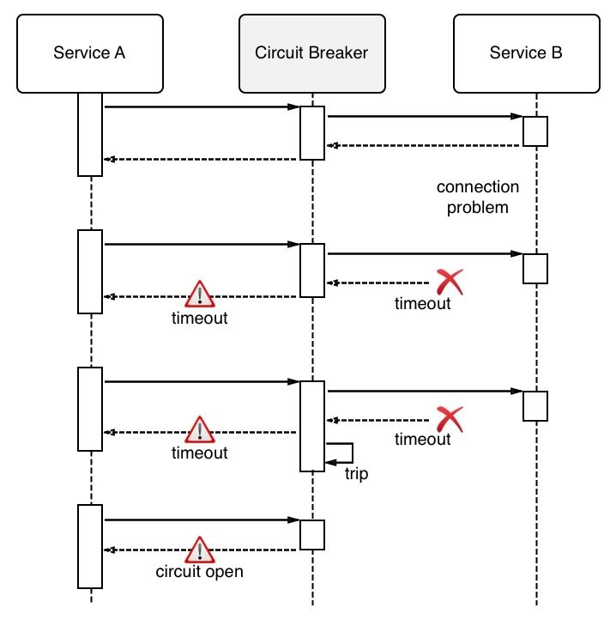
Circuit breaker pattern:
Is a mechanism that is used to avoid a distributed application going down due to a cascading failure of many essential components. Circuit breakers help to avoid one failing component tearing down other dependent services in a domino effect. This can be achieved by wrapping a protected service call in a circuit breaker object. This object monitors for failures. Once the number of failures reaches a certain threshold, the circuit breaker trips. All subsequent calls to the circuit breaker will return with an error, without the protected call being made at all:

Running in production: introspection and monitoring
Produce abundant and meaningful logging information. In a distributed application architecture, with its many components, logging is even more important than in a monolithic application.
Tracing
Is used to find out how an individual request is funneled through a distributed application and how much time is spent overall for the request and in every individual component. This information, if collected, can be used as one of the sources for dashboards that show the behavior and health of the system.
Monitoring
Non-functional metrics such as memory and CPU usage, number of crashes of a system or application component, health of a node, and so on, as well as functional and thus application-specific metrics such as the number of checkouts in an ordering system or the number of items out of stock in an inventory service.
Application updates
Since application updates are so frequent, these updates have to be non-disruptive. We cannot allow the system to go down for maintenance when upgrading. It all has to happen seamlessly and transparently.
Rolling updates
The assumption here is that the particular piece of software that has to be updated runs in multiple instances. Only then can we use this type of update. What happens is that the system stops one instance of the current service and replaces it with an instance of the new service. Since there are always a few instances running at any given time, current or new, the application is operational all the time. No downtime is needed.
Blue-green deployments
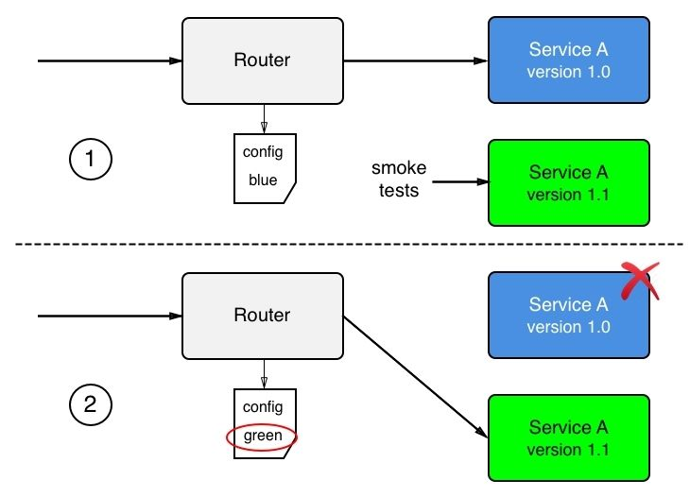
In blue-green deployments, the current version of the application service, called blue, handles all the application traffic. We then install the new version of the application service, called green, on the production system. The new service is not yet wired with the rest of the application. Once green is installed, one can execute smoke tests against this new service and, if those succeed, the router can be configured to funnel all traffic that previously went to blue to the new service, green. The behavior of green is then observed closely and, if all success criteria are met, blue can be decommissioned. But if, for some reason, green shows some unexpected or unwanted behavior, the router can be reconfigured to return all traffic to blue. Green can then be removed and fixed, and a new blue-green deployment can be executed with the corrected version.
Canary releases
Canary releases are releases where we have the current version of the application service and the new version installed on the system in parallel. As such, they resemble blue-green deployments. At first, all traffic is still routed through the current version. We then configure a router so that it funnels a small percentage, say 1%, of the overall traffic to the new version of the application service. The behavior of the new service is then monitored closely to find out whether it works as expected. If all the criteria for success are met, then the router is configured to funnel more traffic, say 5% this time, through the new service. Again, the behavior of the new service is closely monitored and, if it is successful, more and more traffic is routed to it until we reach 100%. Once all traffic is routed to the new service and it has been stable for some time, the old version of the service can be decommissioned.
Irreversible data changes
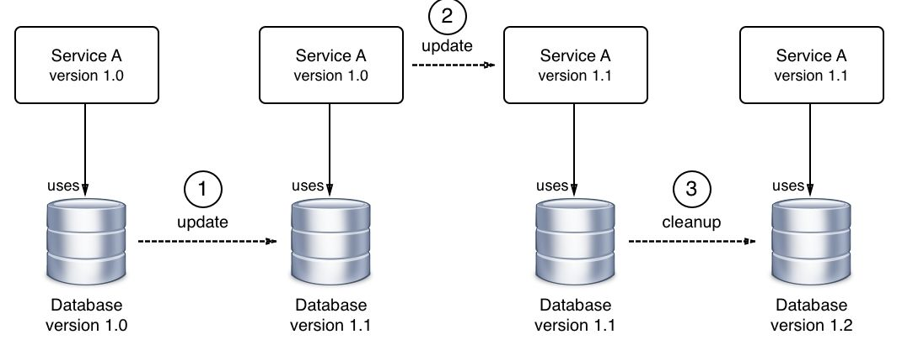
If part of our update process is to execute an irreversible change in our state, such as an irreversible schema change in a backing relational database, then we need to address this with special care. It is possible to execute such changes without downtime if one uses the right approach. It is important to recognize that, in such a situation, one cannot deploy the code changes that require the new data structure in the data store at the same time as the changes to the data. Rather, the whole update has to be separated into three distinct steps. In the first step, one rolls out a backward-compatible schema and data change. If this is successful, then one rolls out the new code in the second step. Again, if that is successful, one cleans up the schema in the third step and removes the backwards-compatibility.
Rollback
In a distributed application architecture, it is not a question of whether a rollback will ever be needed, but rather when a rollback will have to occur. Thus, we need to absolutely be sure that we can always roll back to a previous version of any service that makes up our application. Rollbacks cannot be an afterthought but have to be a tested and proven part of our deployment process. If we are using blue-green deployments to update our services, then rollbacks should be fairly simple. All we need to do is switch the router from the new green version of the service back to the previous blue version.
Single-Host Networking
Docker container networking model and its single-host implementation in the form of the bridge network.
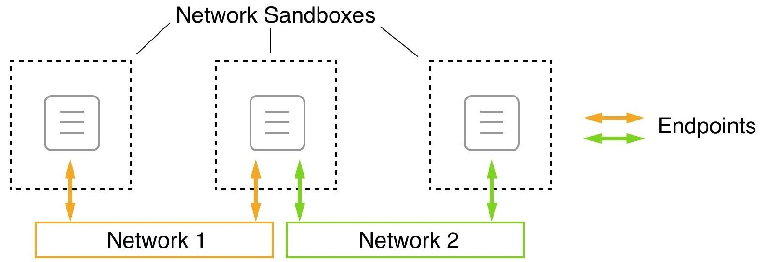
Pathways between containers are called networks. The model is called container network model (CNM)
CNM has three elements:
- Sandbox: The sandbox perfectly isolates a container from the outside world. No inbound network connection is allowed into the sand-boxed container.
- Endpoint: An endpoint is a controlled gateway from the outside world into the network's sandbox that shields the container. The endpoint connects the network sandbox (but not the container) to the third element of the model, which is the network.
- Network: The network is the pathway that transports the data packets of an instance of communication from endpoint to endpoint, or ultimately from container to container.
A network sandbox can have zero to many endpoints.
Network firewalling
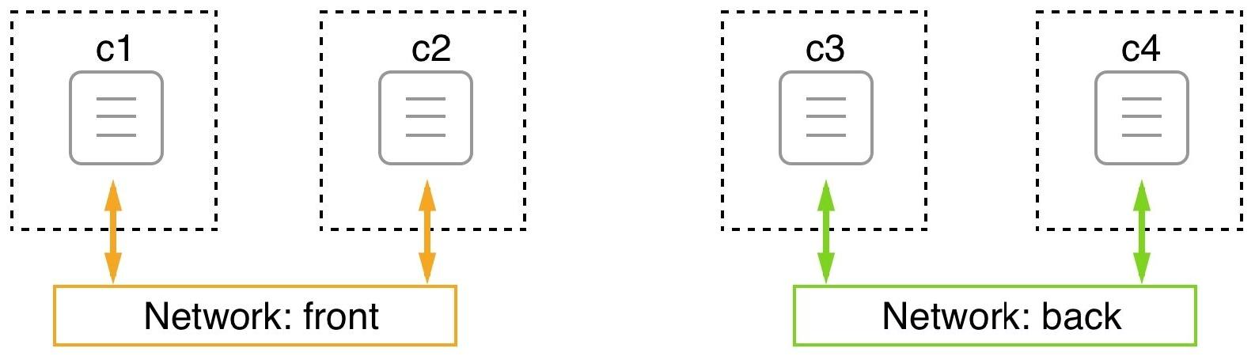
Docker has always had the mantra of security first. All containers that belong to the same network can freely communicate with each other, while others have no means to do so. c1 and c2 have no way to communicate with either c3 or c4, and vice versa.

Since creating Software-defined networks (SDN) is cheap, and each network provides added security by isolating resources from unauthorized access, it is highly recommended that you design and run applications so that they use multiple networks and run only services on the same network that absolutely need to communicate with each other.

The bridge network
This network implementation is based on the Linux bridge. When the Docker daemon runs for the first time, it creates a Linux bridge and calls it docker0. This is the default behavior, and can be changed by changing the configuration. Docker then creates a network with this Linux bridge and calls the network bridge.
To verify that we indeed have a network called bridge of type bridge defined on our host, we can list all networks on the host with the following command:
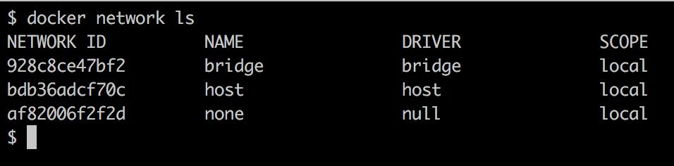
The scope being local just means that this type of network is restricted to a single host and cannot span across multiple hosts.

