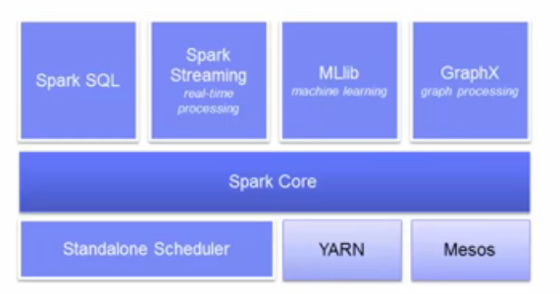
- Spark Core: General purpose system for scheduling, distribution, monitoring applications across clusters
- Easy scale up to thousands of nodes.
- Multiple cluster-managers: ie YARN, Mesos, build-in scheduler
- Fault tolerant, high throughput and scalable

Upper layers inherit improvements of lower layers.

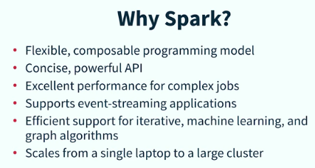
Spark SQL: works with SQL and HiveQL (Scala, Python, Java)
Spark Streaming: live streams processing, Easily switch between data in memory and arriving in real-time.
Spark ML: Scala out across the clusters
SparkX: graph manipulation in parallel.

Advance to Hadoop:
Easier programming and batch, streaming, graph
Reduce overhead when integrated with other systems
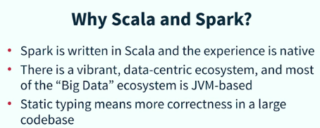
Better support for iterative ML and grapp algoritme
Better performance for complex jobs
Scales down better => use less resources when required to run less complex jobs
API of Hadoop is NOT functional => main shortcoming; Functional we can apply a function to a container (collection, future or option)

Resilient Distributed Datasets (RDD) (Spark primary abstraction == collection, immutable)
Distributed fault-tolerant collection of elements, parallelized across clusters, immutable
Two types of RDD operations:
- transformations: create DAG, lazy evaluation, no return, fault tolerant, linage (when nodes goes of-line the DAG is re-evaluated and rebuild) Return pointer to the RDD created.
- actions: performs transformations and action that follows, returns values as outcome of the action
RDD’s know there parents, so all there ancestors == > lineage of data flow
Caching enables processing in memory. If not fits in memory then spill to disk.

The notion here is that the graphs can be replayed on nodes that need to get back to the state it was before it went off-line thus providing fault tolerance. If node fails it an other node will take over and uses the DAG. So RDD is resilient.

Methods creating RDD (DAG Direct Acyclic Graph is created in transformation):
- Parallelizing existing collection and therefor exists already in Spark sc.parallelize([1,2,3])
- Referencing a dataset ie HDFS, Cassandra, HBase, Amazon S2 etc.
- Transformation existing RDD ie using map, filter

Supported files: text-, sequence files and any Hadoop inputFormat

View DAG of a transformation use toDebugString() Read bottom-up

Transformations:
flatmap, similar to map, but the input can be mapped to 0 or more output items. Returns a sequence
join (otherDataSet,[numtasks]) type (K,V) and (K,W) teturns (K,(V,W)) pairs
reduceByKey(func)
sortByKey(ascending=True, numPartitions=None, keyfunc=<function>)

Actions:
collect(), count(), first(), take(n), foreach(func)

Control methods:
do meta-operations or return state
eq: checkpoint, cache, persist, unpersist, coalesce, repartition.
Dependencies, getCheckpointFile, getStorageLevel, isCheckpointed

Two methods to invoke RDD persistance:
persist() ==> allows to specify a different storage level of caching ie on disk
linesLength.persist(storageLevel=pyspark.StorageLevel.DISK_ONLY)
cache() ==> the default

cache saves RDD in memory; Persist let’s vary where data is saved.
import org.apache.spark.rdd.RDD
val r : RDD[Int] = sc.parallelize(0 until 5)
r.cache() // nothing happens until an action is called == r.persist(MEMORY)

cache, persist both are optimizations; avoid recomputing the lineage of ancestor.
Call before invoking an action
call r.unpersist if done with RDD; Cleanups rdd from the cache
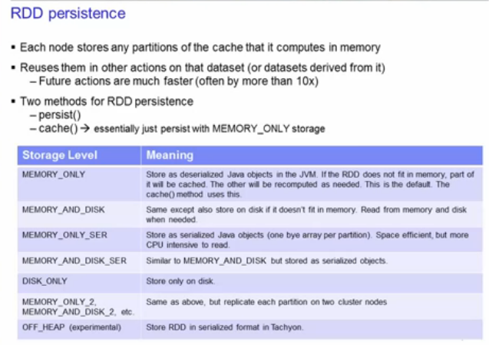

RDD is kept in memory on the node. Caching is fault tolerant, because when partition is lost it will automatically recompute it using the transformation which created in the first place.

Persist method allows the specify which storage level to use.
Cache() is just persist(storageLevel=MEMORY_ONLY)

If RDD fits in memory leave storageLevel Memory_Only
If not try MEMORY_ONLY_SER and select a fast serialization library

checkpoint saves the RDD to file system. Parent lineage is lost/forgotten and no longer needed to reconstruct the parent partitions.
Call checkpoint before evaluating the RDD; when too expensive to rely on caching;
impossible to go back to data source (streaming data)

Only applicable for batch jobs; for streaming jobs done automatically.

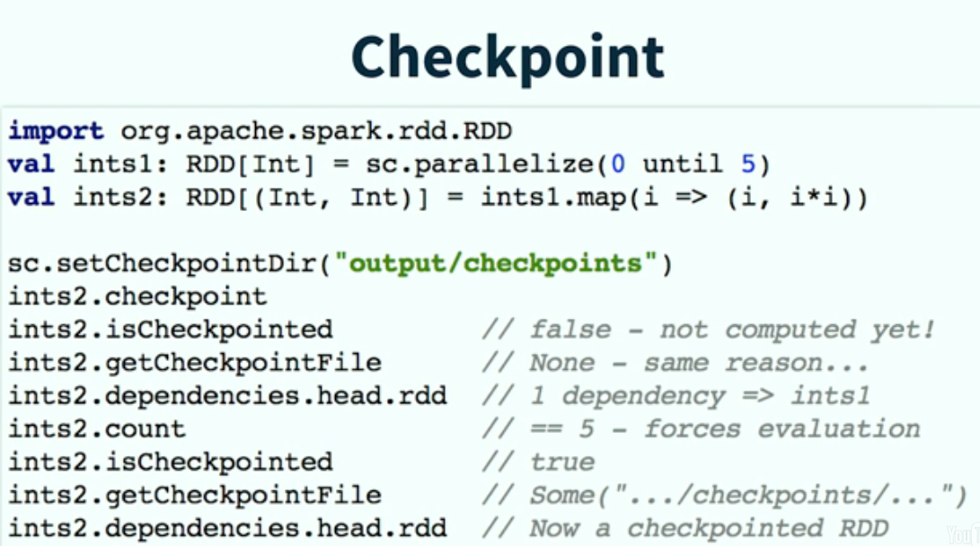

Repartitioning: create more or less partitions based on need
myRDD.repartition(n)
value of n depends on application and dataset. Use Spark console to see partitions in use and if its reasonable.
Might force a shuffle operation; shuffle is expensive.
When less partitions use myrdd.coalesce(n, shuffle = false)

Shared variables when a function is passed from the driver to a worker, normally a separate copy of the variable is used.

Two types of shared variables: p = (‘a’,’b’); p[0] and p[1]
- Broadcast variables. Distribute read-only copy of a large dataset on each machine.
- Accumulators. Variable numeric, extensible with own types, added through an associative operation. Counters and sums. Only drivers can read accumulators; task can only add. Work well in parallel.
Operations are grouping and aggregating by a key ie reduceByKey

Broadcast variables are useful for when you have a large dataset that you want to use across all the worker nodes. A read-only variable is cached on each machine rather than shipping a copy of it with tasks. Spark actions are executed through a set of stages, separated by distributed “shuffle” operations. Spark automatically broadcasts the common data needed by tasks within each stage.
broadcastVar = sc.broadcast([1,2,3])

Accumulators are variables that can only be added through an associative operation. It is used to implement counters and sum efficiently in parallel. “Accumulate some results of the whole job, even when tasks are distributed around the cluster. Spark natively supports numeric type accumulators and standard mutable collections. Programmers can extend these for new types. Only the driver can read the values of the accumulators. The workers can only invoke it to increment the value; only the driver program can read the accumulator’s value
Accum = sc.accumulator(0)

Special operations available on RDD of key-value pairs:
- Grouping and aggregating elements by a key-value
- reduceByKey()

Linking with Spark:
Run python programs in Spark submit /bin/spark-submit

from pyspark import SoarkContext, SparkConf
conf = SparkConf().setAppname(appName).setMaster(master)

appName is the name shown in the cluster UI
master parameter is Spark, Mesis or YARN cluster URL of local to run in local mode.
Do not specify master in production mode but provide it at launch time at spark-submit
For testing use local

sc = SparkContext(conf=conf) # represents the connection to a Spark cluster
sc = SparkContext(‘local’,’simple app’)
Pass functions from the worker to the drivers:
- Anonymous functions (lambda)
- Static method in a global singleton object
- passing by reference

Run pyspark for a py script (because of jupyter):
export PYSPARK_DRIVER_PYTHON=python
export PYSPARK_DRIVER_PYTHON_OPTS=

Spark libraries are tight integrated, which results in less overhead.
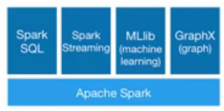
Spark SQL: SQL, HiveQL and Scala expressions
SchemaRDD (like table in rdbms): row objects, schema
created from: existing RDD
parquet file
JSON dataset
HiveQL against Hive
from pyspark.sql import SQLContext sqlContext(sc)

How to create a schemaRDD:
- inferring the schema using reflection
- programmatic interface and apply to an existing RDD (more control when case classes cannot be defined at design time)

Spark Streaming:
scalable, high-troughput, fault-tolerant

recieves data from: kafka, Flume, HDFS/S3, Kinesis, Twitter
Output: HDFS, databases, Dashboards

Dstreams – Sequence of RDD (= input)
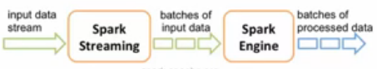

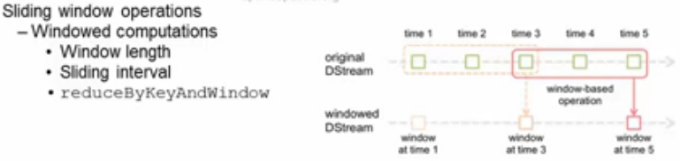
In example the window length = 3 and the Sliding interval = 2. These are the parameters for reduceByKeyAndWindow.

Have to explicit tell the application to start and when to terminate.

Spark Mllib:
Classification, regression, clustering, collaborating filtering, dimensionality reduction

Spark Graph:
- Graph and graph parallel computation
- social networks and language modelling

Spark Resource Management:
- local (scala shell; single JVM and runs all: driver, executor and all tasks)
- Standalone; no outside resource negotiator required; sbin/start-master.sh; jobs FIFO
slaves are started also: sbin/start-slave.sh –master spark://host:7077
- Mesos
- Hadoop YARN
- Standalone on EC2
- Cassandra, Riak and other DB’s soon….
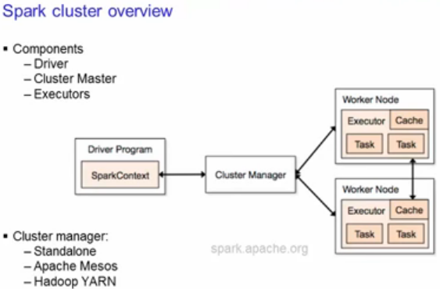

Executors are the processes that run computations and store the data.
Sparkcontext sends the jar or python code to the executors. Then the tasks for each executor.

Each applicantion has its own executors and stay up during the complete execution time.=> apllications are isolated from each other. Either in scheduling and/or JVM. So it is NOT possible to share data across applications. So only by externalize you can share data across applications.

Cluster manager can be any. Driver should be on the same network as the workers.

Spark configuration (default $SPARK_HOME/conf and changed by SPARK_CONF_DIR
- Spark properties where application properties can be set using SparkConf object or through Java properties
- Environment variables: to set machine variables conf/spark-env.sh
- Logging: log4j.properties

Setting Spark properties:
- passing application via sparkConf object
val conf = new SparkConf()
.setMaster(“local”)
.setAppName(“ContingSleep”)
.set(“spark.executor.memory”,”1g”)
val sc = new SparkContext(conf)
- Dynamically setting Spark properties:
- create SparkContext with empty conf
val sc = new SparkContext(new SparkConf())
- Supply the configuration values during runtime with command-line options
- conf/spark-defaults.conf
3. Application web UI
http://<driver>:4040

Priorities:
highest for the properties set to SparkConf
then via commandline and lowest priority for the spark-default.conf

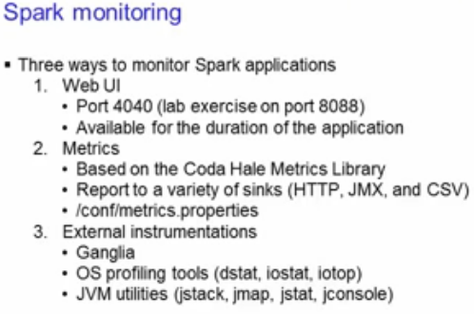
set spark.eventlog.enabled=true when see information after the fact.

History server rans after the fact

Data serialization and memory tuning ==> improve performance.
Data serialization is crucial for network performance and reduce memory usage
First thing to look when problems
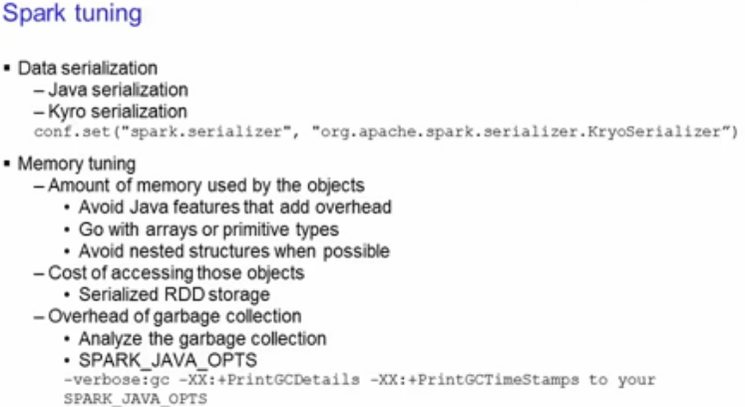
Two serialization libraries:
- java serialization => quite slow but supports all types
- Kyro serialization => faster but support not all serialization types. Register types in advance for best performance. Set in SparkConf object to use.

With Memory tuning are important:
- amount of memory used by the objects (all entire objects in memory?)
- costs of accessing these objects
- overhead garbage collection

Tips to reduce memory:
avoid Java features that add overhead, such as pointer based data structures and wrapper objects.
Use arrays or primitive types
Avoid nested structures
Serialized storage reduces memory usage but it take longer to access the objects
Collect statistics (add SPARK_JAVA_OPTS environment variable)

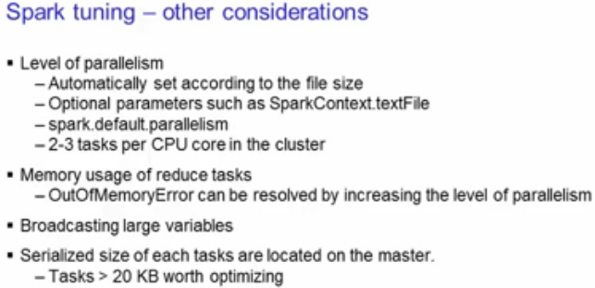
Level of parallelism => utilization of cluster.
Automatically set to file size of the task, but can be configured.
Set 2-3 takst per CPU core in the cluster.

If size of task > 20kb then optimize. Ie create broadcast variables

